SUPPLEMENTAL DATA
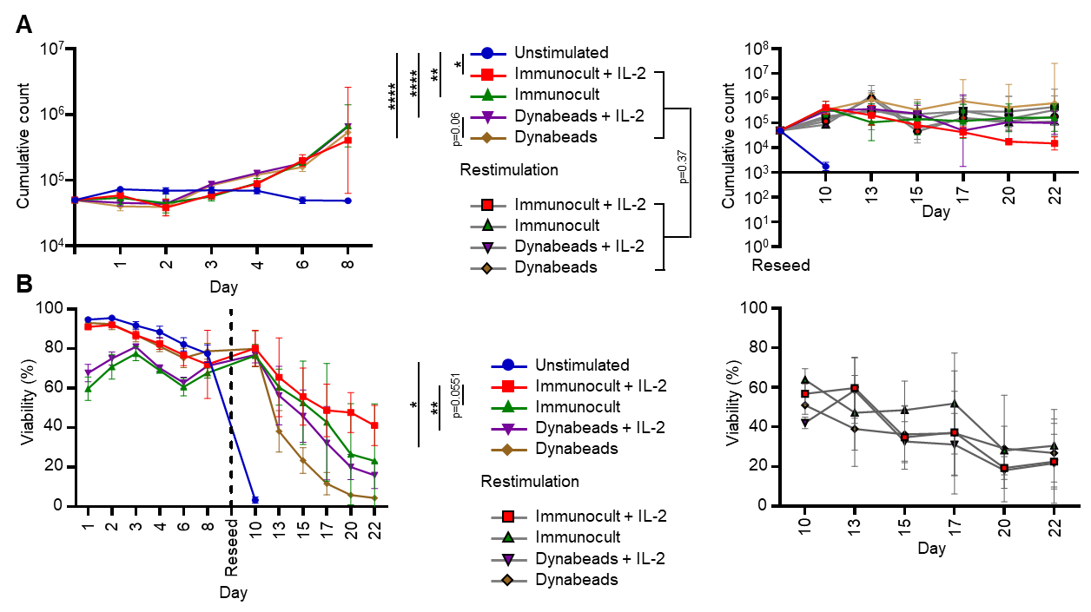
Figure S1 T-cell proliferation of all conditions in the presence or absence of IL-2 after stimulation with antibody-coated beads (Dynabeads) or soluble antibody complexes (ImmunoCult). A Cumulative cell counts and B T-cell viability (%) during the initial stimulation phase (days 0-8), after reseeding in fresh media with or without restimulation on day 8, and throughout the post-restimulation phase (days 10-22). Data represent mean ± SD of four independent donors.
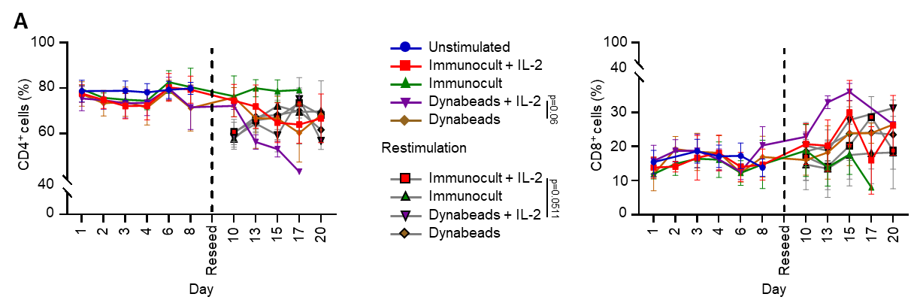
Figure S2 CD4/CD8 T-cell composition of all conditions in the presence or absence of IL-2 following stimulation with antibody-coated beads (Dynabeads) or soluble antibody complexes (ImmunoCult). Percentage of CD4⁺ (left) and CD8⁺ (right) T cells during the initial stimulation phase (days 0-8), after reseeding with or without restimulation on day 8, and throughout the post-restimulation phase (days 10-22). Data represent mean ± SD of four independent donors.

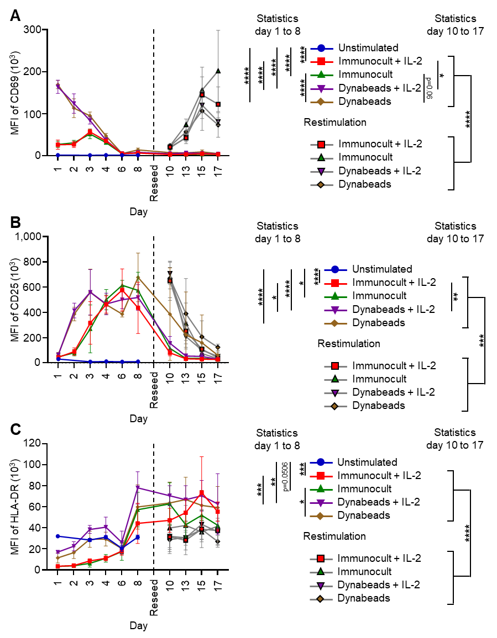
Figure S3 T-cell activation dynamics of all conditions in the presence or absence of IL-2 after stimulation with antibody-coated beads (Dynabeads) or soluble antibody complexes (ImmunoCult) during the initial stimulation phase (days 0-8), after reseeding in fresh media with or without restimulation on day 8, and throughout the post-restimulation phase (days 10-22). Activation marker expression was measured as the Mean Fluorescence Intensity (MFI) of A CD69 (early activation) B CD25 (intermediate-late activation), and C HLA-DR (late activation). Data represent mean ± SD of four independent donors.

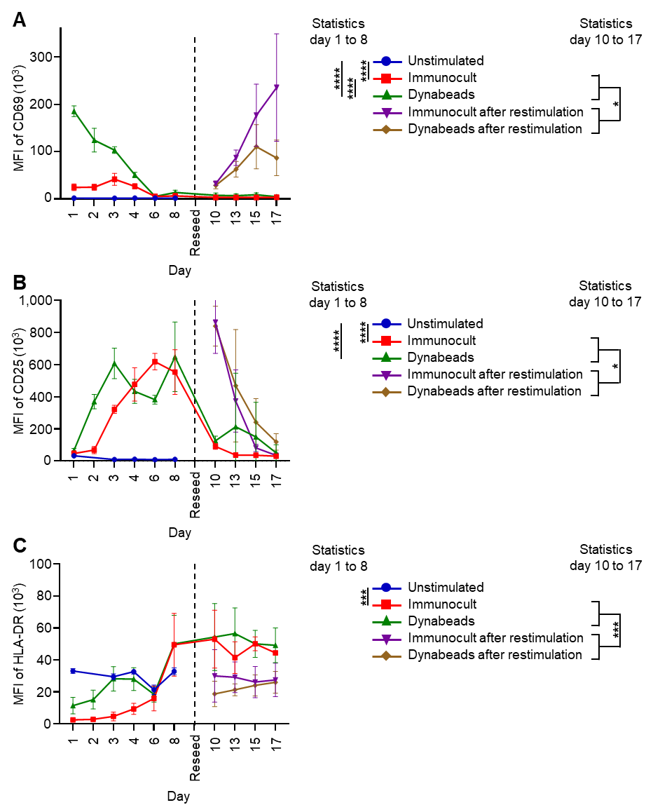
Figure S4 CD4⁺-T-cell activation dynamics of all conditions in the absence of IL-2 after stimulation with antibody-coated beads (Dynabeads) or soluble antibody complexes (ImmunoCult) during the initial stimulation phase (days 0-8), after reseeding in fresh media with or without restimulation on day 8, and throughout the post-restimulation phase (days 10-22). Activation marker expression was measured as the Mean Fluorescence Intensity (MFI) of A CD69 (early activation) B CD25 (intermediate-late activation), and C HLA-DR (late activation). Data represent mean ± SD of four independent donors.

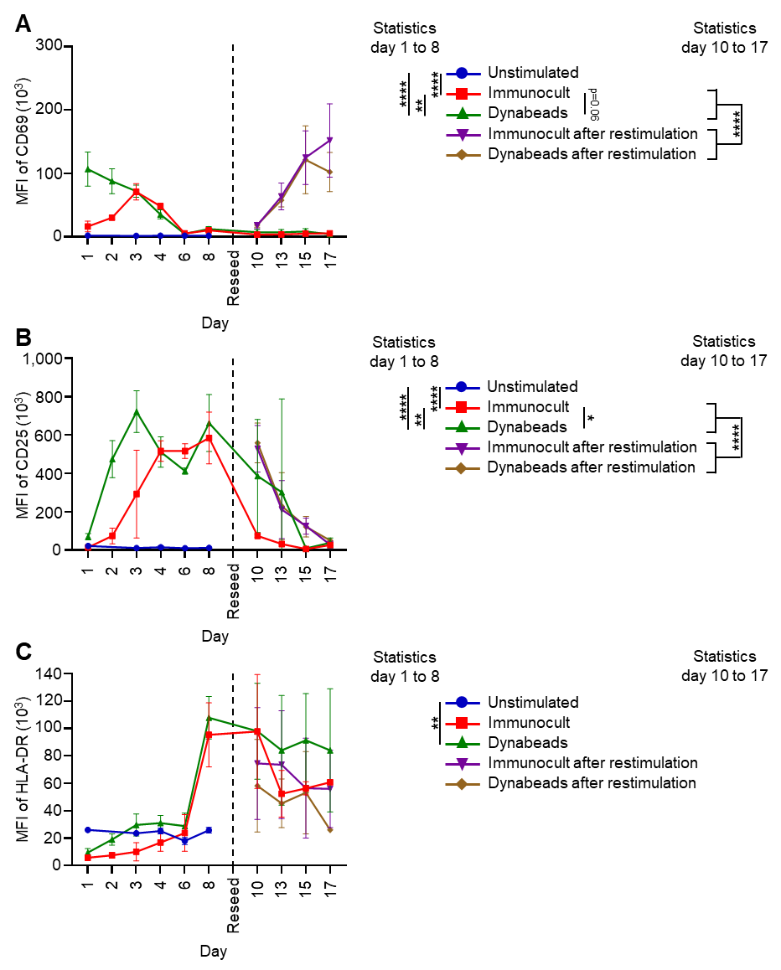
Figure S5 CD8⁺-T-cell activation dynamics of all conditions in the absence of IL-2 after stimulation with antibody-coated beads (Dynabeads) or soluble antibody complexes (ImmunoCult) during the initial stimulation phase (days 0-8), after reseeding in fresh media with or without restimulation on day 8, and throughout the post-restimulation phase (days 10-22). Activation marker expression was measured as the Mean Fluorescence Intensity (MFI) of A CD69 (early activation) B CD25 (intermediate-late activation), and C HLA-DR (late activation). Data represent mean ± SD of four independent donors.

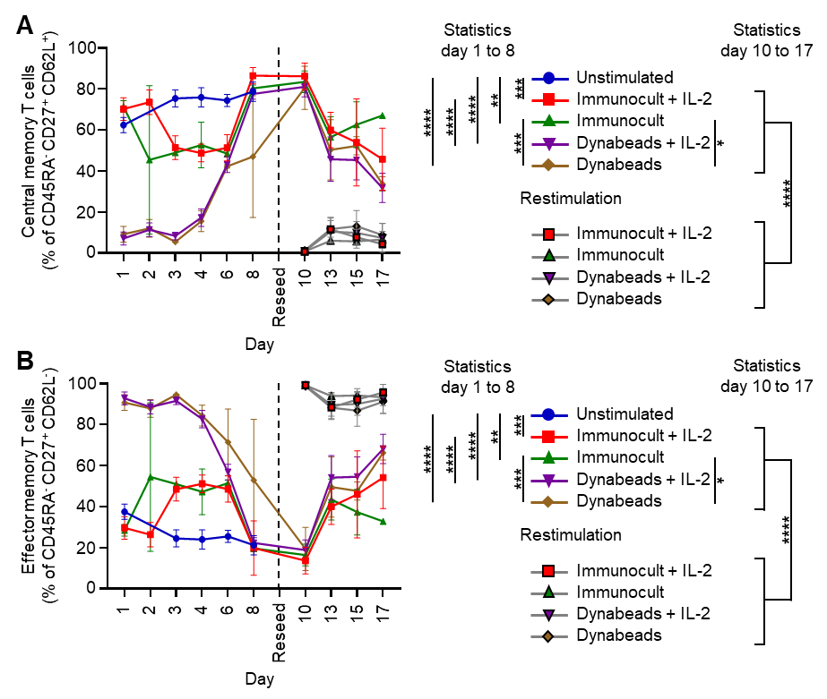
Figure S6 T-cell differentiation dynamics of all conditions in the presence or absence of IL-2 after stimulation with antibody-coated beads (Dynabeads) or soluble antibody complexes (ImmunoCult) during the initial stimulation phase (days 0-8), after reseeding in fresh media with or without restimulation on day 8, and throughout the post-restimulation phase (days 10-22). Memory T cells were categorized as A central memory (% of CD45RA⁻CD27⁺CD62L⁺) or B effector memory (% of CD45RA⁻CD27⁺CD62L⁻). Data represent mean ± SD of four independent donors.

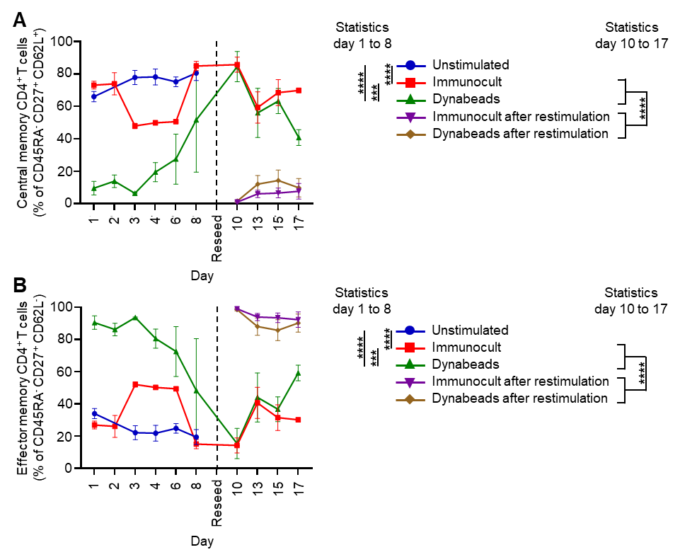
Figure S7 CD4⁺-T-cell differentiation dynamics of all conditions in the absence of IL-2 after stimulation with antibody-coated beads (Dynabeads) or soluble antibody complexes (ImmunoCult) during the initial stimulation phase (days 0-8), after reseeding in fresh media with or without restimulation on day 8, and throughout the post-restimulation phase (days 10-22). Memory T cells were categorized as A central memory (% of CD45RA⁻CD27⁺CD62L⁺) or B effector memory (% of CD45RA⁻CD27⁺CD62L⁻). Data represent mean ± SD of four independent donors.

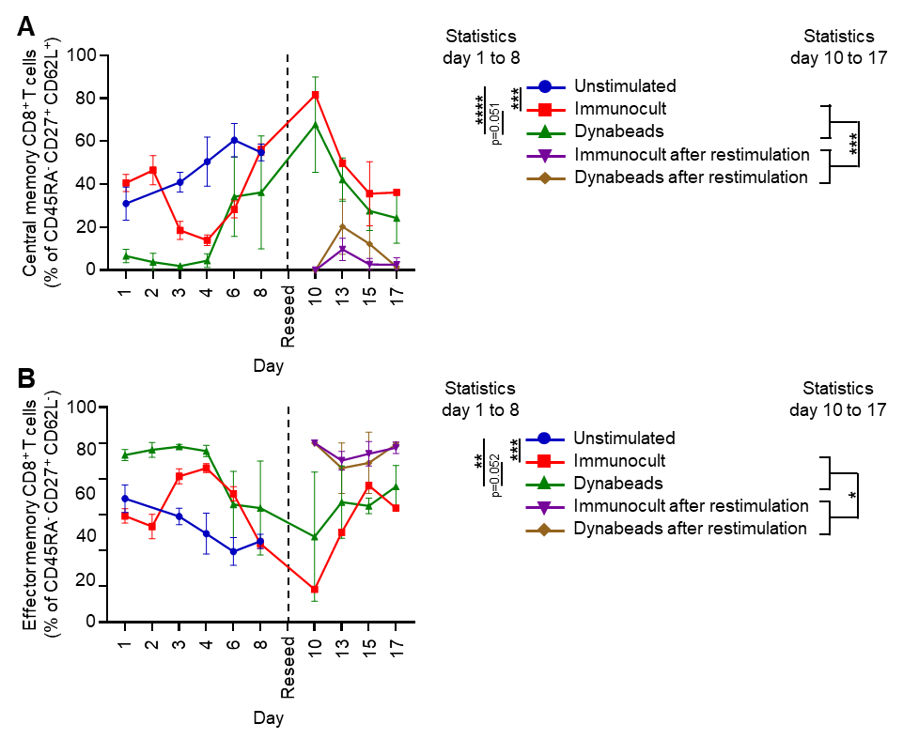
Figure S8 CD8⁺-T-cell differentiation dynamics of all conditions in the absence of IL-2 after stimulation with antibody-coated beads (Dynabeads) or soluble antibody complexes (ImmunoCult) during the initial stimulation phase (days 0-8), after reseeding in fresh media with or without restimulation on day 8, and throughout the post-restimulation phase (days 10-22). Memory T cells were categorized as A central memory (% of CD45RA⁻CD27⁺CD62L⁺) or B effector memory (% of CD45RA⁻CD27⁺CD62L⁻). Data represent mean ± SD of four independent donors.

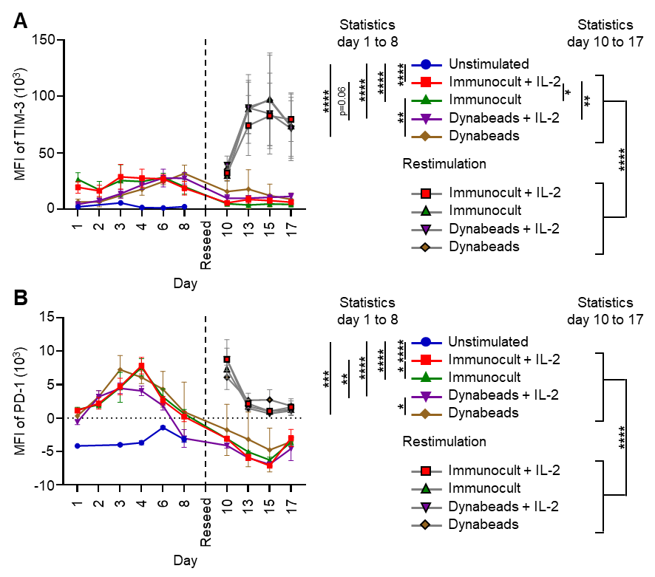
Figure S9 Immune checkpoint receptor dynamics of all conditions in the presence or absence of IL-2 after stimulation with antibody-coated beads (Dynabeads) or soluble antibody complexes (ImmunoCult) during the initial stimulation phase (days 0-8), after reseeding in fresh media with or without restimulation on day 8, and throughout the post-restimulation phase (days 10-22). Receptor expression was measured as the Mean Fluorescence Intensity (MFI) of A TIM-3 or B PD-1.

