Supplementary
Supplementary Table 1. The associated drugs with Drug-Induced Interstitial Lung Disease (DI-ILD) found in the literature
Drug | Key Notes | Therapeutic Group | Ref
Methotrexate | Documented association with ILD, especially at higher doses. | Antineoplastic/ Immunosuppressants | (25)
Cyclophosphamide | Documented association with ILD, especially at higher doses. | Antineoplastic | (33,34)
Bleomycin* | Well-documented association with pulmonary toxicity and DI-ILD. | Antineoplastic | (30)
Vinblastine | Some reports of ILD in some population, though rare | Antineoplastic | (35,36)
Azathioprine | Used to treat ILD, some associations with pulmonary toxicity and DI-ILD, though rare. | Immunosuppressants | (21,37,38)
Sirolimus | Increasing reports of ILD in some population, though less common | Immunosuppressants | (39)
Tacrolimus | Increasing reports of ILD in some population, though less common | Immunosuppressants | (40,41)
Amiodarone* | Well-documented association of DI-ILD, especially after long-term use. | Antiarrhythmics/antihypertensive | (26)
Rituximab | Increasing reports of ILD in some population, though less common | DMARDs | (27,42)
Erlotinib | Some reports of ILD in some population, though less common | Antineoplastic | (43)
Mycophenolate mofetil | Used to treat ILD, some associations with pulmonary toxicity and DI-ILD, though rare. | Immunosuppressants | (23,44)
Infliximab | Some reports of ILD in some population, though less common | DMARDs | (29)
Etanercept | Some reports of ILD in some population, though less common | DMARDs | (28)
Nitrofurantoin* | Well-documented association of DI-ILD, especially after long-term use. | Antimicrobials | (45)
Isoniazid | Some reports of ILD in some population, though less common | Antimicrobials | (22)
Carmustine* | Pulmonary toxicity is a known risk linked to DI-ILD. | Antineoplastic | (31)
Busulfan* | Pulmonary toxicity is a known risk linked to DI-ILD. | Antineoplastic | (32)
Doxorubicin | Some reports of ILD in some population, though less common | Antineoplastic | (46)
Sulfasalazine | Some reports of ILD in some population, though rare | DMARDs | (47)
Hydralazine | Some reports of ILD in some population, though rare | Antiarrhythmics/antihypertensive | (48)
Rifampin* | Some reports of ILD in some population, though rare | Antimicrobials | (49)
Chlorambucil | Some reports of ILD in some population, though rare | Antineoplastic | (50)
Penicillamine | Some reports of ILD in some population, though rare | DMARDs | (20)
Pembrolizumab** | Well-documented association of DI-ILD | Antineoplastic | (51)
Nivolumab** | Well-documented association of DI-ILD | Antineoplastic | (52)
* Well-Documented High-Risk Drugs with DI-ILD
** Well-Documented High-Risk Drugs with DI-ILD, not found in prescription records
DMARDs: Disease-Modifying Antirheumatic Drugs

Supplementary Table 2. Comorbidities ICD-10 codes
Condition | ICD-10 Codes | CCI Score
Comorbidities ICD-10 codes for calculating CCI score
Myocardial infarction | I21-I22 | 1
Congestive heart failure | I50 | 1
Peripheral vascular disease | I70-I74 | 1
Cerebrovascular disease | I60-I69 | 1
Dementia | F01, F03, G30 | 1
Chronic pulmonary disease | J40-J47 | 1
Connective tissue disease | M05-M14, M32-M35 | 1
Peptic ulcer disease | K25-K28 | 1
Liver disease | K70 - K74 | 1
Diabetes | E10-E14 (excluding E10.2, E10.5, E11.2, E11.5, E13.2) | 1
Hemiplegia or paraplegia | G81, G82 | 2
Renal disease | N18-N19 | 2
Any tumor, including leukemia and lymphoma | C00-C96 (excluding C44) | 2
Metastatic solid tumor | C77-C80, C97 | 6
AIDS/HIV | B20-B24 | 6
Other comorbidities ICD-10 codes
Drug-Induced Interstitial Lung Disease (DI-ILD) | J70.2-4
Interstitial Lung Disease (ILD) | J84.XX (J84-J84.9)
Hypertension | I10-I1A, U82.3
Obesity | E66, Z68
Tobacco use, occupation and environmental exposure (Excluded) | F17, Z 71, Z72, F17, Z57, Z77, T65

Supplementary Table 3. History of Drug Exposure Prior to ILD Diagnosis
This table presents the number and percentage of patients who had at least one exposure to each listed drug (within 6 months prior to diagnosis). The proportion of patients with documented autoimmune disease among those exposed to each drug is also shown.
Drug | Coded DIILD (n) | Potential DI-ILD (n) | Potential DI-ILD with autoimmune (n) | Potential DI-ILD without autoimmune (n)
Mycophenolate | 5 | 268 | 39 | 229
Hydralazine | 5 | 232 | 21 | 211
Azathioprine | 1 | 160 | 33 | 127
Amiodarone | 5 | 124 | 8 | 116
Nitrofurantoin | 2 | 109 | 15 | 94
Methotrexate | 2 | 82 | 53 | 29
Rituximab | 0 | 61 | 25 | 36
Tacrolimus | 2 | 59 | 5 | 54
Isoniazid | 0 | 42 | 0 | 42
Etanercept | 0 | 35 | 34 | 1
Sulfasalazine | 0 | 30 | 0 | 30
Cyclophosphamide | 1 | 28 | 4 | 24
Doxorubicin | 2 | 23 | 2 | 21
Bleomycin | 1 | 8 | 0 | 8
Sirolimus | 0 | 7 | 0 | 7
Vinblastine | 1 | 4 | 0 | 4
Erlotinib | 0 | 3 | 0 | 3
Infliximab | 0 | 3 | 0 | 3
Busulfan | 0 | 2 | 0 | 2
Penicillamine | 0 | 2 | 0 | 2
Carmustine | 0 | 1 | 0 | 1
Chlorambucil | 1 | 1 | 0 | 1

Supplementary Figure 1. Percentages of Exposure to DI-ILD–Associated Drugs among ILD Patients by Drug Name. Each bar represents the proportion of patients diagnosed with ILD who had at least one prescription for the listed drug within six months prior to ILD diagnosis.
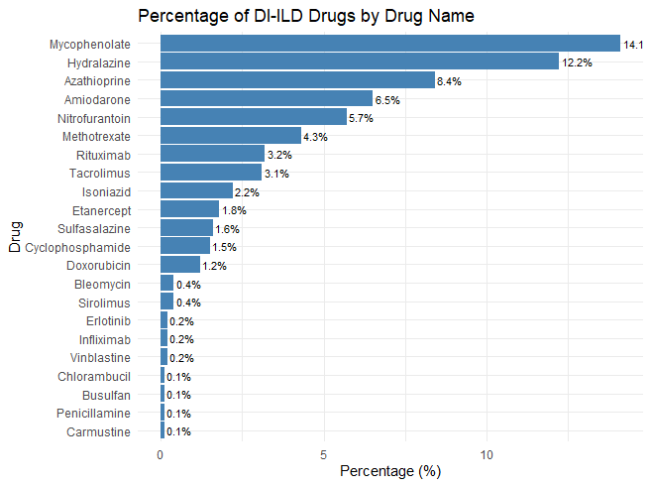Abbreviations: ILD, interstitial lung disease; DI-ILD, drug-induced interstitial lung disease.

