Global Profiling of Protein Lactylation in Pancreatic Ductal Adenocarcinoma
Daniela Toledo,¹ Samuel Abidemi Oluwole,² Solomon Oweridu,³ Grace Carr,³ and Christian Agatemor^{3,*}

¹University of Miami Miller School of Medicine, Miami, FL, 33101, USA.
²Department of Chemistry, University of Miami, Coral Gables, FL, 33146, USA.
³Department of Chemistry, Bucknell University, Lewisburg, PA, 17837, USA.
*Corresponding author: ca024@bucknell.edu

Supplementary information
The following supporting information is available free of charge.
Materials and Methods.
Figure S1. Detection of lysine lactylation in pancreatic cell lysates
Table S1. List of Lactylated Proteins in Cell Lines.
Table S2. List of PSM in Cell Line Lactylome.
Table S3. List of Proteins Unique to hTERT HPNE Cell Line
Table S4. List of Proteins Unique to HPAF-II Cell Line
Table S5. David Enrichment Analysis of hTERT HPNE Lactylome.
Table S6. David Enrichment Analysis of HPAF-II Lactylome.
Table S7. List of Lactylated Proteins in Patient-derived Tumors and Normal Pancreas.
Table S8. List of PSM in Human in Lactylated Proteins of Patient-derived Tumors and Normal Pancreas.
Table S9. DAVID Enrichment Analysis of Patient-derived Normal Pancreas.
Table S10. DAVID Enrichment Analysis of Patient-derived Tumors.

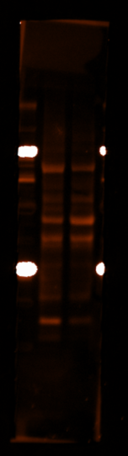

hTERT HPNE
HPAF-II
Lactylated proteins
HPAF-II
hTERT HPNE
GAPDH
(a)
(b)

Figure S1. Detection of lysine lactylation in pancreatic cell lysates. (a) Western blot of lysine lactylated (Kla) proteins in whole-cell lysates from hTERT-HPNE (normal pancreas) and HPAF-II (PDAC) cells, showing multiple bands across a broad range of molecular weights, consistent with widespread protein lactylation in both cell types. Equal amounts of total protein from cell lysate supernatants were separated by SDS–PAGE, transferred to nitrocellulose membranes, blocked with Blocker FL fluorescent blocking buffer, and incubated overnight at 4 °C with a rabbit monoclonal anti-L-lactyl-lysine antibody, followed by an Alexa Fluor 647-conjugated donkey anti-rabbit IgG secondary antibody. Fluorescent signals were acquired using an iBright FL1500 imaging system. (b) Corresponding GAPDH loading control obtained after membrane stripping, re-blocking, and re-probing with a rabbit anti-GAPDH primary antibody and HRP-conjugated anti-rabbit secondary antibody, with chemiluminescent detection on the iBright FL1500 system.

