SUPPLEMENTARY FIGURE
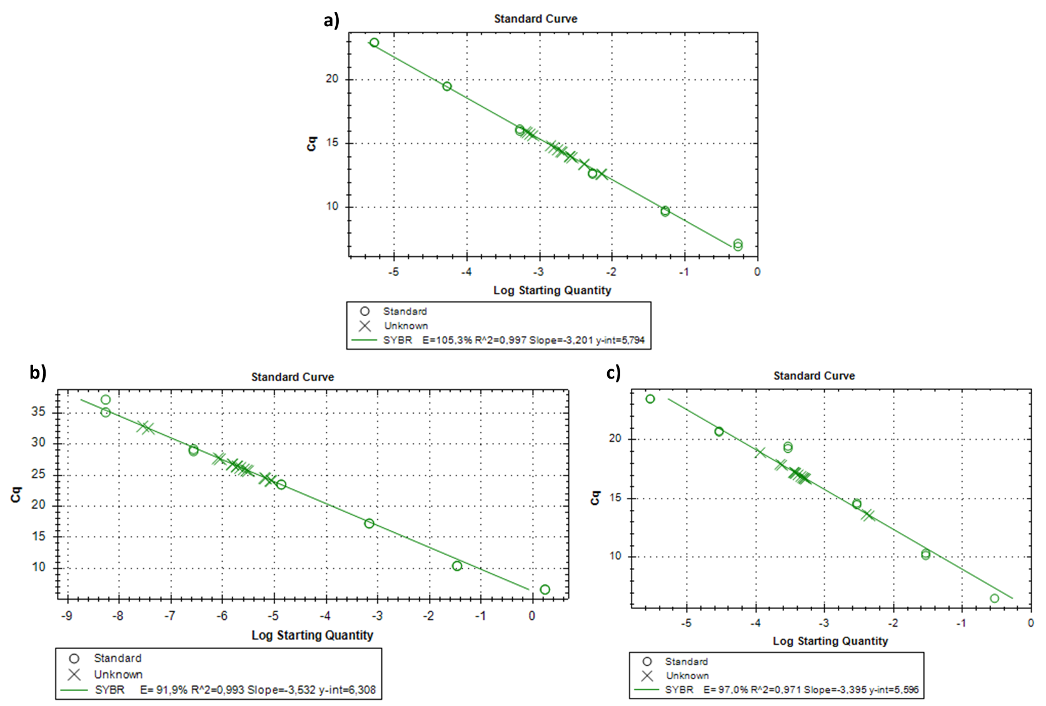

Supplementary Figure S1. Standard curves and RT-qPCR amplification efficiencies for 16S rRNA a), Bacteroidota b), and Bacillota c). The Ct values were plotted against the logarithm of template concentration to assess assay performance. Amplification efficiencies (E) and correlation coefficients (R²) were calculated from the slope of each curve. All three assays demonstrated high linearity and efficiency within the acceptable range (90–110%), indicating reliable quantification of each microbial group.

