Supplementary Materials
Sexual dimorphism in the programming effects of prenatal manganese multi-media biomarker on temporal cognition in school-aged children
Jamil M. Lane et al.
Corresponding author: Jamil M. Lane, jamil.lane@mssm.edu
Note: Models adjusted for BMI z-scores, maternal education (reference: less than high school), SES (reference: low SES), and child age at testing. p < .05 = bold.

Table S1
Linear and quadratic effects on prenatal blood Mn at the 2nd trimester on time perception performance in 6 to 7-year-olds
 | Total |  | Boys |  | Girls
 | Linear  Β (95% CI) | Quadratic  β (95% CI) | Linear  Β (95% CI) | Quadratic  β (95% CI) | Linear  Β (95% CI) | Quadratic  β (95% CI)
Percent of Tasks Completed | 7.10 (-36.73, 50.93) | -0.71 (-10.64, 9.21) | 13.32 (-47.52, 74.16) | -2.70 (-16.46, 11.06) | 2.30 (-61.72, 66.32) | 1.02 (-13.48, 15.53)
Average Hold | 7.87 (-15.13, 30.88) | -2.11 (-7.58, 3.35) | 11.81 (-27.54, 51.16) | -3.07 (-12.14, 5.99) | 2.18 (-27.69, 32.05) | -0.52 (-7.83, 6.79)
Average Latency | 13.12 (4.78, 21.46) | -3.08 (-5.04, -1.12) | 16.52 (2.53, 30.50) | -3.74 (-6.96, -0.52) | 13.11 (2.13, 24.09) | -3.16 (-5.77, -0.54)
Average Latency (SD) | 11.59 (-8.28, 31.45) | -2.64 (-7.25, 1.96) | 15.48 (-21.96, 52.91) | -3.27 (-11.80, 5.27) | 11.63 (-11.61, 34.87) | -2.84 (-8.28, 2.60)
Average Timing Holds | 17.74 (-11.09, 46.57) | -4.03 (-10.87, 2.81) | 23.03 (-25.97, 72.02) | -5.47 (-16.76, 5.82) | 14.31 (-23.32, 51.94) | -2.89 (-12.08, 6.30)
Timing Holds | -15.74 (-85.37, 53.90) | -0.53 (-16.60, 15.54) | 5.72 (-124.90, 136.35) | -5.23 (-34.77, 24.31) | -36.19 (-116.39, 44.00) | 4.18 (-14.60, 22.95)
Total Holds | 133.55 (29.68, 237.42) | -39.69 (-63.89, -15.49) | 263.63 (47.64, 479.63) | -69.42 (-118.97, -19.88) | 73.58 (-36.17, 183.33) | -25.80 (-51.65, 0.06)
Total Hold Time (SD) | 4.25 (-20.12, 28.61) | -0.60 (-6.32, 5.13) | -3.23 (-43.58, 37.13) | 0.58 (-8.63, 9.80) | -0.52 (-32.77, 31.72) | 1.30 (-6.49, 9.08)
Total Holds (excluding holds <2 sec) – Timing Accuracy | -54.24 (-59.65, -48.82) | 11.46 (10.21, 12.71) | -19.81 (-25.62, -13.99) | 3.98 (2.66, 5.29) | -68.72 (-76.39, -61.06) | 14.61 (12.81, 16.40)
Total holds (SD; excluding holds <2 sec) | 15.09 (-11.63, 41.80) | -3.00 (-9.26, 3.27) | 15.00 (-29.56, 59.56) | -3.43 (-13.61, 6.75) | 12.76 (-22.24, 47.77) | -1.84 (-10.26, 6.58)
Total Holds (Timing Accuracy) | 42.23 (20.18, 64.29) | -9.03 (-14.03, -4.03) | 71.36 (37.91, 104.81) | -15.80 (-23.36, -8.24) | 5.85 (-22.56, 34.25) | -0.54 (-6.99, 5.90)

Note: Models adjusted for BMI z-scores, maternal education (reference: less than high school), SES (reference: low SES), and child age at testing. p < .05 = bold.
Table S2
Linear and quadratic effects on prenatal blood Mn at the 3rd trimester on time perception performance in 6 to 7-year-olds
 | Total |  | Boys |  | Girls
 | Linear  Β (95% CI) | Quadratic  β (95% CI) | Linear  Β (95% CI) | Quadratic  β (95% CI) | Linear  Β (95% CI) | Quadratic  β (95% CI)
Percent of Tasks Completed | -17.09 (-60.28, 26.11) | 3.36 (-4.38, 11.09) | -11.01 (-74.86, 52.85) | 1.78 (-9.65, 13.22) | -20.03 (-79.72, 39.65) | 4.42 (-6.28, 15.11)
Average Hold | 25.81 (4.14, 47.49) | -5.11 (-8.94, -1.27) | 31.89 (-3.72, 67.50) | -6.37 (-12.73, -0.02) | 22.28 (-5.65, 50.21) | -4.31 (-9.23, 0.60)
Average Latency | 2.37 (-5.84, 10.59) | -0.35 (-1.80, 1.11) | 4.51 (-8.49, 17.51) | -0.61 (-2.94, 1.71) | 0.54 (-10.57, 11.64) | -0.11 (-2.06, 1.84)
Average Latency (SD) | -6.08 (-25.94, 13.79) | 1.10 (-2.42, 4.61) | -7.03 (-41.82, 27.76) | 1.51 (-4.71, 7.72) | -5.26 (-29.63, 19.10) | 0.81 (-3.47, 5.10)
Average Timing Holds | 47.85 (21.54, 74.16) | -8.86 (-13.52, -4.20) | 65.65 (22.87, 108.43) | -12.05 (-19.70, -4.40) | 34.75 (-0.15, 69.64) | -6.57 (-12.71, -0.43)
Timing Holds | -117.24 (-187.43, -47.05) | 21.13 (8.65, 33.62) | -183.65 (-303.56, -63.75) | 32.95 (11.48, 54.43) | -64.87 (-152.26, 22.53) | 11.99 (-3.49, 27.46)
Total Holds | -117.76 (-221.58, -13.95) | 21.06 (2.39, 39.73) | -187.64 (-391.59, 16.32) | 33.42 (-3.78, 70.62) | -61.17 (-180.93, 58.59) | 11.34 (-10.02, 32.70)
Total Hold Time (SD) | 26.56 (3.88, 49.24) | -5.19 (-9.21, -1.18) | 34.52 (-1.98, 71.02) | -6.70 (-13.22, -0.18) | 20.16 (-10.05, 50.38) | -4.01 (-9.33, 1.31)
Total Holds (excluding holds <2 sec) – Timing Accuracy | 26.92 (20.19, 33.65) | -5.37 (-6.56, -4.17) | -1.03 (-4.86, 2.81) | -0.08 (-0.77, 0.60) | 39.53 (28.54, 50.51) | -7.79 (-9.73, -5.86)
Total holds (SD; excluding holds <2 sec) | 41.19 (15.89, 66.48) | -7.54 (-12.02, -3.06) | 57.75 (17.57, 97.93) | -10.49 (-17.67, -3.30) | 27.19 (-6.99, 61.36) | -5.11 (-11.13, 0.91)
Total Holds (Timing Accuracy) | 34.54 (12.47, 56.61) | -6.03 (-9.98, -2.08) | 63.08 (27.68, 98.49) | -11.35 (-17.69, -5.02) | 7.05 (-19.93, 34.02) | -0.88 (-5.70, 3.95)

Note: Models adjusted for BMI z-scores, maternal education (reference: less than high school), SES (reference: low SES), and child age at testing. p < .05 = bold.

Table S3
Linear and quadratic effects on prenatal urine Mn at the 2nd trimester on time perception performance in 6 to 7-year-olds
 | Total |  | Boys |  | Girls
 | Linear  Β (95% CI) | Quadratic  β (95% CI) | Linear  Β (95% CI) | Quadratic  β (95% CI) | Linear  Β (95% CI) | Quadratic  β (95% CI)
Percent of Tasks Completed | -10.00 (-40.82, 20.82) | 3.20 (-4.88, 11.28) | -23.81 (-67.45, 19.84) | 6.15 (-5.31, 17.60) | 8.69 (-35.40, 52.77) | -0.99 (-12.53, 10.56)
Average Hold | -28.68 (-51.03, -6.33) | 8.01 (1.74, 14.29) | -36.63 (-75.20, 1.93) | 9.78 (-0.98, 20.54) | -22.88 (-50.81, 5.04) | 6.73 (-1.14, 14.61)
Average Latency | 7.63 (0.89, 14.36) | -1.93 (-3.76, -0.11) | 13.96 (4.03, 23.89) | -3.57 (-6.22, -0.93) | 4.25 (-5.25, 13.76) | -1.02 (-3.63, 1.60)
Average Latency (SD) | 4.37 (-11.35, 20.09) | -0.99 (-5.20, 3.21) | 15.49 (-10.89, 41.88) | -3.74 (-10.70, 3.21) | -2.35 (-21.82, 17.12) | 0.72 (-4.55, 5.99)
Average Timing Holds | -19.94 (-47.08, 7.21) | 6.39 (-1.21, 13.99) | -7.23 (-55.13, 40.67) | 2.51 (-10.87, 15.89) | -17.97 (-51.80, 15.86) | 5.96 (-3.53, 15.45)
Timing Holds | 18.30 (-34.74, 71.33) | -9.27 (-23.35, 4.82) | 29.05 (-61.10, 119.21) | -12.14 (-35.81, 11.54) | 3.08 (-61.15, 67.30) | -4.96 (-22.15, 12.23)
Total Holds | 120.91 (44.03, 197.78) | -38.09 (-58.45, -17.72) | 161.07 (24.01, 298.14) | -47.92 (-83.79, -12.05) | 89.75 (1.67, 177.83) | -30.05 (-53.61, -6.50)
Total Hold Time (SD) | -34.70 (-56.33, -13.07) | 10.34 (4.37, 16.32) | -45.16 (-77.78, -12.55) | 12.58 (3.73, 21.43) | -28.64 (-58.44, 1.16) | 9.17 (0.82, 17.51)
Total Holds (excluding holds <2 sec) – Timing Accuracy | -34.54 (-39.15, -29.93) | 8.07 (6.85, 9.30) | -11.94 (-15.66, -8.22) | 2.45 (1.47, 3.42) | -47.63 (-54.84, -40.43) | 11.34 (9.41, 13.27)
Total holds (SD; excluding holds <2 sec) | -15.73 (-39.02, 7.56) | 5.34 (-1.06, 11.74) | -17.67 (-54.04, 18.70) | 5.56 (-4.31, 15.44) | -9.69 (-40.84, 21.46) | 3.87 (-4.77, 12.50)
Total Holds (Timing Accuracy) | 4.89 (-10.94, 20.71) | -0.94 (-5.09, 3.20) | 6.89 (-18.08, 31.86) | -1.76 (-8.31, 4.78) | 5.09 (-14.64, 24.81) | -0.75 (-5.90, 4.40)

Note: Models adjusted for BMI z-scores, maternal education (reference: less than high school), SES (reference: low SES), and child age at testing. p < .05 = bold.

Table S4
Linear and quadratic effects on prenatal urine Mn at the 3rd trimester on time perception performance in 6 to 7-year-olds
 | Total |  | Boys |  | Girls
 | Linear  Β (95% CI) | Quadratic  β (95% CI) | Linear  Β (95% CI) | Quadratic  β (95% CI) | Linear  Β (95% CI) | Quadratic  β (95% CI)
Percent of Tasks Completed | -5.98 (-28.27, 16.30) | 1.25 (-4.57, 7.07) | -18.95 (-52.96, 15.05) | 4.59 (-4.23, 13.41) | 2.10 (-28.12, 32.32) | -0.76 (-8.68, 7.16)
Average Hold | 0.36 (-9.40, 10.11) | 0.14 (-2.46, 2.73) | 6.88 (-8.92, 22.68) | -1.61 (-5.70, 2.48) | -1.81 (-14.88, 11.26) | 0.83 (-2.71, 4.37)
Average Latency | -1.32 (-5.03, 2.40) | 0.50 (-0.49, 1.50) | -3.11 (-9.01, 2.79) | 0.98 (-0.58, 2.53) | 0.63 (-4.46, 5.72) | 0.00 (-1.36, 1.37)
Average Latency (SD) | 1.85 (-7.75, 11.44) | -0.56 (-3.15, 2.02) | -1.68 (-19.23, 15.88) | 0.44 (-4.18, 5.06) | 4.63 (-7.03, 16.30) | -1.33 (-4.51, 1.85)
Average Timing Holds | 6.67 (-4.67, 18.00) | -1.13 (-4.18, 1.91) | 13.25 (-4.19, 30.69) | -2.91 (-7.43, 1.61) | 5.09 (-10.94, 21.12) | -0.53 (-4.95, 3.89)
Timing Holds | -17.48 (-47.80, 12.85) | 2.77 (-5.28, 10.81) | -40.95 (-95.79, 13.90) | 9.82 (-4.42, 24.06) | -8.27 (-44.40, 27.85) | -0.52 (-10.23, 9.19)
Total Holds | 27.73 (-71.70, 16.24) | 5.95 (-5.68, 17.58) | -57.15 (-138.11, 23.81) | 13.66 (-7.26, 34.58) | -22.38 (-74.46, 29.70) | 4.22 (-9.75, 18.19)
Total Hold Time (SD) | 4.80 (-5.36, 14.96) | -0.84 (-3.57, 1.89) | 6.69 (-8.87, 22.26) | -1.27 (-5.30, 2.76) | 6.43 (-8.04, 20.91) | -1.28 (-5.27, 2.71)
Total Holds (excluding holds <2 sec) – Timing Accuracy | 18.42 (-21.82, -15.02) | 4.43 (3.53, 5.33) | -2.85 (-4.85, -0.84) | 0.65 (0.12, 1.17) | -25.80 (-31.25, -20.36) | 6.25 (4.78, 7.71)
Total holds (SD; excluding holds <2 sec) | 5.16 (-5.89, 16.20) | -0.63 (-3.58, 2.32) | 9.98 (-7.76, 27.73) | -1.99 (-6.59, 2.61) | 5.35 (-9.67, 20.37) | -0.54 (-4.63, 3.55)
Total Holds (Timing Accuracy) | 2.55 (-14.29, 9.18) | 0.63 (-2.42, 3.68) | -6.04 (-25.59, 13.51) | 1.51 (-3.55, 6.57) | 2.06 (-12.02, 16.13) | -0.49 (-4.15, 3.17)

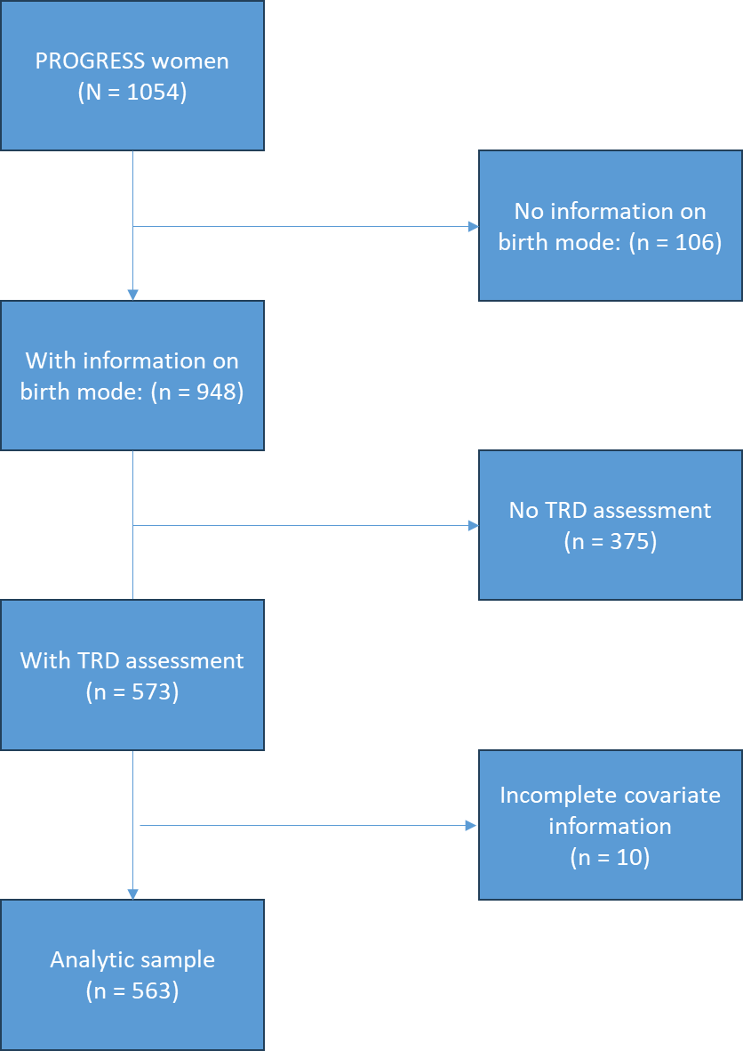
Figure S1. Study Sample Flowchart

