Supplement material
Two Trichoderma endophytic fungi alleviates drought stress and improves plant growth in Cinnamomum migao seedlings
Lan-yue Zhang^{1a}, Tao Fu^{2a}, Jing-zhong Chen², Shuang-yan Hu²
¹ Guizhou Mountain Resources Research Institute, Guiyang, 550025, China
² School of Pharmacy, Guizhou University of Traditional Chinese Medicine, Guiyang 550025, China
aThese authors have contributed equally to this work.

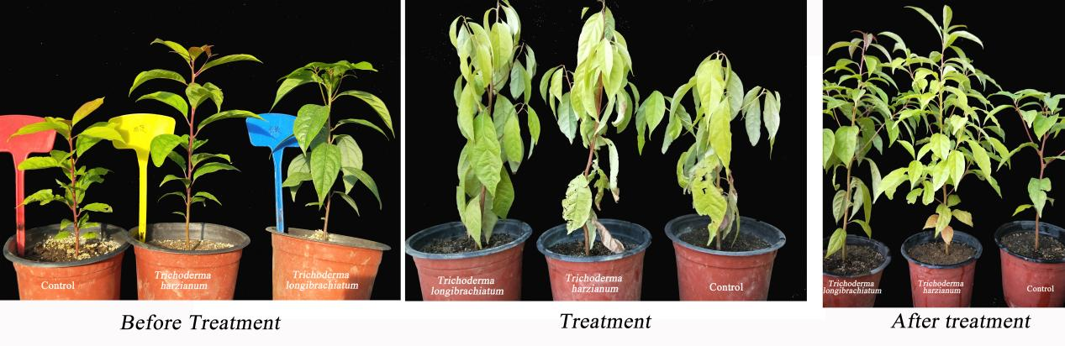Figure S1 Effects of fungal inoculation on C. migao seedlings

