Supplementary figure 1. Schematic timeline of the animal experimental procedure. Following an adaptive feeding period, rats underwent estrus synchronization and subsequent establishment of an endometriosis model via autologous transplantation. After two weeks, endometriosis rats were randomly assigned into three intervention groups receiving purified water, shNC lentivirus, or shSIRT1 lentivirus via tail vein injection for 12 days, alongside β-estradiol 3-benzoate administration. Ectopic lesion volume was measured upon tissue collection at the endpoint.
shRNA, short hairpin RNA; SIRT1, sirtuin 1.
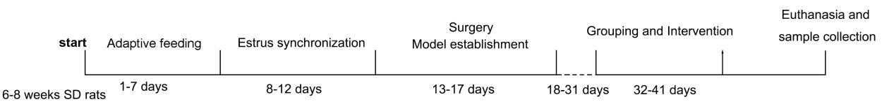

Supplementary figure 2. Graphical abstract. SIRT1 deacetylates HMGB1 to enhance its protein stability, thereby promoting autophagy, inducing a mesenchymal-to-epithelial-like molecular shift, and driving the progression of endometriosis.
SIRT1, sirtuin 1; HMGB1, high mobility group box 1.
