Supplemental Method: Detailed Information for Cognitive Tests & Network Data

Attention: For both the Digit Forward and Digit Backward, participants listen to the test administrator list out a sequence of digits ranging in size from 3 to 9. There are two attempts within each level (i.e., two lists of 6), and the test ends when a participant fails both attempts. The scoring is simply the longest list that a participant achieves for each task.

Speed of Processing: Digit Symbol Substitution is completed on a sheet of paper. Participants match symbols to numbers using a corresponding digit-symbol key at the top of the page. Within the allotted time limit, the participant copies digits into boxes underneath a sequence of symbols. The number of correctly filled in digits is the score derived for this test. For the Trail Making test – Part A, there are 25 circles, numbered 1–25. The participants must draw lines that connect the numbered circles in ascending order. The score is the amount of time, in seconds, the task takes.

Executive Function: For the Trail Making test – Part B, there are 25 circles; however, they contain either numbers or letters. The participants must draw lines that connect the numbered circles in ascending order but alternating with the alphabetical order of circle (i.e., A – 1 – B – 2 and so on). The score is the amount of time, in seconds, the task takes. However, to retain the portion of performance that is unconfounded with overall time, some people use difference scores (i.e., Part B time – Part A time). We opted for statistical orthogonalization via the use of regression-based residuals.

Episodic Memory: The Craft Story 21 task assesses verbal recall of short story. The test administrator reads the story to the subject in a clear voice. Immediately afterward, participants recall from memory. Scores are the sum of all verbatim words recalled from the story. However, the score used for this work came from the delayed trial when participants recalled again after a retention interval of approximately 20 minutes. The Rey Auditory Verbal Learning test is comprised of a reading a 15-word list for participants to immediate recall with 5 trials to learn all 15 words. After an interference trial with 15 new words, they then recall the original list. However, we used the number of words correctly recalled after a retention delay (15–20 min). Following the Benson complex figure (see the Visuospatial Ability section), delayed reproduction was tested approximately 10-15 minutes later. Scoring was the same.

Language: The 32-item MINT consists of black-and-white object drawings. They are presented individually, and participants begin naming them by starting with easier items and ending with more difficult items. A semantic or phonemic cue can be provided if participants experience difficulty on any given trial. Correct spontaneous and cued responses are summed to give a total score out of 32. Word fluency was measured by word list generation tests. Participants were given a starting letter (“F” and “L”) and 60 seconds to name as many words they can that start with that letter. Correct items are totaled after accounting for errors and rule violations (i.e., different conjugations of the same root word).

Visuospatial Ability: The Benson complex figure copy is scored for presence and placement whereby participants see an abstract figure and then reproduce it to the best of their ability. Online copies can be found at the National Alzheimer’s Coordinating Center website.

Supplemental Results: Models with bridging and bonding entered together.
Bridging was significantly associated with higher MoCA scores (β = .14, p = .01), executive function (β = .29, p < .001), memory (β = .10, p = .012), and language (β = .18, p < .001). Bridging was unrelated to depression, anxiety, loneliness, or happiness (all ps > .10),
but was associated with higher perceived support (β = .11, p = .05). Conversely, social bonding was unrelated to all cognitive outcomes (all ps > .10) but was associated with lower depression (β = -.12, p = .048) and loneliness (β = -.21, p = .003) along with higher perceived support (β = .19, p = .011) and happiness (β = .15, p = .019). Comparing the regression coefficients for bridging and bonding within each model revealed that bridging was a significantly stronger predictor for executive function (p = .003), episodic memory (p = .04), and language (p = .02) whereas bonding was only stronger for happiness (p = .01).
To ensure robustness of these effects, the residual estimation procedure was reversed to produce residual bridging and “pure” bonding. The notable changes were that bonding was associated with worse executive functioning (β = -.18, p = .001) and language (β = -.11, p = .011) whereas bridging was associated with lower loneliness (β = -.14, p = .03) and higher perceived support (β = .21, p = .002). Additionally, an interaction term between bridging and bonding was not predictive of any cognitive or mental health outcomes (all ps > .10).
For longitudinal fixed effects analyses, significant effects of bridging emerged for within-person increases in episodic memory (β = .08, p = .007) and language (β = .07, p = .03). Bridging predicted executive function (β = .17, p = .014), but the model was not significant (p = .10) due to the small amount of within-subjects variance being explained (R² = .045) and the conservative estimation in the fixed effect approach. Bonding was predictive of a change within-person in MoCA scores (β = .15, p = .015). Models explained 27% of within-person variance in episodic memory, 14% in language, and 24% in MoCA. Crucially, changes in bonding nor bridging were not associated with changes in mental health.
Mixed effects variance components models with observations over time nested in individuals were used to conduct sensitivity analyses given limitations of fixed effects models. Results again mirrored cross-sectional models in terms of the magnitude and direction of associations. Importantly, with this more liberal estimation procedure, more parameters emerged as statistically significant. Bridging significantly predicted episodic memory (β = .08, p = .002), language (β = .10, p < .001), and executive function (β = .11, p = .04), and all models were significant (ps < .001). Bonding was no longer predictive of MoCA scores (β = .03, p = .52) whereas bridging was (β = .08, p = .03); however, bonding scores were now associated with lower depression (β = -.14, p = .03) and higher happiness (β = .26, p = .005), consistent with cross-sectional models.
A noteworthy constraint is that social bridging and social bonding were negatively correlated, perhaps nonlinearly, which may complicate the exact estimation of their effects. The sensitivity analyses employed here systematically addressed covariance by using residuals to remove shared variance and through the k-means cluster analysis. To examine this issue of nonlinearity, we again regressed bonding onto bridging and included a quadratic predictor (i.e., bridging squared). This nonlinear variable did not significantly change model fit nor did they have a significant association with bonding. A simple linear relationship between bridging and bonding offers the most parsimonious explanation for this data.

Supplemental Figures

Figure S1. Models for latent estimation of bridging and bonding.
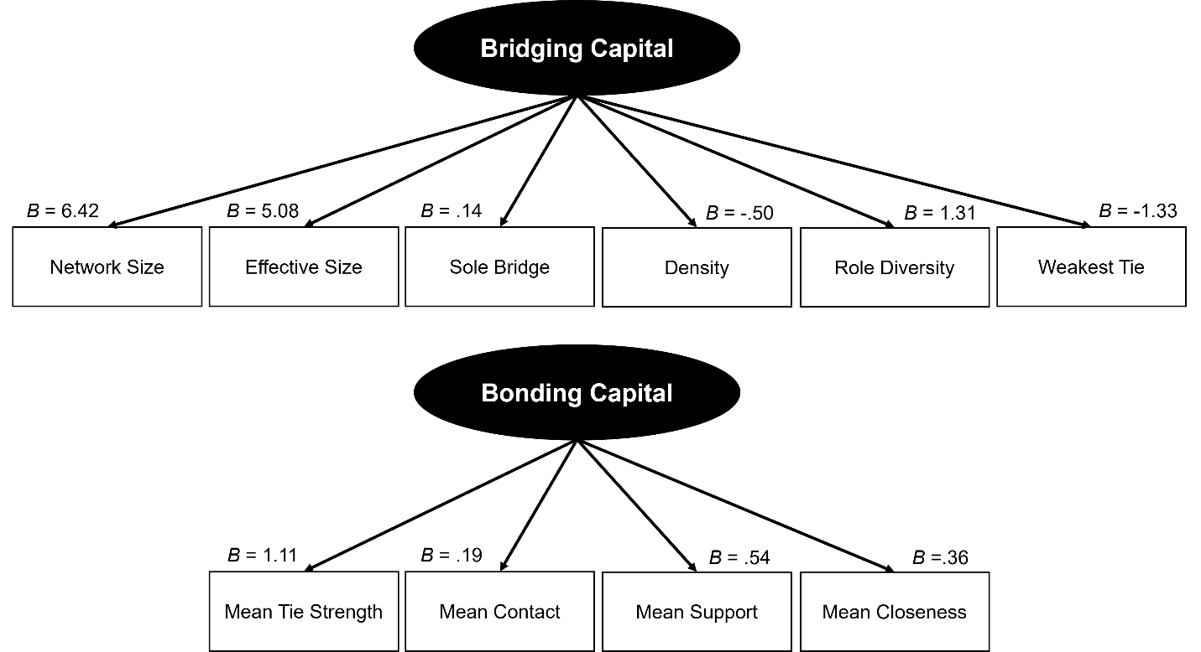

Figure S2. Distributions for latent bridging and bonding scores in the cross-sectional sample.
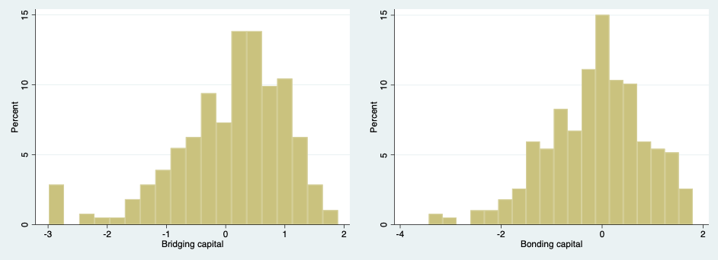

Figure S3. Changes in social bridging and bonding over time in the high-risk sample. Dashed black line represents average change. Gray lines are 50 randomly selected cases.
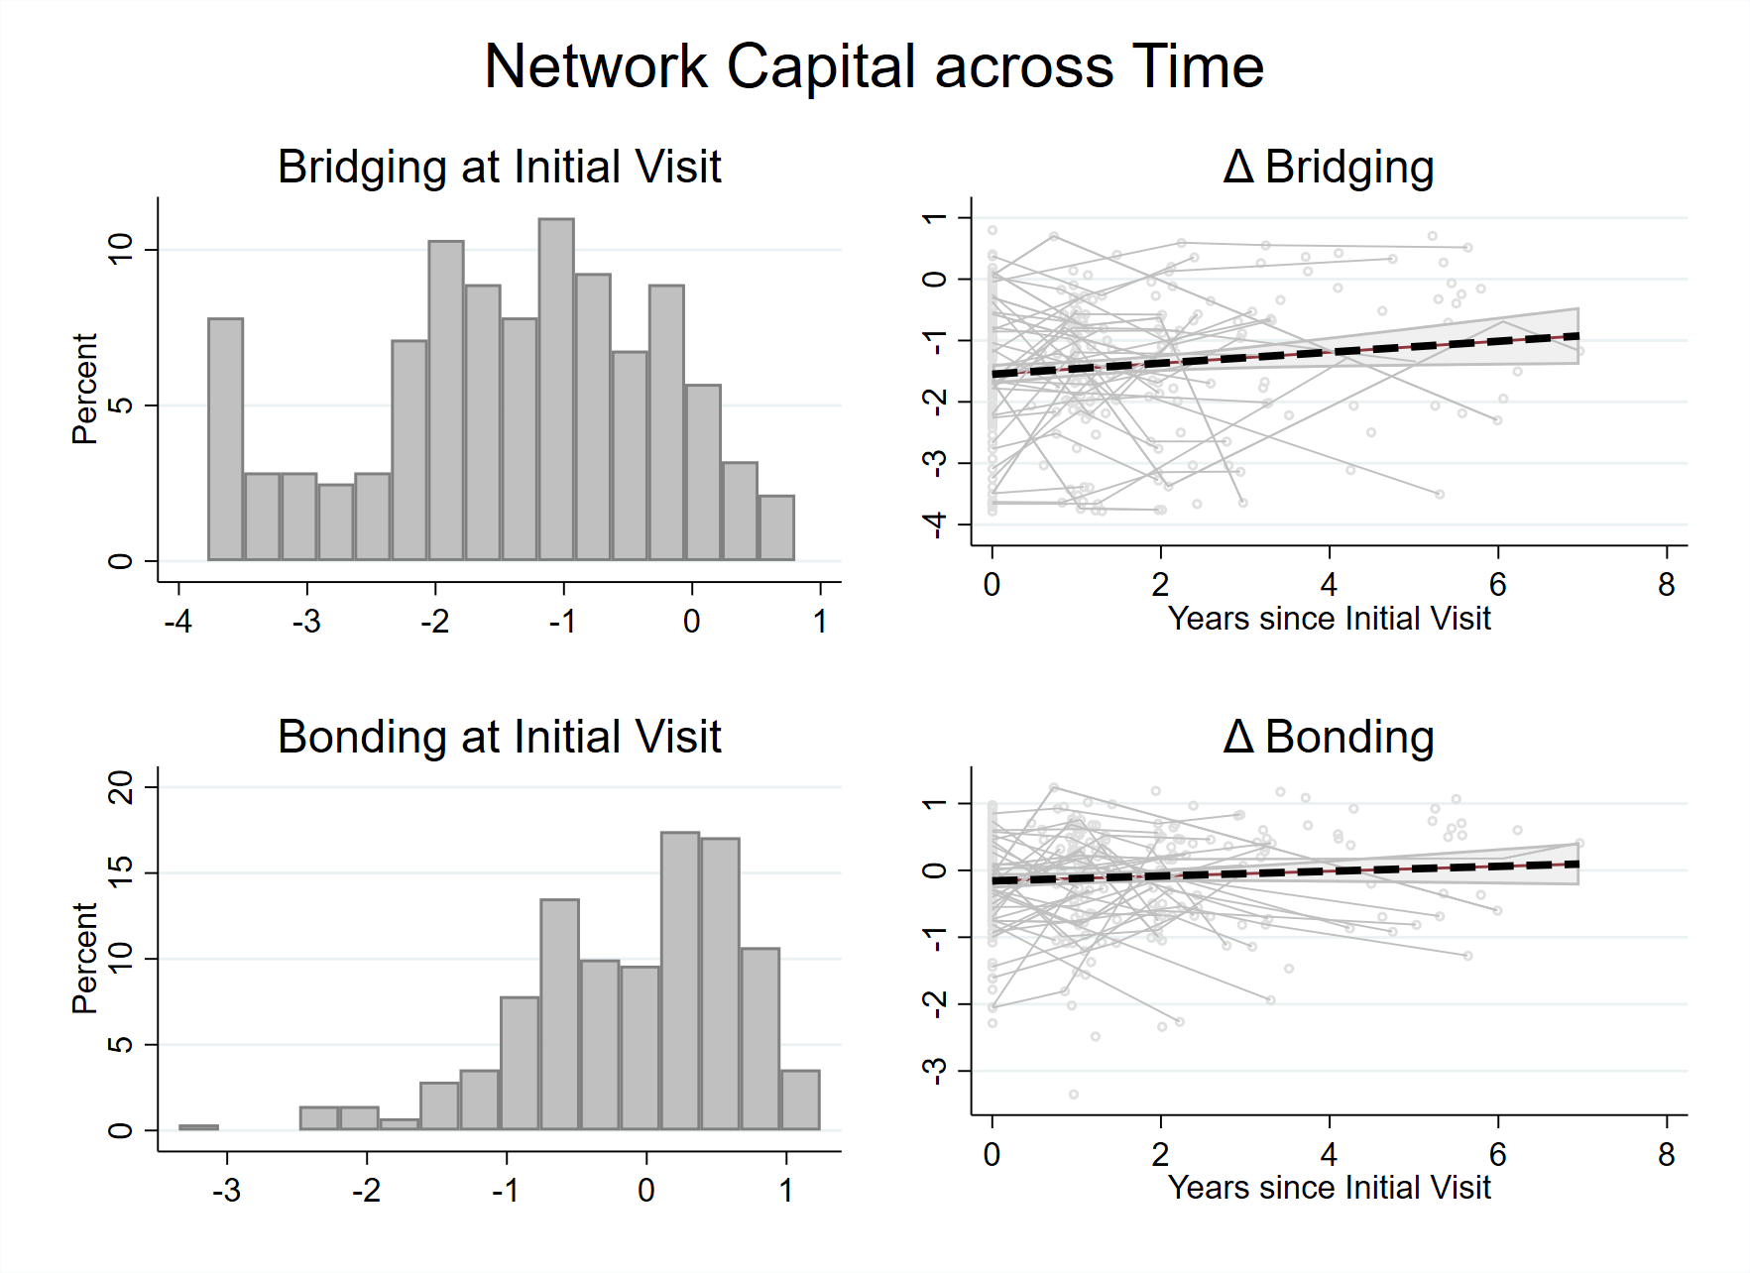

Figure S4. k-means cluster analyses. WSS = Within-group sum of squares. η² = Effect size. PRE = proportional reduction of error.
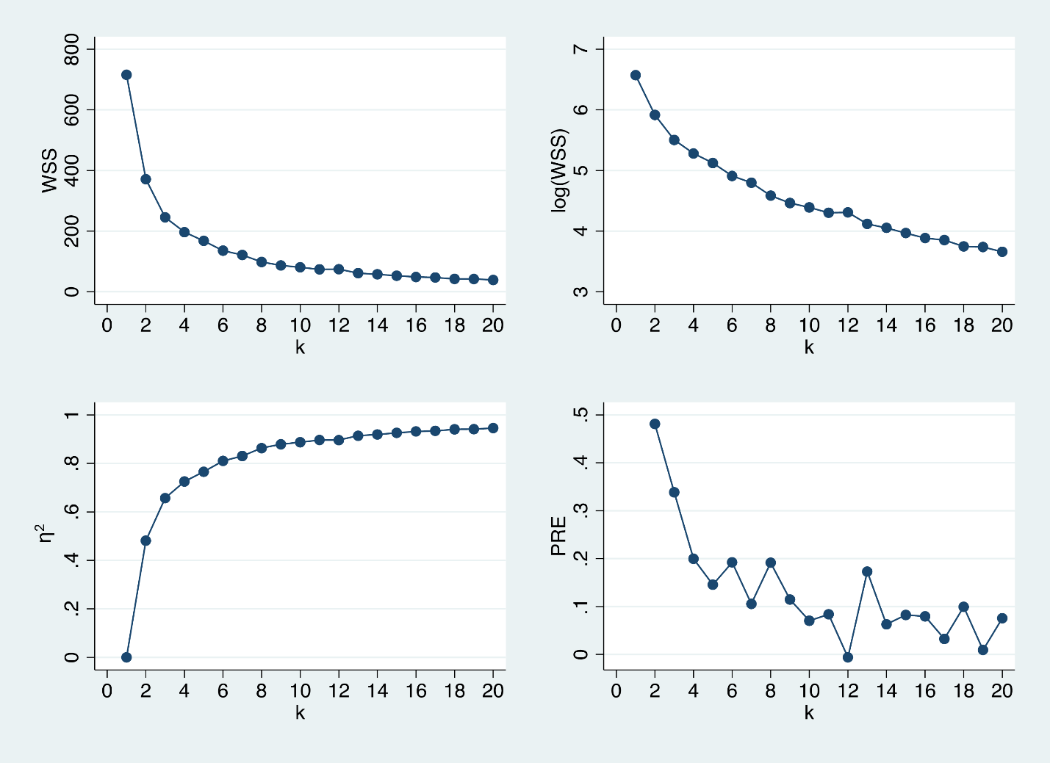

Supplemental Tables
Table S1. Key differences in the social network interview protocol.
Name Generator | Cross-sectional | Longitudinal
Important Matters  - Who are the people in your life with whom you discuss important matters? Who are the people you can really count on?  - Is there anyone who always wants to talk about your important matters whether you want them to or not?  - Are there people who are, in general, a burden to you because they want to discuss matters important to them, even if you do not? | X | X
Health Matters  - Who are the people that you discuss your health with or you can really count on when you have physical, mental, or emotional problems?  - Who are the people, whether or not you have mentioned them before, who are always talking about your mental and physical health and trying to get you to do things about them?  - Are there people who are, in general, a burden to you because of their emotional or physical health problems and always want to talk about them, whether you want them to or not? | X | X
Family Ties  Please name any family members that you see or talk to regularly, if you have not named them already. | X
Work / Volunteering Ties  Please name any coworkers or people you volunteer with that you see or talk to regularly, if you have not named them already. | X
Neighbors  Please name any neighbors that you see or talk to regularly, if you have not named them already. | X
Anyone Else  Please list anyone else who is especially important in your life if you have not listed them in a previous question. | X

Table S2. Prediction models for cognitive outcomes. Bridging and bonding are entered separately. Parameters for control variables are reported using the estimates for bridging models.

 | MOCA | Attention | Processing Speed | Executive Function | Episodic Memory | Language | Visuospatial
Impairment Status | -0.772*** | -0.412** | -0.703*** | -0.533* | -1.039*** | -0.380** | -0.468*
 | (0.158) | (0.137) | (0.156) | (0.207) | (0.120) | (0.124) | (0.223)
Cohort Source | 0.058 | -0.124 | -0.116 | 0.043 | -0.086 | 0.127 | 0.656***
 | (0.103) | (0.114) | (0.092) | (0.130) | (0.105) | (0.087) | (0.108)
Age | -0.024** | 0.001 | -0.037*** | -0.011 | -0.028*** | -0.018** | -0.010
 | (0.008) | (0.008) | (0.007) | (0.008) | (0.006) | (0.007) | (0.008)
Female | 0.129 | -0.091 | 0.174* | -0.147 | 0.151 | 0.080 | -0.001
 | (0.095) | (0.102) | (0.081) | (0.107) | (0.080) | (0.086) | (0.101)
Education | 0.226*** | 0.139** | 0.172*** | 0.092 | 0.112** | 0.149*** | 0.013
 | (0.050) | (0.051) | (0.046) | (0.056) | (0.036) | (0.037) | (0.052)
Marital Status | 0.171 | -0.013 | 0.094 | -0.055 | 0.082 | 0.039 | -0.056
 | (0.091) | (0.102) | (0.082) | (0.106) | (0.084) | (0.086) | (0.117)
Employment | 0.093 | 0.112 | -0.092 | -0.054 | -0.066 | -0.138 | 0.029
 | (0.105) | (0.151) | (0.106) | (0.110) | (0.095) | (0.102) | (0.100)
FAQ | -0.155 | 0.143 | -0.119 | 0.195 | -0.098 | -0.145 | -0.036
 | (0.114) | (0.101) | (0.110) | (0.125) | (0.080) | (0.095) | (0.127)
GDS-15 | -0.033 | -0.002 | -0.048 | -0.087 | -0.014 | 0.021 | -0.217*
 | (0.056) | (0.043) | (0.050) | (0.054) | (0.053) | (0.038) | (0.094)
Bridging | 0.130* | 0.056 | 0.018 | 0.281** | 0.114* | 0.156** | -0.021
 | (0.060) | (0.054) | (0.058) | (0.090) | (0.050) | (0.051) | (0.063)
Bonding | -0.058 | 0.047 | -0.006 | -0.137* | -0.054 | -0.075 | 0.050
 | (0.05) | (0.051) | (0.045) | (0.059) | (0.038) | (0.045) | (0.054)
N | 386 | 386 | 386 | 386 | 386 | 386 | 386
𝜎 ²_{𝜖} | .67 | .71 | .569 | .93 | .515 | .467 | .828
R² | .326 | .062 | .299 | .159 | .375 | .259 | .219

Note. MOCA = Montreal Cognitive Assessment. FAQ = Functional abilities questionnaire which was binarized. GDS-15 = 15-item Geriatric Depression Scale. * = p < .05 ; ** = p < .01; *** = p < .001.

Table S3. Longitudinal estimates of fixed effects on cognition. Bridging and bonding are entered separately. Parameters for control variables are reported using the estimates for bridging models.

 | MOCA | Attention | Speed | Executive Function | Episodic Memory | Language | Visual
Constant | 4.221** | 3.026* | 2.713* | 2.678 | 2.149* | 2.333* | 2.737
 | (1.544) | (1.301) | (1.293) | (2.427) | (0.912) | (0.956) | (1.902)
Diagnosis
MCI | -0.492** | -0.134 | -0.009 | -0.077 | -0.502*** | -0.161 | -0.113
 | (0.147) | (0.123) | (0.123) | (0.228) | (0.086) | (0.090) | (0.181)
Dementia | -1.158*** | -0.375 | -0.359 | 0.136 | -0.734*** | -0.334* | 0.121
 | (0.236) | (0.200) | (0.198) | (0.388) | (0.140) | (0.147) | (0.291)
Age | -0.058** | -0.041* | -0.038* | -0.033 | -0.028* | -0.031* | -0.035
 | (0.022) | (0.018) | (0.018) | (0.034) | (0.013) | (0.013) | (0.027)
Bridging | 0.018 | 0.007 | -0.045 | 0.176* | 0.078** | 0.065* | 0.031
 | (0.045) | (0.038) | (0.038) | (0.070) | (0.027) | (0.028) | (0.056)
Bonding | 0.13* | 0.06 | 0.021 | -0.016 | -0.06 | -0.031 | -0.027
 | (.05) | (.05) | (.05) | (.09) | (.03) | (.03) | (.07)
N_{observations} | 296 | 299 | 297 | 283 | 299 | 299 | 299
R²_{within} | .184 | .057 | .064 | .044 | .251 | .093 | .017
R²_{between} | .485 | .089 | .289 | .015 | .593 | .321 | .040
F | 9.82 | 2.69 | 2.97 | 1.90 | 14.84 | 4.51 | 0.76
p | < .001 | .033 | .021 | .113 | < .001 | .002 | .551
σ_{µ} | .706 | .830 | .879 | 1.01 | .662 | .594 | .721
σ_{ε} | .497 | .421 | .416 | .758 | .295 | .310 | .612
ρ | .669 | .795 | .817 | .640 | .834 | .786 | .581
Note. MOCA = Montreal Cognitive Assessment. * = p < .05 ; ** = p < .01; *** = p < .001.

Table S4. Prediction models for cognitive outcomes with bridging and bonding entered together.

 | MOCA | Attention | Processing Speed | Executive Function | Episodic Memory | Language | Visuospatial
Impairment Status | -0.773*** | -0.400** | -0.703*** | -0.538** | -1.040*** | -0.382** | -0.460*
 | (0.159) | (0.136) | (0.156) | (0.207) | (0.119) | (0.125) | (0.225)
Cohort Source | 0.055 | -0.097 | -0.115 | 0.034 | -0.089 | 0.121 | 0.673***
 | (0.105) | (0.114) | (0.094) | (0.131) | (0.101) | (0.088) | (0.107)
Age | -0.024** | 0.001 | -0.037*** | -0.011 | -0.028*** | -0.018** | -0.010
 | (0.008) | (0.008) | (0.007) | (0.008) | (0.006) | (0.007) | (0.008)
Female | 0.130 | -0.114 | 0.172* | -0.138 | 0.153* | 0.083 | -0.013
 | (0.095) | (0.102) | (0.083) | (0.107) | (0.078) | (0.087) | (0.102)
Education | 0.225*** | 0.150** | 0.172*** | 0.088 | 0.111** | 0.147*** | 0.019
 | (0.051) | (0.051) | (0.047) | (0.056) | (0.037) | (0.038) | (0.053)
Marital Status | 0.169 | -0.038 | 0.087 | -0.041 | 0.086 | 0.040 | -0.064
 | (0.092) | (0.102) | (0.085) | (0.106) | (0.081) | (0.087) | (0.119)
Employment | 0.093 | 0.106 | -0.092 | -0.052 | -0.065 | -0.136 | 0.025
 | (0.105) | (0.150) | (0.107) | (0.110) | (0.096) | (0.103) | (0.100)
FAQ | -0.155 | 0.138 | -0.119 | 0.197 | -0.097 | -0.144 | -0.040
 | (0.114) | (0.101) | (0.110) | (0.126) | (0.081) | (0.095) | (0.127)
GDS-15 | -0.033 | 0.005 | -0.047 | -0.089 | -0.016 | 0.020 | -0.213*
 | (0.056) | (0.044) | (0.050) | (0.054) | (0.053) | (0.038) | (0.096)
Bridging | 0.130* | 0.052 | 0.018 | 0.283** | 0.115* | 0.157** | -0.024
 | (0.060) | (0.054) | (0.058) | (0.089) | (0.050) | (0.051) | (0.062)
Bonding | -0.008 | 0.085 | 0.002 | -0.030 | -0.010 | -0.016 | 0.051
 | (0.053) | (0.056) | (0.047) | (0.058) | (0.046) | (0.047) | (0.065)
N | 386 | 386 | 386 | 386 | 386 | 386 | 386

Note. MOCA = Montreal Cognitive Assessment. FAQ = Functional abilities questionnaire which was binarized. GDS-15 = 15-item Geriatric Depression Scale. * = p < .05 ; ** = p < .01; *** = p < .001.

Table S5. Longitudinal estimates of fixed effects on cognition with bridging and bonding.

 | MOCA | Attention | Processing Speed | Executive Function | Episodic Memory | Language | Visuospatial
Constant | 4.723** | 3.570* | 2.953* | 2.566 | 2.019* | 1.486 | 2.321
 | (1.67) | (1.45) | (1.45) | (2.66) | (.99) | (1.03) | (2.14)
Diagnosis
MCI | -.728*** | -.111 | -.00892 | .0423 | -.69*** | -.449*** | -.135
 | (.21) | (.18) | (.18) | (.34) | (.12) | (.13) | (.27)
Dementia | -1.36*** | -.320 | -.338 | .284 | -.92*** | -.603*** | .0662
 | (.28) | (.24) | (.24) | (.48) | (.16) | (.17) | (.36)
Age | -.064** | -.049* | -.042* | -.032 | -.0247 | -.0179 | -.0289
 | (.02) | (.02) | (.02) | (.04) | (.01) | (.01) | (.03)
Bridging | .00333 | -.00421 | -.0696 | .185* | .078** | .065* | .0475
 | (.05) | (.04) | (.04) | (.08) | (.03) | (.03) | (.06)
Bonding | .147* | .0761 | .00268 | .048 | .005 | -.012 | -.0346
 | (.06) | (.05) | (.05) | (.10) | (.04) | (.04) | (.08)
N_{observations} | 387 | 392 | 384 | 360 | 391 | 392 | 387
R²_{within} | .237 | .0692 | .0765 | .05 | .27 | .13 | .0150
R²_{between} | .457 | .0772 | .271 | .004 | .62 | .38 | .0386
F | 3.52 | 6.99 | 6.79 | 2.95 | 7.57 | 6.98 | 2.190
p | < .001 | .0435 | .0282 | .236 | < .001 | < .001 | .795
σ_{µ} | .741 | .850 | .887 | 1.075 | .631 | .574 | .720
σ_{ε} | .494 | .431 | .428 | .757 | .294 | .307 | .632
ρ | .692 | .795 | .811 | .668 | .821 | .777 | .564
Note. MOCA = Montreal Cognitive Assessment. * = p < .05 ; ** = p < .01; *** = p < .001.

Table S6. Mixed effects variance components models. Bridging and bonding entered separately.

 | MOCA | Attention | Processing Speed | Executive Function | Episodic Memory | Language | Visuospatial | GDS-15 | HCSL-4 | Happiness
Constant | 3.155*** | 1.599** | 3.595*** | 1.31 | 2.904*** | 2.253*** | 1.256* | 0.143 | 0.803 | -0.649
 | (0.49) | (0.62) | (0.61) | (0.70) | (0.45) | (0.42) | (0.49) | (0.69) | (0.91) | (0.85)
Impairment | -0.799*** | -.257*** | -0.416*** | -0.356** | -0.649*** | -0.352*** | -0.250** | 0.277** | 0.0751 | -0.218
 | (0.07) | (0.07) | (0.07) | (0.11) | (0.05) | (0.05) | (0.08) | (0.10) | (0.13) | (0.12)
Age | -.029*** | -0.02 | -0.0423*** | -0.01 | -.028*** | -.024*** | -0.01 | -0.00581 | -0.0123 | 0.011
 | (0.01) | (0.01) | (0.01) | (0.01) | (0.01) | (0.01) | (0.01) | (0.01) | (0.01) | (0.01)
Time from Baseline | -0.02 | -0.02 | 0.02 | 0.00 | 0.02 | 0.00 | -0.02 | -0.00396 | 0.0251 | 0.0312
 | (0.02) | (0.02) | (0.02) | (0.03) | (0.01) | (0.01) | (0.03) | (0.03) | (0.04) | (0.04)
Bridging | 0.0843* | 0.01 | -0.01 | 0.11 | 0.0989*** | 0.0767** | 0.03 | 0.0169 | -0.0297 | -0.105
 | (0.04) | (0.03) | (0.03) | (0.06) | (0.02) | (0.02) | (0.04) | (0.05) | (0.06) | (0.06)
Bonding | 0.00 | 0.02 | -0.01 | -0.07 | -0.02 | -0.05 | -0.04 | -0.133* | -0.0571 | 0.298***
 | (0.05) | (0.04) | (0.04) | (0.07) | (0.03) | (0.03) | (0.05) | (0.06) | (0.09) | (0.09)
N_{observations} | 296 | 299 | 297 | 283 | 299 | 299 | 297 | 299 | 198 | 194

Note. MOCA = Montreal Cognitive Assessment. GDS-15 = 15-item Geriatric Depression Scale. HCSL-4 = 4-item anxiety subscale of the Hopkins Symptom Checklist. * = p < .05 ; ** = p < .01; *** = p < .001.
Table S7. Prediction models for psychological outcomes. Bridging and bonding are entered separately. Parameters for control variables are reported using the estimates for bridging models.

 | GDS-15 | HCSL-4 | UCLA-3 | Happiness | MSPS
Impairment Status | 0.260 | -0.042 | 0.340 | 0.127 | 0.113
 | (0.180) | (0.192) | (0.178) | (0.204) | (0.171)
Cohort Source | 0.231 | 0.109 | 0.282* | 0.158 | -0.420***
 | (0.121) | (0.127) | (0.116) | (0.116) | (0.119)
Age | -0.014 | -0.011 | -0.003 | 0.007 | 0.005
 | (0.008) | (0.008) | (0.009) | (0.008) | (0.007)
Female | -0.027 | 0.022 | -0.146 | 0.260* | 0.326**
 | (0.111) | (0.113) | (0.110) | (0.116) | (0.119)
Education | -0.117* | -0.072 | -0.038 | 0.098 | 0.083
 | (0.054) | (0.059) | (0.051) | (0.064) | (0.055)
Marital Status | -0.149 | -0.050 | -0.518*** | 0.277* | 0.354**
 | (0.113) | (0.117) | (0.113) | (0.116) | (0.117)
Employment | -0.128 | -0.128 | 0.117 | 0.248* | -0.011
 | (0.117) | (0.135) | (0.131) | (0.118) | (0.128)
FAQ | 0.320* | 0.216 | 0.050 | -0.220 | 0.123
 | (0.136) | (0.149) | (0.127) | (0.143) | (0.119)
MOCA | -0.047 | -0.053 | -0.008 | -0.025 | 0.083
 | (0.083) | (0.060) | (0.067) | (0.075) | (0.069)
Bridging | 0.037 | 0.142* | -0.047 | -0.083 | 0.126*
 | (0.063) | (0.058) | (0.058) | (0.063) | (0.059)
Bonding | -0.114* | -0.053 | -0.149* | 0.157** | 0.101
 | (0.054) | (0.056) | (0.063) | (0.057) | (0.064)
N | 386 | 386 | 386 | 386 | 386
𝜎 ²_{𝜖} | .952 | .973 | .897 | .936 | .899
R² | .075 | .024 | .101 | .061 | .100

Note. MOCA = Montreal Cognitive Assessment. FAQ = Functional abilities questionnaire. GDS-15 = 15-item Geriatric Depression Scale. HCSL-4 = 4-item anxiety subscale of the Hopkins Symptom Checklist. UCLA-3 = 3-item UCLA loneliness scale. MSPS = Multidimensional Scale of Perceived Social Support. * = p < .05 ; ** = p < .01; *** = p < .001.

Table S8. Longitudinal estimates of fixed effects on psychological outcomes. Bridging and bonding are entered separately. Parameters for control variables are reported using the estimates for bridging models.

 | GDS-15 | HSCL-4 | Happiness
Constant | -0.580 | -1.303 | -3.128
 | (2.033) | (2.964) | (2.909)
Diagnosis
MCI | 0.032 | -0.023 | -0.028
 | (0.191) | (0.284) | (0.276)
Dementia | 0.086 | 0.411 | -0.688
 | (0.312) | (0.603) | (0.585)
Age | 0.009 | 0.017 | 0.041
 | (0.028) | (0.041) | (0.041)
Bridging | -0.015 | -0.085 | -0.122
 | (0.060) | (0.090) | (0.087)
Bonding | -.063 | -.014 | .175
 | (.07) | (.13) | (.13)
N_{observations} | 299 | 198 | 194
R²_{within} | .001 | .024 | .035
R²_{between} | .003 | .001 | .023
F | 0.07 | 0.56 | 0.80
p | .992 | .691 | .53
σ_{µ} | .905 | 1.02 | .930
σ_{ε} | .658 | .704 | .682
ρ | .654 | .680 | .650
Note. GDS-15 = 15-item Geriatric Depression Scale. HCSL-4 = 4-item anxiety subscale of the Hopkins Symptom Checklist. * = p < .05 ; ** = p < .01; *** = p < .001.

Table S9. Prediction models for psychological outcomes with bridging and bonding entered together.

 | GDS-15 | HCSL-4 | UCLA-3 | Happiness | MSPS
Impairment Status | 0.240 | -0.043 | 0.318 | 0.146 | 0.133
 | (0.179) | (0.192) | (0.180) | (0.207) | (0.172)
Cohort Source | 0.190 | 0.109 | 0.205 | 0.210 | -0.350**
 | (0.118) | (0.127) | (0.121) | (0.117) | (0.124)
Age | -0.014 | -0.011 | -0.003 | 0.007 | 0.006
 | (0.008) | (0.008) | (0.008) | (0.008) | (0.007)
Female | 0.003 | 0.022 | -0.080 | 0.218 | 0.267*
 | (0.113) | (0.116) | (0.109) | (0.118) | (0.121)
Education | -0.130* | -0.072 | -0.052 | 0.110 | 0.096
 | (0.054) | (0.059) | (0.050) | (0.063) | (0.054)
Marital Status | -0.118 | -0.047 | -0.461*** | 0.231 | 0.305*
 | (0.113) | (0.120) | (0.116) | (0.119) | (0.120)
Employment | -0.118 | -0.129 | 0.120 | 0.241* | -0.015
 | (0.117) | (0.135) | (0.129) | (0.116) | (0.129)
FAQ | 0.326* | 0.215 | 0.069 | -0.232 | 0.105
 | (0.136) | (0.149) | (0.127) | (0.142) | (0.120)
MOCA | -0.046 | -0.053 | -0.007 | -0.020 | 0.081
 | (0.082) | (0.060) | (0.066) | (0.074) | (0.068)
Bridging | 0.044 | 0.142 | -0.033 | -0.098 | 0.114*
 | (0.063) | (0.058) | (0.057) | (0.062) | (0.058)
Bonding | -0.121* | 0.000 | -0.206** | 0.149* | 0.188*
 | (0.061) | (0.062) | (0.071) | (0.063) | (0.074)
N | 386 | 386 | 386 | 386 | 386

Note. MOCA = Montreal Cognitive Assessment. FAQ = Functional abilities questionnaire. GDS-15 = 15-item Geriatric Depression Scale. HCSL-4 = 4-item anxiety subscale of the Hopkins Symptom Checklist. UCLA-3 = 3-item UCLA loneliness scale. MSPS = Multidimensional Scale of Perceived Social Support. * = p < .05 ; ** = p < .01; *** = p < .001.

Table S10. Longitudinal estimates of fixed effects on psychological outcomes with bridging and bonding entered together.

 | GDS-15 | HSCL-4 | Happiness
Constant | -1.314 | -2.282 | -1.672
 | (2.14) | (2.91) | (3.17)
Diagnosis
MCI | .00955 | .279 | .382
 | (.26) | (.35) | (.38)
Dementia | .135 | .569 | -.469
 | (.36) | (.59) | (.64)
Age | .0178 | .0282 | .0188
 | (.03) | (.04) | (.04)
Bridging | -.00574 | -.111 | -.157
 | (.06) | (.09) | (.09)
Bonding | -.0657 | -.0142 | .182
 | (.08) | (.13) | (.14)
N_{observations} | 393 | 257 | 253
R²_{within} | .0086 | .020 | .019
R²_{between} | .0041 | .004 | .003
F | 3.669 | 0.61 | 0.58
p | .927 | .660 | .675
σ_{µ} | .864 | .980 | 1.03
σ_{ε} | .635 | .663 | .709
ρ | .649 | .686 | .677
Note. GDS-15 = 15-item Geriatric Depression Scale. HCSL-4 = 4-item anxiety subscale of the Hopkins Symptom Checklist. * = p < .05 ; ** = p < .01; *** = p < .001.

Table S11. Average network characteristics in k-means clusters from cross-sectional data.

 | Bridging-focused |  | Balanced,  non-dominant |  | Bonding-focused
 | M | SD | M | SD | M | SD | F | p | η2
Bridging Capital | .674 | 0.555 | .645 | 0.301 | -1.242 | 0.765 | 333 | < .001 | .64
Network Size | 20.115 | 10.223 | 6.146 | 1.605 | 7.252 | 3.929 | 73.6 | < .001 | .28
Effective Size | 13.876 | 8.012 | 2.427 | 1.561 | 2.509 | 1.609 | 79.9 | < .001 | .33
Sole Bridge | 100% | ⎯ | 98% | ⎯ | 71% | ⎯ | 67.4 | < .001 | ⎯
Network Density | .645 | 0.301 | .841 | 0.274 | 1.753 | 0.509 | 242 | < .001 | .60
Role Diversity | 6.146 | 1.605 | 5.89 | 1.624 | 3.84 | 1.204 | 74.2 | < .001 | .29
Weakest Tie | 2.427 | 1.561 | 3.716 | 2.009 | 6.303 | 2.528 | 93.0 | < .001 | .34
Bonding Capital | -1.219 | 0.599 | .181 | 0.417 | .889 | 0.624 | 432 | < .001 | .69
Mean Contact | 2.191 | 0.315 | 2.483 | 0.227 | 2.597 | 0.314 | 57.4 | < .001 | .24
Mean Strength | 5.931 | 1.412 | 7.411 | 1.061 | 8.56 | 1.321 | 114 | < .001 | .39
Mean Support | 1.58 | 0.627 | 2.291 | 0.773 | 2.802 | 0.829 | 66.6 | < .001 | .27
Mean Closeness | 1.976 | 0.208 | 2.487 | 0.171 | 2.782 | 0.228 | 422 | < .001 | .70
Note. Sole bridge status is dichotomous. Percentages of cases with a sole bridge are reported with χ² test.

Table S12. Typologies predict cognition in the cross-sectional data.

 | MOCA | Attention | Processing Speed | Executive Function | Episodic Memory | Language | Visuospatial
Impairment Status | -0.838*** | -0.423** | -0.727*** | -0.632** | -1.099*** | -0.433*** | -0.464*
 | (0.164) | (0.137) | (0.161) | (0.217) | (0.126) | (0.130) | (0.225)
Cohort Source | 0.103 | -0.069 | -0.138 | 0.200 | -0.050 | 0.234** | 0.636***
 | (0.099) | (0.109) | (0.085) | (0.115) | (0.084) | (0.085) | (0.096)
Age | -0.025** | 0.000 | -0.037*** | -0.013 | -0.028*** | -0.020** | -0.010
 | (0.008) | (0.008) | (0.007) | (0.009) | (0.006) | (0.007) | (0.008)
Female | 0.161 | -0.083 | 0.185* | -0.091 | 0.179* | 0.106 | -0.005
 | (0.093) | (0.102) | (0.082) | (0.107) | (0.080) | (0.086) | (0.100)
Education | 0.234*** | 0.152** | 0.164*** | 0.130* | 0.119** | 0.170*** | 0.009
 | (0.052) | (0.050) | (0.044) | (0.059) | (0.038) | (0.038) | (0.055)
Marital Status | 0.209* | -0.014 | 0.117 | -0.004 | 0.116 | 0.055 | -0.059
 | (0.093) | (0.103) | (0.084) | (0.110) | (0.084) | (0.086) | (0.117)
Employment | 0.091 | 0.117 | -0.100 | -0.038 | -0.066 | -0.135 | 0.027
 | (0.108) | (0.153) | (0.106) | (0.113) | (0.094) | (0.106) | (0.100)
FAQ | -0.179 | 0.134 | -0.123 | 0.145 | -0.119 | -0.170 | -0.032
 | (0.118) | (0.101) | (0.110) | (0.126) | (0.085) | (0.098) | (0.125)
GDS-15 | -0.030 | -0.001 | -0.048 | -0.082 | -0.012 | 0.024 | -0.217*
 | (0.055) | (0.043) | (0.050) | (0.057) | (0.051) | (0.037) | (0.094)
Bridging v. Balanced Network | -0.180 | 0.041 | -0.131 | -0.161 | -0.175* | -0.054 | -0.013
 | (0.119) | (0.117) | (0.098) | (0.152) | (0.084) | (0.095) | (0.120)
N | 386 | 386 | 386 | 386 | 386 | 386 | 386

Note. MOCA = Montreal Cognitive Assessment. FAQ = Functional abilities questionnaire which was binarized. GDS-15 = 15-item Geriatric Depression Scale. * = p < .05 ; ** = p < .01; *** = p < .001.

Table S13. Typologies predict mental health in the cross-sectional sample.

 | GDS-15 | HCSL-4 | UCLA-3 | Happiness | MSPS
Impairment Status | 0.269 | -0.038 | 0.362* | 0.109 | 0.088
 | (0.183) | (0.193) | (0.179) | (0.208) | (0.172)
Cohort Source | 0.223 | 0.164 | 0.223 | 0.167 | -0.334**
 | (0.123) | (0.128) | (0.117) | (0.118) | (0.121)
Age | -0.013 | -0.011 | -0.002 | 0.006 | 0.004
 | (0.008) | (0.008) | (0.009) | (0.008) | (0.007)
Female | -0.032 | 0.034 | -0.158 | 0.263* | 0.342**
 | (0.113) | (0.115) | (0.109) | (0.115) | (0.120)
Education | -0.119* | -0.066 | -0.054 | 0.103 | 0.105
 | (0.054) | (0.057) | (0.050) | (0.063) | (0.054)
Marital Status | -0.156 | -0.049 | -0.523*** | 0.281* | 0.361**
 | (0.113) | (0.119) | (0.113) | (0.115) | (0.118)
Employment | -0.114 | -0.102 | 0.123 | 0.220 | -0.002
 | (0.117) | (0.139) | (0.132) | (0.118) | (0.130)
FAQ | 0.326* | 0.213 | 0.062 | -0.227 | 0.110
 | (0.136) | (0.150) | (0.127) | (0.142) | (0.118)
MOCA | -0.041 | -0.031 | -0.016 | -0.034 | 0.101
 | (0.082) | (0.060) | (0.067) | (0.074) | (0.071)
Bridging v. Bonding Network | 0.118 | 0.180 | 0.095 | -0.247 | 0.005
 | (0.155) | (0.119) | (0.128) | (0.134) | (0.127)
N | 386 | 386 | 386 | 386 | 386

Note. MOCA = Montreal Cognitive Assessment. FAQ = Functional abilities questionnaire. GDS-15 = 15-item Geriatric Depression Scale. HCSL-4 = 4-item anxiety subscale of the Hopkins Symptom Checklist. UCLA-3 = 3-item UCLA loneliness scale. MSPS = Multidimensional Scale of Perceived Social Support. * = p < .05 ; ** = p < .01; *** = p < .001.

