Supplementary Material
New fossil evidence from the Late Cretaceous of Europe (southern France) deepens the origin of Salamandridae (Urodela) and refines the biogeography of the family

Loredana Macaluso*^{,+,1,2}, Olivier Jansen^{+,3}, Xavier Valentin^{3, 5}, Jules Walter¹, Olga Otero³, Romain Amiot⁴ and Geraldine Garcia³
¹ Museo Regionale di Scienze Naturali, Via Giolitti 36, 10123, Turin, Italy
² Dipartimento di Scienze della Terra, Università degli Studi di Torino, Via Valperga Caluso 35, 10125, Turin, Italy
³ Laboratoire Paléontologie Évolution Paléoécosystèmes Paléoprimatologie, UMR CNRS 7262, Université de Poitiers, 86073 Poitiers, France
⁴Université Claude Bernard Lyon 1, LGL-TPE, UMR CNRS 5276, 69622, Villeurbanne, France
⁵Association de recherche Palaios, 86300 Valdivienne, France
*corresponding author; loredana.macaluso@regione.piemonte.it
⁺equal contributions, co-first authors

Appendix S1. List of species selected from Stewart & Wiens (2025) and used as molecular dataset for the divergence timing estimations.
Salamandrella keyserlingii, Speleomantes italicus, Salamandrina perspicillata, Salamandra salamandra, Lyciasalamandra luschani, Chioglossa lusitanica, Mertensiella caucasica, Tylototriton verrucosus, Pleurodeles waltl, Taricha granulosa, Notophthalmus meridionalis, Cynops orientalis, Paramesotriton hongkongensis, Euproctus platycephalus, Calotriton asper, Ichthyosaura alpestris, Lissotriton helveticus, Ommatotriton vittatus, Triturus carnifex

Appendix S2. Extended Systematic Palaeontology.
Koalliella sp.
(Fig. S1, S2)
Material. Les Pennes-Mirabeau: 2 atlases with broken odontoid process (UP.LMI.2024.06, UP.LMI.2024.09); 79 trunk vertebrae (UP.LMI.2004.43-46, UP.LMI.2024.01-05, UP.LMI.2024.07-08, UP.LMI.2024.10-13, UP.LMI.2024.18, UP.LMI.2024.20-22); 51 caudal vertebrae (UP.LMI.2024.15). La Neuve: a total of 33 trunk vertebrae (UM-LNE-1000-1001, UM-LNE-1003-1006, UM-LNE-1012, UP.LNE.2024.01-13, UP.LNE.2024.15, UP.LNE.2003.04-05, UP.LNE.2003.07), including trunk vertebrae in connection (UP.LNE.2024.03, UP.LNE.2024.15 and UM-LNE-1004), and two caudal vertebrae (UM-LNE-1007, UP.LNE.2024.14).
Localities and age. La Neuve: marls, late Campanian (Begudian local stage, Chron33N) and Les Pennes-Mirabeau (LMI): marls with calcareous nodules, late Maastrichtian (Upper Rognacian local stage).
Description and remarks.
Both atlantes from Les Pennes-Mirabeau do not preserve the odontoid process, which is broken at their base (Fig. 1A). The preserved portion of the odontoid process suggests that it was likely shovel-like, as typical of the family Salamandridae, and as wide as each of the cotyles. In UP.LMI.2024.06 the ventral surface is covered by sediment, but in UP.LMI.2024.09, two symmetrical fossae are visible at the base of the odontoid process (Fig. 1E), laterally flanked by two thick inferior crests (sensu Macaluso et al. 2020). The inferior crests and the lateral crests enclose a deep concavity. The cotyles (or occipital joints sensu Macaluso et al. 2023) are flat and form an angle of almost 180° (Fig. 1E). In UP.LMI.2024.06, the posterior cotyle is empty and rather small but the posterior part of it is broken. Only the base of the left wall of the neural arch is preserved in this specimen, showing the foramen for the first spinal nerve. The atlas UP.LMI.2024.09 partly preserves the neural arch, even though it is anteriorly and posteriorly broken (Fig 1A-D). On the left neural arch wall, there is a deep incisura vertebralis cranialis that makes clear that the neural arch was anteriorly projecting beyond the occipital cotyles (Fig. 1C). The lateral crests are rather high, surrounding ventroposteriorly the foramen for the first spinal nerve. Dorsally, the beginning of the neural crest and of the two secondary crests are visible (arrows in Fig. 1B).
Figure S1. Salamandridae from the Late Cretaceous of France: Les Pennes-Mirabeau (A-P), La Neuve (Q-R), Vérane (S-T). Koalliella sp. from Les Pennes-Mirabeau: A-E, atlas UP.LMI.2024.09 in anterior (A), dorsal (B), lateral (C), posterior (D), and ventral (E) views; F-J, 3D model of trunk vertebra UP.LMI.2024.05 in anterior, dorsal, lateral, posterior, ventral views; ventral views of UP.LMI.2024.03 (morphotype I, K), UP.LMI.2024.18 (intermediate morphotype, L), UP.LMI.2024.04 (intermediate morphotype, 3D model, M), UP.LMI.2024.01 (morphotype II, 3D model, N); dorsal views of UP.LMI.2024.01 (3D model, O) and UP.LMI.2024.10 (P). Koalliella sp. from La Neuve: Q-R, two vertebrae in articulation (UM-LNE-1004) in ventral (Q) and dorsal (R) views; S-T, a trunk vertebra (UM-LNE-1001) in anteroventral (S) and laterodorsal (T) views. ?Koalliella sp. from Vérane, trunk vertebra (UP.VER.2024.01) in ventrolateral view (U). Abbreviations: azc, anterior zygapophyseal crest; cnc, capsule of the neural crest; sc, secondary crests of the atlas. Scale bars = 1 mm.
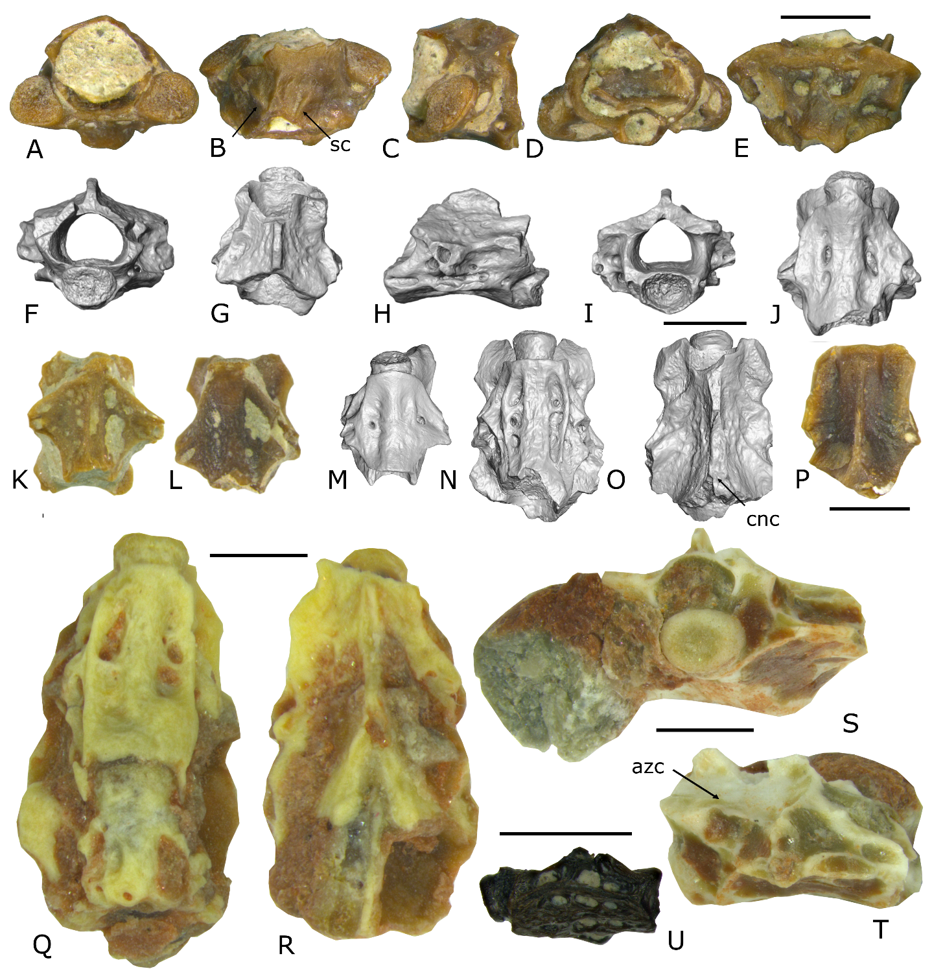
Figure S2. Trunk vertebrae of Koalliella sp. from La Neuve (LNE; A-L) and Les Pennes-Mirabeau (LMI; M-Q). A-C, two vertebrae in articulation, UM-LNE-1012, in anterior (A), lateral (B), and ventral (C) views; D, trunk vertebra, UP.LNE.2024.04, in dorsal view, with the dorsal capsule of the neural crest broken, so that the inner structure of the neural crest is visible, and characterised by a line of foramina; E-I, trunk vertebra, UP.LNE.2003.05, in anterior (E), dorsal (F), lateral (G), posterior (H), and ventral (I) views; J-L, two vertebrae in articulation, UP.LNE.2024, in anterolateral (J), dorsal (K), and ventral? (L) views; M-Q, 3D model of a trunk vertebra, UP.LMI.2024.01, in anterior (M), dorsal (N), lateral (O), posterior (P), and ventral (Q) views. Scale bars = 1 mm. Scale bar in the top right is valid for A to L.
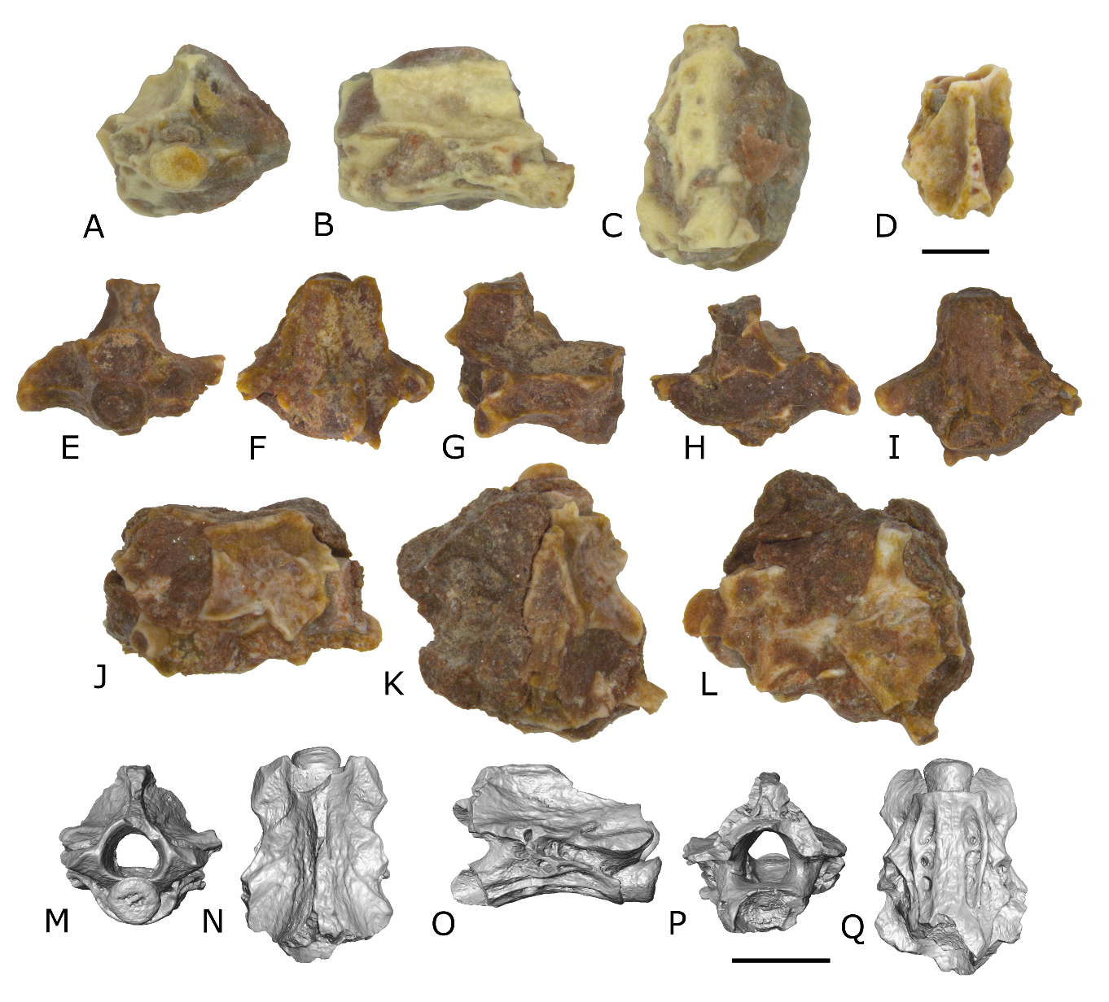
The postatlantal vertebrae from Les Pennes-Mirabeau are opisthocoelous (Fig. 1F-J). The ossification of the anterior condyle is typical of the family Salamandridae, having the condyle constricted by a short neck and ventrally flanked by the ventral lamina. The anterior condyle is flat or with a shallow concavity in the middle, as often observed in Salamandra, and the notochordal foramen is never visible.
The anterior and posterior zygapophyseal crests are horizontal and connect respectively pre- and postzygapophyses to the diapophysis. The anterior zygapophyseal and ventral crests are close to each other so that a long but shallow concavity is present between them (Figs. 1H, S2O). The diapophyses are more posterior than the parapophyses; both are hollow and connected by a lamina (Figs. 1H, S2O).
As typical in Salamandridae, the ventral lamina is formed by the anterior and the posterior ventral crests. The anterior ventral crests connect the anterior edge of the ventral lamina with the parapophyses, while the posterior edge of the ventral lamina and the parapophyses are connected by the posterior ventral crests. The ventral lamina anterior extends laterally to the ventral edge of the condyle, forming a flat surface at the ventroanterior extremity of the vertebrae. Two different morphotypes of the ventral surface can be observed in the material. The morphotype I (Fig. 1K) consists in a wide rhomboidal ventral lamina pierced by small foramina, whereas in the morphotype II (Fig. 1N), the vertebral centrum emerges from the lamina and is laterally flanked by a pair of foramina that are long and enclosed by two parallel low crests. These “basapophysis-like” crests interrupt the ventral lamina, as the anterior and posterior ventral crests are dorsolateral to them. Morphotype II dominates the assemblage (54 vertebrae, including UP.LMI.2004.43-45, UP.LMI.2024.01-02, UP.LMI.2024.07-08, UP.LMI.2024.10, UP.LMI.2024.13, UP.LMI.2024.22), whereas morphotype I is visible in 19 vertebrae (e.g. UP.LMI.2004.46, UP.LMI.2024.03, UP.LMI.2024.11). There is however a continuum in the two morphologies, with intermediate states visible in at least six vertebrae (UP.LMI.2024.04-05, UP.LMI.2024.12, UP.LMI.2024.18, UP.LMI.2024.20-21). For example, UP.LMI.2024.04 (Fig. 1M) only shows a “basapophysis-like” structure on the right side, whereas other specimens (e.g. UP.LMI.2024.18; Fig. 1L) do not have basapophyses-like structures but two long foramina along the centrum, that can have a variable degree of ossification (so the foramina can be more or less wide).
Similarly to this, the two trunk vertebrae from the type series of Koalliella genzeli, from the Paleocene of Walbeck (Herre 1950, Vasilyan & Macaluso 2025), have two different morphotypes of the ventral lamina, in one case characterised by two long foramina flanking the vertebral centrum and in the other case with a rhomboidal ventral lamina pierced by small foramina. These morphotypes are therefore interpreted as intraspecific or intracolumnar variation. Similarly, two morphotypes are visible also in the shape of the neural arch between the prezygapophyses that is either high, visible also in lateral view dorsally to the prezygapophyses, and having a small pseudozygosphene (e.g. UP.LMI.2024.04; e.g., Fig. 1T), or low, not visible in lateral view, and not bearing any zygosphene. A similar variation in the dorsal extension of the neural arch is observable in both extant Lissotriton spp. and Salamandrina (Macaluso et al. 2023).
Despite the variations, the vertebrae preserving the neural crest, or part of it, show a consistent morphology with a high neural crest, dorsally and posteriorly enlarged with a small dermal capping that forms a rough dorsal surface of the neural crest, without sculturing or foramina. The same morphology of the neural crest is present in, and highly diagnostic for, Koalliella (Vasilyan & Macaluso 2025).
The caudal vertebrae (both from Les Pennes-Mirabeau and from La Neuve; UP.LMI.2024.15, UM-LNE-1007) are poorly preserved, mostly characterised by centra alone, but they are referred to the same genus as the trunk vertebrae giving the similar general aspect.
The vertebrae from La Neuve are poorly preserved compared to the ones from Les Pennes-Mirabeau, but they all show an opisthocoelous condition with the ossification of the condyle diagnostic for Salamandridae, which shows a small neck of the condyle. The ventral surface of the vertebrae also shows the typical salamandrid morphology, with an overall rhomboidal ventral lamina. The ventral lamina presents two morphotypes, similarly to the vertebrae from Les Pennes-Mirabeau: morphotype I is observed in UM-LNE-1001, 1005-1006, UP.LNE.2003.05 (Fig. S2E-I), UP.LNE.2024.02, UP.LNE.2024.06-07 and UP.LNE.2024.10, and morphotype II (Fig. 1Q) in UM-LNE-1000, UM-LNE-1003, UM-LNE-1004, UM-LNE-10012, UP.LNE.2024.04 (Fig. S2D), UP.LNE.2024.05, UP.LNE.2024.11-13, and UP.LNE.2003.04, whereas UP.LNE.2024.01, UP.LNE.2003.07 and UP.LNE.2024.08 show an intermediate morphotype.
The anterior zygapophyseal crests, when preserved (e.g. UM-LNE-1000, UM-LNE-1004) are horizontal or slightly ventrally directed, but always reaching the dorsal part of the transverse processes (azc in Fig. 1T), excluding an attribution to Chelotriton or to the other related crocodile newts. The only exception is represented by UM-LNE-1012 (Fig. S2B), where the anterior zygapophyseal crests reach the ventral part of diapophyses, but the overall morphology is consistent with the other vertebrae of the assemblage.
The vertebrae from La Neuve very rarely preserve the neural crest, and if they do it is in most cases broken in its dorsal part, preventing to describe properly the dermal capping of the vertebrae. Based on the base of the neural crest, however, the morphology is consistent with the only taxon found in the Paleocene, Koalliella, being clearly posteriorly enlarging (e.g. UM-LNE-1004, Fig. 1R).
?Koalliella sp.
Material. three vertebral centra (UP.VER.2024.01-03).
Locality and age. Vérane: marls, late Campanian (Begudian local stage, Chron32N)
Description and remarks. Three vertebral centra from Vérane have an opisthocoelous condition with a well-developed neck, allowing an attribution to Salamandridae. The ventral laminae have a similar morphology to the vertebrae from Les Pennes-Mirabeau and La Neuve (morphotype I in UP.VER.2024.02-03, and morphotype II in UP.VER.2024.01 [Fig. 1U]). The assemblage is however too poor and incomplete to assign this material to Koalliella without uncertainties.
Salamandridae indet.
(Fig. S3)
Material. La Neuve: 33 vertebral centra (UP.LNE.2024.09,16-19, UP.LNE.2003.01-03, UM-LNE-1002, UM-LNE-1009), one proximal humerus (UP.LNE.2003.06; Fig. S2G), a portion of tibia (UM-LNE-1008, Fig. S2A-B), two proximal portions of femur (UM-LNE-1010, Fig. C-D; UM-LNE-1011; Fig. S2E-F). Champ-Garimond: one trunk vertebra (CHG-A 29), and three dentary fragments (CHG-A 30-32). Les Pennes-Mirabeau: two vertebral centra (UP.LMI.2024.14), proximal end of a humerus (UP.LMI.2024.16; Fig. S2H-I).
Localities and age. Champ-Garimond: clays with encrustations and calcareous nodules, Campanian (following charophyte biozone, Chron33), La Neuve: marls, late Campanian (Begudian local stage, Chron33N) and Les Pennes-Mirabeau (LMI): marls with calcareous nodules, late Maastrichtian (Upper Rognacian local stage)
Description and remarks. Poorly preserved centra and incomplete limb portions from La Neuve and Les Pennes-Mirabeau are herein cautiously assigned to undetermined Salamandridae, although it is likely that they also belong to Koalliella, being the only salamandrid taxon reported until the early Eocene.
A single vertebra from Champ-Garimond (CHG-A 29), described by Sigé et al. (1997), is also referred to an undetermined Salamandridae, based on the presence of the anterior condyle with a well-developed neck. The vertebra is badly preserved, missing both transverse processes, pre- and postzygapophyses, and the neural crest is only partially preserved in its mid-posterior part. As such, the identification cannot go further than the family level. The vertebra is rather elongated, pointing to a position close to the pelvis. The ventral lamina is formed by the anterior and posterior ventral crests that are slightly ventrally concave in lateral view. The morphology of the ventral lamina is comparable to that of the morphotype I from Les Pennes-Mirabeau based on the absence of basapophyses-like structures and the several foramina visible in ventral view.
The three dentary fragments from Champ-Garimond (CHG-A 30-32; Sigé et al. 1997) are also too fragmented for a precise identification. They have however a size and morphology similar to that of Salamandridae.
Figure S3. Appendicular skeleton of Salamandridae indet. from La Neuve and Les Pennes-Mirabeau. A-B, tibia, UM-LNE-1008, in dorsolateral and ventromedial views. C-D, proximal femur, UM-LNE-1010, in lateral (C) and medial (D) views. E-F, proximal femur, UM-LNE-1011, in lateral (E) and medial (F) views. G, proximal portion of a humerus, UP.LNE.2003.06, in dorsal view. H-I, proximal portion of a humerus, UP.LMI.2024.16, in dorsal (H) and ventral (I) views. Scale bars = 1 mm.
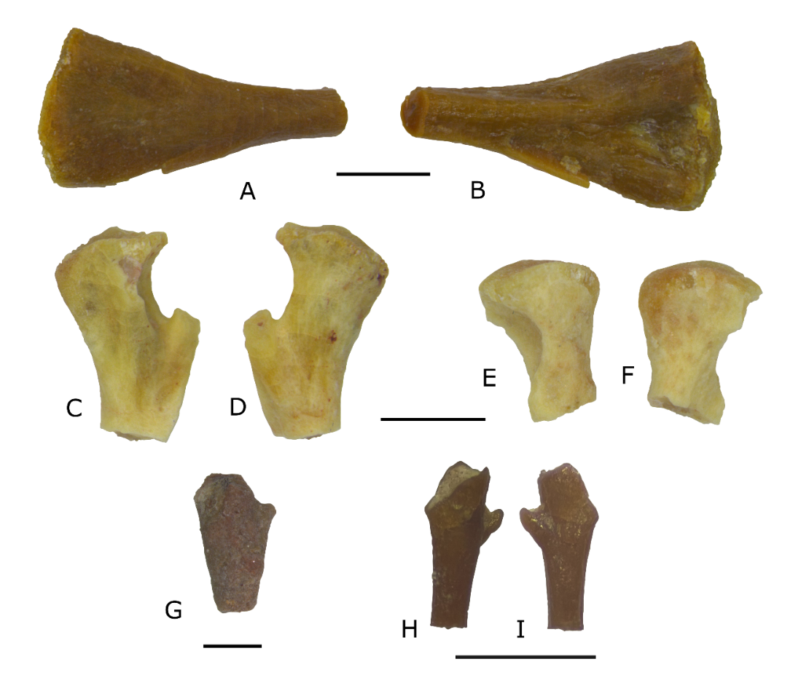

Figure S4. Different topologies of Salamandridae retrieved by: A, Macaluso et al. (2025), that used equal weighting and molecular constraints from Veith et al. (2018); B, this study, using the dataset of Macaluso et al. (2025), but molecular constraints from Stewart & Wiens (2025). C, this study, using the dataset of Macaluso et al. (2025), with no molecular constraints.
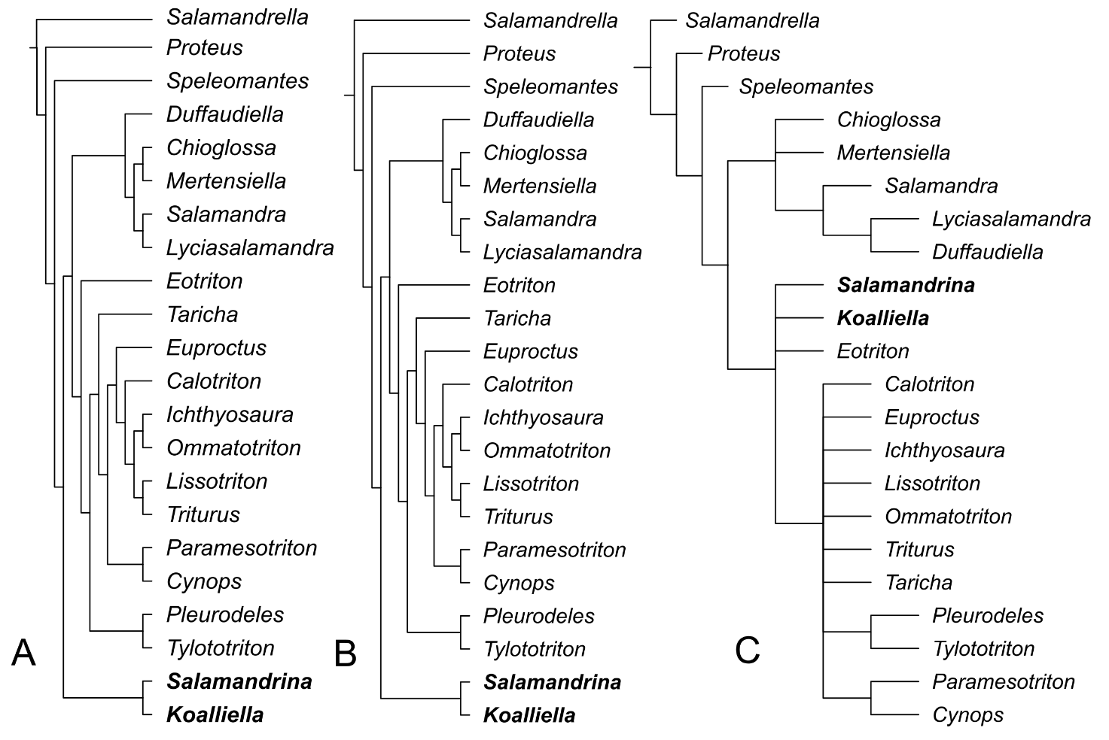

Table S1. Tomographic information of scanned specimens.
Taxon | Specimen | Locality | Material | Resolution (mm) | Current (µA) | Voltage (kV) | Number of slices
Koalliella sp. | UP.LMI.2024.01 | Les Pennes-Mirabeau | Trunk vertebra | 0.00210492 | 60 | 100 | Y=860
Koalliella sp. | UP.LMI.2024.04 | Les Pennes-Mirabeau | Trunk vertebra | 0.00223994 | 63 | 100 | X=1063
Koalliella sp. | UP.LMI.2024.05 | Les Pennes-Mirabeau | Trunk vertebra | 0.00223994 | 63 | 100 | X=1063

