Supplementary Materials

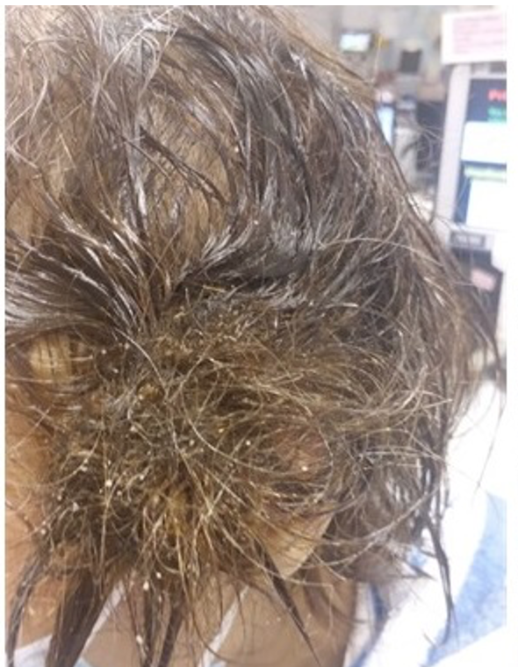

S_Figure 1 A patient experienced hair tangling after the use of cool cap at the 2nd cycle of chemotherapy

S_Table 1 Reasons of refusal to join the study

Reasons | Number of women (%)
Worries of coldness | 34 (60.7%)
Worries of musculoskeletal pain / headache | 2 (3.6%)
Psychiatric stress | 2 (3.6%)
Personal image | 4 (7.1%)
Logistic issue | 3 (5.4%)
Unknown reasons | 11 (19.6%)
Total | 56

S_Table 2 Baseline absolute scores of QOL-related outcomes in the intention-to-treat population

 | Scalp cooling  (N = 40) |  | Control  (N = 39)
Baseline | Median | IQR | Median | IQR | P value
EQ-5D-5L index | 0.748 | 0.324-0.844 | 0.753 | 0.597-0.848 | 0.519
EORTC QLQ-C30 GHS/QOL | 50.0 | 41.7-66.7 | 66.7 | 39.6-77.1 | 0.595
EORTC QLQ-C30 Physical functioning | 60.0 | 46.7-80.0 | 70.0 | 58.3-86.7 | 0.143
EORTC QLQ-C30 Role functioning | 50.0 | 16.7-66.7 | 66.7 | 50.0-83.3 | 0.025
EORTC QLQ-C30 Social functioning | 83.3 | 50.0-83.3 | 66.7 | 50.0-100.0 | 0.749
PHQ9 | 5 | 3.0-9.0 | 7.5 | 3.0-12.0 | 0.289
GAD7 | 6.0 | 1.0-10.0 | 6.5 | 2.0-12.0 | 0.519

S_Table 3 Comparison of PHQ-ADS scoresª at different time points from baseline within individual group

Comparison to baseline | Scalping cooling  (N = 40) |  | Control  (N = 39)
Comparison to baseline | Z | p value | Z | p value
Post - cycle 2 | 1.053 | 0.083 | 1.477 | 0.009
Post - cycle 4 | 0.816 | 0.179 | 1.432 | 0.011
2-3 weeks after completion of chemotherapy | 1.158 | 0.056 | 1.295 | 0.022
3 months after completion of chemotherapy | 0.816 | 0.179 | 1.636 | 0.004
6 months after completion of chemotherapy | 1.526 | 0.012 | 1.659 | 0.003
Overall | 7.885 | 0.163 | 12.841 | 0.025

ª Patient Health Questionnaire Anxiety and Depression Scale (PHQ-ADS) is a 16-item composite measure of depression and anxiety based on the Patient Health Questionnaire 9-item depression scale (PHQ-9) and 7-item Generalized Anxiety Disorder scale (GAD-7)

S_Table 4 Change of the anxiety and depression scores in the intention-to-treat population

 | Scalp cooling  (N = 40) |  | Control  (N = 39)
Change in PHQ9 from baseline ª | Median | IQR | Median | IQR | P value
Post - cycle 2 | -1.0 | -3.0 - 0.75 | 0.0 | -4.5 - 2.5 | 0.60
Post - cycle 4 | -1.0 | -2.0 - 0.0 | - 1.0 | -4.0 - 3.0 | 0.60
2-3 weeks after completion of chemotherapy | -2.0 | -5.0 - 0.0 | - 1.0 | -4.0 - 2.0 | 0.23
3 months after chemotherapy | -2.0 | -4.0 - 0.0 | - 1.0 | -7.8 - 3.3 | 0.37
6 months after chemotherapy | -1.0 | -4.3 - 0.0 | - 2.0 | -6.5 - 1.0 | 0.35
PHQ-9 item 9 – Presence of suicidal ideation ^{b} | Proportion ^{c} (%) | 95% CI | Proportion ^{c} (%) | 95% CI | P value
Before chemotherapy | 5/40 (12.5%) | 2.2 - 22.2% | 9/39 (23.1%) | 11.7 - 39.7% | 0.35
Post - cycle 2 | 4/36 (11.1%) | 0.8 - 21.4% | 5/37 (13.5%) | 2.5 - 24.5% | 0.52
Post - cycle 4 | 5/33 (15.2%) | 2.9 - 27.4% | 3/35 (8.6%) | 0.0 - 7.8% | 0.32
2-3 weeks after completion of chemotherapy | 2/35 (5.7%) | 0.80 - 13.4% | 3/35 (8.6%) | 0.0 - 17.8% | 0.50
3 months after chemotherapy | 2/25 (8.0%) | 0.0 - 18.6% | 6/30 (20.0%) | 5.7 - 34.3% | 0.02
6 months after chemotherapy | 1/26 (3.8%) | 0.0 – 11.2% | 4/29 (13.8%) | 1.2 - 26.3% | 0.21
Change in GAD7 from baseline ^{d} | Median | IQR | Median | IQR | P value
Post - cycle 2 | -2.0 | - 4.75 - 0.0 | -1.0 | -4.5 - 1.0 | 0.40
Post - cycle 4 | -1.0 | - 4.0 - 1.0 | -2.0 | -5.0 - 0.0 | 0.88
2-3 weeks after completion of chemotherapy | -2.0 | - 6.0 - 0.0 | -1.0 | -5.0 - 1.0 | 0.17
3 months after chemotherapy | 0.0 | - 3.5 - 0.5 | -2.5 | -6.3 - 0.5 | 0.60
6 months after chemotherapy | -0.5 | - 5.0 - 1.0 | -2.0 | -7.0 - 0.5 | 0.97
Psychologists and/or psychiatrists referral | 3 (7.5%) | NA | 4 (10.3%) | NA | 0.67

ª Depressive symptom severity was assessed by Patient Health Questionnaire (PHQ-9) using a 4-point Likert scale ranging from 0 (never) to 3 (nearly every day). Depressive symptom severity was quantified by the sum of the items 1 to 9 on PHQ-9, with total score ranging 0-27. Score 1-4 refers to minimal depression, 5-9 refers to mild depression, 10-14 refers to moderate depression, 15-19 refers to moderately severe depression, 20-27 refers to severe depression.
^{b} The item 9 on the PHQ-9, namely “During the past two weeks, how often have you been troubled by the notion that you would be better off dead or hurting yourself” was used to evaluate the presence of suicidal ideation. Specifically, participants who responded to an item 9 as “not at all” (i.e., rating=0) were considered having no suicidal ideation, whereas those whose rating was 1–3 (i.e., “several days”, “more than half the days”, or “nearly every day”) were categorized as having suicidal ideation.
^{c} The denominators represented the total number of participating women who were receiving chemotherapy with (case) or without (control) cool caps, and who had completed the corresponding questionnaire.
^{d} Anxiety symptom severity was assessed by Generalised Anxiety Disorder-7 scale (GAD-7) using a 4-point Likert scale ranging from 0 (never) to 3 (nearly every day). Anxiety symptom severity was quantified by the sum of the items 1 to 7 on GAD-7, with total score ranging from 0–21. Score 1 - 9 refers to mild anxiety, 10 - 14 refers to moderate anxiety, 15-21 refers to severe anxiety.
(IQR, interquartile range; PHQ9, Patient health questionnaire-9; GAD7, General anxiety disorder–7; NA, not applicable)

S_Table 5 Comparison of adverse events between women with and without scalp cooling in the intention-to-treat population

 | Any grades (N, %) |  |  | Grade ≥ 3 (N, %)
 | Cool cap (N=40) | No cool cap  (N=39) | P value | Cool cap (N=40) | No cool cap  (N=39) | P value
All adverse events | 32 (80.0) | 25 (64.1) | 0.1150 | 3 (7.5) | 2 (5.1) | 1
Coldness* | 8 (20.0) | 0 (0) | 0.0053 | 0 (0) | 0 (0) | NA
Headache | 3 (7.5) | 0 (0) | 0.2405 | 0 (0) | 0 (0) | NA
Hair tangling | 1 (2.5) | 0 (0) | NA | 0 (0) | 0 (0) | NA
Musculoskeletal pain | 2 (5.0) | 0 (0) | 0.4937 | 0 (0) | 0 (0) | NA
Rash | 6 (15.0) | 3 (7.7) | 0.4814 | 0 (0) | 0 (0) | NA
Hypertension | 2 (5.0) | 2 (5.1) | 1 | 2 (5.0) | 2 (5.1) | 1
Hypotension | 0 (0) | 0 (0) | NA | 0 (0) | 0 (0) | NA
Sinus tachycardia | 2 (5.0) | 0 (0) | 0.4937 | 0 (0) | 0 (0) | NA
Non-cardiac chest pain | 4 (10.0) | 1 (2.6) | 0.3626 | 0 (0) | 0 (0) | NA
Dizziness | 1 (2.5) | 1 (2.6) | 1 | 0 (0) | 0 (0) | NA
Diarrhea | 1 (2.5) | 0 (0) | 1 | 1 (2.5) | 0 (0) | 1
Malaise | 1 (2.5) | 0 (0) | 1 | 0 (0) | 0 (0) | NA
Nausea / Vomiting | 24 (60.0) | 19 (48.7) | 0.3141 | 0 (0) | 0 (0) | NA
Thermal injury / burns | 0 (0) | 0 (0) | NA | 0 (0) | 0 (0) | NA

*Coldness was graded as chill according to CTCAE v5.0.

