Figure S1: Workflow for the Development and Validation of a Predictive Model Distinguishing Colonization from Infectious Pneumonia
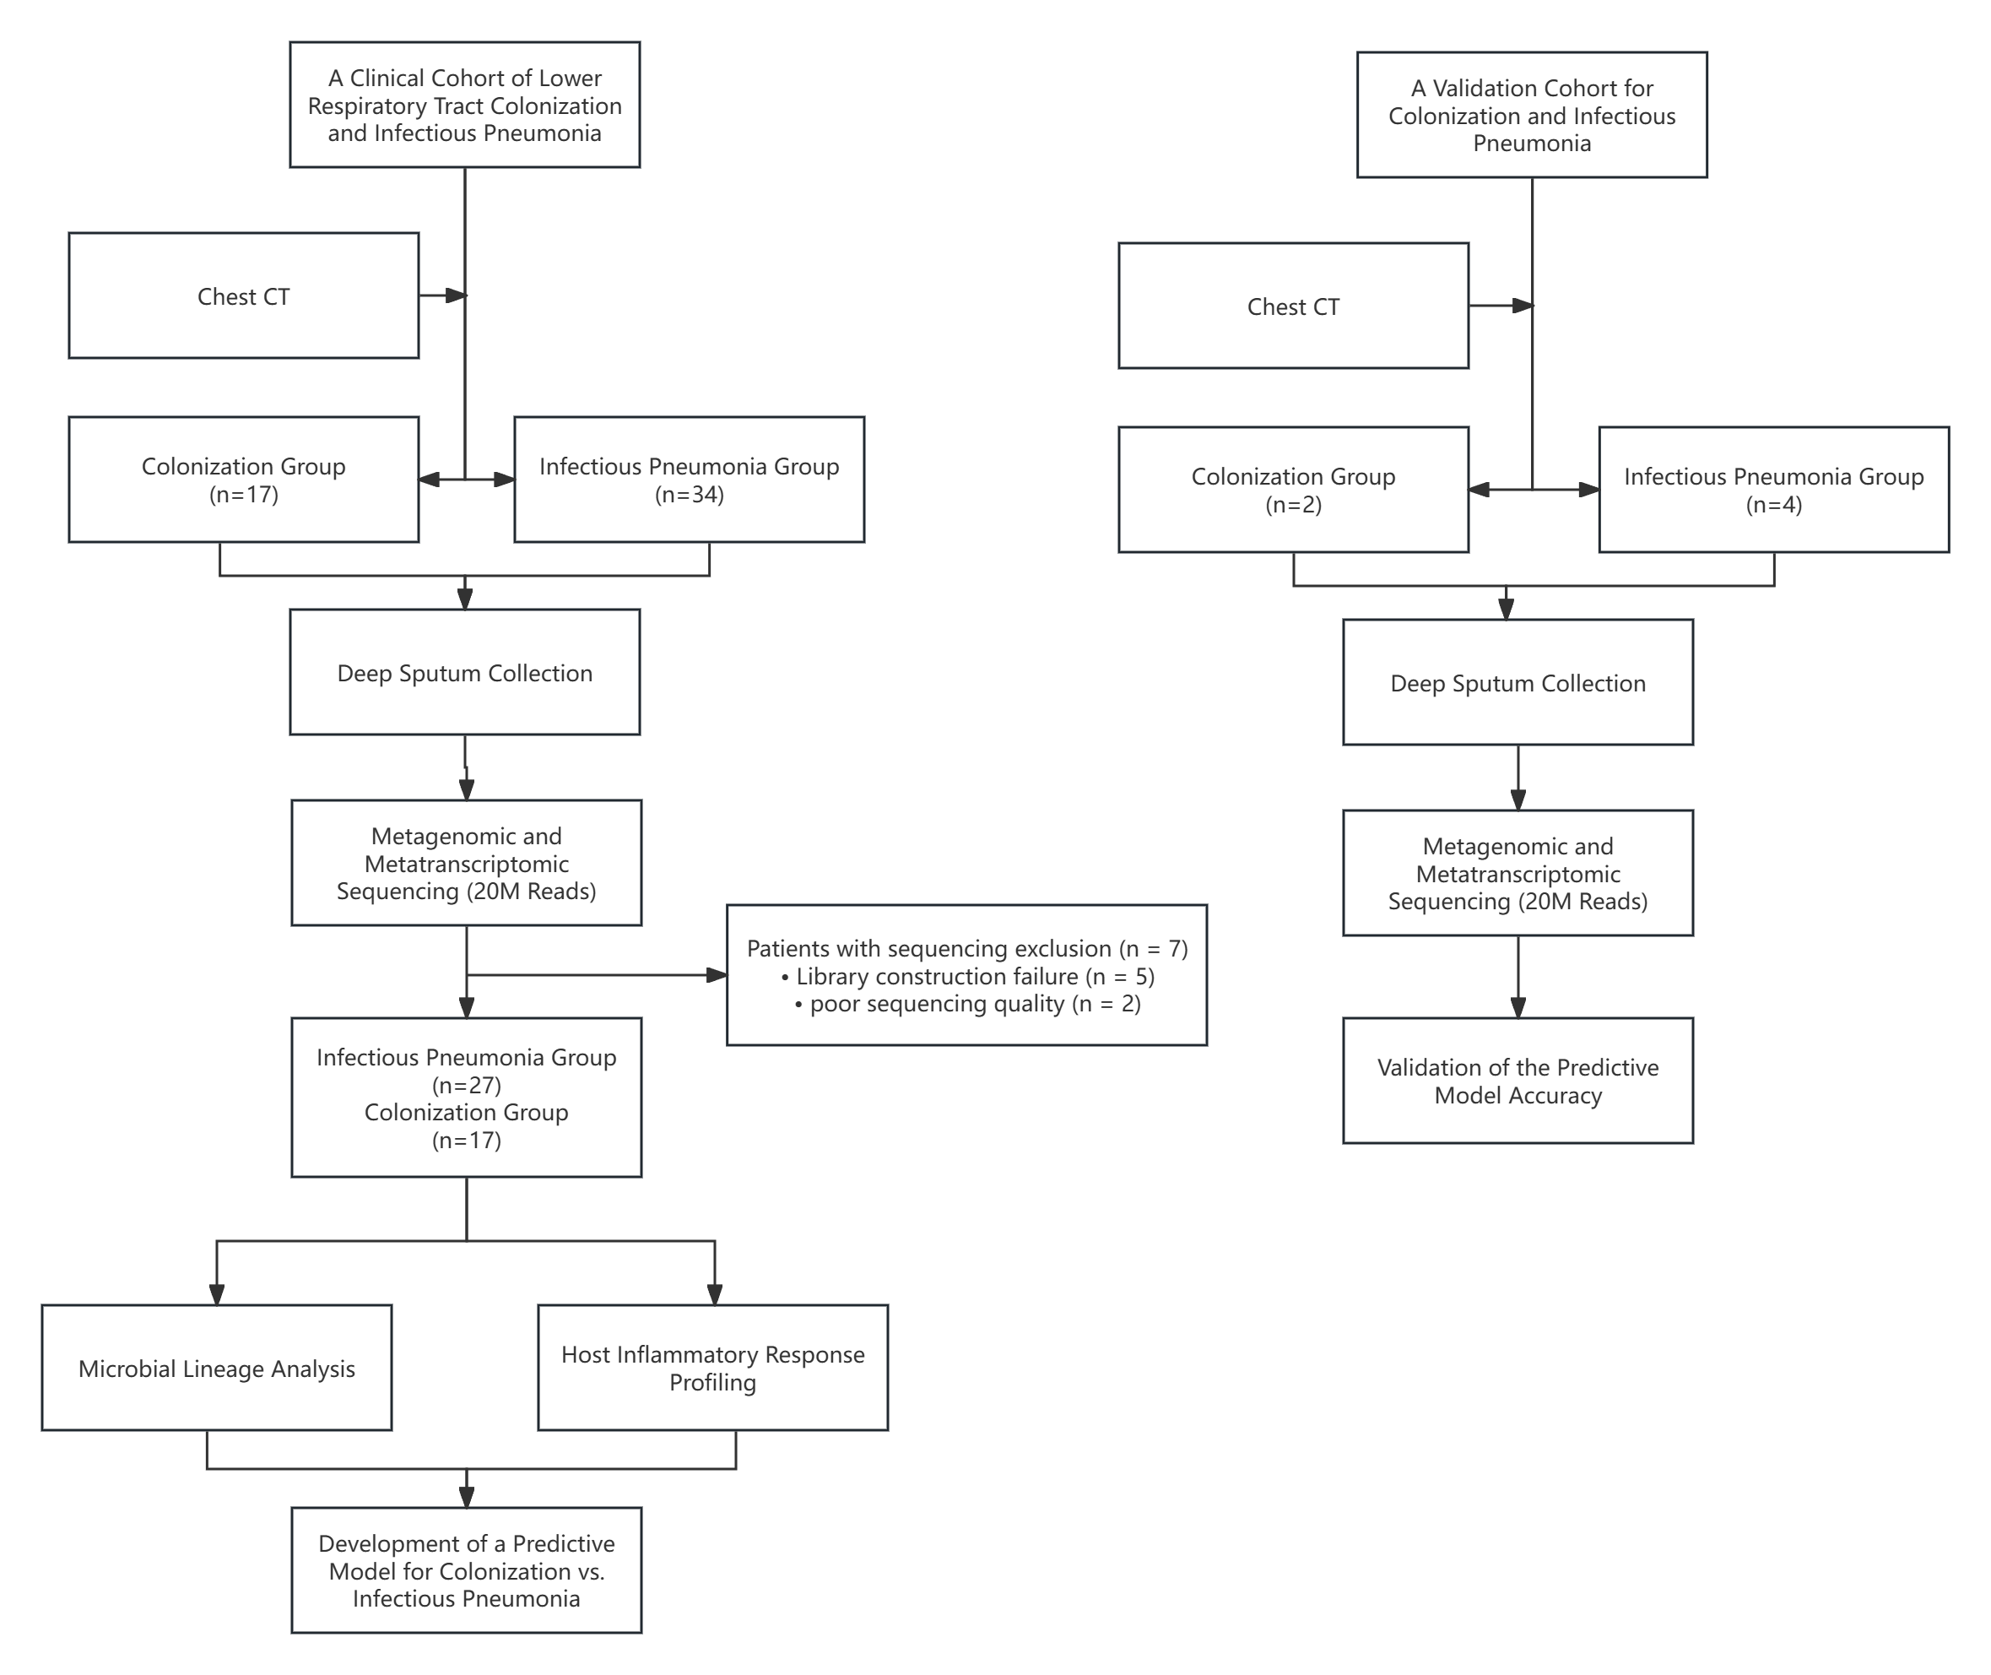
Figure S2. Impact of antibiotic exposure on lower respiratory tract microbial diversity.
(A) α-diversity assessment based on the Shannon index across different antibiotic regimens at the time of sampling. No significant differences in α diversity were detected (Kruskal–Wallis test, P = 0.34).
(B) Principal coordinates analysis (PCoA) based on Bray–Curtis dissimilarity illustrating β-diversity among antibiotic groups. No significant clustering was observed (PERMANOVA, P = 0.146).
These results indicate that concurrent antibiotic treatment did not substantially alter the overall community structure of the lower respiratory microbiota in this cohort.
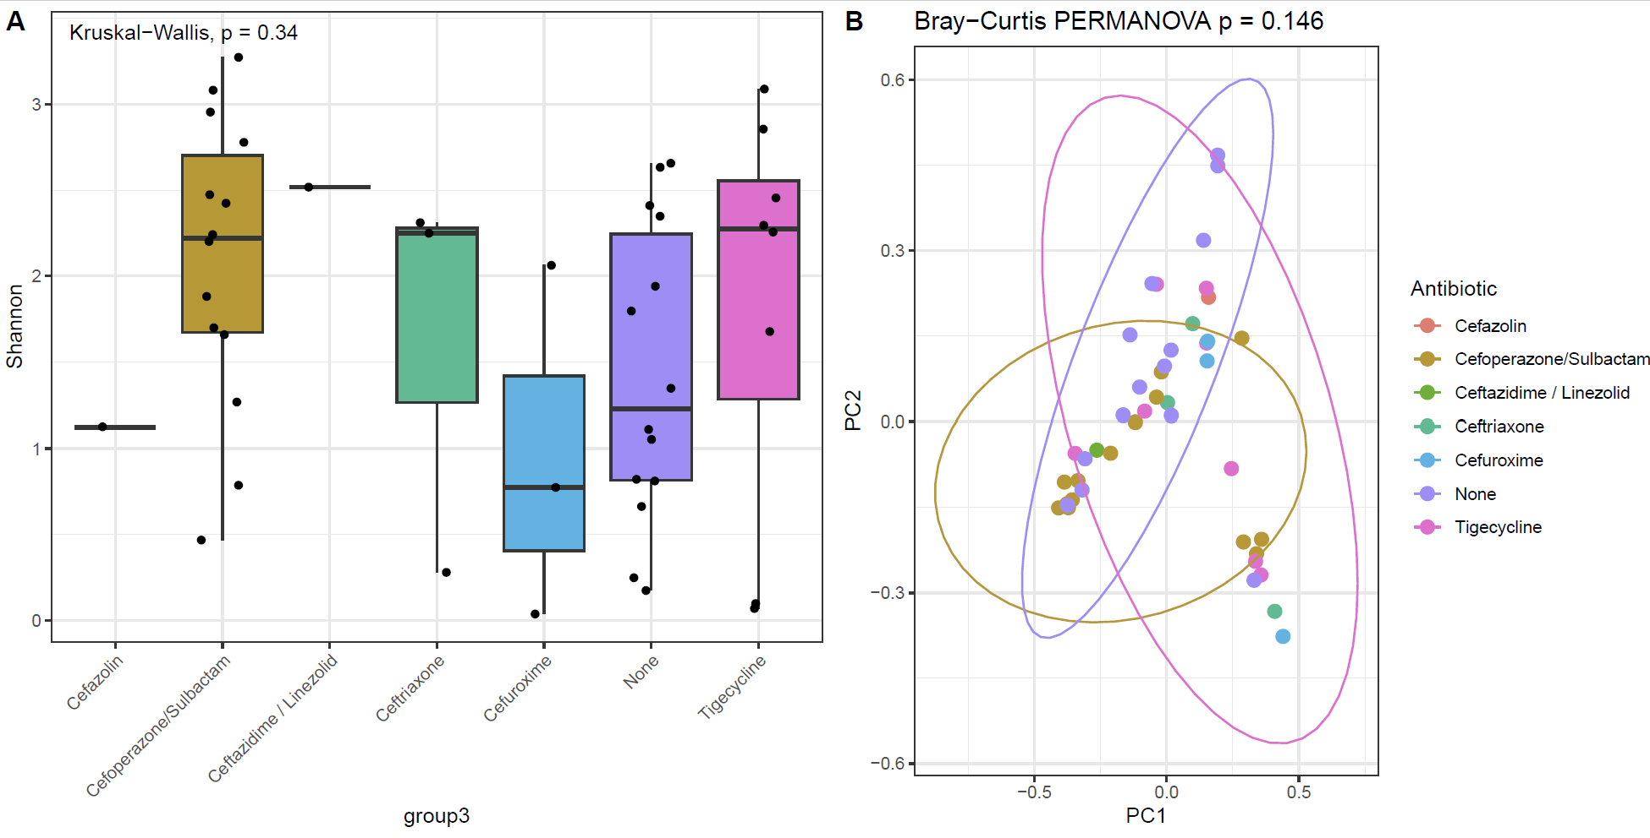
Figure S3. Estimated immune-cell composition of lower respiratory samples in the colonization and infection groups.
CIBERSORT-derived proportions of innate (left) and adaptive (right) immune-cell subsets are shown for patients with microbial colonization (CL) and infectious pneumonia (IM). No statistically significant differences in estimated immune-cell proportions were observed between the two groups, indicating limited confounding from immune-cell composition in the host-response analyses.
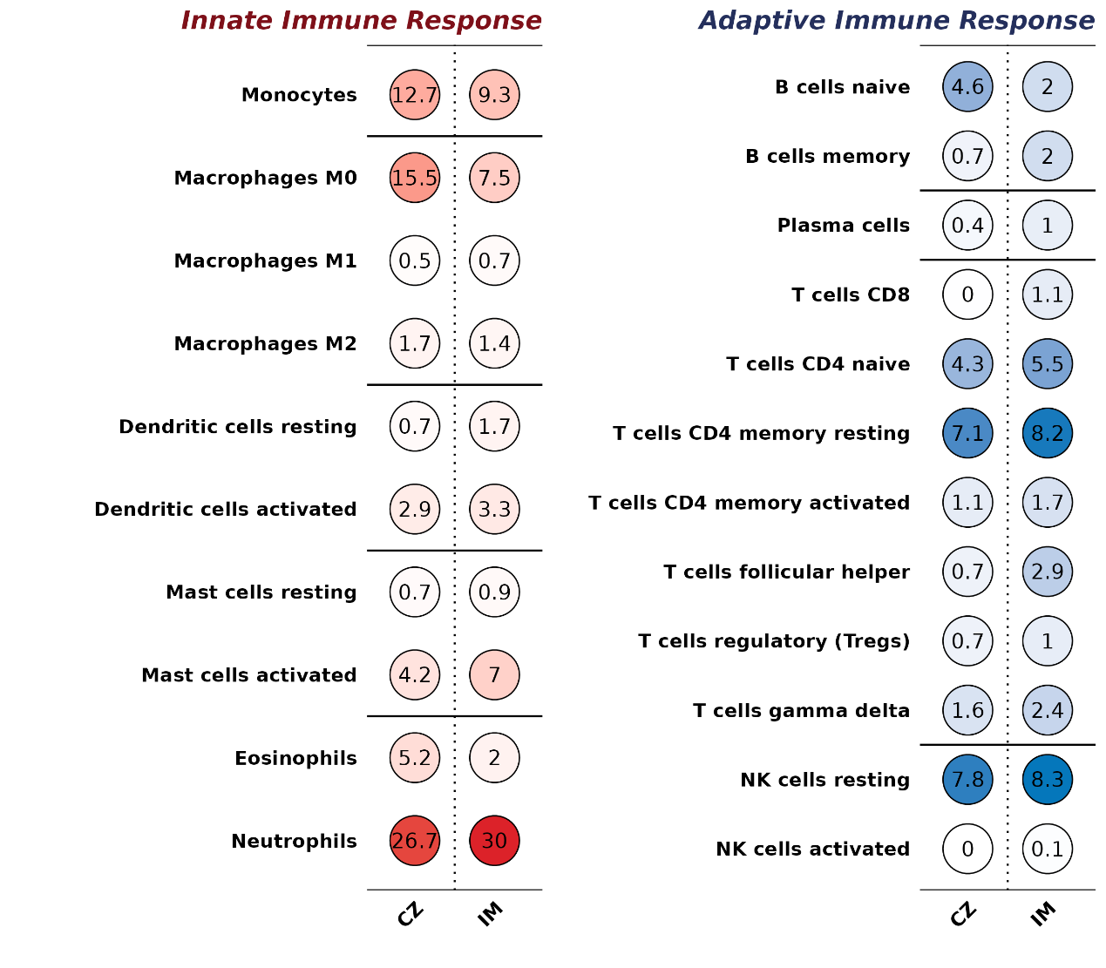
Figure S4. Performance evaluation of the diagnostic models.
(A) Receiver operating characteristic (ROC) curve of the Logistic Regression model in the training cohort, showing an AUC of 0.756.
(B) ROC curves comparing the multi-omics–derived Random Forest model with the clinical-variable–based logistic regression model in the training dataset. The Random Forest model demonstrated significantly superior discriminatory performance (AUC = 0.952 vs. 0.756), as supported by the DeLong test (Z = 2.1294, P = 0.03322).
A B
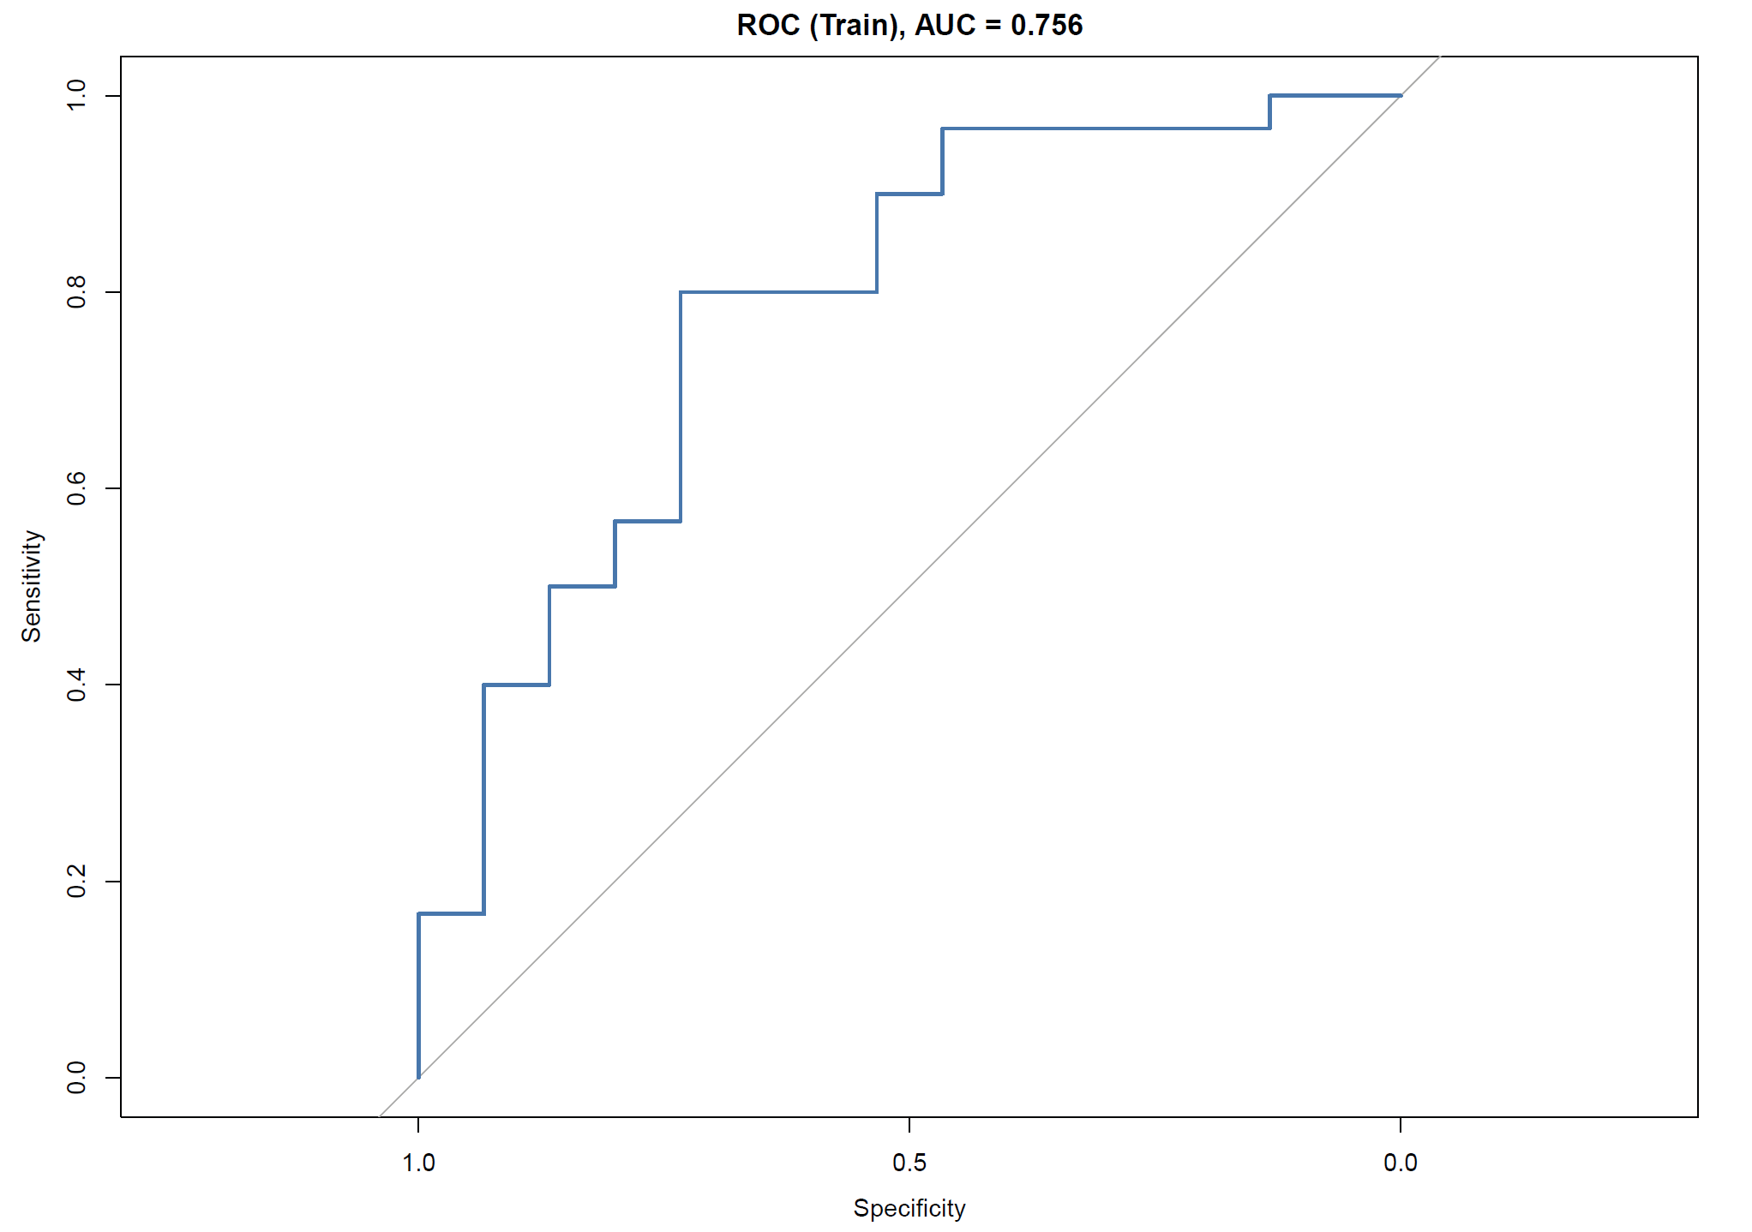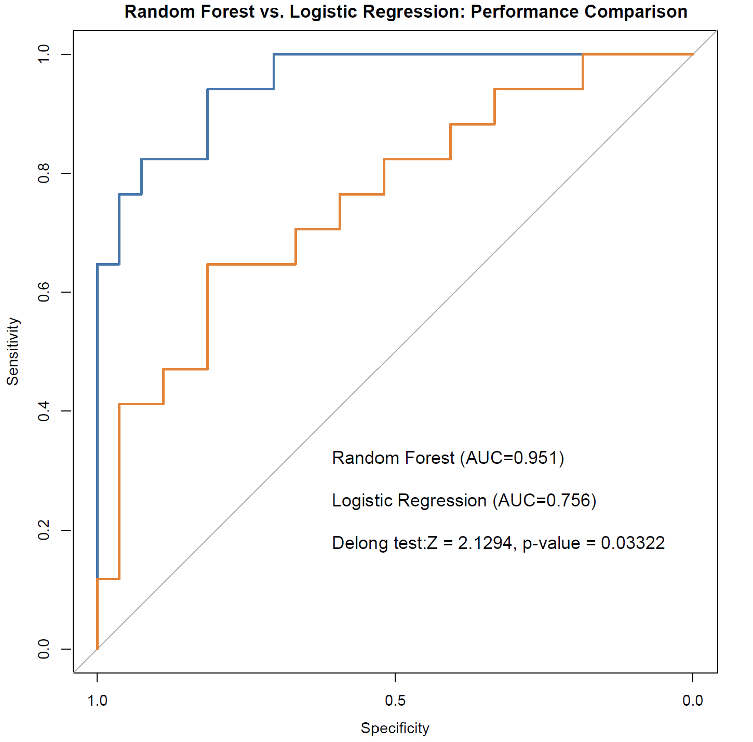
Table S1: Baseline clinical and laboratory characteristics of patients in the training and validation cohorts.
Table S2: Clinical, laboratory, and radiological information of individual patient samples.

Table S3: TRIPOD+AI (Transparent Reporting of a multivariable prediction model for Individual Prognosis or Diagnosis + Artificial Intelligence) checklist for reporting of the diagnostic model.

