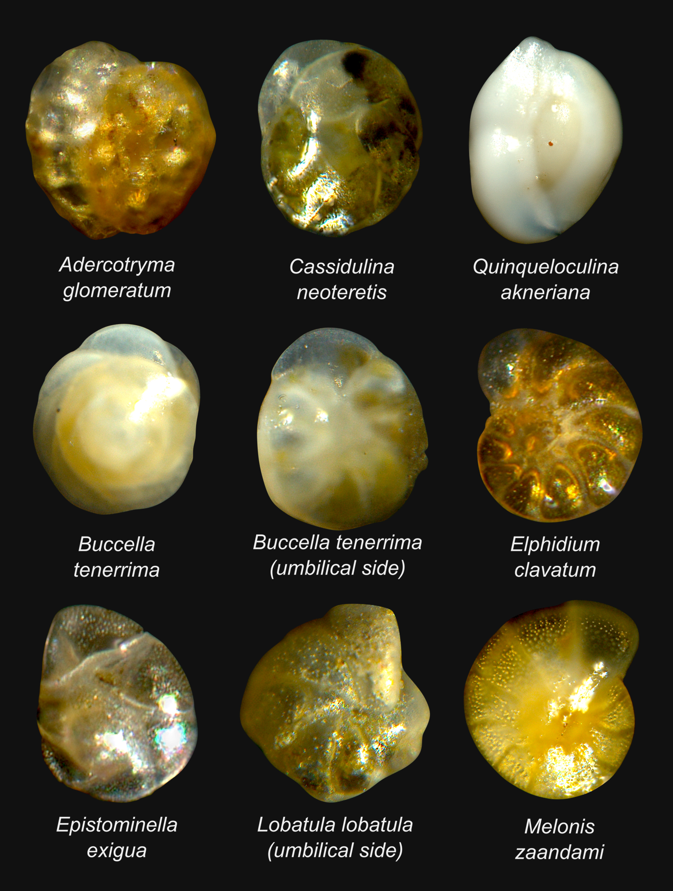

Supplementary Fig. S1 – Foraminiferal species exhibiting well-developed greenish cytoplasm, indicating recent uptake of fresh algal material directly from the phytodetrital fluff. These observations suggest that the species had successfully colonised the phytodetritus. Images were taken by Jutta Wollenburg from frozen, non-Rose Bengal-treated sediment samples.

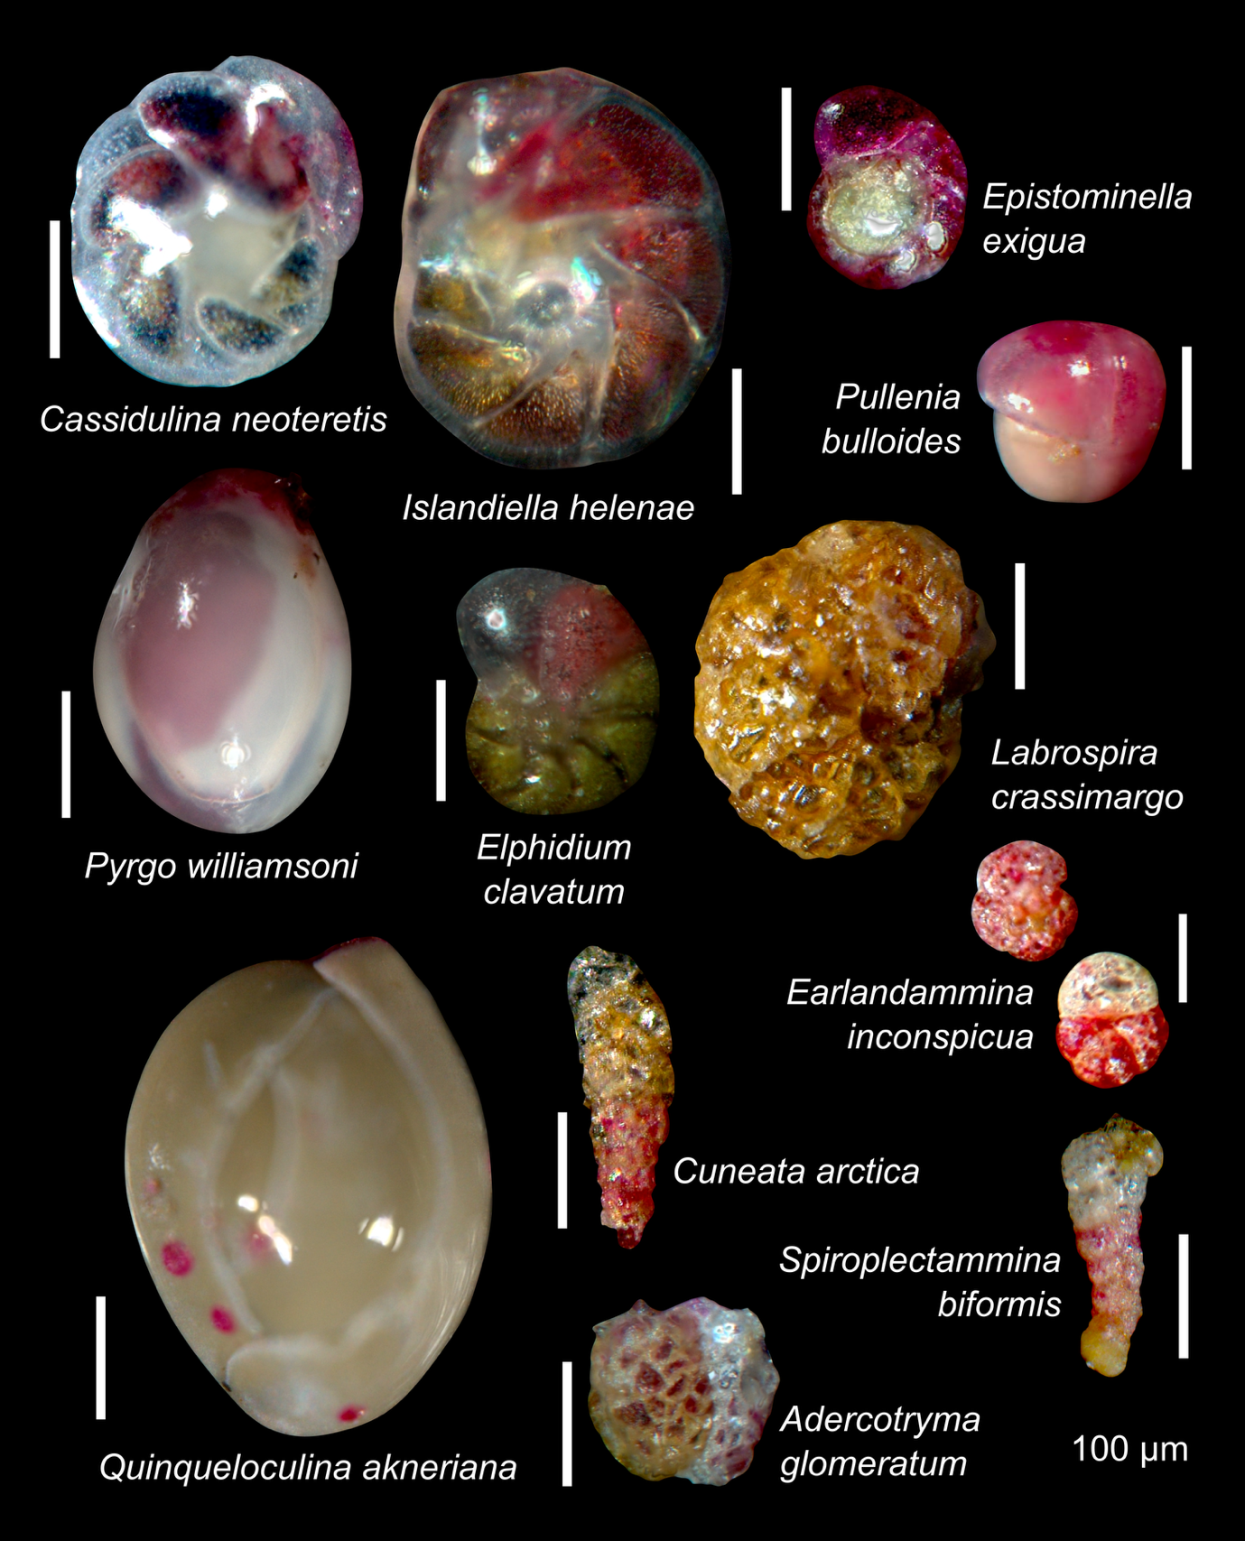

Supplementary Fig. S2 – Living (Rose Bengal-stained) foraminiferal species that colonised the phytodetrital layer (>63 µm). Images were taken and provided by Jutta Wollenburg.

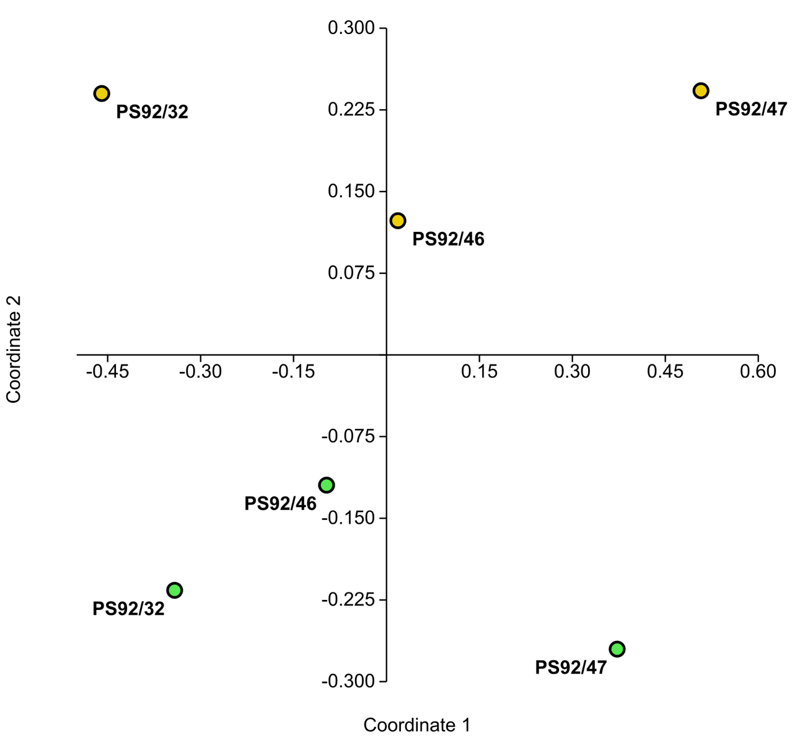
Supplementary Fig. S3 – Non-metric multidimensional scaling (NMDS) based on the Morisita similarity index (Stress=0.09). Yellow dots refer to sediment samples, and green dots correspond to phytodetritus samples.

