Supplementary Table S1. Top 26 features for all participants based on weighted importance
Features | HC  (n = 43) | Early PDs  (n = 63)
P1_MedLat_COP-COM (cm) | 28.05±4.43 | 31.31±2.90
TP_COM_Speed (m/s) | 0.29±0.07 | 0.19±0.06
P1_Left_BF_iEMG (µV·s) | 347.87±267.38 | 662.55±769.48
P2_COM_Pspeed (m/s) | 0.80±0.16 | 0.63±0.16
P1_COM_Sway_Area (cm²) | 36.52±27.88 | 25.05±20.90
P2_Right_RF_iEMG (µV·s) | 606.38±358.90 | 503.77±219.47
P1_Left_Ankle_ROM (°) | 4.52±9.51 | 9.79±13.95
STS_P_Right_RF_iEMG (µV·s) | 545.59±457.63 | 905.67±800.01
P2_Left_BF_PAmp (µV) | 23.65±13.02 | 37.55±23.67
P1_Right_Hip_Mom (N·mm/kg) | 2.88±1.69 | 7.34±7.53
P1_Right_Ankle_POW (W/kg) | 0.01±0.02 | 0.10±0.20
P2_AP_COP-COM (cm) | 54.40±32.32 | 31.93±14.23
P1_Left_GAS_RMS (µV) | 3.99±5.98 | 2.64±2.07
P1_RMS_ASI_TA (%) | 46.97±20.15 | 40.29±19.42
P1_Median_Freq (-) | 851.53±19.27 | 848.44±51.72
P1_Right_RF_PAmp (µV) | 45.09±37.40 | 63.71±73.60
STS_P_RMS_ASI_GAS (%) | 35.60±20.82 | 28.69±19.71
P2_Left_Vetical_PGRF (BW) | 0.80±0.37 | 1.03±0.10
P2_RMS_ASI_TA (%) | 41.80±16.16 | 44.89±23.58
P2_T10_For_ROM (°) | 18.80±10.25 | 17.75±7.33
P2_Right_RF_RMS (µV) | 9.06±5.49 | 6.93±3.24
STS_P_RMS_ASI_TA (%) | 46.98±22.15 | 42.51±18.95
P1_Left_Knee_ROM (°) | 15.66±9.77 | 24.20±22.68
P2_Right_TCH (cm) | 7.94±1.45 | 7.22±1.05
P1_AP_COP-COM (cm) | 32.83±14.31 | 23.15±8.00
P2_Left_BF_iEMG (µV·s) | 520.80±288.94 | 891.15±921.84
All data are presented as mean ± standard deviation. HC: Healthy control; PD: Parkinson’s disease; P1: Phase 1; MedLat: Mediolateral; COP: Center of press; COM: Center of mass; cm: centimeter; TP: Total phase; m/s: Meters per second; BF: Biceps femoris; iEMG: Integrated electromyography; µV·s: Microvolt-seconds; P2: Phase 2; Pspeed: Peak speed; cm²: Square centimeter; ROM: Range of motion; °: Degrees; STS_P: Sit-to-stand phase; PAmp: Peak amplitude; µV: Microvolt; Mom: Moment; N·mm/kg: Newton-millimeters per kilogram; POW: Power; W/kg: Watts per kilogram; AP: Anterior-Posterior; GAS: Gastrocnemius; RMS: Root mean square; ASI: Asymmetry Index; TA: Tibialis anterior; %: Percentage; Freq: Frequency; PGRF: Peak ground reaction force; BW: body weight; T10: The 10th thoracic vertebra; For: Forward; TCH: Toe clearance height.

Supplementary Table S2. Accuracies, precision, recall, and F1 scores of the seven classifiers from five-fold cross-validation
 | MLs | Early-stage PD vs. HC  (200 Features) | Early-stage PD vs. HC  (26 Features) | Early-stage PD vs. HC  (3 Features)
Accuracy | LR | 78.6±5.5 | 88.2±4.6 | 76.2±6.2
Accuracy | KNN | 75.3±8.8 | 83.4±7.6 | 83.3±3.5
Accuracy | NB | 84.9±3.5 | 82.5±2.3 | 73.8±4.2
Accuracy | LDA | 78.6±9.6 | 81.0±5.0 | 78.6±7.7
Accuracy | QDA | 76.2±3.8 | 88.1±2.9 | 76.2±5.5
Accuracy | SVM | 79.5±8.5 | 80.2±5.7 | 78.6±3.7
Accuracy | RF | 87.3±3.2 | 92.1±2.8 | 84.9±5.3
Precision | LR | 79.5±4.9 | 88.8±4.2 | 77.3±7.2
Precision | KNN | 75.6±9.0 | 84.3±8.3 | 83.8±3.2
Precision | NB | 86.5±3.9 | 83.4±2.4 | 77.3±5.5
Precision | LDA | 79.7±8.5 | 81.4±5.1 | 79.7±8.5
Precision | QDA | 84.0±1.6 | 88.6±3.0 | 78.7±5.8
Precision | SVM | 80.5±8.4 | 81.9±5.2 | 79.0±8.4
Precision | RF | 88.4±3.4 | 92.4±2.9 | 85.8±6.1
Recall | LR | 78.6±5.5 | 88.2±4.6 | 76.2±6.2
Recall | KNN | 75.3±8.8 | 83.4±7.6 | 83.3±3.5
Recall | NB | 84.9±3.5 | 82.5±2.3 | 73.8±4.2
Recall | LDA | 78.6±9.6 | 81.0±5.0 | 78.6±7.7
Recall | QDA | 76.2±3.8 | 88.1±2.9 | 76.2±5.5
Recall | SVM | 79.5±8.5 | 80.2±5.7 | 78.6±8.7
Recall | RF | 87.3±3.2 | 92.1±2.8 | 84.9±5.3
F1 score | LR | 78.4±5.8 | 88.1±4.7 | 76.1±6.0
F1 score | KNN | 75.3±8.8 | 83.3±7.6 | 83.3±3.0
F1 score | NB | 84.7±3.5 | 82.4±2.4 | 73.1±4.3
F1 score | LDA | 78.1±10.3 | 80.9±5.0 | 78.4±7.7
F1 score | QDA | 74.7±4.3 | 88.0±2.9 | 75.7±7.7
F1 score | SVM | 79.3±8.7 | 79.9±6.0 | 78.5±8.8
F1 score | RF | 87.2±3.2 | 92.0±2.8 | 84.8±5.2
Values are expressed as mean (%) ± standard deviation (%) from five-fold cross-validation. Mean values presented in boldface denote the best performance (highest value) for each metric; MLs: Machine-learning techniques; PD: Parkinson’s disease; HC: Healthy control LR: Logistic regression; KNN: K-nearest neighbors; NB: Naїve Bayes; LDA: Linear discriminant analysis; QDA: Quadratic discriminant analysis; SVM: Support vector machine; RF: Random Forest.

Supplementary Table S3. Result of Correlation Analysis for 200 Features
This table is provided as an Excel file (Supplementary Table S3.xlsx).

Supplementary Table S4. Anatomical locations of 39 reflective markers based on the Plug-in Gait model
Position | Definition | Maker
Left temple | Left front head | LFHD
Right temple | Right front head | RFHD
Left back of head (defines the transverse plane of the head, together with the frontal markers) | Left back head | LBHD
Right back of head (defines the transverse plane of the head, together with the frontal markers) | Right back head | RBHD
On the spinous process of the 7th cervical vertebra | 7th cervical vertebra | C7
On the spinous process of the 10th thoracic vertebra | 10th thoracic vertebra | T10
On the jugular notch where the clavicles meet the sternum | Clavicle | CLAV
On the xiphoid process of the sternum | Sternum | STRN
Anywhere over the right scapula | Right back | RBAK
On the acromio-clavicular joint | Left shoulder | LSHO
On the acromio-clavicular joint | Right shoulder | RSHO
On the lower lateral 1/3 surface of the left arm (Place asymmetrically with RUPA) | Left upper arm | LUPA
On the lower lateral 1/3 surface of the right arm (Place asymmetrically with LUPA) | Right upper arm | RUPA
On the lateral epicondyle approximating the elbow joint axis | Left elbow | LELB
On the lateral epicondyle approximating the elbow joint axis | Right elbow | RELB
On the lower lateral 1/3 surface of the left forearm (Place asymmetrically with RFRM) | Left forearm | LFRM
On the lower lateral 1/3 surface of the right forearm (Place asymmetrically with LFRM) | Right forearm | RFRM
At the thumb (radial) side of the left wrist, as close to the wrist joint center as possible | Left wrist marker A | LWRA
At the thumb (radial) side of the right wrist, as close to the wrist joint center as possible | Right wrist marker A | RWRA
At the little finger (ulna) side of the left wrist, as close to the wrist joint center as possible | Left wrist marker B | LWRB
At the little finger (ulna) side of the right wrist, as close to the wrist joint center as possible | Right wrist marker B | RWRB
Just proximal to the middle knuckle on the left hand | Left Finger | LFIN
Just proximal to the middle knuckle on the right hand | Right Finger | RFIN
Left anterior superior iliac spine | Left ASIS | LASI
Right anterior superior iliac spine | Right ASIS | RASI
Left posterior superior iliac spine (immediately below the sacro-iliac joints, at the point where the spine joins the pelvis) This marker is used with the RPSI marker as an alternative to the single SACR marker | Left PSIS | LPSI
Right posterior superior iliac spine (immediately below the sacro-iliac joints, at the point where the spine joins the pelvis) This marker is used with the LPSI marker as an alternative to the single SACR marker | Right PSIS | RPSI
Over the lower lateral 1/3 surface of the left thigh in the same plane as the hip and knee joint centers and knee flexion-extension axis | Left thigh | LTHI
Over the lower lateral 1/3 surface of the right thigh in the same plane as the hip and knee joint centers and knee flexion-extension axis | Right thigh | RTHI
On the flexion-extension axis of the left knee | Left knee | LKNE
On the flexion-extension axis of the right knee | Right knee | RKNE
Over the lower 1/3 surface of the left shank, in the same plane as the knee and ankle joint centres and ankle flexion/extension axis | Left tibia | LTIB
Over the lower 1/3 surface of the right shank, in the same plane as the knee and ankle joint centres and ankle flexion/extension axis | Right tibia | RTIB
On the calcaneus at the same height above the plantar surface of the foot as the toe marker | Left heel | LHEE
On the calcaneus at the same height above the plantar surface of the foot as the toe marker | Right heel | RHEE
On the lateral malleolus along an imaginary line that passes through the transmalleolar axis | Left ankle | LANK
On the lateral malleolus along an imaginary line that passes through the transmalleolar axis | Right ankle | RANK
Over the second metatarsal head, on the midfoot side of the equinus break between forefoot and mid-foot | Left toe | LTOE
Over the second metatarsal head, on the midfoot side of the equinus break between forefoot and mid-foot | Right toe | RTOE

Supplementary Table S5. Description of 200 Features
This table is provided as an Excel file (Supplementary_Table_S5.xlsx).

Supplementary Table S6. Model evaluation metrics for RF and XGBoost
Model | Accuracy | Precision | Recall | F1 Score | AUC
RF | 0.77±0.12 | 0.78±0.13 | 0.77±0.12 | 0.76±0.13 | 0.89±0.06
XGBoost | 0.70±0.08 | 0.70±0.09 | 0.70±0.08 | 0.69±0.09 | 0.81±0.06
Mean (%) ± standard deviation (%) values are calculated from five-fold cross-validation. AUC: Area under the receiver operating characteristic curve; RF: Random Forest; XGBoost: Extreme Gradient Boosting.

Supplementary Table S7. Model parameters of the seven classifiers estimated by grid search
MLs | Early-stage PD vs.  HC  (200 Features) | Early-stage PD vs.  HC  (26 Features) | Early-stage PD vs.  HC  (3 Features)
LR | C=0.01 | C=0.01 | C=10
KNN | k=5 | k=9 | k=3
NB | - | - | -
LDA | n_components=1 | n_components=1 | n_components=1
QDA | reg_param=0.001 | reg_param=0.5 | reg_param=0.5
SVM | C = 7.63,  gamma = 0.0001,  kernel = rbf | C= 443.67,  gamma=0.00001,  kernel=rbf | C= 6660.85,  gamma=0.1,  kernel=rbf
RF | max_depth=25,  n_estimators=1500 | max_depth=15,  n_estimators=1500 | max_depth=10,  n_estimators=500
ML: Machine learning; PD: Parkinson’s disease; HC: Healthy control; LR: Logistic regression (C is the inverse of the regularization strength); KNN: K-nearest neighbor (k is the number of neighbors); NB: Naïve Bayes; LDA: linear discriminant analysis (n_components is the number of components); QDA: quadratic discriminant analysis (reg_param is the regularization of the per-class covariance); SVM: support vector machine; RF: Random forest (C is the regularization parameter, and gamma is the kernel coefficient); “n_estimators” is the number of trees in the forest, and “max_depth” is the maximum depth of the tree.

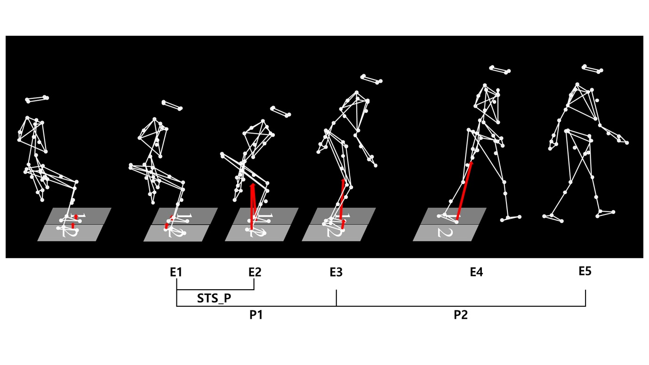
Supplementary Fig. S1. Definition of events and phases. Event 1 (E1) marks the onset of forward movement of the C7 marker. Event 2 (E2) is the time at which the anteroposterior ground reaction force peaks during seat-off, when the buttocks lift from the chair. Event 3 (E3) corresponds to heel-off of the first stepping foot. Event 4 (E4) is the heel-strike of the first stepping foot. Event 5 (E5) is the second heel-strike of the opposite limb, marking the completion of the second step. The analysis intervals are defined as: the sit-to-stand phase from E1 to E2 (STS_P), the first interval from E1 to E3 (P1), and the second interval from E3 to E5 (P2).

