Supplemental Information to

Low-resolution FAIMS for increased peptide coverage in low-load and single-cell proteomics
Dominic G. Hoch^{1,*}, Michael Belford², Lilian R. Heil², Karl Mechtler^{,3,4,5 §}, Manuel Matzinger^{3,*,§}
¹ Thermo Fisher Scientific, Reinach, Switzerland.
² Research Institute of Molecular Pathology (IMP), Vienna BioCenter (VBC), Vienna, Austria
³ Gregor Mendel Institute of Molecular Plant Biology (GMI), Austrian Academy of Sciences, Vienna BioCenter (VBC), Vienna, Austria.
⁴ Institute of Molecular Biotechnology (IMBA), Austrian Academy of Sciences, Vienna BioCenter (VBC), Vienna, Austria.
* These authors contributed equally
§ Correspondence to: karl.mechtler@imp.ac.at, manuel.matzinger@imp.ac.at

Contents
Supplemental Figure 1: LC peak total ion count 2
Supplemental Figure 2: Temperature stability of inner and outer electrode 2
Supplemental Figure 3: Precursor charge distribution 3
Supplemental Figure 4: Overlap of quantified peptides and proteins from 250 pg HeLa upon altered FAIMS resolution 4
Supplemental Figure 5: Overlap of quantified peptides and proteins from single H460 cells upon altered FAIMS resolution 4
Supplemental Table 1: LC gradient details 5

Supplemental Tables and Figures
Supplemental Figure 1: LC peak total ion count. Box plot of the LC peak total fragment ion counts of a 250pg HeLa run with standard (left) and low-resolution (right) FAIMS setting. For statistical comparison an unpaired two tailed students t-test was performed, with *** for p<0.001,

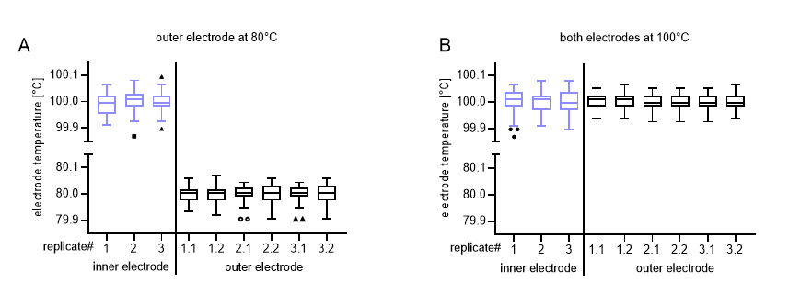
Supplemental Figure 2: Temperature stability of inner and outer electrode. (A) Low-resolution mode with the outer electrode temperature set to 80°C. (B) Standard resolution mode. Each boxplot shows the temperature distribution of each electrode during an entire 80SPD run. Temperature of the outer electrode is measured at two points in the FAIMS electrode assembly, yielding double the datapoints compared to the inner electrode temperature measurements (specified as x.1 and x.2).

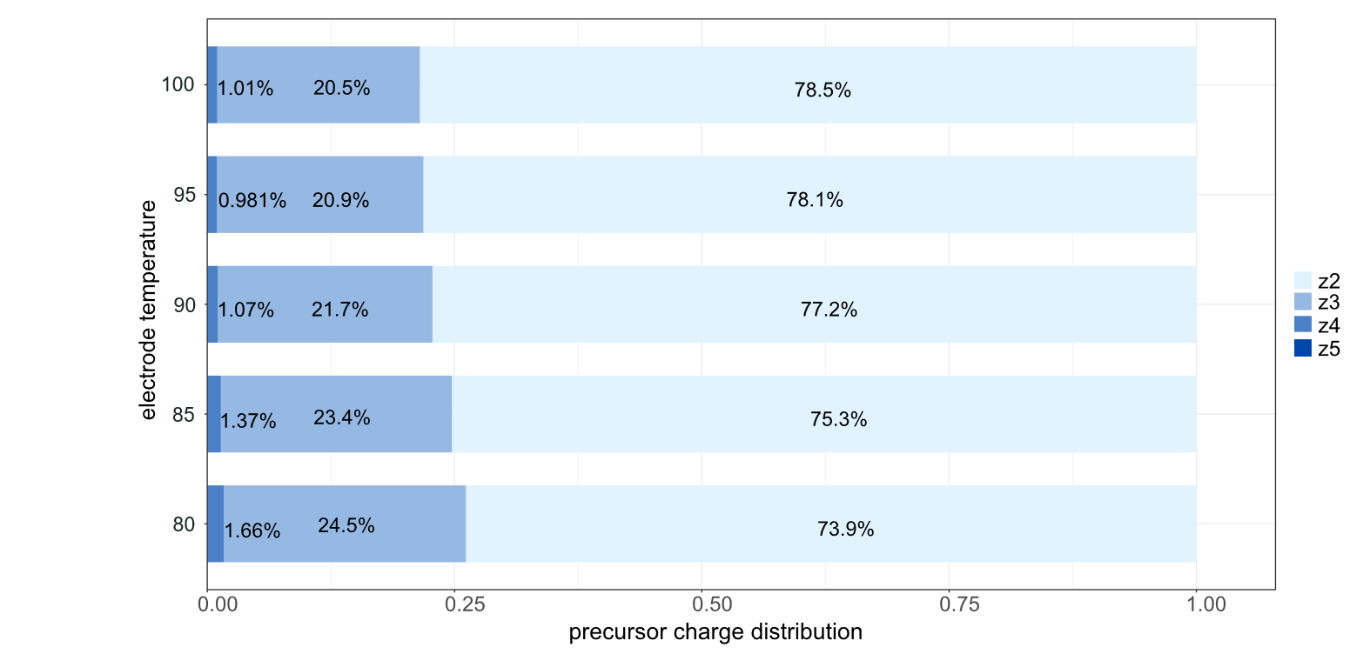
Supplemental Figure 3: Precursor charge distribution in dependence of FAIMS resolution. Barchart shows the charge distribution of identified precursors, data from Figure 2 from 250 pg HeLa recorded with an outer electrode temperature of 100 -80°C. Precursors of higher charges of z>3 were present as given in the legend but at <0.1% prevalence, which is why they are not displayed in the plots due to limited space.

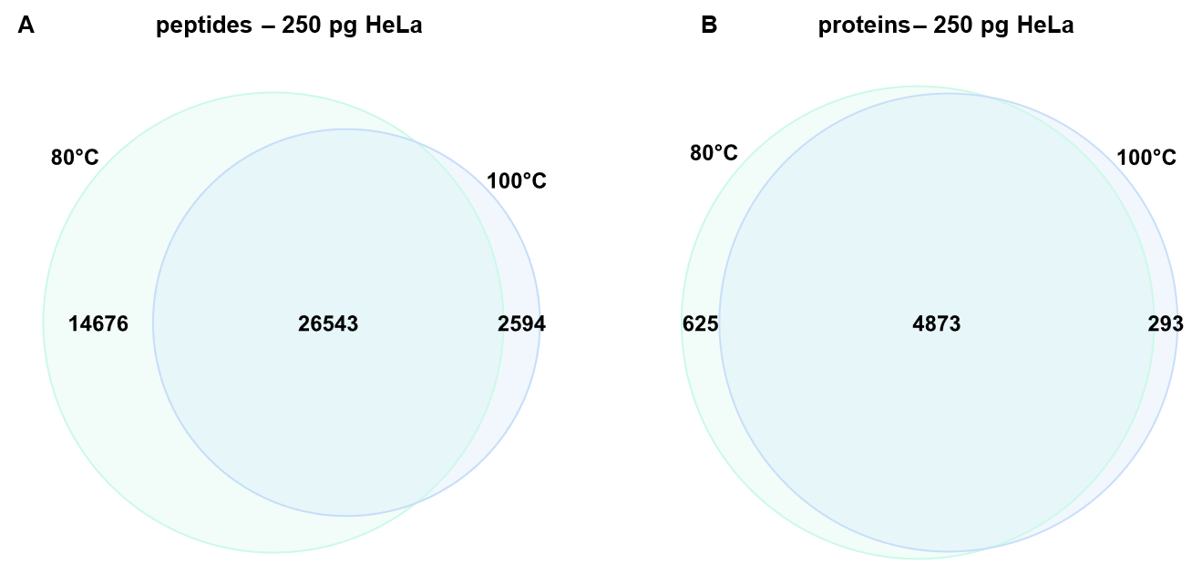
Supplemental Figure 4: Overlap of quantified peptides and proteins from 250 pg HeLa upon altered FAIMS resolution. Venn diagrams show the number of quantified peptides (A) and proteins (B) from 250 pg HeLa recorded at an isolation window of m/z 10 and a maximum injection time of 10 ms at the indicated outer electrode temperature combined from n=3 replicates, data from Figure 3,4.

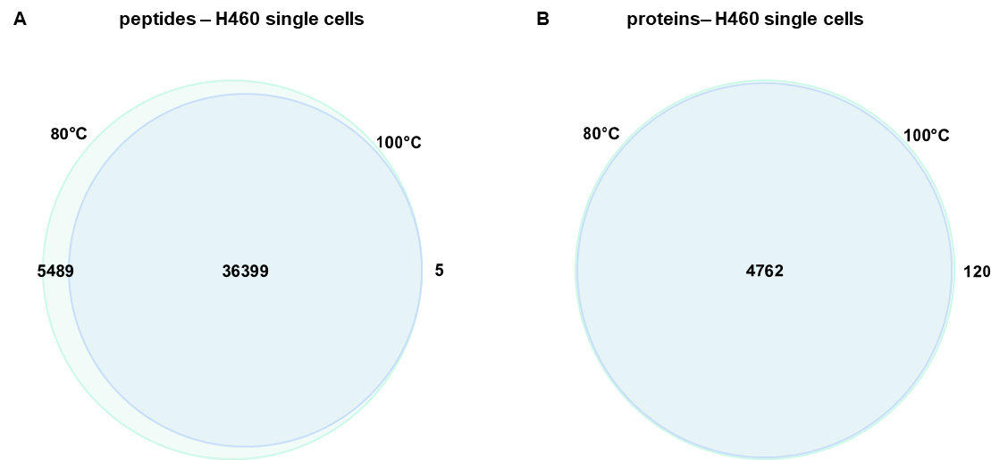
Supplemental Figure 5: Overlap of quantified peptides and proteins from single H460 cells upon altered FAIMS resolution. Venn diagrams show the number of quantified peptides (A) and proteins (B) at the indicated outer electrode temperature combined from n=14 cells each, data from Figure 5.

Supplemental Table 1: LC gradient details
 | 50 SPD |  | 80 SPD
time [min] | flow [nl/min] | % buffer B | flow [nl/min] | % buffer B
0 | 450 | 1 | 1000 | 6
0.1 | 450 | 4 | - | -
0.5 | - | - | 1000 | 10
1.0 | - | - | 250 | 12
1.9 | 450 | 12 | - | -
2 | 200 | - | - | -
10.5 | - | - | 250 | 37
12 | 200 | 22.5 | - | -
12.5 | - | - | 250 | 56
13 | - | - | 1000 | 99
14 | - | - | 1000 | 99
19.5 | 200 | 40 | - | -
20 | - | - | - | -
22 | 300 | 99 | - | -
25 | 300 | 99 | - | -

