Table S1: PROCHECK plot and statistics analysis of receptors models
protein | PROCHECK plot | PROCHECK statistics
protein | PROCHECK plot | Most favored regions% | Additional Allowed regions% | Generously allowed regions% | Disallowed regions%
acetylcholine esterase | 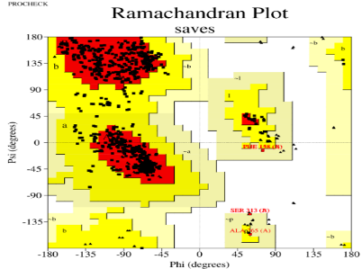 | 89.5% | 10 | 0.5% | 0.0
sodium channel protein | 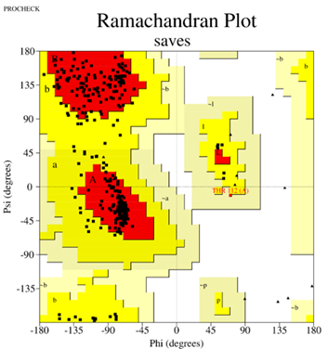 | 82.8%, | 14.8 | 2.1% | 0.3
Glutamate-gated chloride channel receptors | 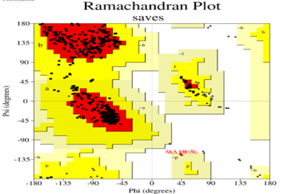 | 82.1% | 17.6 | 0.3% | 0.0

Table S2: Molecular interactions of Emamectin benzoate with the active-site residues of target protein receptor
Docking characters | acetylcholine esterase | sodium channel receptors | Glutamate-gated chloride channel receptors
interaction affinity score (kcal/mol), RMSD (Å) | - 9.8, 1.5 | -8.5, 1.3 | -6.8, 1.3
Interactions other than hydrogen bond | Alkyl, Pi-Alkyl, attractive charge, and caron hydrogen bond | Alkyl, attractive charge, and caron hydrogen | Alkyl, Pi-Alkyl, and caron hydrogen
Amino acids involved in hydrogen bonds: distance | Gly 231: 2.09  TRP 446: 2.11 | ASP 1840: 2.04  ASP 1847: 1.8  ASN 595: 3.07 | GLN 253: 2.3  TYR 249: 2.9

