Supplementary Information

Tobacco smoke but not e-cigarette vapor induces epithelial barrier disruption, inflammation, and DNA damage in human Calu-3 cells

Bernd Mayer¹, Alexander Kollau¹, Wolfgang Kappaun¹, Katrin Rauchegger¹, Gerald Wölkart¹, Alexander Toedtling¹, and Astrid Schrammel^{1*}

¹Department of Pharmacology and Toxicology, Institute of Pharmaceutical Sciences,
University of Graz, Humboldtstraße 46, A-8010 Graz, Austria

Table of contents
Supplementary materials and methods……………………………………….……………2
Supplementary figures ……………………………………………………...……………..4

Figure S1: Experimental setup: (a) Cells were challenged with aerosol extracts in a non-confluent state (2,5 x10⁵ cells per well) and analyzed daily from day 2 to day 7. (b) Confluent Calu-3 cells (TEER >1500 Ω*cm²) were incubated in the absence and presence of aerosol extracts for up to 48 h. Samples were analyzed at indicated timepoints (6, 12, 24, and 48 h). (c) Confluent Calu-3 cells were incubated in the absence and presence of aerosol extracts. After 48 h, IL-4 was added to distinct samples (for induction of hyperpermeability of the barrier) and cells were further incubated for 24 h. Then, cells were analyzed functionally (TEER, FITC-dextran assay) or harvested for biochemical analysis.

PRIMARY ANTIBODIES
Antibody | Dilution | Company | Catalogue #
Claudin-1 | 1:1000 (WB)  1:200 (IHC) | Cell Signaling | 13255
Occludin | 1:1000 | Santa Cruz | 133256
E-Cadherin | 1:1000 | Cell Signaling | 3195
ß-actin | 1:200000 | Sigma | P1978
SECONDARY ANTIBODIES
Antibody | Dilution | Company | Catalogue #
Anti-mouse | 1:5000 | Cell Signaling | 7076
Anti-rabbit | 1:5000 | Cell Signaling | 7074
Anti-rabbit | 1:200 | Invitrogen | A11008

Table 1: List of antibodies (targets in alphabetical order)

Claudin-1 | fw | 5’ CCGGCGACAACATCGTGAC 3’
Claudin-1 | rev | 5’ CGGGTTGCTTGCAATGTGC 3’
Occludin | fw | 5’ TGCATGTTCGACCAATGC 3’
Occludin | rev | 5’ AAGCCACTTCCTCCATAAGG 3’
E-cadherin | fw | 5’ GAAGGTGACAGAGCCTCTGGAT 3’
E-cadherin | rev | 5’ GATCGGTTACCGTGATCAAAATC 3’
IL-6 | fw | 5’ ACTCACCTCTTCAGAACGAATTG 3’
IL-6 | rev | 5’ CCATCTTTGGAAGGTTCAGGTTG 3’
Cyclophilin D | fw | 5’ CAAGCATGATCGGGAGGGTT 3‘
Cyclophilin D | rev | 5’ TGTCGCCAGAGCCATCTTTT 3

Table 2: List of primers (targets in alphabetical order)

Figure S2: Time-dependent formation of the epithelial barrier monitored as increase of TEER under control conditions.

Figure S3: Effects of aerosol extracts on total cellular protein (protocol a).
Figure S4: Effects of aerosol extracts on proliferation of Calu-3 cells (protocol a).
Uncropped representative Westernblots

—20 kDa

Figure S5: Uncropped Western blot of claudin-1 expression.
Area that is outlined in blue is shown in the upper panel of Fig. 2g.

—65 kDa

Figure S6: Uncropped Western blot of occludin expression.
Area that is outlined in blue is shown in the upper panel of Fig. 2h.

—135 kDa

Figure S7: Uncropped Western blot of E-cadherin expression.
Area that is outlined in blue is shown in the upper panel of Fig.2i.

—45 kDa

Figure S8: Uncropped Western blot of β-actin expression. Area that is outlined
in blue is shown in the lower panel of Fig. 2g, 2h, and 2i. Note, that all targets were
detected on the same representative blot; thus, the loading control (β-actin)
is identical in Fig. 2g, 2h, and 2i.

—20 kDa

Figure S9a: Uncropped Western blot of claudin-1 expression.
Area that is outlined in blue is shown in the upper panel of Fig. 4c.

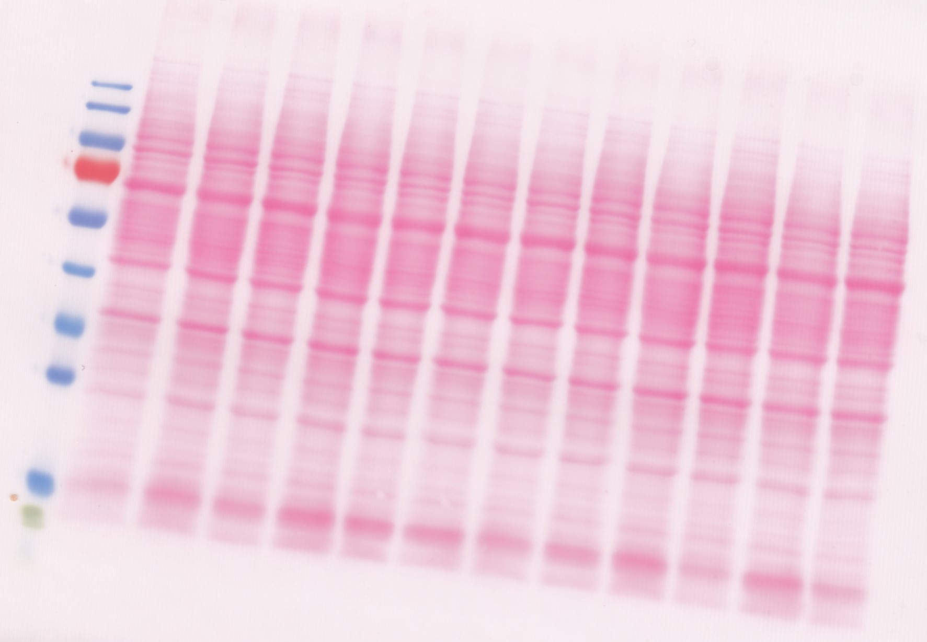

Figure S9b: Uncropped Ponceau S-stained membrane used for
detection of claudin-1 expression. (Figure S9a).

—20 kDa

Figure S10a: Uncropped Western blot of claudin-1 expression.
Area that is outlined in blue is shown in the middle panel of Fig. 4c.

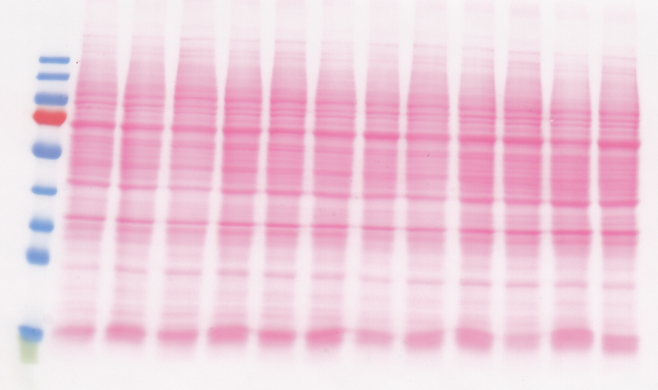

Figure S10b: Uncropped Ponceau S-stained membrane used for
detection of claudin-1 expression. (Figure S10a) Of note, the same
membrane was used for blots shown in Figures S12a and S13a.

—20 kDa

Figure S11a: Uncropped Western blot of claudin-1 expression.
Area that is outlined in blue is shown in the lower panel of Fig. 4c.

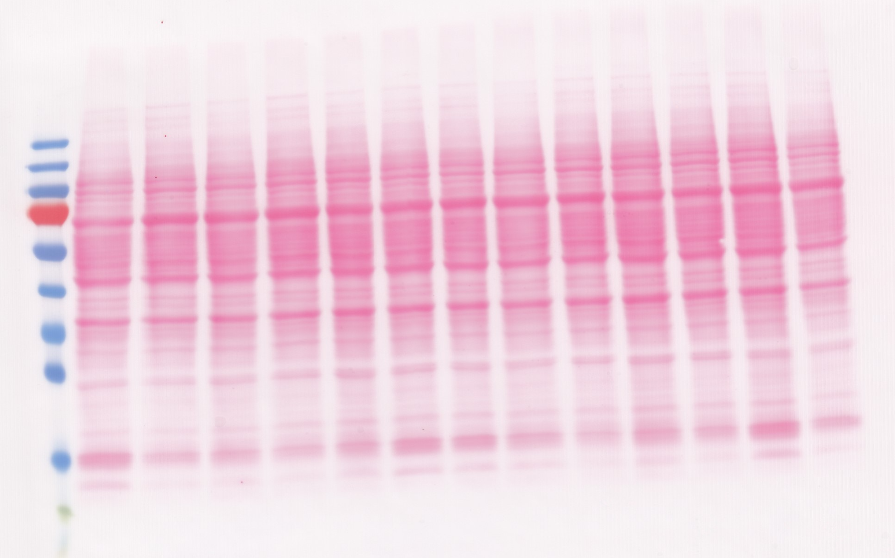

Figure S11b: Uncropped Ponceau S-stained membrane used for
detection of claudin-1 expression. (Figure S11a).

—65 kDa

Figure S12a: Uncropped Western blot of occludin expression.
Area that is outlined in blue is shown in the upper panel of Fig. 4f.

Figure S12b: Uncropped Ponceau S-stained membrane used for
detection occludin expression (Figure S12a). Of note, the same membrane
was used for blots shown in Figures S10a and S13a.

—65 kDa

Figure S13a: Uncropped Western blot of occludin expression.
Area that is outlined in blue is shown in the middle panel of Fig. 4f.

Figure S13b: Uncropped Ponceau S-stained membrane used for
detection occludin expression (Figure S13a). Of note, the same membrane
was used for blots shown in Figures S10a and S12a.

—65 kDa

Figure S14a: Uncropped Western blot of occludin expression.
Area that is outlined in blue is shown in the lower panel of Fig. 4f.

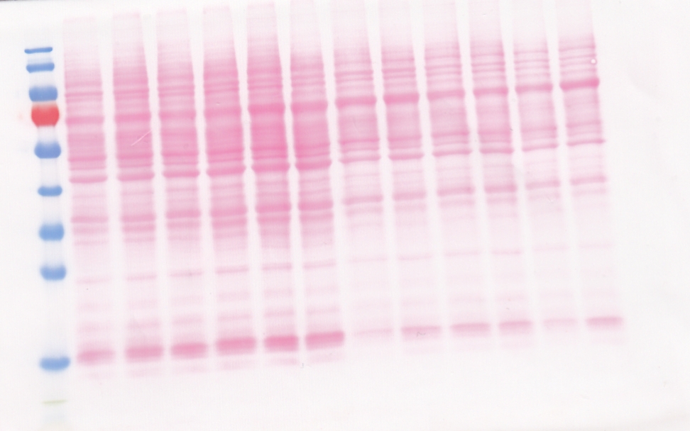

Figure S14b: Uncropped Ponceau S-stained membrane used for
detection of occludin expression. (Figure S14a).

—135 kDa

Figure S15a: Uncropped Western blot of E-cadherin expression.
Area that is outlined in blue is shown in the upper panel of Fig. 4i.

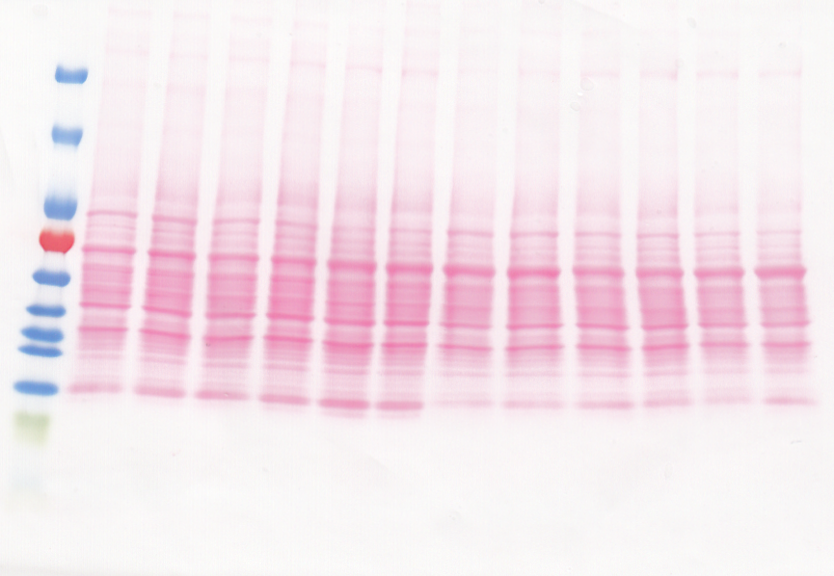

Figure S15b: Uncropped Ponceau S-stained membrane used for
detection of E-cadherin expression. (Figure S15a).

—135 kDa

Figure S16a: Uncropped Western blot of E-cadherin expression.
Area that is outlined in blue is shown in the middle panel of Fig. 4i.

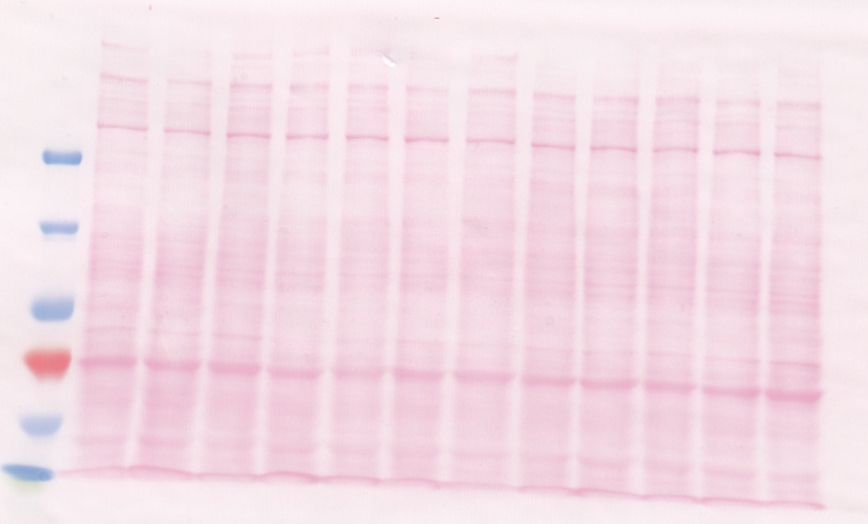

Figure S16b: Uncropped Ponceau S-stained membrane used for
detection of E-cadherin expression. (Figure S16a).

—135 kDa

Figure S17a: Uncropped Western blot of E-cadherin expression.
Area that is outlined in blue is shown in the lower panel of Fig. 4i.

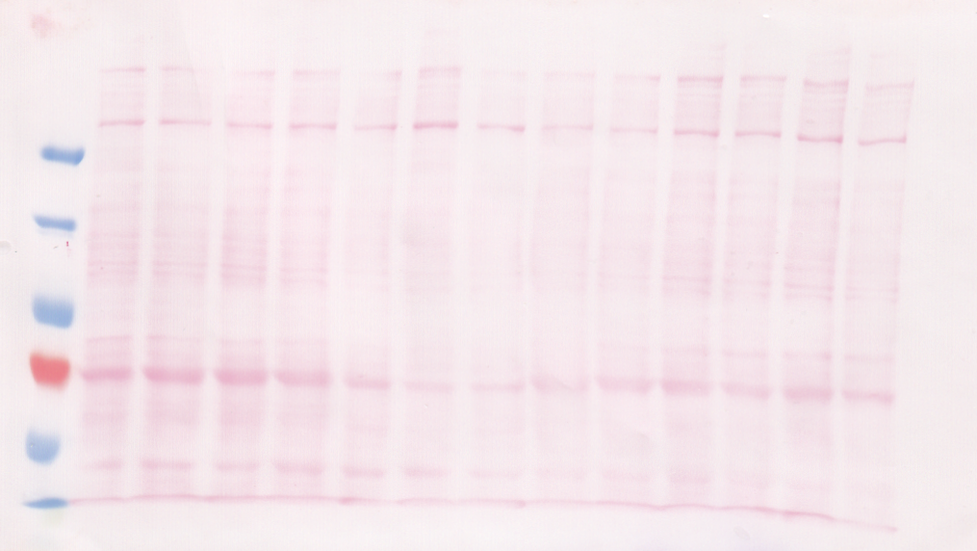

Figure S17b: Uncropped Ponceau S-stained membrane used for
detection of E-cadherin expression. (Figure S17a).

