Associations between per- and polyfluoroalkyl substances (PFAS), DNA methylation and gene expression from background exposed Norwegian women (2003-2006)

Ana Carolina M F Coêlho¹, Torkjel M Sandanger^{1,2}, Dorte Herzke^{2,3}, Charlotta Rylander¹, Vivian Berg^{4,5}, Therese Haugdahl Nøst^{1,6}

¹ Department of Community Medicine, Faculty of Health Sciences, UiT The Arctic University of Norway, Tromsø, Norway
² NILU, Tromsø, Norway
³ Norwegian Institute for Public Health, Oslo, Norway
⁴ Department of Laboratory Medicine, University Hospital of North Norway, Tromsø, Norway
⁵ Department of Medical Biology, Faculty of Health Sciences, UiT The Arctic University of Norway, Tromsø, Norway
⁶ Department of Public Health and Nursing, Norwegian University of Science and Technology, Trondheim, Norway

* Corresponding author: therese.h.nost@uit.no

Table S1. Plasma PFAS concentrations (ng/mL) among study participants (n=269).
PFAS | Median [P5, P95] | LOD | %DR
PFCA
PFBA | <LOD [<LOD, <LOD] | 0.47 | 1.9
PFHpA | <LOD [<LOD, 0.14] | 0.06 | 37.9
PFOA | 2.93 [1.40, 5.45] | 0.13 | 100
PFNA | 0.65 [0.35, 1.15] | 0.24 | 98.9
PFDA | 0.21 [<LOD, 0.67] | 0.02 | 52.4
PFUnDA | 0.37 [0.13, 0.83] | 0.02 | 99.6
PFDoDA | 0.04 [0.13, 0.13] | 0.02 | 60.6
PFTrDA | <LOD [<LOD ¸0.17] | 0.07 | 31.2
PFSA
PFBS | <LOD [<LOD, 0.1] | 0.04 | 28.2
PFPS | <LOD [<LOD, <LOD] | 0.07 | 1.9
PFHxS | 1.04 [0.40, 2.25] | 0.11 | 100
PFHpS | 0.27 [0.07, 0.65] | 0.03 | 98.1
PFOS | 11.49 [5.21, 24] | 0.02 | 100
br-PFOS | 8.15 [3.32, 16.27] | 0.26 | 100
PFNS | <LOD [<LOD, 0.46] | 0.04 | 17.1
PFDS | <LOD [<LOD, 0.12] | 0.05 | 16
FOSA
PFOSA | <LOD [<LOD, <LOD] | 0.06 | 0.37
FTSA
4:2 FTS | <LOD [<LOD, <LOD] | 0.06 | 0
6:2 FTS | <LOD [<LOD, <LOD] | 0.06 | 0.37
8:2 FTS | <LOD [<LOD, 0.1] | 0.06 | 5.6

The grey shading indicates the PFAS compounds included in statistical analyses. Abbreviations: P: percentile; LOD: limit of detection; DR: detection rate; PFCA: perfluoroalkyl carboxylic acids; PFSA: perfluoroalkyl sulfonic acids; PFOSA: perfluorooctane sulfonamide; FTSA: fluorotelomer sulfonic acids.

Table S2. Top 20 CpG sites showing methylation changes associated with PFOA concentrations*.
CpG | Chr | Position | CpG location | Genes | Gene region | logFC | p-value | q-value
cg10724632 | 2 | 3675155 | OpenSea | COLEC11 | Body | -0.16 | 0.00001 | 0.99
cg03108697 | 11 | 9732066 | OpenSea | SWAP70 | Body | 0.02 | 0.00002 | 0.99
cg03134285 | 1 | 67836673 | OpenSea | IL12RB2 | Body | 0.01 | 0.00003 | 0.99
cg16359034 | 16 | 2795664 | OpenSea | LOC100128788 | Body | 0.02 | 0.00003 | 0.99
cg01458752 | 11 | 8008673 | N_Shore | EIF3F | TSS200 | -0.01 | 0.00003 | 0.99
cg04011925 | 8 | 106671637 | OpenSea | ZFPM2 | Body | 0.02 | 0.00003 | 0.99
cg10367244 | 15 | 96865032 | Island | - | - | 0.01 | 0.00004 | 0.99
cg21879272 | 14 | 51135303 | Island | SAV1 | TSS1500 | -0.06 | 0.00004 | 0.99
cg14442557 | 11 | 82909565 | S_Shelf | ANKRD42 | Body | 0.01 | 0.00005 | 0.99
cg23173910 | 2 | 74120274 | OpenSea | ACTG2 | 5'UTR | 0.02 | 0.00005 | 0.99
cg00923678 | 6 | 29581105 | OpenSea | GABBR1 | Body; | 0.01 | 0.00005 | 0.99
cg10857398 | 6 | 31598445 | N_Shore | BAT2 | Body | 0.01 | 0.00005 | 0.99
cg11815438 | 6 | 32023283 | OpenSea | TNXB | Body | 0.01 | 0.00006 | 0.99
cg17476271 | 11 | 128562408 | N_Shore | FLI1 | TSS1500 | -0.02 | 0.00006 | 0.99
cg23434654 | 5 | 121648409 | Island | SNCAIP | 5'UTR | -0.01 | 0.00006 | 0.99
cg23831517 | 8 | 34182528 | OpenSea | - | - | 0.04 | 0.00008 | 0.99
cg04683824 | 16 | 34293670 | N_Shore | - | - | 0.04 | 0.00008 | 0.99
cg03975690 | 7 | 87848292 | N_Shore | SRI | Body | -0.01 | 0.00008 | 0.99
cg19202384 | 17 | 79894511 | N_Shore | PYCR1 | Body | -0.02 | 0.00008 | 0.99
cg25395505 | 7 | 97877765 | N_Shelf | TECPR1 | 5'UTR | 0.02 | 0.00008 | 0.99
Abbreviations: Chr, chromosome; FC, fold change; q-value, False discovery rate (FDR)-adjusted p-value using the Benjamini-Hochberg method.
Notes: The CpG sites were ranked in ascending order based on their unadjusted p-value (*); ¹The models were adjusted for age, BMI and estimated cell proportions.

Table S3. Top 20 CpG sites showing methylation changes associated with PFNA concentrations*.
CpG | Chr | Position | CpG location | Genes | Gene region | logFC | p-value | q-value
cg15096505 | 1 | 206943566 | OpenSea | IL10 | Body | -0.02 | 0.00001 | 0.99
cg26825848 | 4 | 190566175 | N_Shore | - | - | -0.01 | 0.00002 | 0.99
cg06390077 | 7 | 141385142 | OpenSea | KIAA1147 | Body | -0.01 | 0.00003 | 0.99
cg01710886 | 4 | 2819707 | Island | SH3BP2 | TSS1500 | -0.04 | 0.00003 | 0.99
cg23067082 | 12 | 7073179 | OpenSea | MIR141 | TSS200 | 0.01 | 0.00003 | 0.99
cg01824791 | 3 | 12875605 | OpenSea | CAND2 | 3'UTR | -0.01 | 0.00004 | 0.99
cg18151425 | 2 | 69093574 | OpenSea | BMP10 | Body | 0.02 | 0.00004 | 0.99
cg08136432 | 16 | 88902276 | Island | GALNS | Body | -0.20 | 0.00005 | 0.99
cg02951765 | 16 | 65341412 | OpenSea | LOC283867 | Body | 0.04 | 0.00005 | 0.99
cg01448551 | 6 | 32798482 | OpenSea | TAP2 | Body | -0.01 | 0.00005 | 0.99
cg05641650 | 11 | 35693836 | OpenSea | TRIM44 | Body | -0.01 | 0.00006 | 0.99
cg20985635 | 5 | 132947278 | Island | FSTL4 | 5'UTR | -0.01 | 0.00006 | 0.99
cg19315508 | 1 | 149899669 | Island | SF3B4 | 1stExon | 0.01 | 0.00006 | 0.99
cg02445292 | 19 | 40417583 | N_Shelf | FCGBP | Body | -0.01 | 0.00007 | 0.99
cg05014837 | 2 | 135059316 | OpenSea | MGAT5 | Body | -0.01 | 0.00007 | 0.99
cg14388195 | 17 | 1546961 | Island | SCARF1 | Body | 0.01 | 0.00008 | 0.99
cg13350173 | 19 | 38281183 | Island | - | - | -0.04 | 0.00008 | 0.99
cg01614041 | 6 | 34123414 | S_Shore | - | - | -0.05 | 0.00008 | 0.99
cg27455890 | 10 | 118976677 | Island | - | - | -0.04 | 0.00008 | 0.99
cg20269046 | 7 | 149469722 | Island | ZNF467 | 5'UTR | -0.17 | 0.00011 | 0.99
Abbreviations: Chr, chromosome; FC, fold change; q-value, False discovery rate (FDR)-adjusted p-value using the Benjamini-Hochberg method.
Notes: The CpG sites were ranked in ascending order based on their unadjusted p-value (*); ¹The models were adjusted for age, BMI and estimated cell proportions.

Table S4. Top 20 CpG sites showing methylation changes associated with PFHxS concentrations*.
CpG | Chr | Position | CpG location | Genes | Gene region | logFC | p-value | q-value
cg21879272 | 14 | 51135303 | Island | SAV1 | TSS1500 | -0.05 | 0.00000 | 0.21
cg19700328 | 14 | 106028568 | S_Shelf |  |  | -0.08 | 0.00000 | 0.44
cg01458752 | 11 | 8008673 | N_Shore | EIF3F | TSS200 | -0.01 | 0.00000 | 0.44
cg05228110 | 19 | 552948 | S_Shore |  |  | -0.02 | 0.00000 | 0.49
cg10140583 | 8 | 143868110 | OpenSea | LY6D | TSS200 | -0.02 | 0.00003 | 0.99
cg25435332 | 11 | 107328525 | Island | CWF19L2 | 1stExon | -0.02 | 0.00003 | 0.99
cg11791914 | 1 | 4772257 | Island | AJAP1 | Body | -0.01 | 0.00003 | 0.99
cg01035869 | 6 | 31242584 | S_Shelf |  |  | -0.02 | 0.00003 | 0.99
cg00046623 | 8 | 52320263 | N_Shore | PXDNL | Body | 0.01 | 0.00004 | 0.99
cg20166438 | 1 | 110091162 | Island | GNAI3 | TSS200 | -0.003 | 0.00004 | 0.99
cg10437839 | 11 | 64701910 | OpenSea | PPP2R5B | 3'UTR | 0.01 | 0.00005 | 0.99
cg05318026 | 18 | 45936057 | Island |  |  | -0.01 | 0.00005 | 0.99
cg12529083 | 12 | 13197360 | Island | KIAA1467 | 1stExon | -0.005 | 0.00006 | 0.99
cg25424279 | 11 | 65683543 | N_Shore |  |  | -0.01 | 0.00006 | 0.99
cg03975690 | 7 | 87848292 | N_Shore | SRI | Body;Body | -0.01 | 0.00006 | 0.99
cg23173910 | 2 | 74120274 | OpenSea | ACTG2 | 5'UTR | 0.02 | 0.00006 | 0.99
cg09002231 | 13 | 46036179 | N_Shelf |  |  | -0.01 | 0.00006 | 0.99
cg11403706 | 22 | 49042600 | Island | FAM19A5 | Body;Body | -0.01 | 0.00006 | 0.99
cg12602945 | 19 | 49541529 | OpenSea | CGB1 | TSS1500 | -0.03 | 0.00007 | 0.99
cg16553052 | 7 | 2349605 | OpenSea | SNX8 | Body | -0.01 | 0.00007 | 0.99
Abbreviations: Chr, chromosome; FC, fold change; q-value, False discovery rate (FDR)-adjusted p-value using the Benjamini-Hochberg method.
Notes: The CpG sites were ranked in ascending order based on their unadjusted p-value (*); ¹The models were adjusted for age, BMI and estimated cell proportions.

Table S5. Top 20 CpG sites showing methylation changes associated with PFHpS concentrations*.
CpG | Chr | Position | CpG location | Genes | Gene region | logFC | p-value | q-value
cg15932610 | 12 | 108820116 | OpenSea | - | - | 0.01 | <0.00001 | 0.40
cg14883605 | 14 | 57021828 | OpenSea | - | - | 0.02 | <0.00001 | 0.40
cg15063150 | 2 | 239133353 | OpenSea | - | - | 0.01 | <0.00001 | 0.40
cg06311795 | 12 | 130818957 | N_Shelf | - | - | -0.01 | <0.00001 | 0.45
cg04303139 | 7 | 94286753 | S_Shore | SGCE;PEG10 | TSS1500;5'UTR | -0.01 | <0.00001 | 0.45
cg22663489 | 11 | 64107720 | N_Shelf | CCDC88B | 1stExon | -0.02 | 0.00001 | 0.47
cg01458752 | 11 | 8008673 | N_Shore | EIF3F | TSS200 | -0.01 | 0.00001 | 0.47
cg13396436 | 6 | 32041568 | OpenSea | TNXB | Body | -0.01 | 0.00001 | 0.47
cg20956314 | 3 | 38387299 | N_Shore | XYLB | TSS1500 | 0.01 | 0.00001 | 0.47
cg26503018 | 7 | 94286243 | Island | SGCE;PEG10 | TSS1500;5'UTR | -0.01 | 0.00001 | 0.47
cg05819416 | 1 | 214140498 | OpenSea |  |  | 0.01 | 0.00001 | 0.47
cg20055841 | 14 | 52780919 | Island | PTGER2 | TSS200 | -0.003 | 0.00002 | 0.47
cg11819121 | 21 | 37664031 | N_Shelf | DOPEY2 | Body | 0.01 | 0.00002 | 0.47
cg18086592 | 12 | 13153464 | Island | HTR7P;HEBP1 | Body;TSS1500 | -0.01 | 0.00002 | 0.47
cg22626548 | 5 | 2253129 | OpenSea |  |  | 0.01 | 0.00002 | 0.47
cg08270005 | 8 | 96179452 | OpenSea |  |  | 0.01 | 0.00002 | 0.47
cg21160562 | 4 | 183308763 | OpenSea | ODZ3 | Body | -0.01 | 0.00002 | 0.47
cg21039597 | 4 | 1005035 | Island | FGFRL1 | TSS1500 | 0.004 | 0.00002 | 0.47
cg01683270 | 4 | 8136996 | OpenSea | ABLIM2 | Body | 0.01 | 0.00002 | 0.47
cg27366072 | 12 | 12222913 | OpenSea | BCL2L14 | TSS1500 | 0.01 | 0.00002 | 0.47
Abbreviations: Chr, chromosome; FC, fold change; q-value, False discovery rate (FDR)-adjusted p-value using the Benjamini-Hochberg method.
Notes: The CpG sites were ranked in ascending order based on their unadjusted p-value (*); ¹The models were adjusted for age, BMI and estimated cell proportions.

Table S6. Top 20 CpG sites showing methylation changes associated with PFOS concentrations*.
CpG | Chr | Position | CpG location | Genes | Gene region | logFC | p-value | q-value
cg23121615 | 8 | 144176359 | OpenSea |  |  | -0.04 | <0.000001 | 0.60
cg23773680 | X | 8433466 | OpenSea | VCX3B | 5'UTR | -0.01 | <0.000001 | 0.60
cg02187988 | 7 | 138677596 | OpenSea |  |  | 0.01 | 0.00001 | 0.72
cg06605704 | 16 | 4551147 | OpenSea | HMOX2 | 5'UTR | 0.01 | 0.00001 | 0.72
cg26027442 | 14 | 104580345 | N_Shelf |  |  | -0.02 | 0.00001 | 0.72
cg16498741 | 8 | 41144520 | OpenSea | SFRP1 | Body | 0.01 | 0.00001 | 0.72
cg27127645 | 14 | 55220956 | OpenSea | SAMD4A | TSS1500 | 0.01 | 0.00001 | 0.72
cg09938674 | 8 | 1534838 | OpenSea | DLGAP2 | Body | -0.01 | 0.00002 | 0.72
cg18686270 | 3 | 146258875 | N_Shelf | PLSCR1 | 5'UTR | 0.03 | 0.00002 | 0.72
cg23796578 | 17 | 9694472 | OpenSea | DHRS7C | 1stExon | -0.02 | 0.00002 | 0.72
cg21446955 | 4 | 86851425 | OpenSea | ARHGAP24 | 5'UTR | -0.01 | 0.00002 | 0.72
cg21452281 | 4 | 189203965 | Island |  |  | -0.02 | 0.00002 | 0.72
cg19602139 | 3 | 49690254 | Island | BSN | Body | 0.01 | 0.00002 | 0.72
cg03094519 | 17 | 37761662 | N_Shore | NEUROD2 | 3'UTR | 0.01 | 0.00002 | 0.72
cg04125962 | 16 | 27476250 | OpenSea | GTF3C1 | Body | -0.02 | 0.00003 | 0.72
cg01008405 | 5 | 139039026 | N_Shore | CXXC5 | 5'UTR | -0.02 | 0.00003 | 0.72
cg08428266 | 7 | 55238412 | OpenSea | EGFR | 3'UTR | 0.02 | 0.00003 | 0.72
cg10331038 | 1 | 175376028 | OpenSea | TNR | 5'UTR | 0.02 | 0.00004 | 0.72
cg05173758 | 13 | 27335096 | Island | GPR12 | TSS200 | -0.01 | 0.00004 | 0.72
cg08610886 | X | 13397207 | Island |  |  | -0.02 | 0.00005 | 0.72
Abbreviations: Chr, chromosome; FC, fold change; q-value, False discovery rate (FDR)-adjusted p-value using the Benjamini-Hochberg method.
Notes: The CpG sites were ranked in ascending order based on their unadjusted p-value (*); ¹The models were adjusted for age, BMI and estimated cell proportions.

Table S7. Top 20 CpG sites showing methylation changes associated with br-PFOS concentrations*.
CpG | Chr | Position | CpG location | Genes | Gene region | logFC | p-value | q-value
cg16498741 | 8 | 41144520 | OpenSea | SFRP1 | Body | 0.01 | <0.000001 | 0.99
cg17945447 | 1 | 42384002 | Island | HIVEP3 | 5'UTR | -0.03 | 0.00001 | 0.99
cg05173758 | 13 | 27335096 | Island | GPR12 | TSS200 | -0.01 | 0.00001 | 0.99
cg07601058 | 1 | 1597720 | N_Shelf | LOC728661;CDK11B | Body;Body | -0.01 | 0.00001 | 0.99
cg23796578 | 17 | 9694472 | OpenSea | DHRS7C | 1stExon | -0.02 | 0.00002 | 0.99
cg01008405 | 5 | 139039026 | N_Shore | CXXC5 | 5'UTR | -0.01 | 0.00002 | 0.99
cg24435669 | 1 | 15546149 | OpenSea | TMEM51 | Body | -0.01 | 0.00002 | 0.99
cg21152269 | 14 | 55519107 | S_Shore | MAPK1IP1L | 5'UTR | -0.01 | 0.00003 | 0.99
cg02187988 | 7 | 138677596 | OpenSea |  |  | 0.01 | 0.00003 | 0.99
cg00489219 | 3 | 40566141 | Island | ZNF621 | TSS1500 | -0.01 | 0.00004 | 0.99
cg23773680 | X | 8433466 | OpenSea | VCX3B | 5'UTR | -0.01 | 0.00005 | 0.99
cg01828650 | 7 | 112430614 | S_Shore | TMEM168 | TSS200 | -0.005 | 0.00005 | 0.99
cg01185921 | 10 | 116444463 | OpenSea | ABLIM1 | TSS200 | -0.02 | 0.00005 | 0.99
cg11518408 | 2 | 242760773 | Island |  |  | -0.02 | 0.00006 | 0.99
cg15635600 | 21 | 45681834 | S_Shelf | DNMT3L | 5'UTR | -0.03 | 0.00006 | 0.99
cg02189800 | 16 | 88597301 | N_Shore | ZFPM1 | Body | 0.03 | 0.00006 | 0.99
cg21011403 | 2 | 43302362 | OpenSea |  |  | 0.01 | 0.00007 | 0.99
cg00405939 | 19 | 4045108 | Island |  |  | 0.01 | 0.00007 | 0.99
cg27127645 | 14 | 55220956 | OpenSea | SAMD4A | TSS1500 | 0.01 | 0.00007 | 0.99
cg07811074 | 2 | 98350847 | N_Shore | ZAP70 | Body | -0.01 | 0.00007 | 0.99
Abbreviations: Chr, chromosome; FC, fold change; q-value, False discovery rate (FDR)-adjusted p-value using the Benjamini-Hochberg method.
Notes: The CpG sites were ranked in ascending order based on their unadjusted p-value (*); ¹The models were adjusted for age, BMI and estimated cell proportions.

Table S8. Sensitivity analyses for evaluating the impact of smoking status on the associations between PFAS exposure and DNA methylation (n = 263).
 | Model 1#  (n = 269) |  |  | Model 2 (Sensitivity)*  (n = 263)
CpG | logFC | p-value | q-value | logFC | p-value | q-value
cg00149684 | 0.01 | 0.00000000004 | 0.00002 | 0.01 | 0.0000000001 | 0.00003
cg26047920 | -0.04 | 0.0000000001 | 0.00003 | -0.04 | 0.0000000001 | 0.00003
cg13623384 | 0.02 | 0.000000009 | 0.0015 | 0.02 | 0.000000008 | 0.001
cg08154280 | -0.01 | 0.00000002 | 0.002 | -0.01 | 0.0000001 | 0.01
cg23834427 | 0.03 | 0.00000002 | 0.002 | 0.03 | 0.00000002 | 0.002
cg15137396 | 0.02 | 0.00000009 | 0.007 | 0.02 | 0. 0.0000003 | 0.02
cg23232361 | 0.01 | 0.0000002 | 0.01 | 0.01 | 0.0000007 | 0.03
cg10296914 | 0.03 | 0.0000002 | 0.01 | 0.03 | 0.0000006 | 0.03
cg18142228 | 0.02 | 0.0000002 | 0.01 | 0.02 | 0.0000001 | 0.01
cg02790122 | 0.01 | 0.0000002 | 0.01 | 0.01 | 0.0000004 | 0.02
cg12165223 | 0.03 | 0.0000003 | 0.01 | 0.03 | 0.000002 | 0.08
cg07885191 | 0.02 | 0.000001 | 0.04 | 0.01 | 0.000007 | 0.14
cg15499402 | -0.01 | 0.000001 | 0.04 | -0.01 | 0.000003 | 0.09
cg23952828 | 0.01 | 0.000001 | 0.04 | 0.01 | 0.000004 | 0.10
cg22254103 | 0.02 | 0.000001 | 0.04 | 0.02 | 0.000002 | 0.06
cg25050332 | 0.03 | 0.000001 | 0.04 | 0.03 | 0.000003 | 0.10
cg02941923 | 0.01 | 0.000001 | 0.04 | 0.01 | 0.000003 | 0.10
cg15511516 | 0.02 | 0.000001 | 0.04 | 0.02 | 0.00003 | 0.30
cg15693793 | -0.03 | 0.000002 | 0.04 | -0.03 | 0.000004 | 0.10
cg02344868 | 0.02 | 0.000002 | 0.04 | 0.02 | 0.000004 | 0.11
cg14468055 | 0.01 | 0.000002 | 0.045 | 0.01 | 0.00003 | 0.30
Abbreviations: FC, fold change; q-value, False discovery rate (FDR)-adjusted p-value using the Benjamini-Hochberg method.
Notes: # Model 1 included age, BMI, and estimated cell proportions as covariates; * Model 2 further included smoking status as covariate.

Table S9. Top 10 enriched GO terms from the nominally significant (p-value < 0.001) and non-FDR-corrected CpG sites associated with PFAS exposure.
GO ID | GO Term | Total number of genes in Term | Number of genes with methylation changes | p-value | q-value | Genes
BP
GO:2000138 | positive regulation of cell proliferation involved in heart morphogenesis | 6 | 5 | 0.0002 | 1 | BMP10, RBPJ, SMAD4, PIM1, SOX9
GO:2000136 | regulation of cell proliferation involved in heart morphogenesis | 18 | 9 | 0.0003 | 1 | BMP10, RBPJ, ISL1, SMAD4, NOTCH1, PIM1, SOX9, TBX5, HAND2
GO:2001222 | regulation of neuron migration | 41 | 15 | 0.0007 | 1 | NRG3, UNC5D, CTNNA2,  DAB2IP, PHACTR1, ZNF609, FLNA, FLRT2, MDK, ULK4, SEMA6A, STAT3, CAMK2B, KIF20, RAPGEF2
GO:0061323 | cell proliferation involved in heart morphogenesis | 19 | 9 | 0.0007 | 1 | BMP10, RBPJ, ISL1, SMAD4, NOTCH1, PIM1, SOX9, TBX5, HAND2
GO:2000617 | positive regulation of histone H3-K9 acetylation | 8 | 5 | 0.001 | 1 | SMAD4, NAP1L2, PIH1D, PIWIL2, BRCA1
GO:0070424 | regulation of nucleotide-binding oligomerization domain containing signaling pathway | 13 | 6 | 0.001 | 1 | SLC15A4, BIRC3, HSPA1B, XIAP, SLC15A2, TLR4
GO:2001224 | positive regulation of neuron migration | 15 | 7 | 0.003 | 1 | DAB2IP, ZNF609, FLNA, MDK, SEMA6A, KIF20B, RAPGEF2
GO:0035019 | somatic stem cell population maintenance | 42 | 14 | 0.004 | 1 | YAP1, CDX2, TAF6L, SIX2, ZHX2, RBPJ, LRP5, SFRP1, SOX9, VPS72, NANOG, LBH, CUL4A, LDB2
GO:0002385 | mucosal immune response | 32 | 7 | 0.004 | 1 | C17orf99, IFNLR1, DEFA4, IFNL2, PIGR, RPL39, RAB17, H2BC12
GO:2000615 | regulation of histone H3-K9 acetylation | 11 | 5 | 0.005 | 1 | SMAD4, NAP1L2, PIH1D1, PIWIL2, BRCA1
MF
GO:0003712 | transcription coregulator activity | 478 | 79 | 0.007 | 1 | CITED2, YAP1, RBM14, DDX17, DRAP1, TAF6L, RBPMS, TRIM31, CTBP1, CTBP2, HDGFL1, ZXDB, DAXX, ZFPM1, WBP2NL, ASXL1, DNMT3A, DNMT3B, DTX1, JMJD1C, SNW1, PHF8, CAMTA1, MED13L, ZFPM2, KAT6B, TCERG1L, SS18L1, SND1, HCFC1, HMGB2, HMGA1, APEX1, IRF4, KMT5A, MECP2, NAB2, RERE, NFKBIB, CNOT2, NOTCH1, PAWR, BCOR, YY1AP1, MAML3, RCOR3, TRERF1, MTA3, PTPN14, RBBP8, CCND1, TRIM27, PRDM16, TFB2M, BRCA1, TACC1, TAF12, TFAP2A, TLE2, TLE3, TP53BP1, TSG101, BTG2, ZXDC, NCOA4, HMGA2, DPF3, ARID5B, MPND, CBX4, PIR, CBFA2T3, HYAL2, ACTN1, ACTN2, PER2, BUD31, LDB2, COPS2, LPXN, CDYL, RNF14, NCOR2, HDAC4
GO:0004957 | prostaglandin E receptor activity | 5 | 3 | 0.008 | 1 | HPGD, PTGER1, PTGER2
GO:0035259 | glucocorticoid receptor binding | 14 | 6 | 0.009 | 1 | GRIP1, NR4A2, STAT3, STAT5B, TACC1, NCOR2
GO:0042975 | peroxisome proliferator activated receptor binding | 12 | 5 | 0.009 | 1 | ASXL1, HMGA1, MDM2, NFATC4, TACC1
GO:0003779 | actin binding | 436 | 78 | 0.01 | 1 | MAEA, CAP2, SORBS1, GIPC1, IQGAP2, WASF3, FERMT2, FGD4, PACRG, MIB2, CTNNA2, PPP1R18, EEF2, EGFR, EPB41L2, DMTN, PHACTR1, ALDOA, DAAM1, PALLD, FLNA, MPRIP, FLNB, DAAM2, CORO1C, RUSC1, PANX1, FSCN2, RAI14, ABL2, FHOD1, TMOD2, WASH3P, KCNMA1, ABLIM1, MYBPC1, MYH9, MYL2, MYO9B, MYO10, PAWR, LIMA1, PLEC, SNTG1, SSH1, ANLN, INO80, EPS8L1, IMPACT, BAIAP2L1, FMN2, SPIRE1, CORO1B, PTK2, SHROOM3, KLHL1, AFAP1, MYO1G, SLC6A2, PHACTR4, DST, SVIL, TNNI2, UTRN, WIPF1, CORO7, MYH14, FHOD3, CAMK2B, CAPZA2, CAPZB, ANTXR1, ABLIM2, SCIN, ACTN1, ACTN2, IQGAP1, ACTN3, NEXN, MYOT
GO:0008510 | sodium:bicarbonate symporter activity | 6 | 3 | 0.01 | 1 | SLC4A10, SLC4A4, SLC4A7
GO:0140078 | class I DNA-(apurinic or apyrimidinic site) endonuclease activity | 7 | 3 | 0.02 | 1 | NEIL2, NTHL1, NEIL3
GO:0003906 | DNA-(apurinic or apyrimidinic site) endonuclease activity | 12 | 4 | 0.02 | 1 | NEIL2, APEX1, NTHL1, NEIL3, HMGA2
GO:0030145 | manganese ion binding | 63 | 13 | 0.02 | 1 | NUDT16, XXYLT1, ATP13A2, GALNT2, ABL2, GLUL, GYG1, MGAT5, PIM1, FAM20C, XYLT2, MPPE1, XPNPEP1
GO:0019787 | ubiquitin-like protein transferase activity | 445 | 65 | 0.02 | 1 | RNF41, MAEA, RBCK1, RFPL2, WWP1, UBE2C, TRIM31, MARCHF3, TRIM71, UBE2QL1, TRIM50, MIB2, RNF168, DTX1, TRIML2, LNX2, HECW1, FBXW11, MGRN1, TRIM2, NEDD4L, LTN1, FBXO24, FBXO3, FBXL22, RNF175, RNF180, UHRF1, BIRC3, XIAP, NCCRP1, MDM2, TRIM72, RNF165, NOSIP, TRIM17, ANKRD39, UFC1, PEX12, MARCHF5, TRIM44, BCOR, ATG16L1, RNF220, TRIM36, UBE2Q1, PELI1, RNF150, RNF213, TRIM27, BRCA1, PPP1R11, TRAF3, UBE2H, UBE2I, MUL1, RNF39, CUL5, ZFP91, KCTD10, CUL4A, TRIM51, CBX4, HERC2, UBE3B, UBE2M, UBE2L6, RNF14, HDAC4, RNF144A
CC
GO:0032045 | guanyl-nucleotide exchange factor complex | 17 | 7 | 0.001 | 1 | LAMTOR5, DOCK1, C9orf72, RASGRP3, KNDC1, EIF2B3, ELMO1
GO:1902773 | GTPase activator complex | 18 | 7 | 0.002 | 1 | LAMTOR5, DOCK1, C9orf72, RASGRP3, KNDC1, EIF2B3, ELMO1
GO:0070938 | contractile ring | 10 | 5 | 0.007 | 1 | MAEA, MYH9, ANLN, UTRN, KIF20B
GO:0097433 | dense body | 6 | 4 | 0.008 | 1 | SND1, PIWIL2, SYBU, ACTG1
GO:0019814 | immunoglobulin complex | 7 | 3 | 0.009 | 1 | PIGR, LIME1, CD79B
GO:0031315 | extrinsic component of mitochondrial outer membrane | 2 | 2 | 0.01 | 1 | SARM1, SOX10
GO:0005769 | early endosome | 390 | 63 | 0.01 | 1 | ATP9A, FLOT1, STX6, MARCHF3, CLCN4, CLCN5, SLC15A4, MIB2, PHETA2, CLVS1, SNX31, EGFR, EPHA4, LMTK2, MON2, ASTN2, ATP11A, MGRN1, RUSC1, LAMP5, PCSK9, CNTNAP2, ANK2, SNX8, SNX15, HLA-A, HLA-B, HLA-H, MR1, APBB2, APOB, WASH3P, KDR, KIFC1, SLC11A2, DERL2, CCDC93, CMTM6, APPL2, LAPTM4B, KIF16B, TMEM127, VAC14, MAP2K2, TMEM9B, GRIPAP1, ZFYVE28, RAB5C, TRIM27, VIPAS39, RAB17, SH3GL3, SLC5A1, TLR4, TSG101, PLEKHF2, RABEP2, RIN3, RND2, AOC3, SNX3, MVB12B, HAP1, DOP1B
GO:0005826 | Actomyosin contractile ring | 4 | 3 | 0.02 | 1 | MAEA, MYH9, ANLN
GO:0098685 | Schaffer collateral - CA1 synapse | 78 | 18 | 0.02 | 1 | CACNG3, BAIAP2, GIPC1, CPLX1, EPHA4, SYT11, GABBR1, ABR, GRM1, PLAT, PRKAR1B, PTPRD, PTPRS, STAT3, SYP, ACTG1, TNR, CAPZB, BSN
GO:0031301 | integral component of organelle membrane | 375 | 57 | 0.02 | 1 | BCAP31, STX6, SLC15A4, FITM2, XXYLT1, SPPL2C, SYNE4, ABCD1, LEMD2, DOLK, P2RX2, ANKLE2, ATP13A2, GABRA2, SUN3, GALNT2, LRIT1, BSCL2, SLC46A3, COA3, HLA-A, HLA-B, HLA-DPA1, HLA-DPB1, HLA-DQA2, HLA-H, LFNG, NPC1, P2RX5, DERL2, ARMCX3, PIGT, ERGIC3, PEX12, A4GALT, PCSK4, PIGG, FAR2, SPIRE1, ERGIC1, PTPRN2, PTPRS, ELOVL5, RYR1, BNIP3, SYP, SYT1, SYT5, TAP2, TAPBP, SLC35A2, APOO, MUL1, DGAT2, STX10, GPAA1, MCU, SYNGR1, SMDT1, ITM2B
Abbreviations: GO, Gene Ontology; BP, Biological Process; MF, Molecular Function; CC, Cellular Component.

Table S10. Top 20 genes with significant expression changes associated with methylation changes at specific CpG sites in response to PFAS exposure.
PFAS | CpG associated | DNA methylation logFC | DNA methylation  p-value | DNA methylation  q-value | Annotated gene | Gene expression logFC | Gene expression p-value | Gene expression q-value
PFHpS | cg15032638 | -0.005 | 0.00005 | 0.47 | NCOA4 | -0.15 | 0.0008 | 0.1
PFHpS | cg15962031 | -0.008 | 0.0008 | 0.55 | SMYD3 | 0.075 | 0.002 | 0.1
PFHxS | cg15520941 | 0.02 | 0.0008 | 0.99 | C1orf124 | -0.09 | 0.003 | 0.4
PFHpS | cg19995112 | -0.006 | 0.0008 | 0.55 | CSE1L | -0.06 | 0.003 | 0.1
PFOS | cg02546490 | -0.01 | 0.0003 | 0.74 | AATK | -0.1 | 0.003 | 0.6
PFOS | cg18068798 | -0.01 | 0.0004 | 0.74 | RND2 | -0.1 | 0.004 | 0.6
PFOS | cg26224354 | 0.03 | 0.0005 | 0.74 | GPR146 | -0.3 | 0.005 | 0.6
PFHpS | cg07303187 | 0.01 | 0.0003 | 0.55 | ZXDC | -0.07 | 0.006 | 0.2
PFHpS | cg04462547 | -0.01 | 0.0004 | 0.55 | PTPRJ | -0.06 | 0.007 | 0.2
PFHpS | cg06512128 | -0.005 | 0.0004 | 0.55 | RHOC | 0.12 | 0.008 | 0.2
PFHxS | cg16025035 | -0.01 | 0.00008 | 0.99 | TFDP1 | -0.16 | 0.009 | 0.5
PFHpS | cg24158452 | 0.004 | 0.0002 | 0.55 | STAT5B | -0.1 | 0.009 | 0.2
PFOS | cg04162497 | -0.02 | 0.0005 | 0.74 | ZFYVE21 | -0.08 | 0.009 | 0.7
PFHpS | cg15148879 | -0.02 | 0.0003 | 0.55 | FNBP4 | -0.08 | 0.01 | 0.2
PFHpS | cg05651393 | -0.008 | 0.001 | 0.56 | NRD1 | -0.05 | 0.01 | 0.2
PFHxS | cg11732282 | -0.003 | 0.0005 | 0.99 | ARL6IP6 | -0.12 | 0.01 | 0.6
PFHpS | cg24574546 | 0.008 | 0.0008 | 0.55 | TMEM9B | -0.08 | 0.01 | 0.2
PFHpS | cg11030124 | 0.01 | 0.0006 | 0.55 | ASXL1 | -0.04 | 0.01 | 0.2
PFHpS | cg02276269 | -0.01 | 0.0002 | 0.55 | UFC1 | -0.09 | 0.01 | 0.2
PFHpS | cg16346555 | 0.02 | 0.0005 | 0.55 | ANTXR1 | -0.09 | 0.01 | 0.2
Abbreviations: FC, fold change; q-value, False discovery rate (FDR)-adjusted p-value using the Benjamini-Hochberg method.
Notes: The models included age, BMI, and estimated cell proportions as covariates. The grey shading highlights genes that showed changes in expression with a p-value < 0.01.
Table S11. Estimates (β) for the association between PFAS concentrations (ng/mL) and estimated cell type proportions.
PFAS | Monocytes | CD4 T-cells | CD8 T-cells | NK cells | B | Neutrophils | Eosinophils
PFOA | -0.01 | 0.02 | 0 | 0 | 0.01# | -0.02 | 0
PFNA | 0 | 0.03 | -0.02 | 0 | 0 | -0.01 | 0
PFUnDA | 0 | 0 | 0.01 | 0 | 0 | 0 | 0
PFHxS | -0.01 | 0.01 | 0 | -0.01 | 0 | 0 | 0
PFHpS | 0 | 0 | 0.01 | 0 | 0 | -0.01 | 0
PFOS | 0 | 0.01 | 0 | 0.01 | 0 | -0.02 | 0
br-PFOS | 0 | 0 | 0.01 | 0.01 | 0 | -0.02 | 0
Abbreviations: NK, natural killer.

Note: The models adjusted for age and BMI; # p-value < 0.05.

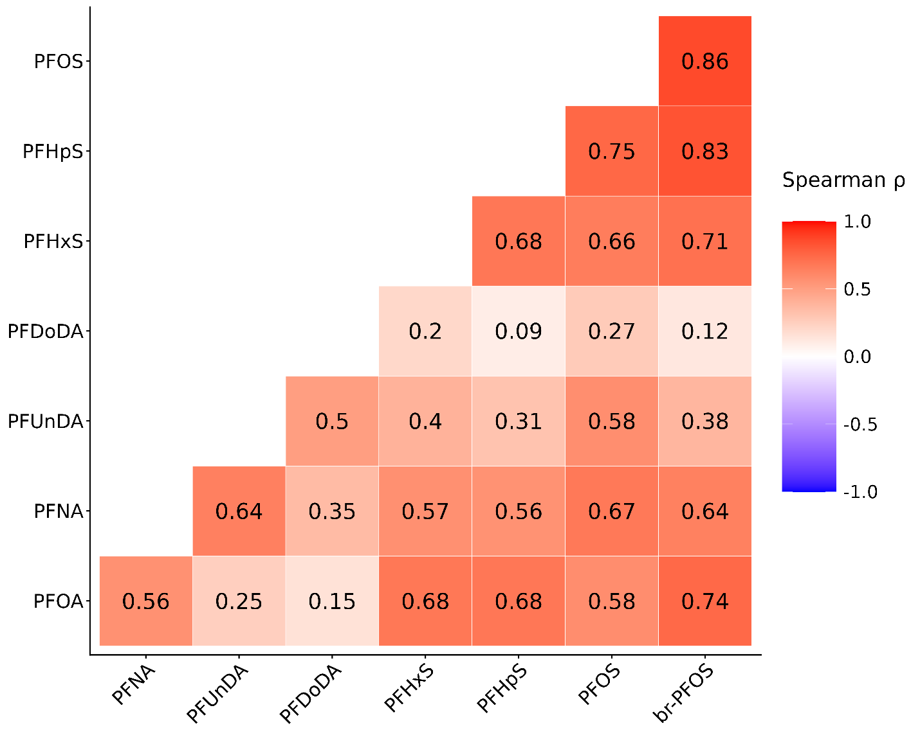
Figure S1. Spearman rank correlation coefficients of plasma concentrations of PFAS compounds (ln-transformed).

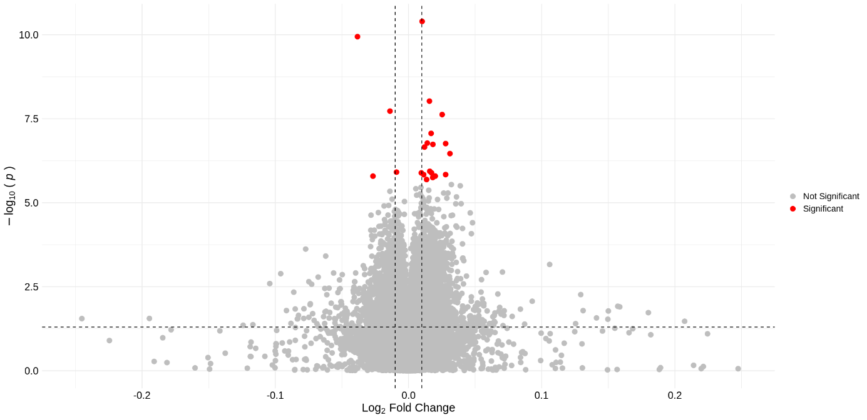

Figure S2. Epigenome-wide identification of CpG methylation changes associated with PFUnDA exposure. Volcano plot showing the log₂-fold change in methylation (β values) (x-axis) and the -log₁₀ (p-value) from the epigenome-wide analysis (y-axis). Significant CpG sites with FDR < 0.05 are shown in red.

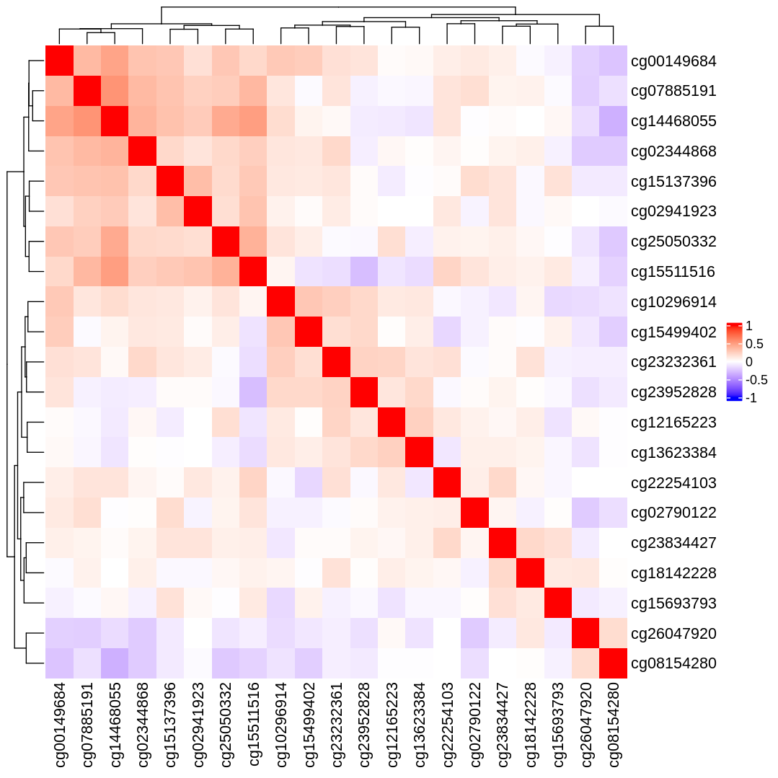

Figure S3. Spearman correlation between CpG sites associated with PFUnDA. Heatmap showing the correlation between significantly associated CpG sites. The strength of the correlation is represented by the color scale shown in the bar on the right.

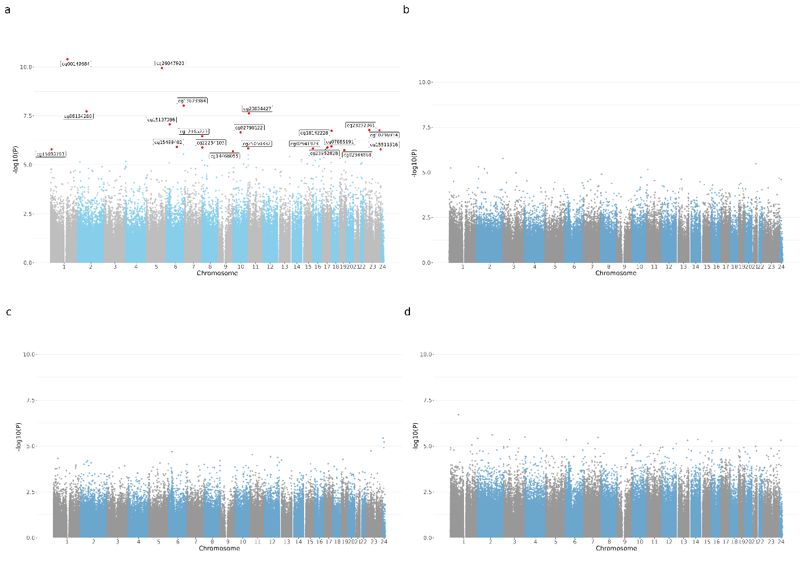
Figure S4. Manhattan plots showing the associations between PFUnDA and DNA methylation at CpG sites. The associations were tested using (a) PFAS concentrations as a continuous variable, and (b-d) tertile comparisons: tertile 3 vs. 1, tertile 3 vs. 2, and tertile 2 vs. 1. The x-axis represents genomic position across chromosomes, and the y-axis shows –log10(p-values) for each CpG site. No statistically significant associations were observed for PFHxS in either continuous or tertile analyses.

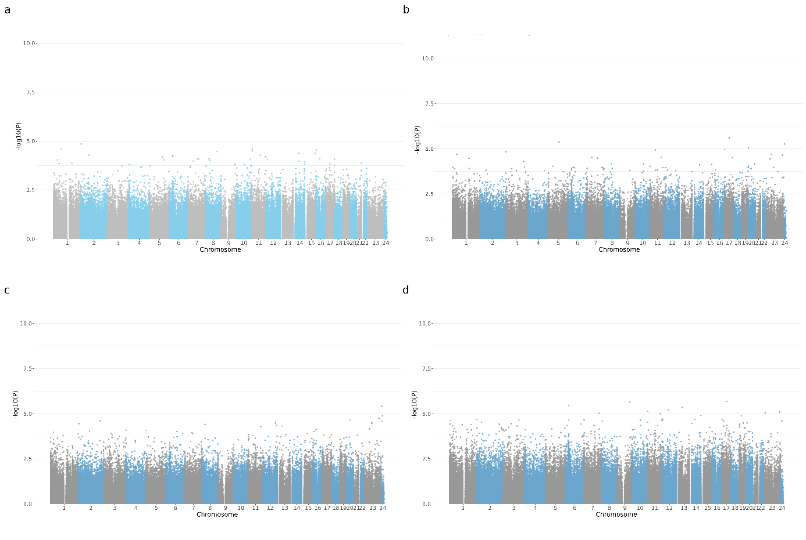
Figure S5. Manhattan plots showing the associations between PFOA and DNA methylation at CpG sites. The associations were tested using (a) PFAS concentrations as a continuous variable, and (b-d) tertile comparisons: tertile 3 vs. 1, tertile 3 vs. 2, and tertile 2 vs. 1. The x-axis represents genomic position across chromosomes, and the y-axis shows –log10(p-values) for each CpG site. No statistically significant associations were observed for PFOA in either continuous or tertile analyses.

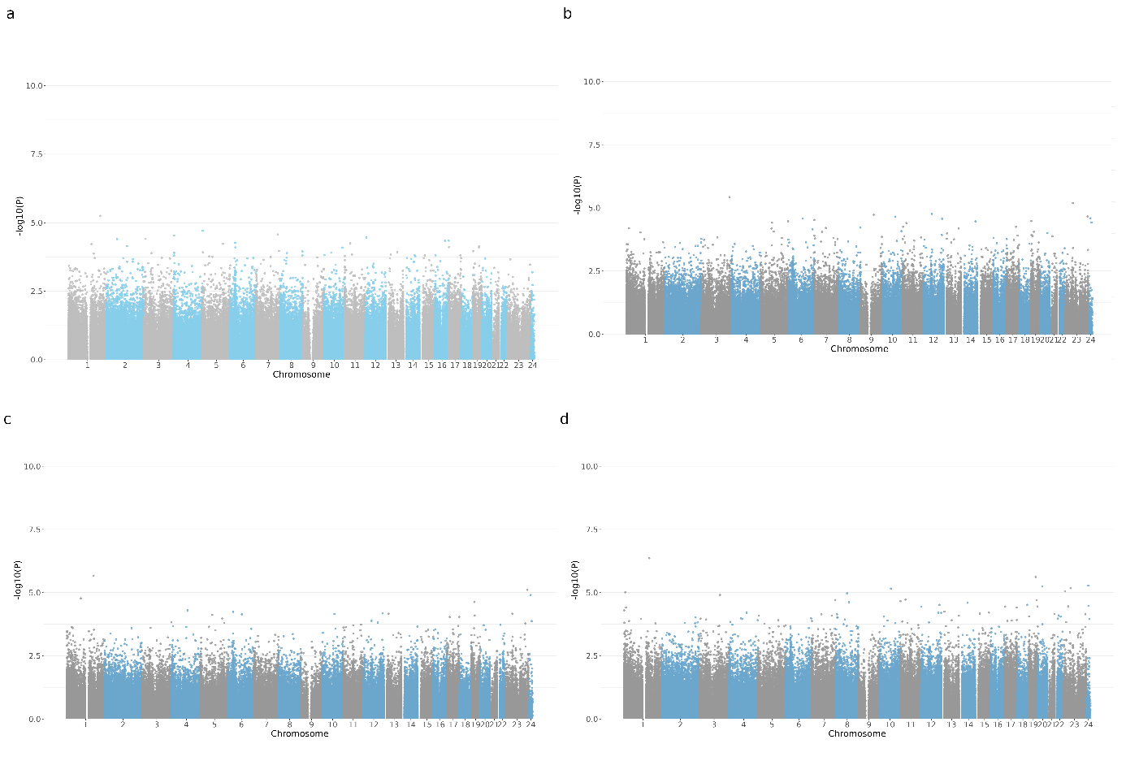
Figure S6. Manhattan plots showing the associations between PFNA and DNA methylation at CpG sites. The associations were tested using (a) PFAS concentrations as a continuous variable, and (b-d) tertile comparisons: tertile 3 vs. 1, tertile 3 vs. 2, and tertile 2 vs. 1. The x-axis represents genomic position across chromosomes, and the y-axis shows –log10(p-values) for each CpG site. No statistically significant associations were observed for PFNA in either continuous or tertile analyses.

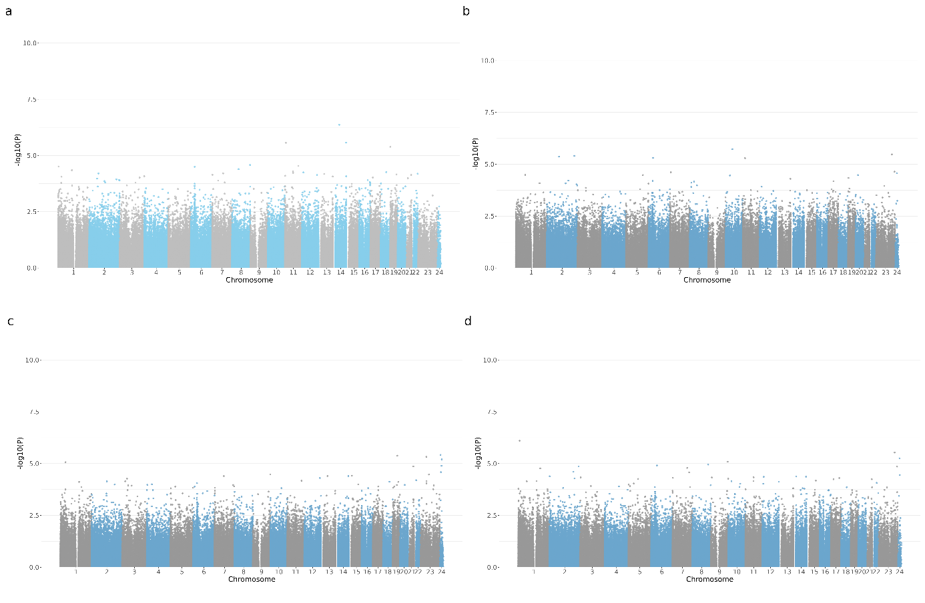
Figure S7. Manhattan plots showing the associations between PFHxS and DNA methylation at CpG sites. The associations were tested using (a) PFAS concentrations as a continuous variable, and (b-d) tertile comparisons: tertile 3 vs. 1, tertile 3 vs. 2, and tertile 2 vs. 1. The x-axis represents genomic position across chromosomes, and the y-axis shows –log10(p-values) for each CpG site. No statistically significant associations were observed for PFHxS in either continuous or tertile analyses.

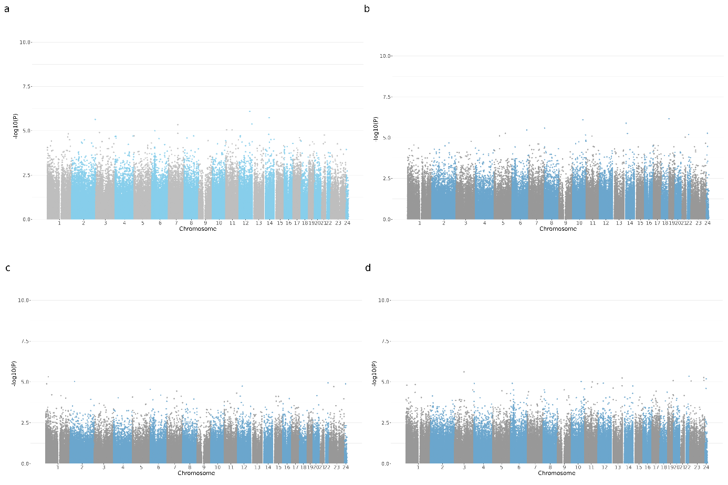
Figure S8. Manhattan plots showing the associations between PFHpS and DNA methylation at CpG sites. The associations were tested using (a) PFAS concentrations as a continuous variable, and (b-d) tertile comparisons: tertile 3 vs. 1, tertile 3 vs. 2, and tertile 2 vs. 1. The x-axis represents genomic position across chromosomes, and the y-axis shows –log10(p-values) for each CpG site. No statistically significant associations were observed for PFHpS in either continuous or tertile analyses.

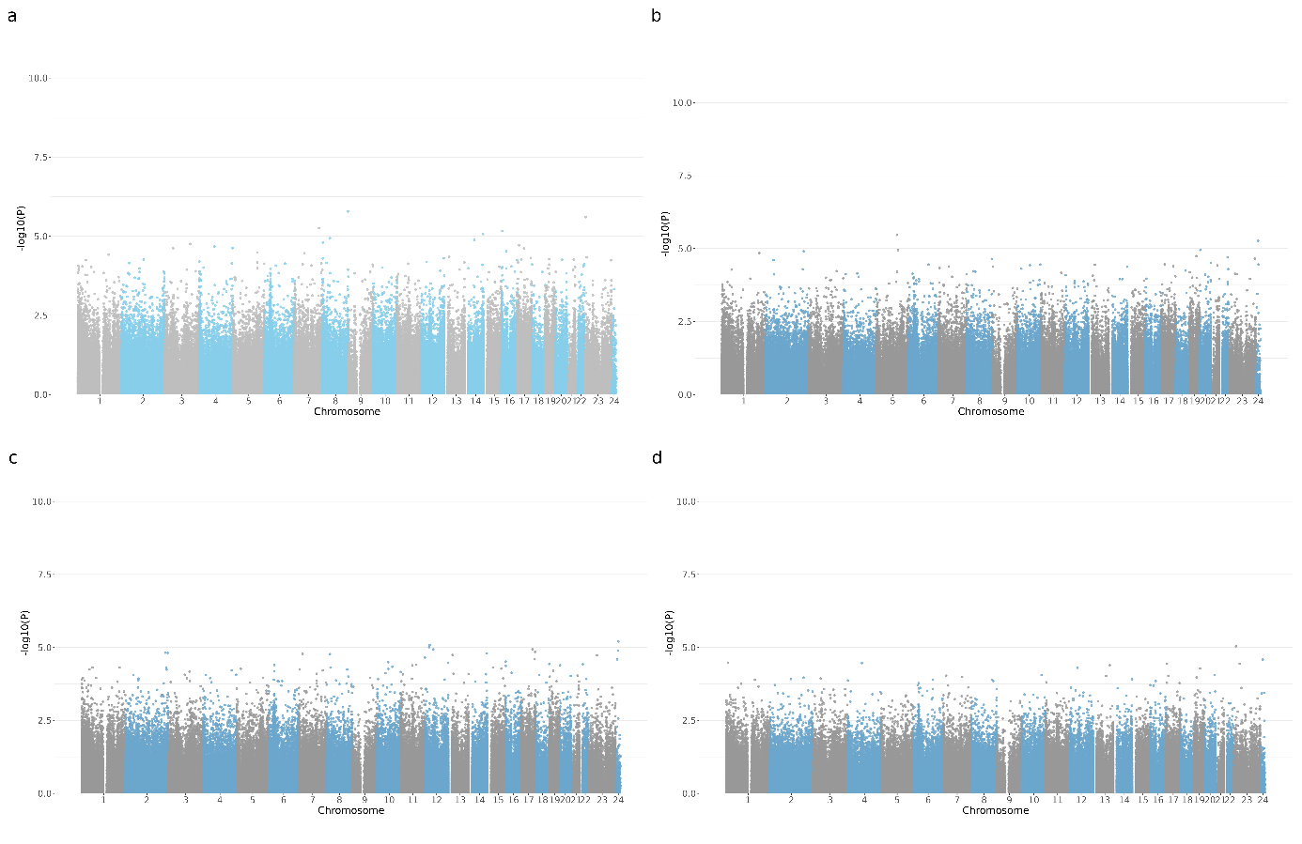
Figure S9. Manhattan plots showing the associations between PFOS and DNA methylation at CpG sites. The associations were tested using (a) PFAS concentrations as a continuous variable, and (b-d) tertile comparisons: tertile 3 vs. 1, tertile 3 vs. 2, and tertile 2 vs. 1. The x-axis represents genomic position across chromosomes, and the y-axis shows –log10(p-values) for each CpG site. No statistically significant associations were observed for PFOS in either continuous or tertile analyses.

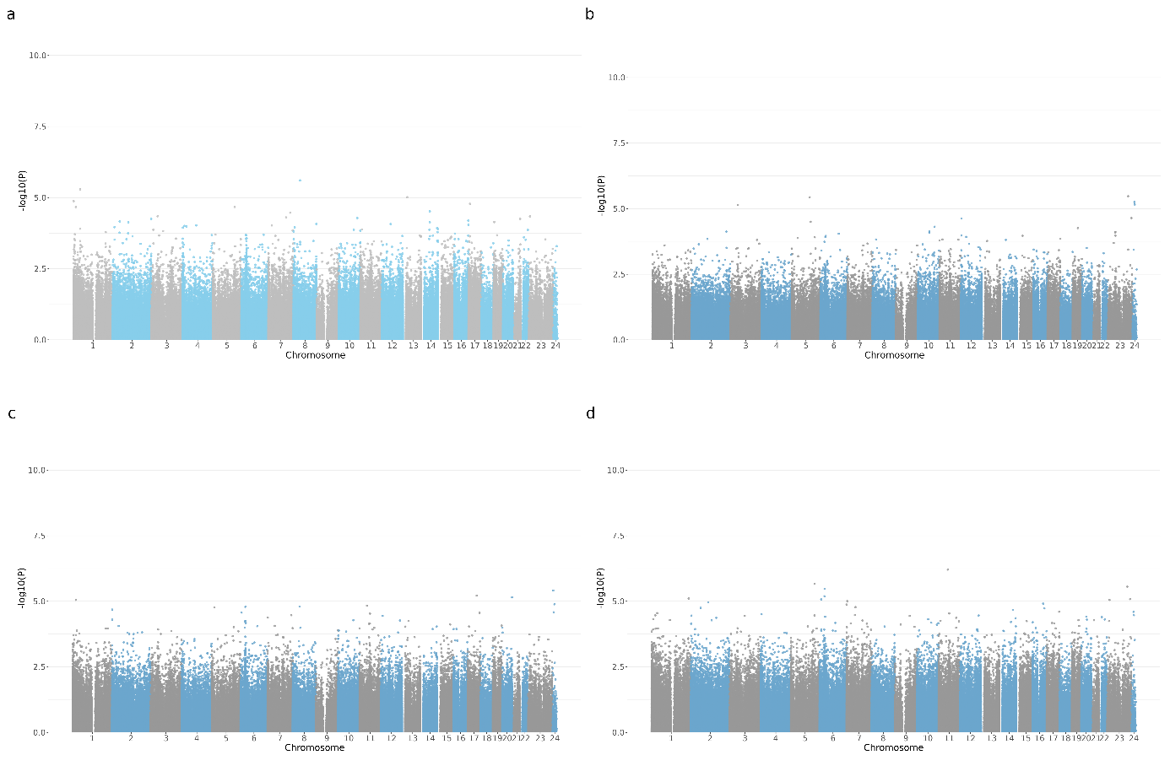
Figure S10. Manhattan plots showing the associations between br-PFOS and DNA methylation at CpG sites. The associations were tested using (a) PFAS concentrations as a continuous variable, and (b-d) tertile comparisons: tertile 3 vs. 1, tertile 3 vs. 2, and tertile 2 vs. 1. The x-axis represents genomic position across chromosomes, and the y-axis shows –log10(p-values) for each CpG site. No statistically significant associations were observed for br-PFOS in either continuous or tertile analyses.

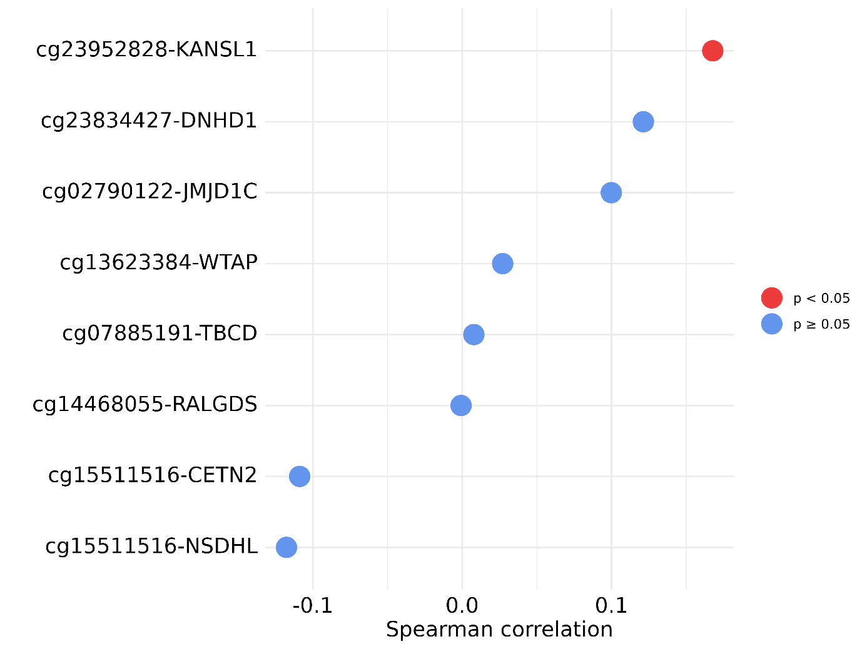

Figure S11. Spearman correlations between CpG site–gene pairs. Correlations were calculated between DNA methylation levels at CpG sites and expression levels of the corresponding genes.

