Supporting Information for

Forewarning Extreme Precipitation Events Using Scaling Behaviors?
Lichao Yang^{1*}, Naiming Yuan^{2*}, Boyu Chen³
¹College of Resource Environment and Tourism, Capital Normal University, Beijing, China
²School of Atmospheric Sciences, Sun Yat-sen University, Zhuhai, China
³National Meteorological Center, China Meteorological Administration, Beijing, China

Contents of this file

Text S1-S3
Figures S1-S7

Introduction

This supporting information file contains detailed explanations on the method of Detrended Fluctuation Analysis (DFA) to estimate the long-term persistence in the times series, the generation of artificial long-term persistent times series, and the detailed explanations on the comparison of forewarn capabilities between the ECMWF and the statistical algorism based on scaling. Additional figures include the spatial distribution of hourly precipitation gauges over Eastern China, the different scaling regimes of hourly precipitation, and boxplot of forewarn capability metrics between the ECMWF and the statistical algorism based on scaling. In addition, figures showing the extreme clustering and forewarning results for the three subregions, as well as the validation using long-term precipitation records, are also provided.

Text S1.
Traditionally, the scaling exponent $β$ is estimated by the slope of the least square regression of the power spectrum plotted in log-log scales. However, the large irregular lines of power spectrum will induce large uncertainties of exponent estimation. In order to avoid spurious results caused by non-stationary in datasets and provide the multiple scaling properties, the DFA is applied to study the LTP of hourly precipitation^{[1-2]}. The steps of DFA algorithm include:
- Calculate the profile of the time series by Eq. (1),
$Y(i)=\sum_{i=1}^{k}{x_{i}^{'}, i=1, 2, …, N}.$ (1)
- Divide the profile series into $N_{s}=[N/s]$ non-overlapping segments with equal length $s$, indexed by. The same procedure is also repeated by the other end of series. Thereby, ${2N}_{s}$ segments are obtained altogether. In each segment $s$, we apply the least square regression method to determine the local trend with a polynomial of order $n$ for each segment and get the $F_{s}\left(k\right)$ as the variance of th segment,
$F_{s}\left(k\right)=\frac{1}{s}\sum_{i=1}^{s}{[Y\left(\left(k-1\right)s+i\right)-p_{k}(i)]^{2}}$. (2)
$p_{k}(i)$ is the fitting polynomial representing the local trend of order $n$ in the segment $k$. It has been known that the DFA will overestimate the crossover position and the deviation is most significant in the DFA with higher detrending order $n$ ^{[2]}. To get a more reliable crossover position and LTP strength, here we employed the order of 2. That means the quadratic trends on the profile $Y\left(i\right)$ are removed.
- Average all segments of length, we obtain the fluctuation function.
$F\left(s\right)=\sqrt{\frac{1}{2N_{s}}\sum_{k=1}^{2N_{s}}{F_{s}(k)}}$ (3)
$F\left(s\right)$ increases with time window $s$ as power law $F\left(s\right)∝s^{α}$ . Consequently, at the timescale range where the scaling holds, the fluctuation $F\left(s\right)$ versus the time scale $s$ would be depicted as a straight line in the double-logarithmic plot. As shown in previous studies, $F\left(s\right)$ normally exhibits initial crossover before $s<8$. So we abandon the first 8 points and the slope of the fitted linear regression line when $s≥8$ is the scaling exponent , also called long-term correlation exponent. If $α=0.5$, the time series is uncorrelated. If $0.5<α<1$, the time series is positively long-term correlated, and the larger $α$ is, the stronger persistence will be. Theoretically, the exponent $β$ estimated from the power spectrum method and $α$ estimated from the DFA method are connected with a relationship of $β=2α-1$.

Text S2.
The artificial data that preserves the LTP can be generated using the Fourier-filtering technique^{[3]}. Specifically, the spectrum of uncorrelated random data is multiplied by $f^{-β}$, where $β$ is the aimed long-term persistence strength ($β=2α-1$). The series is then transformed back by inverse Fourier with modified exponents. The transformed series will exhibit long-term persistence, with the strength characterized by $β$ across all time scales.
To generate LTP artificial times series with a well-defined crossover $s_{x}$, the spectrum of an uncorrelated random series is multiplied by ${\left(f/f_{x}\right)}^{-β_{1}}$ with $β_{1}=2α_{1}-1$ for frequencies $f>f_{x}=1/s_{x}$ only. For frequencies $f<f_{x}=1/s_{x}$, the spectrum of random series is multiplied by ${\left(f/f_{x}\right)}^{-β_{2}}$ with $β_{2}=2α_{2}-1$. Then the series obtained by inverse Fourier transform of this modified power-spectrum will exhibit long-term persistence $α_{1}$ for $s<s_{x}$, and $α_{2}$ for $s>s_{x}$ ^{[2]}.
To better replicate the characteristics of precipitation, the artificially generated time series should not only exhibit the same LTP properties as the observed precipitation but also capture its probability distribution characteristics. That is, we need to generate long-term persistent time series with a certain distribution. Here we use log-normal distribution to model precipitation intensity. To generate a long-term persistent times series with a specific distribution, we first create a sequence of random numbers following the desired distribution. We then restore the desired power spectrum using Fourier filtering and achieve the target distribution through rank-ordered replacement of values in each iteration until convergence is met. A full explanation of the generation process is introduced in Eichner^{[4]}.

Text S3.
In operational forecasts, the numerical weather prediction models are the primary tools for generating forecasts. Here we compare the forewarn capabilities of extreme precipitation using the LTP-based statistical algorithm with that of the numerical weather prediction model.
The precipitation numerical forecasts used are provided by the European Centre for Medium-Range Weather Forecasts (ECMWF). The forecasts are generated four times a day (at 0:00, 6:00, 12:00 and 18:00 Coordinated Universal Time, UTC) from 6 hourly steps to 15 days, utilizing the ECMWF integrated forecasting system. For more information on the ECMWF forecast system, please refer to relevant references available on the ECMWF website (https://www.ecmwf.int/en/publications/ifs-documentation). For the LTP-based statistical forewarn algorithm, the forewarns are also started at 0:00, 6:00, 12:00 and 18:00 UTC, similar to the ECMWF forecasts. The $W_{q}\left(t;1\right)$ at the each station is estimated using the hourly precipitation data from 2016 to 2019, and $Qp$ is determined under the condition that the sum of $Sp$ and $Se$ reaches its maximum for extreme events during the same period. Observed precipitation data from stations in Eastern China (Figure S1) during the summer of 2020 are utilized to evaluate the forewarnings (Figure S3). Given that ECMWF forecasts are gridded, the closest grid points to the observational stations are selected to minimize potential bias introduced by the interpolation method. Here we present the evaluation results for the 6-hour forecasts of extreme precipitation derived from the ECMWF model and the statistical algorithm based on LTP, under the threshold of $R_{q}$=40hour. The forewarn skill is assessed through the performance metrics of $Sp$ and $Se$.
Figure S4 illustrates the forewarn capabilities of the ECMWF and the LTP-based statistical algorithm for 6-hour forecasts of all stations over Eastern China. Although the ECMWF model shows slightly better forewarn capabilities for extreme precipitation than the LTP-based statistical method, the latter still performs well in terms of forewarn accuracy. In ECMWF, the average $Sp$ is 0.15, indicating that 15% of extreme precipitation events are correctly predicted, which is slightly higher than the rate of the statistical model, where the mean $Sp$ is 0.13. Among the 1750 stations considered, the ECMWF achieves a perfect $Sp$ ($Sp=1$) at 13 stations, meaning all extreme events at these stations are accurately forecasted. Similarly, the statistical algorithm successfully predicts all extreme events at 10 stations. Meanwhile, nearly 30% of the stations in the statistical method exhibit higher $Sp$ values compared to the ECMWF. For forecasts of non-extreme events, the average $Se$ for ECMWF is 0.92, indicating that 92% non-extreme events are correctly predicted by the ECMWF model; while the statistical algorithm based on LTP forecasts 85% of such events. The $Se$ values for ECMWF forecasts typically range between 0.90 and 0.94, while for the statistical models, they range from 0.82 to 0.87. In forewarning the non-extreme events, the statistical method performs slightly less effectively.

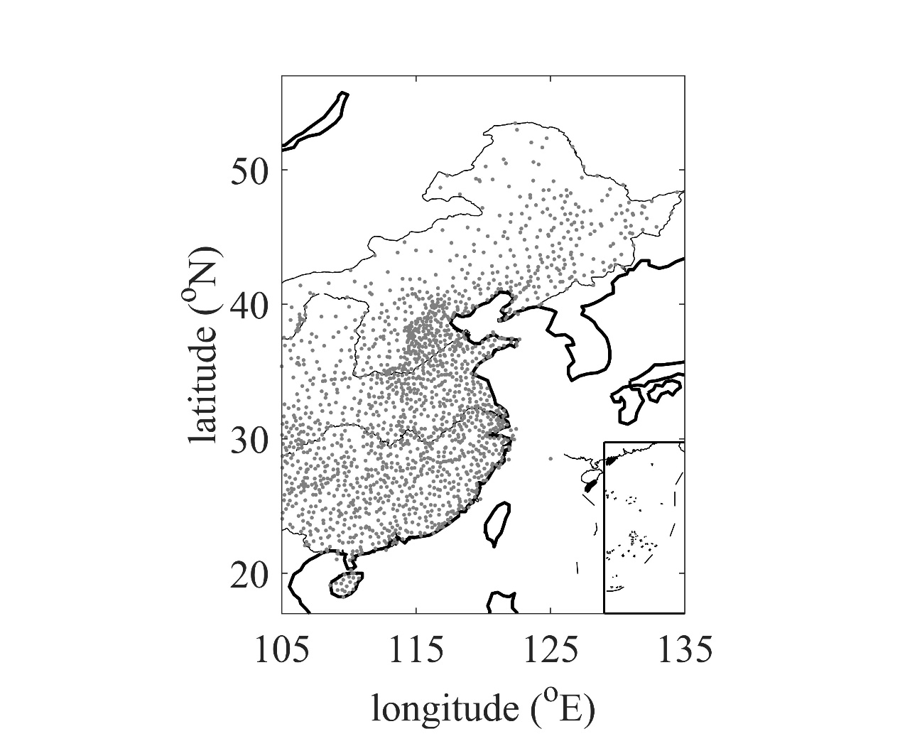
Figure S1. Spatial distribution of 1750 hourly precipitation gauges in Eastern China.

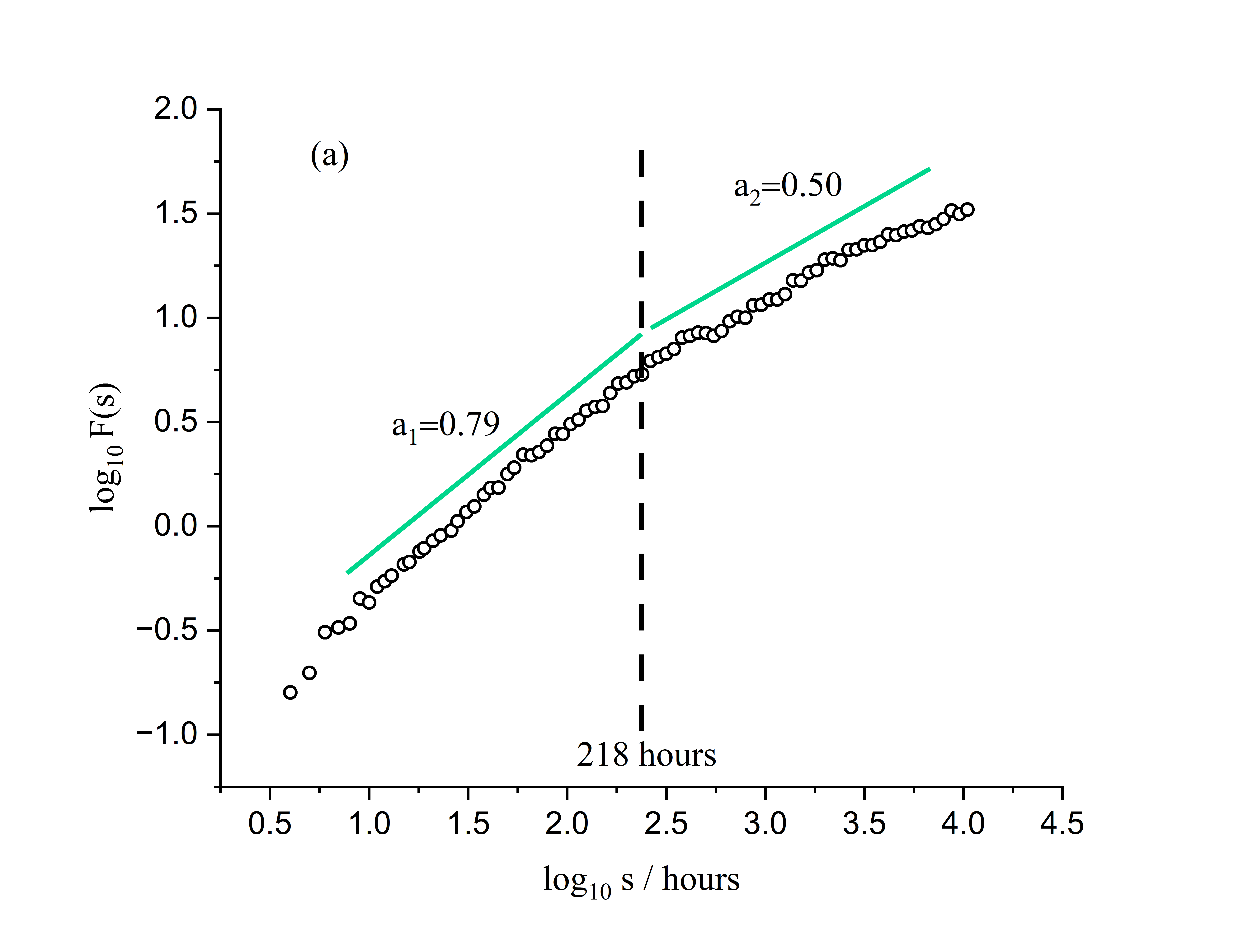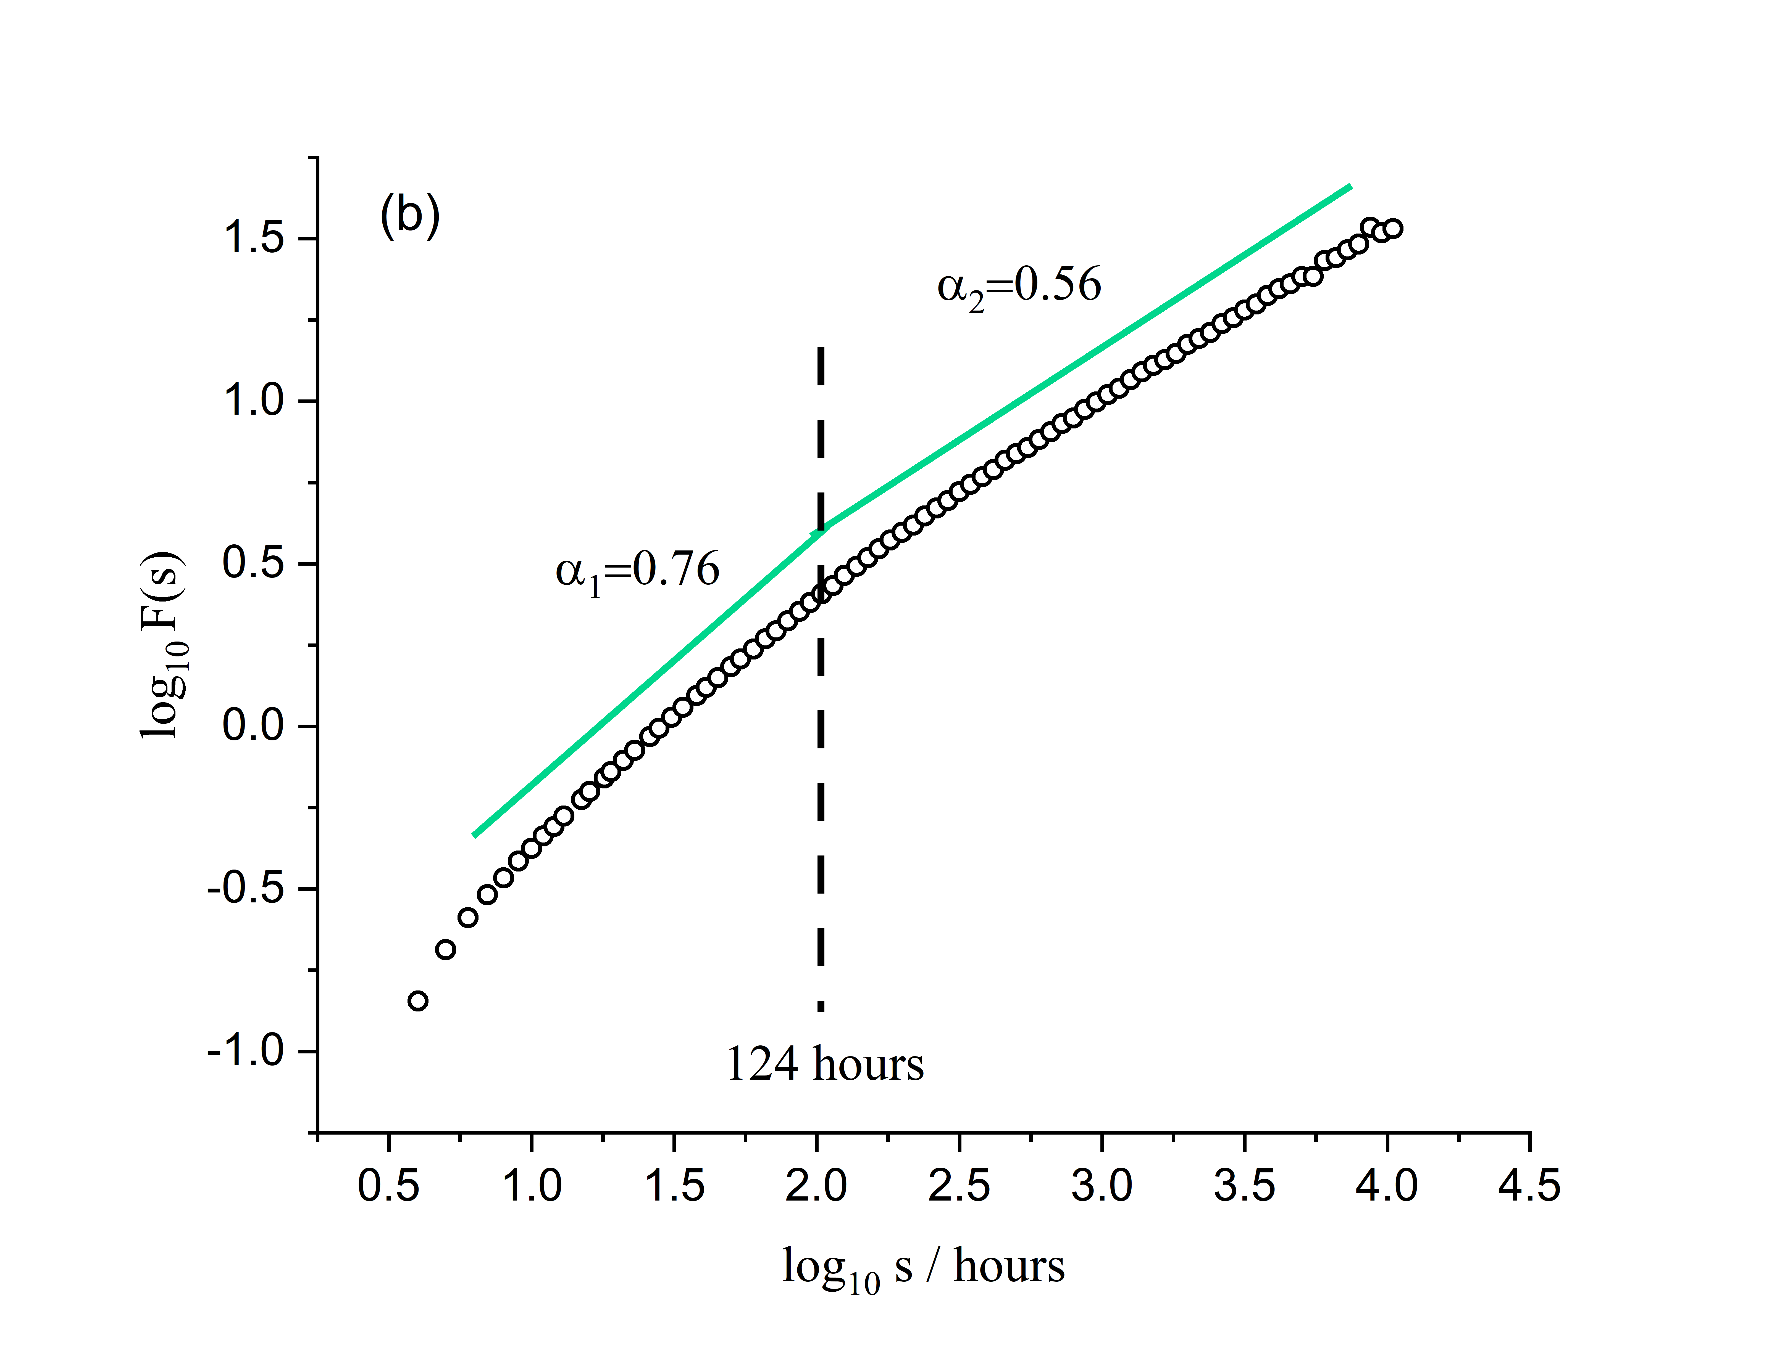
Figure S2. (a) Double log plots of F(s) vs s from hourly precipitation record at Beijing station (116.21ºE, 39.95ºN). Two scaling ranges are separated by a crossover at around 218 hours, where the crossover position is determined by the maximum residual in the least square fitting $\log{F(s)}$ to $\log{s}$ (Yang and Fu. 2019). When $12hour<s<218$hour, $α_{1}$=0.79, indicating a strong LTP. When $218hour<s<416day$, $α_{2}$=0.50, indicating no LTP. (b) Composite diagram of double log plots of F(s) vs s averaged from the studied precipitation series from Eastern China. Two scaling regimes can be found: a regime with stronger LTP (around $12hour<s<124hour, α_{1}=0.76$) and a regime with weak LTP (around $124hour<s<416day, α_{2}=0.56$).

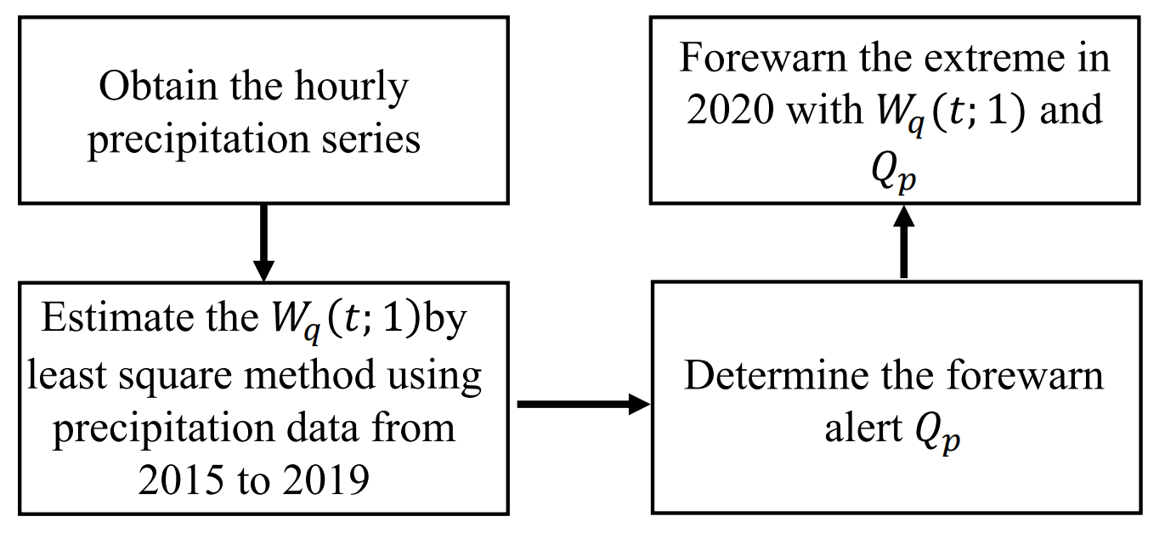
Figure S3. The flowchart of the forewarning model.

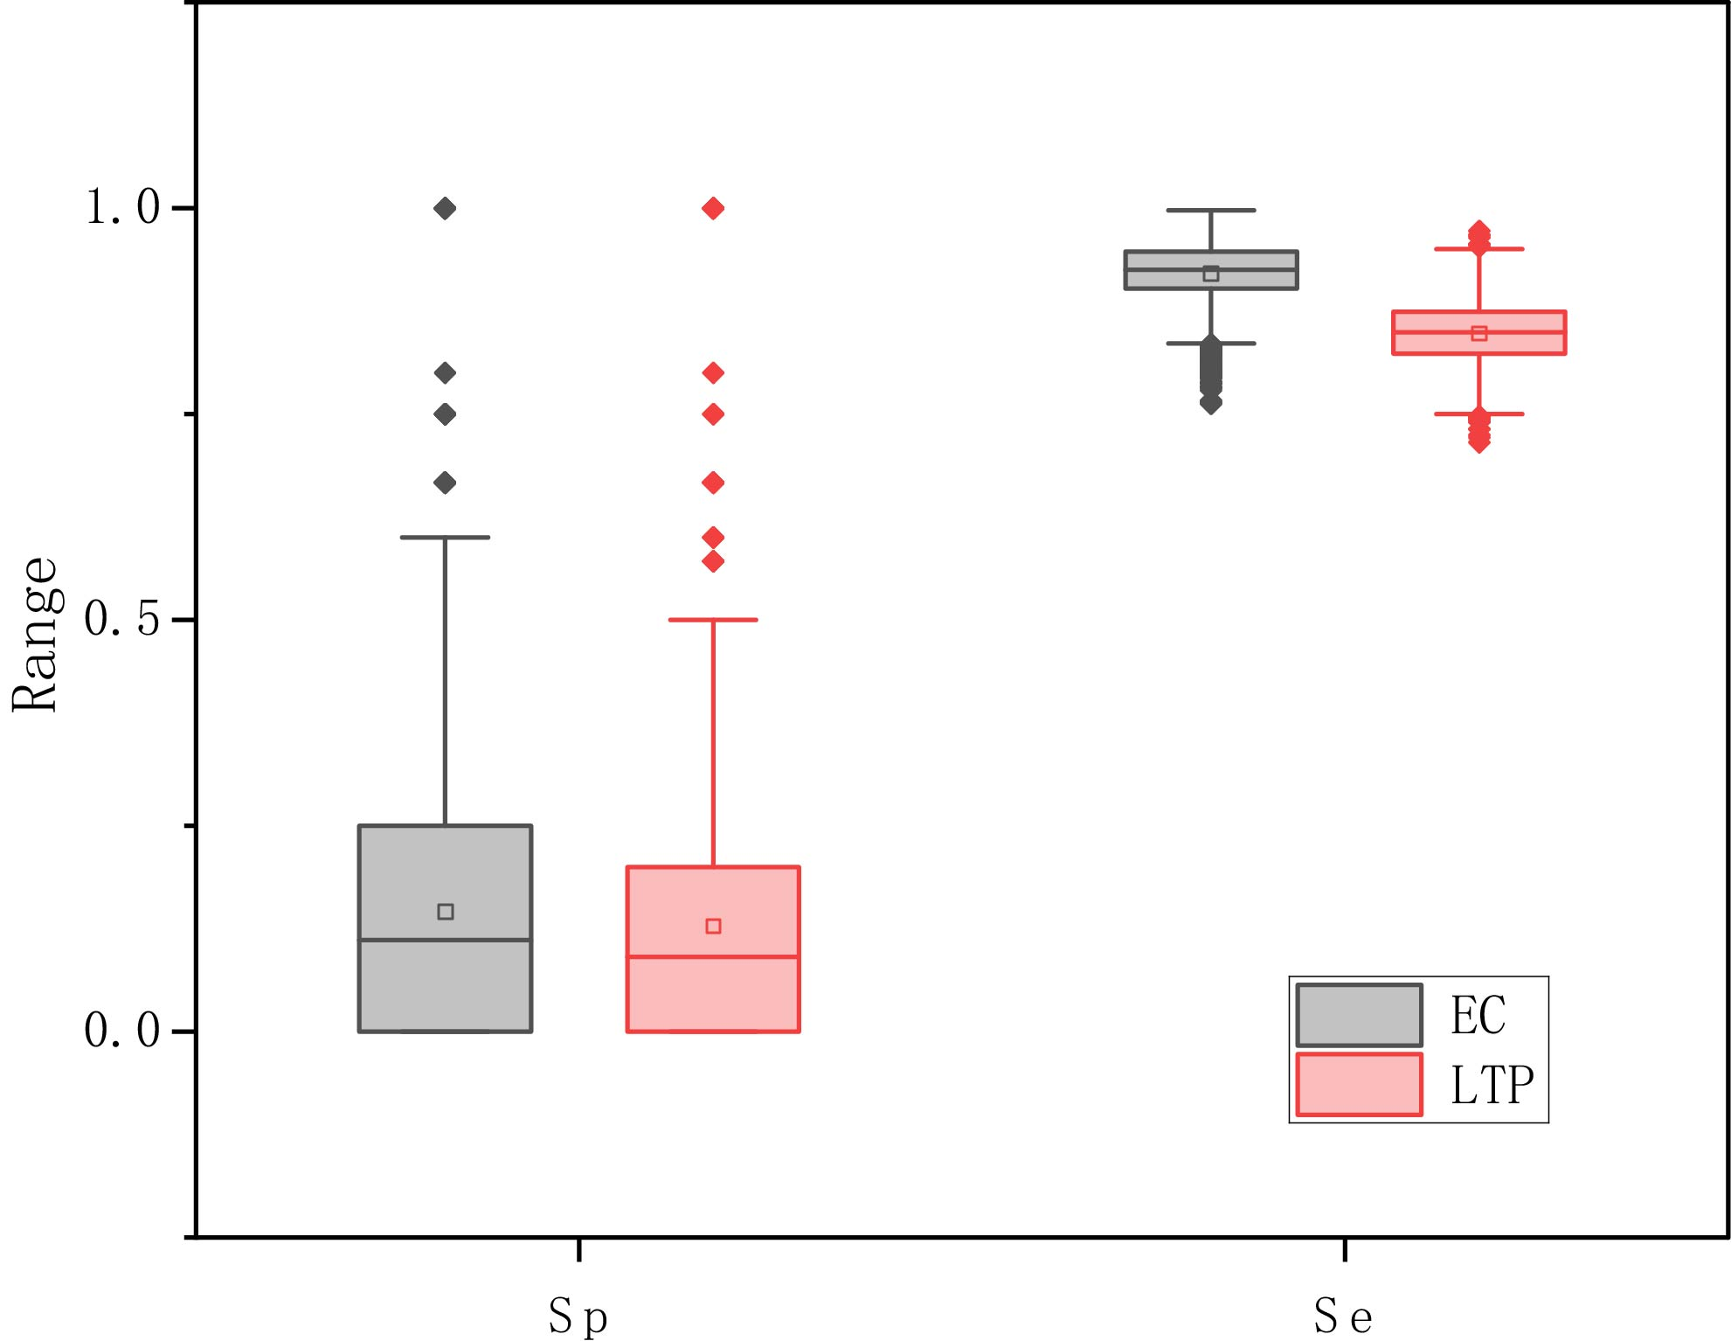
Figure S4. Boxplot of $Sp$ and $Se$ of extreme precipitation obtained from ECMWF (EC, grey shaded) and LTP-based statistical algorithm (LTP, red shaded). The box represents the interquartile range with the median value indicated by the line inside the box. The dot inside the box represents the mean value and the outliers are shown as individual points.

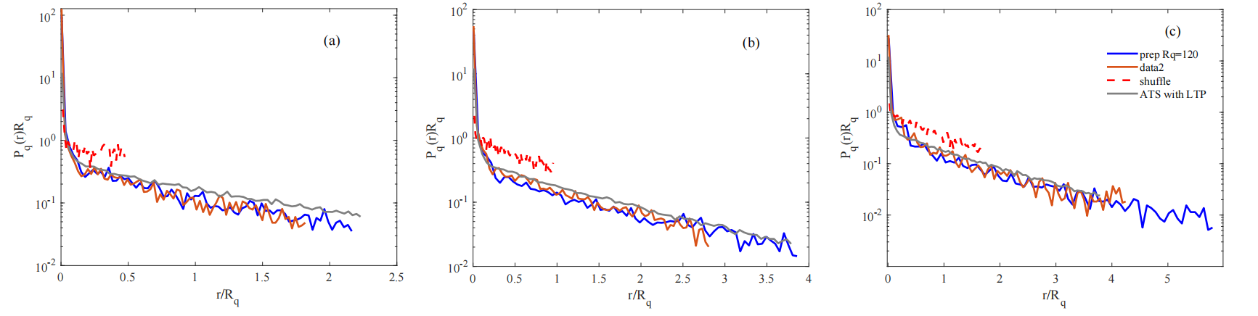
Figure S5. The $P_{q}\left(r\right)$ of observed precipitation with the threshold of Rq=120hour (blue line) and Rq=180hour (orange line), shuffled precipitation (red dashed line, preserving short-term persistence while destroying long-term persistence by block shuffling) and artificial time series (ATS) with the same scaling of observed precipitation (grey line) in (a) north region, (b) middle-lower reaches of the Yangtze River and (c) south region of eastern China.

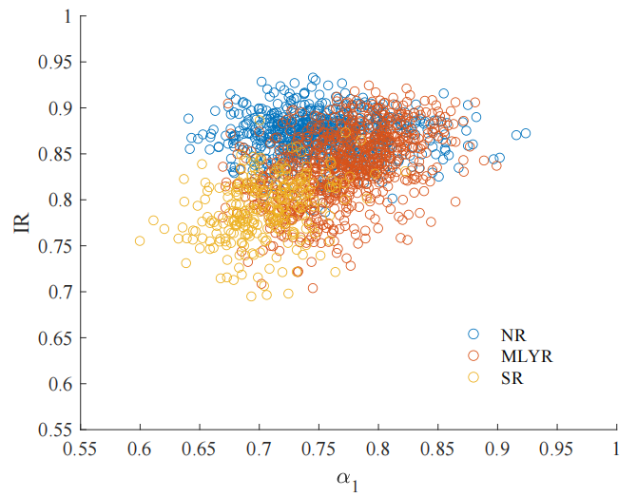
Figure S6. The scatter plot of overall forewarn efficiency (IR) and the LTP strength before crossover ($α_{1}$) of each precipitation record in north region (blue), middle-lower reaches of the Yangtze River (dark red) and south region (yellow) in eastern China.

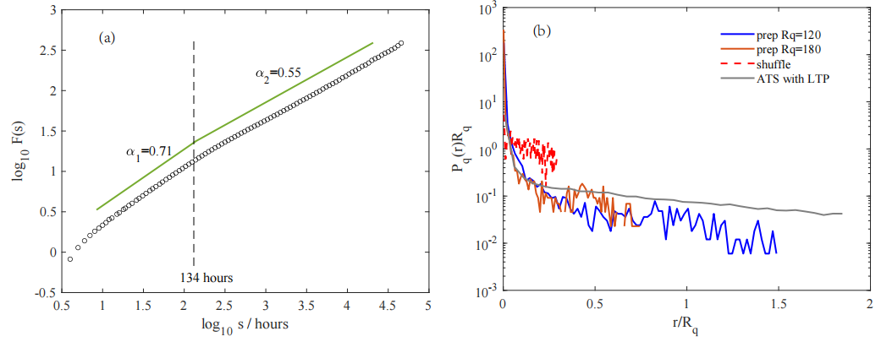
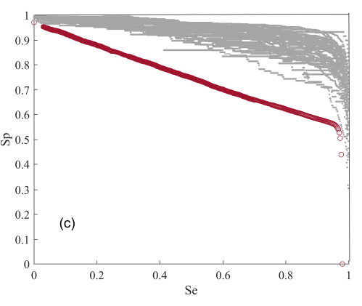
Figure S7. (a) Composite diagram of double log plots of F(s) vs s averaged from the long-term precipitation series from United States. Two scaling regimes can be found: a regime with stronger LTP (around $12hour<s<134hour, α_{1}=0.71$) and a regime with weak LTP (around $134hour<s<831day, α_{2}=0.55$). (b) The $P_{q}\left(r\right)$ of observed precipitation with the threshold of Rq=120hour (blue line) and Rq=180hour (orange line), shuffled precipitation (red dashed line, preserving short-term persistence while destroying long-term persistence by block shuffling) and artificial time series (ATS) with the same scaling of observed precipitation (grey line) (c) The ROC curves of all the precipitation time series (grey dots) and the average ROC for all the shuffled precipitation series (preserving short-term persistence while destroying long-term persistence by block shuffling) is shown in dark red dots.

References for SI:
[1] Kantelhardt, J. W. et al. Detecting long-range correlations with detrended fluctuation analysis. Physica A, 295, 441-454 (2001).
[2] Peng, C. K., Buldyrev, S. V., Havlin, S., Simons, M., & Goldberger, A. L. Mosaic organization of DNA nucleotides. Phys. Rev. E, 49, 1685-1689 (1994).
[3] Makse, H., Havlin, S., Schwartz, M. & Stanley, H. Method for generating long-range correlations for large systems, Phys. Rev. E, 53, 5445-5449 (1996).
[4] Eichner, J. F., Kantelhardt, J. W., Bunde, A. & Havlin, S. Statistics of return intervals in long-term correlated records. Phys. Rev. E. 75, 011128 (2007)

