Supplementary Information for “Astaxanthin suppresses hepatocellular carcinoma via targeting Wnt/Β-catenin pathway: Experimental study on chemically induced HCC in rats”
Mona A. Kortam ª, Marwa Sh. Ismail ^{a,b*}, Maher A. Kamel ^{c}, Noha A. El-Boghdady ª
a Department of Biochemistry, Faculty of Pharmacy, Cairo University, 23 Kasr El-Aini St., Cairo 11562, Egypt.
b Department of Pharmacology and Therapeutics, Faculty of Pharmacy, Pharos University in Alexandria (PUA), Canal El Mahmoudia Street, beside the Green Plaza Complex, Alexandria 21648, Egypt.
c Department of Biochemistry, Medical Research Institute, Alexandria University, 165 Al-Horreya Avenue, Hadara, Alexandria ^{21561, Egypt.}

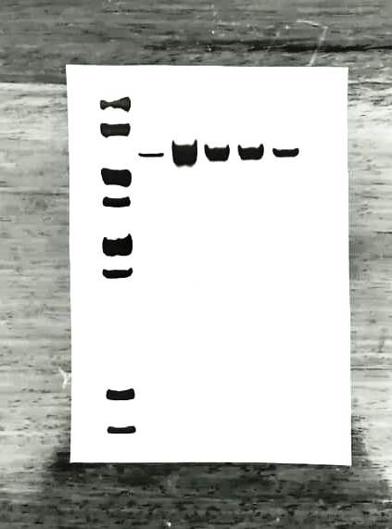
22
28
50
38
113
78
62
154
ATX+DOX
ATX
Control
HCC
DOX
Supplementary Figure S1 Full-length gel FZD-7 western blot image used for quantification in Fig 2c, showing protein expression in liver tissues from the control, HCC, ATX-treated, DOX-treated, and ATX+DOX-treated groups. β-actin used as the loading control. All lanes were run on the same gel and detected in a single exposure.


22
28
38
50
78
62
154
113
HCC
ATX
DOX
ATX+DOX
Control
Supplementary Figure S2 Full-length gel FZD-7 western blot image used for quantification in Fig 2c, showing protein expression in liver tissues from the control, HCC, ATX-treated, DOX-treated, and ATX+DOX-treated groups. β-actin used as the loading control. All lanes were run on the same gel and detected in a single exposure.

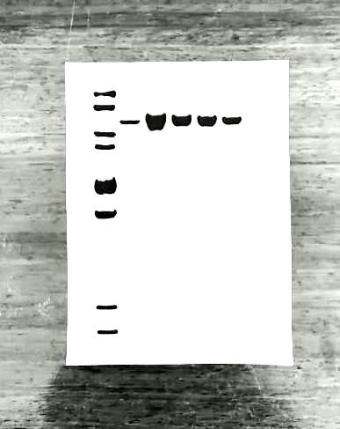
ATX+DOX
DOX
154
113
62
78
50
38
22
28
ATX
HCC
Control
Supplementary Figure S3 Full-length gel FZD-7 western blot image used for quantification in Fig 2c, showing protein expression in liver tissues from the control, HCC, ATX-treated, DOX-treated, and ATX+DOX-treated groups. β-actin used as the loading control. All lanes were run on the same gel and detected in a single exposure.

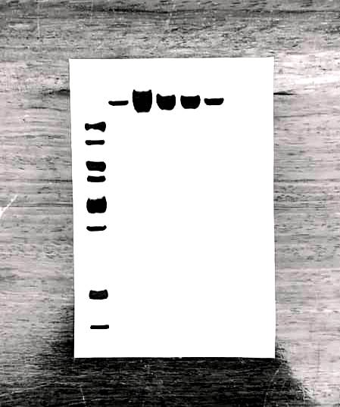
38
50
78
62
113
154
22
28
50
DOX
Control
HCC
ATX+DOX
ATX
Supplementary Figure S4 Full-length gel LRP5/6 western blot image used for quantification in Fig 2d, showing protein expression in liver tissues from the control, HCC, ATX-treated, DOX-treated, and ATX+DOX-treated groups. β-actin used as the loading control. All lanes were run on the same gel and detected in a single exposure.

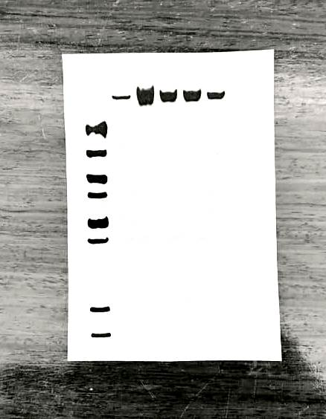
28
22
38
50
62
78
113
154
154
78
113
78
ATX+DOX
DOX
ATX
HCC
Control
Supplementary Figure S5 Full-length gel LRP5/6 western blot image used for quantification in Fig 2d, showing protein expression in liver tissues from the control, HCC, ATX-treated, DOX-treated, and ATX+DOX-treated groups. β-actin used as the loading control. All lanes were run on the same gel and detected in a single exposure.

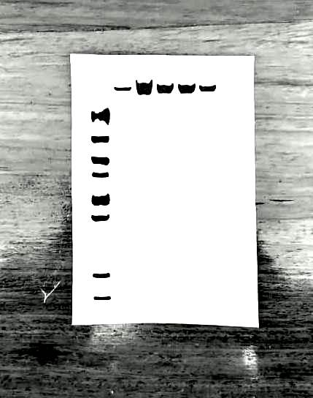
154
22
28
78
62
50
38
113
Control
DOX
ATX+DOX
ATX
HCC
Supplementary Figure S6 Full-length gel LRP5/6 western blot image used for quantification in Fig 2d, showing protein expression in liver tissues from the control, HCC, ATX-treated, DOX-treated, and ATX+DOX-treated groups. β-actin used as the loading control. All lanes were run on the same gel and detected in a single exposure.

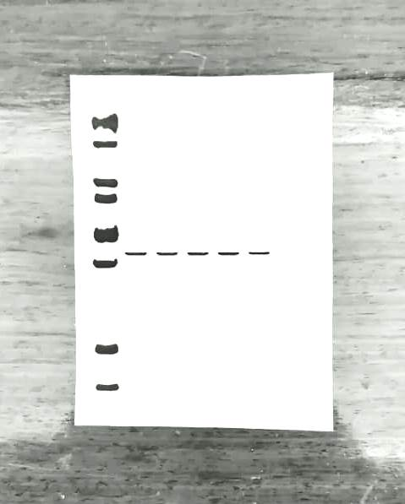
HCC
22
28
38
50
62
78
154
113
DOX
ATX+DOX
ATX
Control
Supplementary Figure S7 Full-length gel β-actin western blot image used for quantification in Figs 2c and 2d, showing protein expression in liver tissues from the control, HCC, ATX-treated, DOX-treated, and ATX+DOX-treated groups. All lanes were run on the same gel and detected in a single exposure.

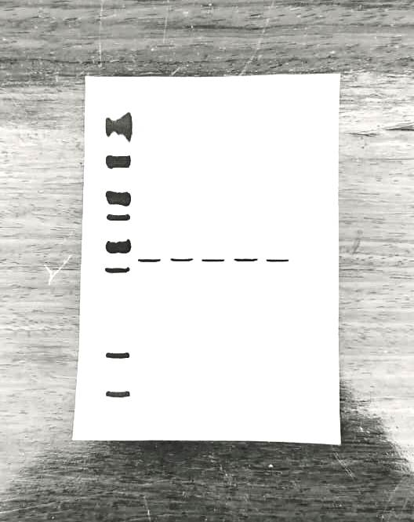
154
113
78
62
50
38
28
22
DOX
Control
ATX
ATX+DOX
HCC
Supplementary Figure S8 Full-length gel β-actin western blot image used for quantification in Figs 2c and 2d, showing protein expression in liver tissues from the control, HCC, ATX-treated, DOX-treated, and ATX+DOX-treated groups. All lanes were run on the same gel and detected in a single exposure.

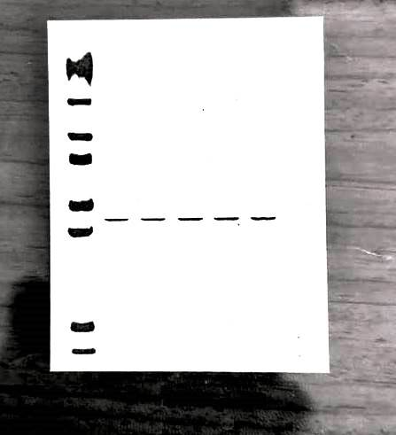
113
154
78
62
50
38
28
22
113
DOX
ATX+DOX
HCC
ATX
Control
Supplementary Figure S9 Full-length gel β-actin western blot image used for quantification in Figs 2c and 2d, showing protein expression in liver tissues from the control, HCC, ATX-treated, DOX-treated, and ATX+DOX-treated groups. All lanes were run on the same gel and detected in a single exposure.

