Antimicrobial class/ subclass | Antimicrobial agents | No. of E. coli isolates (%)
Antimicrobial class/ subclass | Antimicrobial agents | Sensitive (S) | Intermediate (I) | Resistant (R)
Penicillins | Ampicillin | 0 (0) | 0 (0) | 57 (100)
β-lactams combination agents | Amoxicillin-clavulanic acid | 3 (5.3) | 0 (0) | 54 (94.7)
Cephalosporins ӀӀӀ | Ceftriaxone | 4 (7) | 0 (0) | 53 (93)
Cephalosporins ӀӀӀ | Cefuroxime | 4 (7) | 0 (0) | 53 (93)
Carbapenems | Imipenem | 38 (66.7) | 3 (5.3) | 16 (28)
Fluoroquinolones | Levofloxacin | 29 (50.8) | 3 (5.3) | 25 (43.9)
Tetracyclines | Tetracycline | 0 (0) | 0 (0) | 57 (100)
Sulfonamides | Trimethoprim-sulfamethoxazole | 26 (43.9) | 1 (1.7) | 31 (54.4)
Aminoglycosides | Gentamycin | 6 (10.5) | 2 (3.5) | 49 (86)
Table 1S : Results of antimicrobial susceptibility test of E.coli isolates

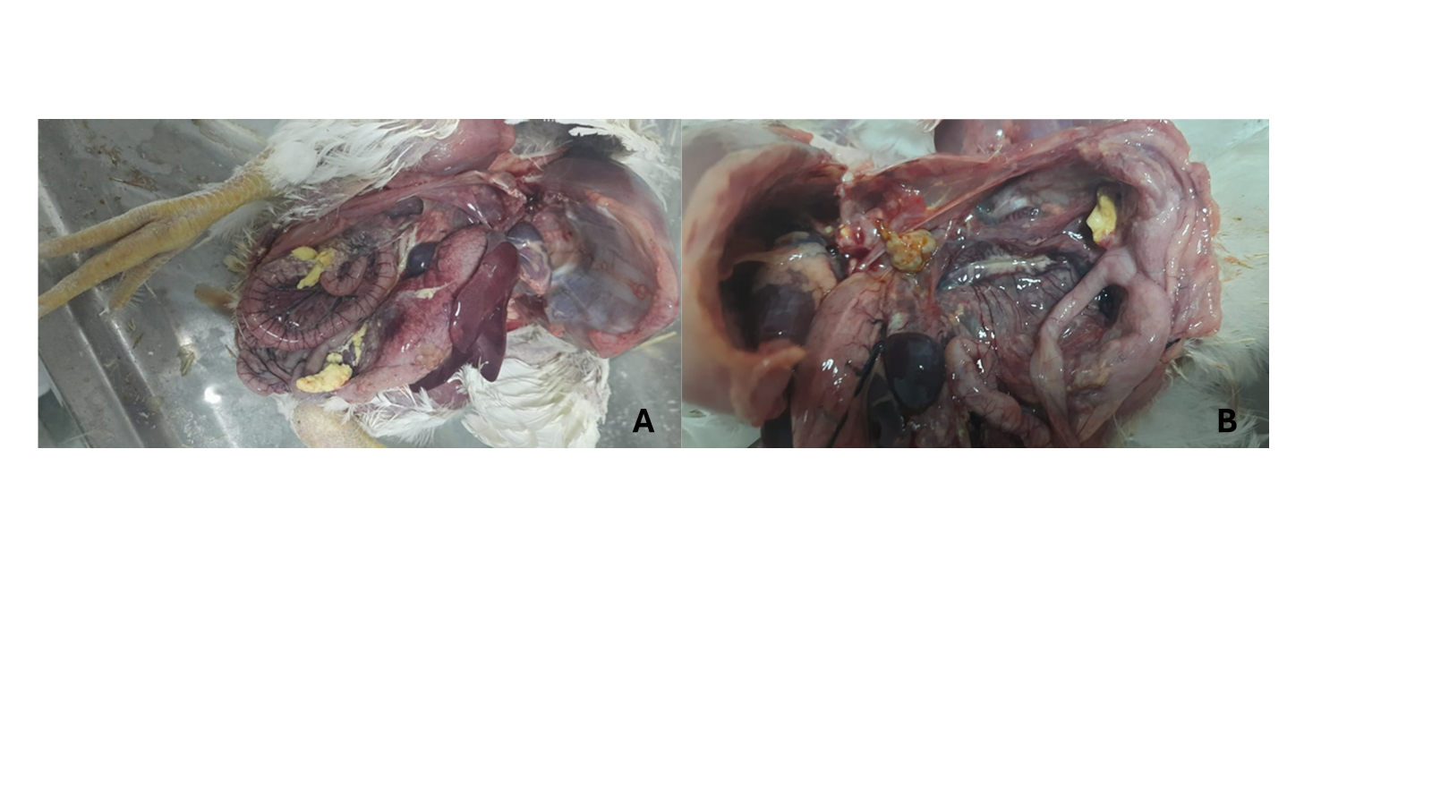
Figure 1SA and B: Yellow lumps are coated on the intestines and within the abdominal cavity, with accumulation of pus (fibrin) that has hardened. A: pale liver and looks "dusty" with a fibrinous layer on it, and B: congested intestine
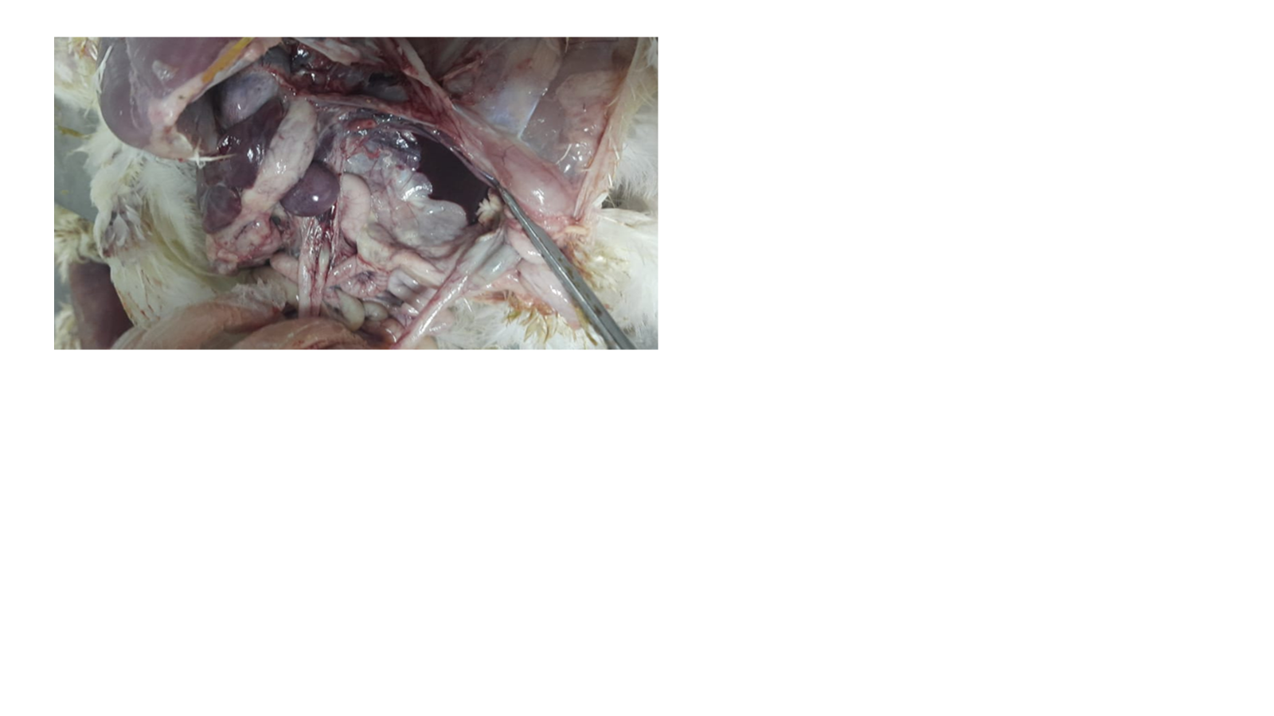
Figure 2S:The heart area is also cloudy and lacks the clearness characteristic of a healthy heart sac

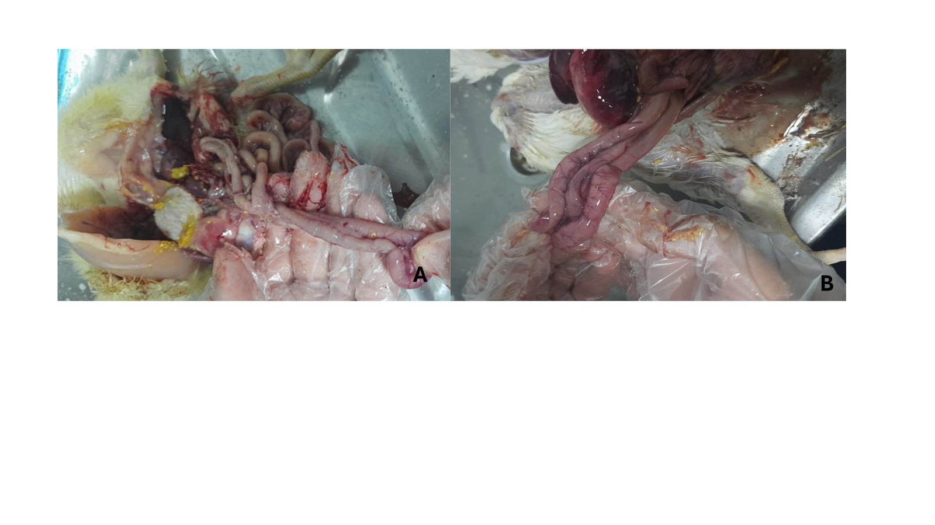
Figure 3SA and B: exhibited enteritis. A: The intestines look very red, irritated, and hemorrhagic. B: The blood vessels on the intestinal wall are hemorrhagic and prominent with hemorrhagic intestine.
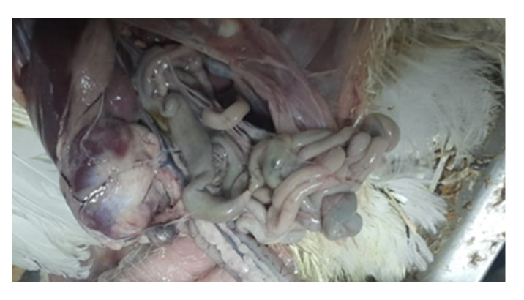
Figure 4S: The spleen looks very swollen, enlarged and hemorrhagic.

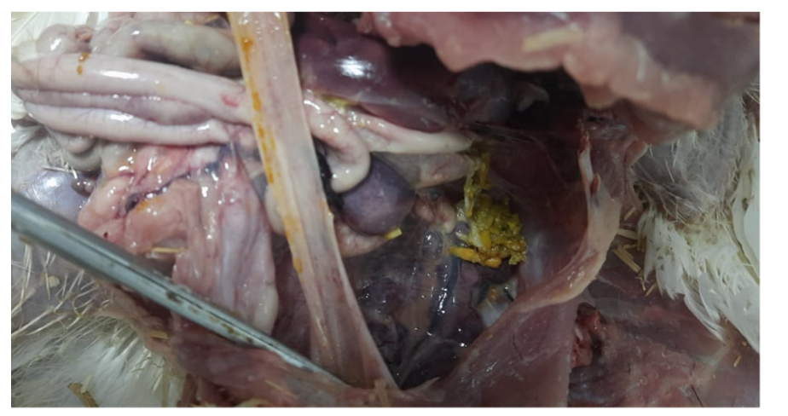

Figure 5S: Cloudy thickened air sacs with fibrin layer
Supplementary Table S1: Contingency table for SXT vs sul1
 | sul1 + | sul1 − | Total
SXT resistant | 31 | 0 | 31
SXT susceptible | 0 | 26 | 26
Total | 31 | 26 | 57
Supplementary Table S2: Contingency table for levofloxacin vs qnrA
 | qnrA + | qnrA − | Total
LEV resistant | 25 | 0 | 25
LEV susceptible | 0 | 32 | 32
Total | 25 | 32 | 57

Supplementary Table S3: Contingency table for gentamycin vs aadA1
 | aadA1 + | aadA1 − | Total
Gentamycin resistant | 49 | 0 | 49
Gentamycin susceptible | 0 | 8 | 8
Total | 49 | 8 | 57

Supplementary Table S4: Contingency table for imipenem vs bla_{IMP‑1}
 | blaIMP-1 + | blaIMP-1 − | Total
Imipenem resistant | 16 | 0 | 16
Imipenem susceptible | 0 | 41 | 41
Total | 16 | 41 | 57

Supplementary Table S5: Contingency table for imipenem vs bla_{VIM‑1}
 | blaVIM-1 + | blaVIM-1 − | Total
Imipenem resistant | 16 | 0 | 16
Imipenem susceptible | 3 | 38 | 41
Total | 19 | 38 | 57

