Supplementary Information for

Human disturbance and higher temperatures are linked to amphibian
chytrid fungus in Catalonia, Northeastern Spain

Maria Puig Ribas, Xavier Fernández Aguilar, Johan Espunyes, Laura Carrera-Faja, Lola Pailler-García, Ignasi Marco and Oscar Cabezón.

Explanatory variables used in GLMMs

Anthropogenic disturbance (variable Anth_Ind)
To quantify the level of anthropogenic disturbance at each sampling point, we constructed an index based on multiple variables reflecting human population density and anthropogenic environmental alterations. We performed a Principal Component Analysis (PCA) and used the first principal component (PC1) as a composite index of anthropogenic disturbance. The variables included in the PCA were:

- Land Cover (variable Urb_percent): percentage of urban land use within a 5 km buffer around the sampling point, obtained from the Institut Cartogràfic i Geològic de Catalunya (ICGC) database. Source: https://www.icgc.cat/ca/Ambits-tematics/Territori-sostenible/Cobertes-del-sol
- Road Density (variable Road_dens): density of roads within a 5 km buffer around the sampling point, extracted from the Centro Nacional de Información Geográfica (CNIG). Source: https://centrodedescargas.cnig.es/CentroDescargas/index.jsp
- Distance to Populations (variable Dist_pop): linear distance from the sampling point to the nearest human settlement.
- Population Density: population density of the comarca (administrative region) where the sampling was performed, obtained from Institut d’Estadística de Catalunya (IDESCAT). Source: https://www.idescat.cat/indicadors/?id=aec&n=15227
- Total Nitrogen (variable Sum_Nit): a proxy for livestock-related environmental impact, calculated as the sum of nitrogen input from livestock farms within a 5 km buffer around the sampling point, based on farm records and species type from the Registre d’Explotacions Ramaderes (Generalitat de Catalunya). Source: https://analisi.transparenciacatalunya.cat/Medi-Rural-Pesca/Registre-d-explotacions-ramaderes/7bpt-5azk/about_data

The PCA was performed on the standardized values of these variables and PC1 was retained as the anthropogenic disturbance index, as it explained the largest proportion of variance among the dataset (Tables S1 and S2).

Table S1. Importance of each principal component describing anthropogenic disturbance.
 | PC1 | PC2 | PC3 | PC4 | PC5
Standard deviation | 1.7168 | 1.2042 | 0.70230 | 0.32031 | 0.08308
Proportion of variance | 0.5895 | 0.2900 | 0.09864 | 0.02052 | 0.00138
Cumulative proportion | 0.5895 | 0.8795 | 0.97810 | 0.99862 | 1.00000

Table S2. Principal Component Analysis (PCA) loadings for variables reflecting anthropogenic alterations to the environment.

Variable | PC1 | PC2 | PC3 | PC4 | PC5
Population Density | -0.472074 | 0.470357 | -0.118096 | 0.350839 | 0.647207
Total Nitrogen | -0.202634 | -0.717549 | -0.472318 | 0.468968 | 0.033399
Distance to Populations | 0.417213 | 0.311918 | -0.833244 | -0.183612 | 0.025119
Urban Land | -0.524623 | 0.336926 | -0.191758 | 0.148828 | -0.743189
Road Density | -0.535593 | -0.230377 | -0.178610 | -0.775318 | 0.164461

Amphibian species richness (variable Sp_rich_Ind)
Count of the amphibian species detected in each sampling point, extracted from observational data from fieldwork and from Natural Park’s registers.

Bioregion (variable Bioregion)
Broad ecological zones that categorize the territory based on climatic and vegetation characteristics, including general thermality index, weighted thermality index, continentality, annual ombrothermal index, ombrothermal index of the two driest months of the year, mean maximum temperature of the coldest month and mean minimum temperature of the warmest month of the year. This classification describes six distinct bioregions: Marsh, Mesomediterranean, Thermomediterranean, Mountainous, Subalpine, and Alpine. Data were obtained from Ministerio para la Transición Ecológica y el Reto Demográfico (MITECO). Sources:
https://www.miteco.gob.es/ca/biodiversidad/servicios/banco-datos-naturaleza/informacion-disponible/memoria_mapa_series_veg_descargas.html

Rivas-Martínez S, Penas Á, Díaz González TE, Cantó P, del Río S, Costa JC, Molero J. Biogeographic units of the Iberian Peninsula and Balearic Islands to district level. A concise synopsis. The Vegetation of the Iberian Peninsula: Volume 1, 2017:131-188.

Habitat type
Categorical variable describing the type of aquatic habitat of the sampling point, obtained from fieldwork. Categories: natural water reservoir, artificial water reservoir, stream, and trail/road.

Altitude (variable Elevation)
Continuous variable representing the altitude in meters of each sampling site. Elevation data were extracted from a Digital Elevation Model (DEM) with a 5x5 meter resolution, provided by the Institut Cartogràfic i Geològic de Catalunya (ICC). Source:
http://www.icc.es/cat/Home-CCCC/Normes-i-estandards/Especificacions-tecniques/Model-d-elevacions-del-terreny-de-Catalunya-15x15-m-MET-15-v2.0-5x5-m-MET-5-v1.0

Mean temperature (variable MeanTemperature)
Continuous variable representing the average air temperature in ºC at each sampling site. It is calculated as the daily mean of the air temperature at 2 meters above the ground level, averaged over the entire study period (2019-2023). Data were obtained from the Copernicus ERA5-Land dataset with a resolution of 9 km. Source: https://cds.climate.copernicus.eu/cdsapp#!/dataset/reanalysis-era5-land?tab=overview

Summer mean maximum temperature (variable MeanMaxTemperature)
Continuous variable representing the average of the daily maximum air temperatures in °C during the summer months (July-August) over the period 2019-2023. This variable is also derived from the air temperature at 2 meters above ground level. Data were obtained from the Copernicus ERA5-Land dataset with a resolution of 9 km. Source: https://cds.climate.copernicus.eu/cdsapp#!/dataset/reanalysis-era5-land?tab=overview

Precipitation (variable Precip)
Continuous variable representing the PC1 derived from the annual total precipitation (mm) over the study period (2019-2023) (variable SumTotalPrecipitation) and the cumulative precipitation during the 90 days before sampling at each site (variable TotalPrecipitation90days). We performed a PCA and used the PC1 as a composite index to summarize the dominant gradient of precipitation intensity and short-term accumulation across the study area, effectively integrating both long-term and recent rainfall patterns. This PC1 explained 84.3% of the total variance. Data were obtained from the Copernicus ERA5-Land dataset with a resolution of 9 km. Source: https://cds.climate.copernicus.eu/cdsapp#!/dataset/reanalysis-era5-land?tab=overview

Species differences in Bd infection prevalence

Table S3. Pairwise comparisons of Batrachochytrium dendrobatidis (Bd) prevalence among positive amphibian species. The table displays species comparisons, unadjusted Fisher's exact test p-values (p.Fisher), and adjusted p-values (p.adj.Fisher) after multiple testing correction. Significant comparisons (p.adj.Fisher < 0.05) indicate differences in Bd prevalence between species. Significant differences in adjusted p-values are highlighted in bold.

Comparisons | p. Fisher | p.adj. Fisher
Alytes obstetricans larvae vs Alytes obstetricans | 1.47E-17 | 1.37E-16
Alytes obstetricans larvae vs Calotriton asper | 4.35E-36 | 1.22E-34
Alytes obstetricans larvae vs Discoglossus pictus | 3.18E-04 | 8.90E-04
Alytes obstetricans larvae vs Epidalea calamita | 3.25E-06 | 1.14E-05
Alytes obstetricans larvae vs Hyla meridionalis | 1.07E-03 | 2.30E-03
Alytes obstetricans larvae vs Pelophylax perezi | 1.66E-12 | 1.16E-11
Alytes obstetricans larvae vs Triturus marmoratus | 8.06E-09 | 3.76E-08
Alytes obstetricans vs Calotriton asper | 1.10E-01 | 1.81E-01
Alytes obstetricans vs Discoglossus pictus | 4.46E-01 | 5.68E-01
Alytes obstetricans vs Epidalea calamita | 5.77E-01 | 6.46E-01
Alytes obstetricans vs Hyla meridionalis | 1.00E-08 | 4.00E-08
Alytes obstetricans vs Pelophylax perezi | 4.37E-04 | 1.11E-03
Alytes obstetricans vs Triturus marmoratus | 1.00E+00 | 1.00E+00
Calotriton asper vs Discoglossus pictus | 1.47E-01 | 2.29E-01
Calotriton asper vs Epidalea calamita | 2.12E-01 | 2.97E-01
Calotriton asper vs Hyla meridionalis | 1.52E-20 | 2.13E-19
Calotriton asper vs Pelophylax perezi | 2.11E-12 | 1.18E-11
Calotriton asper vs Triturus marmoratus | 3.00E-01 | 4.00E-01
Discoglossus pictus vs Epidalea calamita | 1.00E+00 | 1.00E+00
Discoglossus pictus vs Hyla meridionalis | 3.97E-02 | 6.95E-02
Discoglossus pictus vs Pelophylax perezi | 5.03E-01 | 6.01E-01
Discoglossus pictus vs Triturus marmoratus | 5.15E-01 | 6.01E-01
Epidalea calamita vs Hyla meridionalis | 3.67E-03 | 7.34E-03
Epidalea calamita vs Pelophylax perezi | 1.63E-01 | 2.40E-01
Epidalea calamita vs Triturus marmoratus | 1.00E+00 | 1.00E+00
Hyla meridionalis vs Pelophylax perezi | 7.38E-04 | 1.72E-03
Hyla meridionalis vs Triturus marmoratus | 1.33E-04 | 4.14E-04
Pelophylax perezi vs Triturus marmoratus | 3.14E-02 | 5.86E-02

Spatio-temporal patterns of Bd infection

Table S4. Exploratory binomial GLMMs evaluating broad-scale temporal and spatial predictors of Bd detection probability. All models include the sampling site (Point) as a random intercept. Elevation and bioregion were evaluated in year-controlled models. Bioregion models were not estimable due to sparse detections and quasi-complete separation in several regions.

Tested predictor | Model comparison | Test statistic | df | p-value
Year (factor) | Bd ~ 1 + (1|Point) vs Bd ~ Year + (1|Point) | χ² = 33.30 | 4 | < 0.001
Elevation (per 500 m) | Bd ~ Year + (1|Point) vs Bd ~ Year + Elevation + (1|Point) | χ² = 9.72 | 1 | 0.0018
Bioregion | Bd ~ Year + (1|Point) vs Bd ~ Year + Bioregion + (1|Point) | Model not estimable | — | —

Model selection and diagnostics

Table S5. Top candidate models (ΔAICc < 2) ranked by AICc. Fixed‐effect predictors and model selection statistics are shown.
Model rank | Model predictors | df | logLik | AICc | ΔAICc | Weight
1 | Tmax_summer + Anth_Ind | 5 | -97.235 | 204.9 | 0.00 | 0.219
2 | Tmax_summer + Anth_Ind + Sp_rich_Ind | 6 | -96.509 | 205.6 | 0.71 | 0.154
3 | Anth_Ind | 4 | -99.078 | 206.4 | 1.55 | 0.101
4 | Tmax_summer + Anth_Ind + Precip | 6 | -96.963 | 206.5 | 1.62 | 0.098

Table S6. Model‐averaged parameter estimates (full‐average) of fixed effects for the top selected binomial GLMM models (ΔAICc < 2) explaining Batrachochytrium dendrobatidis occurrence in amphibians across Catalonia, including random intercepts for sampling point and year.

Predictor | Estimate (β) | Std. Error | Adjusted SE | z value | p-value
Intercept | –6.361 | 0.899 | 0.907 | 7.016 | <0.001
Anth_Ind | 1.303 | 0.595 | 0.598 | 2.178 | 0.029
Tmax_summer | 1.074 | 0.756 | 0.760 | 1.413 | 0.158
Sp_rich_Ind | 0.092 | 0.213 | 0.214 | 0.430 | 0.667
Precip | 0.035 | 0.131 | 0.132 | 0.262 | 0.794

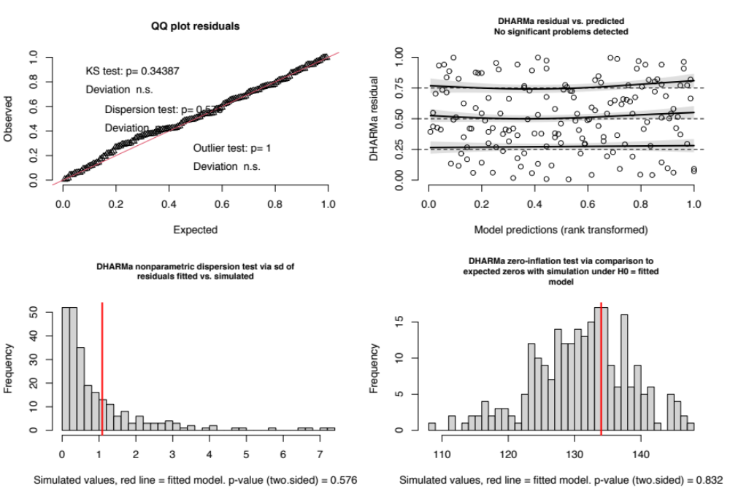

Figure S1. Simulation-based residual diagnostics using the DHARMa package for the best-fitting binomial GLMM selected (Model rank 1). (A) Quantile-quantile (QQ) plot of residuals comparing observed vs. expected residual distributions for model validation, indicating good overall fit. (B) Residuals vs. predicted values plot showing scaled DHARMa residuals plotted against rank-transformed model predictions. The black lines represent smoothed trends, and the shaded regions indicate confidence intervals, showing no systematic deviation. C) Histogram of simulated dispersion values compared to the fitted model (red line). The DHARMa nonparametric dispersion test (based on the standard deviation of fitted vs. simulated residuals) indicated no significant overdispersion (dispersion = 1.12, p = 0.576). (D) Histogram of simulated zero counts compared to the observed data, showing no excess zeros. The DHARMa zero-inflation test (based on the ratio of observed to simulated zeros) yielded ratioObsSim = 1.02, confirming that zero inflation was not significant.

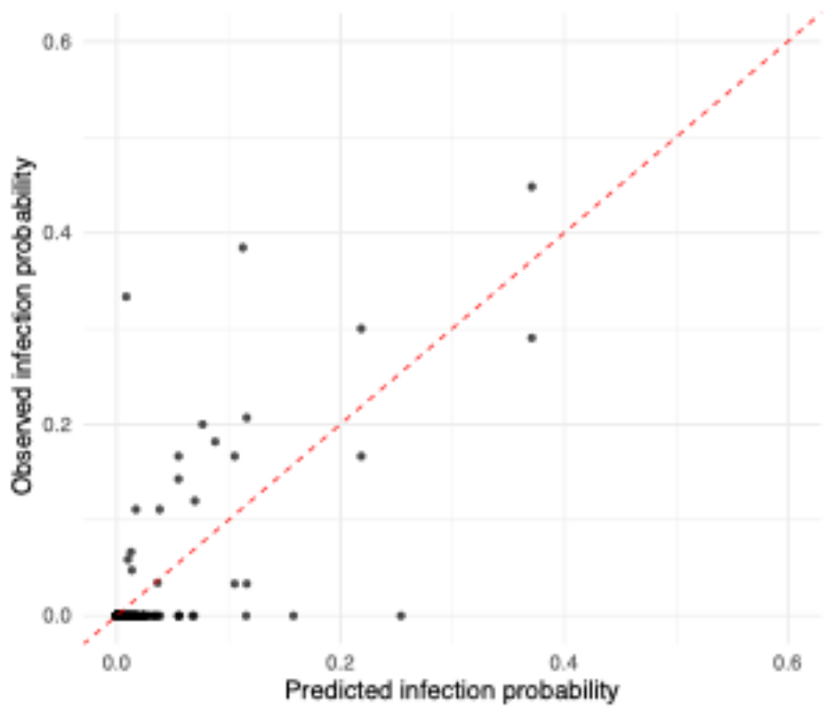

Figure S2. Relationship between observed and model-averaged predicted probabilities of Batrachochytrium dendrobatidis (Bd) infection across Catalonia. Each point represents the observed proportion of Bd-positive individuals per sampling unit, plotted against the corresponding model-averaged predicted infection probability derived from the set of top GLMMs (ΔAICc < 2). The dashed red line indicates the 1:1 relationship. Predictions generally followed observed values, with most observations clustering near zero, reflecting the overall low infection prevalence across sites.

Table S7. Descriptive values of the explanatory variables at each sampling point. For the quantitative ones, the median (minimum and maximum) of the years is presented. For qualitative ones, the category is shown. Pos/N represents the number of positive samples by the total number of samples analysed. See the main text in supplementary materials for the description of each variable.
Point ID | Pos/N | Anth Ind | Sp rich Ind | Bioregion | Habitat type | Altitude | Tmax summer | Total prec | Total prec 90days
Point 1 | 0/51 | -1.39 | 2 | Mesomediterranean | Reservoir artificial | 399.05 | 30.32  (29.7, 30.4) | 5.75  (3.9, 7.3) | 1.13  (0.6, 3.4)
Point 2 | 0/31 | -0.41 | 1 | Mesomediterranean | Reservoir artificial | 226.91 | 30.32  (30.3, 30.3) | 3.86  (3.9, 3.9) | 1.02  (1.0, 1.0)
Point 3 | 3/60 | 0.52 | 9 | Mountaineous | Reservoir artificial | 527.01 | 27.39  (25.7, 28.7) | 14.45  (11.5, 15.5) | 4.77  (4.1, 5.1)
Point 4 | 50/410 | -0.29 | 6 | Mountaineous | Stream | 706.05 | 24.93  (23.3, 25.9) | 12.07  (10.7, 13.2) | 3.51  (1.8, 5.1)
Point 5 | 0/34 | -0.80 | 1 | Marsh | Reservoir | 0.22 | 29.52  (28.4, 30.4) | 6.60  (5.8, 8.7) | 1.36  (0.9, 3.7)
Point 6 | 0/17 | 1.56 | 10 | Mountaineous | Road | 539.73 | 27.85  (27.5, 28.2) | 10.63  (9.4, 11.9) | 2.21  (1.5, 3.3)
Point 7 | 0/22 | 1.08 | 2 | Thermomediterranean | Reservoir artificial | 5.03 | 30.17  (29.9, 30.5) | 5.69  (3.7, 7.7) | 2.02  (0.7, 3.3)
Point 8 | 0/28 | -0.71 | 1 | Marsh | Reservoir | 0.43 | 28.58  (27.3, 29.3) | 6.22  (2.9, 7.0) | 1.35  (0.7, 2.3)
Point 9 | 0/31 | -0.77 | 1 | Marsh | Reservoir | 0.47 | 28.90  (28.4, 29.7) | 0.88  (0.5, 1.3) | 0.28  (0.1, 0.4)
Point 10 | 0/53 | 1.13 | 10 | Mountaineous | Reservoir artificial | 562.19 | 27.50  (26.6, 29.0) | 11.08  (9.4, 14.0) | 3.32  (1.5, 4.1)
Point 11 | 0/43 | 1.13 | 10 | Mountaineous | Reservoir artificial | 693.51 | 27.18  (26.3, 28.7) | 11.35  (9.9, 15.3) | 2.96  (1.7, 3.4)
Point 12 | 0/138 | -1.46 | 1 | Subalpine | Reservoir | 2368.43 | 17.88  (17.1, 19.9) | 12.57  (11.3, 13.9) | 3.39  (3.0, 5.0)
Point 13 | 0/9 | -1.23 | 4 | Subalpine | Reservoir | 2127.45 | 17.40  (17.4, 17.4) | 15.05  (15.0, 15.0) | 4.09  (4.1, 4.1)
Point 14 | 0/151 | -1.76 | 3 | Alpine | Reservoir | 2240.40 | 19.99  (18.1, 20.8) | 14.36  (13.7, 15.1) | 4.04  (3.8, 5.6)
Point 15 | 1/179 | -0.97 | 4 | Subalpine | Reservoir artificial | 1590.04 | 22.30  (20.9, 23.1) | 10.08  (9.9, 17.2) | 3.20  (1.3, 4.5)
Point 16 | 0/100 | -1.95 | 1 | Subalpine | Reservoir artificial | 2244.88 | 20.11  (19.5, 21.6) | 10.87  (10.2, 16.7) | 4.05  (1.8, 5.8)
Point 17 | 0/44 | -0.92 | 3 | Subalpine | Reservoir | 2127.24 | 20.97  (21.0, 21.0) | 10.28  (10.3, 10.3) | 2.01  (2.0, 2.0)
Point 18 | 0/47 | -0.99 | 3 | Mesomediterranean | Reservoir artificial | 202.96 | 30.07  (29.5, 30.4) | 5.78  (3.7, 7.4) | 1.06  (0.7, 3.5)
Point 19 | 58/252 | 5.56 | 3 | Mesomediterranean | Reservoir artificial | 106.24 | 27.82  (26.9, 29.0) | 3.85  (2.8, 4.9) | 0.76  (0.4, 1.2)
Point 20 | 1/12 | 1.14 | 2 | Thermomediterranean | Reservoir | 3.15 | 30.46  (30.5, 30.5) | 7.69  (7.7, 7.7) | 3.30  (3.3, 3.3)
Point 21 | 3/50 | -0.58 | 4 | Mesomediterranean | Reservoir artificial | 950.73 | 30.86  (30.7, 31.4) | 5.97  (4.1, 6.9) | 1.23  (0.5, 2.7)
Point 22 | 0/20 | -0.17 | 3 | Mesomediterranean | Reservoir artificial | 300.89 | 29.97  (30.0, 30.0) | 6.28  (6.3, 6.3) | 1.43  (1.4, 1.4)
Point 23 | 6/84 | 1.19 | 10 | Mountaineous | Reservoir artificial | 561.51 | 27.50  (26.6, 29.0) | 11.08  (9.4, 14.0) | 3.08  (1.7, 3.3)
Point 24 | 8/52 | 1.10 | 10 | Mountaineous | Reservoir artificial | 518.94 | 27.99  (26.7, 29.2) | 10.26  (9.5, 15.0) | 3.42  (1.8, 4.0)
Point 25 | 0/48 | -0.27 | 2 | Mountaineous | Reservoir artificial | 934.81 | 20.80  (20.4, 21.2) | 12.80  (12.4, 13.2) | 4.36  (3.4, 5.3)
Point 26 | 0/10 | -2.08 | 2 | Subalpine | Stream | 1456.36 | 18.01  (18.0, 18.0) | 14.50  (14.5, 14.5) | 3.69  (3.7, 3.7)
Point 27 | 0/115 | -1.07 | 5 | Subalpine | Stream | 1383.91 | 21.43  (20.9, 23.1) | 10.96  (9.9, 17.2) | 3.41  (1.3, 5.9)
Point 28 | 7/133 | 0.61 | 5 | Mesomediterranean | Reservoir | 14.91 | 28.97  (26.9, 29.5) | 5.94  (3.9, 8.5) | 0.81  (0.3, 2.9)
Point 29 | 1/49 | -0.01 | 5 | Marsh | Reservoir | 2.31 | 28.97  (28.6, 29.0) | 5.94  (3.9, 5.9) | 1.06  (0.4, 1.2)
Point 30 | 0/120 | 0.15 | 6 | Mountaineous | Stream | 619.78 | 26.35  (25.6, 28.4) | 14.09  (11.1, 14.8) | 4.63  (3.1, 5.1)
Point 31 | 0/31 | -0.88 | 3 | Mountaineous | Stream | 1428.62 | 21.43  (21.4, 21.7) | 17.21  (12.3, 17.2) | 5.70  (3.7, 6.0)
Point 32 | 1/55 | 0.79 | 10 | Mesomediterranean | Reservoir artificial | 734.46 | 27.50  (26.8, 29.0) | 10.32  (9.4, 11.9) | 2.79  (1.5, 3.9)
Point 33 | 0/11 | 1.25 | 10 | Mountaineous | Road | 605.73 | 26.74  (26.6, 26.8) | 12.15  (10.3, 14.0) | 3.47  (2.8, 4.1)
Point 34 | 0/228 | -1.12 | 5 | Subalpine | Stream | 1426.21 | 21.43  (20.9, 23.1) | 10.96  (9.9, 17.2) | 3.53  (1.3, 6.0)
Point 35 | 0/58 | -1.45 | 3 | Mountaineous | Stream | 1138.53 | 21.78  (21.7, 23.7) | 9.53  (8.1, 13.0) | 1.77  (1.7, 3.2)
Point 36 | 0/214 | -1.60 | 3 | Subalpine | Stream | 2135.99 | 20.28  (18.8, 21.8) | 13.10  (12.1, 14.1) | 3.77  (3.3, 5.2)
Point 37 | 0/144 | -0.38 | 5 | Mountaineous | Stream | 1215.00 | 21.80  (21.5, 23.9) | 11.33  (8.2, 13.1) | 3.08  (1.8, 5.1)
Point 38 | 2/21 | -0.18 | 1 | Marsh | Reservoir | 1.17 | 29.89  (28.3, 30.5) | 7.69  (3.7, 8.1) | 1.75  (1.4, 3.8)
Point 39 | 0/33 | -0.97 | 2 | Mountaineous | Stream | 1575.82 | 20.53  (20.5, 20.5) | 10.27  (10.3, 10.3) | 2.06  (2.1, 2.1)
Point 40 | 0/8 | 1.07 | 10 | Mesomediterranean | Reservoir artificial | 598.84 | 26.83  (26.8, 26.8) | 10.32  (10.3, 10.3) | 2.84  (2.8, 2.8)
Point 41 | 0/45 | 6.12 | 3 | Mesomediterranean | Reservoir artificial | 6.49 | 29.31  (29.3, 29.3) | 3.86  (3.9, 3.9) | 0.98  (1.0, 1.0)

Table S8. Descriptive values of variables composing the anthropogenic index showed by sampling point. See the main text of supplementary materials for the description of each variable.

Point_ID | Name | PopDens | Sum_Nit | Dist_pop | Urb_percent | Road_dens
Point 1 | Bassa de les Collades | 81.10 | 10664.04 | 5505.73 | 0.71 | 0.0030
Point 2 | Basses d'en Borràs | 81.10 | 52144.14 | 2073.84 | 1.88 | 0.0044
Point 3 | Basses de Can Jordà | 83.50 | 317121.85 | 1527.22 | 7.60 | 0.0076
Point 4 | Bolòs, Camprodon | 27.00 | 148186.65 | 2026.27 | 1.97 | 0.0048
Point 5 | Bruguera | 81.10 | 107898.65 | 4233.46 | 6.02 | 0.0039
Point 6 | Camins | 134.50 | 1346864.52 | 1109.96 | 11.56 | 0.0091
Point 7 | Campredó | 81.10 | 594475.74 | 413.25 | 9.30 | 0.0084
Point 8 | Canal Vell | 81.10 | 49649.27 | 2902.54 | 3.55 | 0.0033
Point 9 | Centre Ictiològic | 95.50 | 19559.20 | 2209.04 | 1.92 | 0.0024
Point 10 | El Collell | 134.50 | 990370.38 | 1986.69 | 11.62 | 0.0088
Point 11 | El Pujol | 134.50 | 896000.00 | 747.02 | 7.73 | 0.0082
Point 12 | Estany Sec, Malniu | 36.40 | 25207.83 | 1930.71 | 0.20 | 0.0014
Point 13 | Estany d'Aixeus accessori | 5.30 | 32916.46 | 4205.47 | 0.10 | 0.0010
Point 14 | Estany de Baciver de Baix | 5.30 | 0.00 | 3757.07 | 1.09 | 0.0018
Point 15 | Estany de Buixase | 5.30 | 1912.51 | 5109.44 | 0.01 | 0.0005
Point 16 | Estany del Tarter | 27.00 | 133275.41 | 3584.47 | 0.47 | 0.0028
Point 17 | Estany dels Infants, Ulldeter | 27.00 | 4888.25 | 6263.69 | 0.11 | 0.0007
Point 18 | Font de Tita | 81.10 | 22022.40 | 4874.07 | 2.06 | 0.0045
Point 19 | Fonts de Mossen Cinto Verdaguer | 15876.30 | 5565.60 | 3152.66 | 97.54 | 0.0137
Point 20 | Jardí del Bou | 95.50 | 467280.17 | 1425.87 | 13.19 | 0.0098
Point 21 | La Mussara | 289.20 | 29602.58 | 2897.23 | 1.16 | 0.0044
Point 22 | Mas de Barberans | 95.50 | 282166.99 | 224.43 | 1.00 | 0.0028
Point 23 | Mas el Colomer | 134.50 | 1133370.02 | 1865.10 | 11.04 | 0.0086
Point 24 | Masferrer | 134.50 | 1399087.19 | 3365.37 | 12.54 | 0.0088
Point 25 | Mollera d'Escalarre | 5.30 | 132557.69 | 721.84 | 1.70 | 0.0033
Point 26 | Pla de Boavi | 5.30 | 0.00 | 6687.13 | 0.01 | 0.0005
Point 27 | Pont de les Ribes | 27.00 | 83057.43 | 3340.05 | 0.41 | 0.0021
Point 28 | Reserva Integral 1 Els estanys | 108.10 | 373195.84 | 1395.04 | 15.29 | 0.0065
Point 29 | Reserva Integral 2 Les llaunes | 108.10 | 435138.06 | 3586.74 | 14.58 | 0.0054
Point 30 | Riera de Falgars | 83.50 | 313324.81 | 1435.57 | 2.28 | 0.0060
Point 31 | Riera del Catllar | 27.00 | 174937.73 | 2622.97 | 0.39 | 0.0020
Point 32 | Seva | 134.50 | 375560.44 | 811.99 | 8.41 | 0.0080
Point 33 | Tona | 134.50 | 833852.52 | 694.34 | 11.18 | 0.0085
Point 34 | Torrent de Joan Déu | 27.00 | 83057.43 | 3569.23 | 0.41 | 0.0020
Point 35 | Torrent de Mascarida | 5.30 | 6583.90 | 4964.27 | 0.07 | 0.0012
Point 36 | Torrent de Pi | 36.40 | 253509.76 | 1846.98 | 2.15 | 0.0035
Point 37 | Torrent de la Muga | 34.30 | 12424.38 | 4866.57 | 0.08 | 0.0020
Point 38 | Ullals de Baltasar | 95.50 | 293968.90 | 3993.87 | 7.91 | 0.0064
Point 39 | Vall Llosera | 134.50 | 438076.77 | 782.69 | 12.14 | 0.0088
Point 40 | Vall de la Llosa | 36.40 | 66427.23 | 2440.05 | 0.34 | 0.0016
Point 41 | Zoo de Barcelona | 15876.30 | 5565.60 | 200.00 | 96.51 | 0.0135

