Supplemental Material for
Meals That Heal: A Randomized Controlled Trial Testing the Feasibility of Commercial Meal Delivery as a Convenient Dietary Intervention for Depression

Table of Contents

Tables and Figures referred to in the main text begin on page 2.
Protocol-related materials begin on page 16.

**additional protocol details, including a master grid outlining timing of study tasks can be found on the OSF project page (https://osf.io/pcufr).

Abbreviations:
NG = nutritional guidance

Tables and Figures referred to in the results section:

SM Table A. Differences in Age and Baseline BMI, PHQ, and Dietary Quality based on condition.

 | NG M (SD) | Meal M (SD) | Welch’s t | df | p
Age | 39.27 (14.16) | 38.80 (12.43) | -.09 | 18.52 | .93
BMI | 27.34 (5.73) | 28.72 (5.10) | .67 | 18.74 | .51
PHQ | 13.09 (4.16) | 13.95 (3.03) | .60 | 15.99 | .56
Dietary Quality | 5.16 (2.33) | 4.72 (2.06) | -.52 | 18.66 | .61

SM Table B. Differences in Sex, Race, Ethnicity, and Depression Treatment based on condition. Descriptive counts for each variable are included in the main text, Table 1.

 | χ² | df | p
Sex | .02 | 1 | .90
Race  Asian  Black or African American  White  Not Listed | .69  1.88  5.10  1.88 | 1  1  1  1 | .41  .17  .07  .17
Ethnicity | 1.18 | 1 | .28
Depression Treatment  Medication  Therapy | .13  .06 | 1  1 | .72  .81

SM Figure A. Trajectories of dietary quality across each visit (one plot).

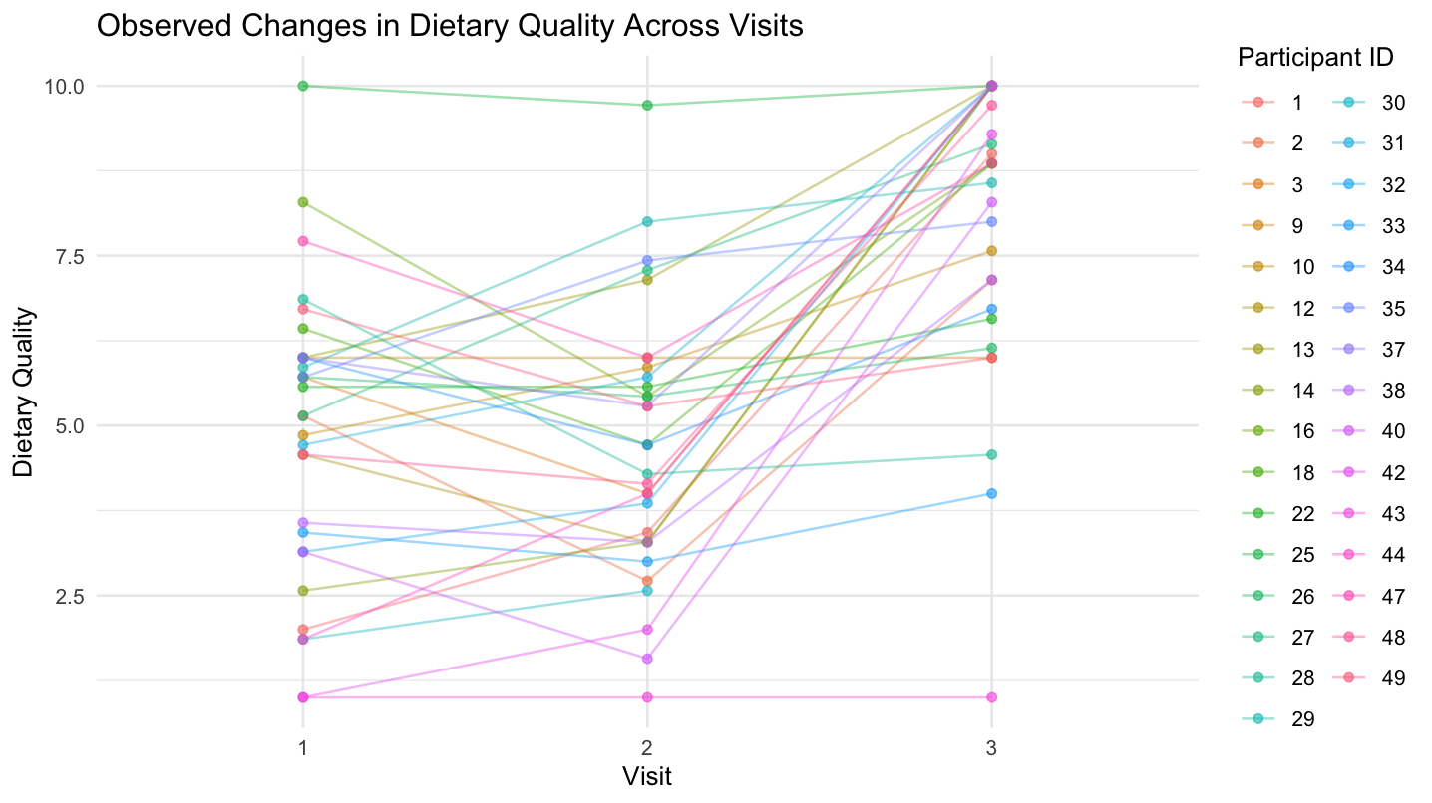

SM Figure B. Individual plots of trajectories in dietary quality across each visit. The nutritional guidance participants are indicated by the green boxes.

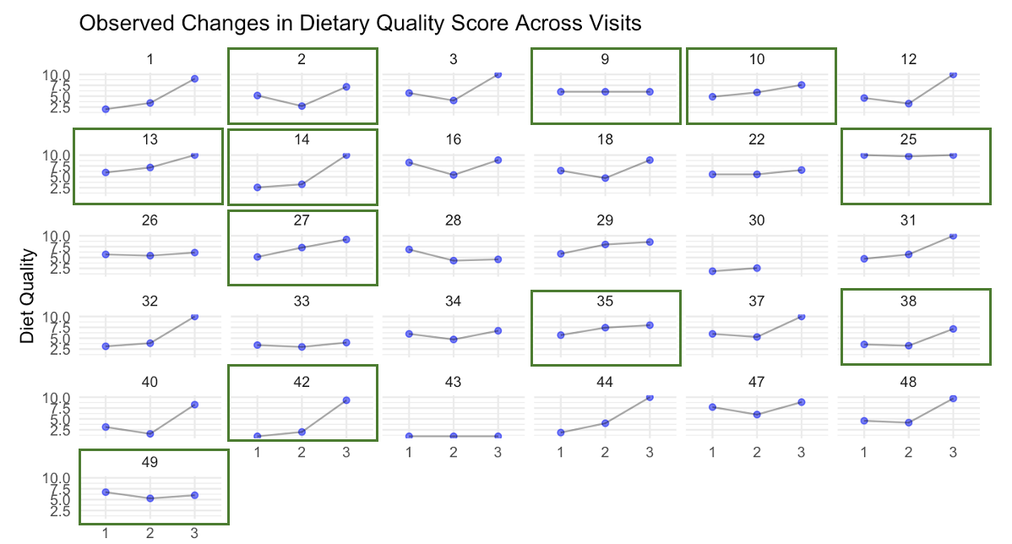

Table C. Linear-mixed model predicting dietary quality based on study assessment, intervention condition (coded 1 = meal delivery, 0 = nutritional guidance), and the interaction between study assessment and intervention condition. Visit 2 (pre-intervention) is the reference group for Visit.

 | Dietary Quality
Predictors | Estimates | SE | 95% CI | p | semipartial R²
(Intercept) | 5.45 | 0.63 | 4.19 – 6.72 | <0.01
Visit 1 | -0.30 | 0.70 | -1.69 – 1.09 | 0.67 | .001
Visit 3 | 2.75 | 0.70 | 1.36 – 4.15 | <0.01 | .09
Condition | -1.15 | 0.79 | -2.73 – 0.42 | 0.15 | .02
Visit 1*Condition | 0.72 | 0.87 | -1.01 – 2.46 | 0.41 | .01
Visit 3*Condition | 0.83 | 0.88 | -0.91 – 2.58 | 0.35 | .01
Random Effects
σ² | 2.70
τ₀₀ _{ID} | 1.73
ICC | 0.39
N _{ID} | 31
Observations | 92
Marginal R² / Conditional R² | 0.35 / 0.61

Table D. Linear-mixed model predicting added sugar based on study assessment, intervention condition (coded 1 = meal delivery, 0 = nutritional guidance), and the interaction between study assessment and intervention condition. Visit 2 (pre-intervention) is the reference group for Visit.
 | Added Sugars
Predictors | Estimates | std. Error | CI | p
(Intercept) | 44.79 | 11.59 | 21.73 – 67.85 | <0.001
Visit 1 | 11.34 | 11.37 | -11.27 – 33.95 | 0.321
Visit 3 | -27.02 | 11.37 | -49.63 – -4.41 | 0.020
Condition | 28.64 | 14.44 | -0.07 – 57.34 | 0.051
Visit 1*Condition | -18.39 | 14.16 | -46.54 – 9.76 | 0.197
Visit 3*Condition | -14.56 | 14.24 | -42.88 – 13.77 | 0.310
Random Effects
σ² | 711.00
τ₀₀ _{ID} | 767.81
ICC | 0.52
N _{ID} | 31
Observations | 92
Marginal R² / Conditional R² | 0.205 / 0.618

SM Table E. Linear-mixed model predicting dietary fiber based on study assessment, intervention condition (coded 1 = meal delivery, 0 = nutritional guidance), and the interaction between study assessment and intervention condition. Visit 2 (pre-intervention) is the reference group for Visit.
 | Dietary Fiber
Predictors | Estimates | std. Error | CI | p
(Intercept) | 25.54 | 4.05 | 17.49 – 33.58 | <0.001
Visit 1 | -2.19 | 4.42 | -10.98 – 6.60 | 0.622
Visit 3 | 14.99 | 4.42 | 6.20 – 23.79 | 0.001
Condition | -7.96 | 5.04 | -17.98 – 2.06 | 0.118
Visit 1*Condition | 5.77 | 5.51 | -5.18 – 16.72 | 0.297
Visit 3*Condition | 10.73 | 5.54 | -0.28 – 21.74 | 0.056
Random Effects
σ² | 107.57
τ₀₀ _{ID} | 72.62
ICC | 0.40
N _{ID} | 31
Observations | 92
Marginal R² / Conditional R² | 0.369 / 0.623

SM Table F. Linear-mixed model predicting calorie intake based on study assessment, intervention condition (coded 1 = meal delivery, 0 = nutritional guidance), and the interaction between study assessment and intervention condition. Visit 2 (pre-intervention) is the reference group for Visit.

Regression Results
 | Estimated Calorie Intake
Predictors | Estimates | std. Error | CI | p
(Intercept) | 2088.42 | 121.47 | 1846.86 – 2329.97 | <0.001
Visit 1 | 12.90 | 33.66 | -54.04 – 79.84 | 0.703
Visit 3 | -15.54 | 33.66 | -82.48 – 51.40 | 0.645
Condition | 80.44 | 151.23 | -220.29 – 381.17 | 0.596
Visit 1*Condition | -23.80 | 41.91 | -107.14 – 59.54 | 0.572
Visit 3*Condition | 26.31 | 42.20 | -57.60 – 110.23 | 0.535
Random Effects
σ² | 6232.21
τ₀₀ _{ID} | 156069.87
ICC | 0.96
N _{ID} | 31
Observations | 92
Marginal R² / Conditional R² | 0.010 / 0.962

SM Table G. Linear-mixed model predicting BMI based on study assessment, intervention condition (coded 1 = meal delivery, 0 = nutritional guidance), and the interaction between study assessment and intervention condition. Visit 2 (pre-intervention) is the reference group for Visit.

Regression Results
 | BMI(kg/m 2)
Predictors | Estimates | std. Error | CI | p
(Intercept) | 27.35 | 1.59 | 24.19 – 30.52 | <0.001
Visit 1 | -0.02 | 0.17 | -0.36 – 0.33 | 0.917
Visit 3 | -0.33 | 0.17 | -0.67 – 0.02 | 0.063
Condition | 1.25 | 1.98 | -2.70 – 5.19 | 0.531
Visit 1*Condition | 0.15 | 0.22 | -0.28 – 0.59 | 0.487
Visit 3*Condition | 0.04 | 0.22 | -0.40 – 0.47 | 0.868
Random Effects
σ² | 0.17
τ₀₀ _{ID} | 27.72
ICC | 0.99
N _{ID} | 31
Observations | 92
Marginal R² / Conditional R² | 0.015 / 0.994

SM Table H. Linear-mixed model predicting dietary quality based on study assessment, race (coded 1 = White, 0 = not White), intervention condition (coded 1 = meal delivery, 0 = nutritional guidance), and the interaction between study assessment and intervention condition. Visit 2 (pre-intervention) is the reference group for Visit.

Regression Results
 | Quality
Predictors | Estimates | std. Error | CI | p
(Intercept) | 5.42 | 0.77 | 3.89 – 6.95 | <0.001
Visit 1 | -0.30 | 0.70 | -1.69 – 1.10 | 0.671
Visit 3 | 2.75 | 0.70 | 1.36 – 4.15 | <0.001
Condition | -1.18 | 0.84 | -2.86 – 0.50 | 0.167
Race | 0.07 | 0.78 | -1.48 – 1.61 | 0.932
Visit 1*Condition | 0.72 | 0.87 | -1.02 – 2.46 | 0.411
Visit 3*Condition | 0.83 | 0.88 | -0.91 – 2.58 | 0.346
Random Effects
σ² | 2.70
τ₀₀ _{ID} | 1.82
ICC | 0.40
N _{ID} | 31
Observations | 92
Marginal R² / Conditional R² | 0.349 / 0.611

Figure C. Histograms illustrating the participants’ success at following study instructions each condition.

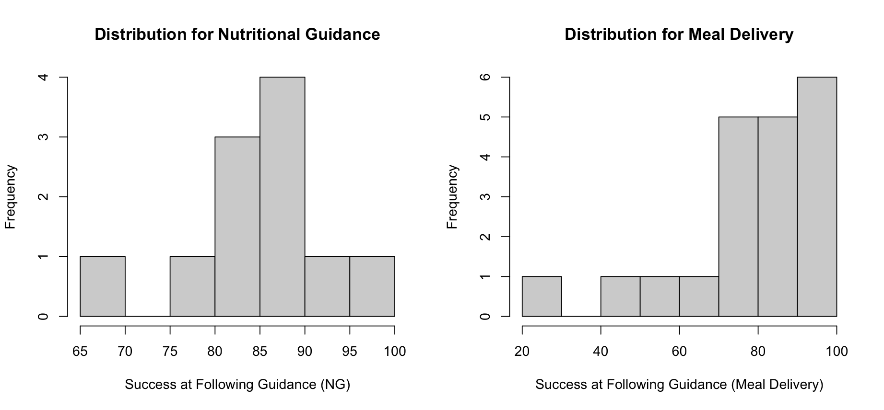

Figure D. Histograms illustrating the participants’ plans to continue to follow the study-provided nutritional guidance after the study in the NG condition, and participants’ plans to continue the meal delivery service after the study in the meal condition.

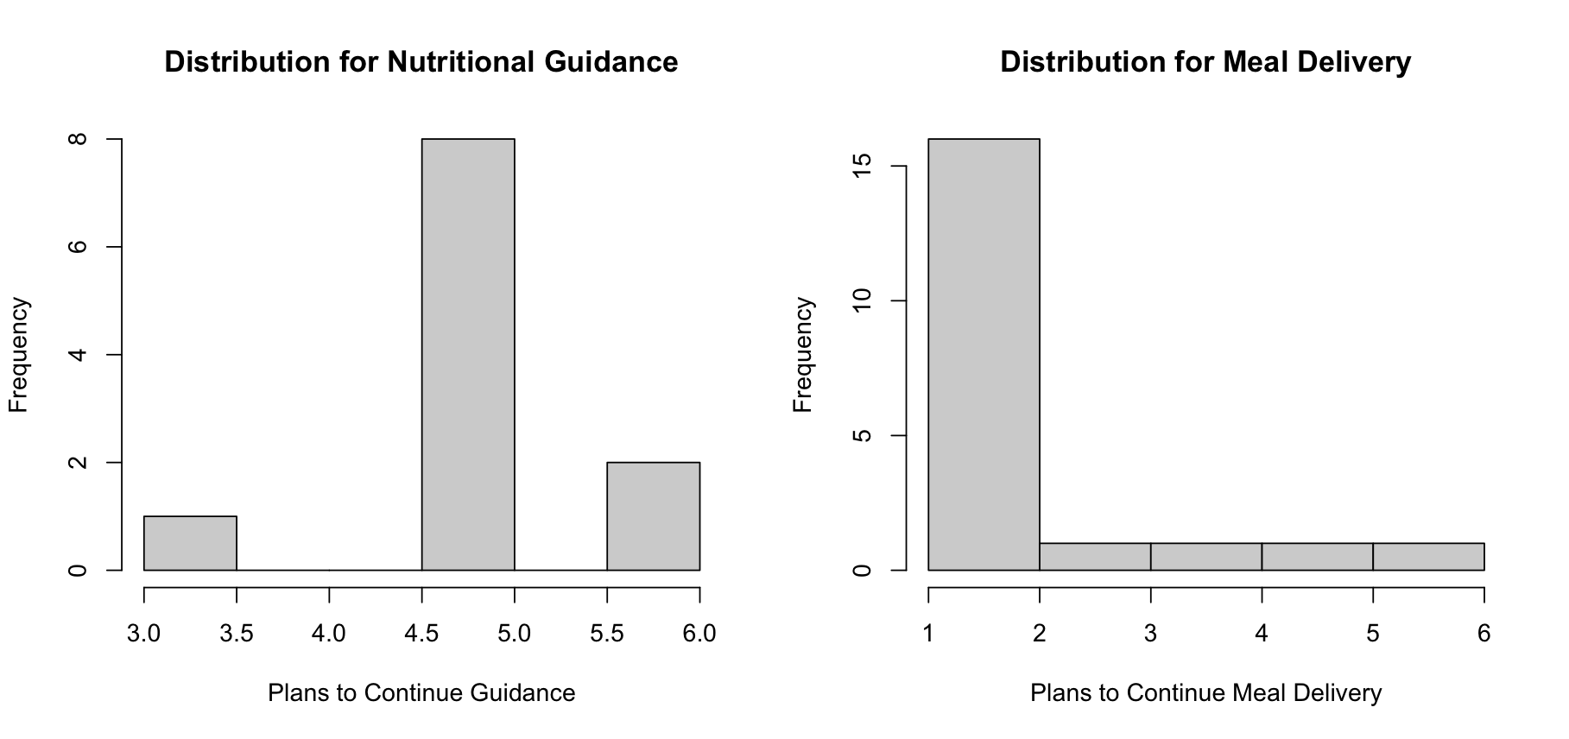

Figure E. Histograms illustrating the similarity of participants’ regular diets (i.e., pre-intervention) to the study-provided nutritional guidance in the NG condition, and the similarity of participants’ regular diets to the delivered meals in the meal condition.
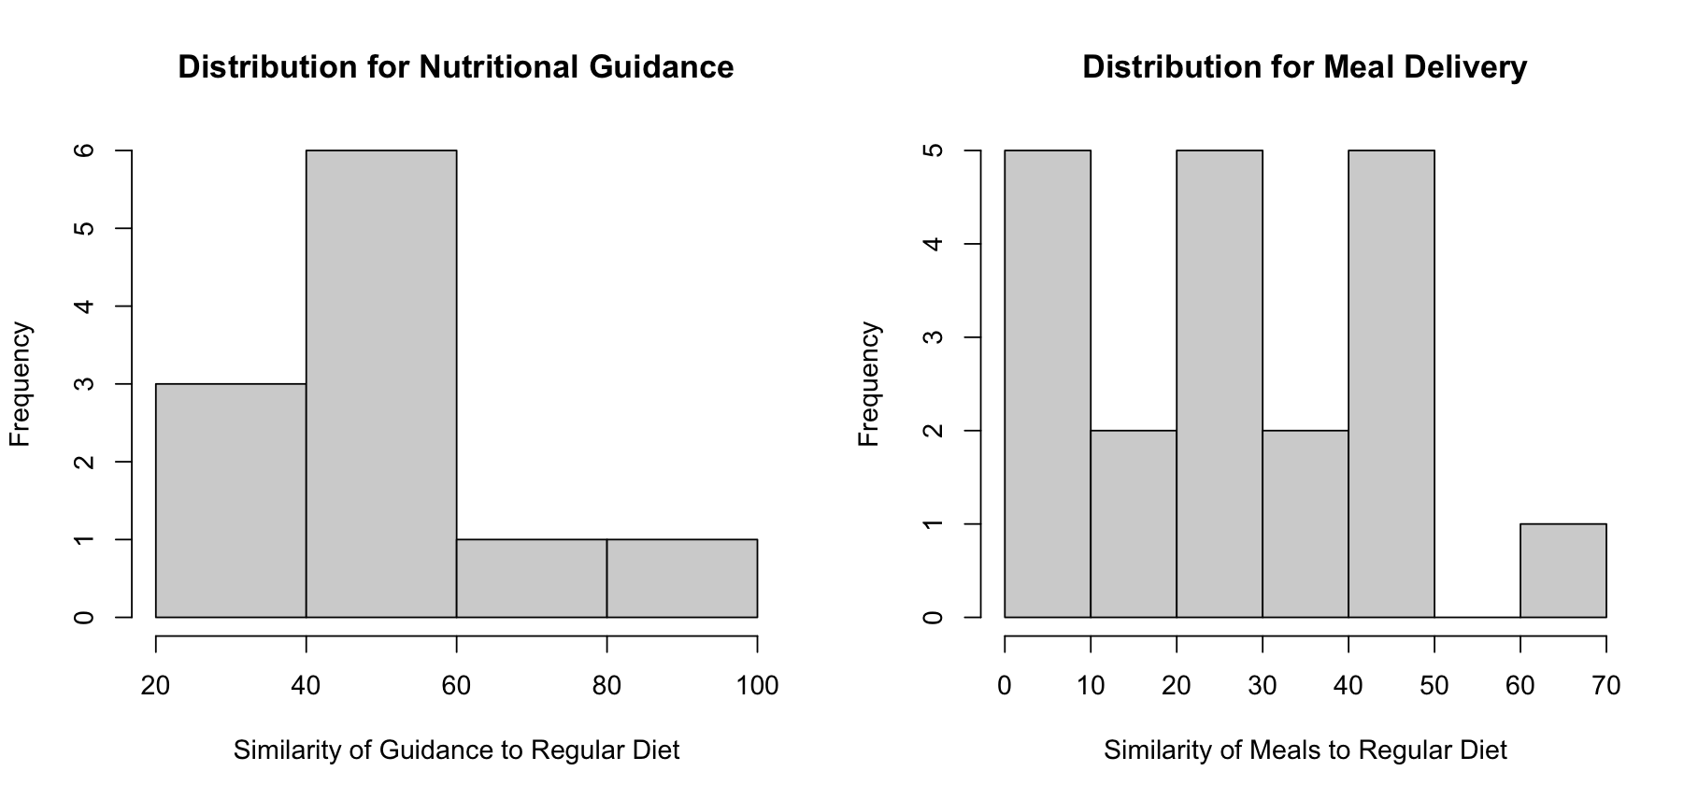

Figure F. Histograms illustrating the distribution of the perceived tastiness and fillingness of meals delivered to participants in the meal condition.
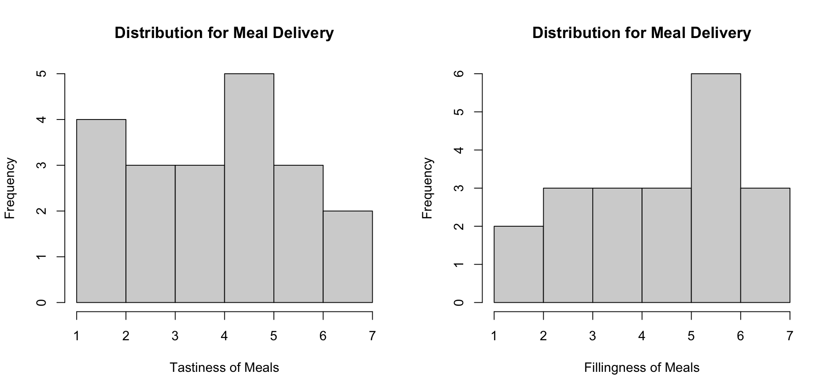

Figure G. Histograms illustrating the perceived impact of study-provided nutritional guidance on mental health for participants in the nutritional guidance condition, and the perceived impact of the meal delivery service on mental health for participants in the meal condition.
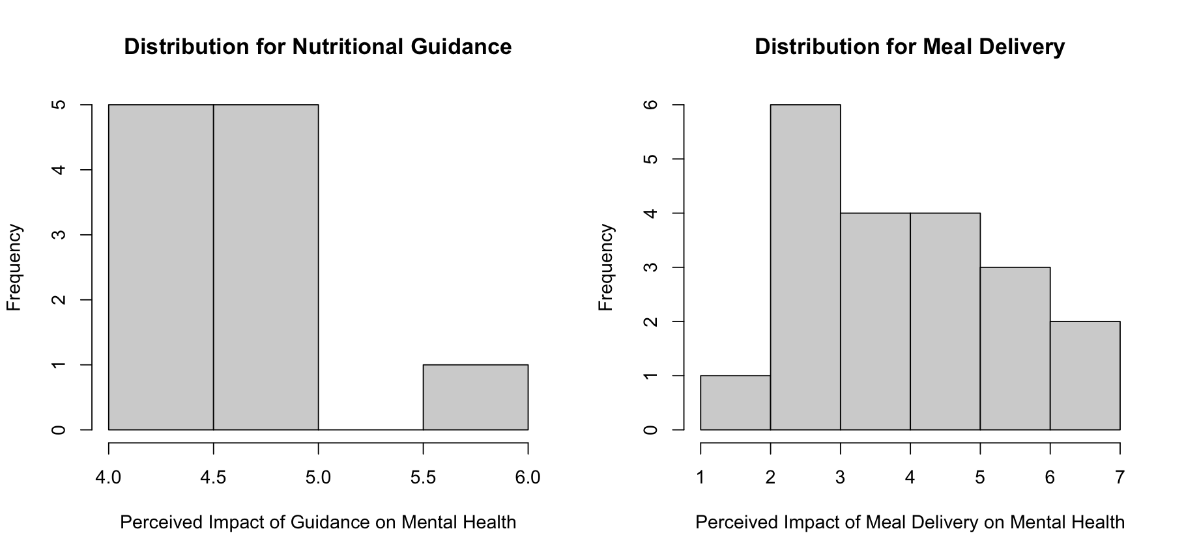

Table M. Correlations between responses to debriefing questions.

 | Nutritional  Guidance  (n = 11) |  | Meal  Delivery  (n = 20)
 | 1 | 2 | 3 | 4 | 5 | 6
1. Similarity of NG to regular diet | -
2. Impact of NG on mental health | .31 | -
3. Intentions to continue NG | .31 | .57†
4. Similarity of meals to regular diet |  |  | -
5. Impact of meal delivery on mental health |  |  | .13 | -
6. Intentions to continue meal delivery |  |  | .29 | .34 | -
7. Tastiness of meals |  |  | .25 | .68*** | .48* | -
8. Fillingness of meals |  |  | .55* | .34 | .00 | .37

Note: †p < .10, *p < .05, **p < .01, ***p < .001

SM Figure H. Trajectories of PHQ-8 scores across each assessment (one plot).
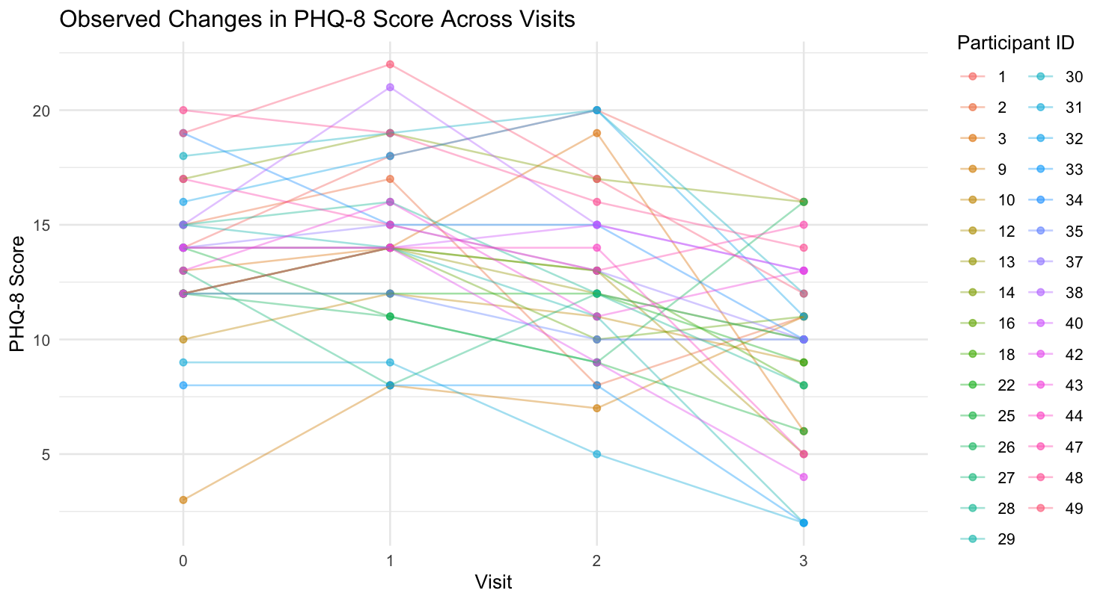

SM Figure I. Individual plots of trajectories in PHQ-8 scores across each assessment. The nutritional guidance participants are indicated by the green boxes.

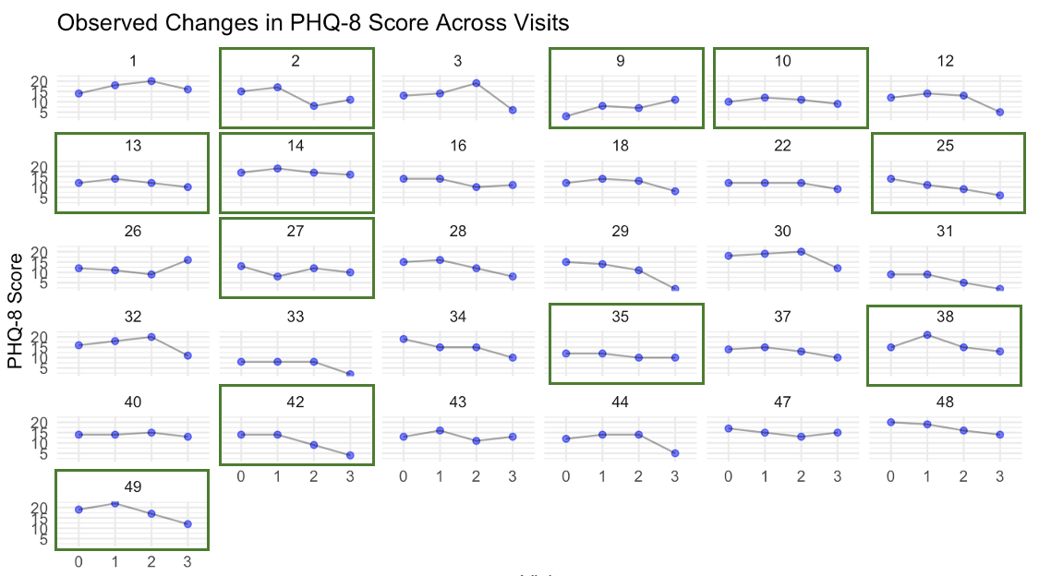

SM Table N. Linear-mixed model predicting PHQ-8 based on study assessment, intervention condition (coded 1 = meal delivery, 0 = nutritional guidance), and the interaction between study assessment and intervention condition. Visit 2 (pre-intervention) is the reference group for Visit.

Regression Results
 | PHQ
Predictors | Estimates | std. Error | CI | p | Semipartial R²
(Intercept) | 11.55 | 1.15 | 9.27 – 13.82 | <0.001
Remote assessment | 1.55 | 1.07 | -0.57 – 3.66 | 0.151 | .01
Visit 1 | 2.82 | 1.07 | 0.70 – 4.93 | 0.010 | .02
Visit 3 | -1.36 | 1.07 | -3.48 – 0.75 | 0.204 | .01
Condition | 1.90 | 1.43 | -0.93 – 4.74 | 0.186 | .01
Remote*Condition | -1.05 | 1.33 | -3.68 – 1.59 | 0.433 | .002
Visit 1*Condition | -1.82 | 1.33 | -4.45 – 0.82 | 0.174 | .01
Visit 3*Condition | -2.69 | 1.33 | -5.32 – -0.05 | 0.046 | .01
Random Effects
σ² | 6.28
τ₀₀ _{ID} | 8.27
ICC | 0.57
N _{ID} | 31
Observations | 124
Marginal R² / Conditional R² | 0.196 / 0.653

SM Table O. Linear-mixed model predicting PHQ-8 based on study assessment, race (coded 1 = White, 0 = not White), BMI, intervention condition (coded 1 = meal delivery, 0 = nutritional guidance), and the interaction between study assessment and intervention condition. Visit 2 (pre-intervention) is the reference group for Visit.

Regression Results
 | PHQ
Predictors | Estimates | std. Error | CI | p
(Intercept) | 12.68 | 1.38 | 9.94 – 15.42 | <0.001
Remote assessment | 1.55 | 1.07 | -0.57 – 3.66 | 0.151
Visit 1 | 2.82 | 1.07 | 0.70 – 4.93 | 0.010
Visit 3 | -1.36 | 1.07 | -3.48 – 0.75 | 0.204
Condition | 2.64 | 1.50 | -0.34 – 5.62 | 0.082
Race | -2.08 | 1.45 | -4.94 – 0.79 | 0.154
Remote*Condition | -1.05 | 1.33 | -3.68 – 1.59 | 0.433
Visit 1*Condition | -1.82 | 1.33 | -4.45 – 0.82 | 0.174
Visit 3*Condition | -2.69 | 1.33 | -5.32 – -0.05 | 0.046
Random Effects
σ² | 6.28
τ₀₀ _{ID} | 7.92
ICC | 0.56
N _{ID} | 31
Observations | 124
Marginal R² / Conditional R² | 0.228 / 0.659

Protocol-related materials

Timing of Tasks Completed Throughout the Study.

Pre-Consent Screening
- Part 1 of screening set to skip logic to auto-screen out when a criterion for inclusion is not met
- Part 2 of the screening required review by member of study team to determine eligibility

Remote Consent Visit
- Remote consent via REDCap
  - PHQ-8 Eligibility Check: inclusion of 10 or above
  - Consent to participate
  - Scheduling of in-lab Visits 1, 2, and 3.

Initial Remote Survey via REDCap (to be completed before Visit 1)
  - PHQ-8
  - Food Craving Questionnaire – Trait-reduced (FCQ-T-r)
  - Yale Food Addiction 2.0 (YFAS 2.0)
  - Night Eating Questionnaire (NEQ)
  - Power of Food Scale (PoFS)
  - Questionnaire for Eating and Weight Patterns-Revised (QEWP-R) (highlighted Qs only)
  - Palatable Eating Motives Scale-7 (PEMS-7)
  - UPPS-P (positive and negative urgency subscales)
  - Barratt Impulsivity Scale (BIS-11)
  - Difficulties in Emotion Regulation Scale (DERS)
  - Alcohol / Caffeine Typical Daily Use
  - Family Tree Questionnaire (FTQ) – All substances including Food Addiction
  - Substance Use Questionnaires (all substances)
  - Coping Strategy Inventory – Short Form (CSI-SF)
  - Morning-Eveningness Measure
  - Adverse Childhood Experiences (ACES)
  - PTSD Checklist for DSM-5 (Abbreviated PCL-5)
  - Pittsburgh Sleep Quality Index (PSQI) – original timeframe
  - Reward Responsiveness Scale
  - Highly Sensitive Person Scale (Brief)
  - USDA Food Insecurity
  - Childhood Food Insecurity Questionnaire
  - Demographics
    - Age
    - Sex
    - Gender
    - Family composition (parenting)
    - Role as meal planner/prepper
    - Education level
    - Race/ethnicity
    - Income-to-needs ratio
    - Perceived socioeconomic status

In-Lab Visit 1 (Baseline Visit)
- Confirmation of Eligibility
  - PHQ-8; inclusion of 8 or above
    - This was originally assessed at the start of Visit 1, but was changed to a remote assessment to be completed 24 hours before Visit 1 after the enrollment of the first 7 participants to reduce participant burden (3 participants screened out at the start of Visit 1 after traveling to the lab)
- Survey Battery 1
  - GAD-7 (anxiety)
  - PSS (perceived stress)
  - Kessler 6 (psychological distress)
  - Personality Inventory for DSM-5 Brief
  - Bradburn Positive Affect Questionnaire
  - World Health Organization (WHO) QoL Brief Scale
  - Good/Bad Events
  - Changes in Status of Mental Health Treatment
- Placement of CGM sensor
- Food and Behavior Interview
  - Recent engagement in any formal weight loss program
  - Qualitative assessment of eating preferences and patterns
- Diet ID
  - Assessed typical diet on weekday and weekend separately
- Survey Battery 2
  - EDE-Q Short Form
  - DEBQ
  - Grazing questionnaire
  - YFAS 2.0 adapted to prior week’s experiences
  - Affective Expectancies about Food Scale (AEFS)
  - Addiction/Liking/Craving of specific foods
  - ProWS
  - Modified Contemplation Ladder (refers to adoption of minimally processed diet vs. smoking cessation)
  - Pittsburgh Sleep Quality Index
  - International Physical Activity Questionnaire – Short Form (IPAQ-SF)
  - Barriers to Healthy Eating
  - Menstrual Cycle and Birth Control Questionnaires
- Body Composition Measurements
  - Height, InBody 570 Scan (includes weight)
- App Training
  - Set up / train on Lifedata (EMA app) and Fitbit
- Upon completion of Visit 1, participants were randomly assigned to their condition (but were not made aware of condition until end of Visit 2).

Week 1 Remote Tasks (i.e., Baseline Period)
- Ambulatory Assessments
  - Pictures of food/beverage intake (on 1 weekday and 1 weekend day)
  - EMA assessing:
    - Daily - prior night sleep quality, severity of depressive symptoms, physical activity intent, alcoholic/caffeinated drink consumption, desire and urge to consume highly processed foods
    - Momentary - affect, food cravings, physical activity intention
  - CGM
  - Fitbit Actigraphy

In-Lab Visit 2 (Pre-Intervention)
- Survey Battery 1
  - PHQ-8
  - GAD-7
  - PSS (perceived stress)
  - Kessler 6 (psychological distress)
  - Personality Inventory for DSM-5 Brief
  - Bradburn Positive Affect Questionnaire
  - World Health Organization (WHO) QoL Brief Scale
  - Good/Bad Events
  - Changes in Status of Mental Health Treatment
- Replacement of CGM sensor
- Diet ID
  - Assessed typical diet on weekday and weekend separately
- Week 1 Reactivity interview
  - General reactivity to Week 1 protocol
- Survey Battery 2
  - EDE-Q Short Form
  - Self-weighing question
  - DEBQ
  - Grazing questionnaire
  - YFAS 2.0 adapted to prior week’s experiences
  - Affective Expectancies about Food Scale (AEFS)
  - Addiction/Liking/Craving of specific foods
  - ProWS
  - Modified Contemplation Ladder
  - Pittsburgh Sleep Quality Index
  - International Physical Activity Questionnaire – Short Form (IPAQ-SF)
  - Barriers to Healthy Eating
  - Menstrual Cycle and Birth Control Questionnaires
- Body Composition Measurements
  - InBody 570 Scan
- App Training Refresher
  - Troubleshooting any issues with apps
- Intervention Condition Instructions
  - Provided with nutritional guidance
  - Provided with tailored instructions for condition (meal or NG)

Week 2-3 Remote Tasks (i.e., Intervention Period)
- Ambulatory Assessments
  - Pictures of food/beverage intake (1 weekday and 1 weekend day each week)
  - EMA assessing:
    - Daily - prior night sleep quality, severity of depressive symptoms, physical activity intent, alcoholic/caffeinated drink consumption, desire and urge to consume highly processed foods, motivation and confidence in following dietary intervention, intervention adherence
      - For meal condition: rating of delivered foods eaten
    - Momentary - affect, food cravings, physical activity intention, intervention adherence
  - CGM
  - Fitbit Actigraphy

In-Lab Visit 3 (Post-Intervention)
- Survey Battery 1
  - PHQ-8
  - GAD-7
  - PSS (perceived stress)
  - Kessler 6 (psychological distress)
  - Personality Inventory for DSM-5 Brief
  - Bradburn Positive Affect Questionnaire
  - World Health Organization (WHO) QoL Brief Scale
  - Good/Bad Events
  - Changes in Status of Mental Health Treatment
- Removal of CGM sensor
- Diet ID
  - Assessed typical diet on weekday and weekend separately
- Survey Battery 2
  - EDE-Q Short Form
  - Self-weighing question
  - DEBQ
  - Grazing questionnaire
  - YFAS 2.0 adapted to prior week’s experiences
  - Affective Expectancies about Food Scale (AEFS)
  - Addiction/Liking/Craving of specific foods
  - ProWS
  - Modified Contemplation Ladder
  - Pittsburgh Sleep Quality index - 2 week
  - International Physical Activity Questionnaire – Short Form (IPAQ-SF)
  - Barriers to Healthy Eating
  - Menstrual Cycle and Birth Control Questionnaires
- Body Composition Measurements
  - InBody 570 Scan
- Debriefing Semi-Structured Interview
  - Experiences with dietary intervention
  - Reactions to other study protocol (e.g., CGM/Fitbit monitoring, EMA)
  - Feasibility and acceptability
  - Deviations from protocol not mentioned in previous reports

1-Month and 6-Month Remote Follow-Up Assessments
- Diet ID
  - Assessed typical diet on weekday and weekend separately
- Remote battery administered via REDCap
  - PHQ-8
  - GAD-7
  - PSS (perceived stress)
  - Kessler 6 (psychological distress)
  - Personality Inventory for DSM-5 Brief
  - Bradburn Positive Affect Questionnaire
  - World Health Organization (WHO) QoL Brief Scale
  - Good/Bad Events
  - EDE-Q Short Form
  - Self-weighing question
  - DEBQ
  - Grazing questionnaire
  - YFAS 2.0 adapted to prior week’s experiences
  - Affective Expectancies about Food Scale (AEFS)
  - Addiction/Liking/Craving of specific foods
  - ProWS
  - Modified Contemplation Ladder
  - Pittsburgh Sleep Quality index - 2 week
  - International Physical Activity Questionnaire – Short Form (IPAQ-SF)
  - Barriers to Healthy Eating
  - Menstrual Cycle and Birth Control Questionnaires
  - Changes in Mental Health Treatment
  - Continuation of Dietary Change
  - BMI: self-reported height and weight

EMA Protocol
Ecological momentary assessments (EMA) were conducted through the RealLife™ Exp mobile application created by LifeData, LLC (https://www.lifedatacorp.com/)--an HIPAA compliant experience sampling platform designed for the creation and distribution of EMA surveys. Through the application, RealLife Exp users download LifePaks™, created by the study team, which include the various EMA questionnaires. Participants were sent daily notifications for the following:
- 1x wake-up report sent each morning between 5am and 10am
- 4x random reports sent throughout each day between 10am and 8pm (had to be completed within 1 hour of notification)
- 1x bedtime report sent each evening between 8pm and 2am
On 2 designated days (one weekend, one weekday) each week, participants also reported everything they consumed other than water through the RealLife Exp app in the form of a brief photo and description upload. Participants were also provided with paper versions of the wake-up and bedtime reports in case they woke up or went to sleep outside of the time window. These paper reports were turned into the study team at the subsequent visit. A complete list of items can be found on the OSF project page.

Screenshot examples (Mahmud, H. https://dribbble.com/shots/1993508-RealLife-Exp-App#).

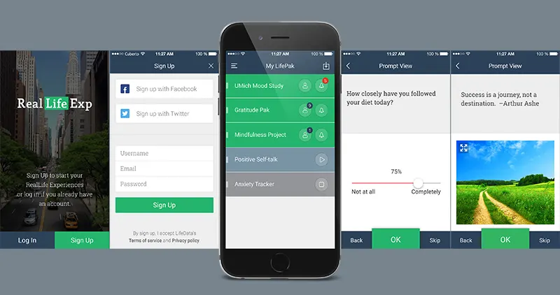

Intervention Conditions and Randomization Protocol

Indication of Food Preferences and Dietary Restrictions
All participants competed a food preference form during the consent call, indicating the following:

- Do you have allergies to any of the following foods?
  - Egg, Sesame, Shellfish, Tree Nuts, Soy, Wheat

- How much would you rate the following food items on a scale of 1-6 with 1 being “like extremely” and 6 being “dislike extremely”?
  - Beans (all different types), Bell Pepper, Dried Mangoes, Chia Seeds, Chicken, Herbal Tea, Cilantro, Eggplant, Garbanzo Bean, Mushrooms, Freeze Dried Apple Chips, Almonds, Quinoa, Almond Flour Crackers, Spelt Crackers, Red Meat, Dried Apricots, Skinny Pop Popcorn, Natural Peanut Butter, Rice, Roasted Edamame, Squash, Turkey, Olives, Pistachios, Roasted Chickpeas, Curry, Daring Chicken (vegan chicken), Beyond Meat (vegan red meat), Impossible Meat (vegan red meat), Eggs, Dairy, Fish, Tree Nuts, Sesame, Shellfish, Wheat, Spicy Foods, Lamb

Nutrition Guidance Instructions
At the end of Visit 2, participants received nutritional guidance instructions to be followed starting the next day until their Visit 3 (~14 days). All participants were provided with a handout outlining nutrition guidelines and a calendar with a general overview of the EMA schedule, when to expect food deliveries, and when their intervention weeks would begin. All participants received the same nutritional guidelines, included on the next page and on the OSF project page (https://osf.io/pcufr). All participants were instructed to keep their caffeine intake the same, replacing any caffeinated beverages that did not fit nutritional guidelines for ones that did. Condition-specific materials are included on the OSF project page.

Your Guide to Minimally Processed Foods
Eating a diet that consists mostly of minimally processed foods will help support your mental health, physical health, and well-being. This guide provides information about processed foods and can help you follow a minimally processed foods diet.
Food is processed before it reaches consumers: it may be cut, cooked, dried, seasoned, canned, preserved, mixed together, or changed by industrial processes. Minimally processed foods are those that are purchased and eaten closer to their original state and include:
- Fresh vegetables
- Fresh fruits
- Frozen or dried vegetables and fruits packaged without added sugars
- Fresh or frozen meat, fish, and poultry without added sauces or breading
- Fresh eggs
- Milk, unless flavored or sweetened
- Beans and legumes, packaged fresh, dry, or frozen
- Nuts and seeds, packaged without added sugars or flavors
- Whole, intact grains
- Herbs and spices, fresh or dried
- Plain, unsweetened yogurt
- Butter or oil added when preparing foods
- Tea or herbal tea, packaged as tea bags or loose-leaf tea
- Coffee, packaged as whole coffee beans or ground

Below are some foods that are considered highly processed and NOT recommended.
- Added sauces or syrups that contain preservatives and/or added sugar (e.g. ketchup, mayonnaise, chocolate syrup, barbecue sauce)
- Added sugar (e.g. foods/drinks with sugar, maple syrup, honey, corn syrup, cane juice, malt syrup/sugar, invert sugar, molasses, sucrose, fruit juice concentrates)
- Artificial sweeteners (e.g. foods/drinks with aspartame, sucralose, saccharin, stevia leaf extracts, monk fruit, acesulfame potassium, xylitol, erythritol)
- Breaded or fried foods (e.g. chicken nuggets, onion rings, sesame chicken, buffalo wings, tempura, chimichangas, egg rolls, beer battered fish)
- Cereals, breads, pastas, or crackers made with refined grains and/or including added sugar (e.g., white bread, sweetened cereal, white pasta, Ritz crackers, cheezits)
- Juices, sodas, or energy drinks (including 100% fruit juice, diet sodas, low- or no-calorie energy drinks, and sparkling water with added fruit juice or sweetener)
- Baked goods, cookies, candy, ice cream, or other frozen desserts (including high protein, paleo, gluten free, low-fat, low-calorie, and keto options)
- Combination frozen foods, such as pizza, burritos, or frozen dinners (including high protein, paleo, gluten free, low-fat, low-calorie, and keto options)

You might have to check the ingredient list of some foods to make sure they fit the nutritional guidelines. If you have any questions about foods that fit the nutritional guidelines, feel free to email [BLINDED] for more information.

Food and Beverage List
The list below includes descriptions and examples of recommended foods and beverages for people following a minimally processed foods diet. It is not an exhaustive list.
Category | Examples
Meat, fish, poultry, and eggs  Fresh or frozen without added sauces or breading; no deli meat or other processed meat products such as bacon or sausage; canned fish containing only water or oil and salt | Beef, chicken, cod, crab, eggs, fish, lobster, pork, salmon, shrimp, tilapia, tuna fish
Beans and legumes  Fresh, dry, or frozen without added sauces or breading; canned beans containing only water and salt; no plant-based protein products such as tofu, tempeh, patties, crumbles; no pre-made hummus, refried beans, or baked beans | Black beans, garbanzo beans/chickpeas, kidney beans, lentils, red beans, soybeans/edamame, white beans
Nuts, Seeds, and Nut Butters  Raw or roasted nuts, or nut butters made from only nuts and salt; no added sugars or flavors | Almond butter (natural, no added sugar), almonds, cashews, peanut butter (natural, no added sugar), peanuts, pecans, pistachios, sesame seeds, sunflower seeds, walnuts
Grains and starches  Whole grains; fresh or frozen starchy vegetables without added sauces or breading; no refined grains, pastas, cereals, breads, or crackers | Barley, brown rice, buckwheat, bulgur, corn, millet, parsnips, peas, popcorn (air-popped), potatoes, quinoa, steel-cut oats, sweet potatoes, wheat berries, whole grain oats, whole grain breads, whole grain pastas
Fruits  Fresh, frozen, or freeze dried without added sugars; dried fruit with no added sugars; no canned fruit | Apples, apricots, avocado, bananas, blueberries, cherries, clementines, grapefruit, grapes, honeydew melon, kiwi, lemon, nectarines, oranges, papaya, peach, pear, pineapple, plantains, plums, raspberries, strawberries, tangerines, watermelon
Vegetables  Fresh or frozen without added sauces or breading; pickled vegetables containing only vinegar, salt, and spices; olives containing only water, salt, and citric acid | Asparagus, beets, bell peppers, bok choy, broccoli, brussels sprouts, cabbage, carrots, cauliflower, celery, collard greens, cucumber, green beans, kale, leeks, lettuce, mushrooms, olives, onions, salad greens, spinach, summer squash, swiss chard, tomatoes
Dairy foods  Unsweetened and unflavored dairy products; cheese; no processed cheese products | Cheese, cottage cheese, cream/half & half, Greek yogurt (plain), milk, yogurt (plain, unsweetened)
Fats, condiments, sauces, and other  ingredients  Butter or oil added when preparing foods, herbs, spices, and vinegar; tahini containing only ground sesame seeds, no margarines; no bottled condiments, gravies, pasta sauces, or dips | Butter (+/- salt), ghee (containing only clarified butter +/- salt), oil (canola, olive, vegetable. etc.); tahini; fresh or dried herbs and spices, salt and pepper, vinegar, lemon juice
Beverages  Drinks with no added sweeteners; unsweetened and unflavored plant-based milks containing only water | Coffee, tea, seltzer water, club soda, unsweetened iced tea, water; flavored seltzer (carbonated water and natural flavors only); almond milk (water and almond only); cashew milk (water and cashew only)

Sample Menu
The sample menus below provide meal and snack examples for people following a minimally processed foods diet.
Sample Day 1 | Sample Day 2 | Sample Day 3
Breakfast
Omelet with cheese and spinach  Watermelon  Coffee with cream | Steel-cut oats with walnuts and raspberries  Latte (unsweetened, unflavored) | Eggs with avocado and tomato  Grapefruit  Coffee with cream
Lunch
Corn and black bean salad (frozen corn, frozen black beans, tomatoes, bell pepper, jalapenos, avocado, lime, cilantro, oil)  Mango | Lentil salad (black lentils, radish, arugula, feta, shallot, lemon, vinegar, oil)  Plain Greek yogurt with blueberries | Grilled chicken and spinach salad (grilled chicken, spinach, pecans, celery, scallions, goat cheese, parsley, lemon, oil)  Clementines
Snack
Apple + Cheddar | Celery + Natural Peanut Butter | Cottage Cheese with Black Pepper + Baby Carrots
Dinner
Grilled salmon  Asparagus  Roasted potatoes  Seltzer | Pork tenderloin  Roasted carrots and parsnips  Grilled pineapple  Unsweetened iced tea | Green salad (mixed greens, cucumber, vinegar, oil) topped with grilled chicken and eggs (hard boiled)  Roasted sweet potatoes
Snack
Air-Popped Popcorn + Milk | Cheese + Fruit | Roasted nuts + Herbal Tea

More Snack Options
- Natural (no added sugar/preservatives) nut butter with fruit
- Handful of nuts with unsweetened dried fruit
- Vegetables with hummus
- Unsweetened yogurt with fruit
- Hard boiled egg with black pepper + baby carrots
- Edamame with black pepper
- Roasted chickpeas made with spices & salt
- Cubes of baked tofu (made with olive oil & spices)
- Marinated olives and artichoke hearts

Randomization and Ordering of Foods

Nutritional Guidance Condition. Participants randomized to the nutritional guidance condition were sent a snack box with 2 to 3 foods available on Amazon, with the total cost being $20 or lower. Foods that participants disliked (i.e. rated 5 or 6) or were allergic to (as indicated during the consent call) were not included in the participant’s snack box. The snacks were ordered to be delivered directly to the participant's home address before the start of their Visit 2. At the end of Visit 1, participants were told that they might receive a food delivery prior to Visit 2, but to not consume any food until after the Visit 2, when instructed to.

Customized snack selection for each participant in the nutritional guidance condition.

PID | Snack Selection
2 | Justin’s Classic No Stir Gluten-Free Peanut Butter Spread (1.75 pound) (x1)  Bare Gluten Free Organic Apple Chips, FUJI AND RED (3.4Oz) (x1)  SkinnyPop Popcorn, Gluten Free, Dairy Free, Non-GMO, Healthy (3.9oz/bag) (x6)
9 | Bare Organic Apple Chips, CINNAMON, Gluten Free (3Oz) (x1)  The Only Bean Crunchy Dry Roasted Edamame Snacks (0.9 Oz) (x10)
10 | SkinnyPop Popcorn, Gluten Free, Dairy Free, Non-GMO, Healthy (3.9 Oz) (x6)  365 by Whole Foods Market, Organic Turkish Apricots (8Oz) (x1)  365 by Whole Foods Market, Creamy Peanut Butter With Salt (1 Pound) (x1)
13 | Bare Gluten Free Organic Apple Chips, FUJI AND RED (3.3 Oz) (x1)  Wonderful Pistachios No Shells, Roasted & Salted Nuts (0.75 Oz) (x9)  365 by Whole Foods Market, Creamy Peanut Butter With Salt (1 Pound) (x1)
14 | 365 by Whole Foods Market, Creamy Peanut Butter With Salt (16 Fl Oz) (x1)  Bare Organic Apple Chips, CINNAMON, Gluten Free (3oz/bag) (x1)  SkinnyPop Popcorn, Gluten Free, Dairy Free, Non-GMO, Healthy (3.9oz/bag) (x6)
25 | Bare Gluten Free Organic Apple Chips, FUJI AND RED (3.4Oz) (x1)  SkinnyPop Popcorn, Gluten Free, Dairy Free, Non-GMO, Healthy (3.9oz/bag) (x6)  365 by Whole Foods Market, Organic Sweetened Smooth Peanut Butter (16 oz jar)
27 | Teddie All Natural Peanut Butter, Smooth (16 oz jar)  SkinnyPop Popcorn, Gluten Free, Dairy Free, Non-GMO, Healthy (3.9oz/bag) (x6)
35 | Wonderful Pistachios No Shells, Roasted & Salted Nuts (0.75 Ouce bags) (x14)  Amazon Brand-Happy Belly Roasted & Lightly Salted Almond (24 ounce) (x1)
38 | Wonderful Pistachios No Shells, Roasted & Salted Nuts (0.75 Ounce) (x14)  SkinnyPop Popcorn Gluten Free, Dairy Free, Non-GM (3.9 Ounce) (x1)
42 | Wonderful Pistachios No Shells, Roasted & Salted Nuts, (0.75 Ounce Bags) (x9)  365 by Whole Foods Market, Mango Bag Organic, 12 Ounce (x1)
49 | SkinnyPop Popcorn, 0.65oz Individual Size Snack Bags (6 Count)  Wonderful Pistachios No Shells, Roasted & Salted Nuts, 0.75 Ounce Bags (Pack of 14)

Meal Condition. Participants randomized to the meal condition were sent 21 meals per week (i.e., 3 meals per day) to their home address. When ordering foods, lab staff added meals that contained foods that participants disliked (i.e. rated 5 or 6) or were allergic to (as indicated during the consent call) as exclusions or allergies to the “Default Meal Plan Preference” page on the meal delivery website. The diets “Mediterranean”, “Paleo” and “Whole 30” meal plans were selected as meal preferences, as meals from these diets consisted primarily of minimally processed foods. Lab staff then select 7 breakfasts and 14 entrees for each participant for each week that were in accordance with participants’ preferences. Food was scheduled to arrive in two deliveries: Week 1 food was delivered one day before participants started their intervention period, after their in-lab Visit 2. Week 2 food was delivered one week after the Week 1 food delivery. Lab staff emailed the meal delivery company directly upon submitting a food order to ensure that the food would arrive on time. At the end of Visit 1, participants were told that they might receive a food delivery prior to Visit 2, but to not consume any food until after the visit, when instructed to.

Customized meal selections for each participant in the meal delivery condition. Nutritional details for each meal can be found in Supplemental Materials (SM2).

PID 001:
- Caprese and Spinach Frittata — 1
- Chicken Apple Sausage Scramble with Brussels Sprouts and Peppers — 2
- Classic Egg and Potato — 5
- Scrambled Eggs and Hash Browns with Chicken Sausage — 1
- Sunnyside with Spinach and Tomato — 1
- BBQ Pulled Chicken and Creamy Polenta with Parmesan Herb Broccoli — 3
- Bang Bang Shrimp and Broccoli with Creamy Coconut Rice — 2
- Chicken Pizzaiola with Summer Squash — 2
- Mediterranean Tofu Bowl with Red Pepper Tzatziki — 1
- Roasted Red Pepper Chicken and Hearty Vegetable Cauliflower Rice Pilaf — 1
- Spaghetti and Herby Chicken Meatballs — 3
- Za'atar Roasted Chicken and Eggplant in Creamy Cashew Sauce — 2
- Cheesy Egg Cups and Cajun Sweet Potatoes — 2
- Chicken Fajita Scramble with Zucchini and Tomatoes — 2
- Caesar Chicken Bake — 3
- Greek Lemon Garlic Chicken Quinoa Bowl with Feta — 4
- Pesto Chicken Meatballs and Veggie Bowl — 3
- Roasted Dill Cod and Sweet Potatoes with Herb Aioli — 4

PID 003:
- Cheesy Egg Cups and Cajun Sweet Potatoes — 4
- Chicken Fajita Scramble with Zucchini and Tomatoes — 2
- Classic Egg and Potato — 4
- Garlic Aioli over Eggs with Patatas Bravas and Salsa — 2
- Zucchini and Bell Pepper Frittata — 2
- Caesar Chicken Bake — 6
- Pesto Chicken Meatballs and Veggie Bowl — 6
- Roasted Dill Cod and Sweet Potatoes with Herb Aioli — 6
- Roasted Red Pepper Chicken and Hearty Vegetable Farro Pilaf — 6
- Tandoori Shrimp with Saffron Jasmine Rice and Peas — 4
PID 012:
- Caprese and Spinach Frittata — 2
- Classic Egg and Potato — 6
- Italian Sausage and Vegetable Frittata — 1
- Balsamic Glazed White Fish and Garlic Sweet Potato Kale Gratin — 3
- Creamy Goat Cheese Polenta with Ratatouille and Pine Nuts — 2
- Lentil Power Bowl with Herb Roasted Potatoes — 3
- Mediterranean Falafel Bowl with Red Pepper Tzatziki — 3
- Pesto Crusted Salmon with Vegetable Medley — 3
- Cheesy Egg Cups and Cajun Sweet Potatoes — 1
- Garlic Aioli over Eggs with Patatas Bravas and Salsa — 1
- Roasted Red Pepper, Spinach and Feta Egg Cups with Mediterranean Hash — 1
- Sunnyside with Pesto — 1
- Zucchini and Bell Pepper Frittata — 1
- Baked Feta Pasta — 2
- Herby Lemon Chickpea and Cheese Casserole — 3
- Herby White Fish with Mediterranean Vegetable Medley — 2
- Pistachio Pesto Pasta with Roasted Tomatoes and Broccoli — 2
- Roasted Dill Cod and Sweet Potatoes with Herb Aioli — 3
- Tandoori Shrimp with Saffron Jasmine Rice and Peas — 2

PID 016:
- Classic Egg and Potato — 4
- Scrambled Eggs and Hash Browns — 2
- Steak and Cheese Frittata — 2
- Zucchini and Bell Pepper Frittata — 1
- BBQ Steak with Veggies — 2
- Cheeseburger Bowl with Secret Sauce — 2
- Creamy Lemon Dijon Chicken with Herb Potatoes and Broccoli — 2
- Lamb Ragu over Spaghetti — 2
- Lemon Butter White Fish with Garlicky Brussels Hash — 2
- Lemon Garlic Chicken with Snap Peas — 2
- Marinara Beef over Spinach and Sweet Potatoes — 2
- Caprese and Spinach Frittata — 1
- Chicken Sausage Queso Breakfast Bowl — 2
- Sunnyside with Spinach and Tomato — 1
- Turkey Bacon, Pepper, and Onion Egg Cups — 1
- French Onion Steak with Roasted Mushrooms and Cauliflower — 1
- Lentil Power Bowl with Herb Roasted Potatoes — 3
- Philly Cheesesteak Bowl with Roasted Onions, Mushrooms, and Peppers — 1
- Red Pepper Bunless Beef Burger with Sweet Potatoes — 3
- Roasted Red Pepper Chicken and Hearty Vegetable Cauliflower Rice Pilaf — 3
- Spaghetti and Herby Chicken Meatballs — 2
- Spaghetti and Herby Meatless Meatballs — 1

PID 018:
- Cheesy Egg Cups and Cajun Sweet Potatoes — 2
- Classic Egg and Potato — 4
- Sunnyside with Asparagus and Tomato — 1
- Yellow Squash Frittata with Onion and Peppers — 2
- Beef Sloppy Joe and Mushroom Bowl — 2
- Chicken Piccata over Orzo and Broccoli — 3
- Creamy Chicken and Broccoli Alfredo — 2
- Marinara Beef over Spinach and Sweet Potatoes — 2
- Roasted Red Pepper Chicken and Hearty Vegetable Cauliflower Rice Pilaf — 3
- Three Cheese Turkey Rotini Bake — 2
- Sunnyside with Spinach and Tomato — 2
- Turkey Sausage Sweet Potato Hash with Scrambled Eggs — 3
- Greek Lemon Garlic Chicken Quinoa Bowl with Feta — 5
- Italian Turkey and Cheese Unstuffed Peppers — 5
- Red Pepper Grilled Chicken with Sweet Potatoes — 4

PID 022:
- Caprese and Spinach Frittata — 3
- Classic Egg and Potato — 5
- Sunnyside with Spinach and Tomato — 1
- Caprese Pesto Orzo Bake — 2
- Chipotle Lime Shrimp with Southwestern Cauliflower Rice — 2
- Citrus Marinated Shrimp with Squash and Brown Rice — 2
- Garlic Butter White Fish over Creamed Kale and Mixed Squash — 2
- Pescado Con Coco with Fried Plantains — 2
- Sweet Chili Shrimp with Peppers and Cauliflower Rice — 2
- Tandoori Shrimp with Saffron Jasmine Rice and Peas — 2
- Cheesy Egg Cups and Cajun Sweet Potatoes — 2
- Sunnyside with Asparagus and Tomato — 1
- Yellow Squash Frittata with Onion and Peppers — 2
- Beans Alla Vodka with Garlic Broccoli and Tomato — 1
- Citrus Marinated Shrimp with Squash and Mushrooms — 2
- Feta and Chickpea Shakshuka — 2
- Indian Green Curry Tofu with Chickpeas and Pistachio Rice — 1
- Roasted Salmon with Spicy Harissa Chickpea Stew — 2
- Smoky Red Sauce Enchiladas with Cauliflower and Sweet Potato — 2
- Southwest Salmon with Roasted Broccoli — 2
- Sweet and Sour White Fish with Bok Choy and Sesame Scallion Rice — 2

PID 026:
- **Fuji Apple Chicken Salad —1
  - **this item was provided by a local restaurant as a replacement for a recalled meal
- Chicken Fajita Scramble with Zucchini and Tomatoes — 2
- Classic Egg and Potato — 4
- Scrambled Eggs and Hash Browns — 1
- Zucchini and Spinach Frittata with Mushrooms and Peppers — 2
- Bang Bang Shrimp and Broccoli with Creamy Coconut Rice — 1
- Chicken Pizzaiola with Summer Squash — 1
- Chicken, Root Vegetables, and Wild Rice Harvest Bowl — 1
- Chimichurri Chicken Meatballs with Garlic Thyme White Sweet Potatoes — 1
- Citrus Marinated Shrimp with Squash and Mushrooms — 1
- Crustless Chicken Potato Pot Pie — 1
- Fajita White Fish Taco Plate with Chunky Mango Salsa — 1
- Feta and Tomato Shrimp Scampi over Noodles — 1
- Goat Cheese, Root Vegetables, and Wild Rice Harvest Bowl — 1
- Italian Turkey Unstuffed Peppers — 1
- Southwestern Chicken with Cilantro Lime Rice — 1
- Spicy West African Chicken with Jollof Rice and Veggies — 1
- Sweet Ginger Glazed Salmon with Bok Choy and Mushrooms — 1
- Thai Red Curry Chicken with Coconut Lime Rice — 1
- Cheesy Egg Cups and Cajun Sweet Potatoes — 1
- Garlic Aioli over Eggs with Patatas Bravas and Salsa — 1
- Roasted Red Pepper, Spinach and Feta Egg Cups with Mediterranean Hash — 1
- Zucchini and Bell Pepper Frittata — 2
- Baked Feta Pasta — 1
- Chipotle Lime Shrimp with Southwestern Cauliflower Rice — 2
- Herby White Fish with Mediterranean Vegetable Medley — 2
- Kalamata and Tomato Marinara Shrimp Linguini — 2
- Pistachio Pesto Pasta with Roasted Tomatoes and Broccoli — 1
- Roasted Vegetable Parmesan with Tomato Orzo — 2
- Sesame Shrimp with Vermicelli and Spicy Thai Almond Sauce — 2
- Tandoori Shrimp with Saffron Jasmine Rice and Peas — 2

PID 028:
- Classic Egg and Potato — 4
- Garlic Aioli over Eggs with Patatas Bravas and Salsa — 1
- Goat Cheese and Pesto Scramble with Kale and Sun-Dried Tomatoes — 1
- Roasted Red Pepper, Spinach and Feta Egg Cups with Mediterranean Hash — 1
- Scrambled Eggs and Hash Browns — 1
- Zucchini and Bell Pepper Frittata — 1
- Chicken Tikka Masala with Jasmine Rice — 1
- Chicken, Root Vegetables, and Wild Rice Harvest Bowl — 2
- Chipotle Lime Shrimp with Southwestern Cauliflower Rice — 1
- Greek Farro Bowl with Chickpeas, Tzatziki, and Feta — 2
- Herby White Fish with Mediterranean Vegetable Medley — 2
- Lemon Butter White Fish with Garlicky Brussels Hash — 1
- Lemon Garlic Chicken with Snap Peas — 1
- Pesto Chicken Meatballs and Veggie Bowl — 1
- Red Pepper Tzatziki Chicken and Roasted Vegetables — 1
- Roasted Chicken with Cilantro Cream Vegetables — 1
- Sweet and Spicy Chicken and Cauliflower over Rice — 1
- Caprese and Spinach Frittata — 2
- Chicken Sausage and Mushroom Breakfast Grits — 1
- Sunnyside with Spinach and Tomato — 2
- Balsamic Glazed White Fish and Garlic Sweet Potato Kale Gratin — 2
- Bang Bang Shrimp and Broccoli with Creamy Coconut Rice — 1
- Caprese Pesto Orzo Bake — 2
- Chicken Pizzaiola with Summer Squash — 1
- Citrus Marinated Shrimp with Squash and Mushrooms — 1
- Pesto Crusted Salmon with Vegetable Medley — 2
- Sesame Chicken with Chili Oil Brussels Sprouts — 2
- Spaghetti and Herby Chicken Meatballs — 1
- Sweet Chili Shrimp with Peppers and Cauliflower Rice — 2

PID029:
- Chicken Fajita Scramble with Zucchini and Tomatoes — 2
- Classic Egg and Potato — 4
- Garlic Aioli over Eggs with Patatas Bravas and Salsa — 1
- Sausage Skillet with Veggies and Cauliflower Rice — 1
- Zucchini and Bell Pepper Frittata — 1
- Caesar Chicken Bake — 1
- Chicken and Broccoli Stir-Fry with Brown Sauce — 1
- Chipotle Lime Shrimp with Southwestern Cauliflower Rice — 2
- Creamy Cilantro Chicken and Veggies — 1
- Pesto Chicken Meatballs and Veggie Bowl — 1
- Rice Pilaf with Lamb, Sun-Dried Tomatoes, and Basil — 2
- Roasted Red Pepper Chicken and Hearty Vegetable Farro Pilaf — 1
- Roasted Vegetable Parmesan with Tomato Orzo — 2
- Taco Seasoned Meat and Veggie Skillet with Cashew Queso — 1
- Tandoori Shrimp with Saffron Jasmine Rice and Peas — 2
- Caprese and Spinach Frittata — 2
- Chicken Sausage Queso Breakfast Bowl — 1
- Sunnyside with Spinach and Tomato — 1
- Turkey Sausage Sweet Potato Hash with Scrambled Eggs — 1
- Balsamic Glazed White Fish and Garlic Sweet Potato Kale Gratin — 2
- Bang Bang Shrimp and Broccoli with Creamy Coconut Rice — 1
- Caprese Pesto Orzo Bake — 1
- Chicken Pizzaiola with Summer Squash — 2
- Chimichurri Shrimp with Vegetables — 1
- Citrus Marinated Shrimp with Squash and Mushrooms — 1
- Creamy Cilantro Chicken and Lentils — 1
- Pesto Crusted Salmon with Vegetable Medley — 1
- Sesame Chicken with Chili Oil Brussels Sprouts — 1
- Spaghetti and Herby Chicken Meatballs — 1
- Sweet Chili Shrimp with Peppers and Cauliflower Rice — 2

PID 030 (Meals)
- Beef, Asparagus and Mushroom Frittata — 1
- Classic Egg and Potato — 5
- Ground Beef Scramble with Asparagus and Mushroom — 1
- Scrambled Eggs and Hash Browns — 2
- Chicken Pizzaiola with Summer Squash — 2
- Chicken, Root Vegetables, and Wild Rice Harvest Bowl — 2
- Chimichurri Chicken Meatballs with Garlic Thyme White Sweet Potatoes — 2
- Crustless Chicken Potato Pot Pie — 1
- Feta and Tomato Shrimp Scampi over Noodles — 2
- Lemon Butter Seared Salmon with Garlicky Brussels Hash — 2
- Maple Tahini Roasted Carrots with Chickpeas and Farro — 2
- Thai Yellow Curry Steak with Sweet Potatoes and Spinach — 1
- Beans and Greens Hash with Salsa Verde and Sunnyside Eggs — 1
- Caprese and Spinach Frittata — 2
- Garlic Aioli over Eggs with Patatas Bravas and Salsa — 1
- Sunnyside with Spinach and Tomato — 1
- Bearnaise Steak with Roasted Sweet Potatoes — 1
- Chicken Tikka Masala with Saffron Cardamom Cauliflower Rice — 1
- Chicken and Artichoke Souvlaki with Couscous and Tzatziki — 2
- Chicken and Broccoli Stir-Fry with Brown Sauce — 2
- Creamy Cilantro Chicken and Veggies — 1
- Greek Lemon Garlic Chicken Quinoa Bowl with Feta — 3
- Pesto Chicken Meatballs and Veggie Bowl — 2
- Spinach and Roasted Cauliflower Enchilada with Salsa Verde — 2
- **Strawberry Poppyseed Chicken Salad – 1
  - **this item was provided by a local restaurant as a replacement for a recalled meal

PID 031:
- Classic Egg and Potato — 2
- Mediterranean Sunnyside with Za'atar Chickpeas, Roasted Potatoes and Feta — 1
- Scrambled Eggs and Hash Browns — 2
- Zucchini and Spinach Frittata with Mushrooms and Peppers — 2
- Chicken Pizzaiola with Summer Squash — 2
- Chicken, Root Vegetables, and Wild Rice Harvest Bowl — 2
- Chimichurri Chicken Meatballs with Garlic Thyme White Sweet Potatoes — 1
- Crustless Chicken Potato Pot Pie — 2
- Fajita White Fish Taco Plate with Chunky Mango Salsa — 2
- Maple Tahini Roasted Carrots with Chickpeas and Farro — 2
- Southwestern Chicken with Cilantro Lime Rice — 2
- Sweet Ginger Glazed Salmon with Bok Choy and Mushrooms — 1
- **Fuji Apple Chicken Salad — 1
  - **this item was provided by a local restaurant as a replacement for a recalled meal

PID 032:
- Caprese and Spinach Frittata — 2
- Classic Egg and Potato — 5
- Italian Sausage and Vegetable Frittata — 2
- Bearnaise Steak with Roasted Sweet Potatoes — 1
- Chicken and Broccoli Stir-Fry with Brown Sauce — 1
- Greek Lemon Garlic Chicken Quinoa Bowl with Feta — 3
- Lamb Ragu over Spaghetti — 2
- Meatball and Eggplant Parm Rigatoni — 2
- Pesto Chicken Meatballs and Veggie Bowl — 2
- Red Pepper Grilled Chicken with Sweet Potatoes — 3
- Beef and Bell Pepper Frittata — 1
- Chicken Sausage and Mushroom Breakfast Grits — 1
- Sunnyside with Asparagus and Tomato — 1
- Yellow Squash Frittata with Onion and Peppers — 2
- Beans Alla Vodka with Garlic Broccoli and Tomato — 1
- Chicken Ropa Vieja over Rice — 2
- Creamy Chicken and Broccoli Alfredo — 2
- Lemon Butter Shrimp over Whipped Polenta and Bruschetta Brussels — 2
- Lentil Power Bowl with Herb Roasted Potatoes — 2
- Mandarin Chicken with Sesame Ginger Rice and Broccoli — 3
- Tuscan Salmon with Herb Roasted Vegetables — 2

PID 033:
- Caprese and Spinach Frittata — 3
- Classic Egg and Potato — 2
- Impossible Sausage with Scrambled Eggs and Hash Browns — 1
- Tofu Scramble with Impossible Sausage — 1
- Garden Veggie Pearl Couscous with Raspberry Vinaigrette and Goat Cheese — 3
- Lentil Power Bowl with Herb Roasted Potatoes — 3
- Red Pepper Pesto Impossible Patty with Roasted Potatoes and Rice — 1
- Spaghetti and Herby Meatless Meatballs — 2
- Teriyaki Tofu with Vermicelli and Vegetables — 3
- Tuscan Daring Chicken and Grilled Portobello with Creamy Herb Polenta — 1
- Vegan Loaded Potato Bowl — 1
- Cheesy Egg Cups and Cajun Sweet Potatoes — 2
- Garlic Aioli over Eggs with Patatas Bravas and Salsa — 1
- Green Goddess Vegan Scramble with Sweet Potato Hash — 2
- Zucchini and Bell Pepper Frittata — 2
- Baked Feta Pasta — 3
- Ginger Glazed Yams with Beans and Roasted Vegetables — 3
- Herby Lemon Chickpea and Cheese Casserole — 2
- Maple Tahini Roasted Carrots with Chickpeas and Farro — 1
- Pistachio Pesto Pasta with Roasted Tomatoes and Broccoli — 1
- Saag Cauliflower with Feta and Lentils — 3
- Teriyaki Vegetable Quinoa Bowl — 1

PID 034:
- Beans and Greens Hash with Salsa Verde and Sunnyside Eggs — 1
- Caprese and Spinach Frittata — 2
- Classic Egg and Potato — 3
- Sunnyside with Spinach and Tomato — 2
- Chicken and Artichoke Souvlaki with Couscous and Tzatziki — 1
- Chipotle Lime Shrimp with Southwestern Cauliflower Rice — 1
- Citrus Marinated Shrimp with Squash and Brown Rice — 1
- Garlic Butter White Fish over Creamed Kale and Mixed Squash — 1
- Greek Lemon Garlic Chicken Quinoa Bowl with Feta — 2
- Lamb Ragu over Spaghetti — 1
- Meatball and Eggplant Parm Rigatoni — 1
- Red Pepper Grilled Chicken with Sweet Potatoes — 1
- Southwestern Chicken with Cilantro Lime Rice — 2
- Spinach and Roasted Cauliflower Enchilada with Salsa Verde — 1
- Sweet Chili Shrimp with Peppers and Cauliflower Rice — 1
- Tandoori Shrimp with Saffron Jasmine Rice and Peas — 1
- Cheesy Egg Cups and Cajun Sweet Potatoes — 1
- Chicken Fajita Scramble with Zucchini and Tomatoes — 2
- Chicken Sausage and Mushroom Breakfast Grits — 2
- Yellow Squash Frittata with Onion and Peppers — 1
- Bang Bang Shrimp and Broccoli with Creamy Coconut Rice — 1
- Chicken Piccata over Orzo and Broccoli — 1
- Chicken Ropa Vieja over Rice — 1
- Chicken and Jalapeno Enchilada Bowl with Avocado Ranch — 1
- Chimichurri Chicken Meatballs with Garlic Thyme White Sweet Potatoes — 1
- Creamy Chicken and Broccoli Alfredo — 1
- Dominican Roasted Chicken with Black Beans and White Rice — 1
- Mandarin Chicken with Sesame Ginger Rice and Broccoli — 1
- Roasted Salmon with Spicy Harissa Chickpea Stew — 1
- Sesame Shrimp with Vermicelli and Spicy Thai Almond Sauce — 1
- Smoky Red Sauce Enchiladas with Cauliflower and Sweet Potato — 2
- Thai Yellow Curry Steak with Sweet Potatoes — 1
- Tuscan Salmon with Herb Roasted Vegetables — 1

PID 037:
- Cheesy Egg Cups and Cajun Sweet Potatoes — 2
- Classic Egg and Potato — 2
- Tofu Scramble with Impossible Sausage — 1
- Yellow Squash Frittata with Onion and Peppers — 2
- Beans Alla Vodka with Garlic Broccoli and Tomato — 2
- Indian Green Curry Tofu with Chickpeas and Pistachio Rice — 2
- Kimchi Fried Rice with a Fried Egg — 1
- Lentil Power Bowl with Herb Roasted Potatoes — 3
- Pistachio Pesto Pasta with Roasted Tomatoes and Broccoli — 2
- Plant-Based Meatballs Fettuccini Alfredo — 1
- Thai Yellow Curry Vegetables and Brown Rice — 2
- Vegan Loaded Potato Bowl — 1
Did not eat week 2 foods as they were delivered to the wrong address. Instead, self-implemented nutritional guidance.

PID 040:
- Chicken Fajita Scramble with Zucchini and Tomatoes — 2
- Classic Egg and Potato — 5
- Garlic Aioli over Eggs with Patatas Bravas and Salsa — 2
- Baked Feta Pasta — 1
- Chicken Tikka Masala with Saffron Cardamom Rice and Spiced Brussels — 2
- Chicken and Broccoli Stir-Fry with Brown Sauce — 1
- Citrus BBQ Shrimp with Edamame Succotash and Yucca Fries — 1
- Creamy Sun-Dried Tomato Chicken with Butternut Squash — 1
- Ginger Glazed Yams with Beans and Roasted Vegetables — 2
- Herby White Fish with Mediterranean Vegetable Medley — 2
- Kalamata and Tomato Marinara Shrimp Linguini — 1
- Pesto Chicken Meatballs and Veggie Bowl — 1
- Saag Cauliflower with Feta and Lentils — 2
- Mediterranean Sunnyside with Za'atar Chickpeas, Roasted Potatoes and Feta — 2
- Roasted Red Pepper Pesto Egg Whites and Italian Sausage with Brussels Hash — 1
- Scrambled Eggs and Hash Browns — 2
- Bang Bang Shrimp and Broccoli with Creamy Coconut Rice — 2
- Chicken Pizzaiola with Summer Squash — 1
- Chicken, Root Vegetables, and Wild Rice Harvest Bowl — 3
- Chimichurri Chicken Meatballs with Garlic Thyme Sweet Potatoes — 2
- Creamy Maple Tahini Roasted Carrots with Feta and Farro — 2
- Feta and Tomato Shrimp Scampi over Noodles — 1
- Lemon Garlic Baked Salmon with Rosemary Dijon Potatoes — 2
- Thai Red Curry Chicken with Coconut Lime Rice — 1
PID 043:
- Beef and Bell Pepper Frittata — 1
- Chicken Fajita Scramble with Zucchini and Tomatoes — 2
- Classic Egg and Potato — 4
- Sunnyside with Asparagus and Tomato — 2
- Chicken and Jalapeno Enchilada Bowl with Avocado Ranch — 2
- Chimichurri Chicken Meatballs with Garlic Thyme Sweet Potatoes — 1
- Creamy Chicken and Broccoli Alfredo — 2
- Creamy Cilantro Chicken and Veggies — 1
- Lentil Power Bowl with Herb Roasted Potatoes — 2
- Mandarin Chicken with Sesame Ginger Rice and Broccoli — 2
- Marinara Beef over Spinach and Sweet Potatoes — 1
- Mexican Street Corn Chicken — 2
- Thai Yellow Curry Steak with Sweet Potatoes and Spinach — 1
- Roasted Red Pepper, Spinach and Feta Egg Cups with Mediterranean Hash — 1
- Scrambled Eggs and Hash Browns — 1
- Zucchini and Bell Pepper Frittata — 3
- Baked Feta Pasta — 1
- Chicken and Artichoke Souvlaki with Couscous and Tzatziki — 2
- Chicken and Artichoke Souvlaki with Tzatziki — 2
- Creamy Sun-Dried Tomato Chicken with Butternut Squash — 3
- Pesto Chicken Meatballs and Veggie Bowl — 3
- Red Pepper Grilled Chicken with Sweet Potatoes — 2
- Sweet and Spicy Cauliflower over Rice — 1

PID 044:
- Beef and Bell Pepper Frittata — 1
- Chicken Sausage and Mushroom Breakfast Grits — 1
- Classic Egg and Potato — 5
- Sunnyside with Asparagus and Tomato — 2
- Creamy Chicken and Broccoli Alfredo — 2
- Korean Ground Beef Stir Fry with Mushrooms and Cauliflower Rice — 1
- Lentil Power Bowl with Herb Roasted Potatoes — 2
- Mandarin Chicken with Sesame Ginger Rice and Broccoli — 3
- Marinara Beef over Spinach and Sweet Potatoes — 1
- Pistachio Pesto Pasta with Roasted Tomatoes and Broccoli — 1
- Thai Yellow Curry Steak with Sweet Potatoes and Spinach — 2
- Three Cheese Turkey Rotini Bake — 2
- Roasted Red Pepper, Spinach and Feta Egg Cups with Mediterranean Hash — 2
- Scrambled Eggs and Hash Browns — 1
- Zucchini and Bell Pepper Frittata — 2
- Baked Feta Pasta — 2
- Cuban Picadillo Beef with Cauliflower Rice — 1
- Greek Farro Bowl with Chickpeas, Tzatziki, and Feta — 4
- Pesto Chicken Meatballs and Veggie Bowl — 3
- Red Pepper Grilled Chicken with Sweet Potatoes — 4

PID 047:
- BBQ Cowboy Breakfast with Chicken Sausage — 1
- Chicken Apple Sausage Scramble with Turnip Brussels Hash — 1
- Classic Egg and Potato — 2
- Mediterranean Sunnyside with Za'atar Chickpeas, Roasted Potatoes and Feta — 2
- Roasted Red Pepper Pesto Egg Whites and Italian Sausage with Brussels Hash — 1
- Scrambled Eggs and Hash Browns — 1
- Bang Bang Shrimp and Broccoli with Creamy Coconut Rice — 2
- Chicken, Root Vegetables, and Wild Rice Harvest Bowl — 2
- Chimichurri Chicken Meatballs with Garlic Thyme Sweet Potatoes — 2
- Citrus Marinated Shrimp with Squash and Mushrooms — 1
- Lemon Garlic Baked Salmon with Rosemary Dijon Potatoes — 2
- Spicy West African Chicken with Jollof Rice and Veggies — 2
- Thai Red Curry Chicken with Coconut Lime Rice — 1
- Walnut Basil Pesto Fish with Cauliflower — 2
- Chicken Sausage and Mushroom Breakfast Grits — 1
- Creamy Avocado Scramble with Sweet Potato Hash — 1
- Italian Sausage and Vegetable Frittata — 1
- Sausage Mushroom Egg Cups with Goat Cheese and Parsnip Hash — 1
- Scrambled Eggs and Hash Browns with Chicken Sausage — 1
- Turkey Bacon with Eggs — 1
- Asian Chicken Meatballs with Creamy Almond Noodles — 2
- Garlic Butter White Fish over Creamed Kale and Mixed Squash — 2
- Garlicky Greek Chicken with Lemon Potatoes and Feta — 2
- Jamaican-Style Mahi Mahi with Roasted Vegetables and Pineapple Salsa — 2
- Red Pepper Grilled Chicken with Sweet Potatoes — 2
- Sweet Chili Shrimp with Peppers and Cauliflower Rice — 2
- Tandoori Shrimp with Saffron Jasmine Rice and Peas — 2

PID 048:
- Classic Egg and Potato — 6
- Garlic Aioli over Eggs with Patatas Bravas and Salsa — 1
- Roasted Red Pepper, Spinach and Feta Egg Cups with Mediterranean Hash — 2
- Scrambled Eggs and Hash Browns — 1
- Baked Feta Pasta — 1
- Chicken and Artichoke Souvlaki with Tzatziki — 2
- Chimichurri Shrimp with Vegetables — 2
- Chipotle Lime Shrimp with Southwestern Cauliflower Rice — 2
- Greek Farro Bowl with Chickpeas, Tzatziki, and Feta — 2
- Herby White Fish with Mediterranean Vegetable Medley — 2
- Jalapeno Tahini Chicken with Chickpeas and Corn — 1
- Sweet and Spicy Chicken and Cauliflower over Rice — 1
- Tofu and Mushroom Shawarma — 1
- Caprese and Spinach Frittata — 2
- Cheesy Egg Cups and Cajun Sweet Potatoes — 2
- Bang Bang Shrimp and Broccoli with Creamy Coconut Rice — 1
- Chicken Pizzaiola with Summer Squash — 2
- Chicken and Jalapeno Enchilada Bowl with Avocado Ranch — 2
- Citrus Marinated Shrimp with Squash and Mushrooms — 1
- Pesto Crusted Basa with Vegetable Medley — 1
- Spicy Coconut Curry Basa over Indian-Style Cauliflower Rice — 1
- Sweet Ginger White Fish with Bok Choy and Mushrooms — 2
- Thai Yellow Curry Chicken with Vegetables and Rice — 2
- Thai Yellow Curry Vegetables and Brown Rice — 2

Additional food allergies and intolerances were screened for during the consent call (see Protocol Section of SM).

