MEF2C 51kDa
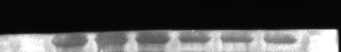
β-actin 42kDa
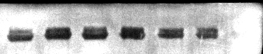
MYOD 35kDa
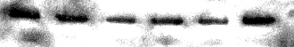
MYOG 25kDa

We confirm that our results were obtained from different regions of the same gel, cut according to the markers mentioned in our manuscript, followed by antibody incubation and development. The first three wells represent the three biological replicates for Group F, while the last three wells represent the three biological replicates for Group S.
Pre-stained Protein Marker 10-180KD (Catalog No.: P1018)

Table 1 Basal diets composition and nutrient level in the early stage of fattening (%)
Ingredient | Content (%) | Nutrient level | Content
Corn | 67 | Digestible Energy | 13.31
Wheat bran | 8 | Crude Protein | 16.367
Sobean meal | 21 | Calcium | 0.85
Grass powder | 0 | Phosphorus | 0.48
Premis | 4 | Lysine | 0.99

Table 2 Basal diets composition and nutrient level in late fattening period (%)
Ingredient | Content (%) | Nutrient level | Content
Corn | 50 | Digestible Energy | 11.18
Wheat bran | 20 | Crude Protein | 13.71
Sobean meal | 5 | Calcium | 1.10
Grass powder | 21 | Phosphorus | 0.57
Premis | 4 | Lysine | 0.76
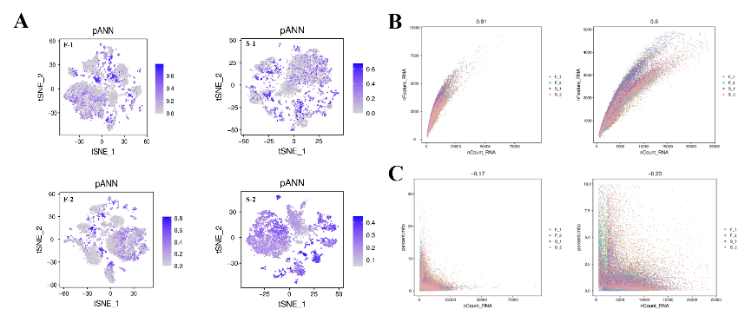
Figure 1: Data quality control and cell filtering
A: tSNE plot of the probability distribution of multicellularity, each point in the plot represents a cell, the scatter points are colored by the size of the pANN value, the darker the color indicates that the larger the pANN value, the higher the probability that the cell is multicellular. B and C:Scatter plots of the distribution of the basic information of the cells before and after the filtration, the points with different colors in the plots represent the cells with different samples of the origin, the X-axis is the number of UMIs, and the Y-axis is the number of genes number (nFeature)/percentage of mitochondria (pMito), the number at the top of the graph is the Pearson's correlation coefficient between the UMI number and the gene number/percentage of mitochondria, and the left and right graphs are the comparisons before and after the filtration, respectively. B is; nCount vs. nFeature; C is: nCount vs. pMito.

Table 3 Basic cell information
Sample | Cells | UMI | UMI/cells | Mitochondrial UMI ratio(%) | Sample saturation(%)
F-1 | 11867 | 58239393 | 4907.68 | 1.30 | 64.30
F-2 | 10209 | 54117512 | 5300.96 | 1.08 | 65.20
S-1 | 6392 | 34883386 | 5457.35 | 1.27 | 75.20
S-2 | 4971 | 35472191 | 7135.83 | 1.93 | 71.90

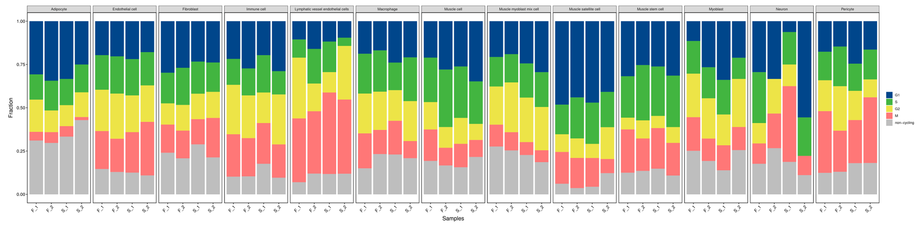
Figure 2: Stacked plots showing the proportion of cells across different cell cycle stages in each sample.
In the stacked bar chart, the top of each bar corresponds to a cluster, while the bottom indicates the sample source for that cluster. Different colors represent distinct phase stages, with the percentage of cells in each phase being proportional to the length of the corresponding color block.

