Supplementary Material

- Supplementary Figures
Supplementary Fig.1. Effects of different concentrations of 3-CP on L02 cells. Experimental data are presented as mean ± SD, n=6 (n.s. represents no significance).
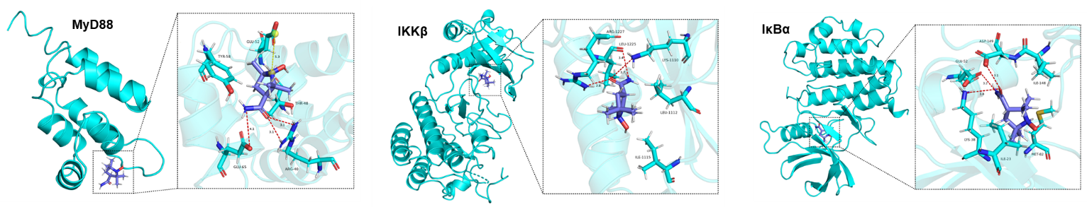
Supplementary Fig. 2. The 3D binding model of 3-CP and MyD88/IκBα/IKKβ. The 3-CP is colored in purple. The surface of MyD88/IκBα/IKKβ is colored in cyan. The interactions are depicted as dashed lines.
Original blot for Figure 4B：
α-SMA:
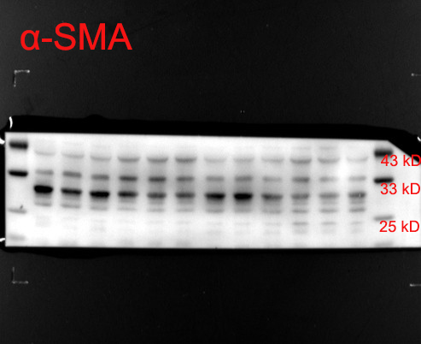
Collagen I:
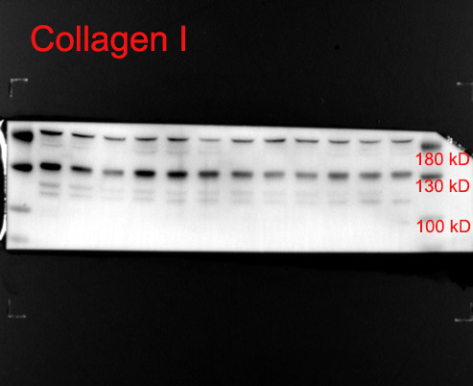
GAPDH:
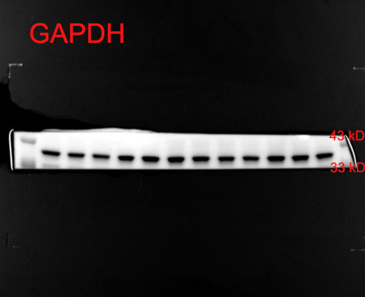

Original blot for Figure 7A：
TLR4:
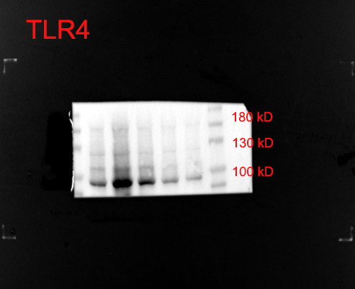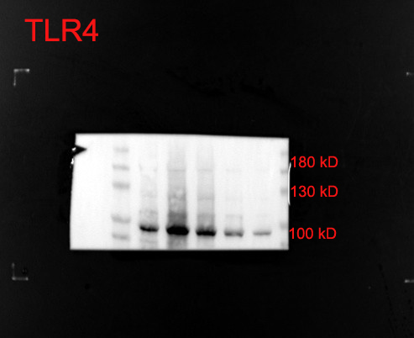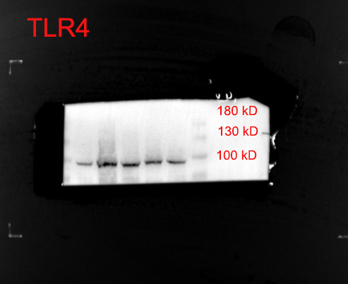

IKKβ:

p-p65:

p65:

p-IκBα:

IκBα:

MyD88:

GAPDH:

Supplementary Fig. 3. The original WB images of α-SMA, Collagen I, and proteins associated with the TLR4/NF-κB signaling pathway.
- Supplementary Tables
Supplementary Table S1. Gene primer sequences for real-time PCR.
Gene name | Forward (5’-3’) | Reverse (5’-3’)
α-SMA (human) | GTGTTGCCCCTGAAGAGCAT | GCTGGGACATTGAAAGTCTCA
Collagen I (human) | GAGGGCCAAGACGAAGACATC | CAGATCACGTCATCGCACAAC
GAPDH (human) | GGAGCGAGATCCCTCCAAAAT | GGCTGTTGTCATACTTCTCATGG
IL-1β | TCGCAGCAGCACATCAACAAGAG | AGGTCCACGGGAAAGACACAGG
IL-6 | CTCCCAACAGACCTGTCTATAC | CCATTGCACAACTCTTTTCTCA
TNF-α | ATGTCTCAGCCTCTTCTCATTC | GCTTGTCACTCGAATTTTGAGA
TGF-β | CTTGCCCTCTACAACCAACA | ACTTGCGACCCACGTAGTAGA
GAPDH | GGTTGTCTCCTGCGACTTCA | TGGTCCAGGGTTTCTTACTCC
Molecular docking analysis revealed that 3-CP binds within the binding pocket of TLR4 (PDB ID: 3fxi) through hydrogen bonding interactions with residues ILE-114 and LEU-117, as well as hydrophobic contacts with ASN-143, ALA-139, and SER-140. For p65 (PDB ID: 1nfi), 3-CP formed hydrogen bonds with PRO-140 and GLN-142, while hydrophobic interactions were observed with LEU-175, and PRO-177. These interacting residues are located within functionally important regions of both proteins and have been previously implicated in ligand recognition.
Supplementary Table S2. The binding energies and key residues for all ‎targets of TLR4/MYD88/NF-κB pathway.
Targets |  | PDB number | Binding energies  (kcal/mol) | Key residues
TLR4 | 3fxi |  | -5.6 | ILE-114, LEU-117, ASN-143, ALA-139, SER-140
MyD88 | 3mop |  | -4.8 | ARG40, THR-48, GLU-52, TYR-58, GLU-65
IκBα | 4kba |  | -5.2 | ILE-23, LYS-38, GLU-52, MET-82, ILE-148, ASP-149
IKKβ | 1r0p |  | -5.4 | LYS-1110, LEU-1112, ILE-1115, LEU-1225, ARG-1227
p65 | 1nfi |  | -5.3 | PRO-140, GLN-142, LEU-175, PRO-177
TRAF6 | 1lb4 |  | -5.2 | VAL-74, CYS-99, GLU-100, GLY-102, ASP-103, ILE-165
IRAK | 6bfn |  | -5.6 | ILE-52, PHE-76, GLU-92, PHE-121, GLU-149
TAK1 | 3p0u |  | -6.1 | VAL-29, ARG-31, LEU-77, ALA-78
Supplementary Table S3. Summarizes and compares the mechanisms of action, molecular targets, and clinical status of pirfenidone, obeticholic acid, and 3-CP.
Compound |  | Primary Mechanism | Molecular Targets | Clinical Status
Pirfenidone | Anti-fibrotic via TGF-β pathway inhibition; some antioxidant effects |  | TGF-β, TNF-α, collagen synthesis | FDA-approved for idiopathic pulmonary fibrosis
Obeticholic acid | FXR agonist regulating bile acid metabolism and inflammation |  | Farnesoid X receptor (FXR) | FDA-approved for primary biliary cholangitis; investigated for NASH
3-CP | Dual antioxidant and anti-inflammatory action |  | ROS scavenging; TLR4/NF-κB pathway inhibition | Preclinical; investigated in liver fibrosis

