Figure 1
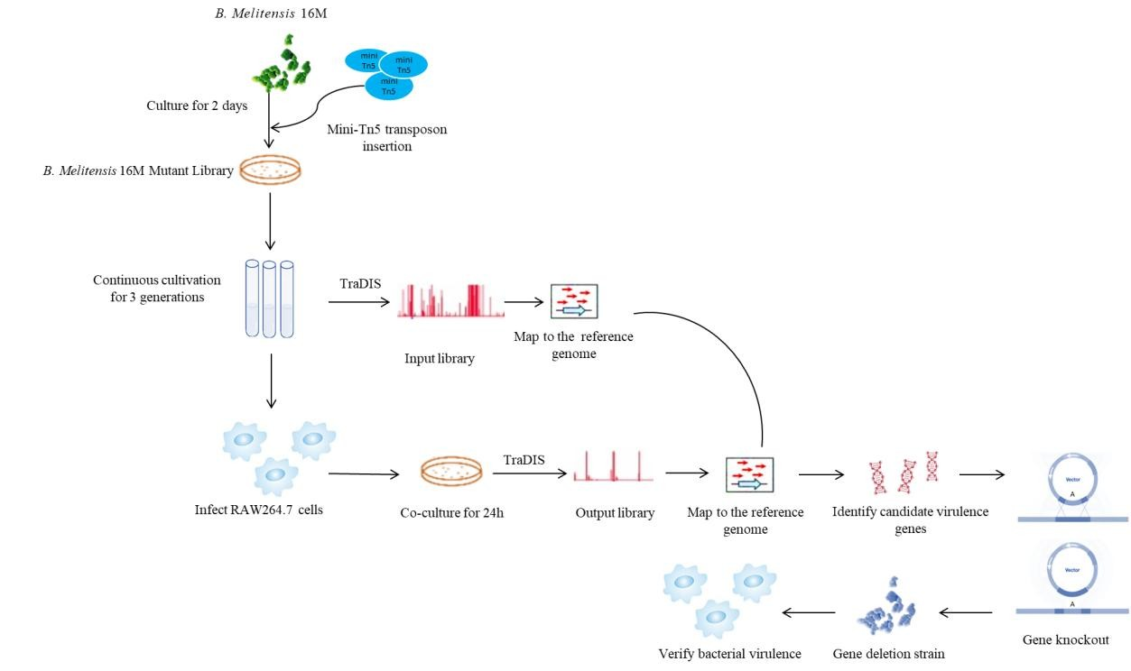
Figure.1. Technical workflow for screening intracellular anti-phagocytic genes in Brucella
Figure.1：Using mini-Tn5 transposon mutagenesis to construct a transposon mutant library, we collected a total of 40,000 mutants through plate-based screening. The mutant library was cultured in vitro for three consecutive generations to exclude mutants with growth-related effects and was subsequently used to infect mouse macrophages. We then employed TraDIS sequencing to analyze the transposon insertion sites in the library both before and after infection. By integrating statistical and bioinformatic analyses, we identified several candidate genes associated with anti-phagocytosis and selected 20 genes with significant changes for knockout experiments. Their virulence was validated using bacterial survival assays in RAW264.7 mouse macrophages

Figure 2
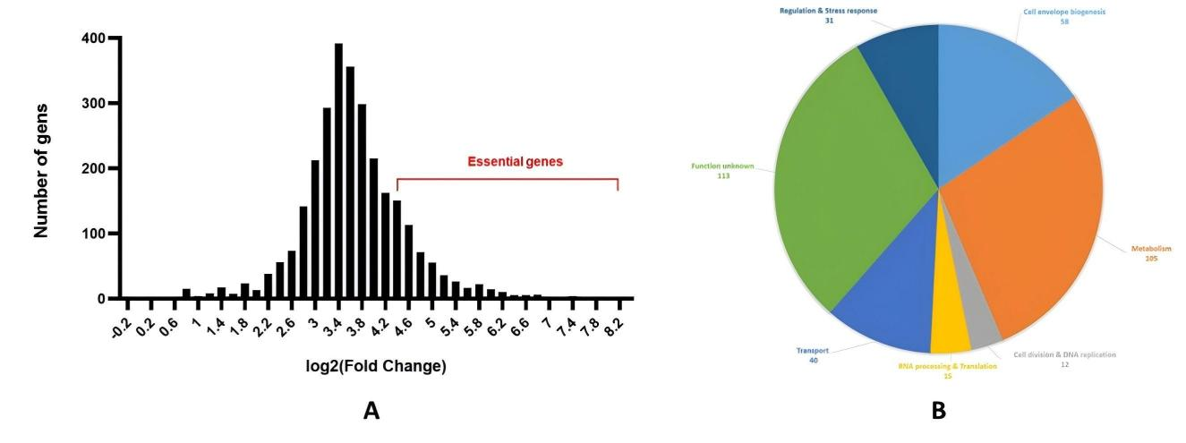
Figure 2. Comparative analysis of input versus output libraries
Figure 2：A: The log2(FC) distribution of input versus output libraries across the whole genome follows a normal distribution. Genes with log2(FC) ≥4.5 were identified as candidate essential genes for intracellular survival of B. melitensis 16M. B: GO classification of candidate essential genes for intracellular survival with log2 (FC) ≥4.5.

Figure 3
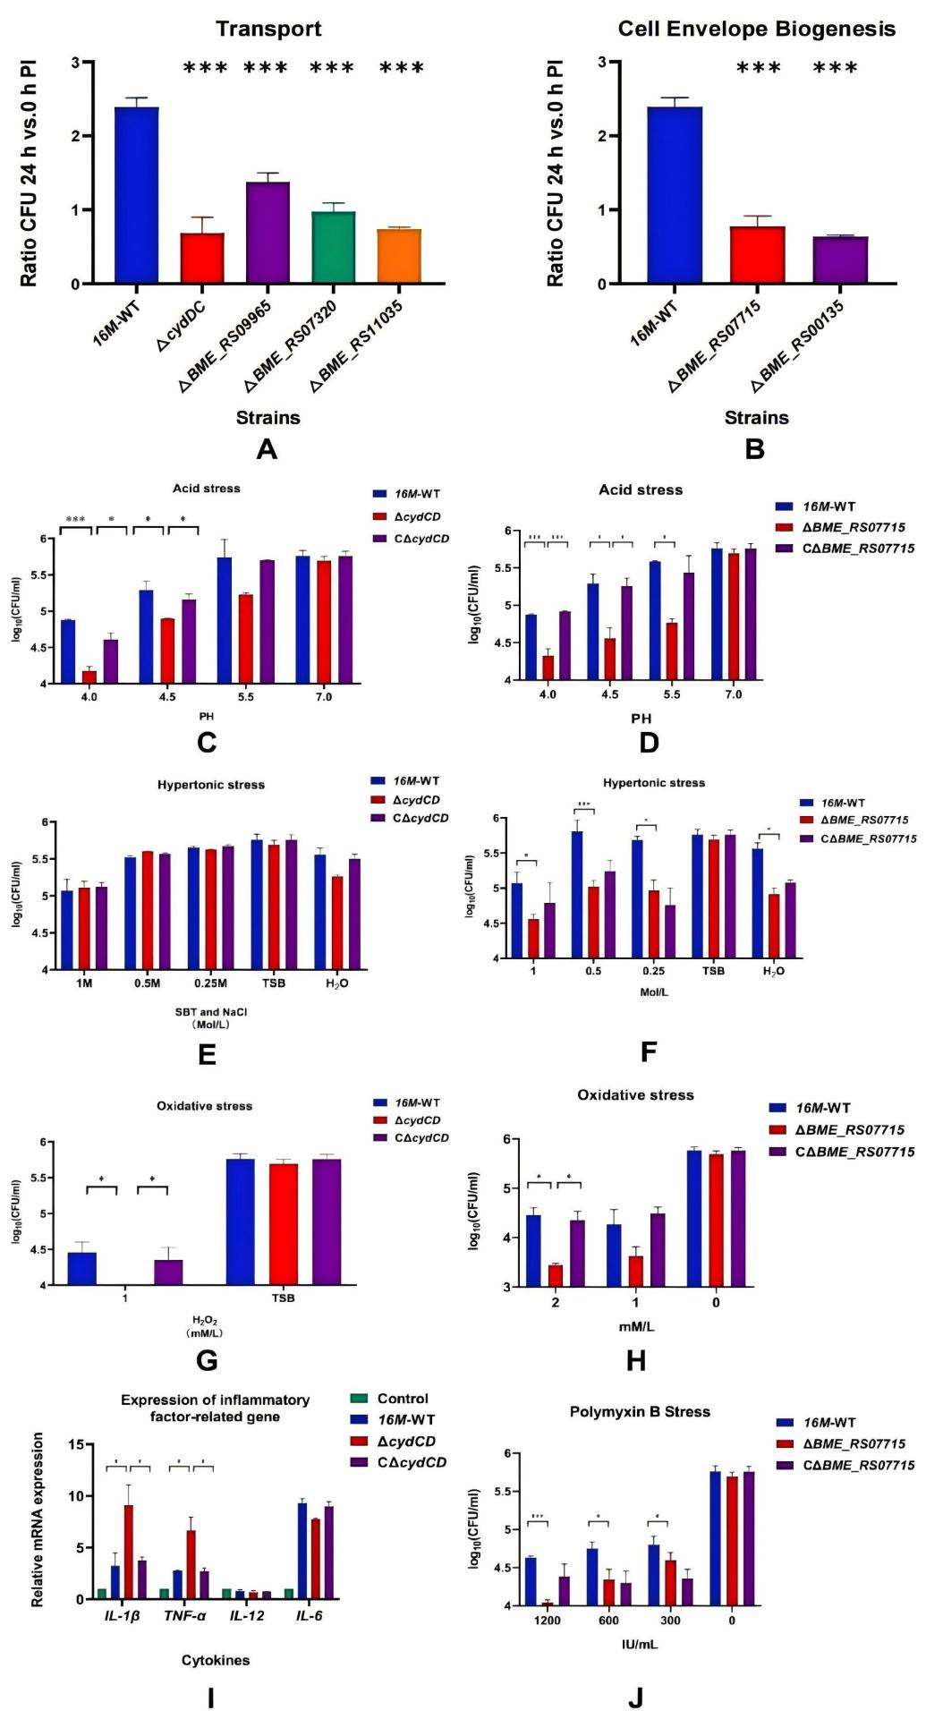
Figure 3. Phenotypic validation of transporter-associated and membrane structures-associated anti-phagocytic genes
Figure 3：AB: Intracellular survival assay of metabolism-related anti-phagocytic gene knockout strains. The intracellular survival rates of all five gene knockout strains were significantly lower than that of the wild-type 16M strain(P<0.05);CD:In acid stress tests, both ΔcydDC and ΔBME_RS07715 mutant strains demonstrated heightened acid sensitivity;EF:In the osmotic stress assay, ΔcydDC displayed no significant sensitivity to osmotic stress conditions, with only the ΔBME_RS07715 mutant strain exhibiting pronounced hypersensitivity(P<0.05);GH:In the oxidative stress assay, the ΔcydDC mutant strain exhibited pronounced hypersensitivity to oxidative stress（P<0.05）;I:Relative to the uninfected control group, all three strains (16M, CΔcydDC, and ΔcydDC) exhibited significant upregulation of IL-1β and TNF-α expression (p < 0.05);J:The results revealed that at concentrations of 1200 IU/mL, 600 IU/mL, and 300 IU/mL, relative to the wild-type strain, the survival rates of ΔBME_RS07715 decreased by 74.9% (P < 0.01), 60.7% (P < 0.05), and 37% (P < 0.05) respectively.
Figure 4
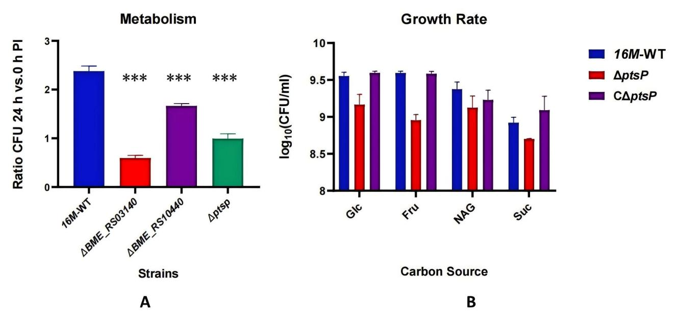
Figure 4 Phenotypic validation of metabolism-related anti-phagocytic genes
Figure 4:A: Intracellular survival assay of metabolism-related anti-phagocytic gene knockout strains. The intracellular survival rates of all three gene knockout strains were significantly lower than that of the wild-type 16M strain; B: Growth assay of Brucella in different single carbon sources. The three strains exhibited varying growth rates across different carbon sources, with the fastest growth observed in glucose and the slowest in succinate. The ΔptsP mutant showed significantly reduced growth rates in glucose, fructose, and succinate compared to the wild-type 16M strain and the complemented strain (P < 0.05).
Figure 5
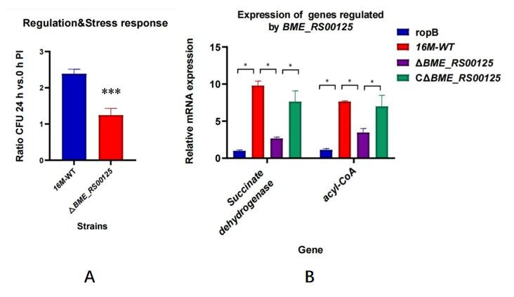
Figure 5. Intracellular survival assay of regulation -related anti-phagocytosis gene knockout strains
Figure 5:A:Compared with the intracellular survival rate of wild-type strain, ΔBME_RS00125 exhibited significantly reduced（P<0.01);B:ΔBME_RS00125 showed significantly downregulated succinate dehydrogenase and acyl-CoA compared to the wild-type and complemented strains (P < 0.05).

Table 1
Transporter-associated and membrane structures-associated anti-phagocytosis genes
GeneName | log2(FC) | GO | KEGG
cydDC | 7.404477376 | Transport | ko02010 ABC transporters
BME_RS17320 | 7.398586446 | Transport | ko02010 ABC transporters
BME_RS11035 | 7.130463687 | Transport | ko03070 Bacterial secretion system
BME_RS09965 | 6.908926566 | Transport | ko02010 ABC transporters
cbiM | 6.059207632 | Transport
tatC | 5.953854631 | Transport | ko02024 Quorum sensing
livM | 5.581885854 | Transport | ko02010 ABC transporters
BME_RS03240 | 5.524170356 | Transport | ko02010 ABC transporters
BME_RS14650 | 5.478292212 | Transport | ko02040 Flagellar assembly
BME_RS03285 | 5.401313608 | Transport | ko02010 ABC transporters
BME_RS10510 | 5.368892131 | Transport | ko02010 ABC transporters
BME_RS09675 | 5.335725267 | Transport | ko02010 ABC transporters
mraY | 5.335725267 | Transport | ko00550 Peptidoglycan biosynthesis
BME_RS14960 | 5.231388607 | Transport | ko02010 ABC transporters
fliP | 5.202657769 | Transport | ko02040 Flagellar assembly
BME_RS06090 | 5.092682336 | Transport | ko02010 ABC transporters
modB | 5.042193097 | Transport | ko02010 ABC transporters
thiQ | 5.038743529 | Transport | ko02010 ABC transporters
BME_RS10610 | 4.909460512 | Transport
flgA | 4.909460512 | Transport | ko02040 Flagellar assembly
BME_RS07715 | 6.502657769 | Cell Envelope Biogenesis
BME_RS0135 | 6.494862731 | Cell Envelope Biogenesis
BME_RS01625 | 6.084013273 | Cell Envelope Biogenesis | ko00362 Benzoate degradation
BME_RS07425 | 5.908926566 | Cell Envelope Biogenesis
BME_RS00330 | 5.84019785 | Cell Envelope Biogenesis
BME_RS15560 | 5.812711251 | Cell Envelope Biogenesis | ko00550 Peptidoglycan biosynthesis
BME_RS11495 | 5.709617758 | Cell Envelope Biogenesis
BME_RS05810 | 5.664348014 | Cell Envelope Biogenesis
flgB | 5.655169974 | Cell Envelope Biogenesis
BME_RS03100 | 5.581885854 | Cell Envelope Biogenesis
secG | 5.276658351 | Cell Envelope Biogenesis | ko02024 Quorum sensing
BME_RS04400 | 5.194862731 | Cell Envelope Biogenesis
BME_RS07955 | 5.118913878 | Cell Envelope Biogenesis
mdh | 5.118913878 | Cell envelope biogenesis | ko00720 Carbon fixation pathways in prokaryotes
BME_RS12790 | 5.069331849 | Cell Envelope Biogenesis
BME_RS01495 | 5.042193097 | Cell Envelope Biogenesis
BME_RS02755 | 5.042193097 | Cell Envelope Biogenesis
yidD | 5.042193097 | Cell envelope biogenesis
btpA | 4.996923353 | Cell envelope biogenesis
BME_RS07285 | 4.954730256 | Cell Envelope Biogenesis

Table 2
Metabolism-related anti-phagocytosis gene
GeneName | log2(FC) | GO | KEGG
ptsP | 7.598586446 | Metabolism
BME_RS02260 | 7.462524896 | Metabolism
BME_RS00880 | 7.385467594 | Metabolism
BME_RS03140 | 7.163656822 | Metabolism | ko01200 Carbon metabolism
BME_RS14240 | 6.84019785 | Metabolism | ko00520 Amino sugar and nucleotide sugar metabolism
upp | 6.78762027 | Metabolism | ko00900 Terpenoid backbone biosynthesis
BME_RS10395 | 6.709617758 | Metabolism | ko00260 Glycine, serine and threonine metabolism
BME_RS04890 | 6.703876378 | Metabolism | ko00630 Glyoxylate and dicarboxylate metabolism
murD | 6.627155598 | Metabolism | ko00471 D-Glutamine and D-glutamate metabolism
folP | 6.478292212 | Metabolism | ko00790 Folate biosynthesis
galE | 6.249310515 | Metabolism | ko00520 Amino sugar and nucleotide sugar metabolism
serS | 6.240132475 | Metabolism | ko00052 Galactose metabolism
accB | 6.231388607 | Metabolism | ko00061 Fatty acid biosynthesis
BME_RS04725 | 6.231388607 | Metabolism | ko01200 Carbon metabolism
BME_RS11925 | 6.202657769 | Metabolism | ko00562 Inositol phosphate metabolism
BME_RS12585 | 6.202657769 | Metabolism | ko01200 Carbon metabolism
BME_RS03680 | 6.176247053 | Metabolism | ko00230 Purine metabolism
mltG | 6.118913878 | Metabolism
nth | 6.059207632 | Metabolism
hemJ | 6.017984969 | Metabolism
grxC | 5.999124375 | Metabolism
BME_RS02020 | 5.954730256 | Metabolism
BME_RS03480 | 5.954730256 | Metabolism | ko00860 Porphyrin and chlorophyll metabolism
BME_RS03995 | 5.954730256 | Metabolism | ko01200 Carbon metabolism
glpD | 5.931828325 | Metabolism | ko00564 Glycerophospholipid metabolism
alr | 5.861620852 | Metabolism
BME_RS09430 | 5.861620852 | Metabolism | ko04215 Apoptosis - multiple species
BME_RS04050 | 5.851975017 | Metabolism | ko00260 Glycine, serine and threonine metabolism
BME_RS06185 | 5.812711251 | Metabolism
BME_RS07650 | 5.762085178 | Metabolism
rimO | 5.703876378 | Metabolism
phoA | 5.690820226 | Metabolism | ko00627 Aminobenzoate degradation
coaE | 5.655414889 | Metabolism | ko00770 Pantothenate and CoA biosynthesis
BME_RS00175 | 5.655169974 | Metabolism | ko01212 Fatty acid metabolism
BME_RS12605 | 5.62370603 | Metabolism | ko01200 Carbon metabolism
BME_RS06005 | 5.598586446 | Metabolism
sucD | 5.553316702 | Metabolism | ko00020 Citrate cycle (TCA cycle)
mazG | 5.553316702 | Metabolism | ko00230 Purine metabolism

Table 3
Regulation -related anti-phagocytosis gene
GeneName | log2(FC) | GO | KEGG
BME_RS00125 | 8.134639346 | Regulation
groL | 7.598586446 | Regulation
BME_RS14210 | 7.084013273 | Regulation
BME_RS11150 | 6.448619323 | Regulation | ko02024 Quorum sensing
BME_RS03045 | 6.059207632 | Regulation
proC | 5.762085178 | Regulation
sfsA | 5.62370603 | Regulation
pdeM | 5.581885854 | Regulation
bcp | 5.335725267 | Regulation
BME_RS10075 | 5.301777935 | Regulation | ko02020 Two-component system
BME_RS04875 | 5.202657769 | Regulation | ko02020 Two-component system
BME_RS14065 | 5.118913878 | Regulation | ko02020 Two-component system
ychF | 5.079385514 | Regulation
BME_RS14360 | 4.964742948 | Regulation | ko02020 Two-component system
hflK | 4.954730256 | Regulation
prfA | 4.909460512 | Regulation
BME_RS11700 | 4.861620852 | Regulation
htpX | 4.84019785 | Regulation
BME_RS04000 | 4.825937157 | Regulation
BME_RS02850 | 4.730490371 | Regulation | ko00550 Peptidoglycan biosynthesis
ccoO | 4.716815434 | Regulation | ko00190 Oxidative phosphorylation
petA | 4.664348014 | Regulation | ko00190 Oxidative phosphorylation
BME_RS14075 | 4.664348014 | Regulation | ko02020 Two-component system
BME_RS04935 | 4.646426106 | Regulation | ko00550 Peptidoglycan biosynthesis
BME_RS08990 | 4.553316702 | Regulation | ko02020 Two-component system
BME_RS01270 | 4.509373354 | Regulation | ko02024 Quorum sensing
dhbA | 4.501086743 | Regulation

Supplementary Figure S1
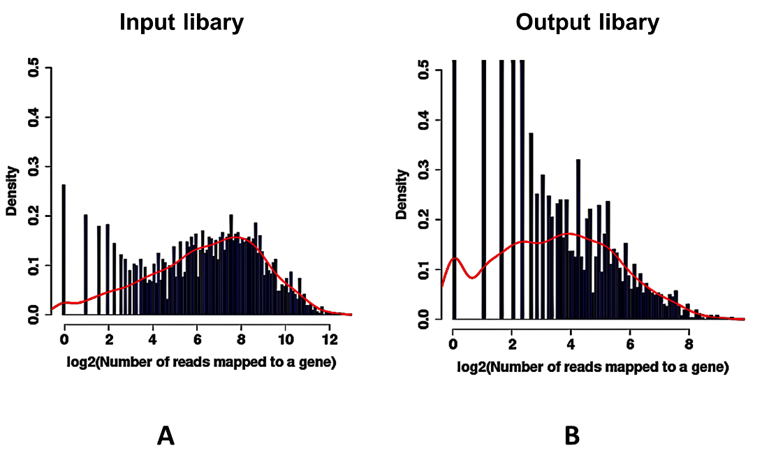
Supplementary Figure S1. Analysis of transposon insertion sites by TraDIS sequencing
A: Insertion frequency distribution across all genes in the input library. Insertion sites were uniformly distributed throughout the genome. B: Insertion frequency distribution in the output library. Under intracellular selection pressure, mutants affecting survival were depleted, leading to reduced read counts at corresponding sites.

Supplementary Figure S2
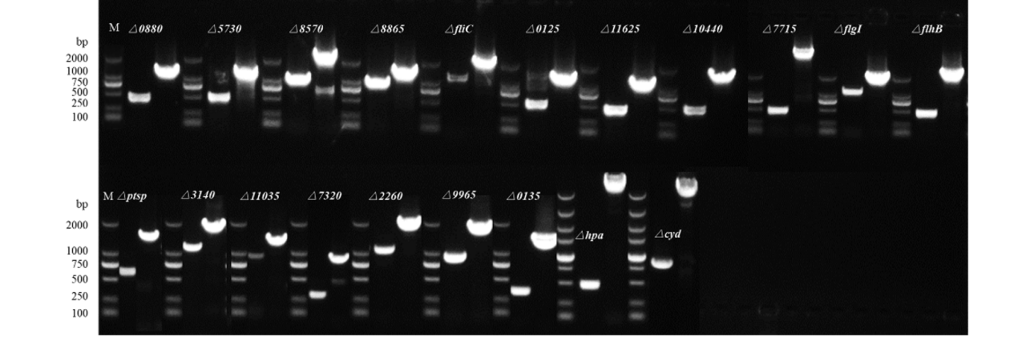
Supplementary Figure S2. Agarose gel electrophoresis analysis of gene deletion mutants PCR results of 20 Brucella gene deletion strains
From left to right: BME_RS00880, BME_RS05730, BME_RS08570, BME_RS08865, flic，BME_RS00125, BME_RS11625, BME_RS10440, BME_RS07715, flgI, flhb, ptsp, BME_RS03140，BME_RS11035, BME_RS17320, BME_RS02260, BME_RS09965, BME_RS00135, hpa, cydDC
Supplementary Table S1
 | File | Reads Matched | Reads Mapped（%） | Unique Insertion Sites
input | 1.raw_1.fastq | 21,884,139 | 14,130,545(64.57) | 39783
input | 1.raw_2.fastq | 23,488,074 | 15,340,646(65.31) | 39915
output | 2.raw_1.fastq | 22,121,967 | 13,663,496（61.76） | 12104
output | 2.raw_2.fastq | 22,119,569 | 13,746,096（62.14） | 12219
Supplementary Table S2
Strains and plasmids | Applications
Brucella melitensis strain 16M | Used for the construction of transposon mutant libraries and intracellular survival experiments
Escherichia coli strain S17 λ pir | Serves as the donor strain for the construction of transposon mutant libraries
Escherichia coli strain WM3064 | Acts as the donor strain for the construction of gene - deletion strains
Plasmid pUTmini - Tn5km2 | Used for the construction of transposon mutant libraries
Plasmid pRE112 | Gene knockout vector
Plasmid pBBR1MCS - 2 | Gene complementation vector

Supplementary Table S3
Primer Name | Sequence | Length
cydCD-F1 | ATCGCATGCGGTACCTCTAGGGGCAGATTTATGCGCTGC | 39
cydCD-R1 | ATCATGGTTCTCTCGCTTAGGCTCCTTCTTGG | 32
cydCD-F2 | CTAAGCGAGAGAACCATGATACTCAGCGATTTG | 33
cydCD-R2 | CGATCCCAAGCTTCTTCTAGAATGAGCCTTCGTAGAAGATCTGG | 44
ptsP-F1 | ATCGCATGCGGTACCTCTAGATCGGCATCGGCATGCGC | 38
ptsP-R1 | ATTGGCTTCGTTCCTCGGAGGCTCCTCTCTTTGC | 34
ptsP-F2 | CTCCGAGGAACGAAGCCAATTGCTCAAATTGAACG | 35
ptsP-R2 | CGATCCCAAGCTTCTTCTAGTCCTTGGGTAGAAGCAGGATTTGC | 44
BME_RS03140-F1 | ATCGCATGCGGTACCTCTAGCAGCAAAATGCAGTGGCGGG | 40
BME_RS03140-R1 | CAAACTTTGCCCCTCATCCTCCTTTGACATGC | 32
BME_RS03140-F2 | AGGATGAGGGGCAAAGTTTGGCTTAGAGCATTTCC | 35
BME_RS03140-R2 | CGATCCCAAGCTTCTTCTAGTCGTCTTTGTATAGGCTGGCTCC | 43
BME_RS07715-F1 | ATCGCATGCGGTACCTCTAGTTCCATCGCAAACGGTCTCG | 40
BME_RS07715-R1 | TCTCTACAGCCGGAAACTCCACTCACACTGAC | 32
BME_RS07715-F2 | GGAGTTTCCGGCTGTAGAGAGGAATCTGCCC | 31
BME_RS07715-R2 | CGATCCCAAGCTTCTTCTAGGCACCGACCAGGATTCCC | 38
BME_RS17320-F1 | ATCGCATGCGGTACCTCTAGGCGGCCTTCACATTGACG | 38
BME_RS17320-R1 | CCTGCGCTTTTGACCTTCTCCCGTTTTTATAGCG | 34
BME_RS17320-F2 | GAGAAGGTCAAAAGCGCAGGCCACGGGC | 28
BME_RS17320-R2 | CGATCCCAAGCTTCTTCTAGAATGTCTCGATCAGCGGCAGC | 41
BME_RS00135-F1 | ATCGCATGCGGTACCTCTAGGTCGGCTTCCACCATGCG | 38
BME_RS00135-R1 | TTTAAATTTCGGTCTCCTCCTCGTCCTTACC | 31
BME_RS00135-F2 | GGAGGAGACCGAAATTTAAATTCAAAATAATAC | 33
BME_RS00135-R2 | CGATCCCAAGCTTCTTCTAGATCGGTTTACTTGCAGCTTTCCG | 43
BME_RS09965-F1 | ATCGCATGCGGTACCTCTAGTCTGGTTGGTTCCTCCATGGG | 41
BME_RS09965-R1 | ACCAATGTGAGGGCGCTGCTCCGCTATAC | 29
BME_RS09965-F2 | AGCAGCGCCCTCACATTGGTTAGGCGAATTGC | 32
BME_RS09965-R2 | CGATCCCAAGCTTCTTCTAGTTCAAATTCGGCGCGTGC | 38
BME_RS10440-F1 | ATCGCATGCGGTACCTCTAGTGGTGTTCAGCGGCTGTTG | 39
BME_RS10440-R1 | TATGCGCAGTATTCAAGCACTCCCGCAG | 28
BME_RS10440-F2 | GTGCTTGAATACTGCGCATATGAACGCG | 28
BME_RS10440-R2 | CGATCCCAAGCTTCTTCTAGCGCGATCTGCTTGTTCATGAGC | 42
BME_RS00125-F1 | ATCGCATGCGGTACCTCTAGGGTCGAGCGCGGCGATTT | 38
BME_RS00125-R1 | GCGAAGTTGTCGCGCTACCCTTATAATTTTGCAA | 34
BME_RS00125-F2 | GGGTAGCGCGACAACTTCGCCGGAACGTAT | 30
BME_RS00125-R2 | CGATCCCAAGCTTCTTCTAGTAAATTGAATAATAAATATTGTTAA | 45
BME_RS11035-F1 | ATCGCATGCGGTACCTCTAGTGTCGAGAAAGGTTTCCATGG | 41
BME_RS11035-R1 | GAAGAAATCGATATTCCGGGCTTTCTCTGC | 30
BME_RS11035-F2 | CCCGGAATATCGATTTCTTCACCCGCGCC | 29
BME_RS11035-R2 | CGATCCCAAGCTTCTTCTAGGTGAAAGTGCCGGGTTCATTCC | 42
Supplementary Table S4
Primer Name | Sequence | Length
cydCD-F3 | ACACAGGAAACAGCTGTGACATCCGTTGCCCCC | 33
cydCD-R3 | CGTAATCATGGTCATTCACCTCATGGTTTTGAGGATGTCG | 40
BME_RS07715-F3 | ACACAGGAAACAGCTGTGCGTCTTGTATCCTTACGAGCG | 39
BME_RS07715-R3 | CGTAATCATGGTCATCTAGCTCCAGCCGCCGCC | 33
ptsP-F3 | ACACAGGAAACAGCTATGCGTGAGCTGACAACCG | 34
ptsP-R3 | CGTAATCATGGTCATCTATAACGGAATTTCGTTGTCTTCG | 40
BME_RS00125-F3 | ACACAGGAAACAGCTATGCATTACGATTATATCATC | 36
BME_RS00125-R3 | CGTAATCATGGTCATTCATCCTGCCGGGCGATA | 33
Test-F2 | TTATGCATGCGCCCAATACG | 20
Test-R2 | ACTATAGGGCGAATTGGAGC | 20
Supplementary Table S5
Material | Volume
2xTelomere Detection Mix | 10 μL
Mouse SDHA Primer set (10 μM) | 1 μL
Nuclease-free H₂O | 7 μL
cDNA | 2 μL

Supplementary Table S6
Program | Temperature (℃) | Times
Predegeneration | 95 | 3 min
Degeneration | 95 | 15 s
Annealing - Elongation | 60 | 30 s
Dissolution curve stage | 60-95
Supplementary Table S7
Test | Bacterial strain | Repeatability assay
Test | Bacterial strain | AVG | SD | CV%
Intracellular viability test | 16M-WT | 2.39 | 0.10 | 4.28
Intracellular viability test | △ cydDC | 0.68 | 0.01 | 1.39
Intracellular viability test | △ BME_RS09965 | 1.38 | 0.10 | 7.23
Intracellular viability test | △ BME_RS07320 | 0.98 | 0.10 | 9.81
Intracellular viability test | △ BME_RS11035 | 0.74 | 0.02 | 3.30
Intracellular viability test | △ BME_RS07715 | 0.77 | 0.12 | 15.10
Intracellular viability test | △ BME_RS00135 | 0.64 | 0.02 | 2.38
Intracellular viability test | △ BME_RS00125 | 1.18 | 0.06 | 5.39
Intracellular viability test | Δptsp | 0.95 | 0.04 | 4.29
Intracellular viability test | ΔBME_RS03140 | 0.58 | 0.05 | 8.11
Intracellular viability test | ΔBME_RS10440 | 1.65 | 0.04 | 2.24
pH | 16M-WT | AVG | SD | CV%
pH | 4 | 74650.00 | 1918.77 | 2.57
pH | 4.5 | 180666.67 | 14817.41 | 8.20
pH | 5.5 | 733833.33 | 44377.80 | 6.05
pH | 7 | 573333.33 | 20949.68 | 3.65
pH | △ cydDC
pH | 4 | 15333.33 | 1407.91 | 9.18
pH | 4.5 | 78500.00 | 1224.74 | 1.56
pH | 5.5 | 169500.00 | 7756.72 | 4.58
pH | 7 | 491666.67 | 44790.87 | 9.11
pH | C△ cydDC
pH | 4 | 45400.00 | 3929.38 | 8.66
pH | 4.5 | 151000.00 | 11575.84 | 7.67
pH | 5.5 | 502000.00 | 9797.96 | 1.95
pH | 7 | 538333.33 | 49385.11 | 9.17
pH | 16M-WT | AVG | SD | CV%
pH | 4 | 74650.00 | 1918.77 | 2.57
pH | 4.5 | 147333.33 | 13888.44 | 9.43
pH | 5.5 | 572500.00 | 7560.86 | 1.32
pH | 7 | 540000.00 | 47081.49 | 8.72
pH | △ BME_RS07715
pH | 4 | 24383.33 | 2357.38 | 9.67
pH | 4.5 | 33333.33 | 1885.62 | 5.66
pH | 5.5 | 57333.33 | 5249.34 | 9.16
pH | 7 | 481666.67 | 44790.87 | 9.30
pH | C△ BME_RS07715
pH | 4 | 322100.00 | 9716.31 | 3.02
pH | 4.5 | 194333.33 | 18153.67 | 9.34
pH | 5.5 | 229333.33 | 18061.62 | 7.88
pH | 7 | 538333.33 | 49385.11 | 9.17
SBT and NaCl（Mol/L） | 16M-WT | AVG | SD | CV%
SBT and NaCl（Mol/L） | 1M | 149666.67 | 6944.22 | 4.64
SBT and NaCl（Mol/L） | 0.5M | 473333.33 | 9428.09 | 1.99
SBT and NaCl（Mol/L） | 0.25M | 479000.00 | 45760.24 | 9.55
SBT and NaCl（Mol/L） | TSB | 506666.67 | 27788.89 | 5.48
SBT and NaCl（Mol/L） | H2O | 393333.33 | 33993.46 | 8.64
SBT and NaCl（Mol/L） | △ BME_RS07715
SBT and NaCl（Mol/L） | 1M | 32666.67 | 2494.44 | 7.64
SBT and NaCl（Mol/L） | 0.5M | 188500.00 | 10637.98 | 5.64
SBT and NaCl（Mol/L） | 0.25M | 77666.67 | 7408.70 | 9.54
SBT and NaCl（Mol/L） | TSB | 491666.67 | 45675.18 | 9.29
SBT and NaCl（Mol/L） | H2O | 92000.00 | 7483.31 | 8.13
SBT and NaCl（Mol/L） | C△ BME_RS07715
SBT and NaCl（Mol/L） | 1M | 30333.33 | 2867.44 | 9.45
SBT and NaCl（Mol/L） | 0.5M | 121666.67 | 6236.10 | 5.13
SBT and NaCl（Mol/L） | 0.25M | 86666.67 | 6182.41 | 7.13
SBT and NaCl（Mol/L） | TSB | 605000.00 | 39370.04 | 6.51
SBT and NaCl（Mol/L） | H2O | 119000.00 | 8981.46 | 7.55
SBT and NaCl（Mol/L） | 16M-WT | AVG | SD | CV%
SBT and NaCl（Mol/L） | 1M | 149666.67 | 6944.22 | 4.64
SBT and NaCl（Mol/L） | 0.5M | 332333.33 | 12229.29 | 3.68
SBT and NaCl（Mol/L） | 0.25M | 446666.67 | 18856.18 | 4.22
SBT and NaCl（Mol/L） | TSB | 540000.00 | 47081.49 | 8.72
SBT and NaCl（Mol/L） | H2O | 393333.33 | 33993.46 | 8.64
SBT and NaCl（Mol/L） | △ cydDC
SBT and NaCl（Mol/L） | 1M | 118666.67 | 10873.00 | 9.16
SBT and NaCl（Mol/L） | 0.5M | 401000.00 | 816.50 | 0.20
SBT and NaCl（Mol/L） | 0.25M | 420000.00 | 8164.97 | 1.94
SBT and NaCl（Mol/L） | TSB | 491666.67 | 58931.22 | 11.99
SBT and NaCl（Mol/L） | H2O | 183000.00 | 5715.48 | 3.12
SBT and NaCl（Mol/L） | C△ cydDC
SBT and NaCl（Mol/L） | 1M | 132666.67 | 14817.41 | 11.17
SBT and NaCl（Mol/L） | 0.5M | 365333.33 | 11469.77 | 3.14
SBT and NaCl（Mol/L） | 0.25M | 466000.00 | 19595.92 | 4.21
SBT and NaCl（Mol/L） | TSB | 595000.00 | 25495.10 | 4.28
SBT and NaCl（Mol/L） | H2O | 318333.33 | 28452.69 | 8.94
H2O2 | 16M-WT | AVG | SD | CV%
H2O2 | 1mM | 31833.33 | 3704.35 | 11.64
H2O2 | TSB | 540000.00 | 47081.49 | 8.72
H2O2 | △ cydDC
H2O2 | 1mM | 0.00 | / | /
H2O2 | TSB | 491666.67 | 58931.22 | 11.99
H2O2 | C△ cydDC
H2O2 | 1mM | 22433.33 | 9207.36 | 41.04
H2O2 | TSB | 571666.67 | 78138.05 | 13.67
H2O2 | 16M-WT | AVG | SD | CV%
H2O2 | 2mM | 30500.00 | 2483.28 | 8.14
H2O2 | 1mM | 38333.33 | 1247.22 | 3.25
H2O2 | TSB | 506666.67 | 27788.89 | 5.48
H2O2 | △ BME_RS07715
H2O2 | 2mM | 2833.33 | 235.70 | 8.32
H2O2 | 1mM | 5966.67 | 449.69 | 7.54
H2O2 | TSB | 487333.33 | 47988.42 | 9.85
H2O2 | C△ BME_RS07715
H2O2 | 2mM | 29100.00 | 2808.32 | 9.65
H2O2 | 1mM | 37666.67 | 3299.83 | 8.76
H2O2 | TSB | 545000.00 | 40207.79 | 7.38
Polymyxin B | 16M-WT | AVG | SD | CV%
Polymyxin B | 1200IU | 42500.00 | 2041.24 | 4.80
Polymyxin B | 600IU | 59333.33 | 2494.44 | 4.20
Polymyxin B | 300IU | 69333.33 | 5734.88 | 8.27
Polymyxin B | 0IU | 506666.67 | 27788.89 | 5.48
Polymyxin B | △ BME_RS07715
Polymyxin B | 1200IU | 11000.00 | 816.50 | 7.42
Polymyxin B | 600IU | 24000.00 | 1632.99 | 6.80
Polymyxin B | 300IU | 34500.00 | 3082.21 | 8.93
Polymyxin B | 0IU | 458333.33 | 11813.36 | 2.58
Polymyxin B | C△ BME_RS07715
Polymyxin B | 1200IU | 24000.00 | 1632.99 | 6.80
Polymyxin B | 600IU | 24500.00 | 1471.96 | 6.01
Polymyxin B | 300IU | 23833.33 | 1027.40 | 4.31
Polymyxin B | 0IU | 549333.33 | 53017.82 | 9.65
Cytokines | 16M-WT | AVG | SD | CV%
Cytokines | IL-1β | 3.74 | 0.30 | 8.09
Cytokines | TNF-α | 2.76 | 0.04 | 1.41
Cytokines | IL-12 | 0.84 | 0.05 | 5.90
Cytokines | IL-6 | 9.30 | 0.25 | 2.66
Cytokines | △ cydDC
Cytokines | IL-1β | 9.09 | 0.89 | 9.77
Cytokines | TNF-α | 6.74 | 0.67 | 9.94
Cytokines | IL-12 | 0.63 | 0.06 | 9.34
Cytokines | IL-6 | 7.74 | 0.05 | 0.65
Cytokines | C△ cydDC
Cytokines | IL-1β | 3.75 | 0.19 | 4.96
Cytokines | TNF-α | 2.69 | 0.18 | 6.67
Cytokines | IL-12 | 0.73 | 0.00 | 0.67
Cytokines | IL-6 | 8.97 | 0.27 | 3.03

