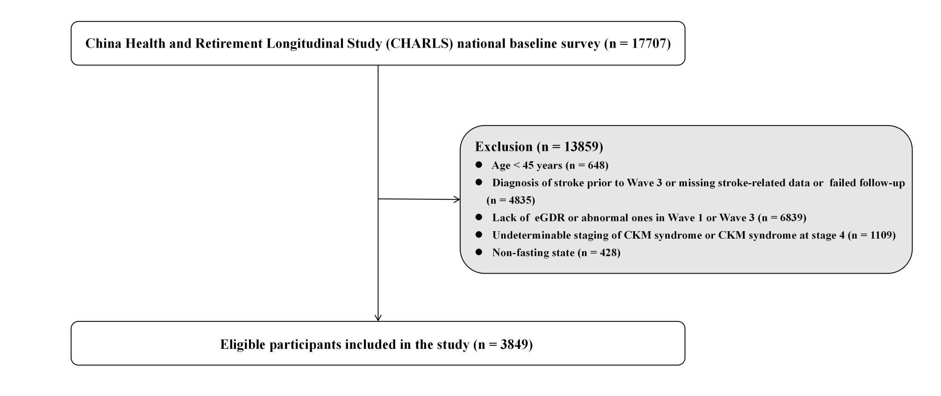

Figure S1. Flow chart of study participants.

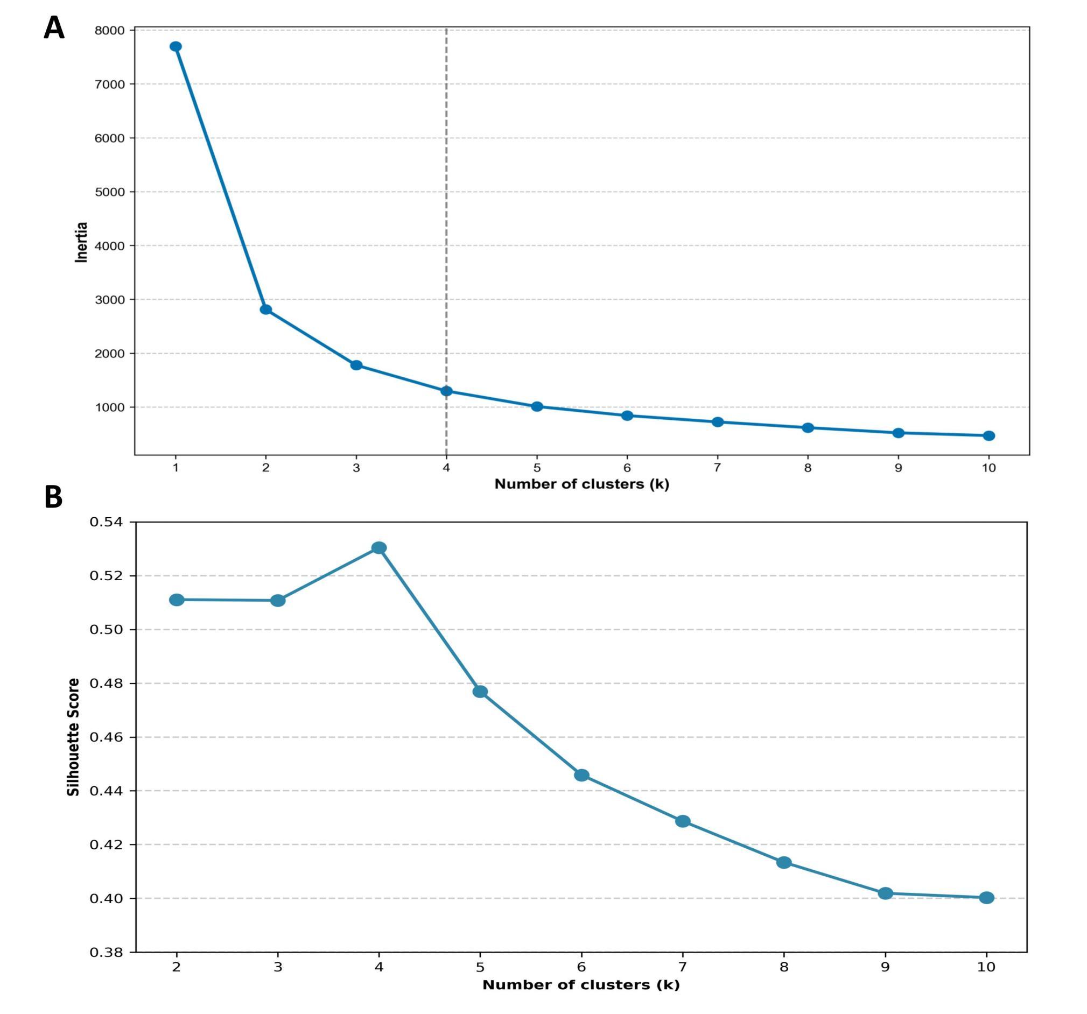

Figure S2. Elbow method (A) and Silhouette Score (B) for determining the optimal number of clusters.

Supplementary Table S1. Imputation of Missing Variables Based on Multiple Imputation Method
Variable | Number
Drinking status | 4
Smoking status | 9
Dyslipidemia | 44
LDL | 5
Education | 1

Supplementary Table S2. Collinearity Analysis of Variables Based on Variance Inflation Factor
Variable | VIF
Gender | 2.739
Age | 1.772
Education | 1.231
Drinking status | 1.548
Smoking status | 2.153
Marital status | 1.086
Habitation | 1.065
BMI | 1.016
TG | 1.508
HDL | 1.313
LDL | 1.086
CRP | 1.017
UA | 1.532
eGFR | 1.594
FBG | 1.152
SBP | 2.371
DBP | 2.236

Supplementary Table S3. Characteristics of the study participants based on the cumulative eGDR
SBP, systolic blood pressure; DBP, diastolic blood pressure; WC, waist circumference; BMI, body mass index; CRP, C-reactive protein; HDL-C, high-density lipoprotein cholesterol; LDL-C, low-density lipoprotein cholesterol; TC, total cholesterol; TG, triglyceride; BUN, blood urea nitrogen; UA, uric acid; FBG, fasting blood glucose; HbA1c, glycated hemoglobin; eGFR, estimated glomerular filtration rate; eGDR, estimated glucose disposal rate; CumeGDR, cumulative estimated glucose disposal rate;

Characteristic | Cumulative eGDR |  |  | P value
Characteristic | T 3 | T 2 | T 1 | P value
Characteristic | (n=1283) | (n=1283) | (n=1283) | P value
Age, years | 56.77±8.23 | 58.64±8.71 | 59.88±8.82 | <0.001
Gender, n (%) |  |  |  | 0.059
Male | 614 (47.9) | 631 (49.2) | 572 (44.6)
Female | 669 (52.1) | 652 (50.8) | 711 (55.4)
Marital status, n (%) |  |  |  | 0.066
Married | 1176 (91.7) | 1161 (90.5) | 1141 (88.9)
Others | 107 (8.3) | 122 (9.5) | 142 (11.1)
Education, n (%) |  |  |  | 0.179
Primary school or below | 874 (68.1) | 908 (70.8) | 914 (71.2)
Above primary school | 409 (31.9) | 375 (29.2) | 369 (28.8)
Habitation, n (%) |  |  |  | <0.001
Agriculture | 916 (71.4) | 866 (67.5) | 816 (63.6)
Others | 367 (28.6) | 417 (32.5) | 467 (36.4)
Smoking status, n (%) |  |  |  | 0.001
Never | 777 (60.6) | 764 (59.5) | 819 (63.8)
Previous | 82 (6.4) | 94 (7.3) | 113 (8.8)
Current | 424 (33) | 425 (33.1) | 351 (27.4)
Drinking status, n (%) |  |  |  | <0.001
Never | 773 (60.2) | 718 (56) | 760 (59.2)
Previous | 80 (6.2) | 87 (6.8) | 117 (9.1)
Current | 430 (33.5) | 478 (37.3) | 406 (31.6)
Comorbidities, n (%)
Diabetes | 75 (5.8) | 166 (12.9) | 311 (24.2) | <0.001
Dyslipidemia | 51 (4) | 86 (6.7) | 160 (12.5) | <0.001
SBP, mmHg | 115.72±11.06 | 130.28±18.92 | 146.61±20.31 | <0.001
DBP, mmHg | 68.88±8.65 | 75.85±11.27 | 84.18±12.11 | <0.001
WC, cm | 79.01±6.70 | 83.88±9.42 | 91.93±7.97 | <0.001
BMI, kg/m² | 21.44±2.49 | 23.02±3.34 | 25.51±3.26 | <0.001
CRP, mg/L | 0.76[1.15] | 0.91[1.25] | 1.26[1.85] | <0.001
HDL, mg/dL | 54.47±15.04 | 52.14±15.73 | 47.68±13.90 | <0.001
LDL, mg/dL | 113.71±31.89 | 116.17±33.98 | 121.61±37.74 | <0.001
TC, mg/dL | 187.67±36.03 | 193.23±36.90 | 201.23±39.58 | <0.001
TG, mg/dL | 87.61[54.87] | 100.00[74.78] | 124.79[95.14] | <0.001
BUN, mg/dL | 15.72±4.35 | 15.64±4.48 | 15.64±4.23 | 0.871
UA, mg/dL | 4.14±1.09 | 4.37±1.22 | 4.57±1.27 | <0.001
FBG, mg/dL | 100.14±15.51 | 107.09±27.42 | 117.88±45.90 | <0.001
HbA1c, % | 5.08±0.41 | 5.22±0.70 | 5.50±1.09 | <0.001
eGFR, mL/min/1.73m² | 94.28±14.30 | 92.63±15.48 | 89.75±16.25 | <0.001
CKM stage, n (%) |  |  |  | <0.001
0 | 214 (16.7) | 40 (3.1) | 1 (0.1) | <0.001
1 | 504 (39.3) | 210 (16.4) | 10 (0.8)
2 | 388 (30.2) | 659 (51.4) | 745 (58.1)
3 | 177 (13.8) | 374 (29.2) | 527 (41.1)
eGDR₂₀₁₂ | 11.25±0.64 | 9.55±1.30 | 6.62±1.02 | <0.001
eGDR₂₀₁₅ | 10.76±0.74 | 7.79±1.11 | 5.91±1.02 | <0.001
CumeGDR | 33.01±1.74 | 26.01±2.43 | 18.79±2.60 | <0.001
Stroke, n (%) | 43 (3.4) | 100 (7.8) | 142 (11.1) | <0.001

Table S4. Incremental predictive value of cumeGDR and clusters of eGDR changes for stroke.
Model | C-statistic (95%CI) | NRI (95% CI) | IDI (95% CI)
Basic model | 0.6574 (0.6352, 0.6993) | Reference | Reference
Basic model + cumeGDR | 0.6734 (0.6499, 0.7114) | 0.2342 (0.1033, 0.3457) | 0.0038 (0.0005, 0.0099)
Basic model + clusters of eGDR changes | 0.6711 (0.6480, 0.7105) | 0.2693 (0.1116, 0.3912) | 0.0032 (0.0009, 0.0095)  )
The basic model (model 4) included: age, sex, residence, educational level, marital status, alcohol consumption, smoking status, SBP, DBP, BMI, eGFR, TG, HDL-C, LDL-C, CRP, UA, and FBG.

Table S5. Subgroup analysis for the association between clusters of eGDR changes and stroke.
Variable | The eGDR cluster groups, OR (95% CI)
Variable | Class 1 | Class 2 | Class 3 | Class 4 | P for interaction
Age |  |  |  |  | 0.919
<60 | Reference | 1.51 (0.86-2.67) | 2.31 (1.20-4.44) | 1.44 (0.81-2.55)
≥60 | Reference | 1.79 (0.94-3.39) | 2.05 (1.03-4.06) | 2.66 (1.42-4.97)
Gender |  |  |  |  | 0.607
Male | Reference | 1.30 (0.72-2.35) | 2.06 (1.09-3.89) | 1.75 (1.00-3.07)
Female | Reference | 1.68 (0.96-2.93) | 2.13 (1.16-3.91) | 1.83 (1.03-3.24)
Marital status |  |  |  |  | 0.772
Married | Reference | 1.35 (0.87-2.09) | 1.96 (1.23-3.13) | 1.89 (1.25-2.87)
Others | Reference | 2.51 (0.82-7.68) | 3.72 (0.89-15.52) | 0.67 (0.13-3.52)
Education |  |  |  |  | 0.208
Primary school or below | Reference | 1.83 (1.15-2.92) | 2.12 (1.26-3.57) | 2.04 (1.29-3.24)
Above primary school | Reference | 0.66 (0.27-1.57) | 1.55 (0.67-3.57) | 1.10 (0.48-2.51)
Habitation |  |  |  |  | 0.762
Agriculture | Reference | 1.64 (1.02-2.63) | 1.92 (1.13-3.28) | 2.06 (1.31-3.24)
Others | Reference | 1.25 (0.56-2.80) | 2.41 (1.10-5.31) | 1.31 (0.56-3.08)
Smoking status |  |  |  |  | 0.989
Never | Reference | 1.48 (0.88-2.49) | 1.64 (0.91-2.94) | 1.47 (0.86-2.52)
Smokers | Reference | 1.55 (0.81-2.96) | 2.32 (1.14-4.74) | 2.23 (1.21-4.11)
Drinking status
  0.945
Never | Reference | 1.89 (1.09-3.26) | 2.68 (1.50-4.81) | 2.08 (1.21-3.58)
Alcohol drinkers | Reference | 1.12 (0.61-2.05) | 1.52 (0.78-2.96) | 1.52 (0.84-2.75)
CKM stage |  |  |  |  | 0.599
0-1 | Reference | 1.42 (0.17-11.79) | 2.91(0.30-28.45) | 1.73 (0.79-3.76)
2 | Reference | 1.65 (1.15-2.38) | 2.38 (1.62-3.53) | 1.46 (0.98-2.18)
3 | Reference | 1.63 (0.70-3.76) | 2.62 (1.04-6.57) | 2.97 (1.26-7.01)
The analysis was adjusted using Model 4.

Table S6. Subgroup analysis for the association between cumulative eGDR and stroke
Variable | cumulative eGDR, OR (95% CI)
Variable | T3 | T2 | T1 | P for interaction
Age |  |  |  | 0.829
<60 | Reference | 2.03 (1.19-3.44) | 2.65 (1.40-5.03)
≥60 | Reference | 2.72 (1.43-5.16) | 3.11 (1.57-6.18)
Gender |  |  |  | 0.818
Male | Reference | 2.24 (1.30-3.86) | 2.38 (1.28-4.44)
Female | Reference | 2.14 (1.23-3.71) | 3.17 (1.74-5.80)
Marital status |  |  |  | 0.171
Married | Reference | 2.27 (1.50-3.44) | 2.69 (1.69-4.29)
Others | Reference | 1.57 (0.52-4.74) | 4.15 (1.14-15.15)
Education |  |  |  | 0.993
Primary school or below | Reference | 2.27 (1.45-3.54) | 2.85 (1.73-4.70)
Above primary school | Reference | 1.73 (0.79-3.81) | 2.12 (0.87-5.13)
Habitation |  |  |  | 0.678
Agriculture | Reference | 2.36 (1.53-3.66) | 2.59 (1.57-4.29)
Others | Reference | 1.95 (0.85-4.45) | 3.48 (1.46-8.34)
Smoking status |  |  |  | 0.675
Never | Reference | 1.96 (1.18-3.26) | 2.49 (1.39-4.46)
Smokers | Reference | 2.47 (1.36-4.50) | 2.74 (1.38-5.46)
Drinking status |  |  |  | 0.362
Never | Reference | 2.91 (1.70-4.97) | 4.10 (2.26-7.43)
Alcohol drinkers | Reference | 1.52 (0.87-2.66) | 1.72 (0.91-3.24)
CKM stage |  |  |  | 0.764
0-1 | Reference | 2.76 (1.33-5.73) | 2.82 (0.30-26.47)
2 | Reference | 1.43 (0.80-2.56) | 2.14 (1.16-3.92)
3 | Reference | 3.66 (1.37-9.75) | 3.70 (1.33-10.29)
The analysis was adjusted using Model 4.

Supplementary Table S7. Sensitivity analysis of the association between different eGDR groups and stroke after excluding the interpolation participants
Variable | Model 1 |  | Model 2 |  | Model 3 |  | Model 4
Variable | OR (95% CI) | P value | OR (95% CI) | P value | OR (95% CI) | P value | OR (95% CI) | P value
Categories
Class 1 | Reference |  | Reference |  | Reference |  | Reference
Class 2 | 1.91 (1.36-2.69) | <0.001 | 1.76 (1.25-2.49) | 0.001 | 1.74 (1.23-2.46) | 0.001 | 1.51 (1.01-2.25) | 0.048
Class 3 | 3.03 (2.17-4.22) | <0.001 | 2.84 (2.03-3.97) | <0.001 | 2.91 (2.08-4.08) | <0.001 | 2.03 (1.31-3.15) | <0.001
Class 4 | 1.92 (1.30-2.85) | 0.001 | 1.87 (1.26-2.77) | 0.002 | 1.87 (1.26-2.77) | 0.002 | 1.76 (1.18-2.62) | 0.006
Tertiles
T 3 | Reference |  | Reference |  | Reference |  | Reference
T 2 | 2.43 (1.68-3.50) | <0.001 | 2.34 (1.62-3.37) | <0.001 | 2.34 (1.62-3.39) | <0.001 | 2.16 (1.47-3.18) | <0.001
T 1 | 3.49 (2.46-4.96) | <0.001 | 3.29 (2.31-4.69) | <0.001 | 3.36 (2.35-4.80) | <0.001 | 2.66 (1.72-4.10) | <0.001
P for trend |  | <0.001 |  | <0.001 |  | <0.001 |  | <0.001
CumeGDR* | 0.64 (0.56-0.72) | <0.001 | 0.65 (0.57-0.74) | <0.001 | 0.64 (0.57-0.73) | <0.001 | 0.71 (0.60-0.85) | <0.001
* Per SD.

Supplementary Table S8. Sensitivity analysis of the association between different eGDR groups and stroke after excluding participants who died within 3 years
Variable | Model 1 |  | Model 2 |  | Model 3 |  | Model 4
Variable | OR (95% CI) | P value | OR (95% CI) | P value | OR (95% CI) | P value | OR (95% CI) | P value
Categories
Class 1 | Reference |  | Reference |  | Reference |  | Reference
Class 2 | 1.62 (1.25-2.09) | <0.001 | 1.57 (1.20-2.04) | <0.001 | 1.59 (1.22-2.07) | <0.001 | 1.68 (1.28-2.23) | <0.001
Class 3 | 2.38 (1.83-3.09) | <0.001 | 2.27 (1.74-2.96) | <0.001 | 2.31 (1.77-3.02) | <0.001 | 2.65 (1.86-3.76) | <0.001
Class 4 | 1.70 (1.26-2.30) | <0.001 | 1.72 (1.27-2.32) | <0.001 | 1.72 (1.27-2.33) | <0.001 | 1.77 (1.30-2.42) | <0.001
Tertiles
T 3 | Reference |  | Reference |  | Reference |  | Reference
T 2 | 1.53 (1.18-1.98) | 0.001 | 1.51 (1.17-1.96) | 0.002 | 1.53 (1.18-1.98) | 0.001 | 1.60 (1.21-2.10) | <0.001
T 1 | 2.15 (1.68-2.76) | <0.001 | 2.06 (1.60-2.64) | <0.001 | 2.08 (1.62-2.68) | <0.001 | 2.30 (1.66-3.17) | <0.001
P for trend |  | <0.001 |  | <0.001 |  | <0.001 |  | <0.001
CumeGDR* | 0.72 (0.56-0.93) | 0.012 | 0.74 (0.57-0.95) | 0.019 | 0.73 (0.56-0.94) | 0.016 | 0.71 (0.53-0.94) | 0.016
* Per SD.

