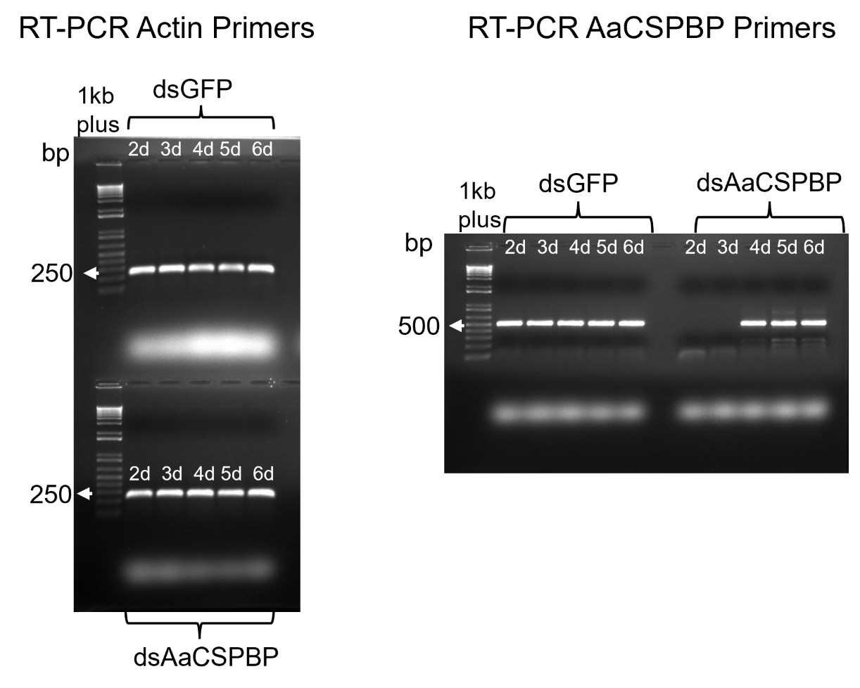
Supplementary Fig. S1. Original version of Figure 3. DNA fragments were separated on a 1% agarose gel, stained with ethidium bromide, and visualized under UV illumination. The 1 kb Plus DNA Ladder (Invitrogen) was used as a molecular weight marker, with arrows indicating the approximate base pair (bp) positions relative to the amplification product. Lanes marked with an ‘X’ covered samples unrelated to this study.
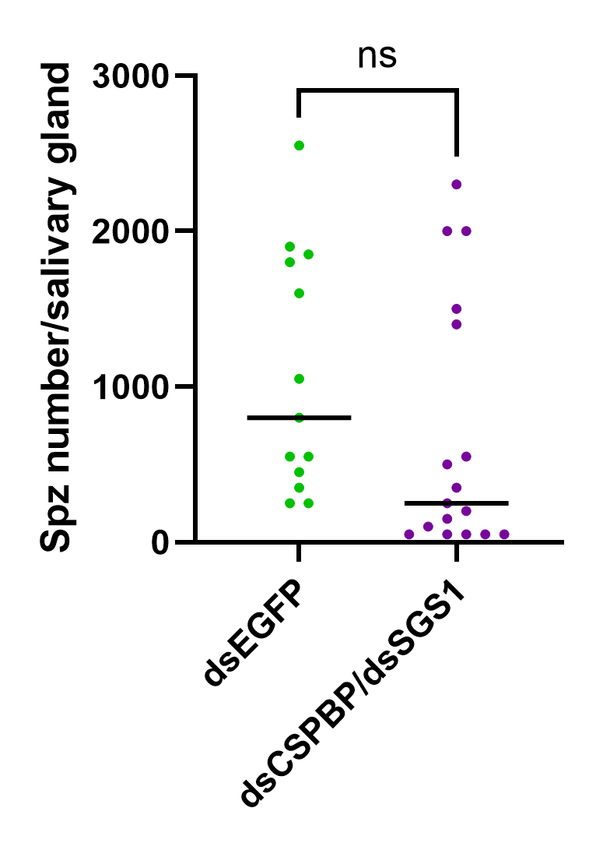
dsGFP
dsCSPBP

Supplementary Fig S2. Sporozoite load in Aedes aegypti salivary glands after thoracic injection of 1500ng of AaCSPBP or GFP dsRNA. Aedes aegypti mosquitoes were infected with Plasmodium gallinaceum and subsequently injected with 1500 ng of either dsAaCSPBP or control dsGFP. Salivary glands were dissected 8 days post-infection, and sporozoite numbers were quantified. The sporozoite load in dsAaCSPBP-injected mosquitoes was compared to that of dsGFP-injected controls. ns indicates the difference was not statistically significant.

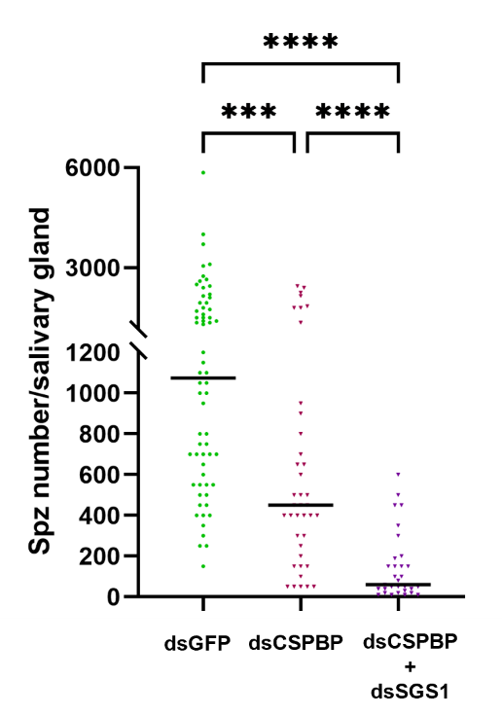
Supplementary Fig S3. Side-by-side comparison of Aedes aegypti mosquitoes subjected to single knockdown (dsAaCSPBP) and dual knockdown (dsAaCSPBP/dsSGS1). The dual knockdown results in a more pronounced reduction in Plasmodium gallinaceum sporozoite invasion of the salivary glands compared to the single knockdown, highlighting the synergistic contribution of CSPBP and SGS1 to parasite entry. Data are presented as medians due to the non-normal distribution, and statistical significance between groups is indicated.

