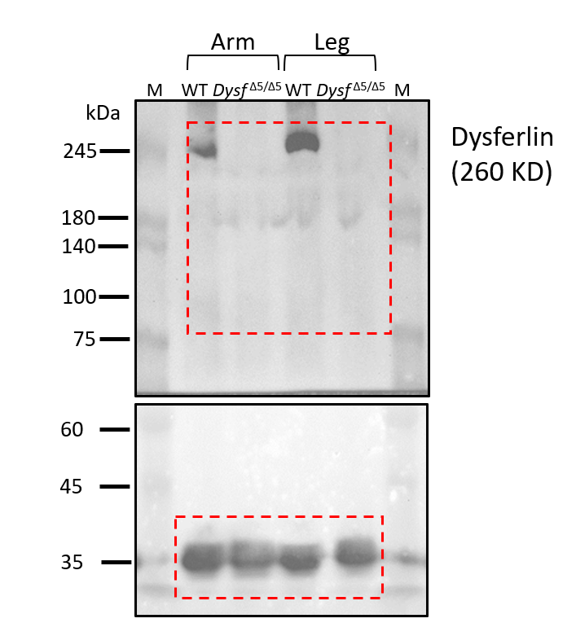
Supplemental Figure 1. Validation of Dysferlin Protein Expression in Dysf ^{Δ5/Δ5} Knock-in Mice.
Western blot analysis of dysferlin protein levels in skeletal muscle lysates (arm and leg) from 24-month-old wild-type (WT) and Dysf ^{Δ5/Δ5} mice. An anti-dysferlin antibody was used for detection. Protein markers (M) are indicated in lanes 1 and 6. Red boxes denote the regions displayed in Figure 1E.

