Supplementary Table S1. Treatment Pattern of Participants (n = 32)
Treatment Pattern | Number of Patients, n (%)
Diet only | 5 (15.6%)
1 antidiabetic drug | 5 (15.6%)
2 antidiabetic drugs | 16 (50.0%)
3 antidiabetic drugs | 3 (9.4%)
4 antidiabetic drugs | 3 (9.4%)
Percentages were calculated based on the total study population (n = 32).
Supplementary Table S2. Distribution of Antidiabetic Drug Classes
Drug Class | Number of Patients, n (%)
Biguanides | 21 (65.6%)
Sulfonylureas | 16 (50.0%)
SGLT2 inhibitors | 7 (21.9%)
DPP-4 inhibitors | 6 (18.8%)
Thiazolidinediones | 3 (9.4%)
Alpha-glucosidase inhibitors | 1 (3.1%)
Insulin | 4 (12.5%)
Percentages were calculated based on the total study population (n = 32). Patients may be receiving more than one drug class; therefore, totals exceed 100%
Supplementary Table S3. Distribution of Antidiabetic Treatment Combinations (n = 32)
Treatment Combination | Number of Patients, n (%)
Metformin + Sulfonylurea | 10 (31.2%)
Diet only | 5 (15.6%)
Metformin only | 3 (9.4%)
Metformin + Sulfonylurea + SGLT2 inhibitor + TZD | 2 (6.2%)
Metformin + DPP-4 inhibitor | 2 (6.2%)
SGLT2 inhibitor + DPP-4 inhibitor | 2 (6.2%)
Metformin + Sulfonylurea + TZD | 1 (3.1%)
Alpha-glucosidase inhibitor only | 1 (3.1%)
Metformin + SGLT2 inhibitor + Insulin | 1 (3.1%)
Insulin only | 1 (3.1%)
SGLT2 inhibitor + Insulin | 1 (3.1%)
Sulfonylurea + Insulin | 1 (3.1%)
Metformin + Sulfonylurea + SGLT2 inhibitor + DPP-4 inhibitor | 1 (3.1%)
Metformin + Sulfonylurea + DPP-4 inhibitor | 1 (3.1%)
Percentages were calculated based on the total study population (n = 32). Abbreviations: SGLT2 inhibitor, sodium-glucose cotransporter-2 inhibitor; DPP-4 inhibitor, dipeptidyl peptidase-4 inhibitor; TZD, thiazolidinedione.

Supplementary Table S4. Correlation Between %CV and CGM Metrics (CGM ≥10 days, n=28)
Variable | Correlation Coefficient (ρ) | P value
Average glucose | -0.015 | 0.939
TIR | -0.157 | 0.426
TBR | 0.506 | 0.006
TAR | 0.081 | 0.684
Number of episodes (<54 mg/dL) | 0.287 | 0.138
Number of episodes (54–69 mg/dL) | 0.501 | 0.007
Number of episodes (181–250 mg/dL) | 0.214 | 0.274
Number of episodes (>250 mg/dL) | 0.065 | 0.741
ρ represents Spearman’s correlation coefficient.
TIR = time in range; TAR = time above range; TBR = time below range.
Statistical significance was defined as p < 0.05.

Supplementary Table S5. Association Between %CV and CGM Metrics: Unadjusted and Adjusted Mixed-Effects Models (CGM ≥10 days, n=28)

Model | β (95% CI) | p-value | Marginal R² | Conditional R²
TIR
Model 0: Unadjusted | 0.032 (-0.245 to 0.31) | 0.819 | 0 | 0.912
Model 1: Age + BMI | 0.045 (-0.233 to 0.322) | 0.752 | 0.168 | 0.916
Model 2: Age + DD | 0.046 (-0.232 to 0.324) | 0.743 | 0.131 | 0.917
Model 3: Age + insulin and/or sulfonylurea use | 0.061 (-0.216 to 0.339) | 0.663 | 0.28 | 0.916
Model 4: Age + Average glucose | -0.03 (-0.239 to 0.18) | 0.780 | 0.835 | 0.946
TBR
Model 0: Unadjusted | 0.219 (0.149 to 0.289) | <0.001 | 0.147 | 0.444
Model 1: Age + BMI | 0.226 (0.156 to 0.296) | <0.001 | 0.162 | 0.444
Model 2: Age + DD | 0.224 (0.154 to 0.295) | <0.001 | 0.162 | 0.446
Model 3: Age + insulin and/or sulfonylurea use | 0.223 (0.153 to 0.294) | <0.001 | 0.168 | 0.448
Model 4: Age + Average glucose | 0.216 (0.146 to 0.285) | <0.001 | 0.24 | 0.49
TAR
Model 0: Unadjusted | -0.252 (-0.517 to 0.013) | 0.063 | 0.002 | 0.923
Model 1: Age + BMI | -0.263 (-0.528 to 0.002) | 0.052 | 0.175 | 0.926
Model 2: Age + DD | -0.265 (-0.53 to 0.001) | 0.051 | 0.133 | 0.927
Model 3: Age + insulin and/or sulfonylurea use | -0.277 (-0.542 to -0.012) | 0.040 | 0.269 | 0.926
Model 4: Age + Average glucose | -0.188 (-0.371 to -0.005) | 0.044 | 0.859 | 0.962
Average Glucose
Model 0: Unadjusted | -0.121 (-0.512 to 0.269) | 0.542 | 0 | 0.951
Model 1: Age + BMI | -0.131 (-0.522 to 0.26) | 0.510 | 0.109 | 0.954
Model 2: Age + DD | -0.131 (-0.521 to 0.26) | 0.511 | 0.088 | 0.954
Model 3: Age + insulin and/or sulfonylurea use | -0.145 (-0.535 to 0.246) | 0.467 | 0.208 | 0.953
β represents regression coefficient from mixed-effects models with random intercept for participant.
DD = diabetes duration; BMI = body mass index; CI = confidence interval; TIR = time in range; TAR = time above range; TBR = time below range.

Supplementary Table S6. Mixed-Effects Logistic Regression Analysis for TBR > 0
Model | Variable | OR (95% CI) | p value
Model 0: Unadjusted | CV | 1.306 (1.157–1.474) | <0.001
Model 1: Age + BMI | CV | 1.313 (1.166–1.478) | <0.001
Model 2: Age + Diabetes Duration | CV | 1.308 (1.160–1.474) | <0.001
Model 3: Age + Insulinotropic therapy | CV | 1.326 (1.173–1.498) | <0.001
Model 4: Age + Average glucose | CV | 1.473 (1.295–1.675) | <0.001
OR = odds ratio; CI = confidence interval. Logistic mixed-effects regression models were used to examine the association between coefficient of variation (CV) and the presence of time below range (TBR > 0).
Model 0: Unadjusted.
Model 1: Adjusted for age and body mass index (BMI).
Model 2: Adjusted for age and diabetes duration.
Model 3: Adjusted for age and insulinotropic therapy.
Model 4: Adjusted for age and average glucose.

Supplementary Figure S1. Diagnostic plots for the mixed-effects regression model evaluating the association between %CV and time in range (TIR).
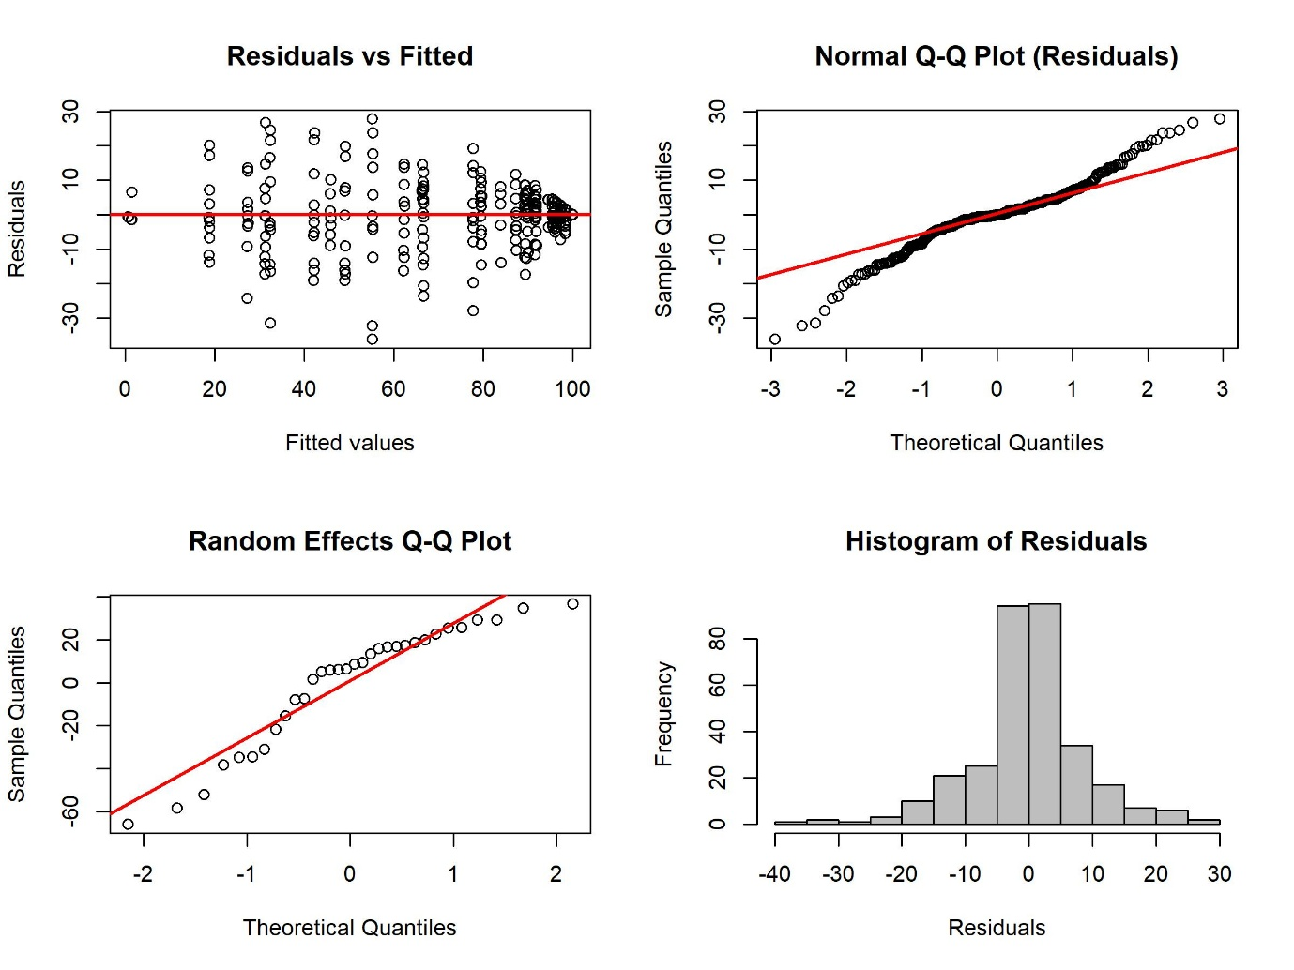
Diagnostic plots used to assess model assumptions for the mixed-effects regression model. Panels include: (A) residuals versus fitted values plot to assess homoscedasticity, (B) normal Q–Q plot of residuals to evaluate normality, (C) Q–Q plot of random effects to assess the distribution of random effects, and (D) histogram of residuals to examine the overall distribution of residuals.

Supplementary Figure S2. Diagnostic plots for the mixed-effects regression model evaluating the association between %CV and TBR.
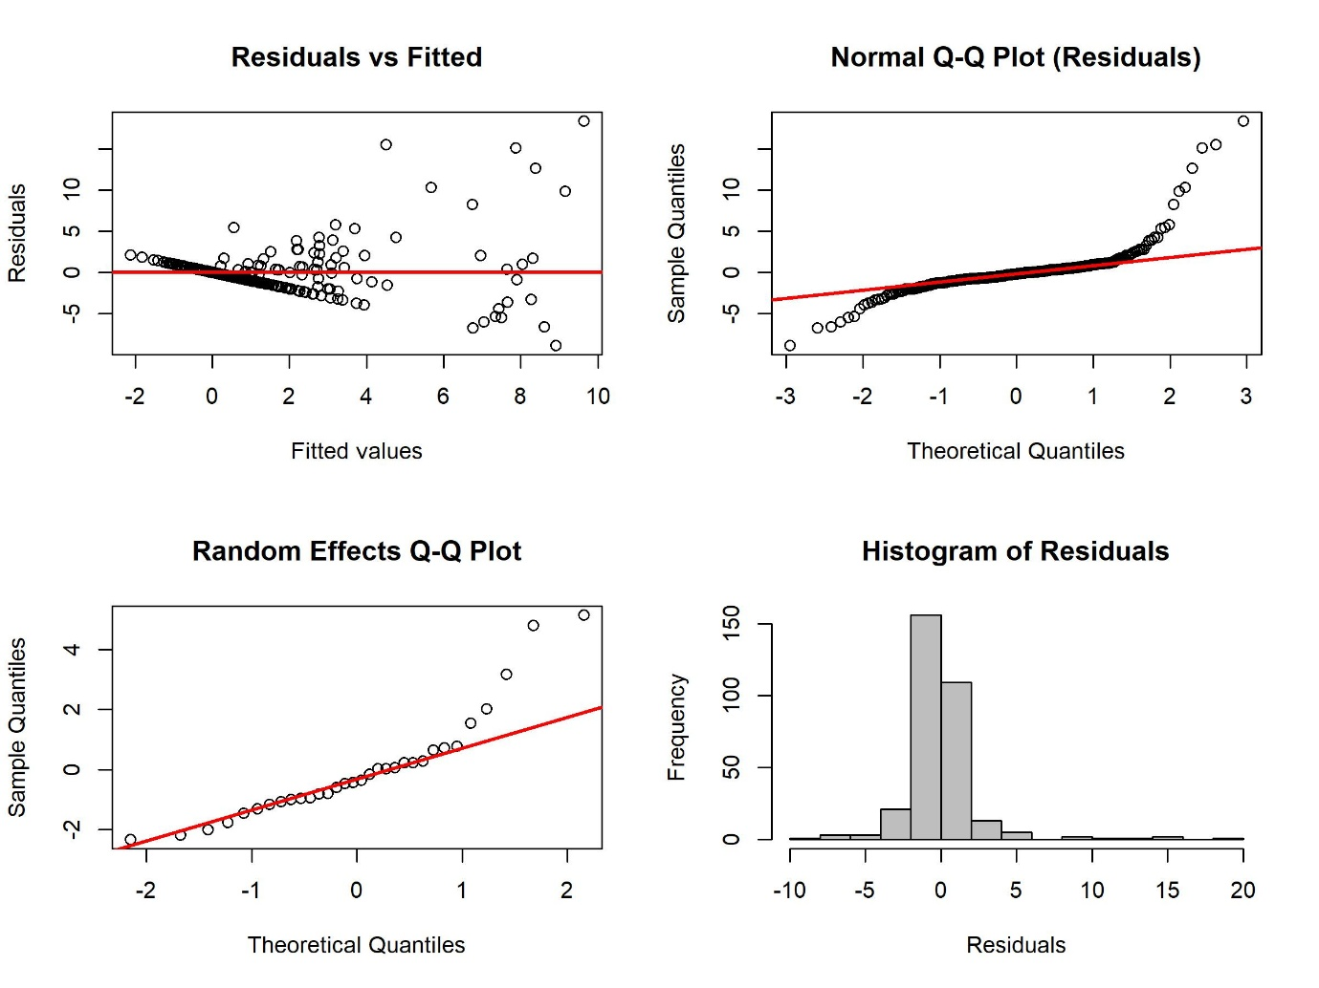
Diagnostic plots used to assess model assumptions for the mixed-effects regression model. Panels include: (A) residuals versus fitted values plot to assess homoscedasticity, (B) normal Q–Q plot of residuals to evaluate normality, (C) Q–Q plot of random effects to assess the distribution of random effects, and (D) histogram of residuals to examine the overall distribution of residuals.

Supplementary Figure S3. Diagnostic plots for the mixed-effects regression model evaluating the association between %CV and TAR.
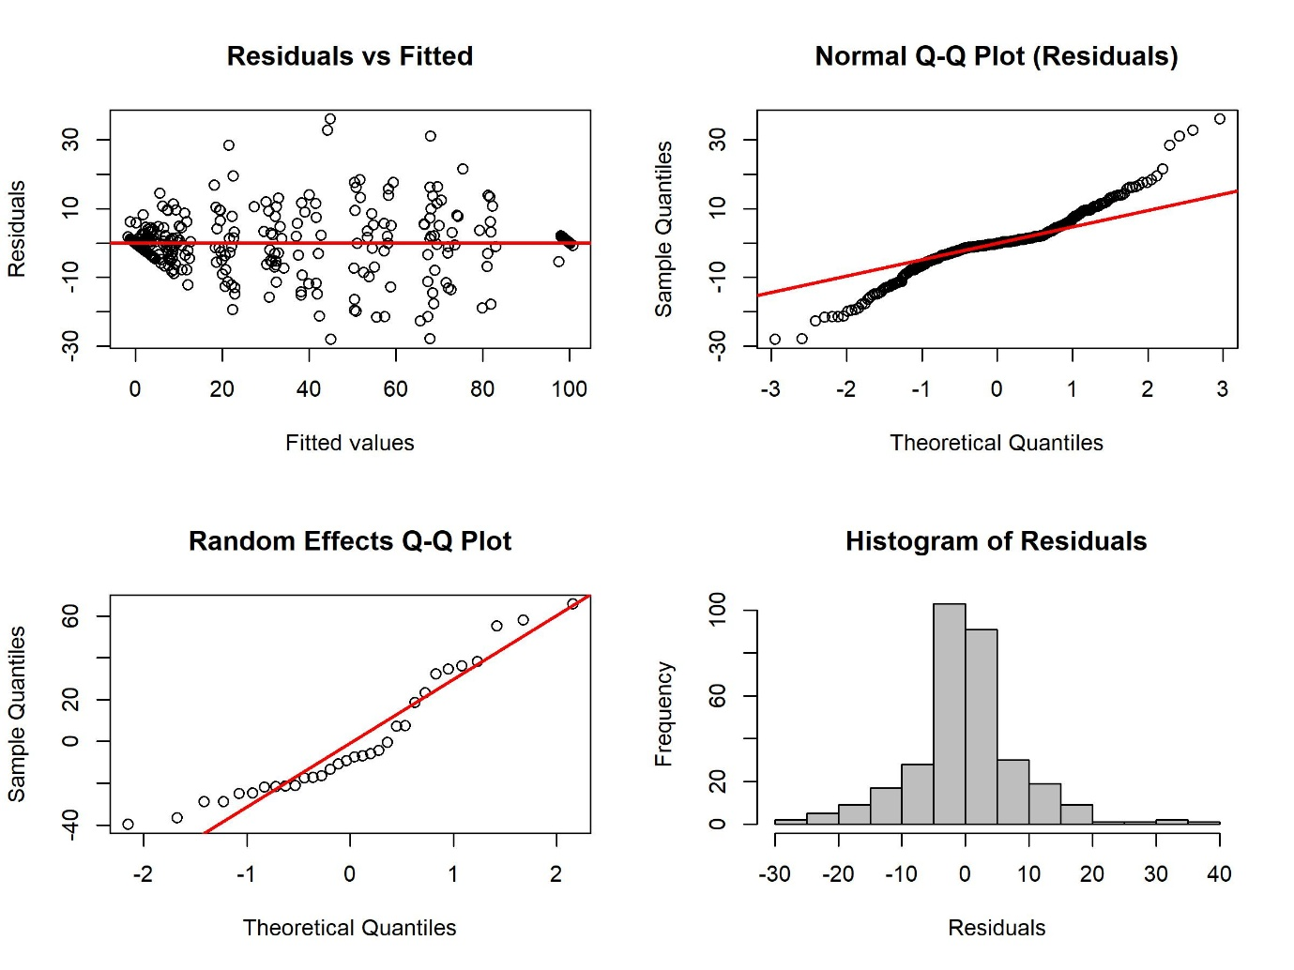
Diagnostic plots used to assess model assumptions for the mixed-effects regression model. Panels include: (A) residuals versus fitted values plot to assess homoscedasticity, (B) normal Q–Q plot of residuals to evaluate normality, (C) Q–Q plot of random effects to assess the distribution of random effects, and (D) histogram of residuals to examine the overall distribution of residuals.

Supplementary Figure S4. Diagnostic plots for the mixed-effects regression model evaluating the association between %CV and Average glucose.
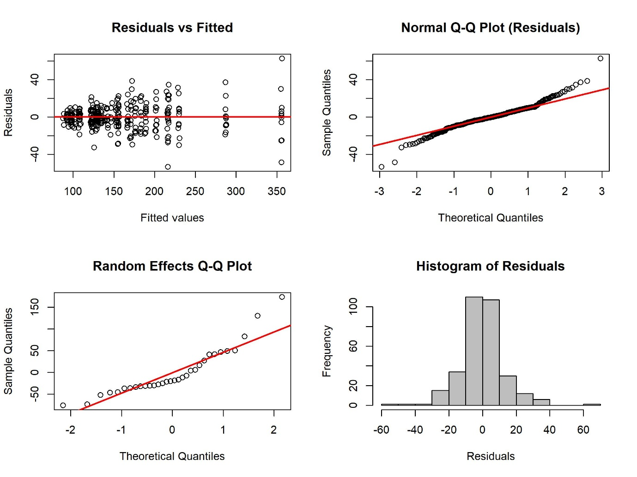
Diagnostic plots used to assess model assumptions for the mixed-effects regression model. Panels include: (A) residuals versus fitted values plot to assess homoscedasticity, (B) normal Q–Q plot of residuals to evaluate normality, (C) Q–Q plot of random effects to assess the distribution of random effects, and (D) histogram of residuals to examine the overall distribution of residuals.

