Supplementary Information

Early-life gut microbiota differentiation in sympatric wild raptors
Rafał Łopucki¹, Dagmara Stępień-Pyśniak^{2*}, Janusz Wójciak³, Marceli Pacan^{1,5}, Sara Jurczyk⁴, Agnieszka Kuźniar⁵

¹ Department of Biomedicine and Environmental Research, Faculty of Medicine, The John Paul II Catholic University of Lublin, Konstantynów 1J, 20-708 Lublin, Poland, lopucki@kul.pl
² University of Life Sciences in Lublin, Faculty of Veterinary Medicine, Department of Veterinary Prevention and Avian Diseases, Głęboka 30, Lublin 20-612, Poland, dagmara.stepien@up.lublin.pl
³ Lubelskie Ornithological Society, Akademicka 13, 20-033 Lublin, Poland, lto@wp.pl
⁴ Department of Artificial Intelligence, Faculty of Social and Technical Sciences, The John Paul II Catholic University of Lublin, Konstantynów 1 H; 20-708 Lublin, Poland, sara.jurczyk@kul.pl
⁵ Laboratory of Genomics and Genetics, Faculty of Medicine, The John Paul II Catholic University of Lublin, Konstantynów 1J, 20-708 Lublin, Poland, agnieszka.kuzniar@kul.pl

* To whom correspondence should be addressed: Dagmara Stępień-Pyśniak email: dagmara.stepien@up.lublin.pl

Table S1. Sequencing depth and observed ASV richness
Sample ID | Nests ID where multiple chicks were sampled | Total_reads | Observed_features_ASV
HA01 | N1 | 302893 | 197
HA02 |  | 279934 | 330
HA03 | N1 | 205969 | 262
HA04 | N2 | 228611 | 242
HA05 |  | 242305 | 321
HA06 | N3 | 177486 | 505
HA07 | N2 | 221293 | 321
HA08 | N3 | 182576 | 309
HA09 | N4 | 250241 | 396
HA10 | N4 | 240444 | 360
HA11 | N2 | 290799 | 205
HA12 | N5 | 170530 | 174
HA13 |  | 277030 | 135
HA14 |  | 245993 | 164
HA15 | N5 | 167796 | 146
HA16 |  | 105013 | 363
HA17 | N6 | 243748 | 178
HA18 |  | 238597 | 156
HA19 | N7 | 188044 | 132
HA20 | N6 | 329390 | 147
HA21 | N7 | 138146 | 237
HA22 |  | 309282 | 640
HA23 |  | 176225 | 540
HA24 |  | 121369 | 350
HA25 |  | 259321 | 350
HA26 |  | 221520 | 390
HA27 |  | 355713 | 329
HA28 |  | 247066 | 290
HA29 |  | 223073 | 216
HA30 |  | 216039 | 272
CP01 |  | 147702 | 177
CP02 |  | 219565 | 134
CP03 |  | 158359 | 137
CP04 |  | 127320 | 166
CP05 |  | 125969 | 1057
CP07 |  | 147926 | 102
CP08 |  | 249800 | 303
CP09 |  | 170900 | 92
CP11 |  | 227192 | 111
CP12 |  | 512885 | 3082
CP13 |  | 133698 | 83
CP14 |  | 282363 | 336
CP15 |  | 235491 | 108
CP16 |  | 276275 | 130
CP19 |  | 173145 | 182
CP21 |  | 150522 | 397
CP22K |  | 207755 | 282
CP23 |  | 125633 | 245
CP24 |  | 174099 | 233
CP25 |  | 110710 | 394
CP27 |  | 206025 | 162
CP28 |  | 178138 | 171
CP31 |  | 138407 | 225
CP32 |  | 128572 | 126
CP33 |  | 101897 | 120
CP34 |  | 95858 | 78
CP35 |  | 174424 | 134
CP36 |  | 131322 | 438
CP37 |  | 585062 | 302
CP38 |  | 397752 | 315

Table S2. Results of non-parametric Mann–Whitney U tests comparing alpha diversity metrics of the fecal bacterial microbiota between nestlings of two raptor species: the lesser spotted eagle (CP) and the white-tailed eagle (HA).
Metric | U statistic | p-value | Interpretation
Shannon diversity index | 696 | 0.00028 | HA > CP
Simpson dominance index | 695 | 0.0003 | HA > CP
Pielou’s evenness | 639 | 0.003 | HA > CP
Simpson evenness | 444 | 0.923 | ns
Chao1 richness estimator | 636 | 0.006 | HA > CP

Table S3. Analysis of differences in the abundance of bacterial taxa at the family level using ANCOM-BC2 between the gut microbiota of white-tailed eagle (HA) and lesser spotted eagle (CP) chicks. Taxa were considered significant if their FDR-adjusted q-values were below 0.05 and if they passed the pseudo-count sensitivity filter.

Table S4. Analysis of differences in the abundance of bacterial taxa at the genus level using ANCOM-BC2 between the gut microbiota of white-tailed eagle (HA) and lesser spotted eagle (CP) chicks. Taxa were considered significant if their FDR-adjusted q-values were below 0.05 and if they passed the pseudo-count sensitivity filter.

Table S5. DADA2 read processing statistics, including filtering, merging efficiency, and chimera removal for all samples.
sample-id | input | filtered | % of input passed filter | denoised | merged | % of input merged | non-chimeric | % of input non-chimeric
CP01 | 160861 | 148718 | 92.45 | 148474 | 147940 | 91.97 | 147702 | 91.82
CP02 | 240340 | 223223 | 92.88 | 222935 | 221744 | 92.26 | 219565 | 91.36
CP03 | 171621 | 159255 | 92.79 | 159091 | 158682 | 92.46 | 158359 | 92.27
CP04 | 149048 | 129061 | 86.59 | 128272 | 127768 | 85.72 | 127320 | 85.42
CP05 | 143788 | 130736 | 90.92 | 129951 | 127536 | 88.7 | 125969 | 87.61
CP07 | 164342 | 148821 | 90.56 | 148627 | 148091 | 90.11 | 147926 | 90.01
CP08 | 278890 | 255069 | 91.46 | 254667 | 253094 | 90.75 | 249800 | 89.57
CP09 | 191541 | 177973 | 92.92 | 177658 | 176559 | 92.18 | 170900 | 89.22
CP11 | 254531 | 232498 | 91.34 | 232193 | 231013 | 90.76 | 227192 | 89.26
CP12 | 781796 | 717066 | 91.72 | 704006 | 668342 | 85.49 | 512885 | 65.6
CP13 | 146868 | 134670 | 91.69 | 134521 | 133911 | 91.18 | 133698 | 91.03
CP14 | 313271 | 290570 | 92.75 | 290029 | 288445 | 92.08 | 282363 | 90.13
CP15 | 259077 | 238635 | 92.11 | 238320 | 237225 | 91.57 | 235491 | 90.9
CP16 | 310680 | 286512 | 92.22 | 286230 | 284682 | 91.63 | 276275 | 88.93
CP19 | 194897 | 178988 | 91.84 | 178669 | 178010 | 91.34 | 173145 | 88.84
CP21 | 164156 | 152598 | 92.96 | 152319 | 151401 | 92.23 | 150522 | 91.69
CP22K | 276467 | 254038 | 91.89 | 252483 | 247861 | 89.65 | 207755 | 75.15
CP23 | 141294 | 127225 | 90.04 | 127056 | 125871 | 89.08 | 125633 | 88.92
CP24 | 192569 | 175573 | 91.17 | 175293 | 174609 | 90.67 | 174099 | 90.41
CP25 | 127891 | 112511 | 87.97 | 111804 | 111258 | 86.99 | 110710 | 86.57
CP27 | 226769 | 208134 | 91.78 | 207926 | 206936 | 91.25 | 206025 | 90.85
CP28 | 197891 | 179652 | 90.78 | 179391 | 178805 | 90.36 | 178138 | 90.02
CP31 | 150064 | 140220 | 93.44 | 139983 | 139542 | 92.99 | 138407 | 92.23
CP32 | 158959 | 130942 | 82.37 | 129889 | 129091 | 81.21 | 128572 | 80.88
CP33 | 112602 | 102769 | 91.27 | 102637 | 102043 | 90.62 | 101897 | 90.49
CP34 | 105277 | 96383 | 91.55 | 96244 | 96006 | 91.19 | 95858 | 91.05
CP35 | 190318 | 177276 | 93.15 | 177083 | 176237 | 92.6 | 174424 | 91.65
CP36 | 155809 | 133842 | 85.9 | 132507 | 131733 | 84.55 | 131322 | 84.28
CP37 | 701688 | 645977 | 92.06 | 644487 | 639826 | 91.18 | 585062 | 83.38
CP38 | 448483 | 410078 | 91.44 | 409403 | 406883 | 90.72 | 397752 | 88.69
HA01 | 386614 | 358504 | 92.73 | 356784 | 351586 | 90.94 | 302893 | 78.35
HA02 | 315874 | 286192 | 90.6 | 285558 | 283473 | 89.74 | 279934 | 88.62
HA03 | 332955 | 304226 | 91.37 | 301718 | 293452 | 88.14 | 205969 | 61.86
HA04 | 297895 | 273412 | 91.78 | 272002 | 266559 | 89.48 | 228611 | 76.74
HA05 | 320808 | 294210 | 91.71 | 292915 | 286839 | 89.41 | 242305 | 75.53
HA06 | 249580 | 228398 | 91.51 | 226369 | 216829 | 86.88 | 177486 | 71.11
HA07 | 266632 | 249383 | 93.53 | 248536 | 244481 | 91.69 | 221293 | 83
HA08 | 222836 | 209461 | 94 | 208083 | 203047 | 91.12 | 182576 | 81.93
HA09 | 280218 | 255768 | 91.27 | 255119 | 253159 | 90.34 | 250241 | 89.3
HA10 | 316771 | 288253 | 91 | 286135 | 278586 | 87.95 | 240444 | 75.9
HA11 | 396035 | 364488 | 92.03 | 363025 | 357014 | 90.15 | 290799 | 73.43
HA12 | 188521 | 171892 | 91.18 | 171560 | 170901 | 90.65 | 170530 | 90.46
HA13 | 389980 | 358161 | 91.84 | 356809 | 351719 | 90.19 | 277030 | 71.04
HA14 | 317949 | 292845 | 92.1 | 291708 | 287597 | 90.45 | 245993 | 77.37
HA15 | 242889 | 221908 | 91.36 | 220357 | 216360 | 89.08 | 167796 | 69.08
HA16 | 123477 | 114333 | 92.59 | 113599 | 111438 | 90.25 | 105013 | 85.05
HA17 | 322037 | 293928 | 91.27 | 292918 | 288061 | 89.45 | 243748 | 75.69
HA18 | 286579 | 242883 | 84.75 | 240341 | 239160 | 83.45 | 238597 | 83.26
HA19 | 208803 | 190167 | 91.07 | 189903 | 188971 | 90.5 | 188044 | 90.06
HA20 | 447058 | 408804 | 91.44 | 406873 | 400941 | 89.68 | 329390 | 73.68
HA21 | 153395 | 139769 | 91.12 | 139563 | 138855 | 90.52 | 138146 | 90.06
HA22 | 449393 | 413740 | 92.07 | 409941 | 397410 | 88.43 | 309282 | 68.82
HA23 | 197472 | 184105 | 93.23 | 183332 | 181075 | 91.7 | 176225 | 89.24
HA24 | 152490 | 131755 | 86.4 | 130043 | 126317 | 82.84 | 121369 | 79.59
HA25 | 302613 | 278052 | 91.88 | 276719 | 273091 | 90.24 | 259321 | 85.69
HA26 | 249377 | 226995 | 91.02 | 226568 | 224995 | 90.22 | 221520 | 88.83
HA27 | 444065 | 410157 | 92.36 | 408038 | 401019 | 90.31 | 355713 | 80.1
HA28 | 305277 | 281220 | 92.12 | 280158 | 276130 | 90.45 | 247066 | 80.93
HA29 | 248830 | 227294 | 91.35 | 226901 | 225445 | 90.6 | 223073 | 89.65
HA30 | 245708 | 224592 | 91.41 | 224132 | 222102 | 90.39 | 216039 | 87.93

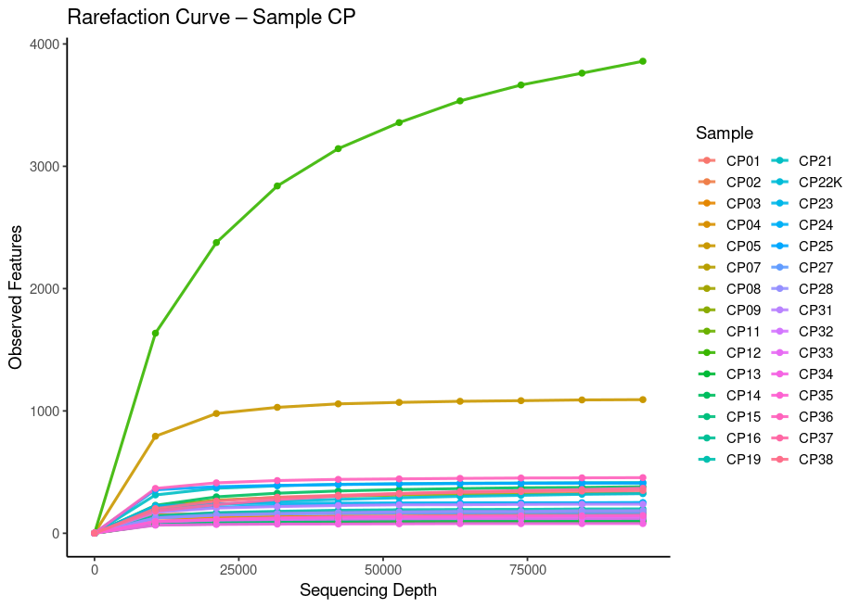
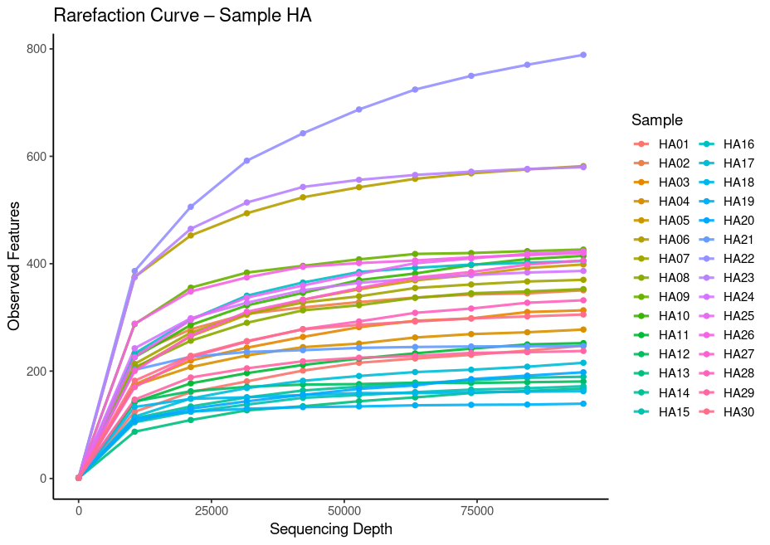
Figure S1. Rarefaction curves for samples of white-tailed eagle (HA) and lesser spotted eagle (CP) chicks.

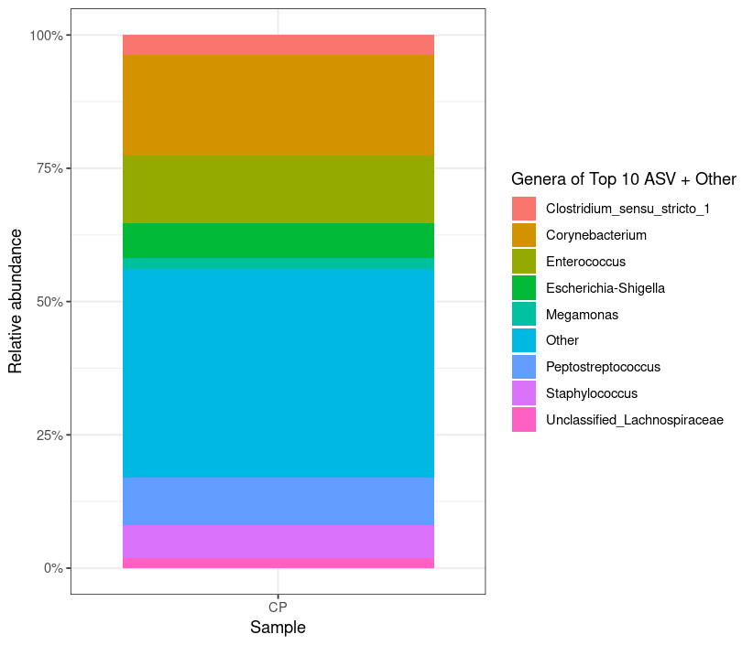
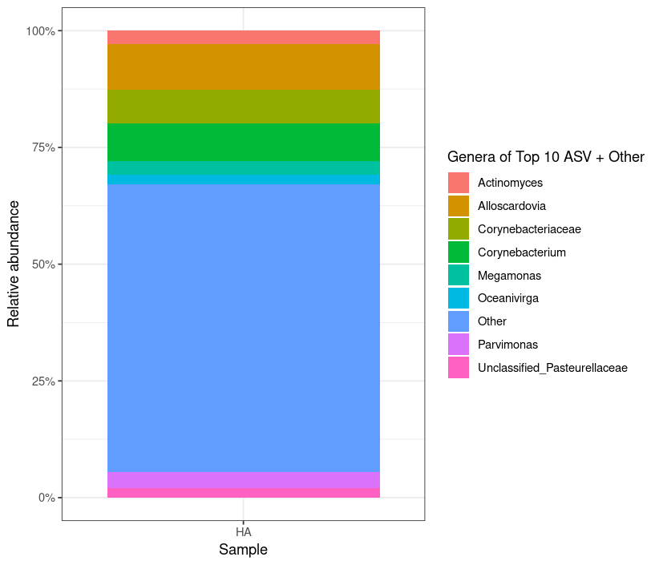
Figure S2. Relative abundance of dominant (Top 10) bacterial genera in the Lesser Spotted Eagle (CP) and the White-tailed Eagle (HA) nestlings.

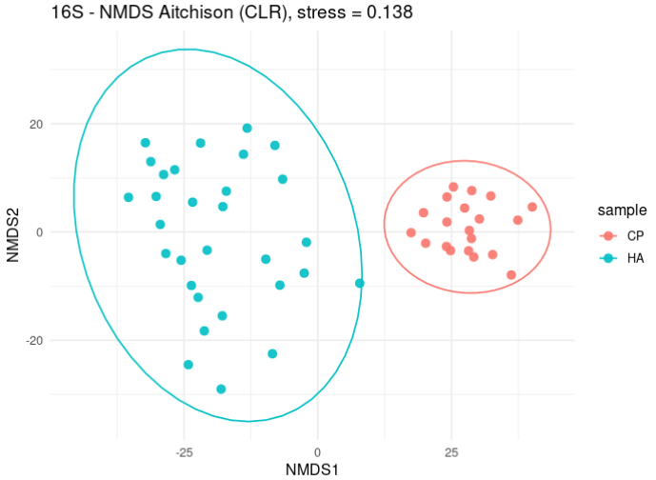Figure S3. Non-metric multidimensional scaling (NMDS) based on Aitchison (CLR-transformed) distances showing clear separation of the HA and CP microbiome profiles (stress = 0.138). Each point represents one sample, and ellipses indicate 95% confidence intervals for each group.

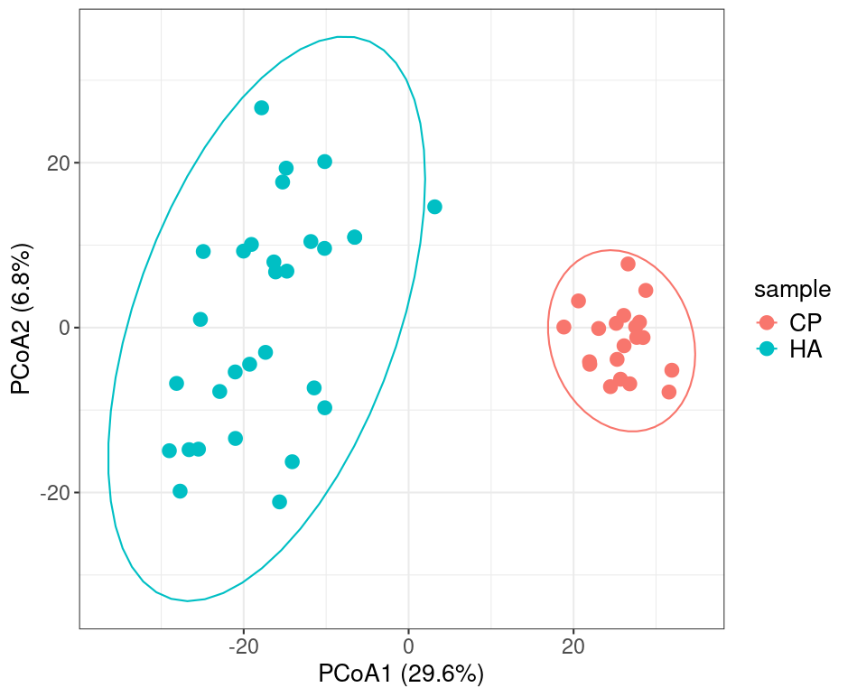
Figure S4. Principal Coordinates Analysis (PCoA) based on Aitchison (CLR–Euclidean) distance showing clear separation between HA and CP samples. The first two coordinates explain 29.6% and 6.8% of the variance in microbial community composition, respectively.

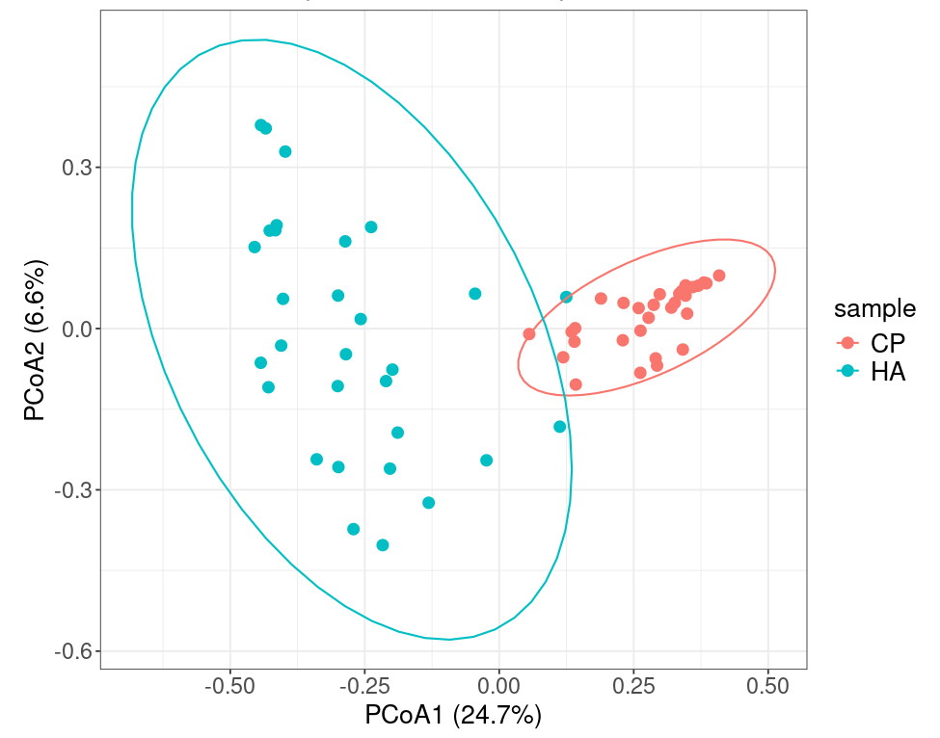
Figure S5. Principal Coordinates Analysis (PCoA) based on Bray–Curtis dissimilarity showing distinct clustering of CP and HA samples. Each point represents one 16S rRNA sample, and the first two axes explain 24.7% and 6.6% of the variation in community composition, respectively.

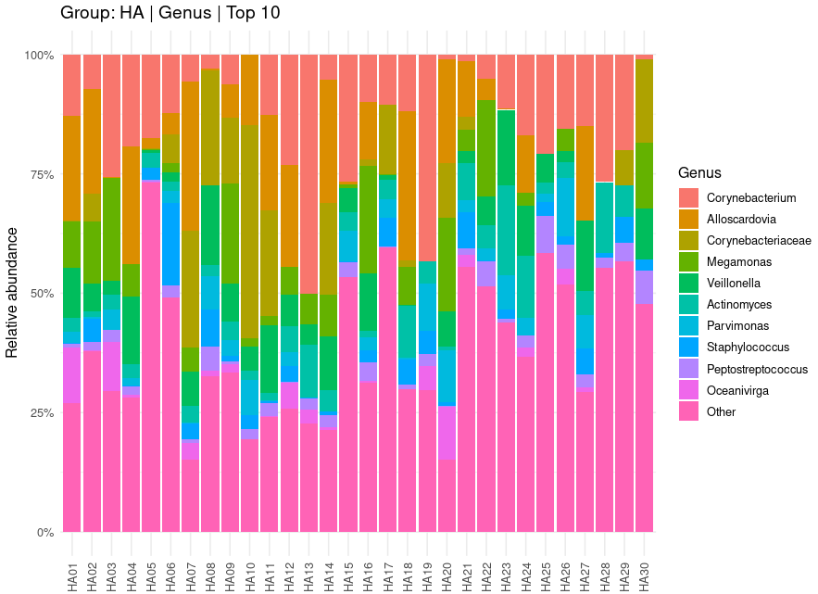

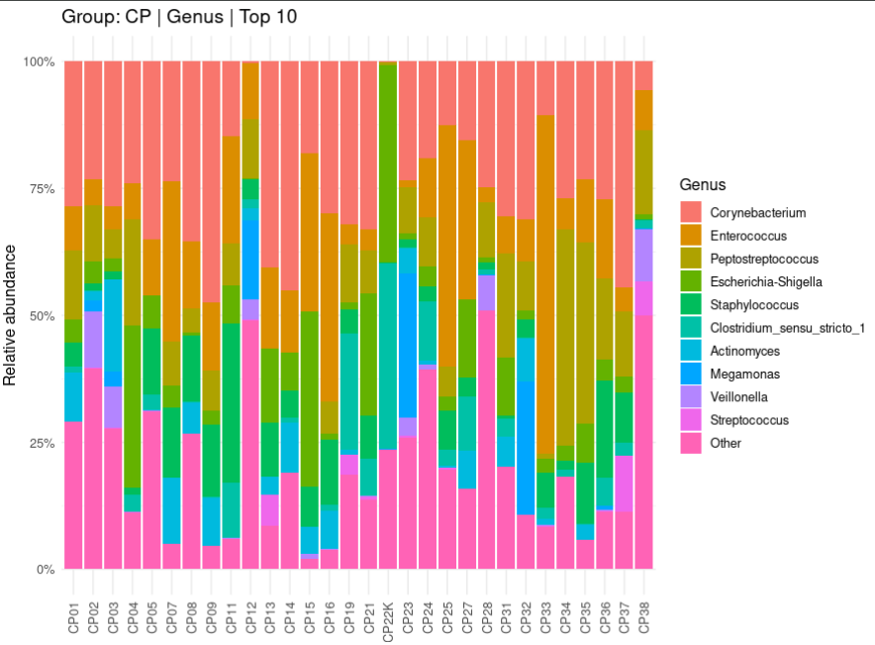
Figure S6. Sample-level relative abundance of dominant (Top 10) bacterial genera in fecal microbiota of white-tailed eagle (HA) and lesser spotted eagle (CP) nestlings. Each bar represents one individual sample and shows the proportional contribution of the ten most abundant genera.

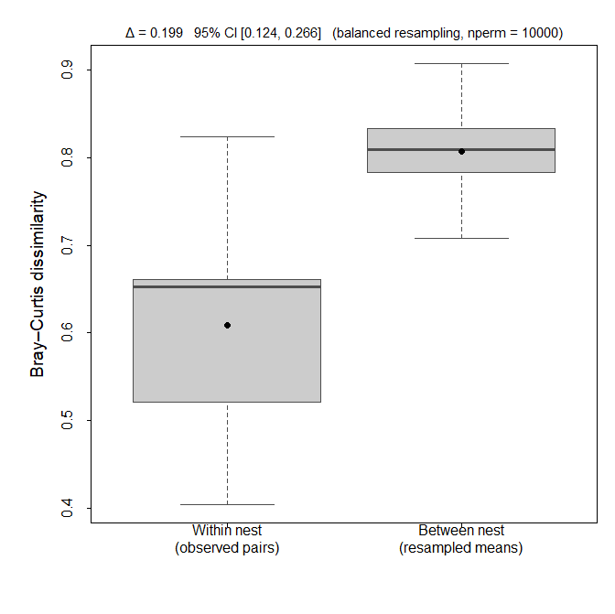
Figure S7. Within- and between-nest gut microbiota dissimilarity in white-tailed eagle chicks. Bray–Curtis dissimilarities are shown for pairwise comparisons among chicks originating from the same nest (within nest) and for balanced resampling of comparisons between chicks from different nests (between nest). Due to the limited number of within-nest comparisons (9 pairs), between-nest values are presented as the distribution of mean dissimilarities obtained by resampling an equal number of between-nest pairs. Despite substantial within-nest variation in gut bacterial community composition, dissimilarity between nests was consistently higher (Δ = 0.199; 95% CI: 0.124–0.266).

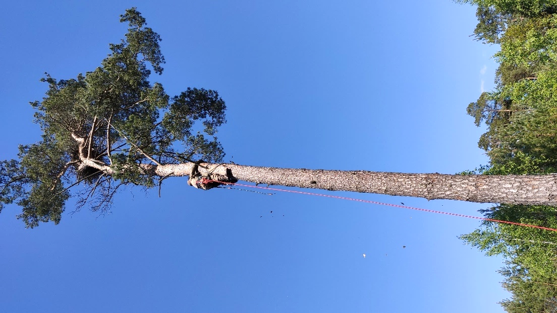
Figure S8. Ornithologist from the Lublin Ornithological Society climbing to a white-tailed eagle nest to ring the nestlings. The photo illustrates the fieldwork conditions during routine monitoring activities, when fecal samples were opportunistically collected from nestlings for microbiota analysis. (Photo: Janusz Wójciak).

