Sex-Based Effects of Shock Energy Exposure in Warfighters

Melissa Sutter, Catherine Johnson*

Corresponding Author: Catherine.johnson@mst.edu
Department of Mining and Explosive Engineering, Missouri University of Science and Technology, 290 McNutt Hall, Rolla, MO, United States

Supplementary Information

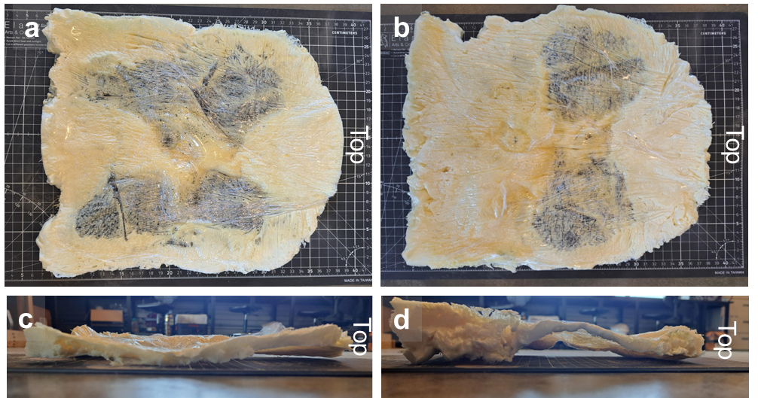
Figure S 1. Foam-casted void-space replicas of the air gaps between the manikin torsos and body armor: front view for the (a) male and (b) female, and side view for the (c) male and (d) female.

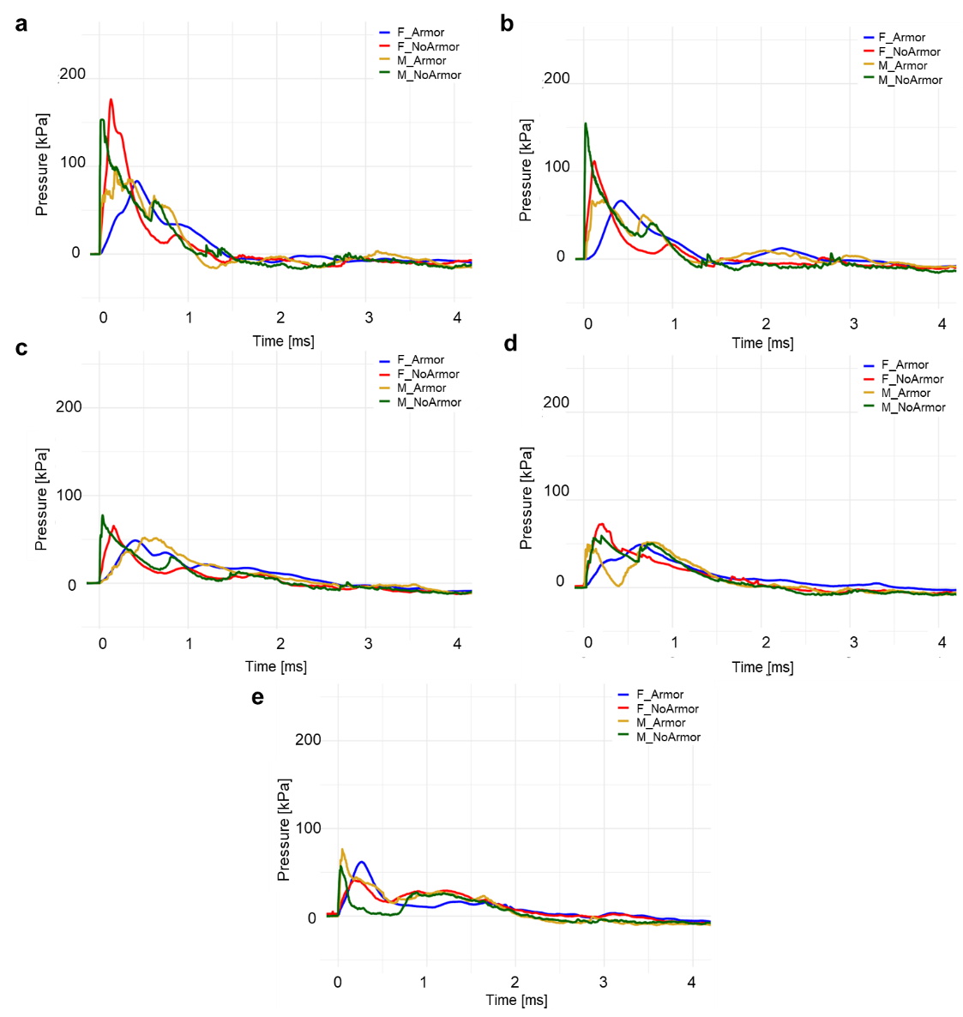
Figure S 2. Time-pressure waveforms from the nipple further from the shock source (Sensor 2) at varied orientations of (a) 0, (b) 45, and (c) 90, (d) 135, and (e) 180-degrees.

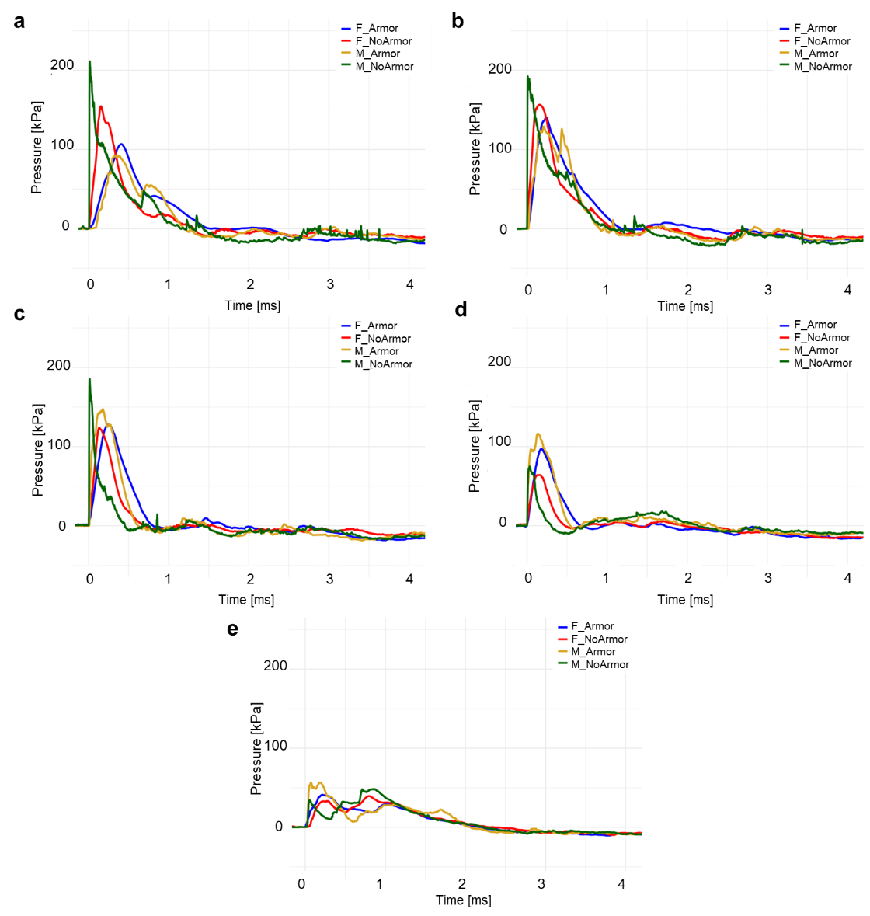
Figure S 3. Time-pressure waveforms from the nipple closer from the shock source (Sensor 3) at varied orientations of (a) 0, (b) 45, and (c) 90, (d) 135, and (e) 180-degrees.
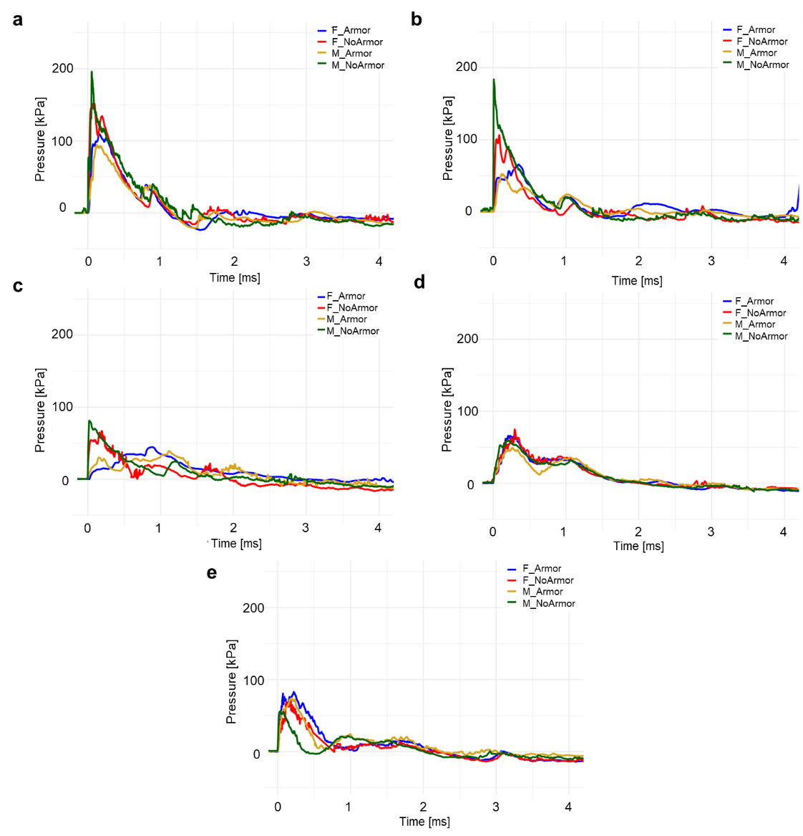
Figure S 4. Time-pressure waveforms from the underbust area further from the shock source (Sensor 4) at varied orientations of (a) 0, (b) 45, and (c) 90, (d) 135, and (e) 180-degrees.
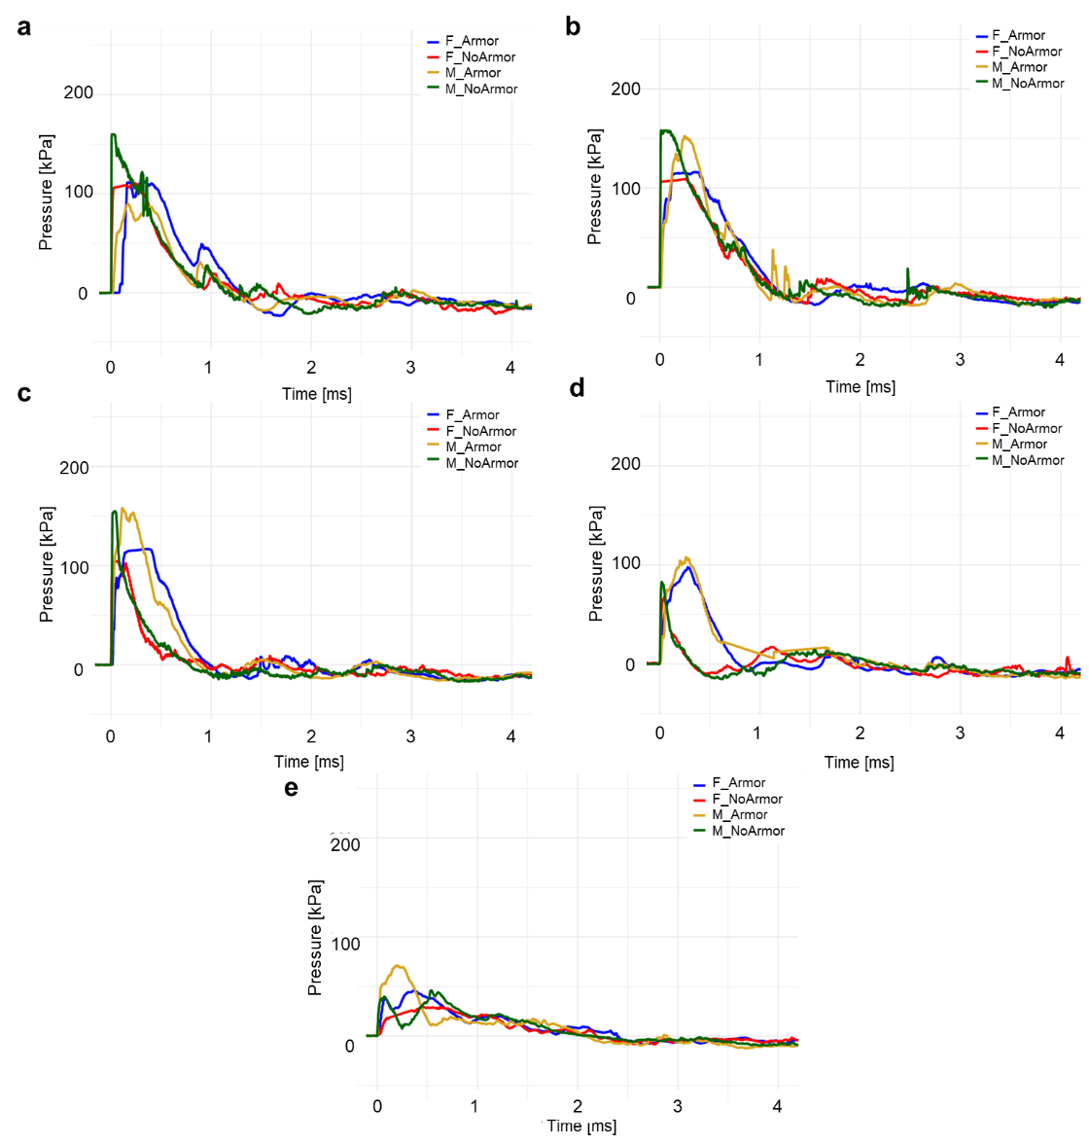
Figure S 5. Time-pressure waveforms from the underbust area closer to the shock source (Sensor 5) at varied orientations of (a) 0, (b) 45, and (c) 90, (d) 135, and (e)-180-degrees.

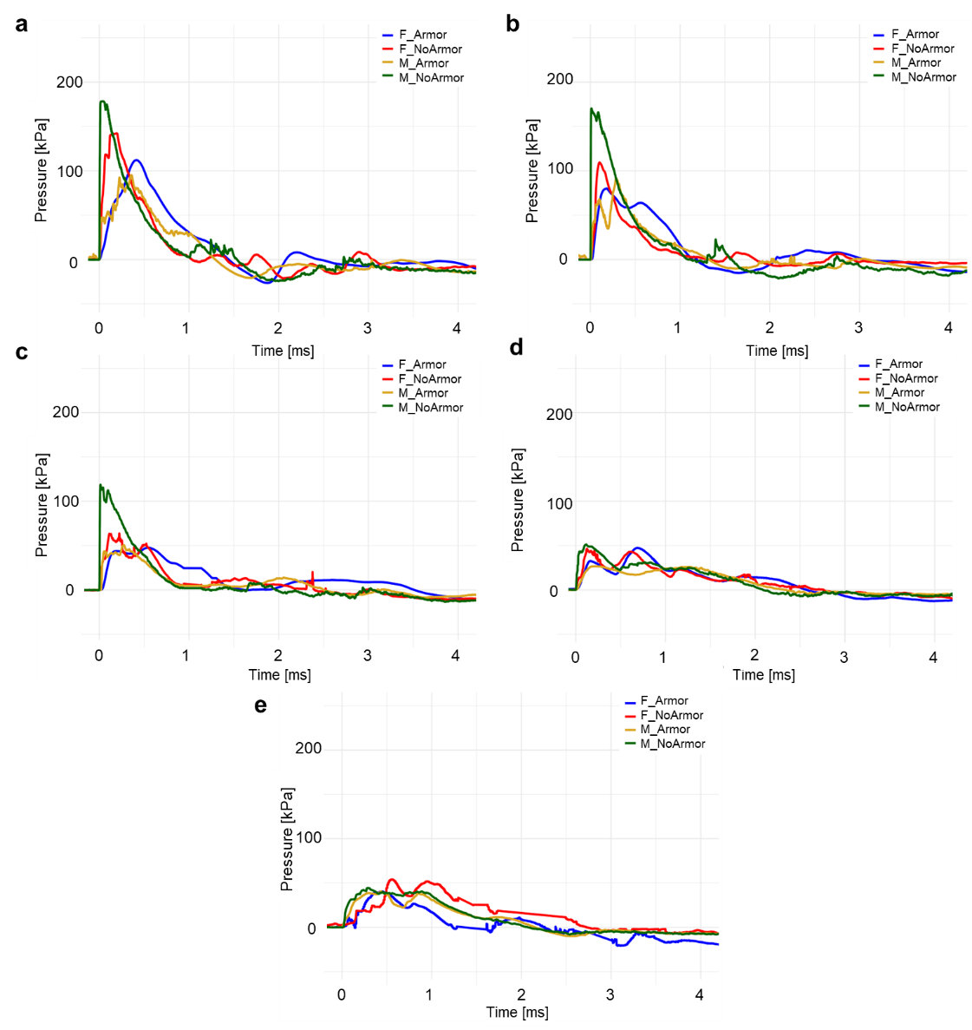
Figure S 6. Time-pressure waveforms from the lower sternum (Sensor 6) at varied orientations of (a) 0, (b) 45, and (c) 90, (d) 135, and (e) 180-degrees from the shock source.

Table S 1. Average peak pressure values for the male (M) and female (F) warfighters.
Sex | Orientation | S1 | S2 | S3 | S4 | S5 | S6 | Total | Far | Near | Center
M | 0 | 157.7 | 99.5 | 106.6 | 93.5 | 107.6 | 101.1 | 111.0 | 107.1 | 96.5 | 129.4
M | 45 | 94.4 | 132.0 | 70.2 | 154.5 | 56.0 | 99.7 | 101.1 | 63.1 | 143.3 | 97.0
M | 90 | 49.6 | 169.2 | 57.2 | 158.4 | 40.8 | 52.2 | 87.9 | 49.0 | 163.8 | 50.9
M | 135 | 41.9 | 122.0 | 52.0 | 108.6 | 54.6 | 30.6 | 68.3 | 53.3 | 115.3 | 36.3
M | 180 | 76.8 | 59.0 | 79.1 | 72.2 | 78.4 | 41.5 | 67.8 | 78.7 | 65.6 | 59.1
F | 0 | 118.5 | 83.6 | 108.2 | 111.4 | 112.8 | 112.8 | 107.9 | 97.5 | 110.5 | 115.7
F | 45 | 88.6 | 67.2 | 141.3 | 79.2 | 117.4 | 86.6 | 96.7 | 73.2 | 129.4 | 87.6
F | 90 | 83.1 | 49.5 | 136.4 | 49.6 | 118.7 | 50.1 | 81.2 | 49.6 | 127.5 | 66.6
F | 135 | 54.7 | 49.4 | 97.7 | 80.5 | 98.8 | 47.4 | 71.4 | 65.0 | 98.3 | 51.1
F | 180 | 91.9 | 62.1 | 42.1 | 91.9 | 46.2 | 40.6 | 62.5 | 77.0 | 44.2 | 66.3

Table S 2. Average impulse values for the male (M) and female (F) warfighters.
Sex | Orientation | S1 | S2 | S3 | S4 | S5 | S6 | Total | Far | Near | Center
M | 0 | 67.7 | 53.3 | 58.6 | 52.1 | 49.2 | 58.3 | 56.5 | 53.9 | 52.7 | 63.0
M | 45 | 49.6 | 62.8 | 42.3 | 75.4 | 30.8 | 47.6 | 51.4 | 36.5 | 69.1 | 48.6
M | 90 | 47.9 | 56.6 | 50.5 | 67.2 | 39.6 | 35.4 | 49.5 | 45.0 | 61.8 | 41.6
M | 135 | 44.3 | 36.0 | 47.1 | 47.9 | 45.2 | 40.8 | 43.6 | 46.3 | 42.0 | 42.5
M | 180 | 56.5 | 47.2 | 50.4 | 45.4 | 46.6 | 46.0 | 48.7 | 48.5 | 46.3 | 51.2
F | 0 | 68.6 | 50.6 | 64.8 | 54.9 | 70.4 | 73.4 | 63.8 | 52.8 | 67.6 | 71.0
F | 45 | 53.6 | 38.9 | 70.3 | 34.7 | 79.0 | 53.9 | 55.1 | 36.8 | 74.6 | 53.7
F | 90 | 48.8 | 50.7 | 50.7 | 44.5 | 67.4 | 50.7 | 52.1 | 47.6 | 59.0 | 49.8
F | 135 | 47.9 | 52.8 | 31.1 | 51.3 | 42.3 | 50.7 | 46.0 | 52.1 | 36.7 | 49.3
F | 180 | 54.5 | 43.1 | 41.5 | 37.9 | 43.0 | 26.4 | 41.1 | 40.5 | 42.3 | 40.5

