Katarína Greškovičová*, Katarina Krizova, Bronislava Šoková, Júlia Halamová

Table S1. Measurement Invariance Across Sex for the PHQ-9 Factor Models
Model | Invariance Level | χ² | df | p | CFI | TLI | RMSEA | SRMR | ΔCFI | ΔRMSEA
One-factor | Configural/Metric | 159.887 | 62 | < .001 | .988 | .987 | .033 | .050 | — | —
 | Scalar | 185.149 | 70 | < .001 | .986 | .986 | .034 | .047 | –.002 | +.001
 | Strict | 194.744 | 79 | < .001 | .986 | .988 | .032 | .049 | .000 | –.002
Two-factor | Configural/Metric | 88.351 | 59 | .008 | .997 | .996 | .019 | .037 | — | —
 | Scalar | 95.925 | 66 | .009 | .996 | .996 | .018 | .034 | –.001 | –.001
 | Strict | 101.609 | 75 | .022 | .997 | .997 | .016 | .036 | +.001 | –.002
Four-factor | Configural/Metric | 58.461 | 47 | .122 | .999 | .998 | .013 | .030 | — | —
 | Scalar | 62.835 | 52 | .144 | .999 | .998 | .012 | .028 | .000 | –.001
 | Strict | 68.991 | 61 | .225 | .999 | .999 | .010 | .030 | .000 | –.002
Notes: Under the delta parameterization for ordinal data (Wu & Estabrook, 2016), factor loadings are constrained to equality at the configural level for model identification; the metric invariance model is therefore equivalent to the configural model. Scalar invariance additionally constrains item thresholds; strict invariance further constrains scale factors (residual variances). Good model fit: CFI and TLI ≥ 0.95, RMSEA ≤ 0.06, SRMR ≤ 0.08 (Hu & Bentler, 1999). Invariance was supported when ΔCFI ≤ 0.01 and ΔRMSEA ≤ 0.015 (Chen, 2007). χ² = chi-square; df = degrees of freedom; CFI = comparative fit index; TLI = Tucker-Lewis index; RMSEA = root mean square error of approximation; SRMR = standardized root mean square residual.

Table S2: Descriptive Statistics of Variables
 |  |  |  |  |  |  |  |  |  |  |  |  |  |  |  | One-factor |  | Two-factor |  |  |  | Four-factor
 |  | Anxiety |  | Inadequate Self |  | Hated Self |  | Self-Reassurance |  | Compassion Fatigue |  | Compassion Satisfaction |  | Burnout |  | total |  | Cog-Aff |  | Somatic |  | Affective |  | Somatic |  | Interna-lizing |  | Sensori-motor
Mean |  | 12.944 |  | 21.430 |  | 7.803 |  | 28.942 |  | 55.435 |  | 108.402 |  | 44.119 |  | 6.294 |  | 3.324 |  | 2.970 |  | 1.614 |  | 2.970 |  | 0.766 |  | 0.944
Std. Error of Mean |  | 0.072 |  | 0.137 |  | 0.060 |  | 0.108 |  | 0.316 |  | 0.506 |  | 0.301 |  | 0.085 |  | 0.056 |  | 0.038 |  | 0.026 |  | 0.038 |  | 0.019 |  | 0.022
Median |  | 12.000 |  | 20.000 |  | 7.000 |  | 29.000 |  | 54.000 |  | 116.000 |  | 45.000 |  | 5.000 |  | 3.000 |  | 3.000 |  | 1.000 |  | 3.000 |  | 0.000 |  | 1.000
Mode |  | 11.000 |  | 15.000 |  | 5.000 |  | 32.000 |  | 54.000 |  | 121.000 |  | 43.000 |  | 3.000 |  | 0.000 |  | 2.000 |  | 0.000 |  | 2.000 |  | 0.000 |  | 0.000
Std. Deviation |  | 3.894 |  | 7.394 |  | 3.235 |  | 5.821 |  | 17.008 |  | 27.218 |  | 16.164 |  | 4.595 |  | 3.016 |  | 2.057 |  | 1.410 |  | 2.057 |  | 1.044 |  | 1.178
Skewness |  | 0.991 |  | 0.546 |  | 1.744 |  | -0.440 |  | 0.102 |  | -1.553 |  | -0.480 |  | 1.177 |  | 1.391 |  | 0.880 |  | 0.740 |  | 0.880 |  | 1.977 |  | 1.542
Std. Error of Skewness |  | 0.046 |  | 0.046 |  | 0.046 |  | 0.046 |  | 0.046 |  | 0.046 |  | 0.046 |  | 0.046 |  | 0.046 |  | 0.046 |  | 0.046 |  | 0.046 |  | 0.046 |  | 0.046
Kurtosis |  | 1.119 |  | -0.160 |  | 3.368 |  | 0.020 |  | 0.908 |  | 2.655 |  | 0.481 |  | 1.632 |  | 2.635 |  | 0.347 |  | 0.173 |  | 0.347 |  | 4.980 |  | 2.619
Std. Error of Kurtosis |  | 0.091 |  | 0.091 |  | 0.091 |  | 0.091 |  | 0.091 |  | 0.091 |  | 0.091 |  | 0.091 |  | 0.091 |  | 0.091 |  | 0.091 |  | 0.091 |  | 0.091 |  | 0.091
Minimum |  | 7.000 |  | 9.000 |  | 5.000 |  | 8.000 |  | 0.000 |  | 0.000 |  | 0.000 |  | 0.000 |  | 0.000 |  | 0.000 |  | 0.000 |  | 0.000 |  | 0.000 |  | 0.000
Maximum |  | 28.000 |  | 45.000 |  | 25.000 |  | 40.000 |  | 124.000 |  | 156.000 |  | 90.000 |  | 27.000 |  | 18.000 |  | 9.000 |  | 6.000 |  | 9.000 |  | 6.000 |  | 6.000
Number of Items |  | 7 |  | 9 |  | 5 |  | 8 |  | 23 |  | 26 |  | 17 |  | 9 |  | 6 |  | 3 |  | 2 |  | 3 |  | 2 |  | 2
Reliability Estimate |  | .856 |  | .879 |  | .752 |  | .850 |  | .878 |  | .905 |  | .853 |  | .840 |  | .780 |  | .736 |  | .561* |  | .736 |  | .599* |  | .625*
Notes: Anxiety = GAD-7 total score (Spitzer et al., 2006); Inadequate Self, Hated Self, and Self-Reassurance = subscales of the Forms of Self-Criticising/Attacking and Self-Reassuring Scale (FSCRS; Gilbert et al., 2004); Compassion Fatigue, Compassion Satisfaction, and Burnout = subscales of the Compassion Fatigue and Satisfaction Self-Test (CFST; Figley & Stamm, 1995). PHQ-9 factor scores are organized by model: One-factor model (Total); Two-factor model (Cog-Aff = Cognitive-Affective, Somatic); Four-factor model (Affective, Somatic, Internalizing, Sensorimotor). * Spearman-Brown coefficient

Table S3: Correlational matrix of factors in Factor Models of the PHQ-9 and other variables
 | One-factor | Two-factor |  | Four-factor
Variables / PHQ | Total | Cog-Aff | Somatic | Affective | Somatic | Internalizing | Sensorimotor
Anxiety | 0.675 | 0.633 | 0.574 | 0.526 | 0.574 | 0.548 | 0.487
Upper 95% CI | 0.695 | 0.655 | 0.598 | 0.552 | 0.598 | 0.573 | 0.514
Lower 95% CI | 0.655 | 0.611 | 0.549 | 0.499 | 0.549 | 0.522 | 0.458
Inadequate Self | 0.593 | 0.579 | 0.475 | 0.436 | 0.475 | 0.598 | 0.432
Upper 95% CI | 0.616 | 0.603 | 0.502 | 0.465 | 0.502 | 0.621 | 0.461
Lower 95% CI | 0.569 | 0.554 | 0.446 | 0.406 | 0.446 | 0.574 | 0.402
Hated Self | 0.549 | 0.557 | 0.415 | 0.418 | 0.415 | 0.563 | 0.440
Upper 95% CI | 0.574 | 0.582 | 0.445 | 0.447 | 0.445 | 0.588 | 0.468
Lower 95% CI | 0.523 | 0.532 | 0.385 | 0.387 | 0.385 | 0.538 | 0.410
Self-Reassurance | -0.468 | -0.461 | -0.367 | -0.357 | -0.367 | -0.484 | -0.340
Upper 95% CI | -0.439 | -0.432 | -0.335 | -0.325 | -0.335 | -0.455 | -0.308
Lower 95% CI | -0.496 | -0.490 | -0.398 | -0.389 | -0.398 | -0.511 | -0.372
Compassion Fatigue | 0.545 | 0.517 | 0.451 | 0.401 | 0.451 | 0.462 | 0.438
Upper 95% CI | 0.570 | 0.544 | 0.479 | 0.431 | 0.479 | 0.490 | 0.467
Lower 95% CI | 0.518 | 0.490 | 0.421 | 0.370 | 0.421 | 0.432 | 0.408
Compassion Satisfaction | -0.369 | -0.361 | -0.297 | -0.311 | -0.297 | -0.320 | -0.256
Upper 95% CI | -0.337 | -0.329 | -0.263 | -0.277 | -0.263 | -0.286 | -0.222
Lower 95% CI | -0.400 | -0.393 | -0.330 | -0.343 | -0.330 | -0.352 | -0.290
Burnout | 0.463 | 0.433 | 0.390 | 0.348 | 0.390 | 0.364 | 0.350
Upper 95% CI | 0.491 | 0.463 | 0.420 | 0.379 | 0.420 | 0.395 | 0.382
Lower 95% CI | 0.433 | 0.403 | 0.359 | 0.315 | 0.359 | 0.331 | 0.318
Notes: Rank correlations are shown. Anxiety = GAD-7 total score (Spitzer et al., 2006); Inadequate Self, Hated Self, and Self-Reassurance = subscales of the Forms of Self-Criticising/Attacking and Self-Reassuring Scale (FSCRS; Gilbert et al., 2004); Compassion Fatigue, Compassion Satisfaction, and Burnout = subscales of the Compassion Fatigue and Satisfaction Self-Test (CFST; Figley & Stamm, 1995). PHQ-9 factor scores are organized by model: One-factor model (Total); Two-factor model (Cog-Aff = Cognitive-Affective, Somatic); Four-factor model (Affective, Somatic, Internalizing, Sensorimotor).

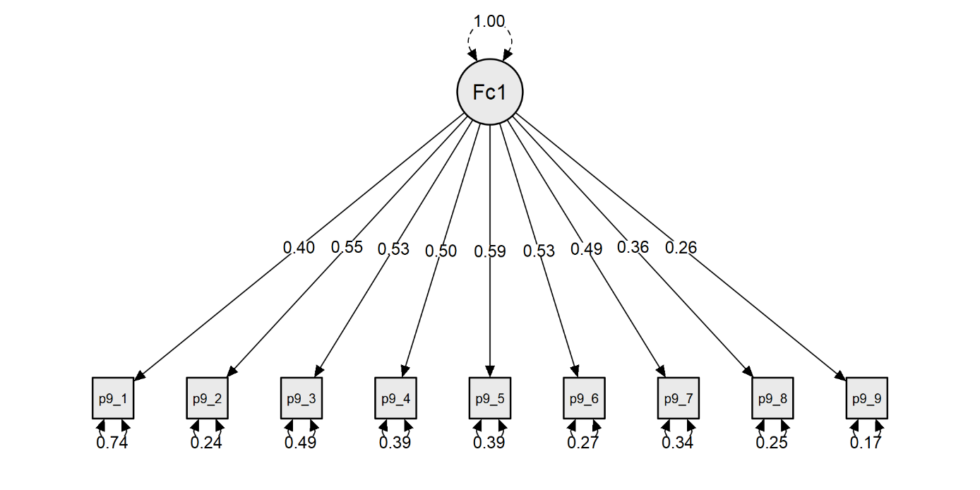
Picture 1 Model plot of the One-Factor Model
Note: Standardized factor loadings are shown. F1 = Depression (general factor). P9-1 = Anhedonia; P9-2 = Depressed mood; P9-3 = Sleep; P9-4 = Fatigue; P9-5 = Appetite; P9-6 = Worth/Guilt; P9-7 = Concentration; P9-8 = Psychomotor; P9-9 = Suicidality.
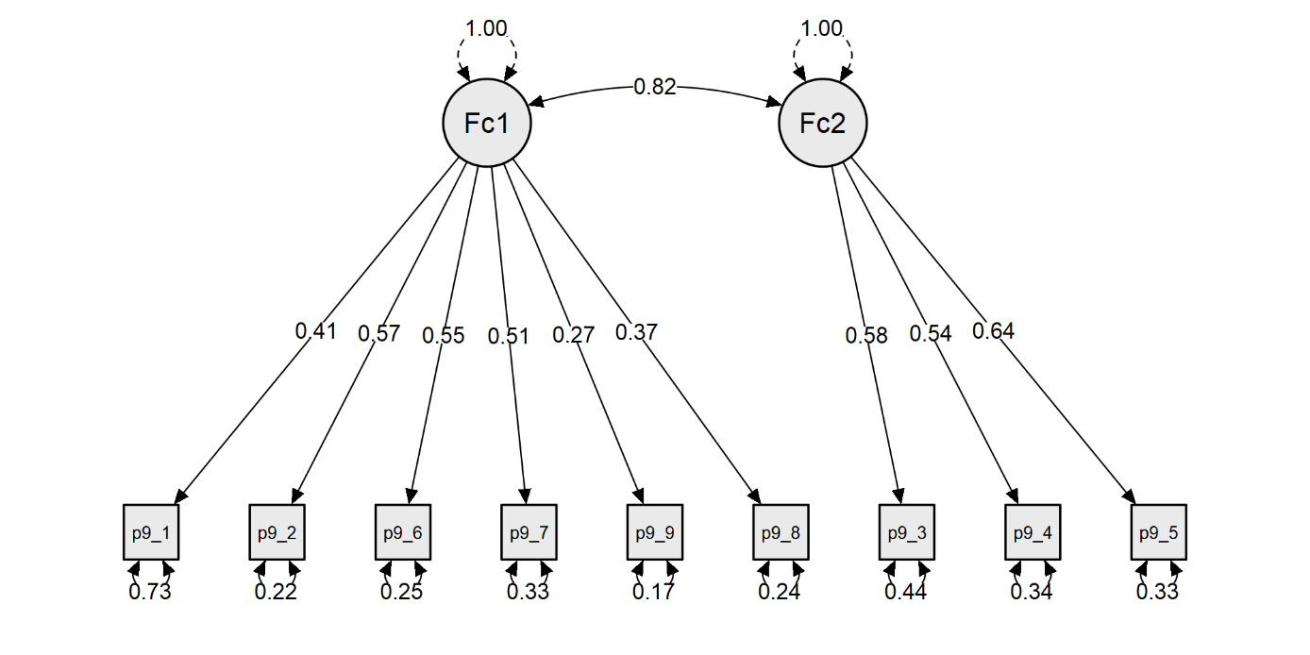
Picture 2 Model plot of the Two-Factor Model
Note: Standardized factor loadings are shown. FC1 = Cognitive-Affective; FC2 = Somatic. P9-1 = Anhedonia; P9-2 = Depressed mood; P9-3 = Sleep; P9-4 = Fatigue; P9-5 = Appetite; P9-6 = Worth/Guilt; P9-7 = Concentration; P9-8 = Psychomotor; P9-9 = Suicidality.

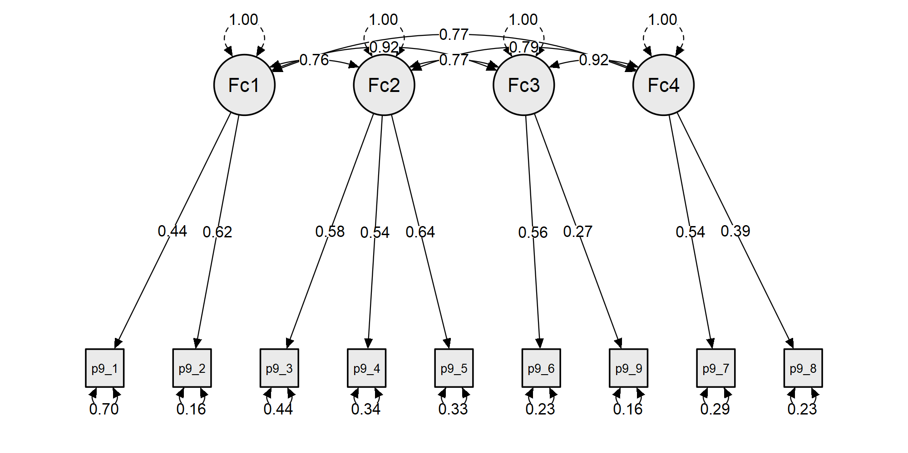
Picture 3 Model plot of the Four-factor model
Note: Standardized factor loadings are shown. FC1 = Affective; FC2 = Somatic; FC3 = Internalizing; FC4 = Sensorimotor. P9-1 = Anhedonia; P9-2 = Depressed mood; P9-3 = Sleep; P9-4 = Fatigue; P9-5 = Appetite; P9-6 = Worth/Guilt; P9-7 = Concentration; P9-8 = Psychomotor; P9-9 = Suicidality.

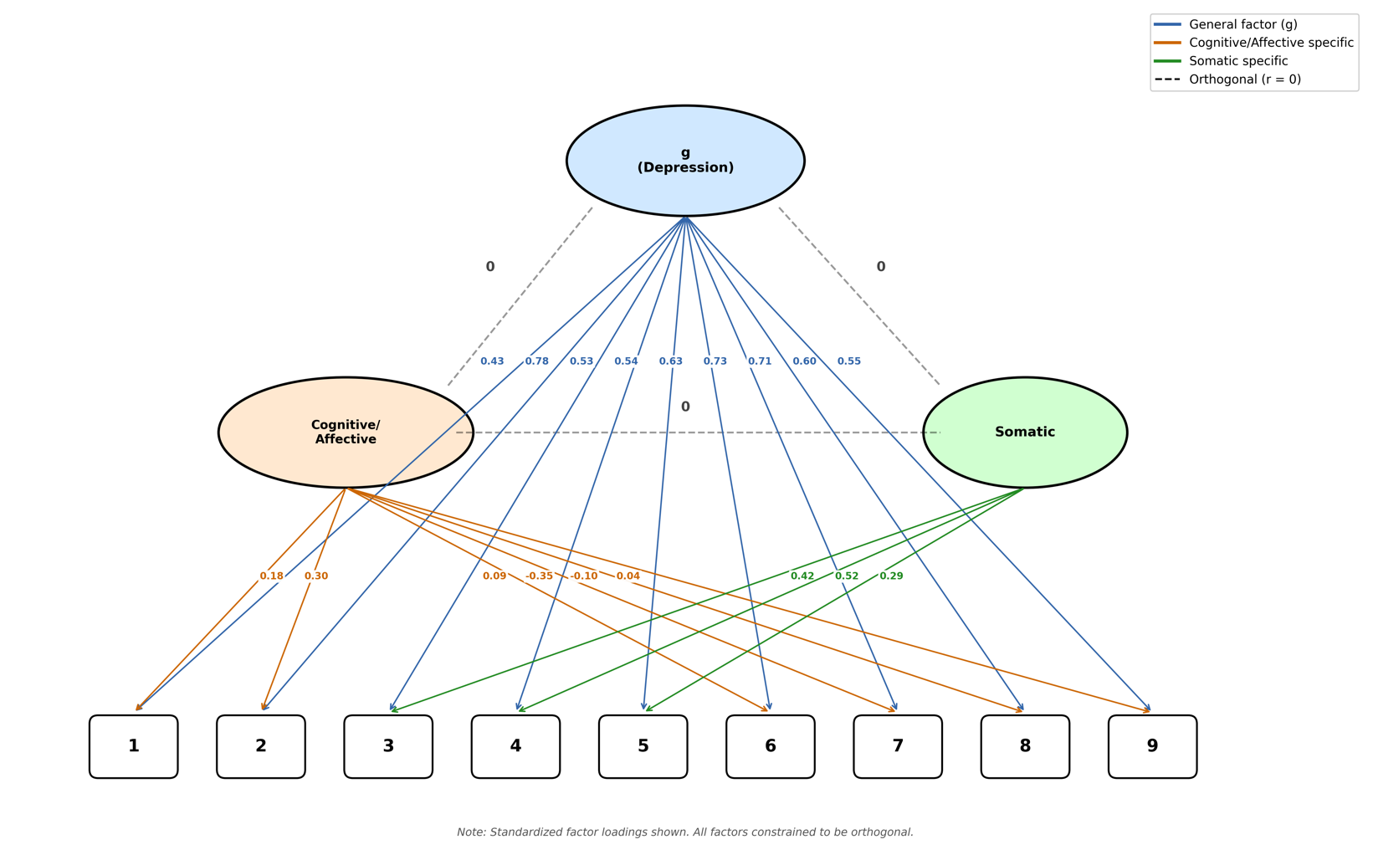
Picture 4 Model plot of the Bi-factor model
Note: Standardized factor loadings are shown. All factors are constrained to be orthogonal. g = general depression factor; Cognitive/Affective and Somatic = specific factors. 1 = Anhedonia; 2 = Depressed mood; 3 = Sleep; 4 = Fatigue; 5 = Appetite; 6 = Worth/Guilt; 7 = Concentration; 8 = Psychomotor; 9 = Suicidality.

