Supplementary Information

Light-Triggered Drug Release via Fiber Optic Heater-Integrated with Thermoresponsive Microgels for Locoregional Cancer Therapy
Tania Mariastella Caputo^{1§}, Gaia Maria Berruti^{1§}, Silvia Vanni^{2§}, Angela Maria Cusano³, Claudia Cocchi², Chiara Liverani²*, Marco Consales¹*, Laura Mercatali⁴, Toni Ibrahim⁴, Alessandro De Vita^{2#}, Anna Aliberti^{1,3#}, Andrea Cusano^{1,3#}
- Optoelectronics Group, Department of Engineering, University of Sannio, Palazzo Dell' Aquila Bosco Lucarelli, Benevento, Italy.
- Preclinic and Osteoncology Unit, Bioscience Laboratory, IRCCS Istituto Romagnolo per lo Studio dei Tumori (IRST) “Dino Amadori”, Meldola, Italy
- CeRICTscrl Regional Center Information Communication Technology, Benevento, Italy
- Osteoncology, Bone and Soft Tissue Sarcomas and Innovative Therapies Unit, IRCCS Istituto Ortopedico Rizzoli, Bologna, Italy

Table S1. MGs monomers quantitative and time of reaction used for each formulation.
 | NIPAM (g) | NIPMAM (g) | MAAC (g) | BIS (g) | KPS(g) | Time (h)
DD1 | 0.900 | - | 0.048 | 0.050 | 0.050 | 4
DD2 | - | 0.612 | 0.100 | 0.060 | 0.054 | 5
DD3 | 0.700 | - | 0.100 | 0.026 | 0.030 | 5

Figure S1. Core offset fusion splice fabrication: a) fibers alignment; b) Final core offset of 6 µm.
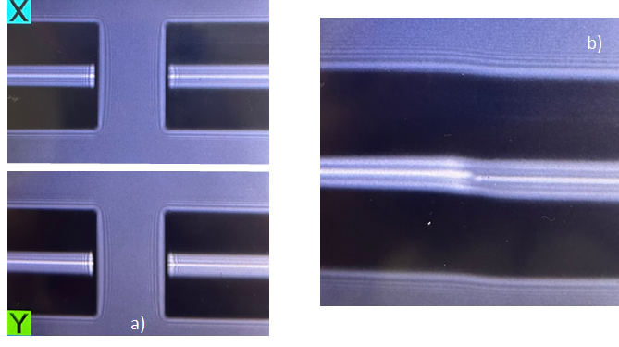

B
A
Figure S2. CLSM (A) and optical microscope images (B) of DOX@MGs integrated on the FOH gold surface.

Figure S3. Typical response of the optical fiber platform during the internal activation test (l= 10 mm and P_{IN} = 210 mW)
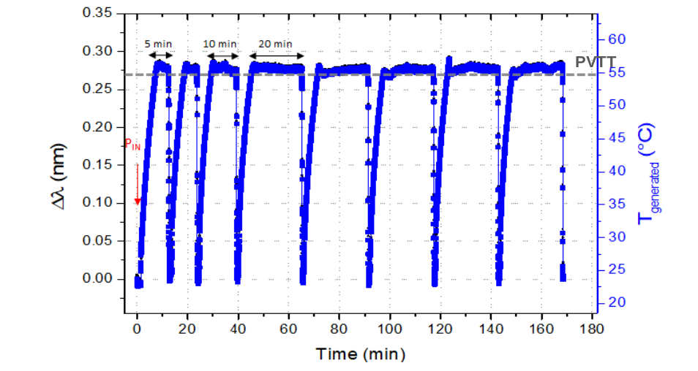

Figure S4. Efficacy of free DOX on cell proliferation inhibition in MCF7 cell line after 72 h of treatment in 2D and 3D culture models.

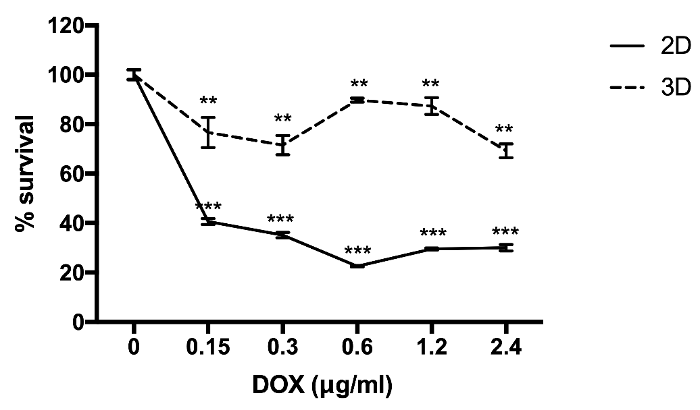
Figure S5. Cell cycle analysis of the MCF7 cell line treated with DOX after 24h, 48h, or 72h.
