Snailfish Body-Length (BL)

1.1 BL Method and Speed-Normalization Definition
For each track, we extracted a smoothed centerline from a representative annotated frame, consisting of 100 ordered points:
$$C_{i}=(x_{i},y_{i}), i=0,1,…,99$$
The pixel distance between adjacent points was defined as:
$$d_{i}^{px}={∥C_{i+1}-C_{i}∥}_{2}, i=0,1,…,98$$
The scale conversion followed the project camera chain:
$$d_{c,a}=\frac{D_{ref}}{\text{cos}(α)}$$
$$mm_per_px(z_{i}^{mid})=\left(\frac{S_{ref}}{P_{ref}}\right)⋅\left(\frac{z_{i}^{mid}}{d_{c,a}}\right), z_{i}^{mid}=\frac{z_{i}+z_{i+1}}{2}$$
The final body length was reported under the unified 2D body-length convention:
$$BL_{mm}=\sum_{i=0}^{98}{d_{i,mm}^{xy}}=\sum_{i=0}^{98}{\left(d_{i}^{px}⋅mm_per_px(z_{i}^{mid})\right)}$$
The speed numerator used MA21 on speed_3d (window size 21, reflect padding):
$${\hat{v}}_{t}=\frac{1}{21}\sum_{k=-10}^{10}{v_{t+k}^{ref}}$$
where $v^{ref}$ denotes the reflect-padded speed sequence at the boundaries.
The valid-frame set was defined as:
$$V=\left\{t | {summary_type}_{t}=⌀, is_anomaly_{t}≠True, is_excluded_{t}≠True, {\hat{v}}_{t}∈R\right\}$$
The MA21 mean speed and BL/s were:
vMA21=1|V|t∈V​vt
$$BL/s=\frac{{\overline{v}}_{MA21}}{BL_{mm}}$$

1.2 BL and BL/s Results
All values below are taken directly from the finalized summary file (results/bl_segment_depth_summary.csv):
Track | points_used | segments_used | BL_mm (mm) | valid_speed_samples | mean_speed_mm_s_ma21 (mm/s) | BL_s_ma21 (BL/s)
track1 | 100 | 99 | 257.9043 | 2160 | 159.3177 | 0.617739
track2 | 100 | 99 | 241.9501 | 11915 | 171.2643 | 0.707850
track3 | 100 | 99 | 221.2799 | 8215 | 178.0513 | 0.804643
Across the three tracks, the BL/s range in the feeding context is $0.618\text{–}0.805$, with a mean of approximately $0.710$.

- The body-length centerline figures were changed to a “yellow line + yellow points” style, with the red main-axis / endpoint annotations removed.
- All fonts in the speed dashboard were increased uniformly by +1 point.
- The y-axis of panel d was fixed to $0\text{–}1000$ mm/s to avoid text overlap.
- An additional dashboard version was generated with BL/s on the right axis of panels a/b/c.

Figure R1. MA21 speed dashboard (filtered valid frames, unit: mm/s)
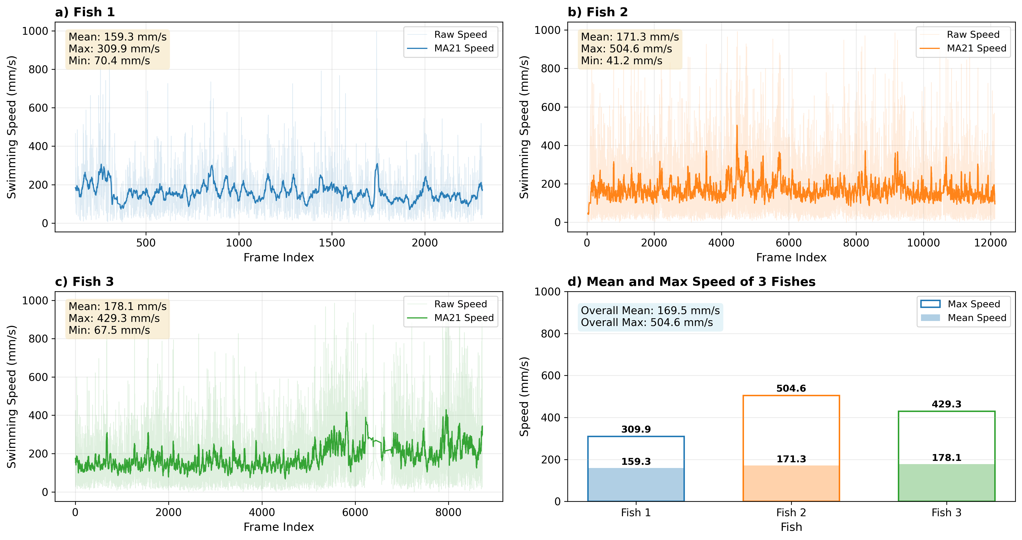
Figure R1. MA21 speed dashboard (mm/s).

Figure R2. MA21 dashboard with BL/s right axes (a/b/c)
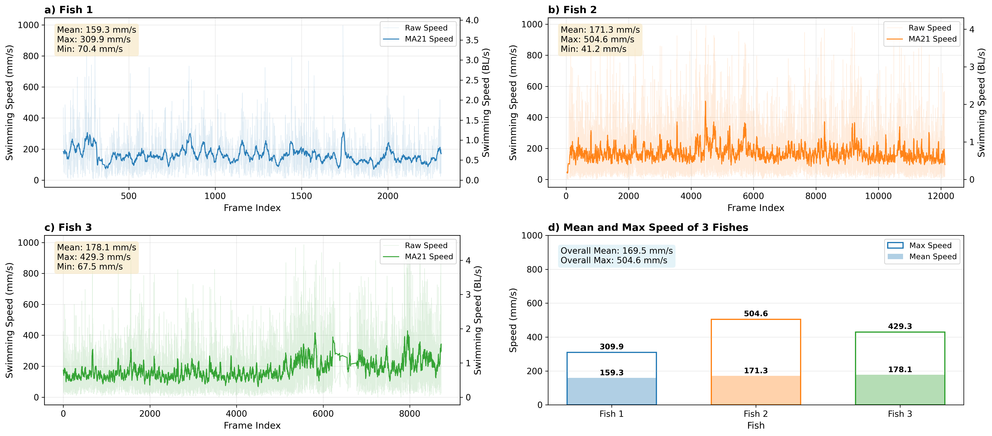
Figure R2. MA21 speed dashboard with BL/s right axes.

Figure R3. Track 1 centerline used for BL computation
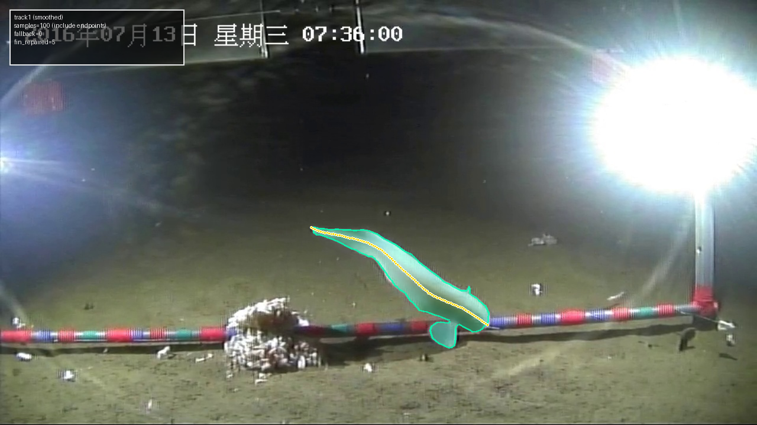
Figure R3. Track 1 smoothed centerline (yellow line + points).

Figure R4. Track 2 centerline used for BL computation
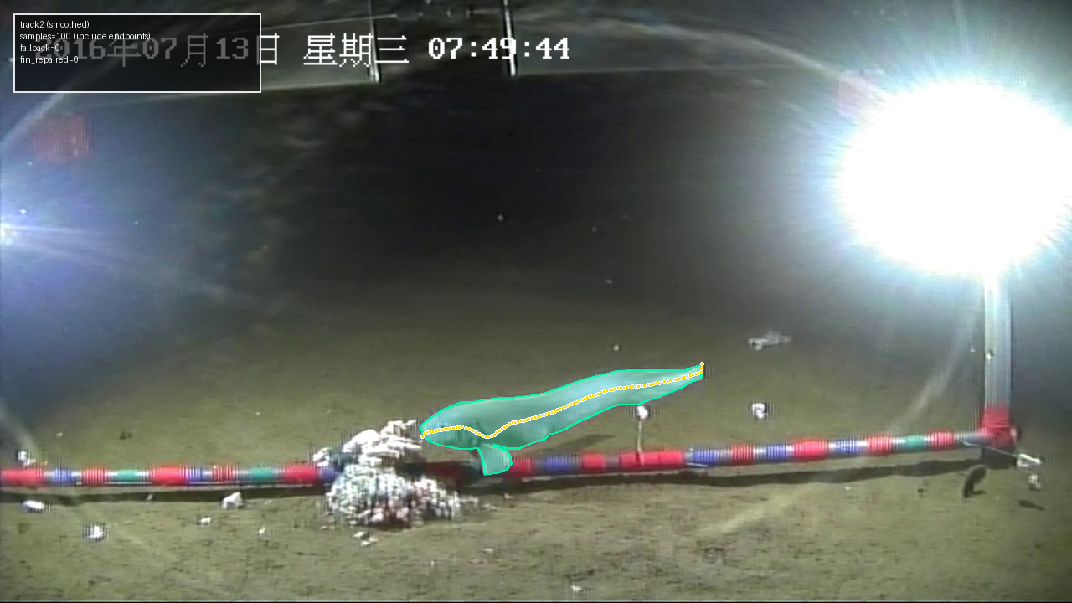
Figure R4. Track 2 smoothed centerline (yellow line + points).

Figure R5. Track 3 centerline used for BL computation
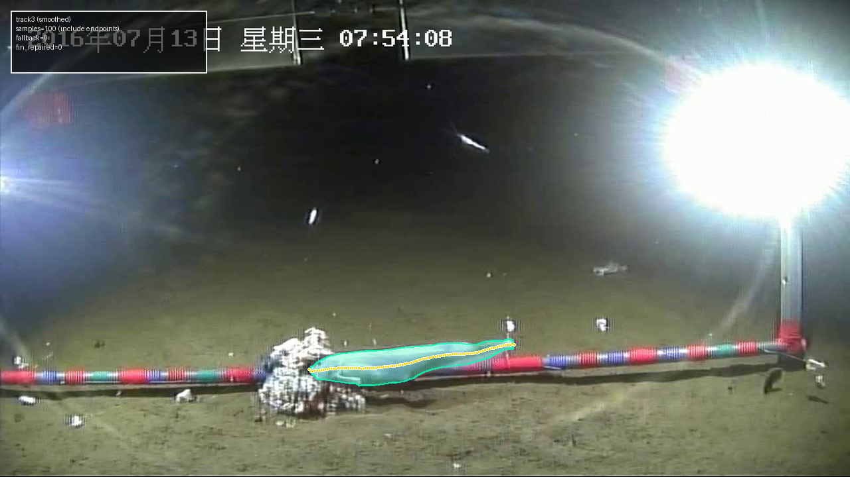
Figure R5. Track 3 smoothed centerline (yellow line + points).

1.4 Interpretation, Biological Reasonableness, and Conclusion
The updated BL/s values indicate relatively high locomotor activity of snailfish in the feeding context. This is behaviorally interpretable because speed during bait-interaction periods is typically higher than during routine cruising.
The literature reports hadal liparid flow / swimming contexts around bait of about 3-7 cm/s, as well as sustained swimming in flume experiments of about 10-14 cm/s, with even higher short-duration levels also observed. Under a body-length context of about 22.5 cm, these values correspond to an approximate BL/s range of 0.13-0.76 (derived value). The current range in this study, 0.618-0.805, is generally close to that upper active interval, with the fastest track slightly above it. Considering the feeding-driven behavioral context, we consider this reasonable; however, these values are still likely higher than a baseline routine swimming level.
At the same time, we explicitly acknowledge the main limitations: single-frame body-length anchoring for each track, the 2D projected body-length convention, and the behavioral bias introduced by the feeding context may all shift BL/s upward relative to routine locomotion.Since the velocity of the snailfish is obtained from video footage, it is also affected by factors including limited video resolution, partial occlusion of the fish body, dust or suspended particles in the water, and fluctuations in video exposure. All these factors reduce the stability of fish body segmentation, center point localization, and depth estimation, thereby affecting the velocity measurement of the snailfish.

