Swimming speed of deep-sea snailfish

Supplementary material section 1
The segmentation network used to detect and segment Pseudoliparis swirei was trained with a CBAM attention module on annotated underwater images. Training was monitored using box and mask losses (box regression, segmentation, classification and distribution focal loss) and standard detection metrics (precision, recall, mAP at IoU 0.5 and mAP at IoU 0.5 to 0.95) on both training and validation sets. The evolution of these quantities over 800 epochs is shown in Supplementary Figure S1 and confirms that the model converged with low losses and high precision, recall and mAP on the validation data.
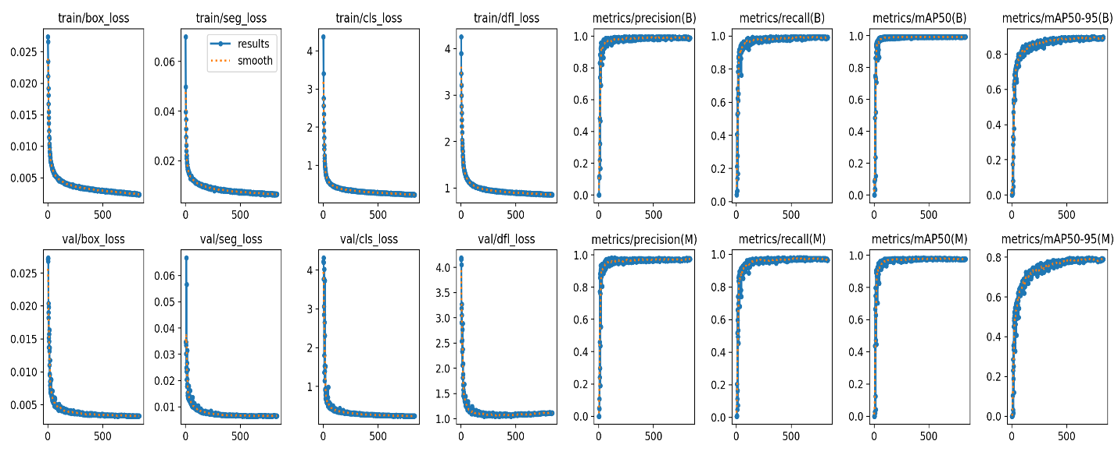
Supplementary Figure S1 Training history of the segmentation model used for detection of Pseudoliparis swirei.

Training and validation curves for the CBAM enhanced segmentation network. The top row shows training box loss, segmentation loss, classification loss and distribution focal loss, followed by box level precision, recall, mAP at IoU 0.5 and mAP averaged over IoU 0.5 to 0.95. The bottom row shows the corresponding validation losses and mask level metrics. Solid blue lines indicate per epoch values and orange dotted lines show smoothed curves. Losses decrease rapidly and then converge at low values, while precision, recall and mAP values approach 0.9 to 1.0 on both training and validation data, indicating stable convergence and accurate segmentation performance.
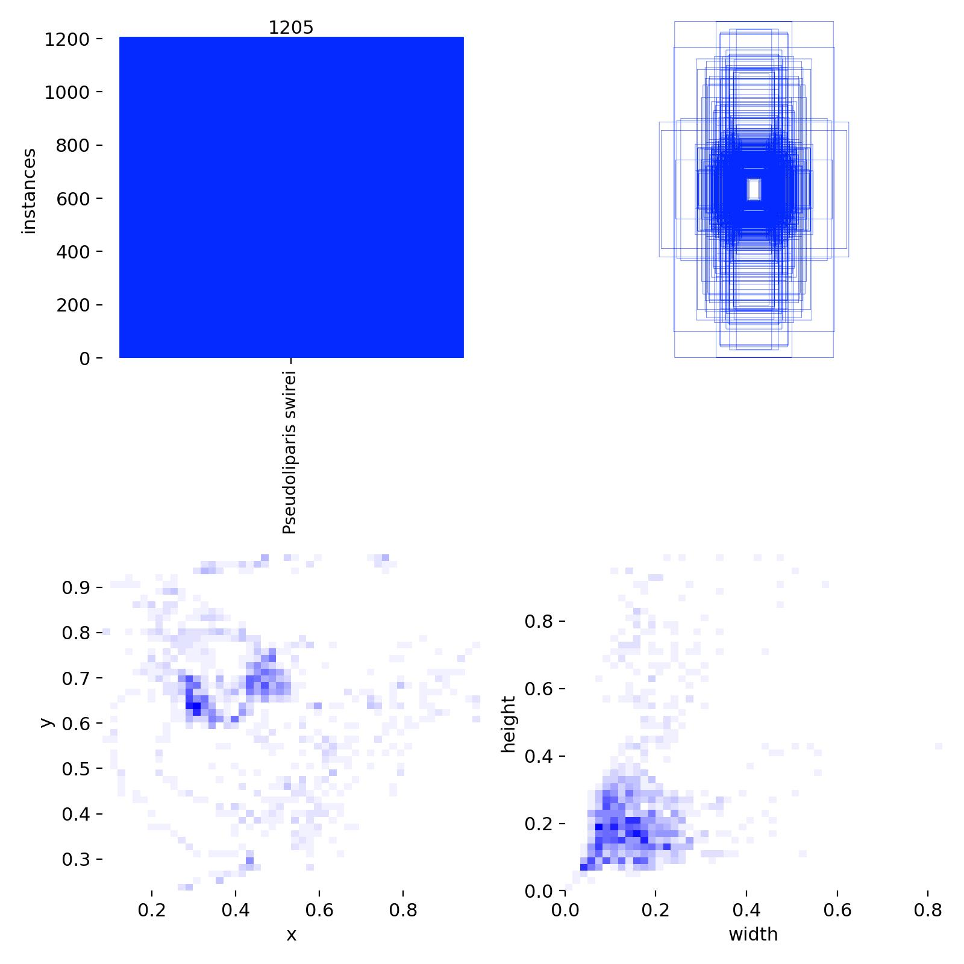
Supplementary Figure S2. Distribution of bounding box annotations for Pseudoliparis swirei.
Top left, number of annotated instances (1205) for the single class P. swirei. Top right, overlay of all bounding boxes in normalised image coordinates. Bottom left, heatmap of box centre positions (x,y)(x, y)(x,y). Bottom right, heatmap of box width and height (normalised to image size). The fish appears predominantly in the central field of view with relatively consistent box size and aspect ratio.
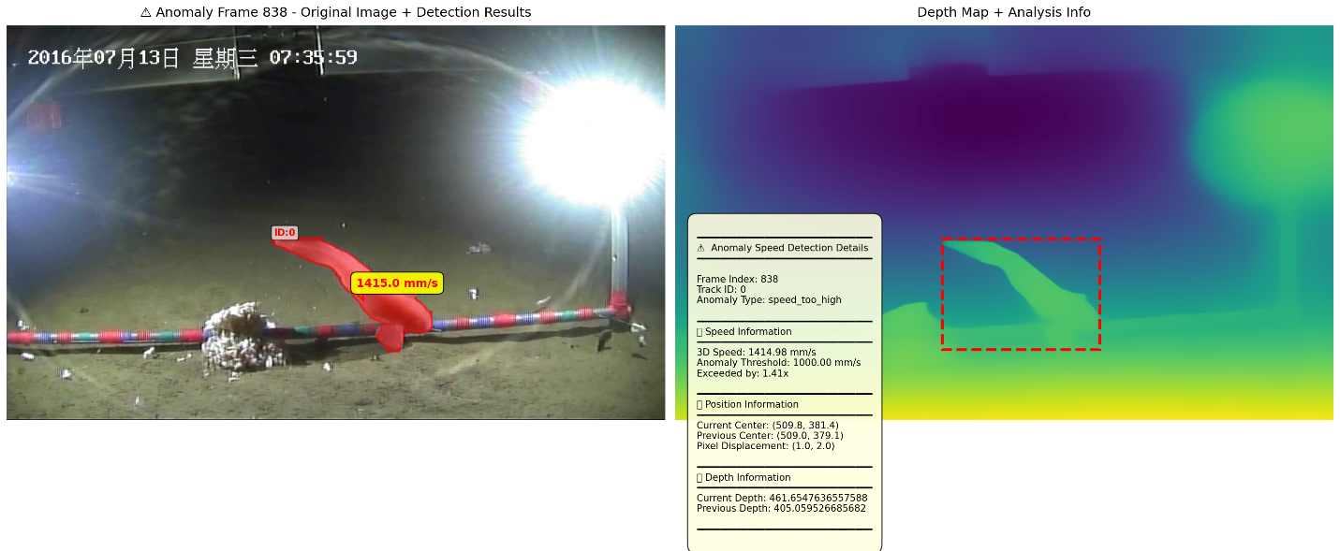Supplementary Figure S3. Example frame flagged as a high speed anomaly. Left, original lander frame with the segmentation mask of Pseudoliparis swirei in red and the instantaneous three dimensional speed displayed in yellow. Right, corresponding depth map generated by the Depth Anything model, with the fish location highlighted by a red dashed box. The inset panel summarises the anomaly type (“speed too high”), the 3D speed estimate, the anomaly threshold, the factor by which the threshold was exceeded, and the pixel and depth changes between frames. This visual output was used during manual inspection to distinguish true rapid movements from tracking or depth artefacts.

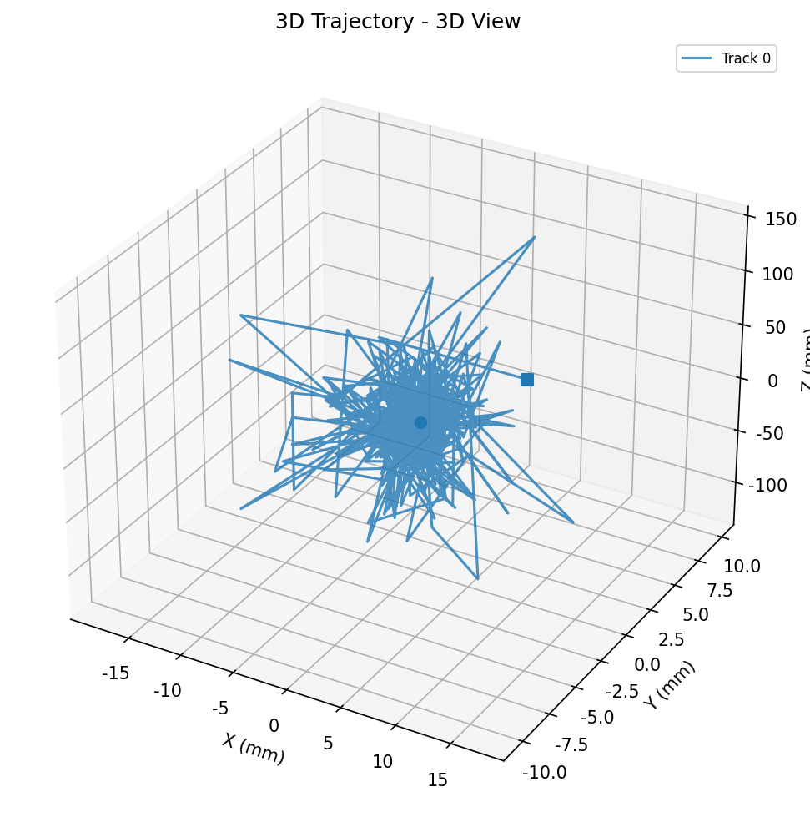
Supplementary Figure S4. Three-dimensional raw trajectory reconstructed from the center-of-mass displacement of the segmented fish mask in camera coordinates. The plot illustrates the unsmoothed frame-to-frame motion used to compute 3D velocities. This visualization confirms that the 3D reconstruction pipeline produces coherent trajectories with expected small-scale jitter due to pixel-level segmentation variation. Smoothed trajectories and biologically interpretable movement patterns are presented in the main text (Fig. 3)

Supplementary material section 2

1. Report Objective
This report provides a comprehensive and detailed estimation of the distribution radius of the Mariana snailfish by integrating the “Maximum Self-Consistent Intersection Method” with an “Initial Random Walk Model.” The report will systematically explain the physical principles, mathematical formulas, and parameter selection for the model construction. It will also present the final results calculated based on precise timestamps and provide an in-depth interpretation of these results.

2. Model Principles and Construction

2.1 Core Model: Maximum Self-Consistent Intersection Method

2.1.1 Time Partition
The model divides the total duration (from bait deployment to the end of observation) into two consecutive and independent key phases:
- Phase 1: Odor Plume Propagation ($t_{b}$) This is the time required for the chemical cue to travel through the water from the moment of bait deployment ($T_{0}$) to the first arrival at the snailfish’s location ($T_{1}$).
$$t_{b}=T_{1}-T_{0}$$
- Phase 2: Fish Response ($t_{f}$) This phase begins when the snailfish first perceives the odor ($T_{1}$) and starts its directed movement towards the bait source, continuing until the selected end of observation ($T_{2}$).
$$t_{f}=T_{2}-T_{1}$$
The total observation duration $T$ is the sum of these two phases:
$$T=t_{b}+t_{f}$$
Since $T_{1}$ is unknown, $t_{b}$ and $t_{f}$ become the key unknown variables that the model needs to solve.

2.1.2 Odor Plume Front Propagation Model
This formula describes the maximum distance the odor plume can travel from the source within a given time $t_{b}$. It combines two physical processes: advection (transport by current) and diffusion (random spreading).
Formula:
$$R_{p}(t_{b})=u⋅t_{b}+k\sqrt{4D_{eff}t_{b}}$$
Parameter Definitions: $R_{p}(t_{b})$: The maximum down-current distance the plume front can reach in time $t_{b}$. $u$: The mean near-bottom current velocity. $k$: A dimensionless “caliber coefficient” that defines the effective boundary of the plume ($k=1.0$ corresponds to the RMS radius). $D_{eff}$: The effective diffusion coefficient, which is the sum of molecular diffusion ($D_{m}$) and turbulent diffusion ($D_{t}$).
$$D_{eff}=D_{m}+D_{t}$$

2.1.3 Fish Response Displacement Model
This formula models the total displacement of the fish towards the bait source during the response phase $t_{f}$. It is modeled as a “Biased Random Walk.”
Formula:
$$L(t_{f})=\sqrt{(v_{c}t_{f})^{2}+4D_{fish}t_{f}}$$
Parameter Definitions: $L(t_{f})$: The total displacement produced by the fish in the response time $t_{f}$. $v_{c}=x⋅v$: The effective chemotactic velocity, where $v$ is the fish’s mean swimming speed and $x$ is the “orientation coefficient.” $D_{fish}=\frac{v^{2}}{2dγ}$: The fish’s equivalent diffusion coefficient, calculated from its mean swimming speed $v$, turning frequency $γ$, and the number of spatial dimensions ($d=3$).

2.1.4 Self-Consistent Intersection Condition
This is the core of the estimation method. The model solves for the unknowns by applying a physically self-consistent assumption: the distance the odor travels to reach the fish is exactly equal to the distance the fish travels from that point to the bait source.
Condition:
$$R_{p}(t_{b})=L(T-t_{b})$$
By solving this equation, a unique optimal solution for $t_{b}^{*}$ and $t_{f}^{*}$ can be found, along with the final distribution radius $R=R_{p}(t_{b}^{*})=L(t_{f}^{*})$. This value of $R$ represents the most robust upper-bound estimate for the distribution radius given the limited information.

2.2 Model Extension: Initial Position Estimation via Random Walk

2.2.1 Core Assumption
During the time interval $t_{b}$, as the snailfish has not yet received the chemical signal, its movement is assumed to be a non-directional Random Walk.

2.2.2 Random Walk Displacement Calculation
The Root-Mean-Square (RMS) linear displacement, $L_{random}$, produced by this random walk over the time $t_{b}$ can be calculated as follows:
$$L_{random}(t_{b})=\sqrt{\frac{v^{2}}{γ}t_{b}}$$
The mean swimming speed $v$, turning frequency $γ$, and plume propagation time $t_{b}$ are all known quantities calculated by the core model.

2.2.3 Initial Distribution Radius $R_{initial}$ Interval Estimation
The initial position at $t=0$, $R_{initial}$, depends on the direction of the fish’s random walk during $t_{b}$. Since this direction is unknown, we provide an estimated possible range:
$$R_{initial}∈[\text{max}(0,R-L_{random}), R+L_{random}]$$

3. Calculation Parameters and Procedure
The parameters used in the model calculation are divided into three categories: fixed input parameters, data-driven biological parameters, and time parameters derived from the model calculations.

3.1 Input Parameters (Fixed Values)
These parameters are based on literature or general assumptions and remain constant across all calculations.
Parameter | Symbol | Value | Unit | Description
Near-bottom Current Velocity | $$u$$ | 0.01 | m/s | Estimated mean current speed
Turbulent Diffusion Coeff. | $$D_{t}$$ | 1.0e-4 | m²/s | Diffusion from environmental turbulence
Caliber Coefficient | $$k$$ | 1.0 | - | Defines the plume boundary (RMS)
Molecular Diffusion Coeff. | $$D_{m}$$ | 1.0e-9 | m²/s | Molecular diffusion of the chemical cue

3.2 Biological Parameters (Data-Driven)
These parameters are calculated from the snailfish’s movement trajectory data in each video sequence.
- Turning Frequency (γ): Defined as the number of times the fish’s direction of movement changes significantly (by more than 25 degrees) per unit of time. This value reflects the tortuosity of the fish’s trajectory.
- Orientation Coefficient (x): Defined as the average cosine of the angle between the fish’s velocity vector and the vector pointing towards the bait source (only considering movements towards the source). This value ranges from 0 to 1, where 1 represents a perfectly straight path towards the source and 0 indicates no directional preference.
Sequence | Mean Speed $v$ (m/s) | Turning Frequency $γ$ (1/s) | Orientation Coeff. $x$
1 | 0.143 | 21.904 | 0.67
2 | 0.154 | 21.561 | 0.58
3 | 0.160 | 20.610 | 0.59

3.3 Time Parameters (Model-Calculated)
The total duration $T$ is determined by the precise timestamps, while $t_{b}$ and $t_{f}$ are the core results obtained by solving the intersection method.
Sequence | Total Duration $T$ (s) | Plume Propagation Time $t_{b}$ (s) | Fish Response Time $t_{f}$ (s)
1 | 38055.0 | 34344.6 | 3710.4
2 | 38428.0 | 34489.1 | 3938.9
3 | 39121.0 | 35306.7 | 3814.3

4. Summary of Calculation Results (Based on Precise Timestamps)
The following table summarizes the final calculation results using the updated, precise absolute timestamps.
Sequence | $R(t=t_{b})$ (m) | $L_{random}$ (m) | Initial Radius Interval $R_{initial}$ (m)
2016-07-13-07-06-58_CBAM | 347.2 | 5.7 | [341.5, 352.8]
2016-07-13-07-40-38_clip_001875_014000 | 348.6 | 6.2 | [342.5, 354.8]
2016-07-13-07-40-38_clip_clip_019525_028250_CBAM | 356.8 | 6.6 | [350.2, 363.5]

5. Interpretation of Results and Conclusion
- Distribution Radius Estimation: Based on the results from the three sequences, the position radius of the snailfish at the moment of first odor perception is more accurately concentrated in the range of 347 - 357 meters.
- Initial Position Interval: Considering the fish’s random walk before odor perception, its initial position at the time of bait deployment is estimated to be within the range of 341 – 364 meters.
- Key Finding: The updated results further reinforce the previous conclusion. The random walk displacement $L_{random}$ (approx. 6-7 meters) is negligible compared to the radius $R$ itself (approx. 350 meters). This indicates that during the nearly 10-hour odor propagation time, the fish’s own random movement has a very small impact on its final position. Therefore, the fish’s position at the moment of perceiving the odor is extremely close to its initial position at the time of bait deployment. This finding greatly enhances our confidence in the estimation of $R≈350$ meters.

Supplementary Material Section 3

Model visualization of odor plume geometry and bait-approaching trajectories

3.1 Overview
To illustrate the spatial configuration used in the odor–response model, we generated complementary 3D and 2D visualizations showing the modeled odor diffusion field, the estimated initial distribution region of P. swirei, and representative simulated approach trajectories. These visualizations correspond to the environmental and behavioral parameters described in Supplementary Method Section 2.

3.2 Components of the visualization
Both 3D and 2D views include the following elements:
- Near-bottom current (blue arrow).
A uniform west–east flow (W→E) representing the mean near-bottom current at the Challenger Deep.
- Odor diffusion field (green surface).
Depicted as an ellipsoid in the 3D view and as an ellipse in the x–y projection.
Its anisotropic shape reflects downstream stretching caused by advection.
- Initial random-motion region (yellow region).
Modeled as a thin spherical shell in 3D and as an annulus in 2D.
This region represents the possible initial positions of P. swirei at the moment the odor plume first reaches the fish.
- Representative trajectories (three red lines).
These illustrate simulated movements from the initial region toward the baited lander following odor detection.
Each trajectory consists of:
  - a short random-movement period, and
  - a directed (biased) motion phase toward the lander.
- Lander position (red dot).
Located at the coordinate origin.

3.3 Interpretation of views
- 3D View.
Shows the full spatial geometry of the model including the ellipsoidal plume, the initial spherical shell, and the depth component of fish approach trajectories.
- 2D View.
Provides a horizontal projection of the same fields, emphasizing the downstream elongation of the plume and the relative lateral positions of the simulated trajectories.
- Combined Panel.
Presents the 3D and 2D views side by side with a shared legend for direct comparison.

3.4 Assumptions underlying the visualization
- Environmental constancy:
A uniform near-bottom current flows from west to east.
- Advection–diffusion plume model:
The odor field is determined by current velocity uuu, effective diffusivity DeffD_{\mathrm{eff}}Deff​, and propagation time tbt_btb​.
- Fish movement model:
The initial position is constrained to a spherical shell defined by random-walk displacement during tbt_btb​.
The post-detection trajectory follows a biased random walk whose parameters (mean speed vvv, turning frequency γ\gammaγ, and directionality coefficient xxx) are extracted from empirical tracking data.

