Supporting Information
Fluorine-Free Fabrication of Durable Superhydrophobic Nonwoven Membranes for Efficient Oil–Water Separation
Hongjie Zhang¹, Linjian Li², Meng Wang¹, Chan Guo³, Fengguang Liu^{4,}*,
Yipeng Zang ^{5,}*, Cheng Chen ^{3,}*

¹College of Textile and Clothing, Quanzhou Normal University, Quanzhou 362000, China
²College of Textile and Clothing, Xinjiang University, Urumqi 830000, China
³Agricultural Photocatalysis Laboratory, School of Resources and Environment, Anhui Agricultural University, 130 Changjiang West Road, Hefei, 230036, Anhui, China
⁴Ningbo Institute of Materials Technology and Engineering, Chinese Academy of Sciences, Ningbo 315201, People's Republic of China
⁵ Anhui Provincial Key Laboratory of Magnetic Functional Materials and Devices, School of Materials Science and Engineering, Anhui University, Hefei 230601, China
*Corresponding E-mail: chc@ahau.edu.cn; liufengguang@nimte.ac.cn; ypzang@ahu.edu.cn

Table S 1 Comparison of Performance of Different Substrates
Substrates | Fabrication Method | Fluorine Content | Separation Efficiency (%) | Flux (L·m⁻²·h⁻¹) | Durability | Ref.
Melamine / polyurethane sponge | Dip-coating / chemical vapor deposition | Contains fluorine / Fluorine-free | 98.4-99.82 | About 1200 | Moderate mechanical stability | [12-14]
Cellulose / graphene / chitosan aerogel | Freeze-drying / chemical modification | Contains fluorine | About 98 | 12000 | Limited compression resilience; recyclable in most cases | [15-17]
Cotton cloth | Padding / graft polymerization | Contains fluorine / Fluorine-free | 96.3-99 | 6110.84 | Moderate washing resistance; stable over multiple cycles | [18-20]
PVDF / PAN, etc. | Electrospinning + post-treatment | Contains fluorine / Fluorine-free | 99.00-99.79 | 2275-6700 | Good structural stability; chemical resistance varies with material | [21-23]
viscose/polyester composite | Dip-coating + heat treatment (PDMS + HDTMS) | Fluorine-free | ＞99.9 | ＞5800 | Maintains superhydrophobicity after ultrasonication and repeated cycles; good mechanical stability | This work

Fig S1. Roll Angle Testing Device
Note: The roll angle testing device is depicted in FigS1. A 10μL droplet of deionized water was deposited on the sample surface at room temperature. The surface inclination angle (θ_{SA}) relative to the horizontal plane was systematically adjusted, and both the tilt angle (θ_{SA}) and dynamic behavior of the water droplet were carefully monitored and recorded.

Fig S2. Mechanical durability test
Note: In the mechanical durability test, a 100 g counterweight was applied to the sample surface, which was then dragged horizontally over 1000 grit sandpaper for a stroke length of 15 cm. This reciprocating motion constituted one complete test cycle, and the experiment was repeated for 1–5 cycles under identical conditions.
Contact separation testing was performed, as shown in FigS4. When 5μL droplets of deionized water were deposited on both the pristine viscose/polyester (50/50) and PDMS@HDTMS@viscose / polyester surfaces, distinct wetting behaviors were observed: (1) The droplet was instantaneously absorbed by the unmodified viscose/polyester substrate, demonstrating its inherent hydrophilicity; (2) In contrast, the water droplet maintained its spherical morphology on the PDMS@HDTMS@viscose / polyester surface without any infiltration, confirming the successful superhydrophobicity achieved through the dual-layer coating process.

Fig S3. Dyeing solutions without pH dyes
Note: Dyeing solutions without pH dyes, aqueous solutions with varying pH values (1, 3, 5, 9, 11, and 13) were prepared by adding different volumes of hydrochloric acid or different masses of sodium hydroxide to deionized water, followed by staining with distinct colorimetric dyes for visual identification.
Fig S4. 5μl of deionized water was in contact with the (a) nonwoven fabric and (b) superhydrophobic nonwoven fabric.
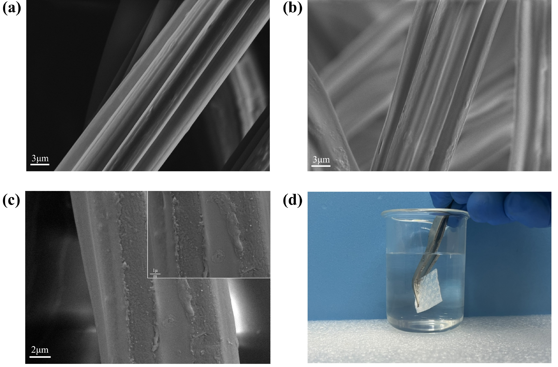
Fig S5. SEM of Viscose: (a) viscose/polyester, (b) HDTMS@viscose/polyester, (c) PDMS@HDTMS@viscose / polyester, and (d) silver mirror phenomenon.

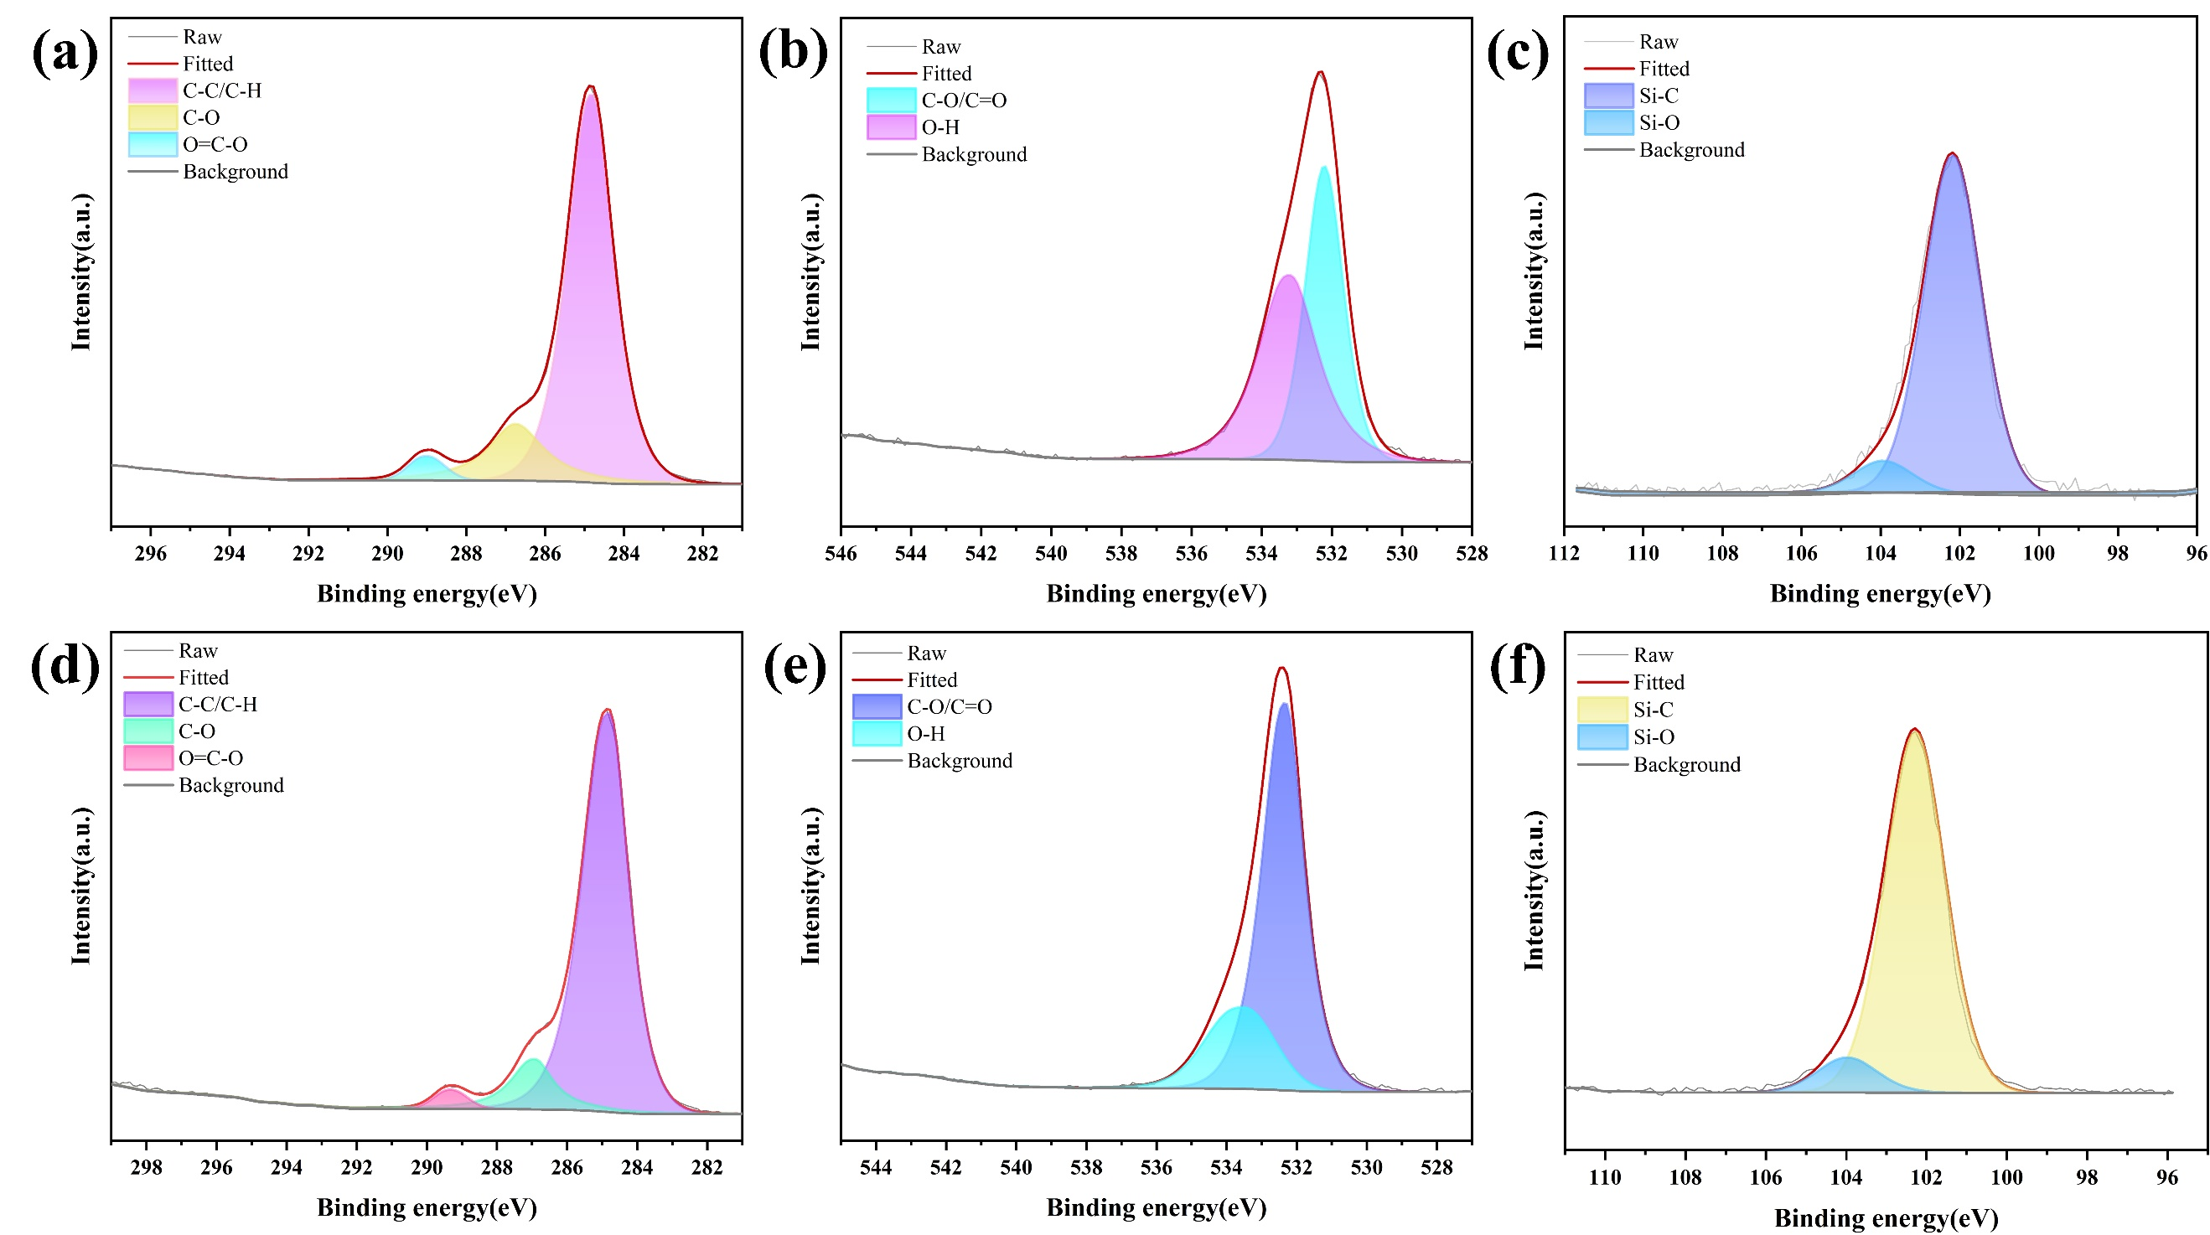
Fig S6. XPS High-resolution spectra of (a) C 1s, (b) O 1s, and (c) Si 2p for HDTMS@Viscose/polyester. High-resolution spectra of (d) C 1s, (e) O 1s, and (f) Si 2p for PDMS@HDTMS@Viscose/Polyester.
Note: The C-C/C-H peak intensity in the C 1s spectrum of PDMS@HDTMS@Viscose/polyester was further increased compared to that of HDTMS@Viscose/polyester (Fig S6a and Fig S6d), indicating that the methyl group of PDMS was covered on the HDTMS layer, whereas the C 1s intensity of PDMS@HDTMS @Viscose/polyester showed a decrease in O-H intensity (Fig S6b and Fig S6e) and an increase in the Si 2p intensity (Fig S6c and Fig S6f), further demonstrating that PDMS was cured on the surface of HDTMS@Viscose/polyester.

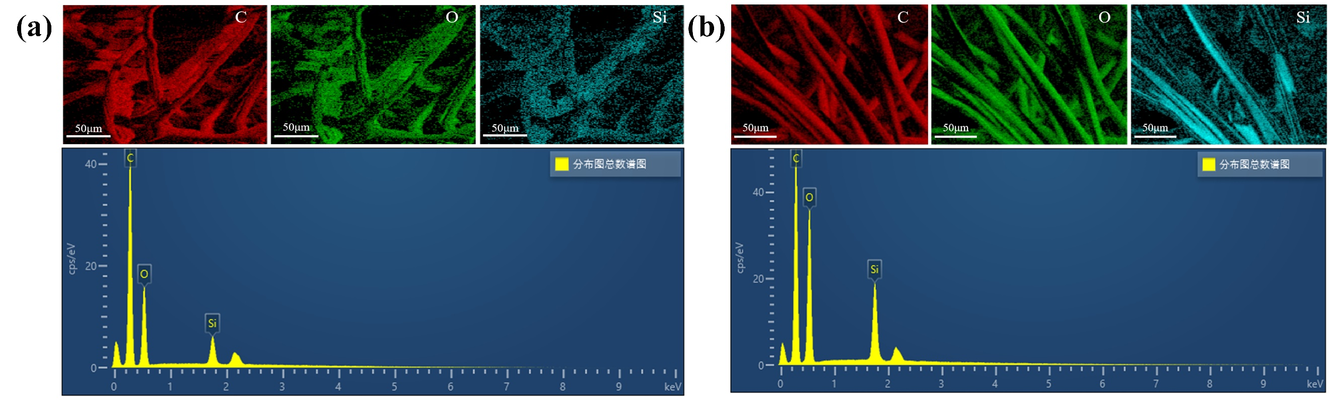
Fig S7. EDS mapping: (a) HDTMS@viscose/polyester EDS, (b) PDMS@HDTMS@viscose/polyester EDS.
Note: Both the HDTMS@viscose/polyester and PDMS@HDTMS@viscose/polyester composites exhibited distinct silicon signals.
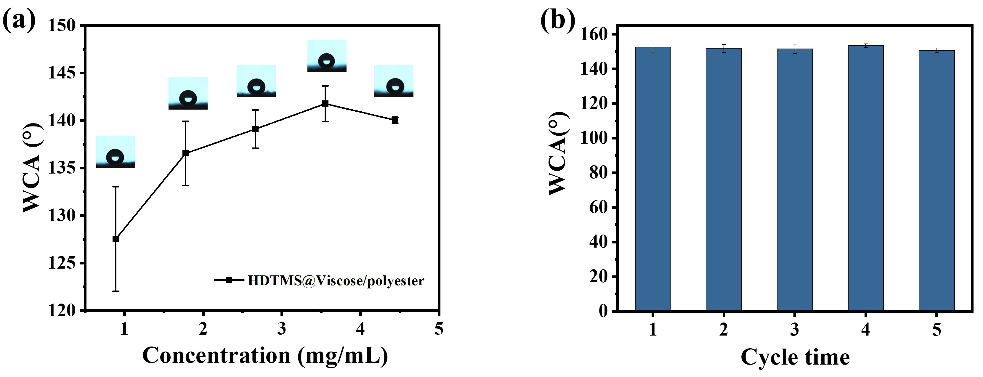
Fig S8. (a) Changes in the hydrophobic angle of HDTMS@Viscos/polyester after treatment with different concentrations of HDTMS. (b)Change of hydrophobic angle in friction resistance test

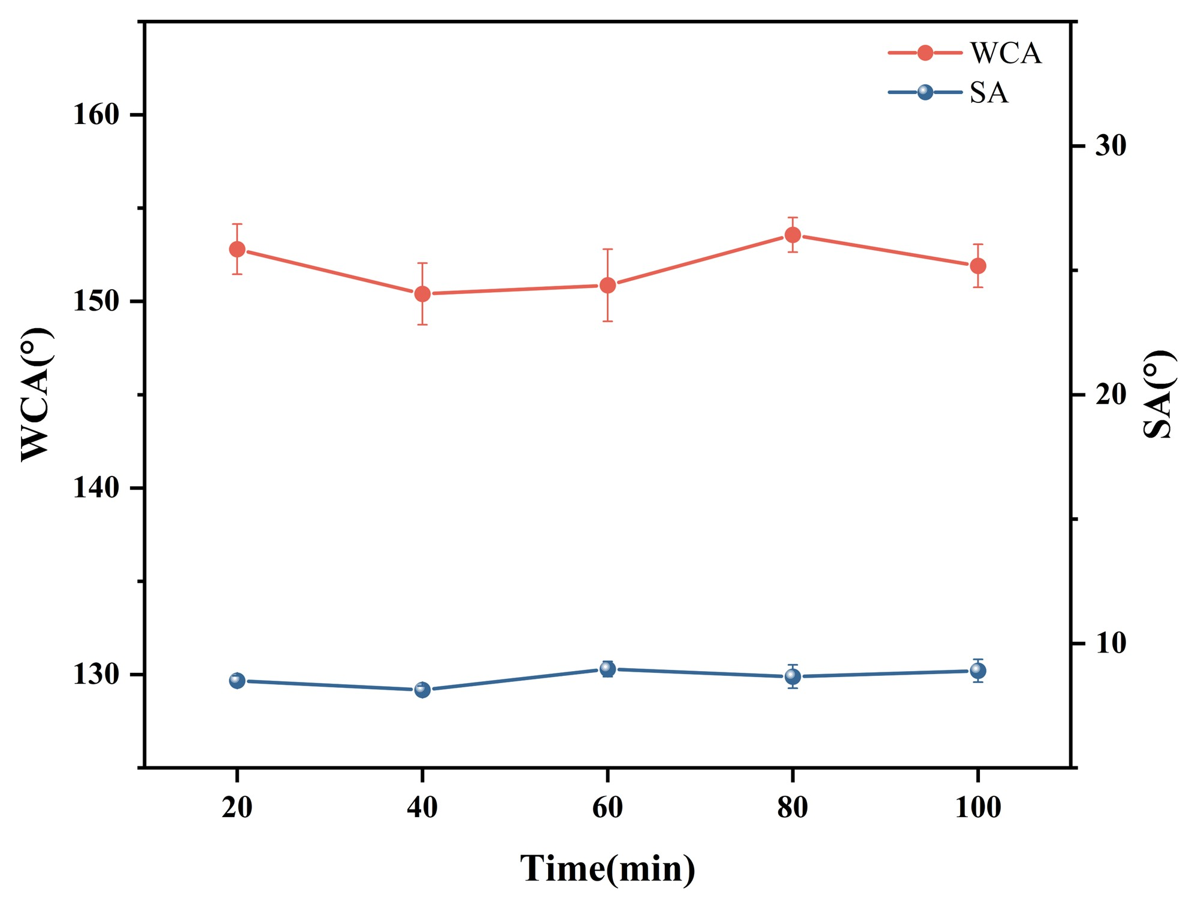
Fig S9. Hydrophobic angle change in ultrasound resistance test

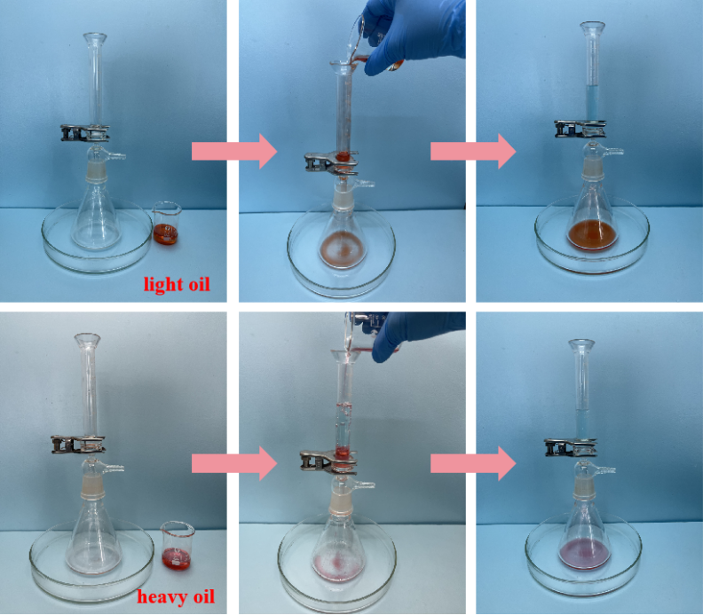
Fig S10. Oil-water separation process
Note: The flux and oil–water separation performance of the samples were measured using a gravity‐driven separation setup (see Supplementary Material, Fig. S10). The time required for a specific volume of the oil phase to pass through the sample under only gravity was recorded. The hydrostatic pressure head corresponds to the initial height of the H₂O phase liquid column in the separation setup. The inner diameter of the glass tube used (approximately 18 mm), the effective separation area of the membrane (approximately 254.47 mm²). The hydrostatic pressure head corresponds to the initial height of the H₂O phase liquid column in the separation setup (10 ml, equaling to a pressure of approximately 386 Pa). Water was dyed blue with methylene blue, while the oil phases, including n-hexane, petroleum ether, ethyl acetate, dichloromethane, and carbon tetrachloride, were dyed red with Sudan III. The time required for the sample to filter a specific volume of oil under gravity was measured. Three subsamples were tested for each sample, and the average value was calculated.

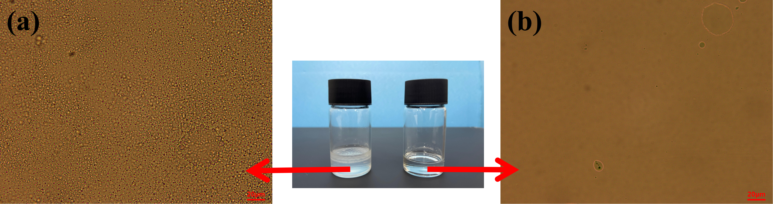
Fig S11. (a) Water-in-oil emulsion. (b) System after membrane treatment.
Note: Experimental procedure for the preparation of water-in-oil emulsion: 20 mL of n-hexane was added to a clean beaker, followed by the addition of a magnetic stir bar. 1 g of Span80 was weighed and added to the n-hexane. The beaker was placed on a magnetic stirrer and stirred at 300 r/min for 5 min at room temperature until the Span80 was completely dissolved and the system became transparent and uniform. While maintaining a stirring speed of 300 r/min, 10 mL of deionized water was slowly added dropwise to the n-hexane oil phase using a separatory funnel. The total addition time was controlled to be no less than 15 min. During the dropwise addition, the beaker was sealed to reduce n-hexane volatilization. After the complete addition of the water phase, the stirring speed was increased to 600 r/min, and stirring was continued for 4 h at room temperature under sealed conditions to obtain the water-in-oil emulsion.

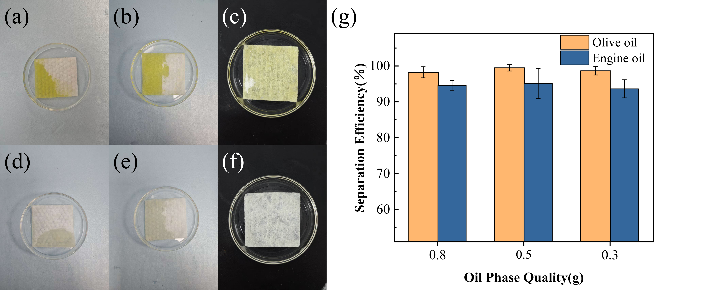
Fig S12. Digital photographs of the as-prepared sample (4 cm × 4 cm) after adsorptive separation of olive oil/water and engine oil/water mixtures with different oil loadings (0.3 g, 0.5 g, and 0.8 g). (a–c) Samples after treating olive oil/water mixtures. (d–f) Samples after treating engine oil/water mixtures. (g) Separation efficiency for olive oil/water and engine oil/water mixtures.
Note: 0.3 g, 0.5 g, and 0.8 g of olive oil were each mixed with 20 g of deionized water and allowed to stand for 5 min to obtain olive oil/water mixtures. Similarly, 0.3 g, 0.5 g, and 0.8 g of engine oil were each mixed with 20 g of deionized water and allowed to stand for 5 min to obtain engine oil/water mixtures. Adsorptive separation experiments were conducted on the olive oil/water mixtures with different oil loadings using the as-prepared sample (4 cm × 4 cm). The sample after the experiment is shown in Figures (a–c). Likewise, adsorptive separation experiments were conducted on the engine oil/water mixtures with different oil loadings using the as-prepared sample (4 cm × 4 cm). The sample after the experiment is shown in Figures (d–f), and the separation efficiencies are shown in Figure (g).

Fig S13. (a) Different beverages. (b) Anti-fouling test of viscose/polyester fabric. (c) Anti-fouling test of silk/cotton fabric. (d) Anti-fouling test of seaweed/TENCEL. (e) Anti-fouling test of wood pulp/polyester composite. (f) Anti-fouling test of Tencel/fine denier. (e) Anti-fouling test of bamboo fiber/fine denier fiber.

Fig S14. (a) Acid and alkali resistance tests of viscose/polyester. (b) Acid and alkali resistance tests of silk/cotton. (c) Acid and alkali resistance tests of seaweed/Tencel. (d) Acid and alkali resistance tests of wood pulp/polyester. (e) Acid and alkali resistance tests of Tencel/fine denier. (f) Acid and alkali resistance tests of the bamboo fiber/fine denier.

Fig S15. (a) Self-cleaning experiment. (b) Self-cleaning experiment after oil absorption.

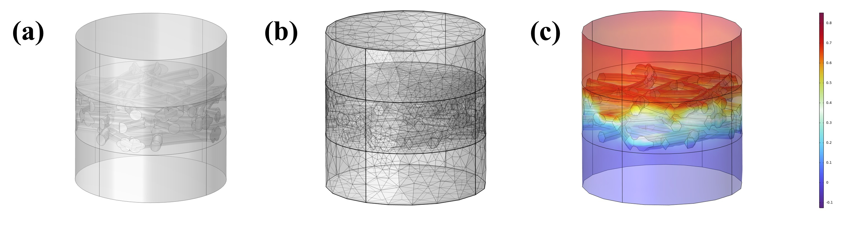
Fig S16. Modeling process diagram (a) Geometric Model. (b) Mesh Generation. (c) Pressure Boundary Conditions.
Note: Computational Modeling of Oil-Water Separation: Simulation Objectives & Physical Model. Separation target: Achieve >99.9% oil-water separation efficiency. Physical model: a selectively permeable membrane, acts as a functional barrier that permits oil penetration while blocking water transmission.
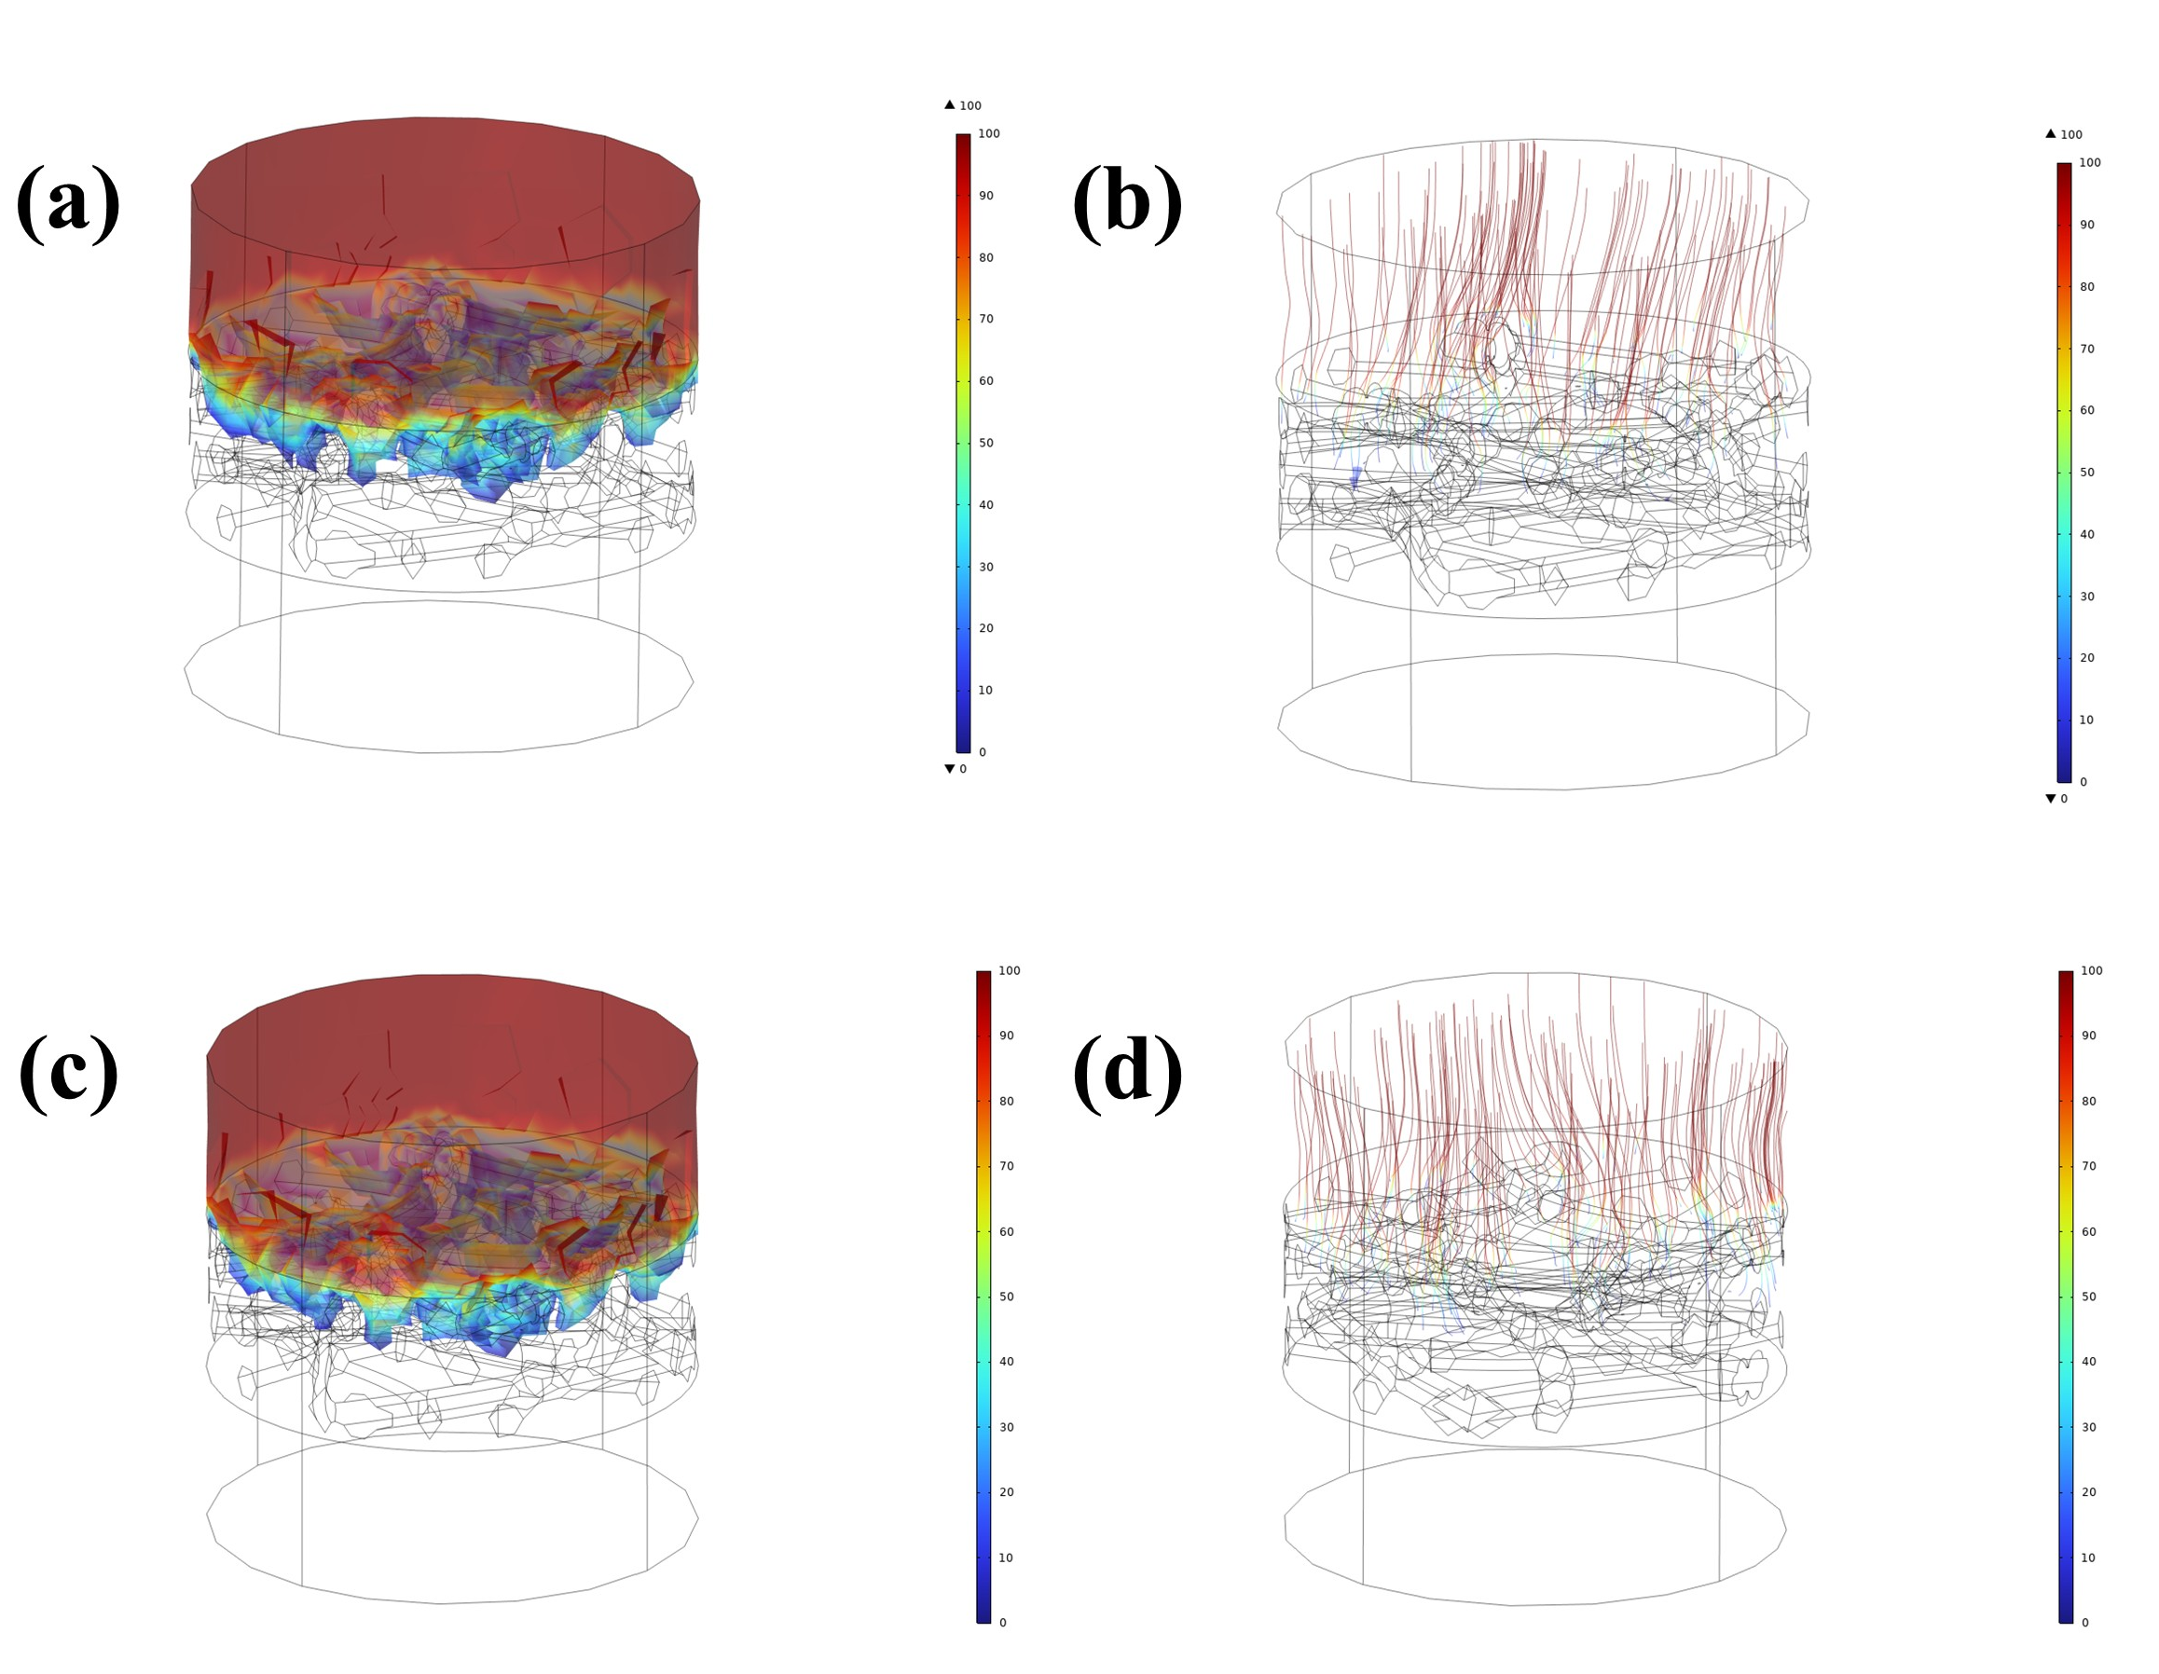
Fig S17. Simulation results (a) Concentration distribution of the water phase (DCM/water). (b) Motion trajectory of the water phase (DCM/water). (c) Concentration distribution of the water phase (n-hexane/water mixture). (d) Motion trajectory of the water phase (n-hexane/water).

Governing equations:
The oil-water biphasic flow is described by the Navier-Stokes equations.
Continuity equation (mass conservation for incompressible flow):
$∇_{\vec{U}}=0$ (1)
where u = (u,v,w) is the velocity vector in Cartesian coordinates.
Momentum equation:
$ρ\frac{D\vec{u}}{Dt}=-∇p+μ∇^{2}\vec{u}+F$ (2)
where:
ρ = fluid density
D/Dt = material derivative
p = pressure
μ = dynamic viscosity
F = body force
The x-direction component is as follows:
$ρ\left(\frac{∂u}{∂t}+u\frac{∂u}{∂x}+v\frac{∂u}{∂y}+w\frac{∂u}{∂z}\right)=-\frac{∂p}{∂x}+μ\left(\frac{∂^{2}u}{∂x^{2}}+\frac{∂^{2}u}{∂y^{2}}+\frac{∂^{2}u}{∂z^{2}}\right)+F_{X}$ (3)
(y/z-direction components follow analogous forms)
Note: Phase-specific properties (ρₒᵢₗ, μₒᵢₗ ≠ ρᵥₐᵢᵣ, μᵥₐᵢᵣ) are assigned accordingly.
Spatial discretization:
Unstructured tetrahedral meshing (Fig S14b) adapts to complex geometries, thereby enhancing the boundary layer resolution.
Solver:
The finite element method (FEM) resolves near-wall flows and interfacial dynamics with second-order accuracy.
Boundary Conditions:
The pressure boundary conditions are illustrated in Fig S9c
Inlet: Volume fractions αₒᵢₗ = 0.X, αᵥₐᵢᵣ = 1-0.X
Outlet: Atmospheric pressure (Pᵣₑ𝒻 = 101325Pa)
Walls: No-slip condition (u = 0)
Solution Scheme:
Initialization: Phase fraction distribution
Iteration: Newton-Raphson method with convergence criteria:
‖ϕⁿ⁺¹ - ϕⁿ‖/‖ϕⁿ‖ < 10⁻⁵

