Health-Related Quality of Life in Patients with Psoriasis in Asian Countries: A Systematic Review and Meta-Analysis of EQ-5D Utility Scores

Harshavardhan K¹, Priyankaa V¹, Hariharan Murugadoss¹, Lavanya Ayyasamy², and Madhumitha Haridoss*².
¹Department of Pharmacy practice, SRM College of Pharmacy, Faculty of Medicine and Health Sciences , SRM Institute of Science and Technology, Kattankulathur, Chengalpattu, Tamilnadu, India
²Division of Medical Research, SRM Medical College Hospital and Research Centre, Faculty of Medicine and Health Sciences, SRM Institute of Science and Technology, Kattankulathur, Chengalpattu, Tamilnadu, India
*Corresponding author:
H. Madhumitha PhD
Assistant Professor (Research)
Division of Medical Research,
SRM Medical College Hospital and Research Centre,
Faculty of Medicine and Health Sciences ,
SRM Institute of Science and Technology,
Kattankulathur,
Chengalpattu, Tamilnadu, India
Email: madhumih@srmist.edu.in

Supplementary Material

Supplementary Appendix
Supplementary Table 1: Search strategy – PubMed
Supplementary Table 2: Search strategy – Scopus
Supplementary Table 3: Search strategy – Embase
Supplementary Table 4: Search strategy – Cochrane Library
Supplementary Table 5: Search strategy – Google Scholar
Supplementary Table 6: Reasons for exclusion of studies after full-text screening
Supplementary Figure 1: Risk of Bias assessment of included cross-sectional studies using the AXIS tool
Supplementary Figure 2: Risk of Bias assessment of included cohort studies using the Newcastle–Ottawa Scale (NOS)
Supplementary Figure 3: Risk of Bias assessment of the included randomized controlled trial using the RoB-2 tool

Supplementary Figure 4: Subgroup analysis of pooled EQ-5D mean scores by ethnicity among patients with psoriasis
Supplementary Figure 5: Subgroup analysis of pooled EQ-5D mean scores by psoriasis type
Supplementary Figure 6: Subgroup analysis of pooled EQ-5D VAS mean scores by country
Supplementary Figure 7: Subgroup analysis of pooled EQ-5D VAS mean scores by psoriasis type
Supplementary Figure 8: Sensitivity (leave-one-out) analysis for pooled EQ-5D index utility estimates
Supplementary Figure 9: Sensitivity (leave-one-out) analysis for pooled EQ-5D VAS estimates
Supplementary Figure 10: Funnel plot assessing publication bias for pooled EQ-5D index mean scores
Supplementary Figure 11: Bubble plot showing the relationship between mean age and EQ-5D utility values
Supplementary Figure 12: Bubble plot showing the relationship between disease duration and EQ-5D utility values
Supplementary Figure 13: Separate analysis of pooled EQ-5D mean scores by disease severity (moderate-to-severe psoriasis)
Supplementary Figure 14: Separate analysis of pooled EQ-5D VAS mean scores by disease severity (moderate-to-severe psoriasis)
Supplementary Figure 15: Forest plot of pooled proportion of patients reporting mobility problems
Supplementary Figure 16: Forest plot of pooled proportion of patients reporting self-care problems
Supplementary Figure 17: Forest plot of pooled proportion of patients reporting usual activities problems
Supplementary Figure 18: Forest plot of pooled proportion of patients reporting pain/discomfort problems
Supplementary Figure 19: Forest plot of pooled proportion of patients reporting anxiety/depression problems

Supplementary table 1: Search strategy- Pubmed

Framework | Search Terms | On 22/06/2025
P-Population | ((((Asia OR Asian OR "Afghanistan" OR "Armenia" OR "Azerbaijan" OR "Bahrain" OR "Bangladesh" OR "Bhutan" OR "Brunei" OR "Cambodia" OR "China" OR "Cyprus" OR "Georgia" OR "India" OR "Indonesia" OR "Iran" OR "Iraq" OR "Israel" OR "Japan" OR "Jordan" OR "Kazakhstan" OR "Kuwait" OR "Kyrgyzstan" OR "Laos" OR "Lebanon" OR "Malaysia" OR "Maldives" OR "Mongolia" OR "Myanmar" OR "Nepal" OR "North Korea" OR "Oman" OR "Pakistan" OR "Palestine" OR "Philippines" OR "Qatar" OR "Saudi Arabia" OR "Singapore" OR "South Korea" OR "Sri Lanka" OR "Syria" OR "Taiwan" OR "Tajikistan" OR "Thailand" OR "Timor-Leste" OR "Turkey" OR "Turkmenistan" OR "United Arab Emirates" OR "Uzbekistan" OR "Vietnam" OR "Yemen")) OR (("Asia"[Mesh] OR "Asia, Central"[Mesh] OR "Asia, Eastern"[Mesh] OR "Asia, Southeastern"[Mesh] OR "Asia, Western"[Mesh] OR "Middle East"[Mesh]))) OR (("Afghanistan"[Mesh] OR "Armenia"[Mesh] OR "Azerbaijan"[Mesh] OR "Bahrain"[Mesh] OR "Bangladesh"[Mesh] OR "Bhutan"[Mesh] OR "Brunei"[Mesh] OR "Cambodia"[Mesh] OR "China"[Mesh] OR "Cyprus"[Mesh] OR "Georgia (Republic)"[Mesh] OR "India"[Mesh] OR "Indonesia"[Mesh] OR "Iran"[Mesh] OR "Iraq"[Mesh] OR "Israel"[Mesh] OR "Japan"[Mesh] OR "Jordan"[Mesh] OR "Kazakhstan"[Mesh] OR "Kuwait"[Mesh] OR "Kyrgyzstan"[Mesh] OR "Laos"[Mesh] OR "Lebanon"[Mesh] OR "Malaysia"[Mesh] OR "Maldives"[Mesh] OR "Mongolia"[Mesh] OR "Myanmar"[Mesh] OR "Nepal"[Mesh] OR "Oman"[Mesh] OR "Pakistan"[Mesh] OR "Philippines"[Mesh] OR "Qatar"[Mesh] OR "Saudi Arabia"[Mesh] OR "Singapore"[Mesh] OR "Sri Lanka"[Mesh] OR "Syria"[Mesh] OR "Taiwan"[Mesh] OR "Tajikistan"[Mesh] OR "Thailand"[Mesh] OR "Timor-Leste"[Mesh] OR "Turkey"[Mesh] OR "Turkmenistan"[Mesh] OR "United Arab Emirates"[Mesh] OR "Uzbekistan"[Mesh] OR "Vietnam"[Mesh] OR "Yemen"[Mesh]))) | 8,611,222
I-Intervention OR Exposure | psoria* OR (("Psoriasis"[Mesh]) OR "Arthritis, Psoriatic"[Mesh]) | 75,464
C-Comparator
O-Outcome | (EQ-5D OR EQ5D OR (EQ 5-Dimension) OR (“EQ 5D”) OR Euroqol OR utilit* OR HRQoL OR (Health-related quality of life)) | 948,348
P AND I AND C AND O |  | 1,383
Filter | (((Review[Title]) OR ("systematic review"[Title/Abstract])) OR (Metaanalysis[Title/Abstract])) OR (Meta-analysis[Title/Abstract]) | 1,233

Supplementary table 2: Search strategy- Scopus

Framework | Search Terms | Search Hits as on 22/06/2025
P-Population | (Asia OR Asian OR "Afghanistan" OR "Armenia" OR "Azerbaijan" OR "Bahrain" OR "Bangladesh" OR "Bhutan" OR "Brunei" OR "Cambodia" OR "China" OR "Cyprus" OR "Georgia" OR "India" OR "Indonesia" OR "Iran" OR "Iraq" OR "Israel" OR "Japan" OR "Jordan" OR "Kazakhstan" OR "Kuwait" OR "Kyrgyzstan" OR "Laos" OR "Lebanon" OR "Malaysia" OR "Maldives" OR "Mongolia" OR "Myanmar" OR "Nepal" OR "North Korea" OR "Oman" OR "Pakistan" OR "Palestine" OR "Philippines" OR "Qatar" OR "Saudi Arabia" OR "Singapore" OR "South Korea" OR "Sri Lanka" OR "Syria" OR "Taiwan" OR "Tajikistan" OR "Thailand" OR "Timor-Leste" OR "Turkey" OR "Turkmenistan" OR "United Arab Emirates" OR "Uzbekistan" OR "Vietnam" OR "Yemen") | 5,528,419
I-Intervention | psoria* | 114,684
C-Comparator
O-Outcome | EQ-5D OR (EQ 5-Dimension) OR “EQ 5D” OR EQ5D OR Euroqol OR utilit* OR HRQoL OR (Health-related quality of life) | 2,995,680
P AND I AND C AND O |  | 531
 | ( ALL ( ( asia OR asian OR "Afghanistan" OR "Armenia" OR "Azerbaijan" OR "Bahrain" OR "Bangladesh" OR "Bhutan" OR "Brunei" OR "Cambodia" OR "China" OR "Cyprus" OR "Georgia" OR "India" OR "Indonesia" OR "Iran" OR "Iraq" OR "Israel" OR "Japan" OR "Jordan" OR "Kazakhstan" OR "Kuwait" OR "Kyrgyzstan" OR "Laos" OR "Lebanon" OR "Malaysia" OR "Maldives" OR "Mongolia" OR "Myanmar" OR "Nepal" OR "North Korea" OR "Oman" OR "Pakistan" OR "Palestine" OR "Philippines" OR "Qatar" OR "Saudi Arabia" OR "Singapore" OR "South Korea" OR "Sri Lanka" OR "Syria" OR "Taiwan" OR "Tajikistan" OR "Thailand" OR "Timor-Leste" OR "Turkey" OR "Turkmenistan" OR "United Arab Emirates" OR "Uzbekistan" OR "Vietnam" OR "Yemen" ) ) ) AND ( TITLE-ABS-KEY ( psoria* ) ) AND ( ALL ( eq-5d OR ( eq AND 5-dimension ) OR ( eq AND 5d ) OR eq5d OR euroqol OR utilit* OR hrqol OR ( health-related AND quality AND of AND life ) ) ) AND ( EXCLUDE ( DOCTYPE , "re" ) OR EXCLUDE ( DOCTYPE , "ch" ) OR EXCLUDE ( DOCTYPE , "le" ) OR EXCLUDE ( DOCTYPE , "cp" ) OR EXCLUDE ( DOCTYPE , "ed" ) OR EXCLUDE ( DOCTYPE , "tb" ) OR EXCLUDE ( DOCTYPE , "bk" ) OR EXCLUDE ( DOCTYPE , "er" ) ) | 2,382

Supplementary table 3: Search strategy- Embase

Framework | Search Terms | Search Hits as on 22/06/2025
P-Population | ('asia' OR asia OR asian OR 'afghanistan' OR 'armenia' OR 'azerbaijan' OR 'bahrain' OR 'bangladesh' OR 'bhutan' OR 'brunei' OR 'cambodia' OR 'china' OR 'cyprus' OR 'georgia' OR 'india' OR 'indonesia' OR 'iran' OR 'iraq' OR 'israel' OR 'japan' OR 'jordan' OR 'kazakhstan' OR 'kuwait' OR 'kyrgyzstan' OR 'laos' OR 'lebanon' OR 'malaysia' OR 'maldives' OR 'mongolia' OR 'myanmar' OR 'nepal' OR 'north korea' OR 'oman' OR 'pakistan' OR 'palestine' OR 'philippines' OR 'qatar' OR 'saudi arabia' OR 'singapore' OR 'south korea' OR 'sri lanka' OR 'syria' OR 'taiwan' OR 'tajikistan' OR 'thailand' OR 'timor leste' OR 'turkey' OR 'turkmenistan' OR 'united arab emirates' OR 'uzbekistan' OR 'vietnam' OR 'yemen') | 12,688,831
I-Intervention | psoria* | 144,158
C-Comparator
O-Outcome | EQ-5D OR ‘EQ 5-Dimension’ OR ‘EQ 5D’ OR EQ5D OR Euroqol OR utilit* OR HRQOL OR (Health-related quality of life) | 580,673
P AND I AND C AND O |  | 647

Supplementary table 4: Search strategy- Cochrane Library

Framework | Search Terms | Search Hits as on 22/06/2025
P-Population | (Asia OR Asian OR "Afghanistan" OR "Armenia" OR "Azerbaijan" OR "Bahrain" OR "Bangladesh" OR "Bhutan" OR "Brunei" OR "Cambodia" OR "China" OR "Cyprus" OR "Georgia" OR "India" OR "Indonesia" OR "Iran" OR "Iraq" OR "Israel" OR "Japan" OR "Jordan" OR "Kazakhstan" OR "Kuwait" OR "Kyrgyzstan" OR "Laos" OR "Lebanon" OR "Malaysia" OR "Maldives" OR "Mongolia" OR "Myanmar" OR "Nepal" OR "North Korea" OR "Oman" OR "Pakistan" OR "Palestine" OR "Philippines" OR "Qatar" OR "Saudi Arabia" OR "Singapore" OR "South Korea" OR "Sri Lanka" OR "Syria" OR "Taiwan" OR "Tajikistan" OR "Thailand" OR "Timor-Leste" OR "Turkey" OR "Turkmenistan" OR "United Arab Emirates" OR "Uzbekistan" OR "Vietnam" OR "Yemen") | 695,766
I-Intervention | psoria* | 7,914
C-Comparator
O-Outcome | EQ-5D OR ‘EQ 5-Dimension’ OR ‘EQ 5D’ OR EQ5D OR Euroqol OR utilit* OR HRQOL OR (Health-related quality of life) | 303,271
P AND I AND C AND O |  | 15

Supplementary table 5: Search strategy- Google Scholar

 | Search Terms | Search Hits as on 22/06/2025
With all the words | psoriasis
 | "EQ 5D" OR "EQ OR 5 Dimension" OR EQ 5D OR EQ5D OR Euroqol OR utility OR “health-related quality of life”
P AND I AND C AND O |  | 1650

Supplementary Table 6: Reason for exclusion

S.No | Study label | Study title | Reason for exclusion
1 | Chang, C.W. et al. 2010 | Health-state utilities and willingness to pay and their association with health-related quality of life among patients with psoriasis in Taiwan | Wrong publication type
2 | Noppakun, N et al. 2012 | Subjects with psoriatic arthritis have worse quality of life and greater quality-of-life improvement on Etanercept therapy than subjects with psoriasis alone: The PRISTINE trial | Wrong publication type
3 | Augustin, M. et al. 2012 | Nail assessment in psoriasis and psoriatic arthritis (NAPPA): An integrated approach of outcomes measurement in nail psoriasis | Wrong publication type
4 | Kemeny, L et al. 2013 | Etanercept provides improved quality of life regardless of the presence of psoriatric arthritis in moderate/severe psoriasis subjects from Central and Eastern Europe, Latin America and Asia | Wrong publication type
5 | Zhao, M. et al. 2013 | Validation and comparison of the SF-6d and EQ-5d in chinese patients with moderate to severe psoriasis | Wrong publication type
6 | Wu, J et al. 2013 | Health utility and its affacting factors for patients with psoriasis in china | Wrong publication type
7 | Romiti, R. et al. 2016 | Psoriatic arthritis is associated with a greater economic and humanistic burden among patients with psoriasis: Results from a multinational physician and patient survey | Wrong publication type
8 | Ko et al. 2016 | Health state utility, willingness to pay, and quality of life among Taiwanese patients with psoriasis | Wrong publication type
9 | Mędrek, K. et al. 2016 | Determinants of psoriatic patients' psychosocial well-being-results of the multinational study | Wrong population
10 | Huang et al. 2016 | Health related quality of life and work productivity impairment among patients with moderate to severe psoriasis in Taiwan | Wrong publication type
11 | Frueh, J et al. 2017 | Secukinumab shows high and sustained efficacy in nail psoriasis: Week 80 results from the transfigure study | Wrong publication type
12 | Huang Y.-H. et al. 2017 | Quality-of-life impact of sensitive body areas affected by psoriasis: Results from an epidemiological study of psoriasis in Taiwan | Wrong publication type
13 | Blauvelt A et al. 2017 | Secukinumab is superior to ustekinumab in clearing skin of subjects with moderate-to-severe plaque psoriasis up to 1 year: Results from the CLEAR study. | Wrong population
14 | Conaghan, P.G et al. 2017 | Pain still remains a high unmet need among psoriatic arthritis patients receiving existing biologic treatment: Results from a multi national real-world survey | Wrong publication type
15 | Alten, R. et al. 2017 | Psoriatic arthritis (PSA) patients failing biologic treatment have poor outcomes: Survey results including APAC and middle east | Wrong publication type
16 | Coates LC et al. 2018 | Achieving minimal disease activity in psoriatic arthritis predicts meaningful improvements in patients' health-related quality of life and productivity. | Wrong population
17 | Kavanaugh, A et al. 2018 | Impact of improvement in skin and joint on quality of life in active psoriatic arthritis patients | Wrong publication type
18 | Reich, K et al. 2018 | Secukinumab shows high and sustained efficacy in nail psoriasis: 2.5-year transfigure study results | Wrong publication type
19 | Chiowchanwisawakit, P et al. 2018 | Relationship between health-related quality of life and patient acceptable symptom state with disease activity and functional status in psoriatic arthritis | Wrong publication type
20 | Marzo-Ortega, H et al. 2018 | Efficacy and safety of ixekizumab at week 24 in biologic-experienced patients with active psoriatic arthritis: Summary results | Wrong publication type
21 | Spelman, L et al. 2018 | Continuous treatment with secukinumab 300 mg demonstrates sustained efficacy in clearing skin, and improving patient-reported outcomes in moderate-tosevere plaque-psoriasis: Two-year results from the CLEAR-study | Wrong publication type
22 | Tillett, W et al. 2019 | Relative impact of joint and skin symptoms on quality of life and work productivity in psoriatic arthritis (PSA) patients | Wrong publication type
23 | Osipyants, R et al. 2019 | Association of anxiety, depression with ultrasonographic evaluation of the joints, disease activity, functional disability and quality of life in patients with rheumatic diseases | Wrong publication type
24 | Strand, V et al. 2019 | Assessing the humanistic and economic burden of enthesitis among patients with peripheral and axial spondyloarthritis: Results from a multi-national real world survey database | Wrong publication type
25 | Nguyen SH et al. 2019 | Health-Related Quality of Life Impairment among Patients with Different Skin Diseases in Vietnam: A Cross-Sectional Study. | Wrong outcome
26 | Gladman DD et al. 2019 | Ixekizumab and complete resolution of enthesitis and dactylitis: integrated analysis of two phase 3 randomized trials in psoriatic arthritis. | Wrong population
27 | Tsang HHL et al. 2019 | Psychometric validation of the EuroQoL 5-dimension (EQ-5D) questionnaire in patients with spondyloarthritis. | Wrong population
28 | Okubo Y et al. 2019 | Long-term efficacy and safety of secukinumab in Japanese patients with moderate to severe plaque psoriasis: 3-year results of a double-blind extension study. | Wrong outcome
29 | Kavanaugh A et al. 2019 | The contribution of joint and skin improvements to the health-related quality of life of patients with psoriatic arthritis: a post hoc analysis of two randomised controlled studies. | Wrong population
30 | Strand, V et al. 2020 | Improvement in Patient-Reported Outcomes for Upadacitinib versus Placebo among Patients with Psoriatic Arthritis and an Inadequate Response to Biologic Disease-Modifying Anti-Rheumatic Drugs | Wrong publication type
31 | Chang, J et al. 2020 | PSY2 Evaluating Patient-Reported Outcomes and Work Productivity Among Patients with Psoriasis in Taiwan | Wrong publication type
32 | Sahin Eskara, A et al. 2020 | Changes in PSAID-12 scores before and after biological treatment in patients with psoriatic arthritis | Wrong Outcome
33 | Emmanuel T et al. 2020 | Effect of Dead Sea Climatotherapy on Psoriasis; A Prospective Cohort Study. | Wrong population
34 | Ohata, C et al. 2020 | 14004 Depression and anxiety in patients with psoriasis treated with brodalumab: Real-world patient-reported outcome study | Wrong publication type
35 | Strand, V et al. 2020 | Improvement in Patient-Reported Outcomes in Patients with Psoriatic Arthritis with Inadequate Response to Non-Biologic DMARDs Treated with Upadacitinib versus Placebo or Adalimumab: Results from a Phase 3 Study | Wrong publication type
36 | Augustin M et al. 2020 | Effect of Risankizumab on Patient-Reported Outcomes in Moderate to Severe Psoriasis: The UltIMMa-1 and UltIMMa-2 Randomized Clinical Trials. | Wrong outcome
37 | Bessette, L et al. 2021 | Impact of early pain improvement on patient-reported outcomes in patients with psoriatic arthritis: Results from a phase 3 trial | Wrong publication type
38 | Curtis, J et al. 2021 | Patient characteristics/clinical features associate with health-related quality of life in bio-naïve, active psoriatic arthritis patients through week 24 of DISCOVER-2 | Wrong publication type
39 | Hider, S.L et al. 2021 | A pilot study of a nurse-led integrated care review (the INCLUDE review) for people with inflammatory rheumatological conditions in primary care: feasibility study findings | Wrong outcome
40 | Reich K et al. 2021 | Secukinumab shows high and sustained efficacy in nail psoriasis: 2.5-year results from the randomized placebo-controlled TRANSFIGURE study. | Wrong outcome
41 | Okubo Y et al. 2021 | Sustained efficacy and safety of guselkumab in patients with palmoplantar pustulosis through 1.5 years in a randomized phase 3 study. | No EQ-5D baseline data
42 | Ohata C et al. 2022 | Difference in health-related quality of life between anxiety and depressive symptoms in Japanese patients with plaque psoriasis: the ProLOGUE study. | Wrong publication type
43 | Raghuwanshi, A.S. et al. 2022 | A Cross-Sectional Study to Assess the Psychosocial impact of Skin Diseases | Wrong outcome
44 | Balp, M.M et al. 2022 | PCR209 Burden of Chronic Inducible Urticaria Relative to Psoriasis and Atopic Dermatitis in Five European Countries (France, Germany, Italy, Spain, and United Kingdom) | Wrong publication type
45 | McGonagle, D et al. 2022 | ASSOCIATION OF THE IMPROVEMENT OF SYNOVITIS AND ENTHESITIS WITH QUALITY OF LIFE/PATIENT REPORTED OUTCOMES IN PATIENTS WITH PSORIATIC ARTHRITIS TREATED WITH IXEKIZUMAB | Wrong publication type
46 | Kontodimopoulos N et al. 2022 | A Comparison of EQ-5D-3L, EQ-5D-5L, and SF-6D Utilities of Patients with Musculoskeletal Disorders of Different Severity: A Health-Related Quality of Life Approach. | Wrong population
47 | Miyagi T et al. 2022 | Itch as a critical factor in impaired health-related quality of life in patients with plaque psoriasis achieving clear or almost-clear skin: Analysis of the single-arm, open-label, multicenter, prospective ProLOGUE study. | Wrong outcome
48 | Morita A et al. 2022 | Efficacy and safety of apremilast and phototherapy versus phototherapy only in psoriasis vulgaris. | Wrong outcome
49 | Wongpraparut, C et al. 2023 | CO112 Clinical Characteristics and Quality of Life of Thai Moderate to Severe Psoriasis Patients Before Initiating Secukinumab: An Interim Analysis from Prompt Study | Wrong publication type
50 | Ayan, G et al. 2023 | THE IMPACT OF 6-MONTH DELAY IN DIAGNOSIS ON CLINICAL AND FUNCTIONAL STATUS IN THE PSA PATIENTS UNDER BDMARD TREATMENT: RESULTS FROM TREASURE DATABASE | Wrong publication type
51 | Gossec L et al. 2023 | Improvement in patient-reported outcomes and work productivity following 3-year ustekinumab or tumour necrosis factor inhibitor treatment in patients with psoriatic arthritis: results from the PsABio real-world study. | Wrong population
52 | Ioannides, D et al. 2024 | Real-World Experience of Secukinumab Treatment in Patients with Moderate-to-Severe Plaque Psoriasis in Greece: 3-Year Interim Results of the SERENA Study | Wrong population
53 | López-Medina et al. 2024 | IMPACT of PERIPHERAL MANIFESTATIONS on FUNCTION, HEALTH, and WORK PRODUCTIVITY in PATIENTS with AXIAL SPONDYLOARTHRITIS, PERIPHERAL SPONDYLOARTHRITIS and PSORIATIC ARTHRITIS - DATA from the ASAS-PERSPA STUDY | Wrong publication type
54 | Hide, M et al. 2025 | Prevalence and Burden of Chronic Spontaneous Urticaria in Japan: A Cross-Sectional Study | Wrong population
55 | Kristensen LE et al. 2025 | Synergistic Improvements in Synovitis, Enthesitis, and Patient-Reported Outcomes for Patients with Psoriatic Arthritis Treated with Ixekizumab in SPIRIT Trials. | Wrong population
56 | Jo SJ et al. 2025 | Disease features, treatments, and burden of palmoplantar pustulosis in Korea: The EPPPIK study. | Wrong population
57 | Chang, C.W. et al. 2010 | Health-state utilities and willingness to pay and their association with health-related quality of life among patients with psoriasis in Taiwan | Wrong publication type
58 | Noppakun, N et al. 2012 | Subjects with psoriatic arthritis have worse quality of life and greater quality-of-life improvement on Etanercept therapy than subjects with psoriasis alone: The PRISTINE trial | Wrong publication type

Author | Q1 | Q2 | Q3 | Q4 | Q5 | Q6 | Q7 | Q8 | Q9 | Q10 | Q11 | Q12 | Q13 | Q14 | Q15 | Q16 | Q17 | Q18 | Q19 | Q20
Masaki et al., 2016 |  |  |  |  |  |  |  |  |  |  |  |  |  |  |  |  |  |  | 
Liu L, et al., 2018 |  |  |  |  |  |  |  |  |  |  |  |  |  |  |  |  |  |  |  | 
 |  |  |  |  |  |  |  |  |  |  |  |  |  |  |  |  |  |  | 
Yew YW, et al., 2024 |  |  |  |  |  |  |  |  |  |  | 
Leung YY, et al.,2013 |  | 
Chiowchanwisawakit P, et al., 2019 |  |  |  |  |  |  |  |  |  |  |  |  |  |  |  |  |  |  | 
Li S, et al., 2017 |  |  |  |  |  |  |  |  |  |  |  |  |  |  |  |  |  |  | 
Sawangjit R et al., 2023 |  |  |  |  |  |  |  |  |  |  |  |  |  |  |  |  |  |  |  | 
Chularojanamontri et al., 2023 |  |  |  |  |  |  |  |  |  |  |  |  |  |  |  |  |  | 
T.-F. Tsai et al., 2018 |  |  |  |  |  |  |  |  |  |  |  |  |  |  |  |  |  |  |  | 
C. Yu et al., 2022 |  |  |  |  |  |  |  |  |  |  |  |  |  |  |  |  |  | 
Arora K, et al., 2024
mafuku S, et al., 2021 |  |  | 
Supplementary Figure 01: Risk of Bias assessment of included cross-sectional using the AXIS.

Legend: Figure showing risk of bias in cross-sectional studies where ‘+’ symbol in green indicate YES (*vice versa) and ‘-‘symbol in red indicate NO (*vice versa) whereas ‘?’ in yellow indicate Do not Know
Q1. Were the aims/objectives of the study clear?
Q2. Was the study design appropriate for the stated aim(s)?
Q3. Was the sample size justified?
Q4. Was the target/reference population clearly defined? (Is it clear who the research was about?)
Q5. Was the sample frame taken from an appropriate population base so that it closely represented the target/reference population under investigation?
Q6. Was the selection process likely to select subjects/participants that were representative of the target/reference population under investigation?
Q7. Were measures undertaken to address and categorize non-responders?
Q8. Were the risk factor and outcome variables measured appropriate to the aims of the study?
Q9. Were the risk factor and outcome variables measured correctly using instruments/measurements that had been trialed, piloted or published previously?
Q10. Is it clear what was used to determine statistical significance and/or precision estimates (e.g., p-values, confidence intervals)?
Q11. Were the methods (including statistical methods) sufficiently described to enable them to be repeated?
Q12. Were the basic data adequately described?
Q13. Does the response rate raise concerns about non-response bias?
Q14. If appropriate, was information about non-responders described?
Q15. Were the results internally consistent?
Q16. Were the results presented for all the analyses described in the methods?
Q17. Were the authors’ discussions and conclusions justified by the results?
Q18. Were the limitations of the study discussed?
Q19. Were there any funding sources or conflicts of interest that may affect the authors’ interpretation of the results?
Q20. Was ethical approval or consent of participants attained?

Study | Representativeness | Non-exposed Cohort | Ascertainment of Exposure | Outcome Not Present at Start | Comparability | Outcome Assessment | Follow-Up Duration | Adequacy of Follow-Up | Total Rating
Kim DH, et al., 2023 |  |  |  |  |  |  |  |  | 6/9 Moderate
Supplementary Figure 02: Risk of Bias assessment of included Cohort studies using the NOS.

Study label | Randomization Process | Deviations from Intended Intervention | Missing Outcome Data | Measurement of the Outcome | Selection of the Reported Result | Overall ROB
Yamamoto T, et al., 2020
Supplementary Figure 03: Risk of Bias assessment of included RCT using the RoB-2.


Low risk High risk Some concern

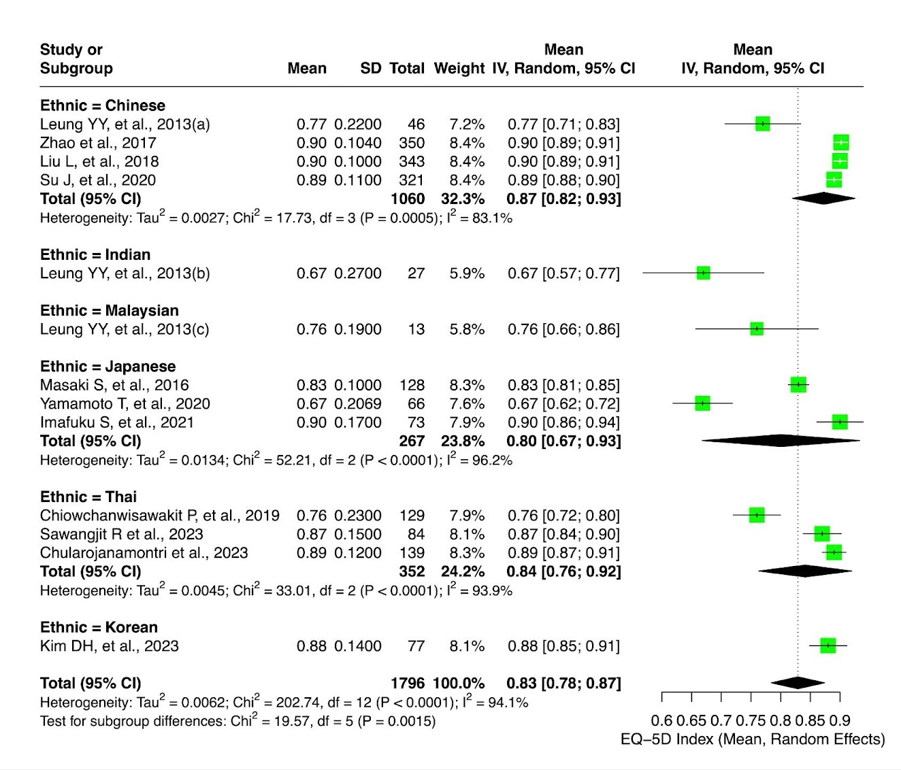
Supplementary Figure 4. Subgroup analysis of pooled EQ-5D mean scores by Ethnicity among people with psoriasis.

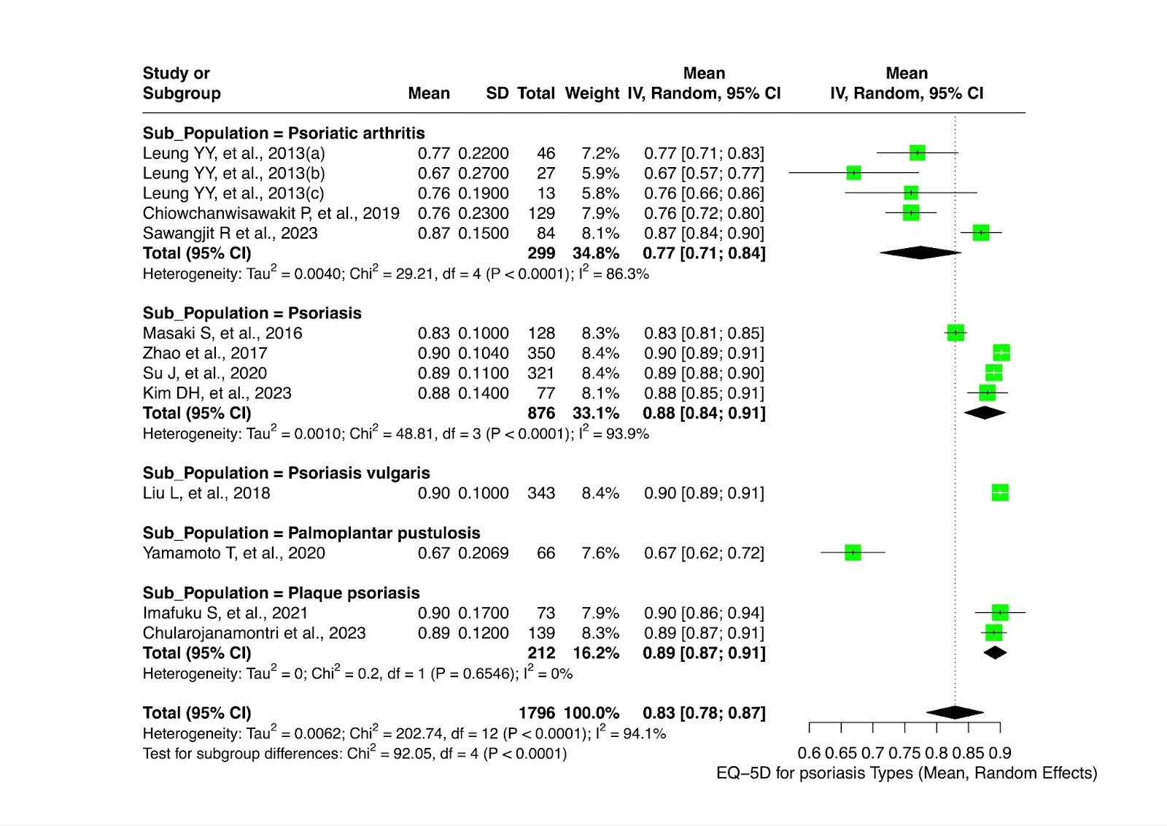
Supplementary Figure 5. Subgroup analysis of pooled EQ-5D mean scores by Psoriasis type among people with psoriasis.
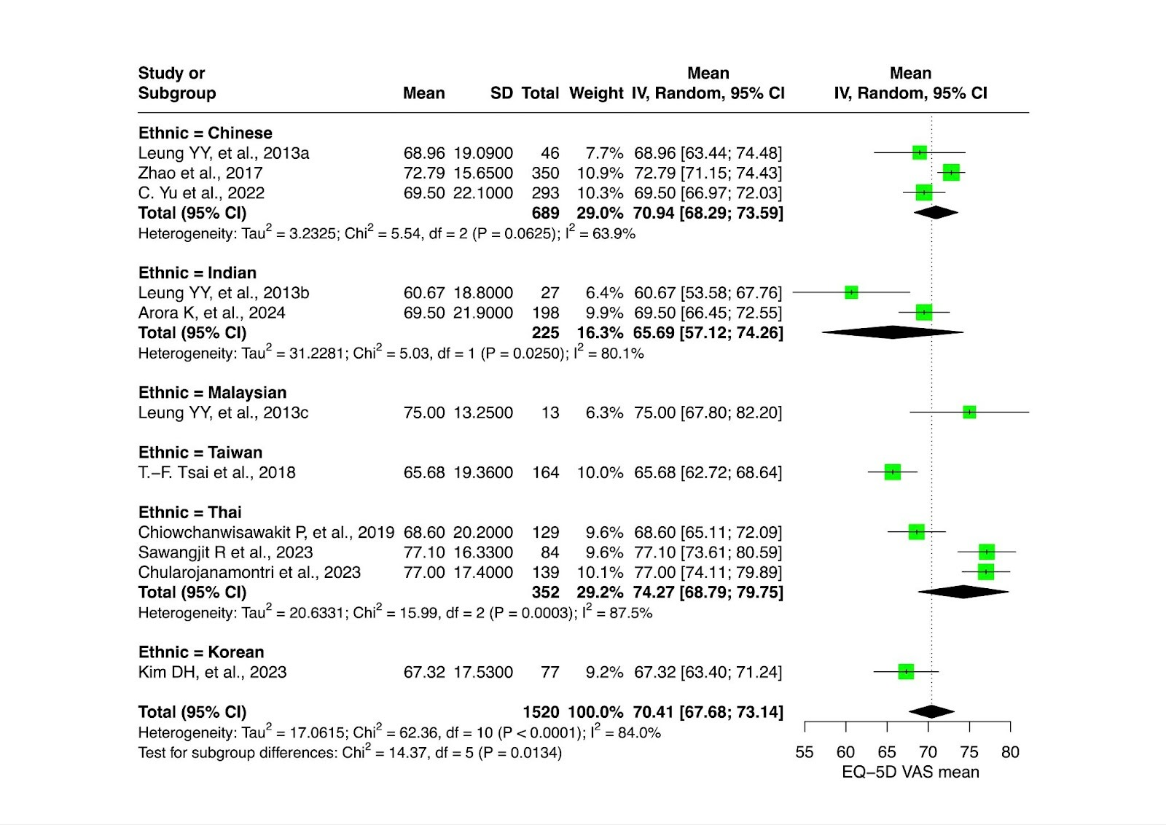
Supplementary Figure 6. Subgroup analysis of pooled EQ-5D VAS mean scores by country among people with psoriasis.

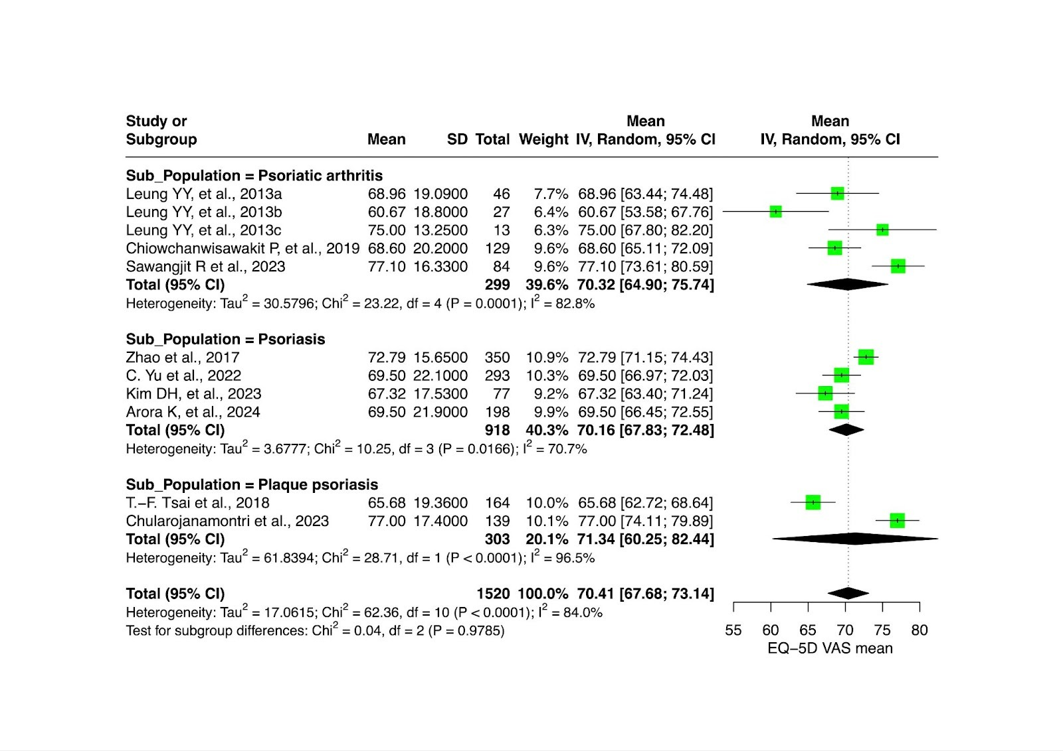
Supplementary Figure 7. Subgroup analysis of pooled EQ-5D VAS mean scores by psoriasis type among people with psoriasis.

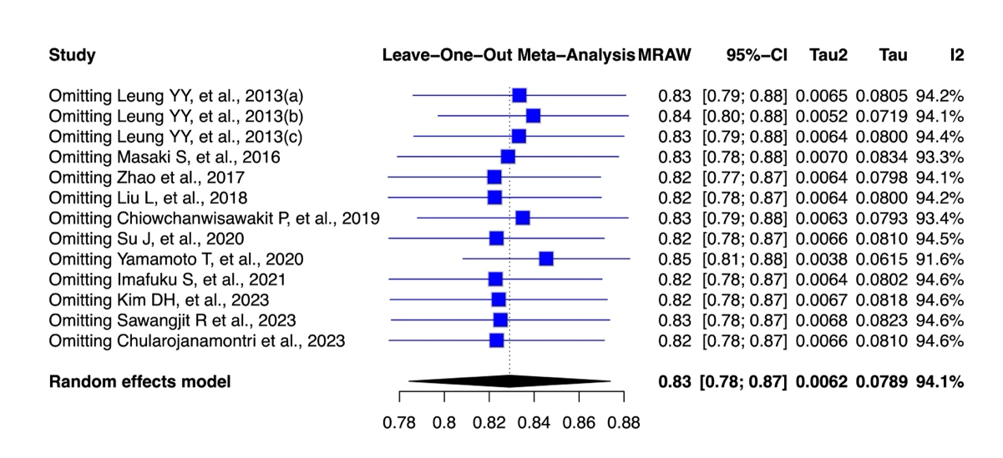
Supplementary Figure 8. Sensitivity analysis for EQ-5D pooled utility estimates

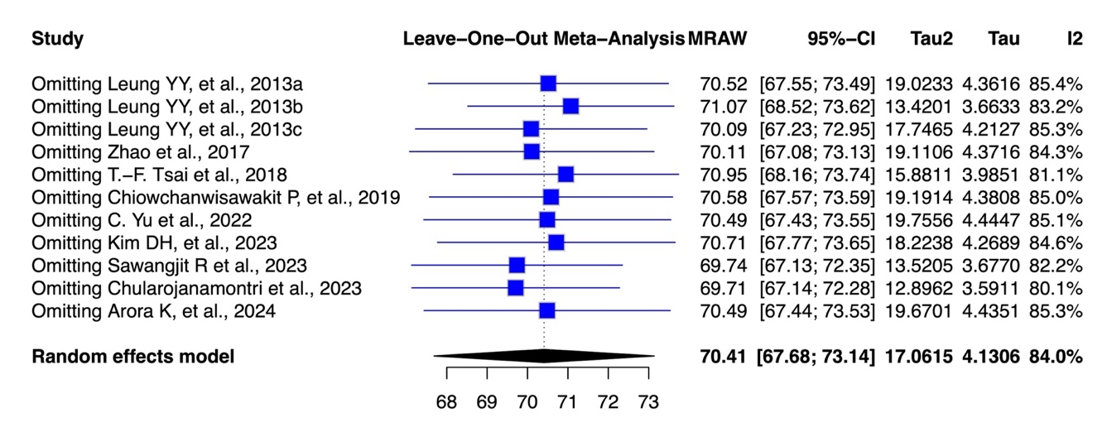
Supplementary Figure 9. Sensitivity analysis for EQ-5D VAS pooled estimates

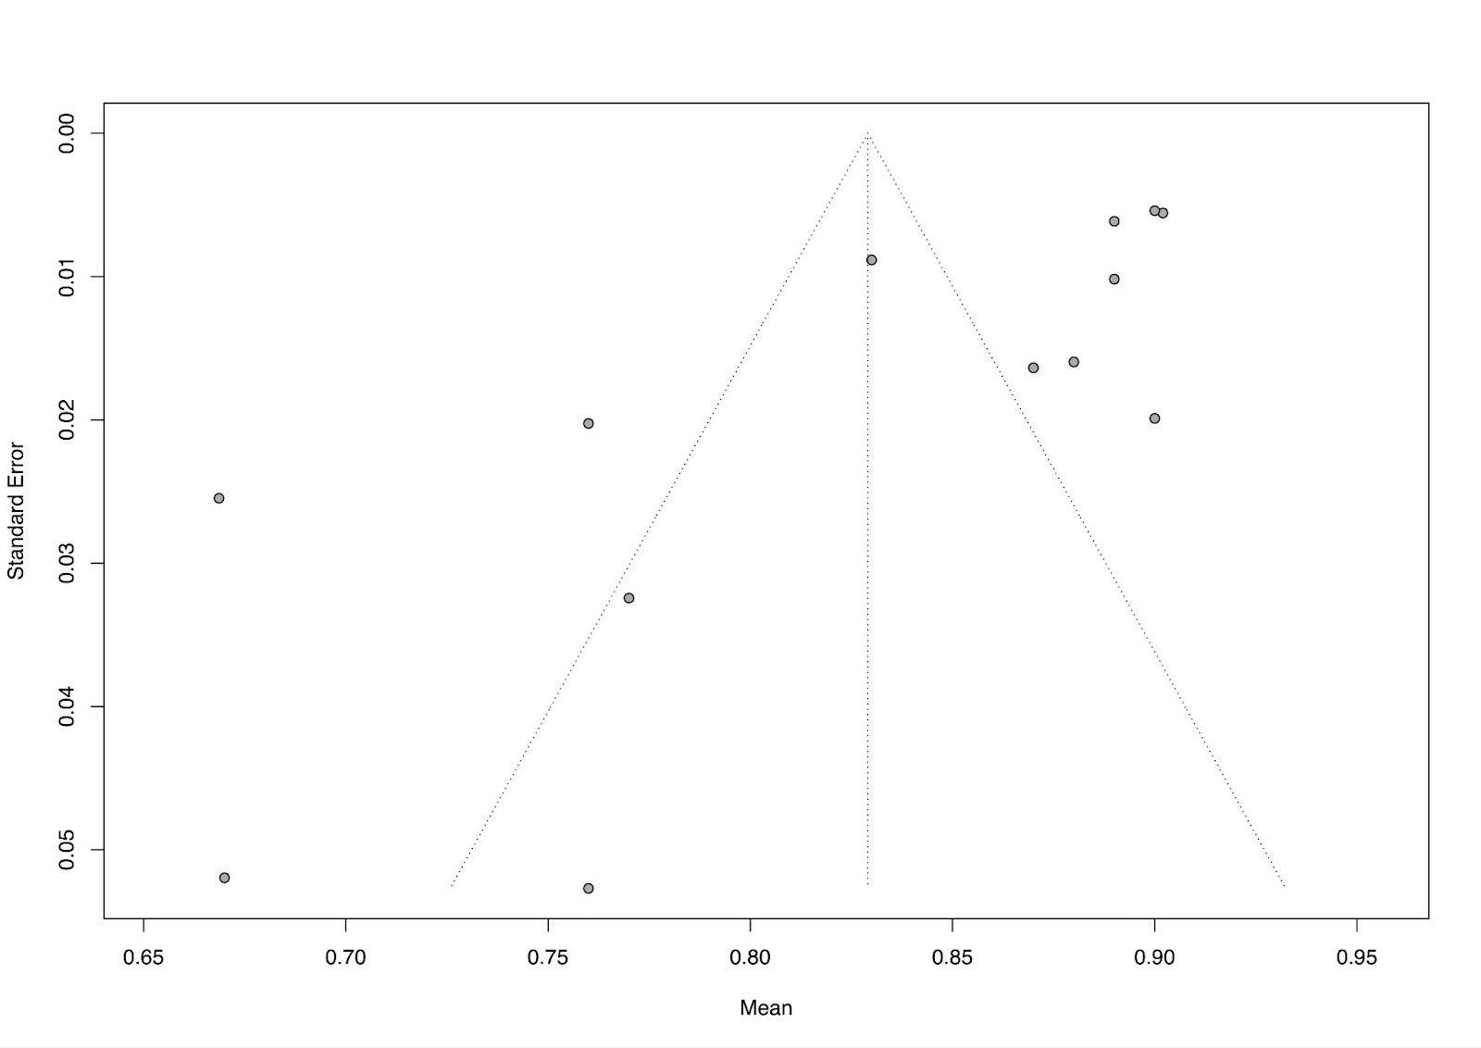
Supplementary Figure 10. Funnel plot assessing publication bias for overall pooled EQ-5D index mean scores people with psoriasis.
`

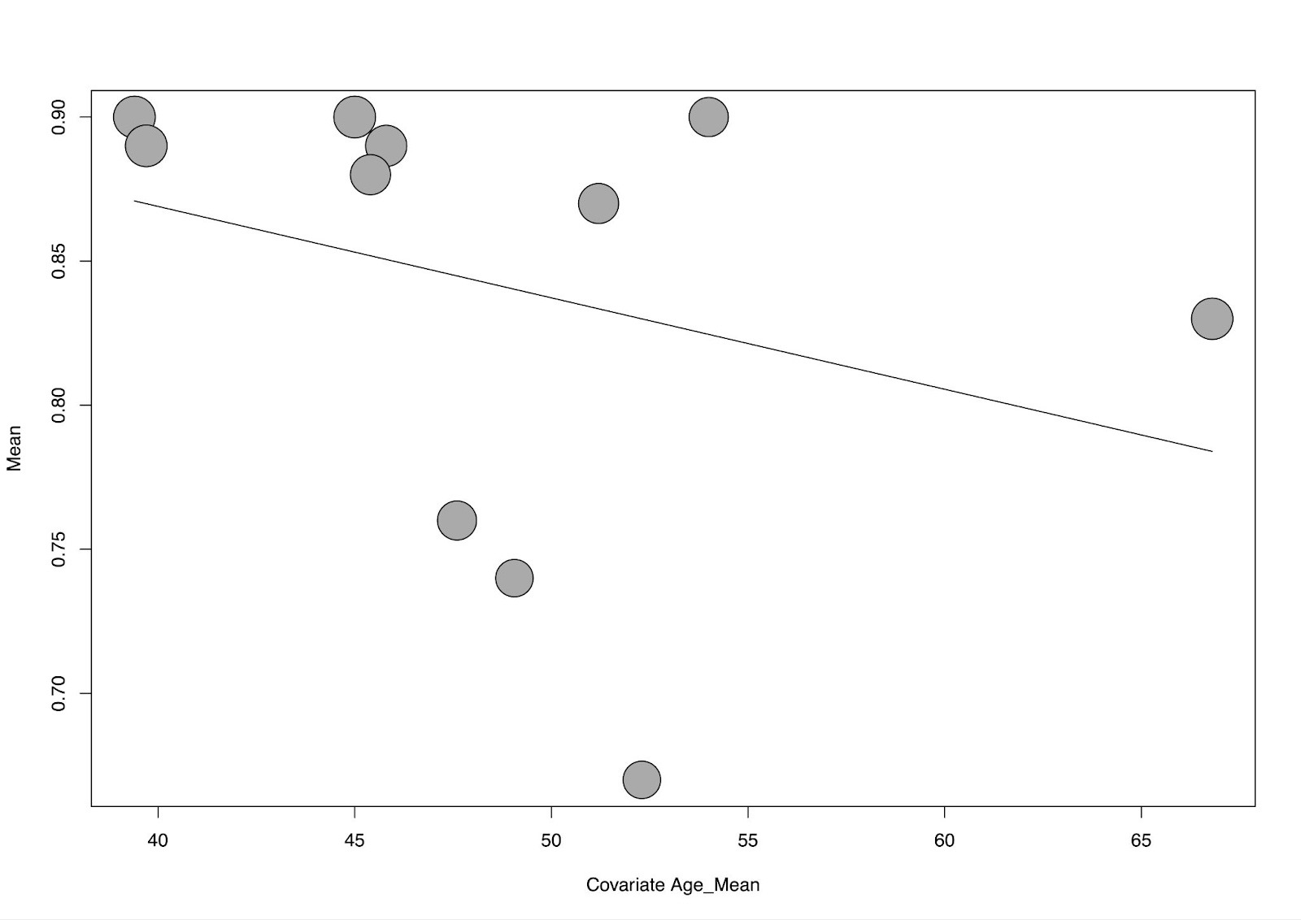
Supplementary Figure 11. Bubble plot showing the regression relation between Age and EQ-5D utility values in people with psoriasis.

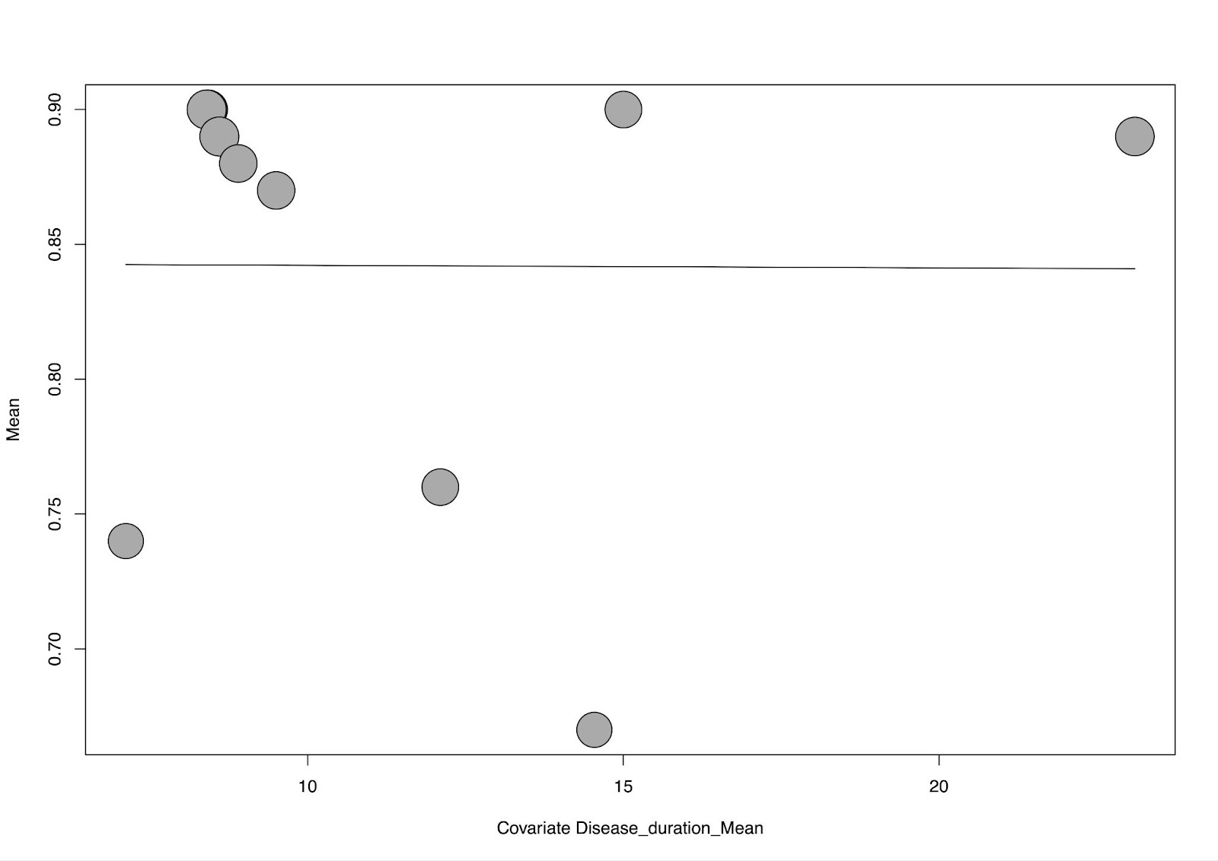
Supplementary Figure 12. Bubble plot showing the regression relation between Disease duration and EQ-5D utility values in people with psoriasis.

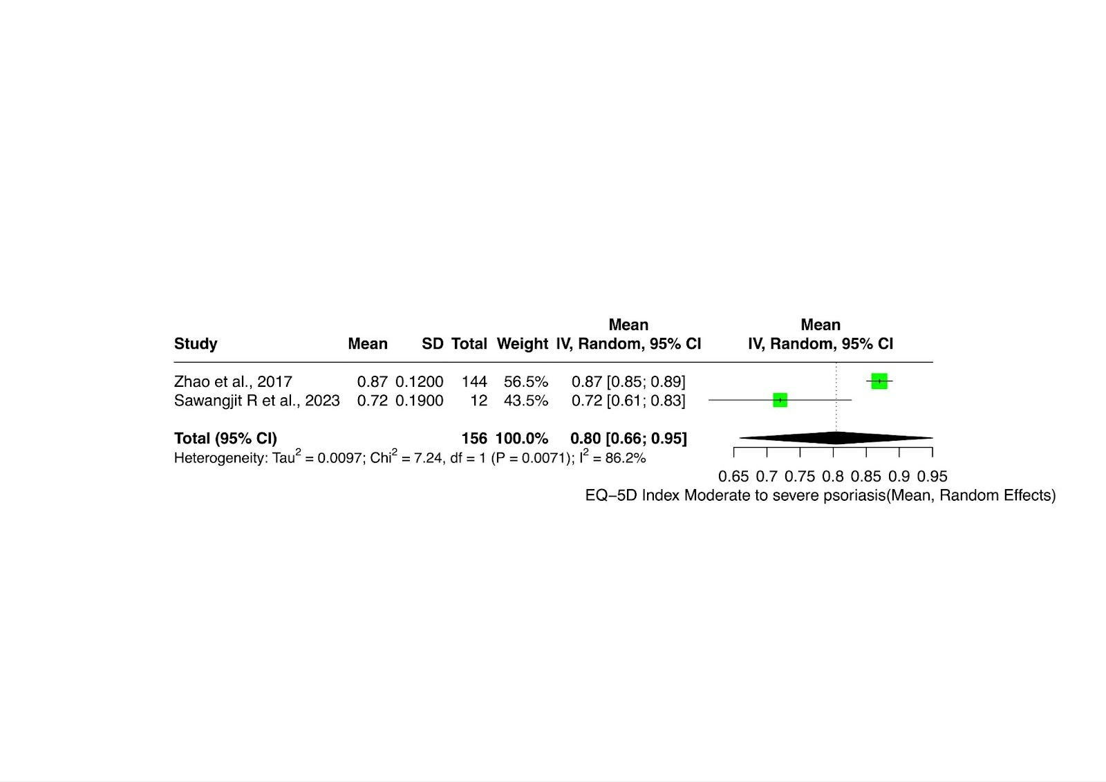
Supplementary Figure 13. Separate analysis of pooled EQ-5D mean scores by Severity (Moderate to severe) among people with psoriasis.

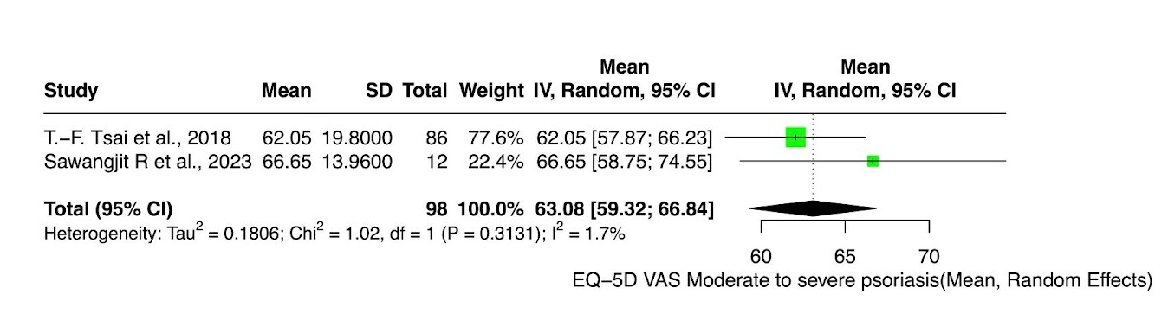
Supplementary Figure 14. Separate analysis of pooled EQ-5D VAS mean scores by Severity (Moderate to severe) among people with psoriasis.

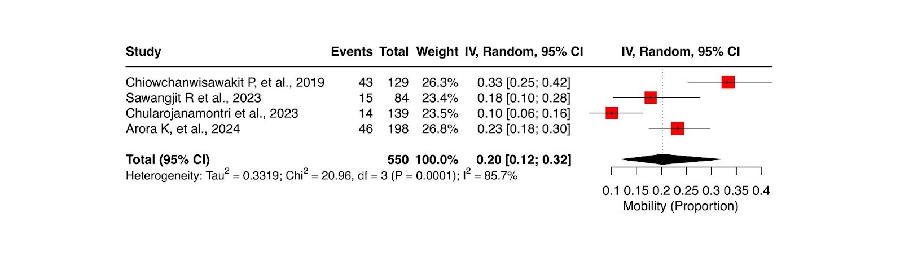
Supplementary Figure 15. Forest plot of pooled proportion of psoriasis patients reporting mobility problems based on EQ-5D across Asian studies.

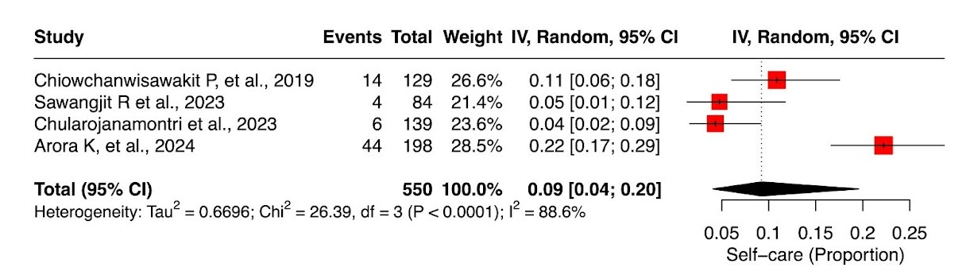
Supplementary Figure 16. Forest plot of pooled proportion of psoriasis patients reporting Self-care problems based on EQ-5D across Asian studies.

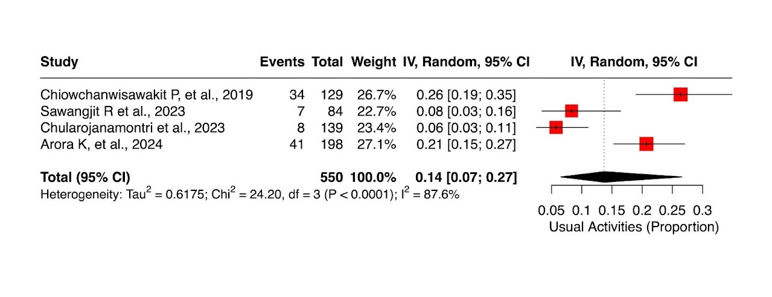
Supplementary Figure 17. Forest plot of pooled proportion of psoriasis patients reporting usual activities problems based on EQ-5D across Asian studies.

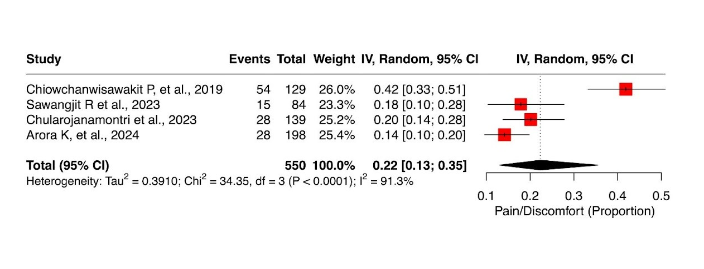
Supplementary Figure 18. Forest plot of pooled proportion of psoriasis patients reporting pain/discomfort problems based on EQ-5D across Asian studies.

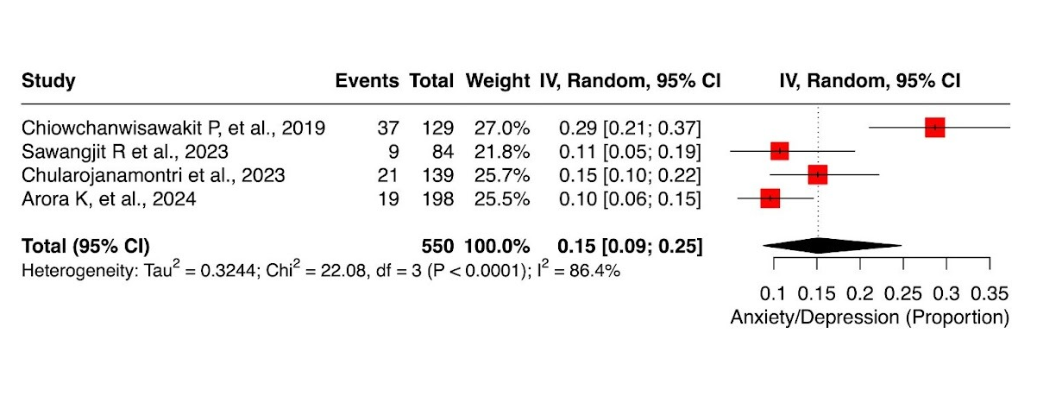
Supplementary Figure 19. Forest plot of pooled proportion of psoriasis patients reporting anxiety/depression problems based on EQ-5D across Asian studies.

