PSMC2 Serves as a Potential Regulatory Target of EZH2 in Promoting Glioma Progression via Epithelial-Mesenchymal Transition
Yufeng Zhu^{1,2}, Xinlong Li^{1,2}, Peng Feng^{1,2}, JunQiang Dai², Juncheng Wang^{1,2}, Guoqiang Yuan^{1,2,3*}, Yawen Pan^{1,2,3,4*}
¹ Lanzhou University, Lanzhou, Gansu 730000, P.R. China;
² The Second Medical College of Lanzhou University, Lanzhou, Gansu 730030, P.R. China;
³ Department of Neurosurgery and Laboratory of Neurosurgery, Lanzhou University Second Hospital, Gansu Province, 730000, China;
⁴Academician Workstation of The Second Hospital & Clinical Medical School, Lanzhou University;
*Corresponding authors:
Guoqiang Yuan: yuangq08@lzu.edu.cn
Yawen Pan: pyw@lzu.edu.cn

Materials and methods
Data sources for bioinformatics analysis
Transcriptomic and clinical data were obtained from three publicly available repositories: the Chinese Glioma Genome Atlas (CGGA) database (http://www.cgga.org.cn) ，The Cancer Genome Atlas (TCGA) database (https://portal.gdc.cancer.gov/). and Gene Expression Omnibus (GEO) database (https://www.ncbi.nlm.nih.gov/geo/). These databases provided a comprehensive dataset for our analysis. The gene expression profiles and corresponding clinical information used in this study were obtained from the CGGA database. A total of 1018 patients were initially included, and 980 samples were ultimately enrolled for further analysis in accordance with the following inclusion and exclusion criteria: samples with definite WHO grade classification, complete overall survival time and survival status were included, while those without clear WHO grade or incomplete survival information were excluded. We conducted correlation analysis using the limma R package and selected a gene set with a correlation coefficient greater than 0.4 and a P-value less than 0.05.
Non-negative matrix factorization (NMF) is a powerful matrix decomposition approach similar to principal component analysis (PCA) and singular value decomposition (SVD), but with a key distinction: all elements in the decomposed matrices are required to be non-negative (i.e., greater than or equal to zero). This seemingly simple constraint endows NMF with unique properties and advantages. The core concept of NMF is to approximately decompose a non-negative data matrix V into the product of two smaller non-negative matrices W and H. Panel A shows the performance of NMF under different decomposition ranks, including six subgraphs that separately display the dynamic changes of six indicators: coherence, dispersion, variability, residual sum of squares (RSS), silhouette coefficient, and sparsity, all of which are associated with the decomposition rank. Each indicator illustrates the performance of different decomposition methods, including the basis vector method, best fit method, coefficient method, and consensus method. Consequently, by employing the NMF algorithm, we constructed two subtypes with independent prognostic significance. WGCNA was utilized to identify gene modules associated with the clustering of high and low PSMC2 expression groups. A scale-free topology criterion was adopted to determine the soft-thresholding power β. The minimum module size was set to 50 genes, and the dynamic tree cut method was employed to identify modules with a Median Rank Dissimilarity Threshold parameter value of 0.25. Additionally, GSEA was performed to evaluate the enrichment of EMT between the high and low PSMC2 expression groups.
Construction of cell lines transiently transfected with siRNA
Two siRNAs targeting PSMC2 (siPSMC2#1 sense sequence: 5’-GCCAGGGAGAUUGGAUAGAAATT-3’, siPSMC2#2 sense sequence: 5’-CAACGUAAAGCAGUUUGCCAATT-3’) and Scramble siRNA (sense sequence: 5’- UUCUCCGAACGUGUCACGUTT-3’) were generated by HanBio (Shanghai, China). Three siRNAs targeting EZH2 (siEZH2#1 sense sequence: 5’-GGAUACAGCCUGUGCACAU-3’, siPSMC2#2 sense sequence: 5’-GGAUGGUACUUUCAUUGAA-3’) and Scramble siRNA (sense sequence: 5’- GCUCUAGACAACAAACCUU-3’) and EZH2 overexpression plasmid were generated by AZENTA (Suzhou, China). According to the growth rate and condition of the cells, they were seeded into 6-well plates at a density of 30-50 ×10^4 cells per well. The cells were incubated for approximately 6 hours to ensure complete adherence prior to siRNA or plasmid transfection. According to the manufacturer’s instructions, the siRNAs or plasmid were transfected into cells using RNAFit or Lipofectamine 3.0 (HanBio HBRG-RF-003; Invitrogen, HBRG-LF3-001). Target gene expression was evaluated by qRT-PCR or immunoblot after 48 h of transfection.
Table S1. List of primers used in this study.
Primers | Sequence (5'-3')
Primers for qRT-PCR
PSMC2 | Forward: GCCAGGGAGATTGGATAGAAA
PSMC2 | Reverse: CAACGTAAAGCAGTTTGCCAA
GAPDH | Forward: GGAGCGAGATCCCTCCAAAAT
GAPDH | Reverse: GGCTGTTGTCATACTTCTCATGG

Table S2. List of antibodies used in this study.
Antibodies | Cat. No | Company | Dilution
PSMC2-WB | 14905-1-AP | Proteintech | 1:2000
PSMC2-IF | DF6736 | Affinity | 1:200
PSMC2-IP | sc-166972 | Santa Cruz | 4-8ug
EZH2-WB | 66476-1-IG | Proteintech | 1:5000
EZH2-IF | 14-9867-82 | ThermoFisher | 1:200
Vimentin-WB/IF | 60330-1-IG | Proteintech | 1:20000
N-Cadherin-WB | 22018-1-AP | Proteintech | 1:5000
E-Cadherin-WB | 20874-1-AP | Proteintech | 1:20000
SNAIL-WB | WLO1863 | Wanleibio | 1:1000
IgG-IP | AB172730 | Abcam | 4-8ug
IgG-IP | 98136-1-RR | Proteintech | 4-8ug
GAPDH-WB | 60004-1-Ig | Proteintech | 1:50000

Table S3. List of antibodies used in this study.
Reagent | Brand | Catalog numbers
DMEM | Keygen Biotech | KGL1211-500
FBS | Sangon | E600001-0500
Puromycin | Solarbio | P8230
CCK-8 | YeaSen | 40203ES60
EDU | Sangon | E607204-0100
Transwell | Corning | CLS3422
Apoptosis | Yeasen | 40302ES
Cell Cycle | Beyotime | C1052
RNA purification kit | Beyotime | R0017M
Reverse Transcription | ABclonal | RK26501
SYBR Green qPCR Mix with UDG | ABclonal | RK21219
BCA | Beyotime | P0010S
10%SDS | Beyotime | ST628
RIPA | Beyotime | P0013B
PVDF | Millipore | IPVH00010
Phalloidin | Biosharp | BL1189A
NP-40 | Beyotime | P0013F

List of the sequence of Full length transcript in this study
PSMC2 Full length transcript(70~ -1371 bp)
a tgccggatta cctcggtgcc gatcagcgga agaccaaaga ggatgagaag
gacgacaagc ccatccgagc tctggatgag ggggatattg ccttgttgaa aacttatggt
cagagcactt actctaggca gatcaagcaa gttgaagatg acattcagca acttctcaag
aaaattaatg agctcactgg tattaaagaa tctgacactg gcctggcccc accagcactc
tgggatttgg ctgcagataa gcagacactc cagagtgaac agcctttaca ggttgccagg
tgtacaaaga taatcaatgc tgattcggag gacccaaaat acattatcaa cgtaaagcag
tttgccaagt ttgtggtgga ccttagtgat caggtggcac ctactgacat tgaagaaggg
atgagagtgg gcgtggatag aaataaatat caaattcaca ttccattgcc tcctaagatt
gacccaacag ttaccatgat gcaggtggaa gagaaacctg atgtcacata cagtgatgtt
ggtggctgta aggaacagat tgagaaactg cgagaagtag ttgaaacccc attacttcat
ccagagaggt ttgtgaacct tggcattgag cctcccaagg gcgtgctgct ctttggtcca
cccggtacag gcaagacact ctgtgcgcgg gcagttgcta atcggactga tgcgtgcttc
attcgagtta ttggatctga gcttgtacag aaatacgtcg gtgagggggc tcgaatggtt
cgtgaactct ttgaaatggc cagaacaaaa aaagcctgcc ttatcttctt tgatgaaatt
gatgctattg gaggggctcg ttttgatgat ggtgctggag gtgacaatga agtgcagaga
acaatgttgg aactgatcaa tcagcttgat ggttttgatc ctagaggcaa tattaaagtg
ctgatggcca ctaacagacc tgatactttg gatccagcac tgatgaggcc agggagattg
gatagaaaaa ttgaatttag cttgcccgat ctagagggtc ggacccacat atttaagatt
cacgctcgtt caatgagtgt tgaaagagat atcagatttg aactgttagc acgactgtgt
ccaaatagca ctggtgctga gattagaagc gtctgcacag aggctggtat gtttgccatc
agagcacggc gaaaaattgc taccgagaag gatttcttgg aagctgtaaa taaggtcatt
aagtcttatg ccaaattcag tgctactcct cgttacatga catacaactg a
EZH2 Full length transcript (136 ~ 2391 bp)
atggg ccagactggg aagaaatctg agaagggacc agtttgttgg
cggaagcgtg taaaatcaga gtacatgcga ctgagacagc tcaagaggtt cagacgagct
gatgaagtaa agagtatgtt tagttccaat cgtcagaaaa ttttggaaag aacggaaatc
ttaaaccaag aatggaaaca gcgaaggata cagcctgtgc acatcctgac ttctgtgagc
tcattgcgcg ggactaggga gtgttcggtg accagtgact tggattttcc aacacaagtc
atcccattaa agactctgaa tgcagttgct tcagtaccca taatgtattc ttggtctccc
ctacagcaga attttatggt ggaagatgaa actgttttac ataacattcc ttatatggga
gatgaagttt tagatcagga tggtactttc attgaagaac taataaaaaa ttatgatggg
aaagtacacg gggatagaga atgtgggttt ataaatgatg aaatttttgt ggagttggtg
aatgcccttg gtcaatataa tgatgatgac gatgatgatg atggagacga tcctgaagaa
agagaagaaa agcagaaaga tctggaggat caccgagatg ataaagaaag ccgcccacct
cggaaatttc cttctgataa aatttttgaa gccatttcct caatgtttcc agataagggc
acagcagaag aactaaagga aaaatataaa gaactcaccg aacagcagct cccaggcgca
cttcctcctg aatgtacccc caacatagat ggaccaaatg ctaaatctgt tcagagagag
caaagcttac actcctttca tacgcttttc tgtaggcgat gttttaaata tgactgcttc
ctacatcgta agtgcaatta ttcttttcat gcaacaccca acacttataa gcggaagaac
acagaaacag ctctagacaa caaaccttgt ggaccacagt gttaccagca tttggaggga
gcaaaggagt ttgctgctgc tctcaccgct gagcggataa agaccccacc aaaacgtcca
ggaggccgca gaagaggacg gcttcccaat aacagtagca ggcccagcac ccccaccatt
aatgtgctgg aatcaaagga tacagacagt gatagggaag cagggactga aacgggggga
gagaacaatg ataaagaaga agaagagaag aaagatgaaa cttcgagctc ctctgaagca
aattctcggt gtcaaacacc aataaagatg aagccaaata ttgaacctcc tgagaatgtg
gagtggagtg gtgctgaagc ctcaatgttt agagtcctca ttggcactta ctatgacaat
ttctgtgcca ttgctaggtt aattgggacc aaaacatgta gacaggtgta tgagtttaga
gtcaaagaat ctagcatcat agctccagct cccgctgagg atgtggatac tcctccaagg
aaaaagaaga ggaaacaccg gttgtgggct gcacactgca gaaagataca gctgaaaaag
gacggctcct ctaaccatgt ttacaactat caaccctgtg atcatccacg gcagccttgt
gacagttcgt gcccttgtgt gatagcacaa aatttttgtg aaaagttttg tcaatgtagt
tcagagtgtc aaaaccgctt tccgggatgc cgctgcaaag cacagtgcaa caccaagcag
tgcccgtgct acctggctgt ccgagagtgt gaccctgacc tctgtcttac ttgtggagcc
gctgaccatt gggacagtaa aaatgtgtcc tgcaagaact gcagtattca gcggggctcc
aaaaagcatc tattgctggc accatctgac gtggcaggct gggggatttt tatcaaagat
cctgtgcaga aaaatgaatt catctcagaa tactgtggag agattatttc tcaagatgaa
gctgacagaa gagggaaagt gtatgataaa tacatgtgca gctttctgtt caacttgaac
aatgattttg tggtggatgc aacccgcaag ggtaacaaaa ttcgttttgc aaatcattcg
gtaaatccaa actgctatgc aaaagttatg atggttaacg gtgatcacag gataggtatt
tttgccaaga gagccatcca gactggcgaa gagctgtttt ttgattacag atacagccag
gctgatgccc tgaagtatgt cggcatcgaa agagaaatgg aaatcccttg a

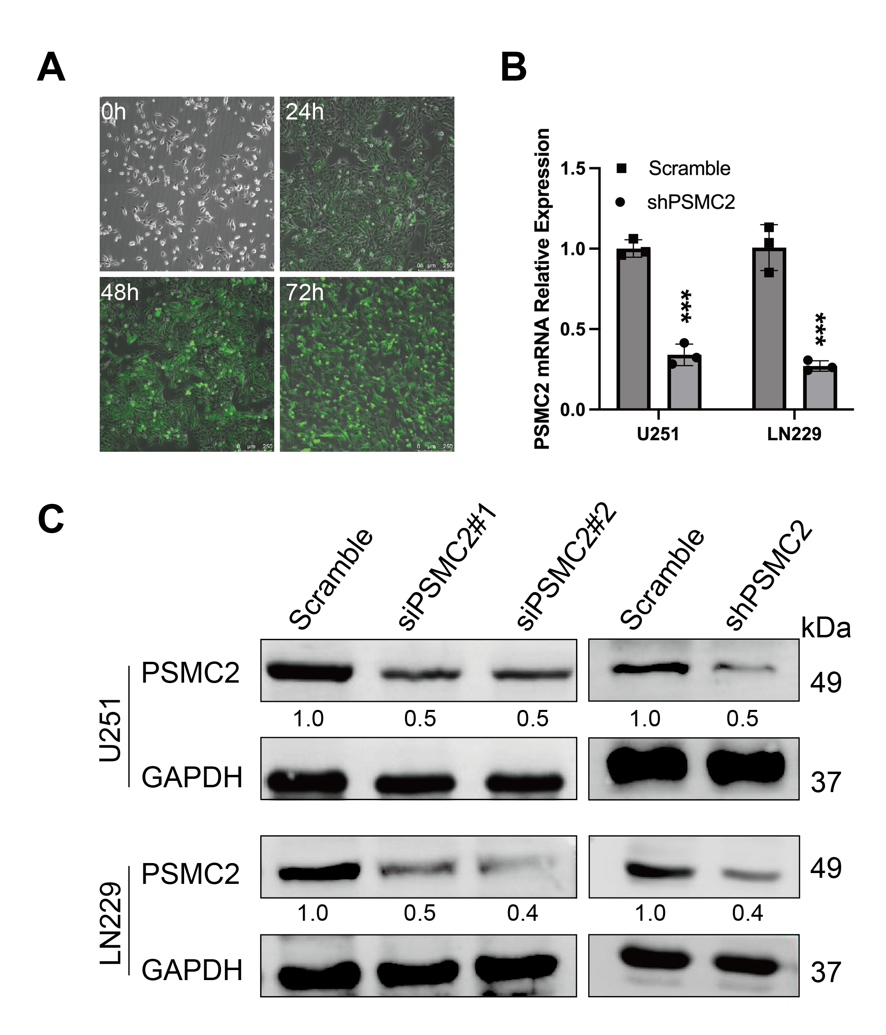
Fig. S1 Construction of siPSMC2 and shPSMC2 cell lines (U251,LN229) and verification of transfection effect. A The fluorescence intensity maps of lentivirus transfection were recorded at different time points (0h, 24h, 48h, 72h). Bar = 250 µm, ****p < 0.0001. B The expression level of PSMC2 mRNA in different cells was detected by RT-qPCR. C The expression of PSMC2 protein was detected by WB.

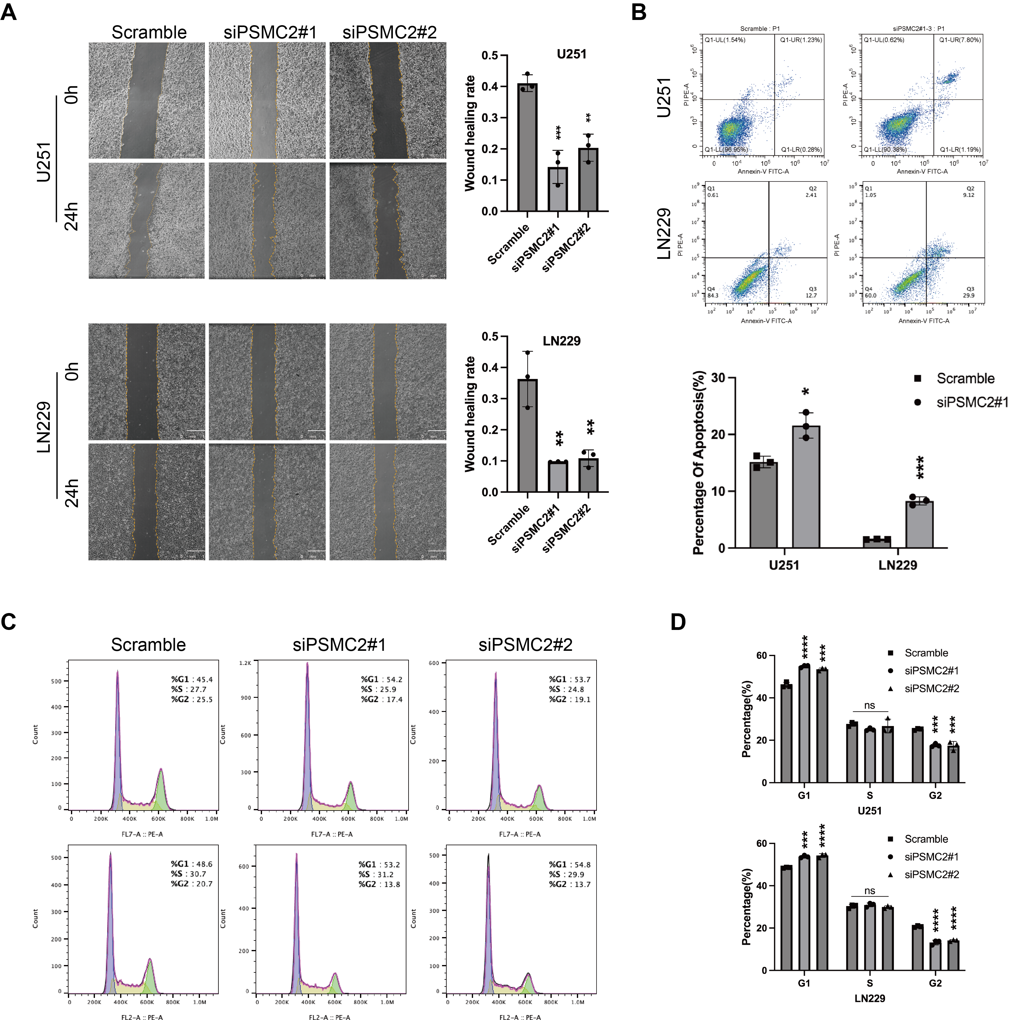
Fig. S2 The effect of PSMC2 knockdown on the motility, apoptosis, and cell cycle of glioma cells (U251, LN229). A Wound healing assay was used to detect the ability of cell migration. B,C,D Flow cytometry analysis was used to detect changes in apoptosis and cell cycle distribution of U251 and LN229 cells before and after PSMC2 knockdown. Bar = 50 µm or 200µm, *p < 0.05, **p < 0.01, ***p < 0.001, ****p < 0.0001.
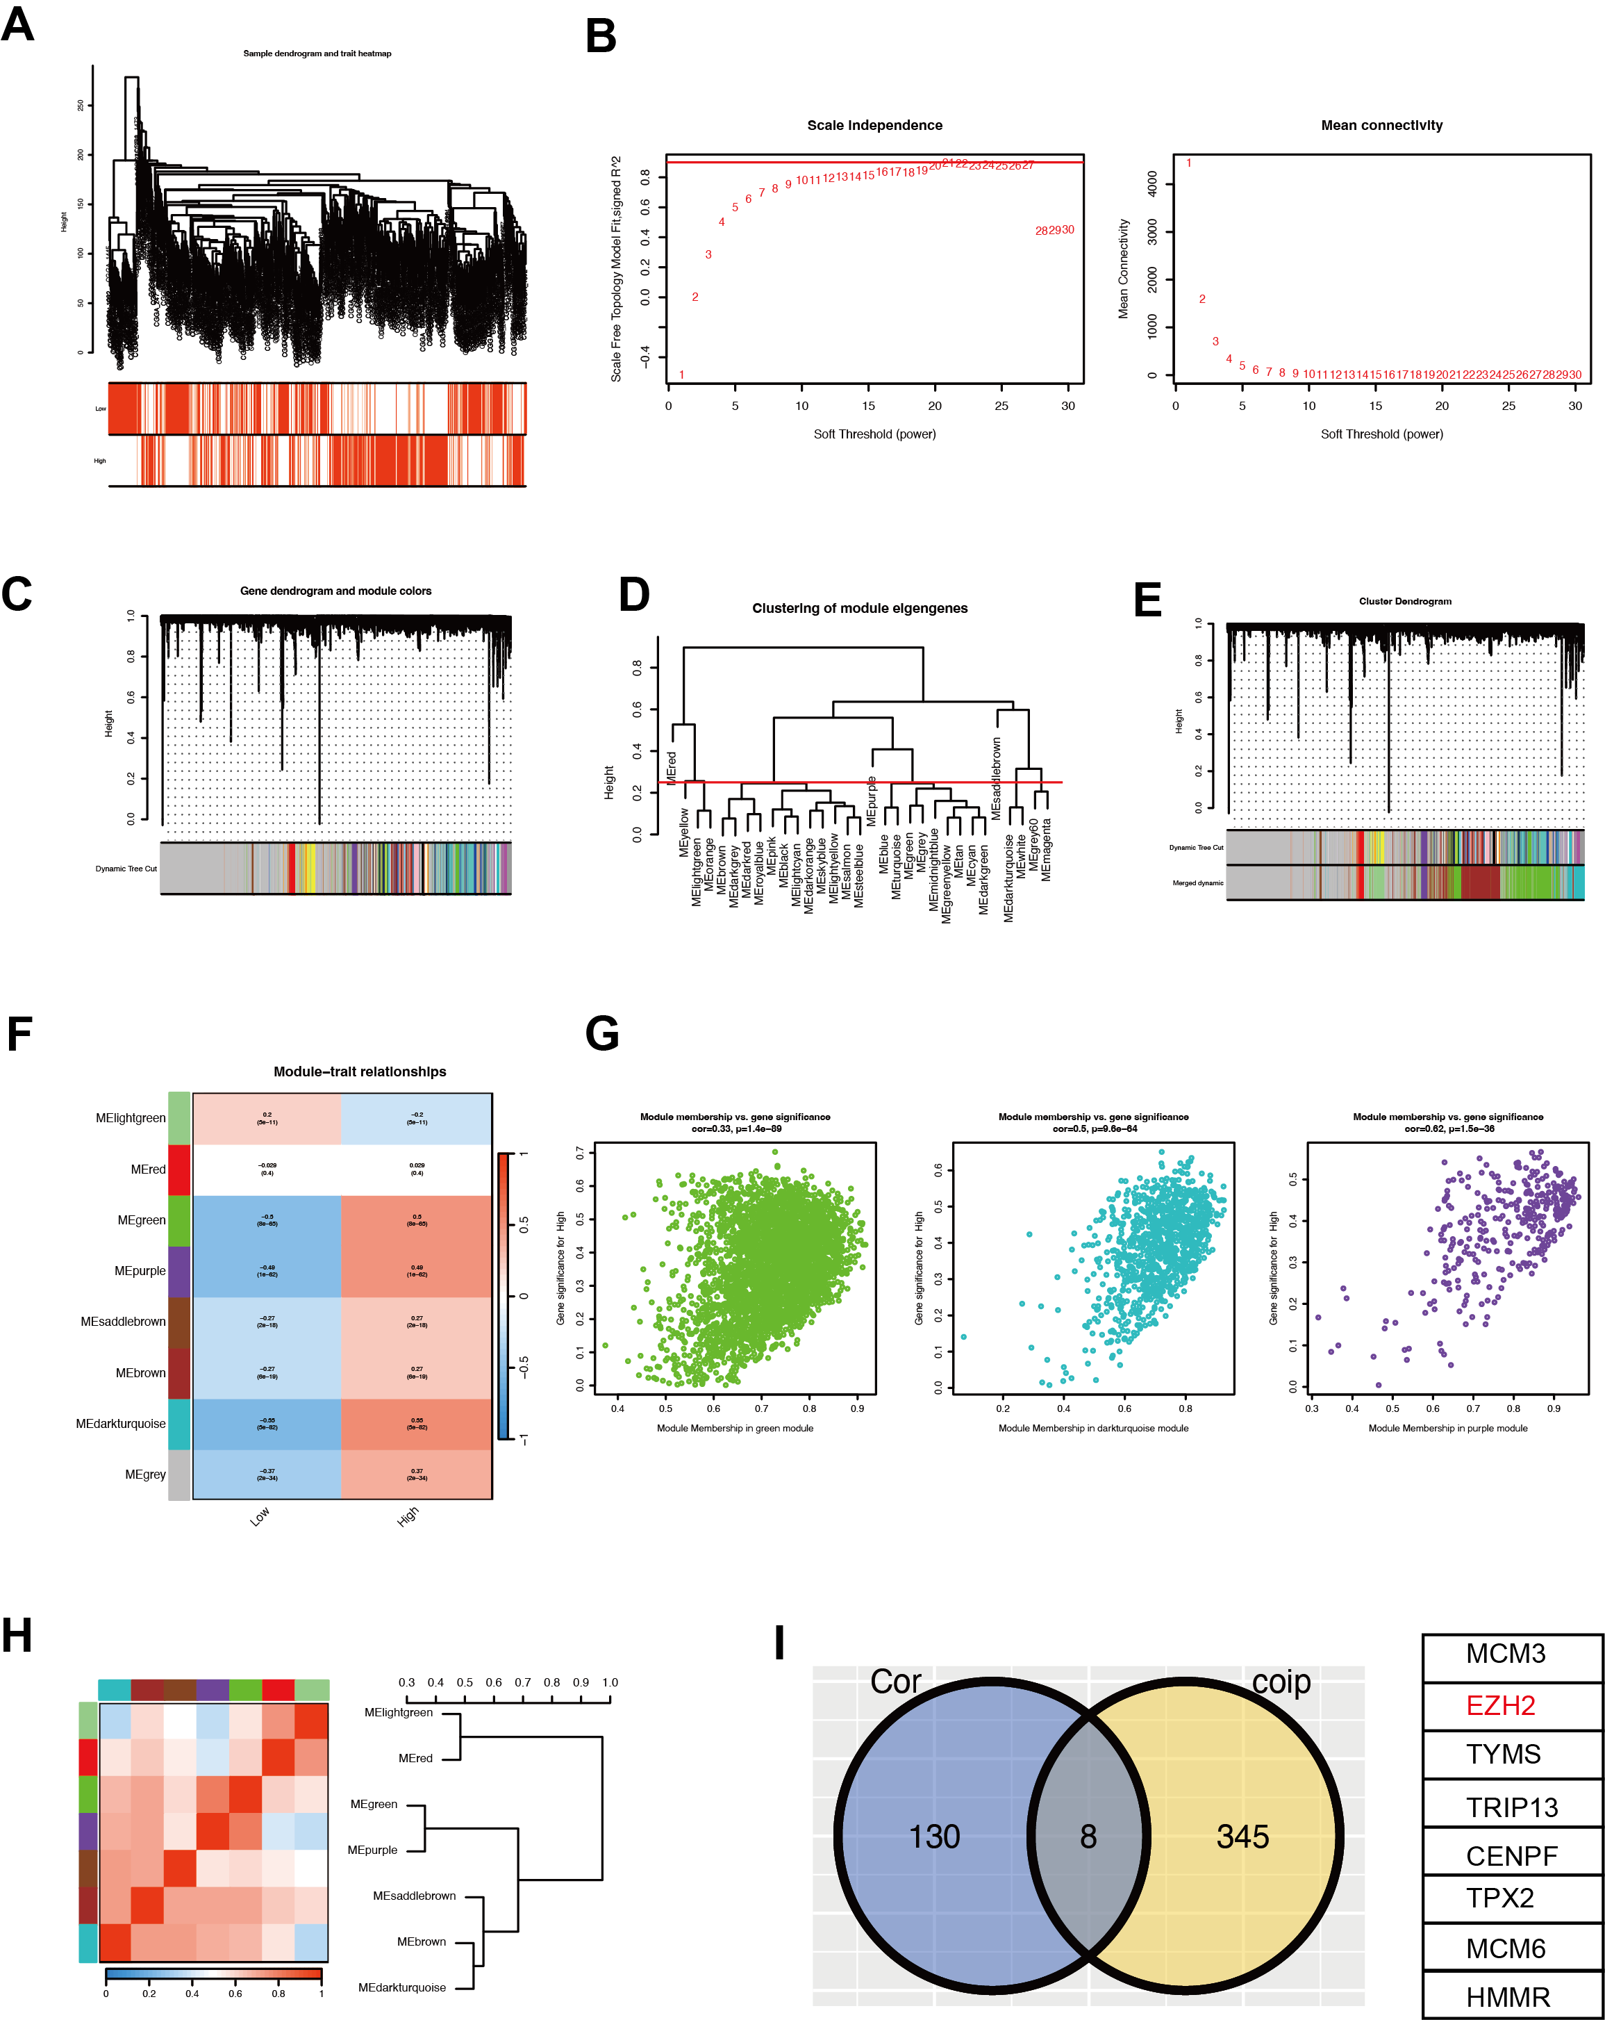
Fig. S3 A WGCNA analysis determined the number of modules in the two clusters. B Determine the irrelevance index of the best rule for the various soft thresholds β. C Gene number map and nodule color. D Hierarchical clustering analysis. E cluster-based gene tree map. F, G, H Modular correlation map of two grouped subgroups. I Intersection of high expression associated gene modules and significantly differentially expressed genes in the PSMC2 protein proteomics.

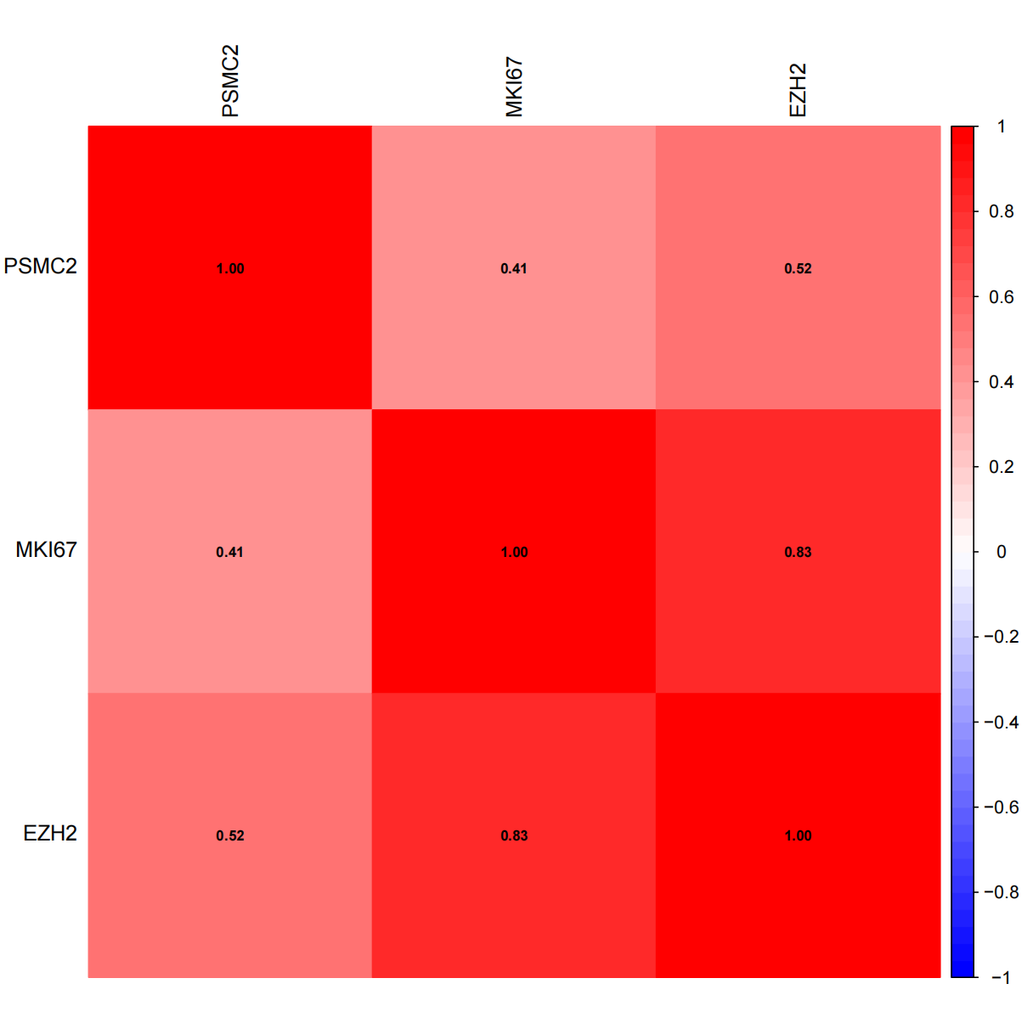
Fig. S4 The mRNA expression levels of PSMC2, EZH2, and Ki67 from the public Chinese Glioma Genome Atlas (CGGA) database.

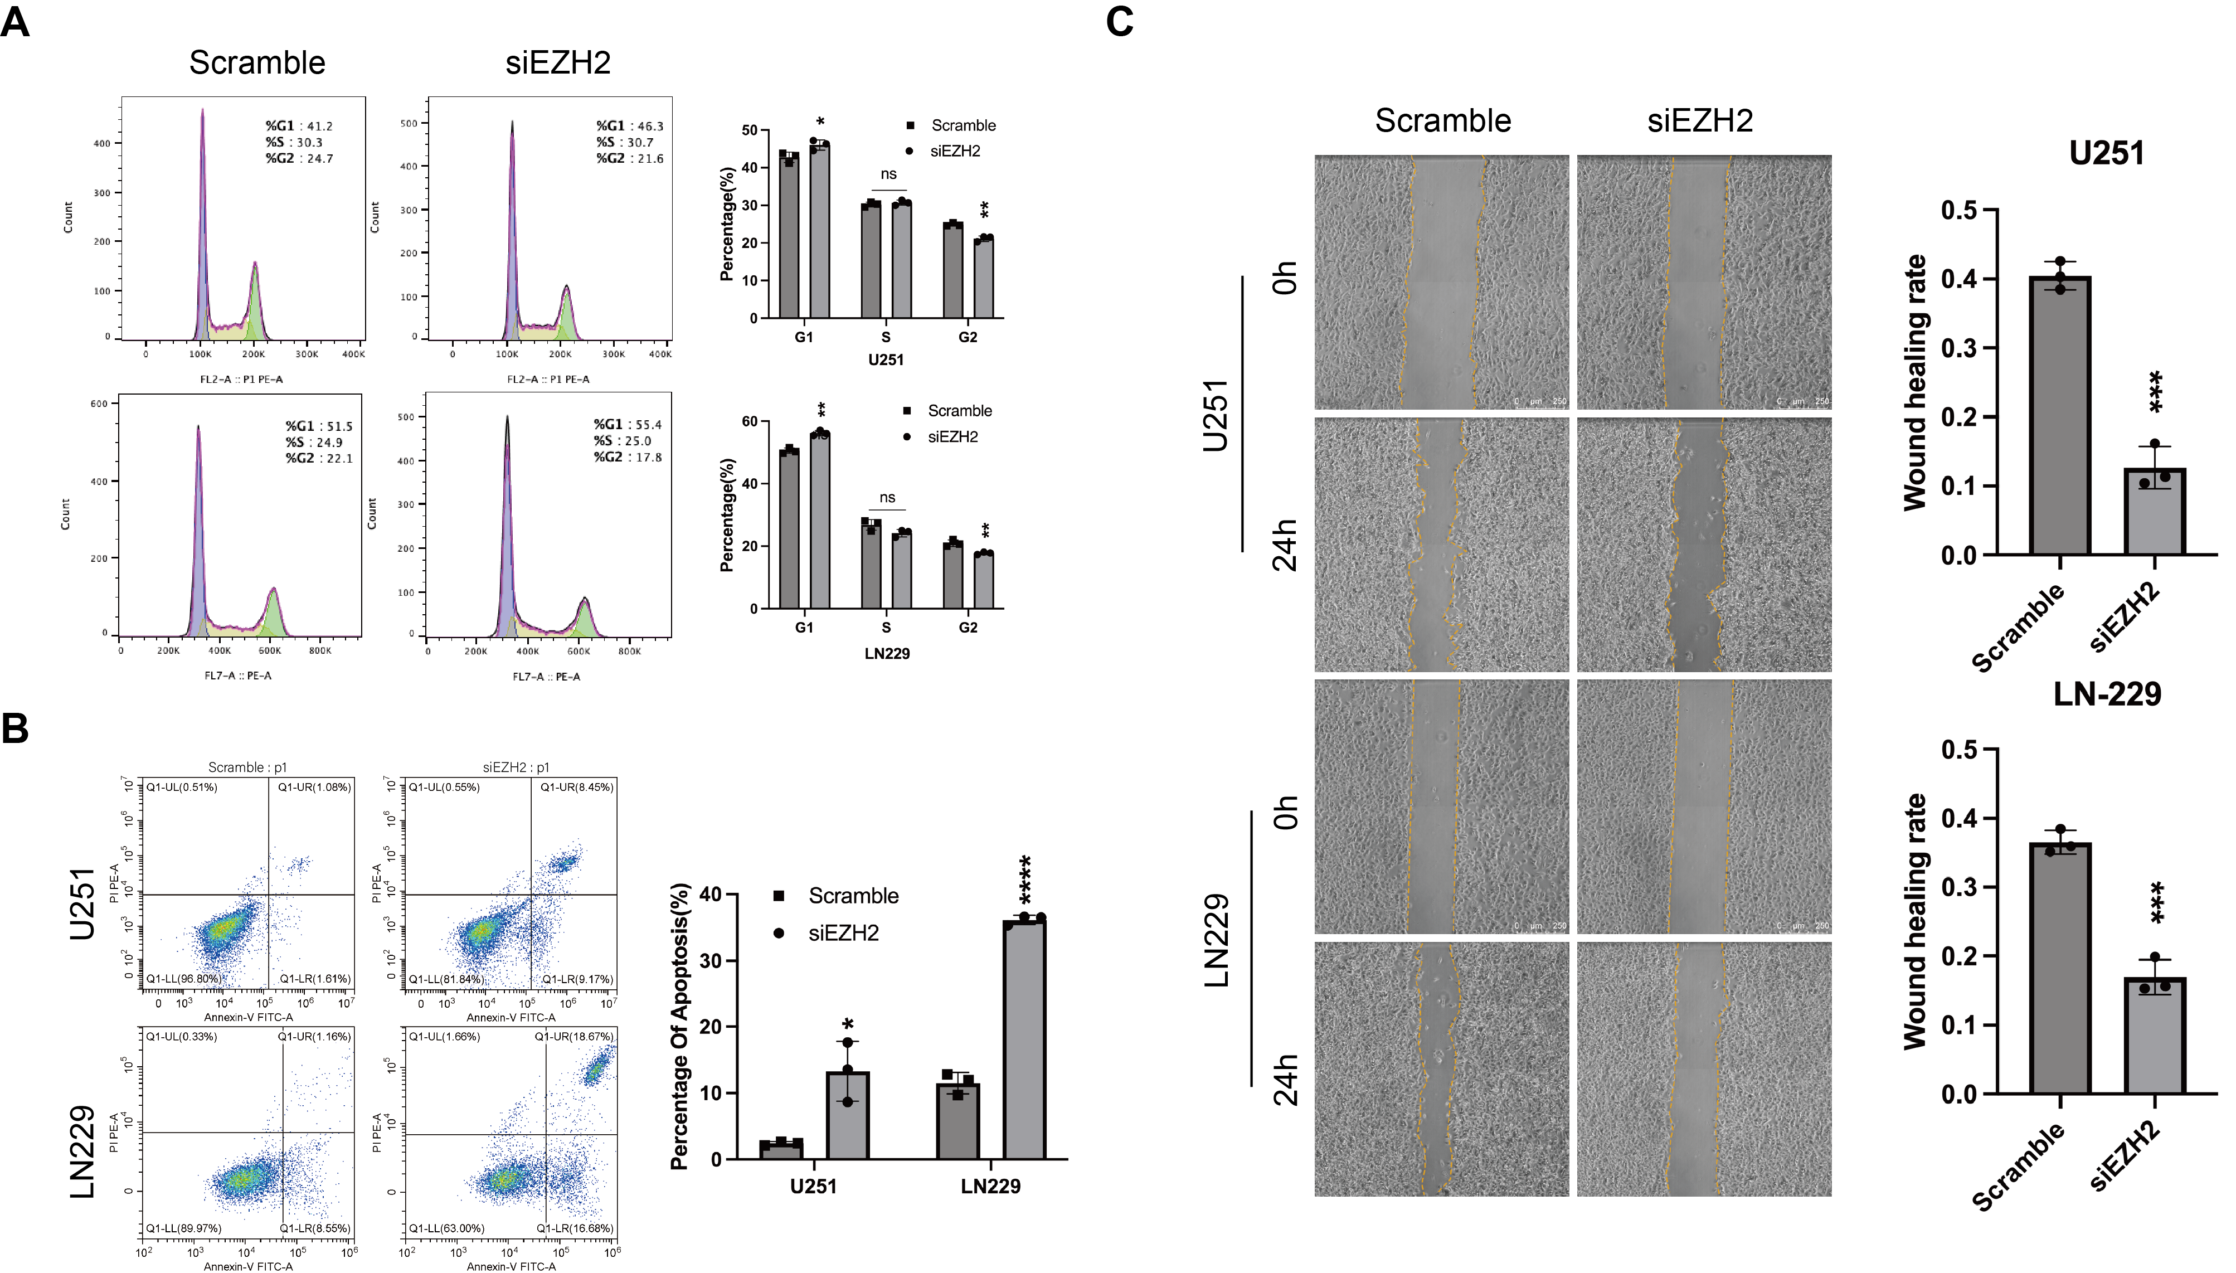
Fig. S5 Effection of EZH2 knockdown on glioma cells (U251, LN229). A, B Flow cytometry was used to detect the cell cycle (A) and apoptosis (B) of glioma cells. C The migration ability of glioma cells were detected by Wound-healing assay. Bar = 50 µm or 250µm. *p < 0.05, **p < 0.01, ***p < 0.001, ****p < 0.0001.

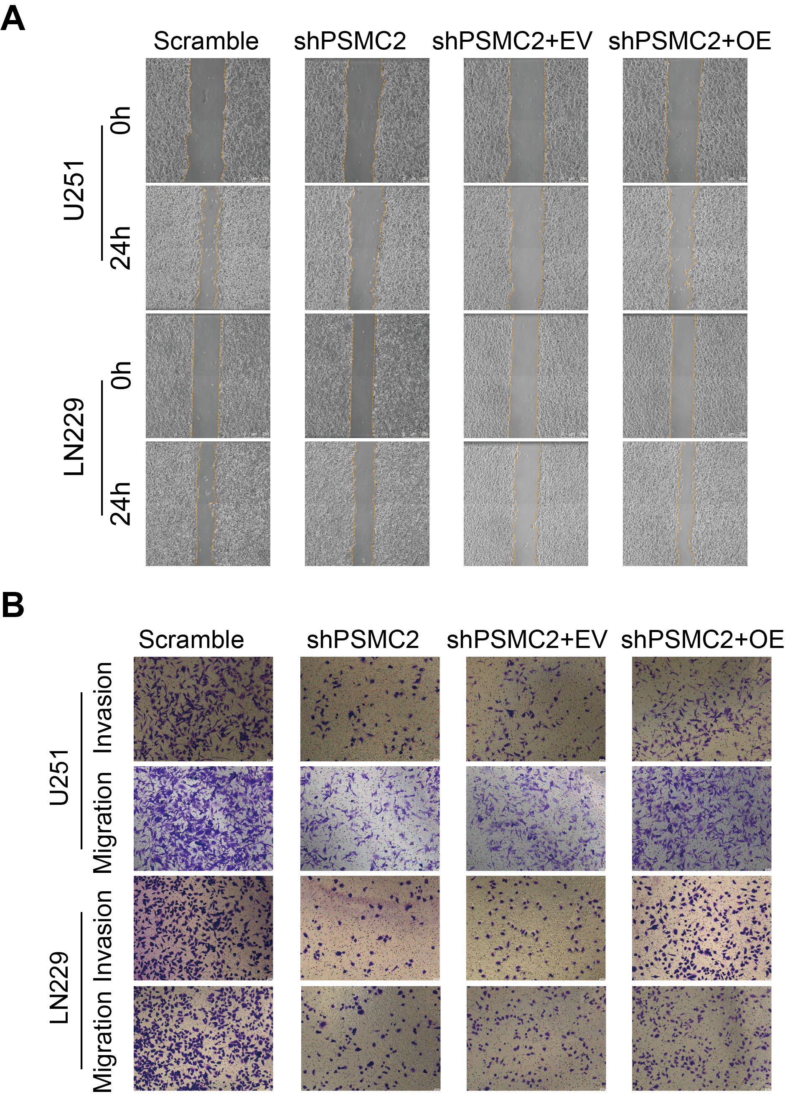
Fig. S6 The effect of overexpressing EZH2 on shPSMC2 cells. A, B The migration and invasion ability of glioma cells were detected by Wound healing (A) and Transwell assay (B).

Original data of western blot

