Supplementary Material for:
Live-cell STED microscopy enables 50 nm resolution imaging with preserved cell proliferation
Frank N. Mol¹, Sietse J. Dijt¹, Thomas C.Q. Burgers¹, Teresa M. Maunz¹, and Rifka Vlijm¹
¹Molecular Biophysics, Zernike Institute for Advanced Materials, University of Groningen, Nijenborgh 7, 9747 AG Groningen, The Netherlands.
* Corresponding author: Rifka Vlijm
Email: r.vlijm@rug.nl
Contents
Supplementary Figures 2
Supplementary Table 19
Supplementary Movie captions 20
Supplementary References 21

Supplementary Figures
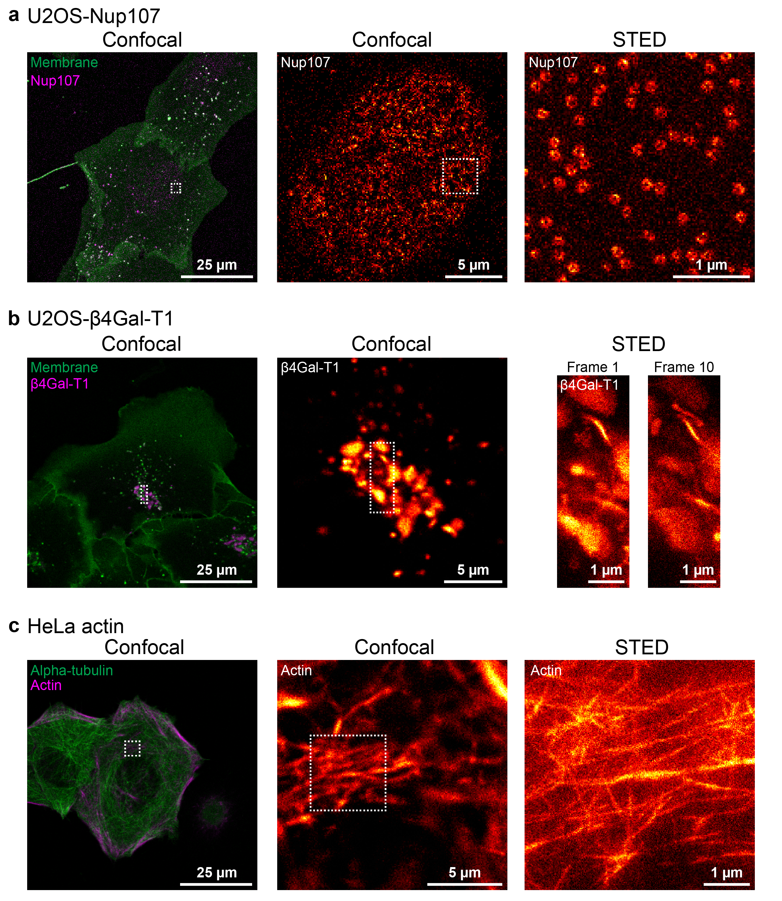
Supplementary Figure S1. (continued on next page).

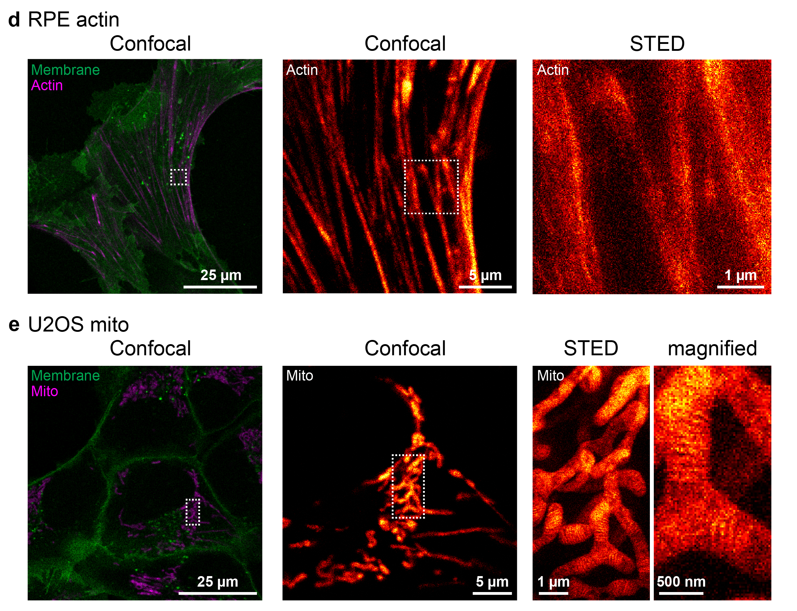
Supplementary Figure S1. Representative examples for each of the imaged cell lines. The STED-imaged region is indicated by a white box in each confocal image. (a) Left panel: confocal field of view of U2OS Nup107 cells showing the membrane (green) and Nup107 (magenta). Middle panel: confocal image of a sub-region showing Nup107. Right panel: high-resolution STED image of Nup107. (b) Left panel: confocal field of view of U2OS β4Gal-T1 cells showing the membrane (green) and β4Gal-T1 (magenta). Middle panel: confocal image of a sub-region showing β4Gal-T1. Right panel: first and last frame of the 10 high-resolution STED frames of β4Gal-T1. (c) Left panel: confocal field of view of HeLa Kyoto cells showing alpha-tubulin (green) and actin (magenta). Middle panel: confocal image of sub-region showing actin. Right panel: high-resolution STED image of actin. (d) Left panel: confocal field of view of RPE-1 cells showing the membrane (green) and actin (magenta). Middle panel: confocal image of a sub-region showing actin. Right panel: high-resolution STED image of actin. (e) Left panel: confocal field of view of U2OS cells showing the membrane (green) and mitochondria (magenta). Middle panel: confocal image of a sub-region showing mitochondria. Right panel: high-resolution STED image of mitochondria, showing both the full field of view and a magnified part of the image. For all panels, intensity of the left confocal images was rescaled to enhance visibility if necessary. Scale bars: 25 µm for the left confocal image, 5 µm for the middle confocal image of a sub-region, 1 µm for the STED image, and 500 nm for the magnified part of the STED image.

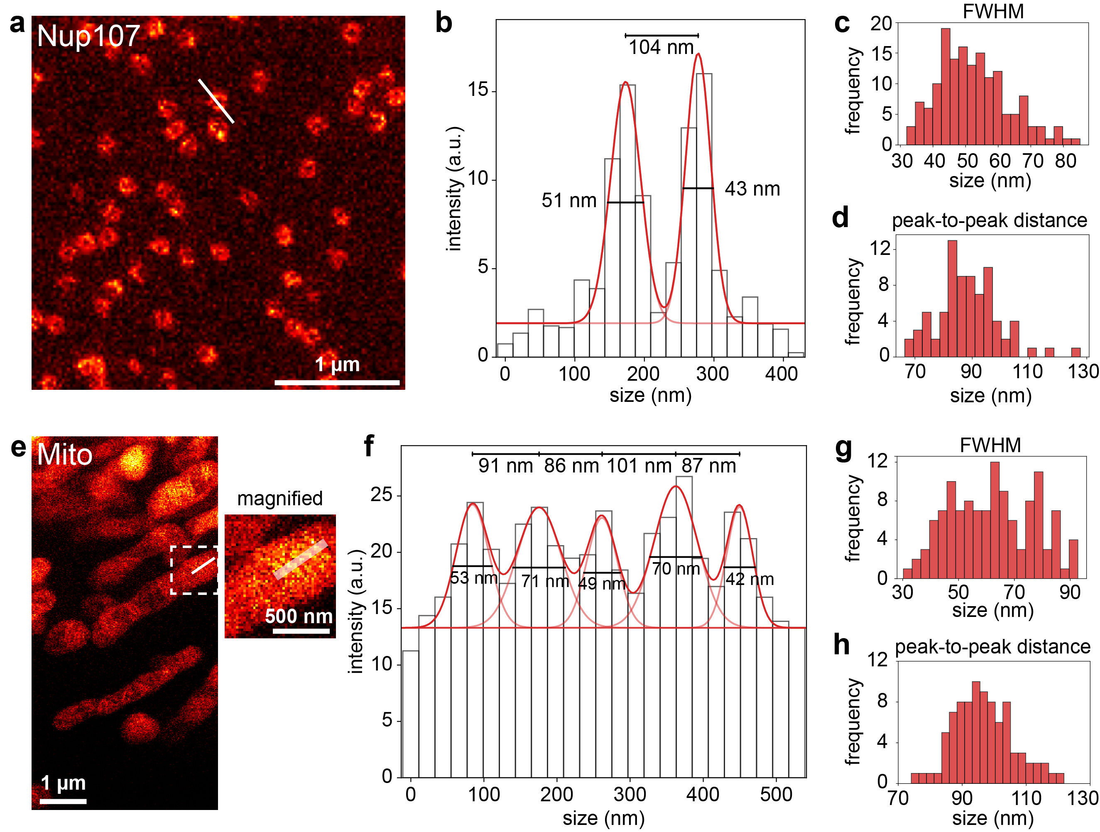
Supplementary Figure S2. STED resolution. (a) A 3 × 3 µm² FOV containing Nup107 labeled with SNAP-Cell 647-SiR imaged using STED. Line profiles are drawn, as illustrated by the white line. Scale bar: 1 μm. (b) Line profile of the line drawn in (a), with a double Gaussian fit resulting in a full width at half maximum (FWHM) of 51 nm and 43 nm. Furthermore, the distance between the peaks was calculated to verify the validity of the data. (c) Histogram of the FWHM of 156 Gaussians obtained from double Gaussian fits on 78 line profiles, measured in 78 different cells across 3 independent measurements. The median FWHM was 51.6 nm. Taking the size of the structure into account and by not considering merely the thinnest structures for the line fits, we considered 50 nm to be a conservative estimate of our obtained resolution. (d) Histogram of the peak-to-peak distances of the 78 line profiles, resulting in an average peak distance of 88.6 ± 10.9 nm. This is in line with the expected diameter of 98 nm¹, especially since a small tilt in the pores will result in an underestimation of the pore diameter. These results thus underline the quality of the STED image. (e) Left: A 4 × 8 µm² FOV containing mitochondria labeled with LIVE RED mito imaged using STED. Right: a magnified view of the region marked by the white box in the left image. Line profiles are drawn, as illustrated by the white line. Scale bars: 1 μm for the left image and 500 nm for the magnified view on the right. (f) Line profile of the line drawn in (e), with a quintuple Gaussian fit resulting in a full width at half maximum (FWHM) of 53 nm, 71 nm, 49 nm, 70 nm, and 42 nm for the individual Gaussians. Furthermore, the distance between the peaks was determined. (g) Histogram of the FWHM of 122 Gaussians obtained from multiple Gaussian fits on 35 line profiles, measured in 29 different cells across 3 independent measurements. The number of Gaussians used to fit each line profile was manually set based on the number of observed cristae. The median FWHM was 62.2 nm. Considering the size of the cristae structure and the broadening effect of a potential tilt on the FWHM, this result is in line with the resolution determined in (c). (h) Histogram of the 87 peak-to-peak distances in the 35 line profiles, resulting in an average peak-to-peak distance of 96.5 ± 9.4 nm. This is in line with previously reported values of inter-crista distances: 74 ± 15 nm (U2OS, measured using transmission electron microscopy)², 85 ± 14 nm (U2OS, measured using expansion microscopy)³, 123 nm (HeLa, measured using live-cell STED microscopy)⁴.

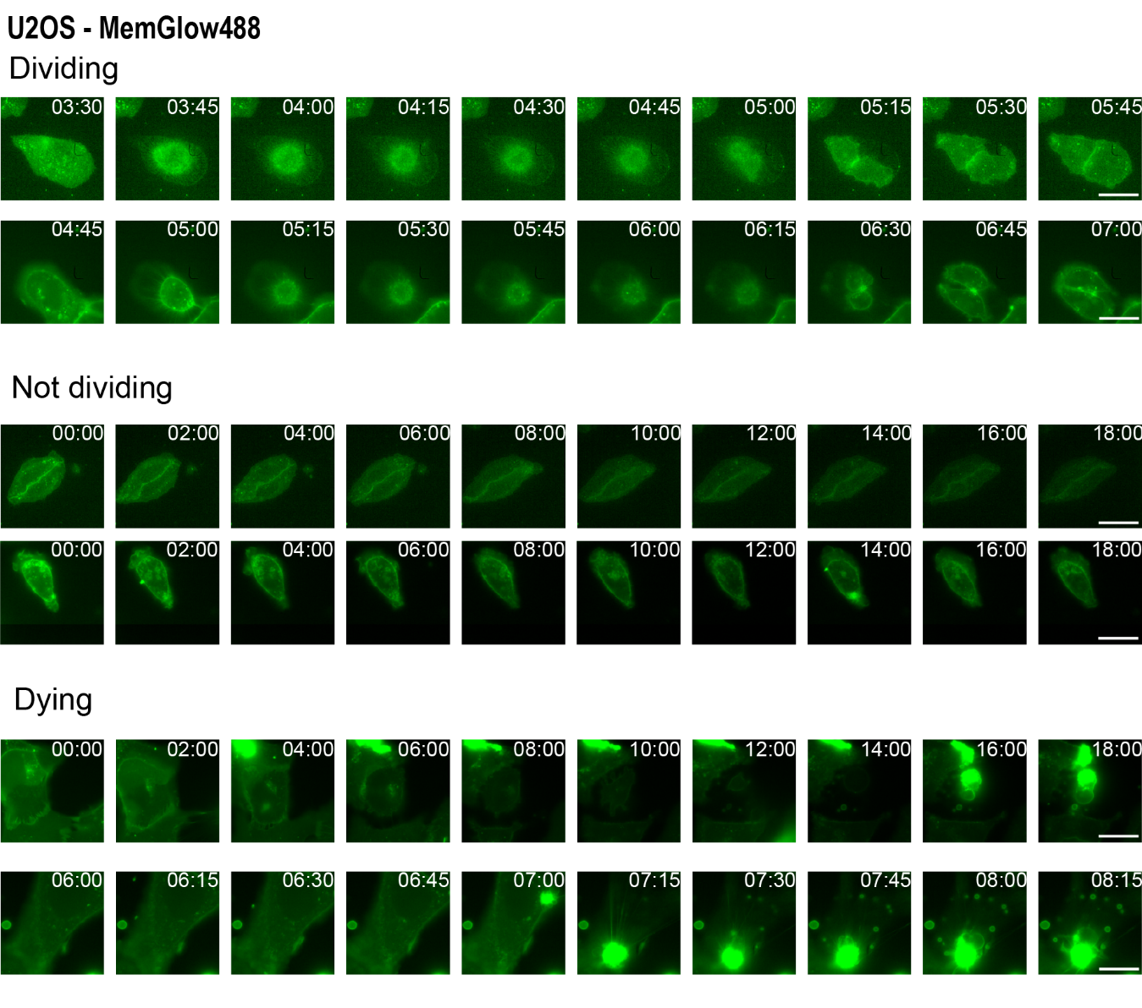
Supplementary Figure S3. Cell fate examples for the U2OS cell lines (wild-type, endogenously tagged with a SNAP-tag on Nup107 or stably expressing β4Gal-T1-Halo), in which the membrane label MemGlow488 was imaged using epifluorescence widefield microscopy (490 nm LED). For each class, two representative time lapses are presented in the relevant time window. Frame times are displayed in the format hh:mm. Scale bar: 25 µm.

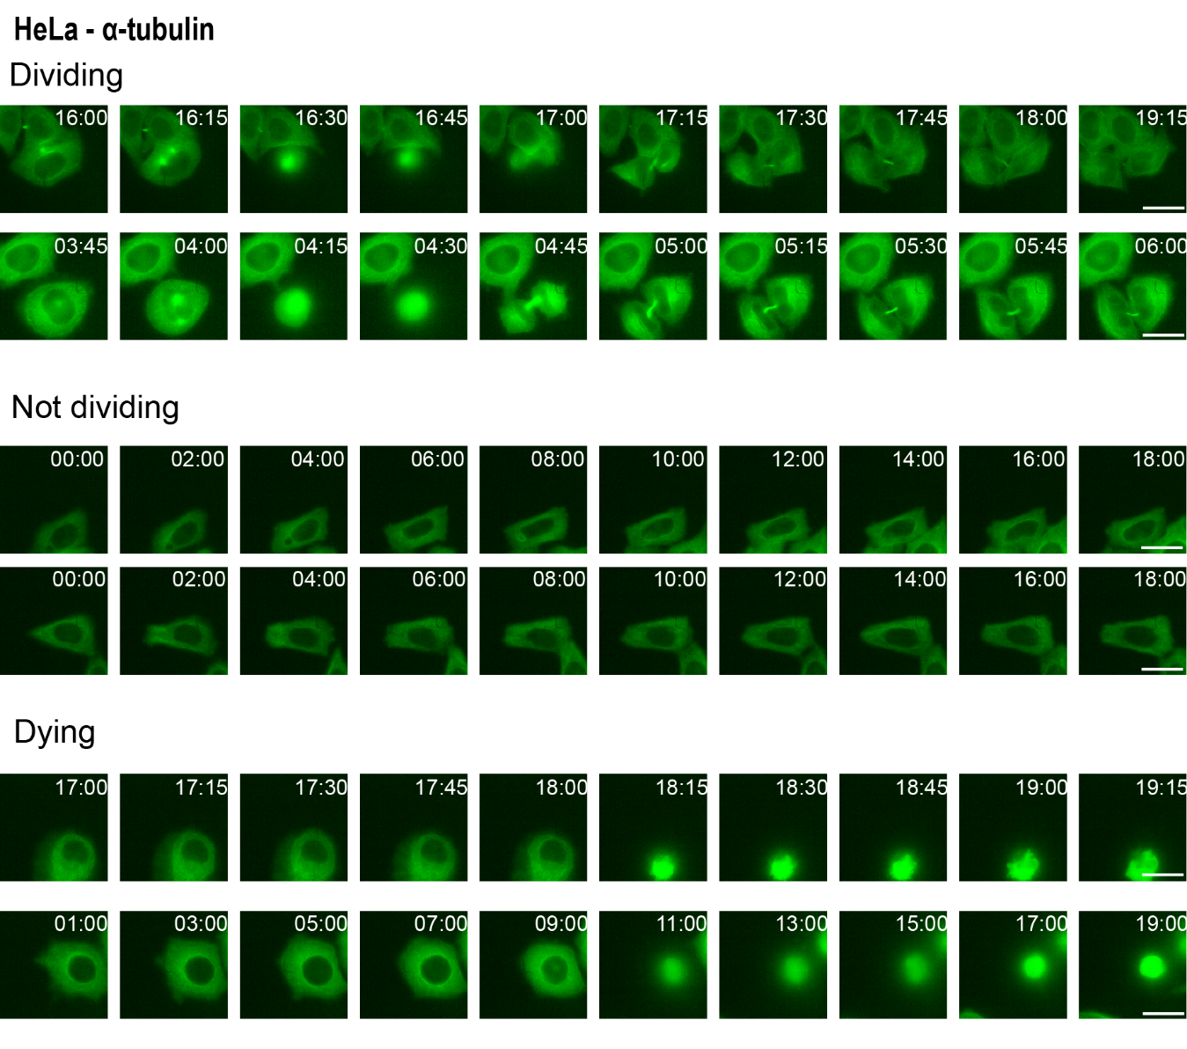
Supplementary Figure S4. Cell fate examples for the HeLa cell line in which EGFP on α-tubulin was imaged using epifluorescence widefield microscopy (490 nm LED). For each class, two representative time lapses are presented in the relevant time window. Frame times are displayed in the format hh:mm. Scale bar: 25 μm.
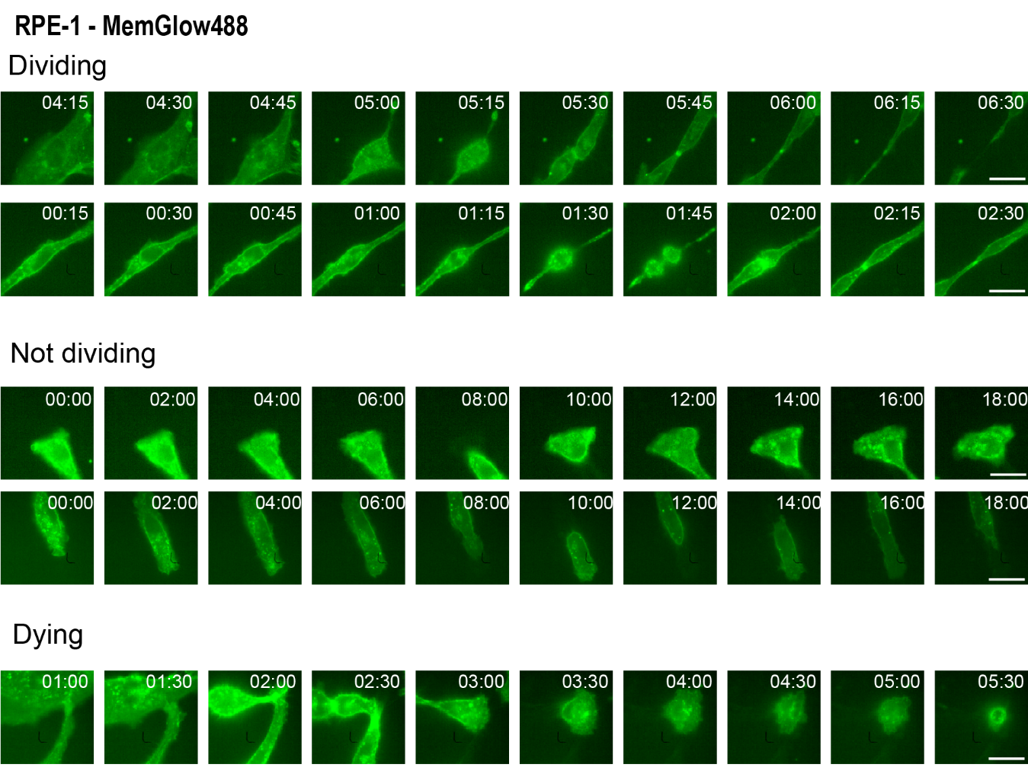
Supplementary Figure S5. Cell fate examples for the RPE-1 cell line, in which the membrane label MemGlow488 was imaged using epifluorescence widefield microscopy (490 nm LED). For each class, two representative time lapses are presented in the relevant time window. Frame times are displayed in the format hh:mm. Scale bar: 25 μm.

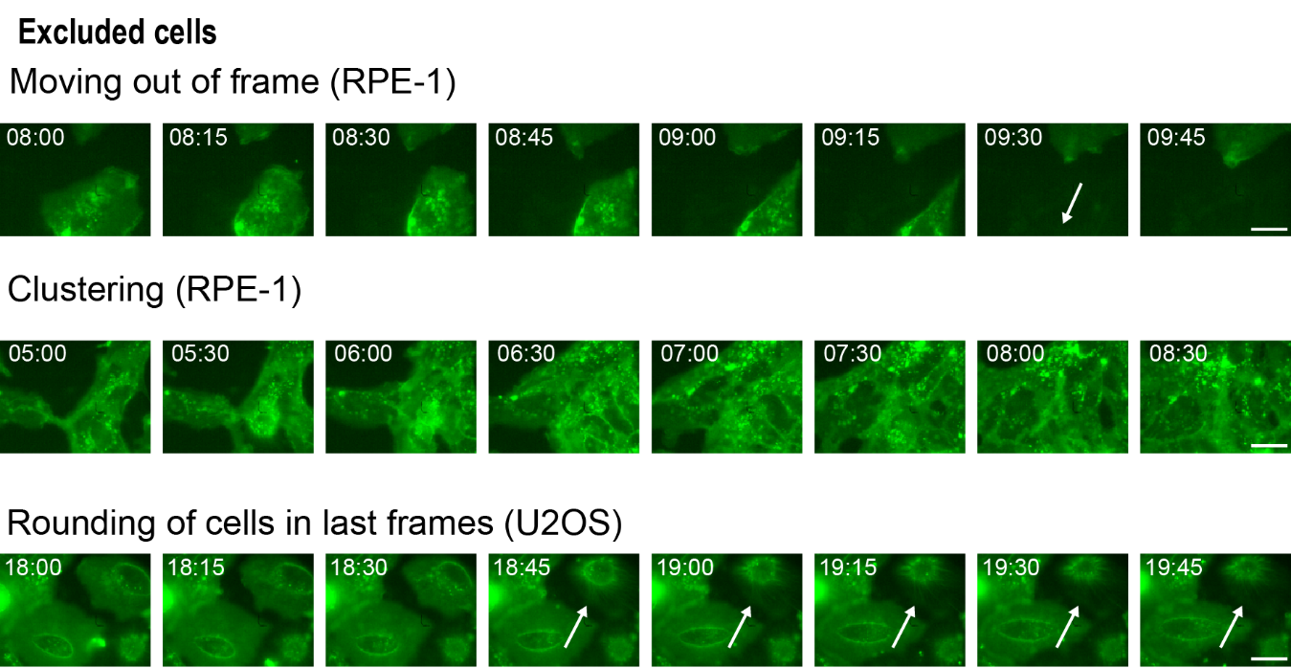 Supplementary Figure S6. Examples of cells excluded from long-term stress observations due to the inability to determine whether the cells proliferated or died. One factor for undetermined cell fate is cell motility, as cells can move out of the frame (top row, RPE-1 with membrane staining) or can move into a cluster, preventing the tracking of individual cells (mid row, RPE-1 with membrane staining). Another cause of undetermined cell fate was the rounding of cells at the end of the time lapse. The lack of additional frames hindered a clear distinction between mitosis and apoptosis (bottom row, U2OS with membrane staining). Frame times are displayed in the format hh:mm. Scale bar: 25 μm.

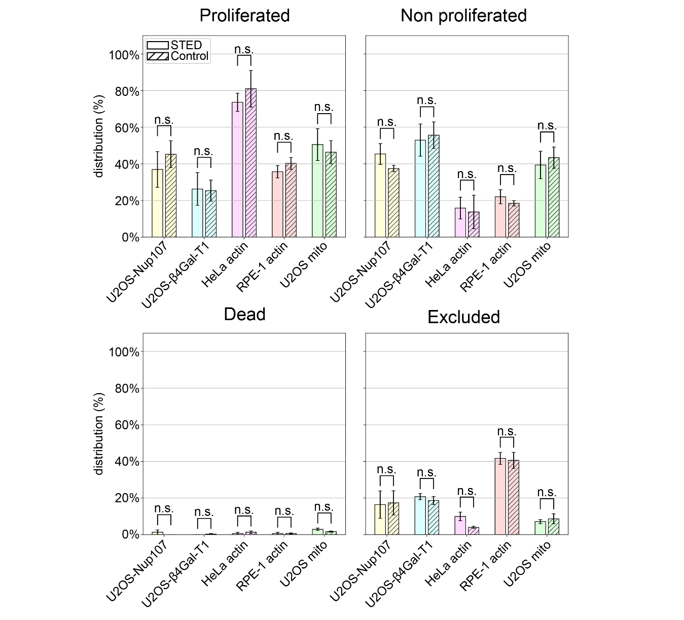
Supplementary Figure S7. Cell fate after STED imaging (including the occurrence of cells whose fate was undetermined, marked as excluded), observed for 20 h using widefield microscopy (with a membrane or α-tubulin label excited using a 490 nm wavelength LED). A comparison was made between cells imaged using high-resolution STED microscopy and control cells that were observed only. No significant differences were observed (p > 0.05) for any of the classifications—proliferated cells, nonproliferating living cells, dead cells, and excluded cells. For U2OS NUP107, 148 STED-imaged and 297 control cells were observed (proliferated p = 0.53, nonproliferated p = 0.25, dead p = 0.37, and excluded p = 0.93). For U2OS β4Gal-T1, 149 STED-imaged and 300 control cells were observed (proliferated p = 0.93, nonproliferated p = 0.82, dead p = 0.37, and excluded p = 0.48). For HeLa Actin, 151 STED-imaged and 299 control cells were observed (proliferated p = 0.54, nonproliferated p = 0.85, dead p = 0.50, and excluded p = 0.07). For RPE-1 Actin, 149 STED-imaged and 298 control cells were observed (proliferated p = 0.38, nonproliferated p = 0.44, dead p = 0.98, and excluded p = 0.86). For U2OS Mito, 168 STED-imaged and 300 control cells were observed (proliferated p = 0.72, nonproliferated p = 0.70, dead p = 0.13, and excluded p = 0.63). P-values were obtained using a two-sided unpaired t-test. Boxplot annotations: n.s. = p > 0.05. Error bars represent the standard error of the mean (SEM).
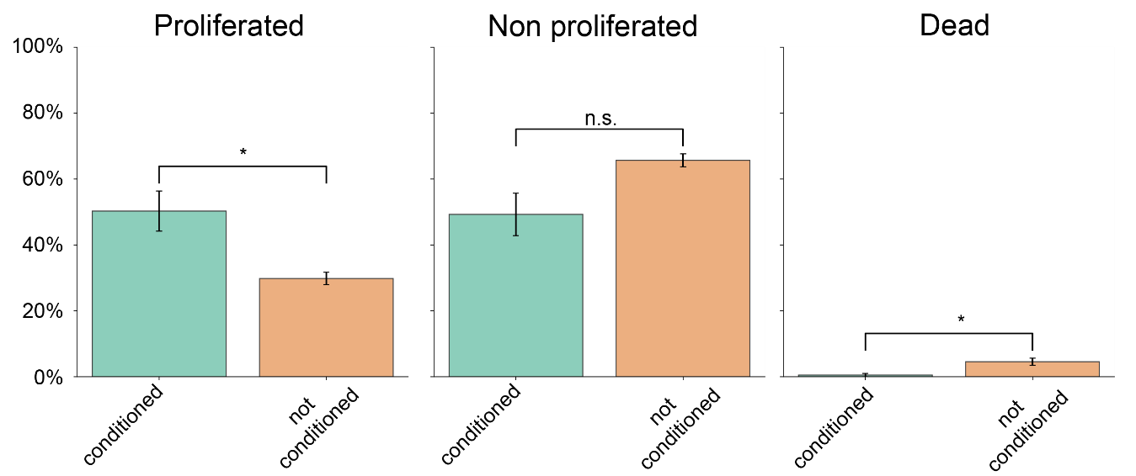
Supplementary Figure S8. Comparison of the cell fate of U2OS Nup107 cells that were supplied with either conditioned medium or completely fresh medium prior to imaging. The conditioned medium was prepared in a 1:1 ratio of conditioned (obtained from ~50% confluent cultured cells) and fresh medium. The cells were observed for 20 h by imaging a membrane label (MemGlow488). The cells supplied with conditioned medium had a significantly higher proliferation rate (p = 0.03), a nonsignificantly lower amount of nonproliferated cells (p = 0.07), and a significantly lower mortality rate (p = 0.03). The number of cells observed in the conditioned medium was 369, measured over n = 3 replicates, and the number of cells observed in the fresh medium was 394, measured over n = 3 replicates. P-values were obtained using a two-sided unpaired t-test. Boxplot annotations: * = p < 0.05, n.s. = p > 0.05. Error bars represent the standard error of the mean (SEM).

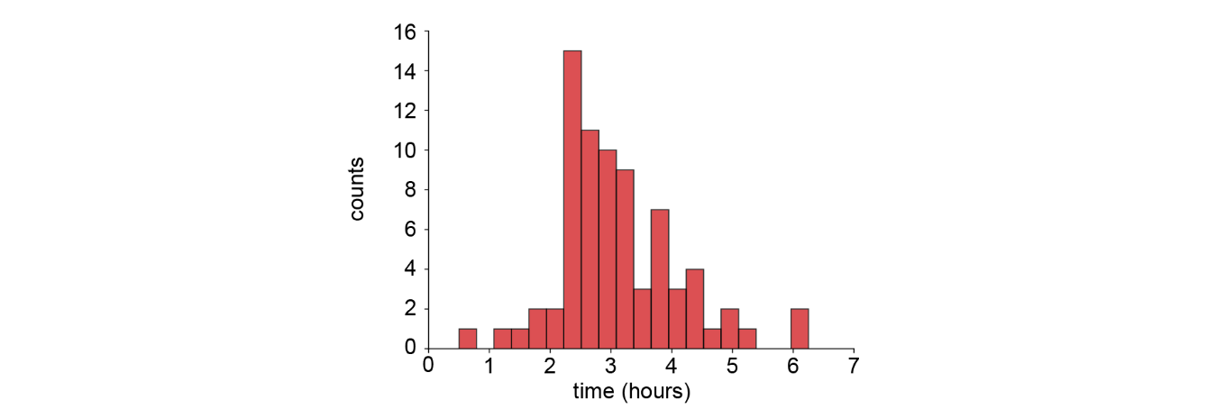
Supplementary Figure S9. Distribution of the onset of cell death of U2OS Nup107 cells after turning off the CO₂ supply during imaging. The time at which the humidified CO₂ gas flow was turned off was t = 0. The epifluorescence widefield time lapse of membrane-stained cells was used to determine the onset of cell death. The data represent n = 3 replicates, with a total of 75 cells.

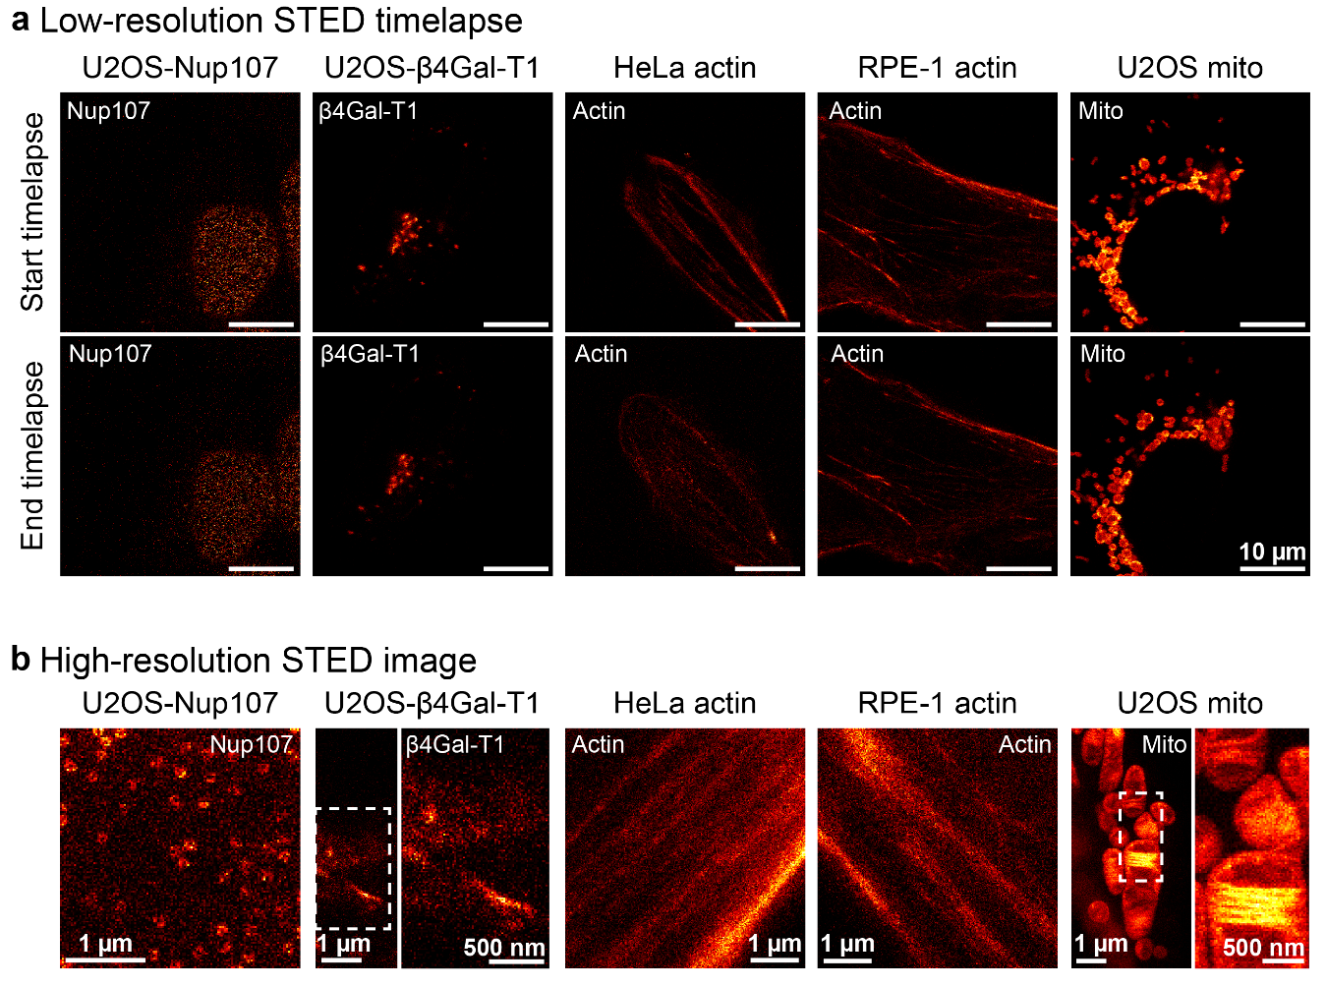
Supplementary Figure S10. Examples of STED images acquired during short-term cell stress experiments. (a) Start (sum of frames 1-5) and end (sum of frames 446-450) of a low-resolution STED time lapse for each STED-imaged structure and cell line. Intensities were scaled individually for optimal visibility and to correct for photobleaching. For the full time lapses, see Supplementary Movies S2-S6. Scale bars: 10 µm. (b) High-resolution STED image for each STED-imaged structure and cell line. For U2OS β4Gal-T1 and U2OS mito, the area indicated by the white box in the left image is shown magnified in the right image. Scale bars: 1 µm (full image) or 500 nm (magnified image).

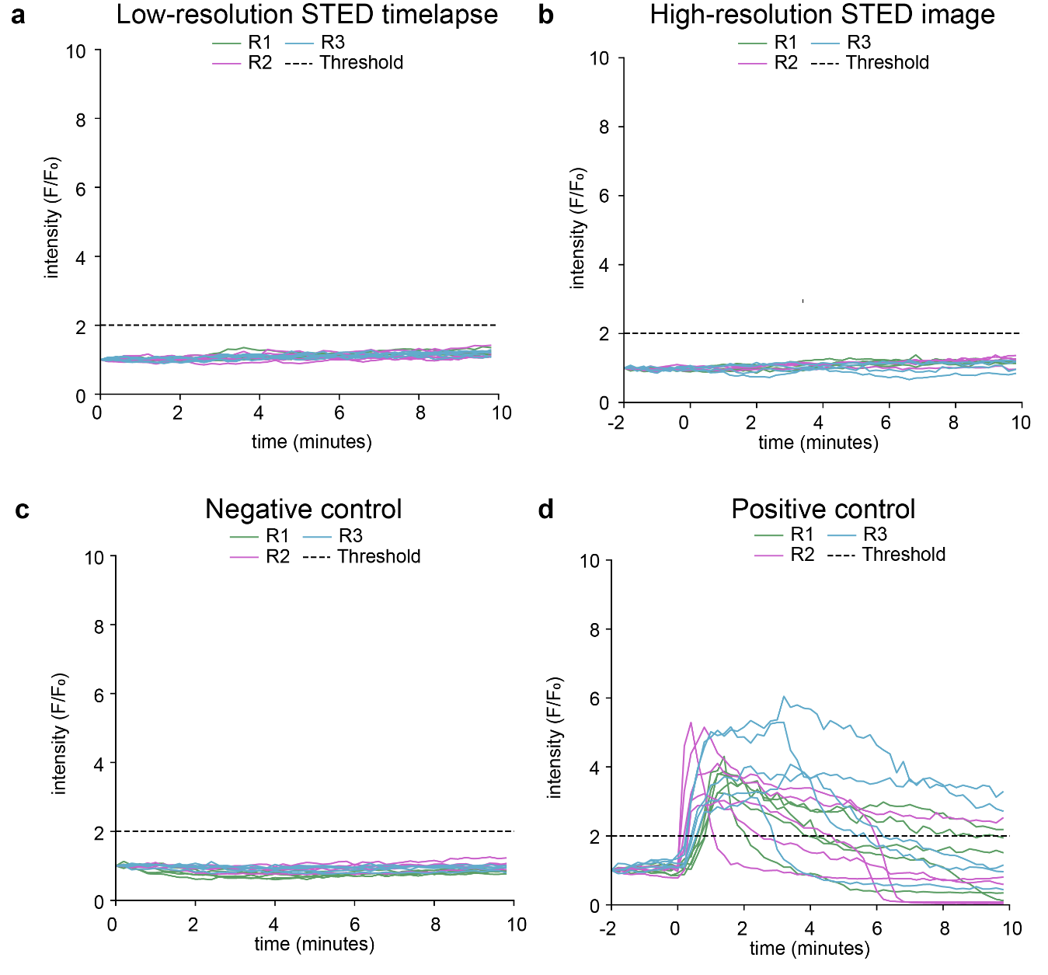
Supplementary Figure S11. U2OS Nup107 short-term stress response measured using cytosolic calcium levels using FluoForte. For each experiment, individual cells were plotted and labeled by replicate number. In each experiment, n = 12 to n = 18 cells were observed. See Supplementary Table S1 for detailed information.
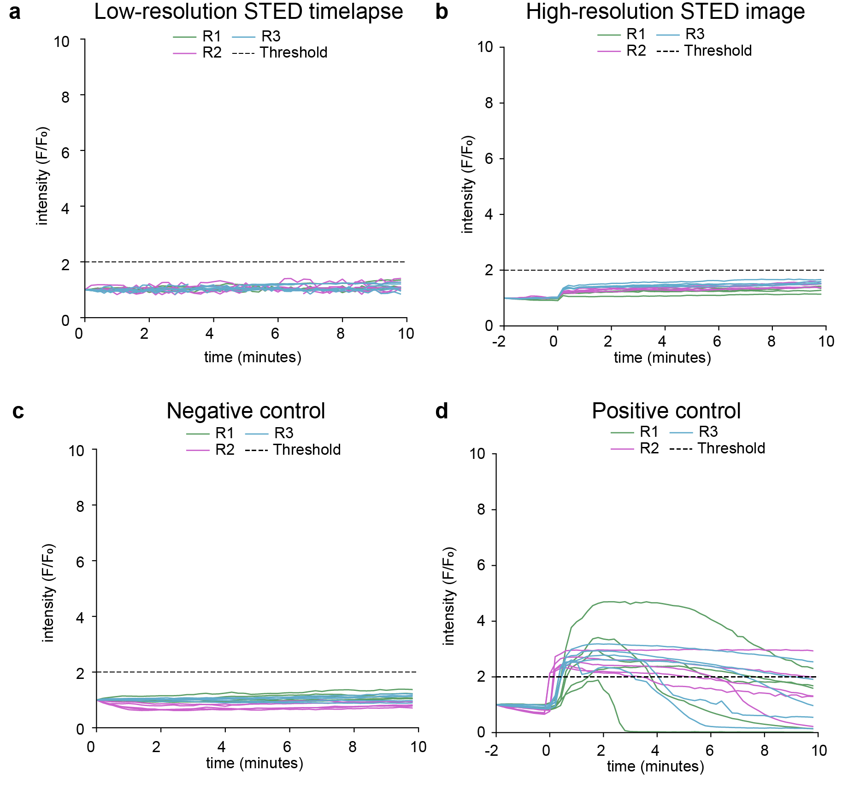
Supplementary Figure S12. U2OS β4Gal-T1 short-term stress response measured using cytosolic calcium levels using FluoForte. For each experiment, individual cells were plotted and labeled by replicate number. In each experiment, n = 12 to n = 15 cells were observed. See Supplementary Table S1 for detailed information.

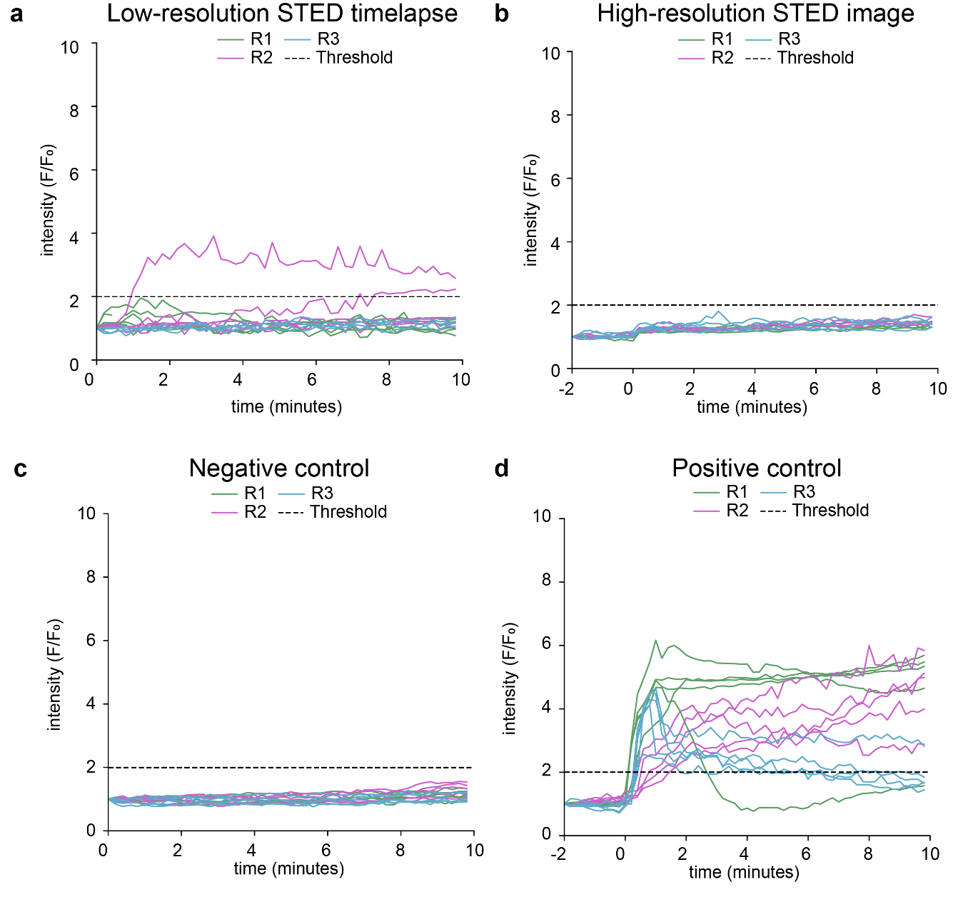
Supplementary Figure S13. HeLa Actin short-term stress response measured using cytosolic calcium levels using FluoForte. For each experiment, individual cells were plotted and labeled by replicate number. In each experiment, n = 12 to n = 15 cells were observed. See Supplementary Table S1 for detailed information.

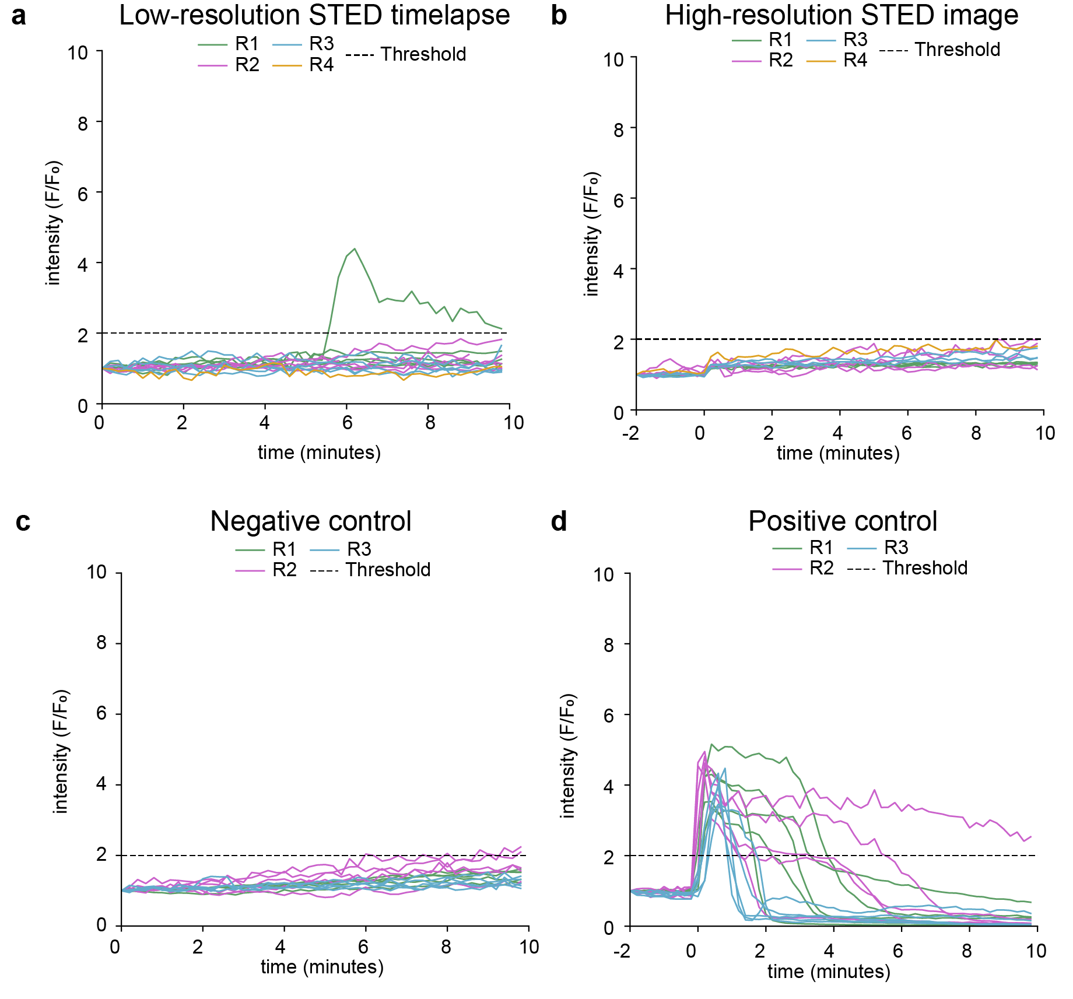
Supplementary Figure S14. RPE-1 Actin short-term stress response measured using cytosolic calcium levels using FluoForte. For each experiment, individual cells were plotted and labeled by replicate number. In each experiment, n = 12 to n = 15 cells were observed. See Supplementary Table S1 for detailed information.

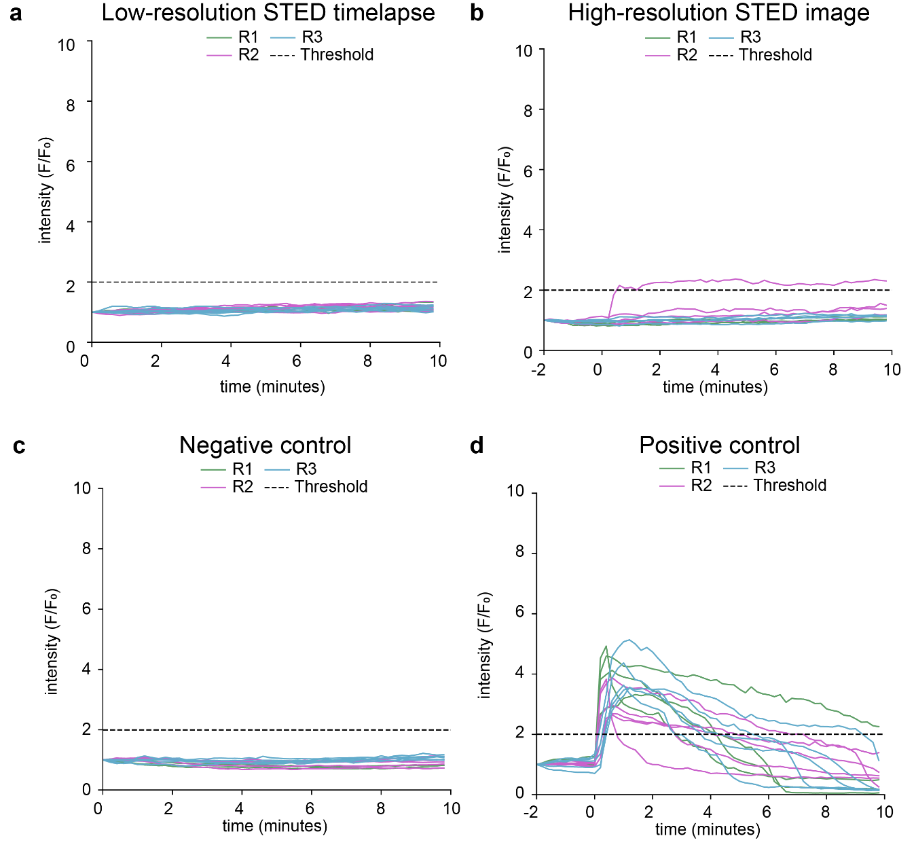
Supplementary Figure S15. U2OS Mito short-term stress response measured using cytosolic calcium levels using FluoForte. For each experiment, individual cells were plotted and labeled by replicate number. In each experiment, n = 12 to n = 16 cells were observed. See Supplementary Table S1 for detailed information.

Supplementary Table
Supplementary Table S1. Overview of the short-term stress response measurements, with p-values calculated using Fisher’s exact test. No significant differences were observed for either the low-resolution STED image series or the single high-resolution STED image compared to the negative control. Furthermore, highly significant differences were observed (p < 0.0001) for both the low-resolution STED image series and the single high-resolution STED image compared to the positive control. Overall, these results indicate that no significant stress responses were observed for the STED measurements.
Cell line | Set | Stressed / total | Compare Set | Stressed / Total | p-value
U2OS Nup107 | STED HR image | 0/12 | Negative Control | 0/15 | 1
 | STED HR image | 0/12 | Positive Control | 15/15 | 6e-8
 | STED LR scan | 0/18 | Negative Control | 0/15 | 1
 | STED LR scan | 0/18 | Positive Control | 15/15 | 1e-9
 | Negative Control | 0/15 | Positive Control | 15/15 | 1e-8
U2OS β4Gal-T1 | STED HR image | 0/12 | Negative Control | 0/15 | 1
 | STED HR image | 0/12 | Positive Control | 14/15 | 7e-7
 | STED LR scan | 0/15 | Negative Control | 0/15 | 1
 | STED LR scan | 0/15 | Positive Control | 14/15 | 2e-7
 | Negative Control | 0/15 | Positive Control | 14/15 | 2e-7
HeLa Actin | STED HR image | 0/12 | Negative Control | 0/15 | 1
 | STED HR image | 0/12 | Positive Control | 15/15 | 6e-8
 | STED LR scan | 2/14 | Negative Control | 0/15 | 0.22
 | STED LR scan | 2/14 | Positive Control | 15/15 | 2e-6
 | Negative Control | 0/15 | Positive Control | 15/15 | 1e-8
RPE-1 Actin | STED HR image | 0/12 | Negative Control | 2/15 | 0.48
 | STED HR image | 0/12 | Positive Control | 15/15 | 6e-8
 | STED LR scan | 1/15 | Negative Control | 2/15 | 1
 | STED LR scan | 1/15 | Positive Control | 15/15 | 2e-7
 | Negative Control | 2/15 | Positive Control | 15/15 | 2e-6
U2OS Mito | STED HR image | 1/12 | Negative Control | 0/13 | 0.48
 | STED HR image | 1/12 | Positive Control | 14/14 | 2e-6
 | STED LR scan | 0/16 | Negative Control | 0/13 | 1
 | STED LR scan | 0/16 | Positive Control | 14/14 | 7e-9
 | Negative Control | 0/13 | Positive Control | 14/14 | 5e-8

Supplementary Movie captions
Supplementary Movie S1. 20-hour epifluorescence widefield time lapse of EGFP on α-tubulin imaged in HeLa cells (4 frames per hour). The time lapse was acquired after STED imaging of actin in 50 of the cells present in the time lapse, annotated by cells 1-50. Cells 51-149 serve as controls. Frame times are displayed in the format hh:mm. Scale bar: 200 μm.
Supplementary Movie S2. Low-resolution STED time lapse acquired during a short-term stress experiment of U2OS Nup107 (450 frames acquired over 10 min). Frame times are displayed in the top left corner. Scale bar: 10 µm.
Supplementary Movie S3. Low-resolution STED time lapse acquired during a short-term stress experiment of U2OS β4Gal-T1 (450 frames acquired over 10 min). Frame times are displayed in the top left corner. Scale bar: 10 µm.
Supplementary Movie S4. Low-resolution STED time lapse acquired during a short-term stress experiment of HeLa Actin (450 frames acquired over 10 min). Frame times are displayed in the top left corner. Scale bar: 10 µm.
Supplementary Movie S5. Low-resolution STED time lapse acquired during a short-term stress experiment of RPE-1 Actin (450 frames acquired over 10 min). Frame times are displayed in the top left corner. Scale bar: 10 µm.
Supplementary Movie S6. Low-resolution STED time lapse acquired during a short-term stress experiment of U2OS Mito (450 frames acquired over 10 min). Frame times are displayed in the top left corner. Scale bar: 10 µm.

Supplementary References
1 Sabinina, V. J. et al. Three-dimensional superresolution fluorescence microscopy maps the variable molecular architecture of the nuclear pore complex. Mol Biol Cell 32, 1523-1533 (2021). https://doi.org:10.1091/mbc.E20-11-0728
2 Lange, F. et al. In situ architecture of the human prohibitin complex. Nature Cell Biology 27, 633-640 (2025). https://doi.org:10.1038/s41556-025-01620-1
3 Louvel, V. et al. iU-ExM: nanoscopy of organelles and tissues with iterative ultrastructure expansion microscopy. Nature Communications 14, 7893 (2023). https://doi.org:10.1038/s41467-023-43582-8
4 Stephan, T., Roesch, A., Riedel, D. & Jakobs, S. Live-cell STED nanoscopy of mitochondrial cristae. Scientific Reports 9, 12419 (2019). https://doi.org:10.1038/s41598-019-48838-2

