

Figure S1A: A phylogenetic tree depicting the evolutionary relationships among the 513 viral contigs retrieved in this study.

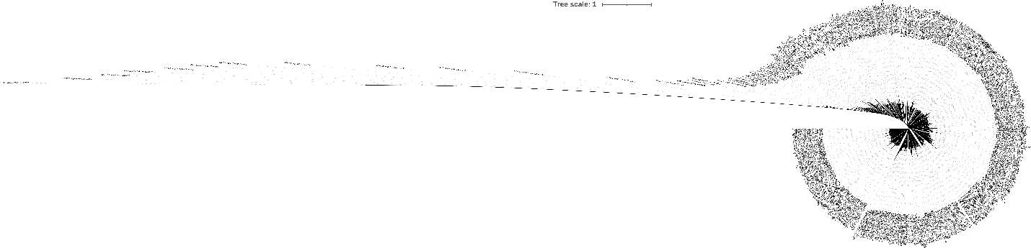
Figure S1B: The main clade of the phylogenetic tree is highlighted, representing a significant evolutionary lineage within the viral contigs dataset.

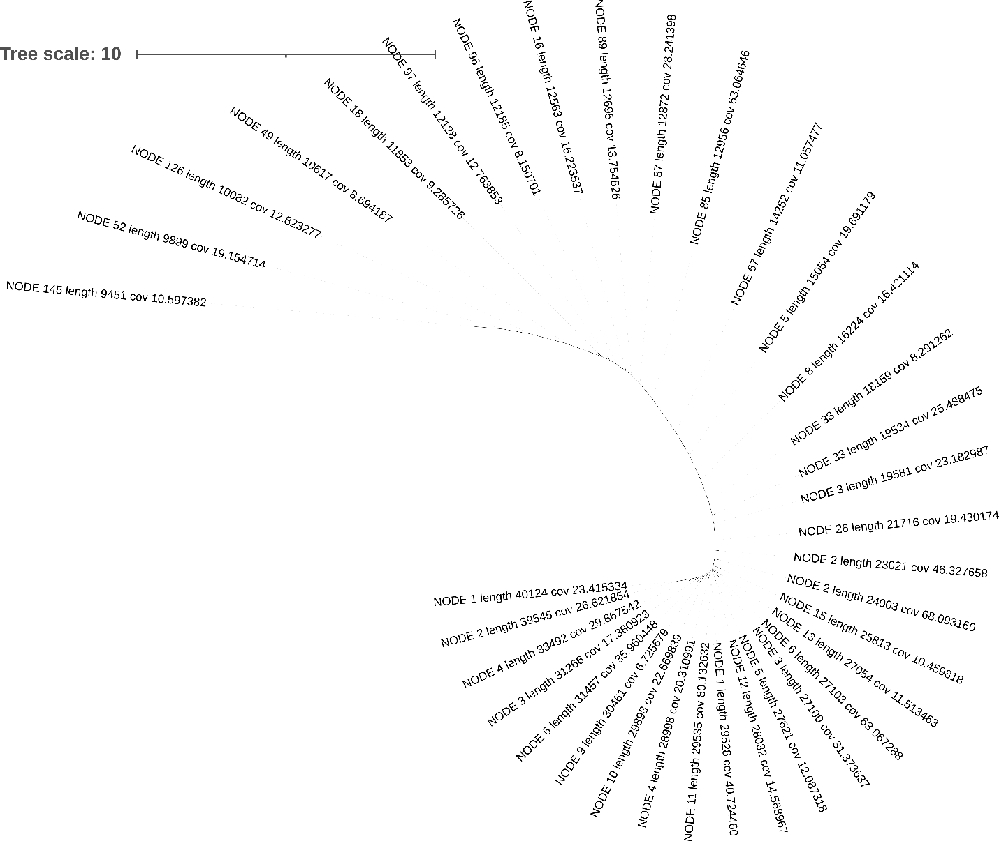

Figure S1C: The 2nd clade of the phylogenetic tree, delineating another distinct evolutionary lineage within the dataset of viral contigs. This clade likely encompasses a subgroup of viral sequences that share a more recent common ancestry with each other compared to the main clade.

