Supplementary information
Table S1: Sequences of the primer pairs used in current study.
Target gene | Primer name | Oligonucleotide | Amplicon size | Reference
16S rRNA | 27F | AGAGTTTGATCMTGGCTCAG | 1450 | (Marcial Gomes, et al. 2008)
16S rRNA | 1492R | TACGGYTACCTTGTTACGACTT | 1450 | (Marcial Gomes, et al. 2008)
16S rRNA | 16SqF | TAGGTGGCAAGCGTTATCCG | 127 | This study
16S rRNA | 16SqR | GCACTCAAGTTCCCCCAGTT | 127 | This study
BVBM3_v1_ua3131 | ua3131F | AGCAACACGTCCAGAAGACA | 85 | This study
BVBM3_v1_ua3131 | ua3131R | GCTACACCTGTATCCGAGCC | 85 | This study
BVBM3_v1_ug0150 | ug0150F | GGCTGAAAAAGCAGCGGAAG | 94: | This study
BVBM3_v1_ug0150 | ug0150R | CAGAATCAGAAGCGGTCGGT | 94: | This study
Cat-2,3-diox | catF | AGCTCGTAATGGAGCGTTGT | 79 | This study
Cat-2,3-diox | catR | CCCTTCACCTTGCCACGTAT | 79 | This study

Table S2: A list of biochemical characteristics of the strain Bm3, including Gram staining, salinity tolerance, hemolytic activity, catalase activity, oxidase activity, urease activity, and amylase activity.
Characteristic | Positive or Negative (+/-)
Gram-staining | +
Aerobic condition | +
Mobility | +
Salinity tolerance | +
Hemolytic activity | +
Catalase | +
Oxidase | +
Esterase | -
Indole | -
Protease | -
Urease | +
Amylase | +

Table S3: A summary of EggNOG functional classification of B. velezensis Bm3 genome based on COG categories.

COG Process | COG Category | COG Category description | CDS | (%)
CELLULAR PROCESSES AND SIGNALING | D | Cell cycle control, cell division, chromosome partitioning | 56 | 1.03%
CELLULAR PROCESSES AND SIGNALING | M | Cell wall/membrane/envelope biogenesis | 267 | 4.93%
CELLULAR PROCESSES AND SIGNALING | N | Cell motility | 61 | 1.13%
CELLULAR PROCESSES AND SIGNALING | O | Posttranslational modification, protein turnover, chaperones | 99 | 1.83%
CELLULAR PROCESSES AND SIGNALING | T | Signal transduction mechanisms | 206 | 3.81%
CELLULAR PROCESSES AND SIGNALING | U | Intracellular trafficking, secretion, and vesicular transport | 58 | 1.07%
CELLULAR PROCESSES AND SIGNALING | V | Defense mechanisms | 124 | 2.29%
CELLULAR PROCESSES AND SIGNALING | W | Extracellular structures | 3 | 0.04%
INFORMATION STORAGE AND PROCESSING | B | Chromatin structure and dynamics | 3 | 0.02%
INFORMATION STORAGE AND PROCESSING | J | Translation, ribosomal structure and biogenesis | 225 | 4.16%
INFORMATION STORAGE AND PROCESSING | K | Transcription | 425 | 7.85%
INFORMATION STORAGE AND PROCESSING | L | Replication, recombination and repair | 183 | 3.38%
METABOLISM | C | Energy production and conversion | 230 | 4.25%
METABOLISM | E | Amino acid transport and metabolism | 463 | 8.56%
METABOLISM | F | Nucleotide transport and metabolism | 145 | 2.68%
METABOLISM | G | Carbohydrate transport and metabolism | 291 | 5.38%
METABOLISM | H | Coenzyme transport and metabolism | 153 | 2.83%
METABOLISM | I | Lipid transport and metabolism | 146 | 2.70%
METABOLISM | P | Inorganic ion transport and metabolism | 303 | 5.60%
METABOLISM | Q | Secondary metabolites biosynthesis, transport and catabolism | 110 | 2.03%
POORLY CHARACTERIZED | S | Function unknown | 1764 | 32.60%

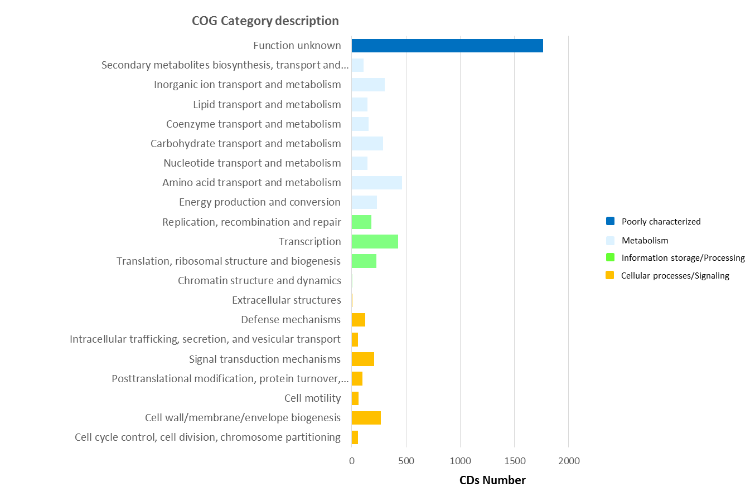

Figure S1. EggNOG functional classification of B. velezensis Bm3 genome. Functional analysis and orthologous group predictions for genes across multiple organisms was performed using the Evolutionary genealogy of genes: Non-supervised Orthologous Groups (EggNOG) through MaGe interface (https://mage.genoscope.cns.fr/).

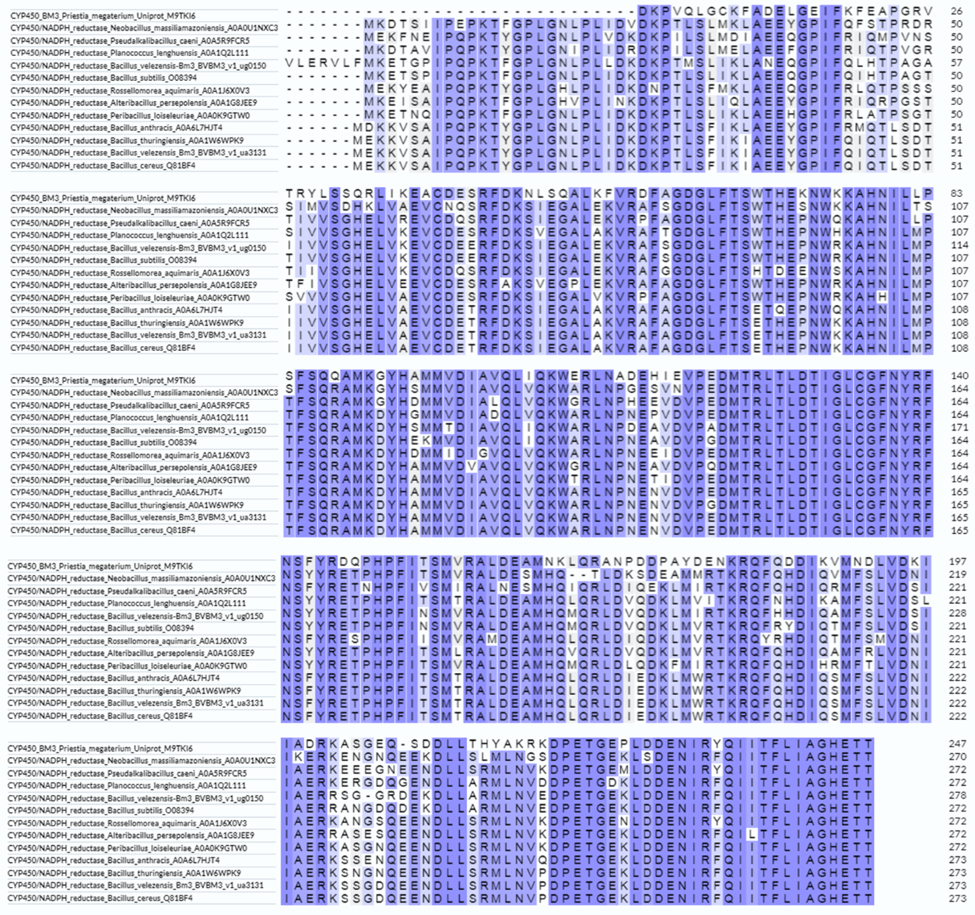

Figure S2: Multi-alignment of amino acids sequences of CYPBM3 of B. velezensis Bm3 with the top 10 proteins sharing the highest identities.

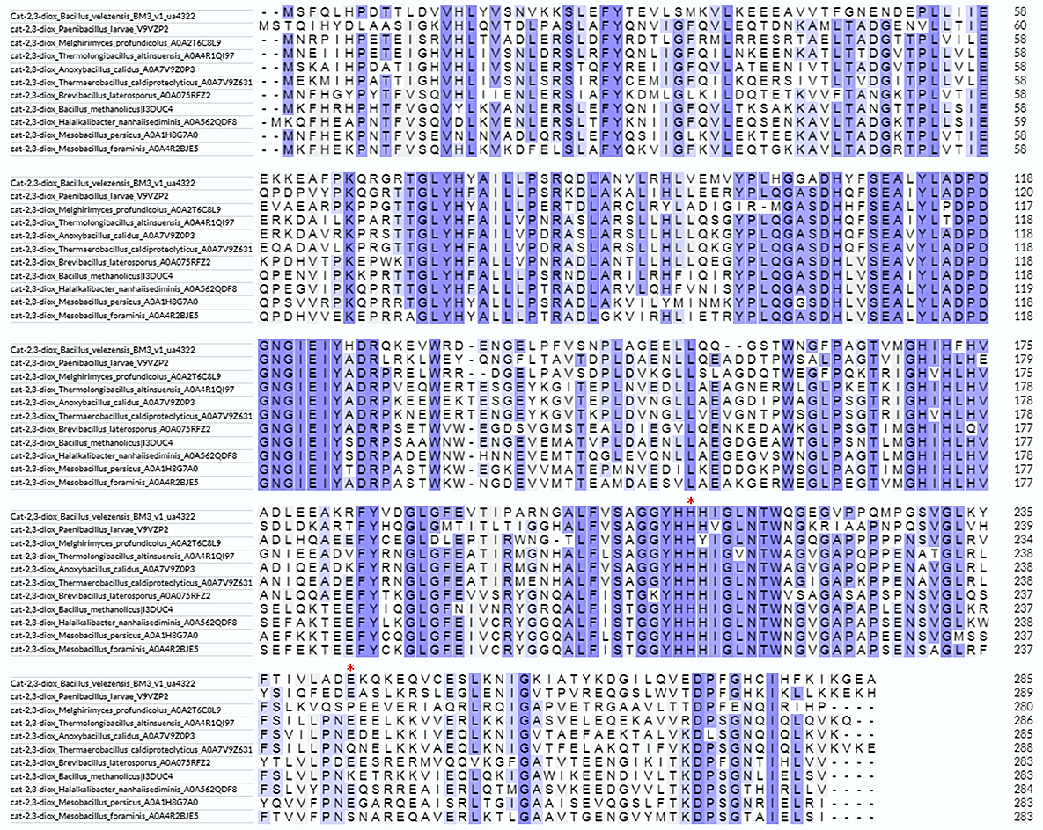

Figure S3: Multi-alignment of amino acids sequence of Catechol-2,3-dioxygenases from B. velezensis Bm3 with the top 10 sequences protein scoring the highest identities. (*) indicates the highly conserved active-site residues, the histidine at position 213 (H213) and glutamic acid at position 251 (E251) which are required for Fe(II) binding.

