Supplementary Materials: A Spatial and Technical Assessment of Floating Offshore Wind Energy in the Red Sea Using a GIS–AHP Framework

Appendix
Appendix A: Red Sea Characteristics
To assess the potential for offshore wind on the Red Sea, a better understanding of the characteristics of the Red Sea is required. The significant role of the Red Sea in global trade, being part of the East-West Shipping Lane, makes it an area of congested marine traffic. The Red Sea extends from Bab El-Mandeb in the south, which connects with the Gulf of Aden, all the way north to the Gulf of Suez in Egypt and the Gulf of Aqaba in Jordan. The area of the Red Sea is approximately 450,000 km², and its length from Bab Al-Mandeb to the Suez is about 1,930 km. The Gulf of Aqaba is about 180 km long and has an average width of 20 km [30]. The Gulf of Suez is about 300 km long and has a maximum width of 50 km [31].

Water depth
Figure 3a below depicts the range of depth on the Red Sea in meters, where the maximum depth of the Red Sea is observed at approximately 3,040 m. The Gulf of Suez has shallower waters that range from 54.86 m to 64 m and has a broad coastal plain. On the other hand, the Gulf of Aqaba has a contrasting narrow coastal plain, and a maximum depth of approximately 1,676.40 m with an average depth of 800 m. The remaining Red Sea coastline that begins from the convergence of the Gulf of Suez and the Gulf of Aqaba towards the southern Bab Al-Mandeb has a maximum depth of around 1,219 m [74].

Wind speed
In terms of wind characteristics on Saudi Arabia’s Red Sea Coast, the wind direction usually flows from the north-west, while wind speed depends on the location along the coast. Looking at speed observations in Saudi Arabia over the last decade collected by Windy [75], a weather forecast application, highlights the differences in wind speed range along its coastline. On the north-most west coast region of Saudi Arabia, in the Aqaba area of Tabuk Province, wind speeds can range from a low of 4.11 meters per second (m/s) to a high of 11.83 m/s, however, the typical range in the region is between 7.17 to 8.75 m/s. In the central-west coast region of Saudi, between the coastlines of Makkah and Madinah provinces, typical average wind speed profiles range from 6.11 to 7.83 m/s. While on the south-west coast of the country, in Jazan province, average wind speeds usually range from a low of 5.11 m/s to 6.17 m/s.
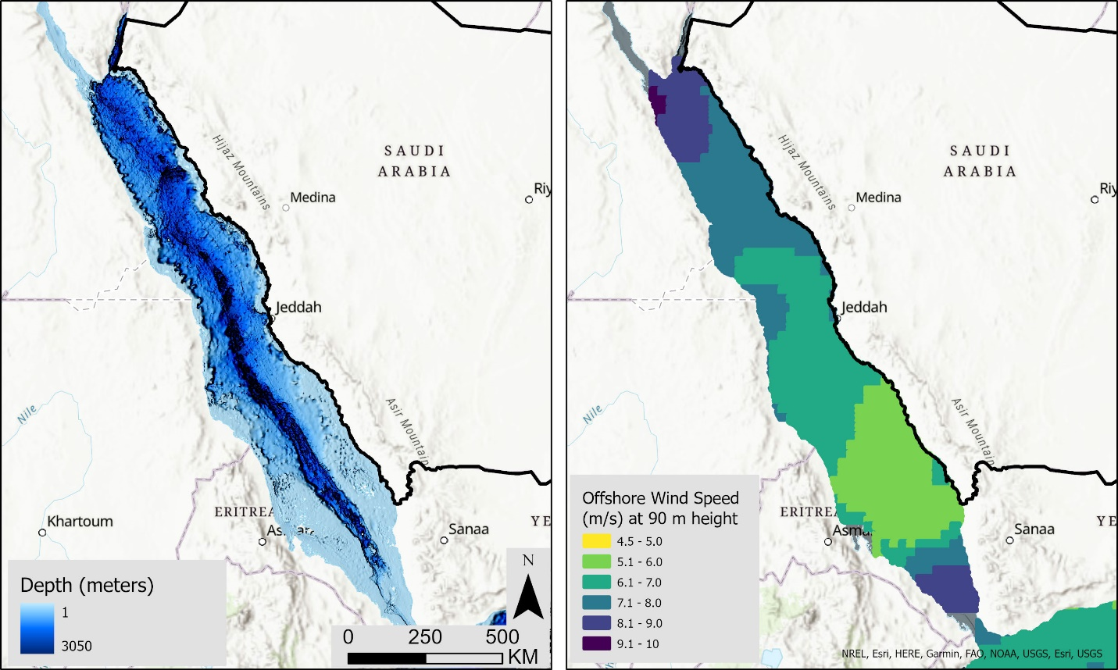
Figure A1 (left)- Red Sea depth in meters [6]. Figure 3b (Right)- Offshore wind potential in the Red Sea in meters/second. [76]

Saudi Arabia’s Red Sea ports
Installation of large structures is always a challenge, especially when it is in the middle of the sea. However, unlike fixed offshore wind turbines, part of the FOWT installation is done onshore on a floating structure before it is moored to the desired location and tethered to the seabed. The sheer size of the wind turbine components means they need a dedicated large area in the port for installations. Saudi Arabia has the necessary port infrastructure on its Red Sea coast to support the installation and mooring of FOWT.
On its Red Sea coast, Saudi Arabia has six of its 11 ports. Figure 4 above, showcases the distribution of the ports along the Red Sea, starting from the north with Duba Port, Yanbu Commercial Port, Yanbu Industrial Port, King Abdullah Port (the only private port in the country), Jeddah Islamic Port, and Jizan Port. Saudi Arabia is endowed with a strategic geographic location along the East-West shipping lane, where around 13% of international trade passes through the Suez Canal. In KSA, seaborne trade makes up an estimated 94% of the goods transported in volume and 77% in value. In 2019, the Saudi Ports Authority (MAWANI) indicated that the throughput in all Red Sea coast ports, including the private King Abdullah Port in KAEC, was an estimated 6.4 million TEUs. The total throughput reported in 2019 by MAWANI, excluding crude oil, is 262 million tons or 9.98 million Twenty-foot Equivalent Units (TEUs) for its nine public ports. The Jeddah Islamic Port is a major container port, handling approximately 63% of the country’s container throughput with 1.76 million container TEUs handled in 2019. The Yanbu Industrial Port is a major port in liquid bulk, handling approximately 61% of the country’s liquid bulk throughput (excluding crude oil) with 3 million TEUs.

Appendix B: AHP matrix consistency ratio
The CR is computed as the ratio of the consistency index (CI) to the random consistency index (RI), where CI = (λmax - n)/(n - 1), with λmax being the maximum eigenvalue of the pairwise comparison matrix and n the number of criteria. For our 7-criteria evaluation, the calculated CR value is 0.08, which is below the acceptable threshold of 0.1. This confirms that our pairwise comparisons are logically consistent and that the derived criteria weights are reliable and not the result of random judgments
Table B1: Normalized AHP Matrix and weights determination
Criteria | Wind speed​ | Bathymetry​ | Distance from Ports​ | Distance from Grid infrastructure​ | Low shipping  density | Distance from Tourism & Conservation​ | Distance from Aviation Radars | Weights
Wind speed​ | 0.47 | 0.70 | 0.39 | 0.43 | 0.28 | 0.24 | 0.30 | 40%
Bathymetry​ | 0.09 | 0.14 | 0.31 | 0.33 | 0.28 | 0.18 | 0.24 | 22%
Distance from Ports​ | 0.09 | 0.04 | 0.08 | 0.05 | 0.16 | 0.15 | 0.18 | 11%
Distance from Grid infrastructure​ | 0.12 | 0.05 | 0.16 | 0.11 | 0.16 | 0.21 | 0.18 | 14%
Low shipping  density | 0.07 | 0.02 | 0.02 | 0.03 | 0.04 | 0.09 | 0.03 | 4%
Distance from Tourism & Conservation​ | 0.06 | 0.02 | 0.02 | 0.02 | 0.01 | 0.03 | 0.02 | 3%
Distance from Aviation Radars | 0.09 | 0.04 | 0.03 | 0.04 | 0.08 | 0.09 | 0.06 | 6%

Table B2: Calculating consistency (Validation)
Criteria | Wind speed​ | Bathymetry​ | Distance from Ports​ | Distance from Grid infrastructure​ | Low shipping  density | Distance from Tourism & Conservation​ | Distance from Aviation Radars | Weighted  sum  value (1) | Weights (2) | (1)/(2)
Wind speed​ | 0.40 | 1.12 | 0.54 | 0.56 | 0.29 | 0.20 | 0.30 | 3.41 | 0.40 | 8.49
Bathymetry​ | 0.08 | 0.22 | 0.43 | 0.42 | 0.29 | 0.15 | 0.24 | 1.84 | 0.22 | 8.20
Distance from Ports​ | 0.08 | 0.06 | 0.11 | 0.07 | 0.17 | 0.13 | 0.18 | 0.79 | 0.11 | 7.36
Distance from Grid infrastructure​ | 0.10 | 0.07 | 0.21 | 0.14 | 0.17 | 0.18 | 0.18 | 1.05 | 0.14 | 7.55
Low shipping  density | 0.06 | 0.03 | 0.03 | 0.03 | 0.04 | 0.08 | 0.03 | 0.30 | 0.04 | 7.11
Distance from Tourism & Conservation​ | 0.05 | 0.04 | 0.02 | 0.02 | 0.01 | 0.03 | 0.02 | 0.19 | 0.03 | 7.46
Distance from Aviation Radars | 0.08 | 0.06 | 0.04 | 0.05 | 0.08 | 0.08 | 0.06 | 0.44 | 0.06 | 7.29

Table B3: Calculating consistency ratio
Number of criteria (n) | 7
Lambda | 7.6386
Consistency Index (C.I.) | 0.1064
Consistency Ratio (C.R.) = Consistency Index (C.I.)/Random Index(R.I.)
Consistency Ratio (C.R.) | 0.0806

Appendix C: Turbine choice justification
This analysis utilizes the NREL 15 MW reference turbine as the baseline technology. This choice reflects the current trajectory of offshore wind technology development and is justified by several considerations:
- Technology timeline alignment: Given Saudi Arabia's FOWT development is in early planning stages, any large-scale deployment would occur in the late 2020s or early 2030s. By that timeframe, 15 MW-class turbines will represent mature, commercially available technology. Several manufacturers including Vestas (V236-15.0 MW), GE Renewable Energy (Haliade-X 14 MW with 15+ MW uprate potential), and Siemens Gamesa (SG 14-222 DD with planned uprates) have already announced 14-15 MW offshore turbines entering the market in 2024-2026 [52].
- Industry trend toward larger turbines: The offshore wind industry has consistently moved toward larger unit sizes to reduce levelized costs. Recent European and Asian tenders increasingly specify 14-15 MW turbines, and development continues toward 18-20 MW designs for deployment in the 2030s [3].
- FOWT cost optimization: Larger turbines are particularly beneficial for floating platforms, as foundation and mooring costs scale more slowly than turbine rated power, resulting in improved unit economics. Studies indicate that 15 MW turbines on floating platforms can achieve 15-20% lower LCOE compared to 10 MW turbines in similar wind regimes [12].

Figure C1: NREL ATB reference 15MW turbine power curve

