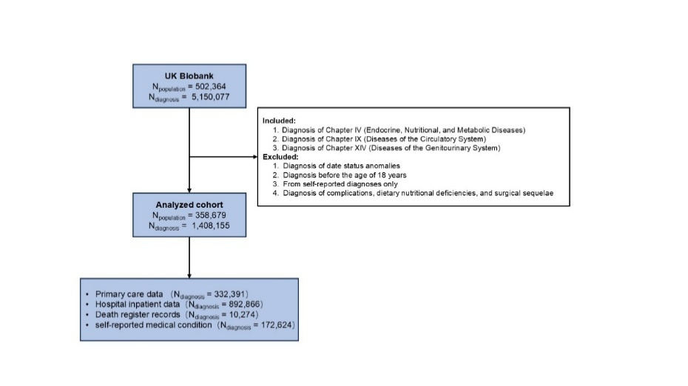
Supplementary Figure 1. Flowchart of Data Inclusion and Exclusion for Trajectory Analysis.
Supplementary Figure 2. Age- and calendar-year distributions of diagnoses across data sources and sex. Upper panels show kernel-smoothed counts of diagnoses by age at diagnosis (years); lower panels show counts by calendar year of diagnosis. Rows are stratified by sex, columns by data source, and colored areas stack counts for ICD-10 Chapters.
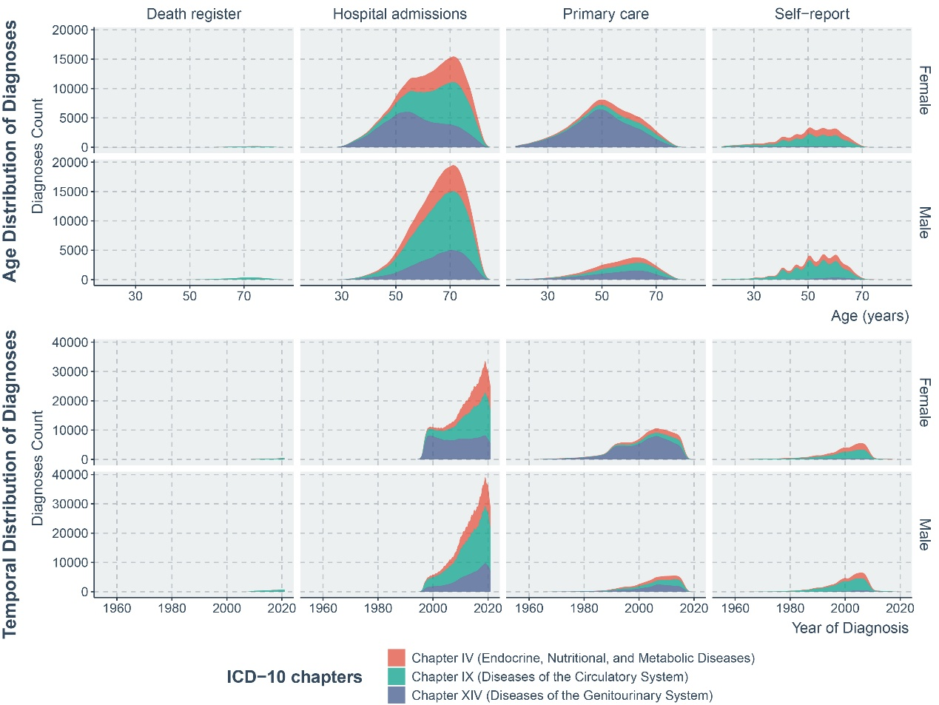

Supplementary Figure 3. Top Initial Diagnoses Across Three- to Five-Stage Disease Trajectories. Different colors denote distinct diseases and correspond to the color scheme used in the Sankey diagram in Figure 3.
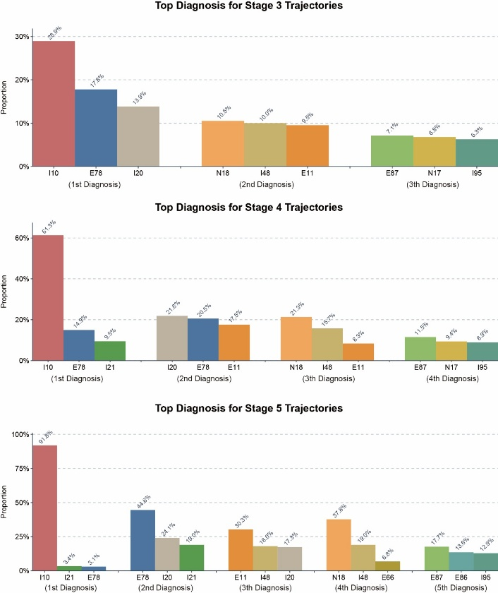
Supplementary Figure 4. Network‐Based Identification of Disease Clusters Using Louvain Community Detection (Left panel) and Markov Clustering (Right panel).
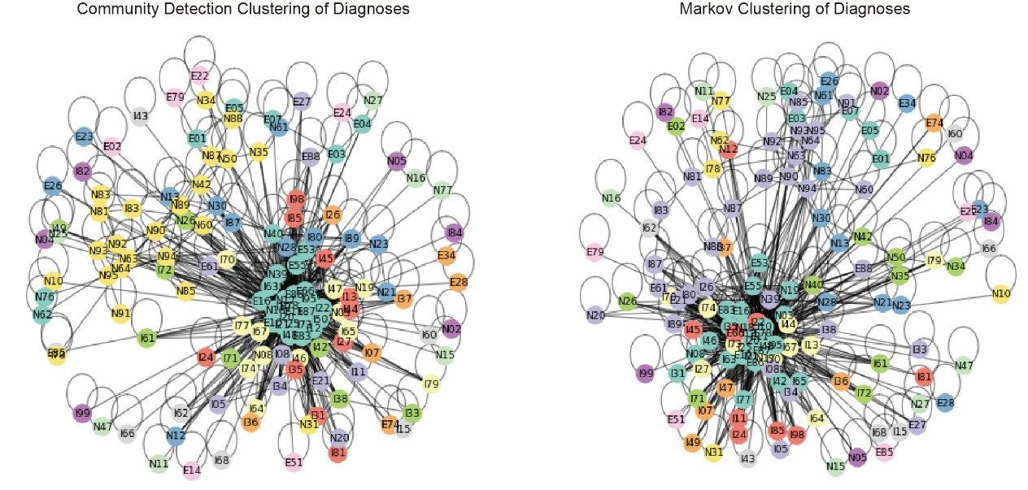

Supplementary Figure 5. Sankey diagrams of ICD-10 diagnostic transitions in hospital-based data. (A) Trajectory-based Sankey chart showing aggregated sequential disease pairs; only transitions occurring in ≥10 cases are displayed. (B) Individual-based Sankey chart showing person‐level transitions; only transitions occurring in ≥100 individuals are displayed. Node color denotes the corresponding ICD-10 category. (C) Directed subnetwork of the core module: node size is proportional to five‐year mortality risk, and edge width reflects the five‐year transition probability between diagnoses.

