Supplementary Method
Causal relations among the whole set of 196 diseases
By pairing every possible combination of two diagnoses, we generated a large set of diagnostic pairs. For each pair $\left(D_{1},D_{2}​\right)$, we then constructed a separate cohort (Figure 1). Within that cohort, all individuals with a first‐occurrence diagnosis of $D_{1}$​​ (and no prior $D_{2}$) comprised the exposed group ($N_{exposed}$); the date of hospital discharge for $D_{1}$​​​ defined each subject’s time zero. We then counted the number of those subjects who received a diagnosis of $D_{2}$​ within five years ($C_{exposed}$​​). In parallel, we built 1:1 age‐, sex‐, and discharge‐date–matched control groups of individuals without $D_{1}$​​​​ ($N_{control}$) and likewise observed their five‐year incidence of $D_{2}$​​ ($C_{control}$​​)​. To ensure temporal ordering, anyone in either group with a prior $D_{2}$​ diagnosis before time zero was excluded from analysis.
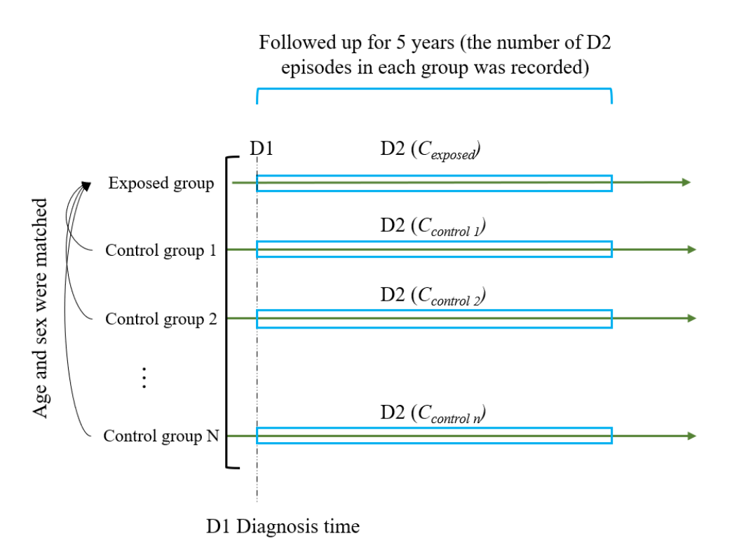
Figure 1. Schematic of Cohort Construction and Five-Year Follow-up for D₂ Incidence in Exposed versus Matched Control Groups. Exposed group ($N_{exposed}$): individuals with a first‐occurrence D₁ and no prior D₂. Control group ($N_{control}$): age-, sex- and discharge-date–matched individuals without prior D₁ or D₂ (1∶1 matching).

We quantified the strength of association for each diagnostic pair by computing the risk ratio (RR):
$$Relative Risk \left(RR\right)=\frac{C_{exposed}}{\frac{1}{N}\sum_{i}{C_{control, i}}}$$
(Equation 1)
To obtain confidence bounds and a significance P value (Equation 2) without relying solely on a single point estimate, we would ideally resample controls many times.
$$P=\frac{1}{N}\left\{\left.i\right|C_{control, i}≥C_{exposed}\right\}$$
(Equation 2)
Here, $C_{control, i}$ is the five‐year event count in the $ith$ resampled control set, and $N$ is the total number of such sets.

However, extensive resampling across all diagnostic pairs would incur prohibitive computational costs. To pre‐screen candidate pairs rapidly, we adopted the simplified binomial‐model approach of Brunak et al.; they showed that, in the region of small P values, this binomial approximation is in fact more conservative than full resampling.
In the prescreening step, we denoted the total number of exposed individuals with diagnosis D₁ as $n_{exposed}$ ​. For the $i$-th exposed individual, we defined the size of its matched‐control pool as $n_{match,i}$ and let $C_{i}$ be the number of those control individuals that experienced diagnosis D₂ within five years; thus, the control group event probability for that trail is $\operatorname{Pr}\left(D2​\right)$ (Equation 3). Averaging over all $n_{exposed}$​ trials gives the overall event‐probability estimate $\hat{Pr}{\left(D_{2}\right)}_{\text{test}}$(Equation 3).

$$\operatorname{Pr}\left(D2​\right)=\frac{c_{i}}{n_{\text{match},i}}​$$
(Equation 3)

$$\hat{Pr}{\left(D_{2}\right)}_{\text{test}}=\frac{1}{n_{\text{exposed}}}\sum_{i=1}^{n_{\text{exposed}}}{\frac{c_{i}}{n_{\text{match},i}}}$$
(Equation 4)
Using this binomial framework greatly reduces computational cost while remaining conservative in the small P regime. We then applied a significance threshold (P < 0.05) and required $C_{exposed} ≥ 20$ to filter out unstable estimates. Pairs that passed these filters then underwent bootstrap validation against 10,000 resampled control sets, yielding RR estimates with 95% CIs and exact p-values (Equation 1, 2).

Directionality of the Multimorbid Disease Pairs
For each diagnostic pair ($D1, D2$) with a RR > 1 and at least one direction ($D_{1}→D_{2}$ or $D_{2}→D_{1}$) yielding a significant P value, we performed a directionality test to establish whether one diagnosis consistently precedes the other in time. In this test, we first identified all individuals who received both diagnoses at least once. For each such individual, we recorded the order in which $D_{1}$and $D_{2}$ appeared at their first diagnosis bearing both codes. We then counted three mutually exclusive groups:
- $N_{D1}$: number of individuals whose first‐discharge record lists $D_{1}$ before $D_{2}$,
- $N_{D2}$: number whose record lists $D_{2}$ before $D_{1}$, and
- $N_{same}$: number whose record lists $D_{1}$ and $D_{2}$, together on the same discharge.
These satisfy $N_{tatol}= N_{D1}+ N_{D2}+ N_{same}$. Under the null hypothesis of no temporal bias, a individual with both diagnoses is equally likely to receive $D_{1}$ first or $D_{2}$, first (each with probability 0.5). We therefore applied two one‐sided binomial tests (including all $N_{same}$ cases in the denominator $N_{tatol}$ to ask separately whether $N_{D1}$ or $N_{D2}$ significantly exceeds its expected value. We computed P values for both directions and applied a Bonferroni correction for two tests, retaining only pairs with one significant direction. This guarantees reproducible temporal ordering and highlights directional (and potentially causal) multimorbidity relationships.

Construction of multi‐level disease trajectories
Each significant directional disease pair ($D_{1}$→$D_{2}$) was treated as a stage 2 trajectory. To further explore individuals’ progression pathways, we concatenated related diagnostic pairs to extend these into stage 3 trajectories ($D_{1}$→$D_{2}$→$D_{3}$). Two distinct strategies were employed during trajectory extension: one, termed “trajectory flow,” identifies all potential trajectories; the other, termed “population flow,” relies on trajectories observed in the actual cohort.
In trajectory flow, we first retrieved the cohort of individuals following a given stage 2 trajectory ($D_{1}$→$D_{2}$) and tabulated the types and frequencies of subsequent diagnoses ($D_{3}$) in their later encounters. We then ranked these candidate $D_{3}$ diagnoses in descending order of occurrence frequency and, starting from the most frequent, iteratively identified individual subgroups corresponding to each stage 3 trajectory ($D_{1}$→$D_{2}$→$D_{3}$) until no further candidate diagnoses remained. This approach allowed us to examine all potential stage 4 trajectories and confirm the individual populations adhering to each. Using the same procedure, we sequentially expanded stage 3 trajectories into stage 4, stage 5, and stage 6 trajectories, terminating when no additional individuals met the criteria for longer sequences. At each expansion stage, we recorded the number of individuals fitting the current trajectory and relevant cohort statistics.
In population flow, we first grouped individuals by each stage 2 trajectory ($D_{1}$→$D_{2}$) and assigned each individual to exactly one such trajectory; if a individual qualified for multiple stage 2 trajectories, they were only allocated to the trajectory with the largest population, reflecting the most prevalent pathway in the real‐world cohort. Within each assigned stage 2 trajectory, individuals were then similarly allocated to at most on stage 3 trajectory—specifically, the candidate trajectory with the highest individual count. The same allocation strategy was subsequently applied to expand higher stage trajectories. In this way, each individual was assigned to a single trajectory, thereby fully illustrating the distribution of different pathways within the real‐world population.
We evaluated trajectory robustness via bootstrap resampling to compute a support value for each trajectory, defined as the proportion of resampled cohorts in which at least 20 individuals still follow the trajectory. The original number of individuals on the trajectory ($N$) and​ the total cohort size ($N_{pop}$), we set the sampling probability ($p=N/N_{pop}$)​. In each of 10,000 resamples of size ​, the number of trajectory individuals follows a Binomial distribution ($N_{pop}, p$). The support value is then estimated as the fraction of resamples meeting ($C ≥20$). Only trajectories with support exceeding 0.99 were retained. This bootstrap‐based assessment was performed independently for each trajectory order, and the corresponding results were saved for subsequent analysis.

Construction of trajectory networks and identification of key diagnoses
We further analyzed the relationships and patterns among the identified trajectory flows by applying clustering algorithms to detect diagnostic combinations with similar characteristics. Specifically, we calculated the Jaccard similarity coefficient for each pair of trajectories—reflecting shared diagnoses—to construct a distance matrix, which was then used as input for community detection via the Markov cluster algorithm (MCL) and the Louvain method. To evaluate the consistency between these two clustering approaches, we quantified their agreement using normalized mutual information (NMI). Based on the clustering results, we selected trajectories for downstream analysis by retaining only those whose constituent diagnoses fell entirely within the clusters of interest.
We constructed a directed disease network in which each node’s size reflects its 5-year mortality rate and each edge’s thickness encodes the probability that disease $D_{1}$ progresses to $D_{2}$ within five years. From our trajectory data, we extracted every consecutive disease pair and—restricting to patients with at least five years of follow-up—calculated both the unconditional progression probability (the fraction of $D_{1}$ patients who developed $D_{2}$ within five years) and the probability of death after $D_{1}$.
To reveal each disease’s role in the network, we performed a comprehensive topological analysis using centrality metrics. Degree centrality (the count of direct connections) gauges a disease’s immediate influence, while betweenness centrality (how often a node falls on the shortest paths between others) identifies those that act as critical “bridges.” Closeness centrality (the inverse average distance to all other nodes) measures how efficiently a disease can transmit effects through the network, and eigenvector centrality weights each connection by its neighbor’s importance, thus capturing global prominence.

Validate Central Diagnosis
For each index diagnosis, we defined the set of diagnoses occurring beforehand as the preceding diagnosis set and those occurring afterward as the subsequent diagnosis set. To assess the impact of each key diagnosis, we built a separate prospective nested case–control cohort for each one. In each cohort, the exposed group included individuals who, after receiving any diagnosis from the preceding set, later developed a diagnosis from the subsequent set during follow-up. We then matched these exposed subjects to controls by age, sex, and observation time; controls had a preceding set diagnosis but did not go on to develop any subsequent set diagnosis within the same follow-up period. For each cohort, we compared the incidence of the key diagnosis between exposed and control groups by calculating the relative risk (RR), and we used a resampling method to estimate its confidence interval and statistical significance (The calculations were the same as the causal diagnostic estimates described above).

