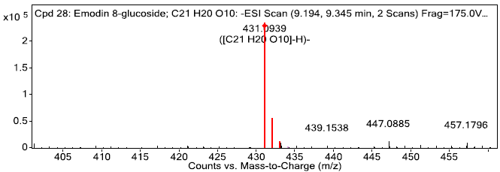
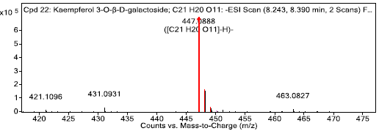
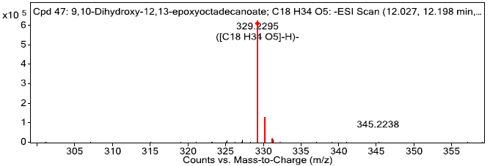
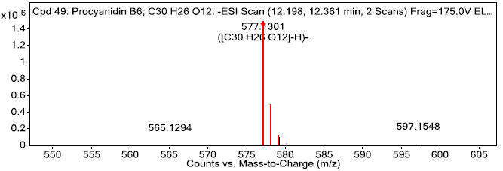
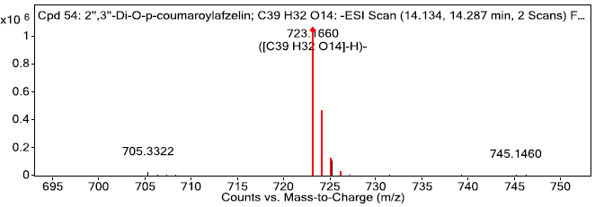
A
B
C
D
E

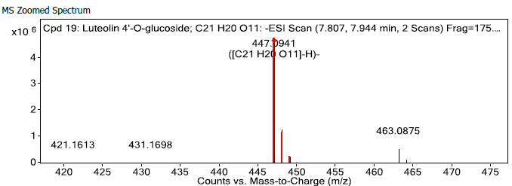
F

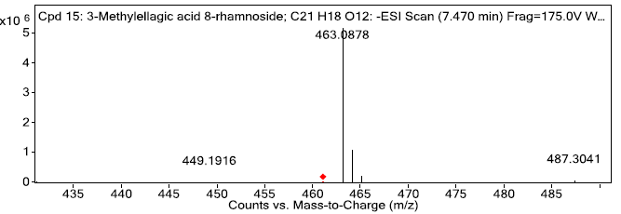
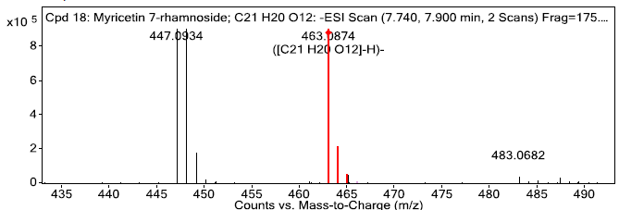
H
G

Figure S1: Mass spectral analysis of top-ranked docked compounds against 4-Hydroxyphenylpyruvate dioxygenase (HPPD) from A. lanatum ethanol (Ale) and water extracts (Alw): (A) Kaempferol 3-O-β-D-galactoside (Ale), (B) Emodin 8-glucoside (Ale), (C) 9,10-Dihydroxy-12,13-epoxyoctadecanoate (Ale), (D) Procyanidin B6 (Ale), (E) 2'',3''-Di-O-p-coumaroylafzelin (Ale), (F) Luteolin 4’-O- glucoside (Alw), (G) Myricetin 7-rhamnoside (Alw), (H) 3-Methylellagic acid 8-rhamnoside (Alw)

