BA-1/BA-3 preparation [1]( https://doi.org/10.1016/j.ejmech.2023.115975)
Synthesis of 1. 4-(diphenylamino) phenylboronic acid (433.7 mg, 1.50 mmol), pyridine-4-boronic acid (289.4 mg, 1.50 mmol), potassium carbonate (1382.1 mg, 10.00 mmol), and tetrakis (triphenylphosphine)- palladium (80.9 mg, 0.070 mmol) were dissolved into a mixture of THF (50 mL) and H2O (5 mL), and the mixture was ultrasonically degassed and refluxed at 70 ◦C for 8 h under an N2 atmosphere. TLC was used to determine the progress of the reaction (VPE: VEA =12:1). Then, 1 was purified by column chromatography on silica gel with a mixture of PE and EA as an eluent (10:1 by volume), obtaining a faint yellow powder (225.0 mg, 46.6 % yield). 1H NMR (400 MHz, DMSO‑d6) δ 8.58 (d, J =5.6 Hz, 2H), 7.73 (d, J =8.3 Hz, 2H), 7.65 (d, J =5.6 Hz, 2H), 7.35 (t, J =7.7 Hz, 4H), 7.10 (t, J =7.5 Hz, 6H), 7.03 (d, J =8.3 Hz, 2H). 13C NMR (101 MHz, DMSO‑d6) δ 150.62, 148.90, 147.14, 146.78, 130.46, 130.20, 128.27, 125.24, 124.32, 122.64, 120.89. Mp: 160–162 ◦C. MS (ESI-APCI): calculated for [C23H18N2+H] +323.1; found 323.1. Synthesis of 2. Potassium tert-butoxide (134.6 mg, 1.20 mmol) and 4-methylpyridine (93.0 mg, 1.00 mmol) were dissolved into DMF (20 mL), and the mixture was stirred at R.T. for 0.5 h under an N2 atmosphere. Then, 4-(N, N-diphenylamino) benzaldehyde was added and the mixture was ultrasonically degassed and refluxed at 80 ◦C for 12 h under an N2 atmosphere. TLC was used to determine the progress of the reaction (VPE: VEA =5:1). Then, 2 was purified by column chromatography on a silica gel with a mixture of PE and EA as an eluent (3:1 by volume), obtaining a yellow powder (298.0 mg, 85.6 % yield). 1H NMR (400 MHz, DMSO‑d6) δ 8.51 (d, 2H), 7.55 (d, 2H), 7.51 (dd, J =6.8, 2.3 Hz, 3H), 7.46 (s, 1H), 7.33 (t, 4H), 7.14–7.01 (m, 7H), 6.96 (d, 2H). 13C NMR (101 MHz, DMSO‑d6) δ 150.42, 148.16, 147.22, 145.02, 132.97, 130.42, 130.13, 128.76, 125.00, 124.44, 124.10, 122.73, 121.09. Mp: 130–131 ◦C. MS (ESI-APCI): calculated for [C25H20N2+H] +349.1; found 349.1.
Synthesis of 4. 4,7-dibromo-2,1,3-benzothiadiazole (437.7 mg, 1.50 mmol), 4-(diphenylamino)phenylboronic acid (433.7 mg, 1.50 mmol), potassium carbonate (1382.1 mg, 10.00 mmol), and tetrakis (triphenylphosphine)-palladium (80.9 mg, 0.070 mmol) were dissolved into a mixture of THF (50 mL) and H2O (5 mL), and the mixture was ultrasonically degassed and refluxed at 70 ◦C for 8 h under an N2 atmosphere. TLC was used to determine the progress of the reaction (VPE: VEA =20:1). Then, 1 was purified by column chromatography on silica gel with a mixture of PE and EA as an eluent (10:1 by volume), obtaining a yellow powder (278.8 mg, 40.8 % yield). 1H NMR (400 MHz, DMSO‑d6) δ 8.08 (d, J =7.7 Hz, 1H), 7.94–7.86 (m, 2H), 7.73 (d, J =7.6 Hz, 1H), 7.40–7.31 (m, 4H), 7.14–7.05 (m, 8H). 13C NMR (101 MHz, chloroform- d) δ 153.98, 153.17, 148.46, 147.35, 133.59, 132.38, 129.91, 129.86, 129.41, 127.33, 125.06, 123.53, 122.63, 112.20. Mp: 140–142 ◦C.
Synthesis of 3. 4 (685.5 mg, 1.50 mmol), pyridine-4-boronic acid (184.6 mg, 1.50 mmol), potassium carbonate (1382.1 mg, 10.00 mmol), and tetrakis (triphenylphosphine)-palladium (80.9 mg, 0.070 mmol) were dissolved into the mixture of THF (50 mL) and H2O (5 mL), and the mixture was ultrasonically degassed and refluxed at 70 ◦C for 8 h under an N2 atmosphere. TLC was used to determine the progress of the reaction (VPE: VEA =2:1). Then, 1 was purified by column chromatography on silica gel with a mixture of PE and EA as an eluent (1:1 by volume), obtaining a deep yellow powder (236.9 mg, 34.6 % yield). 1H NMR (400 MHz, chloroform-d) δ 8.80–8.74 (m, 2H), 7.97–7.91 (m, 2H), 7.88 (dd, J =8.0, 3.4 Hz, 3H), 7.78 (d, J =7.4 Hz, 1H), 7.30 (t, J =7.8 Hz, 4H), 7.24–7.17 (m, 7H), 7.08 (t, J =7.3 Hz, 2H). 13C NMR (101 MHz, chloroform-d) δ 154.08, 153.65, 150.19, 148.52, 147.35, 144.73, 134.72, 130.18, 130.08, 129.43, 129.29, 128.95, 126.87, 125.10, 123.56, 123.49, 122.57, 60.39, 14.21. Mp: 147–149 ◦C. MS (ESI-APCI): calculated for [C23H18N2+H] +457.1; found 457.1.
General procedure for the preparation of 5, 6, and 7. BA (456.7 mg, 1.00 mmol), 1,4-dibromobutane (855.6 mg, 4.00 mmol), and potassium carbonate (138.2 mg, 1.00 mmol) were dissolved into acetone (20 mL), and the mixture was refluxed at 65 ◦C for 4 h. TLC was used to determine the progress of the reaction (VPE: VEA =3:1). Then, 5, 6, or 7 were purified by column chromatography on a silica gel with a mixture of PE and EA as an eluent (2:1 by volume).
White powder 5 (500.0 mg, 84.7 % yield): 1H NMR (400 MHz, chloroform-d) δ 4.73 (d, J =2.3 Hz, 1H), 4.60 (dd, J =2.4, 1.4 Hz, 1H), 4.19–4.04 (m, 2H), 3.44 (t, J =6.6 Hz, 2H), 3.18 (dd, J =11.2, 5.0 Hz, 1H), 3.05–2.94 (m, 1H), 2.27–2.14 (m, 2H), 2.02–1.75 (m, 6H), 1.68 (s, 4H), 1.67–1.45 (m, 3H), 1.45–1.39 (m, 2H), 1.43–1.35 (m, 5H), 1.38–1.32 (m, 1H), 1.35–1.22 (m, 2H), 1.24–0.99 (m, 2H), 0.96 (s, 6H), 0.92 (s, 3H), 0.82 (s, 3H), 0.75 (s, 3H), 0.72–0.64 (m, 1H). 13C NMR (101 MHz, chloroform-d) δ 176.09, 150.52, 109.63, 78.99, 62.84, 56.59, 55.38, 50.59, 49.44, 47.03, 42.44, 40.74, 38.87, 38.75, 38.34, 37.22, 37.06, 34.36, 32.98, 32.20, 30.65, 29.68, 29.51, 28.00, 27.51, 27.43, 25.56, 20.93, 19.38, 18.31, 16.14, 16.05, 15.36, 14.71. Mp: 67–69 ◦C. [α]D 20 =+70.2◦ (c 0.1, CH3OH).
White powder 6 (512.5 mg, 86.8 % yield): 1H NMR (400 MHz, chloroform-d) δ 5.29 (t, J =3.7 Hz, 1H), 4.05 (t, J =6.2 Hz, 2H), 3.43 (t, J =6.7 Hz, 2H), 3.21 (dd, J =11.3, 4.8 Hz, 1H), 2.86 (dd, J =13.7, 4.5 Hz, 1H), 2.03–1.82 (m, 5H), 1.85–1.72 (m, 2H), 1.75–1.64 (m, 1H), 1.67–1.57 (m, 4H), 1.61–1.43 (m, 4H), 1.47–1.40 (m, 1H), 1.40–1.24 (m, 3H), 1.13 (s, 3H), 1.24–1.02 (m, 3H), 0.99 (s, 3H), 0.97 (s, 1H), 0.95–0.88 (m, 9H), 0.76 (d, J =19.7 Hz, 7H). 13C NMR (101 MHz, chloroform-d) δ 176.09, 150.52, 109.63, 78.99, 62.84, 56.59, 55.38, 50.59, 49.44, 47.03, 42.44, 40.74, 38.87, 38.75, 38.34, 37.22, 37.06, 34.36, 32.98, 32.20, 30.65, 29.68, 29.51, 28.00, 27.51, 27.43, 25.56, 20.93, 19.38, 18.31, 16.14, 16.05, 15.36, 14.71. Mp: 65–68 ◦C. [α]D 20 =+66.5◦ (c 0.1, CH3OH).
White powder 7 (522.6 mg, 88.5 % yield): 1H NMR (400 MHz, chloroform-d) δ 5.24 (t, J =3.7 Hz, 1H), 4.18–3.93 (m, 2H), 3.43 (t, J =6.7 Hz, 2H), 3.21 (dd, J =10.8, 5.0 Hz, 1H), 2.22 (dd, J =11.4, 1.8 Hz, 1H), 2.09–1.93 (m, 2H), 1.95 (dd, J =5.1, 2.0 Hz, 1H), 1.97–1.86 (m, 3H), 1.83–1.21 (m, 14H), 1.08 (s, 3H), 0.99 (s, 3H), 0.97–0.90 (m, 6H), 0.86 (d, J =6.4 Hz, 3H), 0.77 (d, J =12.7 Hz, 6H), 0.72 (dd, J =11.6, 1.8 Hz, 1H). 13C NMR (101 MHz, chloroform-d) δ 177.51, 138.24, 125.63, 79.03, 63.16, 55.24, 52.90, 48.14, 47.57, 42.09, 39.58, 39.10, 38.89, 38.76, 38.64, 37.00, 36.78, 33.06, 30.68, 29.53, 28.16, 27.98, 27.34, 27.25, 24.25, 23.56, 23.31, 21.17, 18.33, 17.17, 17.02, 15.63, 15.46. Mp: 51–53 ◦C. [α]D 20 =+88.1◦ (c 0.1, CH3OH).
General procedure for the preparation of BA-1and BA-3. 1 (161.1 mg, 0.50 mmol), 2 (174.1 mg, 0.50 mmol), or 3 (228.1 mg, 0.50 mmol), and 5 (295.2 mg, 0.50 mmol), 6 (295.2 mg, 0.50 mmol), or 7 (295.2 mg, 0.50 mmol) were dissolved into acetonitrile (10 mL), and the mixture was refluxed at 90 ◦C for 12 h. TLC was used to determine the progress of the reaction (VDCM:VMeOH =80:1). Then, BA-1and BA-3 were purified by column chromatography on silica gel with a mixture of DCM and MeOH as an eluent (40:1 by volume).
Yellow powder BA-1 (250.1 mg, 54.8 % yield): 1H NMR (400 MHz, chloroform-d) δ 9.26 (d, J =6.7 Hz, 2H), 8.07 (d, J =6.6 Hz, 2H), 7.69–7.63 (m, 2H), 7.36 (t, J =7.8 Hz, 4H), 7.24–7.14 (m, 6H), 7.10–7.03 (m, 2H), 4.96 (t, J =7.5 Hz, 2H), 4.70 (d, J =2.3 Hz, 1H), 4.59 (t, J =1.9 Hz, 1H), 4.22–4.06 (m, 3H), 3.17 (dd, J =11.4, 4.6 Hz, 1H), 3.00–2.89 (m, 1H), 2.25–2.16 (m, 1H), 2.20–2.09 (m, 2H), 2.08 (d, J =8.6 Hz, 1H), 1.81 (q, J =6.6 Hz, 4H), 1.66 (s, 3H), 1.71–1.50 (m, 3H), 1.50–1.18 (m, 7H), 1.22–1.08 (m, 2H), 1.07–0.85 (m, 8H), 0.81 (s, 3H), 0.73 (d, J =10.0 Hz, 6H), 0.69–0.61 (m, 1H). 13C NMR (101 MHz, chloroform-d) δ 176.21, 155.08, 152.35, 150.41, 145.73, 144.21, 129.87, 129.02, 126.34, 125.50, 123.72, 122.63, 120.17, 109.70, 78.90, 62.52, 60.39, 59.70, 56.56, 55.31, 50.51, 49.38, 46.99, 42.40, 40.71, 38.84, 38.70, 38.25, 37.16, 37.03, 34.32, 32.07, 30.61, 29.69, 28.50, 27.99, 27.38, 25.50, 21.03, 20.91, 19.32, 18.27, 16.13, 16.09, 15.39, 14.67, 14.19. Mp: 169–178 ◦C. [α]D 20 =+9.3◦ (c 0.1, CH3OH). HPLC purity: 96.43 %. MS (ESI-APCI): calculated for [C57H73N2O3] +833.5; found 833.5.
Deep red powder BA-3 (281.0 mg, 53.7 % yield): 1H NMR (400 MHz, chloroform-d) δ 9.52–9.46 (m, 2H), 8.96–8.89 (m, 2H), 8.31 (d, J =7.7 Hz, 1H), 7.95–7.83 (m, 3H), 7.32 (dd, J =8.5, 7.3 Hz, 4H), 7.24–7.08 (m, 8H), 5.13 (t, J =7.5 Hz, 2H), 4.71 (d, J =2.3 Hz, 1H), 4.59 (t, J =1.9 Hz, 1H), 4.27–4.07 (m, 2H), 3.14 (dd, J =11.5, 4.5 Hz, 1H), 3.01–2.90 (m, 1H), 2.25–2.17 (m, 1H), 2.21–2.13 (m, 1H), 2.19–2.00 (m, 1H), 1.85 (h, J =6.3, 5.9 Hz, 3H), 1.66 (s, 3H), 1.62–1.51 (m, 1H), 1.48–1.18 (m, 6H), 1.17–1.09 (m, 1H), 1.06–0.85 (m, 7H), 0.87–0.80 (m, 1H), 0.78 (s, 3H), 0.65 (d, J =7.6 Hz, 6H). 13C NMR (101 MHz, chloroform-d) δ 176.26, 153.98, 153.02, 152.64, 150.38, 149.53, 146.92, 144.48, 138.47, 132.26, 130.49, 129.55, 128.46, 126.41, 126.34, 125.55, 124.13, 122.99, 121.64, 109.74, 78.88, 62.32, 60.42, 56.58, 55.25, 50.48, 49.39, 47.00, 42.40, 40.70, 38.79, 38.66, 38.25, 37.12, 34.30, 30.61, 29.70, 28.63, 27.93, 27.34, 25.60, 25.49, 20.89, 19.32, 18.20, 16.09, 16.04, 15.31, 14.66. Mp: 235–242 ◦C. [α]He-Ne 20 =+6.2◦ (c 0.1, CH3OH). HPLC purity: 97.53 %. MS (ESI-APCI): calculated for [C63H75N4O3S] +967.5; found 967.5.
Dimethyl sulfoxide (DMSO) was uniformly used as the solvent for preparing BA-1 and BA-3 stock solutions. The stock concentrations of BA-1 and BA-3 were both set to 20 mM. This concentration was determined based on the solubility of the compounds in DMSO and the experimental concentration range required for PDT on melanoma cells, which can ensure that the stock solution has good stability and can be diluted to the required working concentration without obvious precipitation. A two-step gradient dilution method was adopted to prepare the working concentration of BA-1 and BA-3 from the stock solution. First, the 20 mM stock solution was diluted with DMSO to a 2 mM intermediate dilution solution; then, the intermediate dilution solution was further diluted with complete Dulbecco's Modified Eagle Medium (DMEM) (containing 10% fetal bovine serum and 1% penicillin-streptomycin) to the working concentrations required for the experiment (the working concentration range of BA-1 was 0.5~10 μM, and that of BA-3 was 0.5~20 μM). During the dilution process, the solution was gently mixed by vortex oscillation for 30 seconds each time to ensure uniform concentration and avoid local concentration differences. After dilution to the working concentration, the final volume percentage of DMSO (solvent) in the cell culture medium was 0.1% for both BA-1 and BA-3 experimental groups. The vehicle control group was added with DMSO diluted with complete DMEM, and the final volume percentage of DMSO in the culture medium was also 0.1%, which was completely consistent with that of the BA-1 and BA-3 experimental groups. This ensures that the interference of DMSO itself on the experimental results can be effectively excluded, and the experimental effects can be accurately attributed to the compounds and PDT synergistic effect.
Table SI The antibodies involved in the article：
Antibody | Catalog number | Dilution | Supplier
C-MYC | 67447-1-Ig | 1:1000 | Proteintech
PCNA | ab92552 | 1:5000 | abcam
MMP2 | Ab86607 | 1:1000 | abcam
GAPDH | 60004-1-Ig | 1:50000 | Proteintech
Bax | 50599-2 | 1:1000 | Proteintech
Bcl-2 | 12789-1 | 1:1000 | Proteintech
Cleaved Caspase-3 | 25128-1 | 1:1000 | Proteintech
Cleaved Caspase-9 | 28794-1 | 1:5000 | Proteintech

Table SII BA-AIEgens inhibits melanoma cell proliferation
Compound | A375 cell IC₅₀ (μM)ª |  |  | B16F0 cell IC₅₀ (μM)ª
Compound | Dark | Light | PI | Dark | Light | PI^{f}
BA-1 | 2.69 ± 0.44^{b} | 0.24 ± 0.03^{b} | 11.21 | 4.76 ± 0.45^{d} | 0.43 ± 0.04^{d} | 11.07
BA-3 | 10.94 ± 1.57^{c} | 0.26 ± 0.03^{c} | 42.08 | 39.52 ± 4.1e | 0.49 ± 0.03e | 80.65

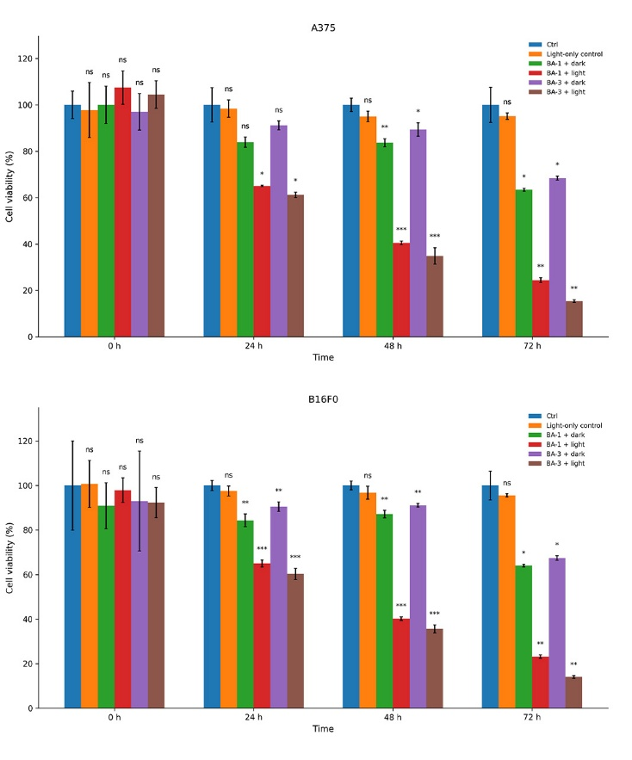
Figure SI CCK-8 analysis of A375 and B16F0 cell viability under different treatments at 0, 24, 48, and 72 h. Data are shown as mean ± SD (n = 5). Statistical significance was determined versus the Ctrl group. *p < 0.05, **p < 0.01, ***p < 0.001; ns, not significant.
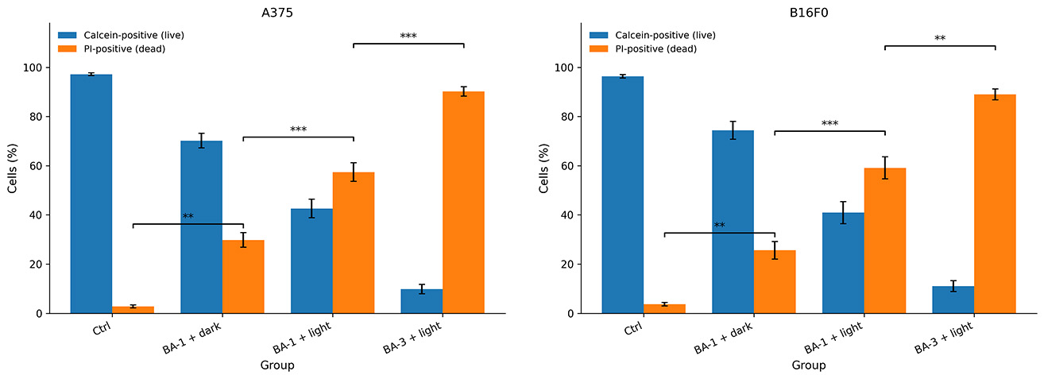
Figure SII Quantitative analysis of Calcein-positive (live) and PI-positive (dead) cells in each treatment group. Data are presented as mean ± SD (n = 3).
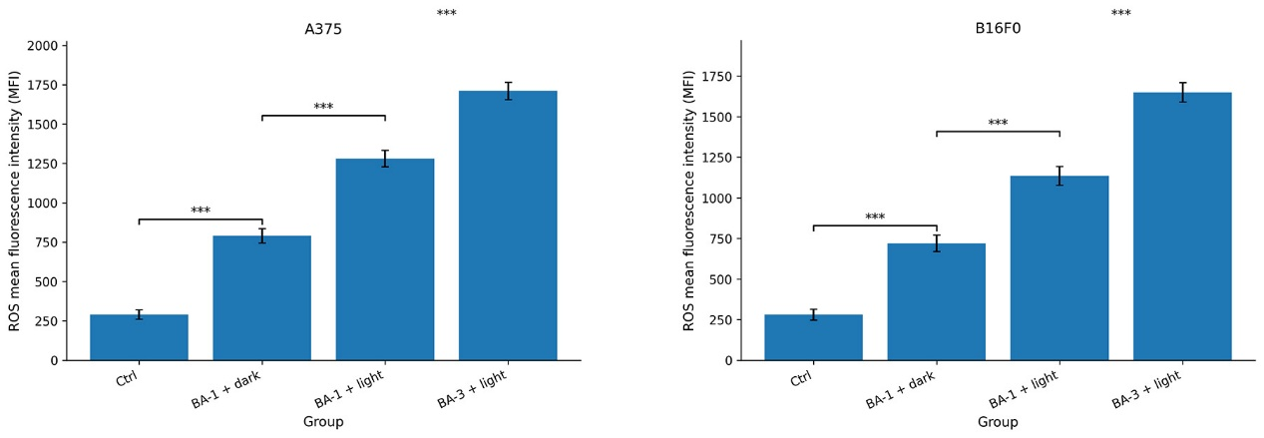
Figure SIII Quantitative analysis of intracellular ROS levels measured by flow cytometry and expressed as mean fluorescence intensity (MFI). Data are presented as mean ± SD (n = 3).
Reference
1. Wang X, Zhang X, Zheng G, Dong M, Huang Z, Lin L, Yan K, Zheng J, Wang J: Mitochondria-targeted pentacyclic triterpene NIR-AIE derivatives for enhanced chemotherapeutic and chemo-photodynamic combined therapy. Eur J Med Chem 2024, 264:115975.
Table SII The Western uncropped Gels and Blots involved in the article：
File label | Extracted band / strip
B16F0-Bax (Composite) | 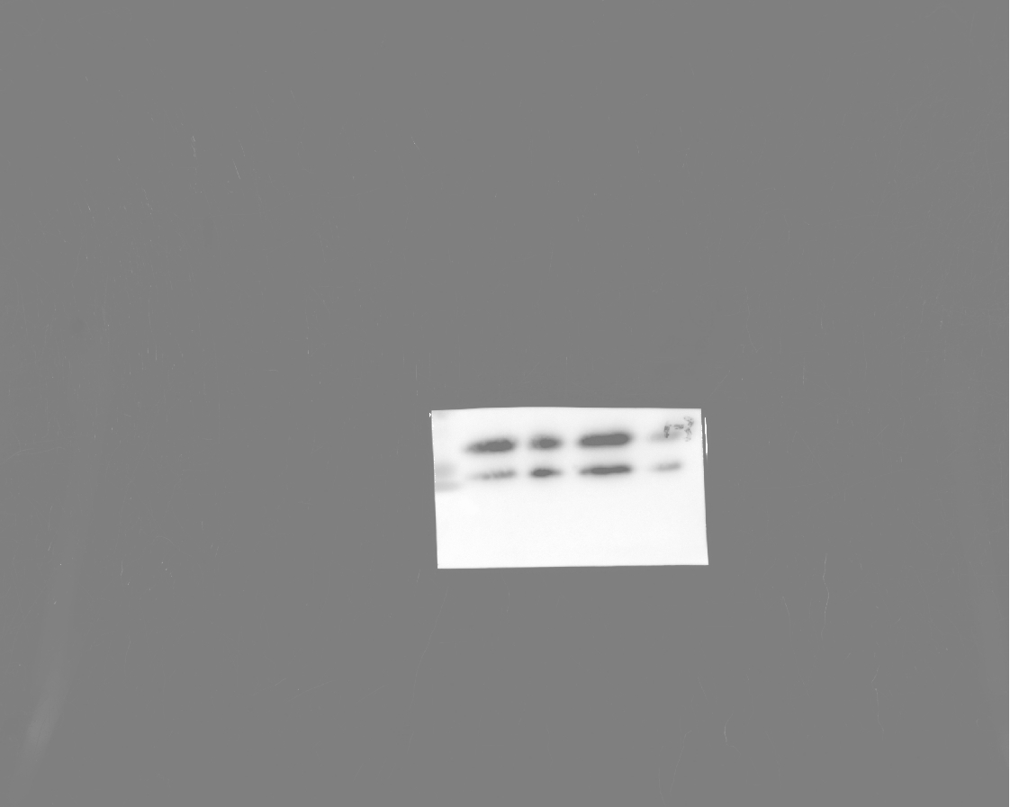
B16F0-Bcl-2(Composite)
B16F0-C-MYC
B16F0-Cleaved caspase-3(Composite)
B16F0-Cleaved caspase-9(Chemiluminescence) | 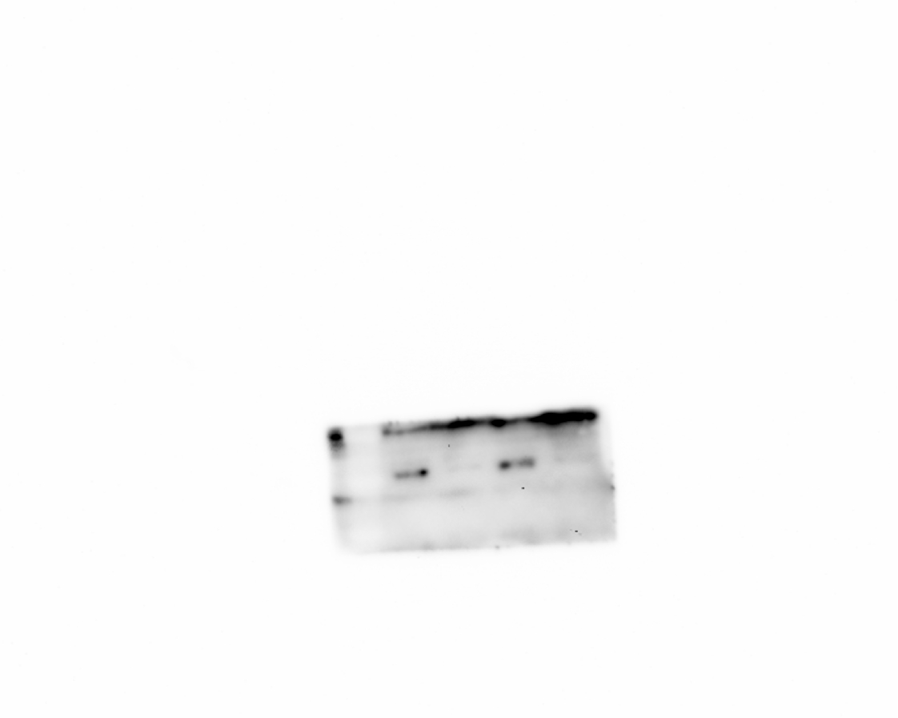
B16F0-Cleaved caspase-9(Composite)
B16F0-GAPDH-A
B16F0-GAPDH-B(Composite) | 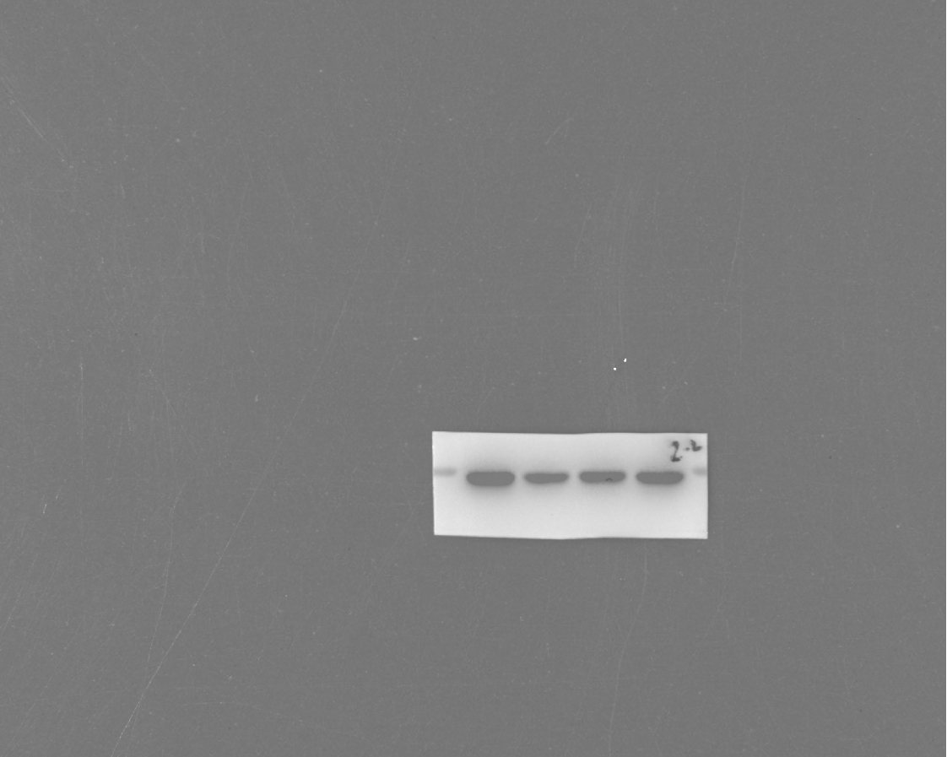
B16F0-MMP2
B16F0-PCNA(Composite)

Western blotting images depicting the results of the second and third experimental replicates
