Supplementary
MetaXVP: An Interpretable Machine Learning Framework for Deep Insight into Variant Pathogenicity and VUS Classification

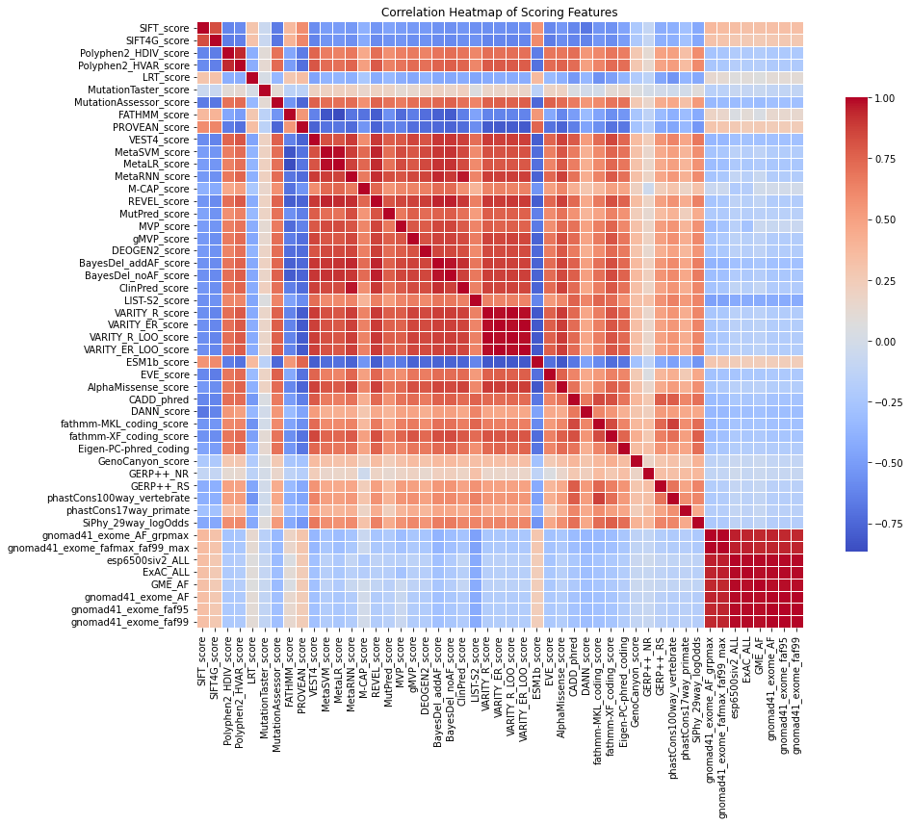

Figure S1: The correlation heat map plot of primarily features.

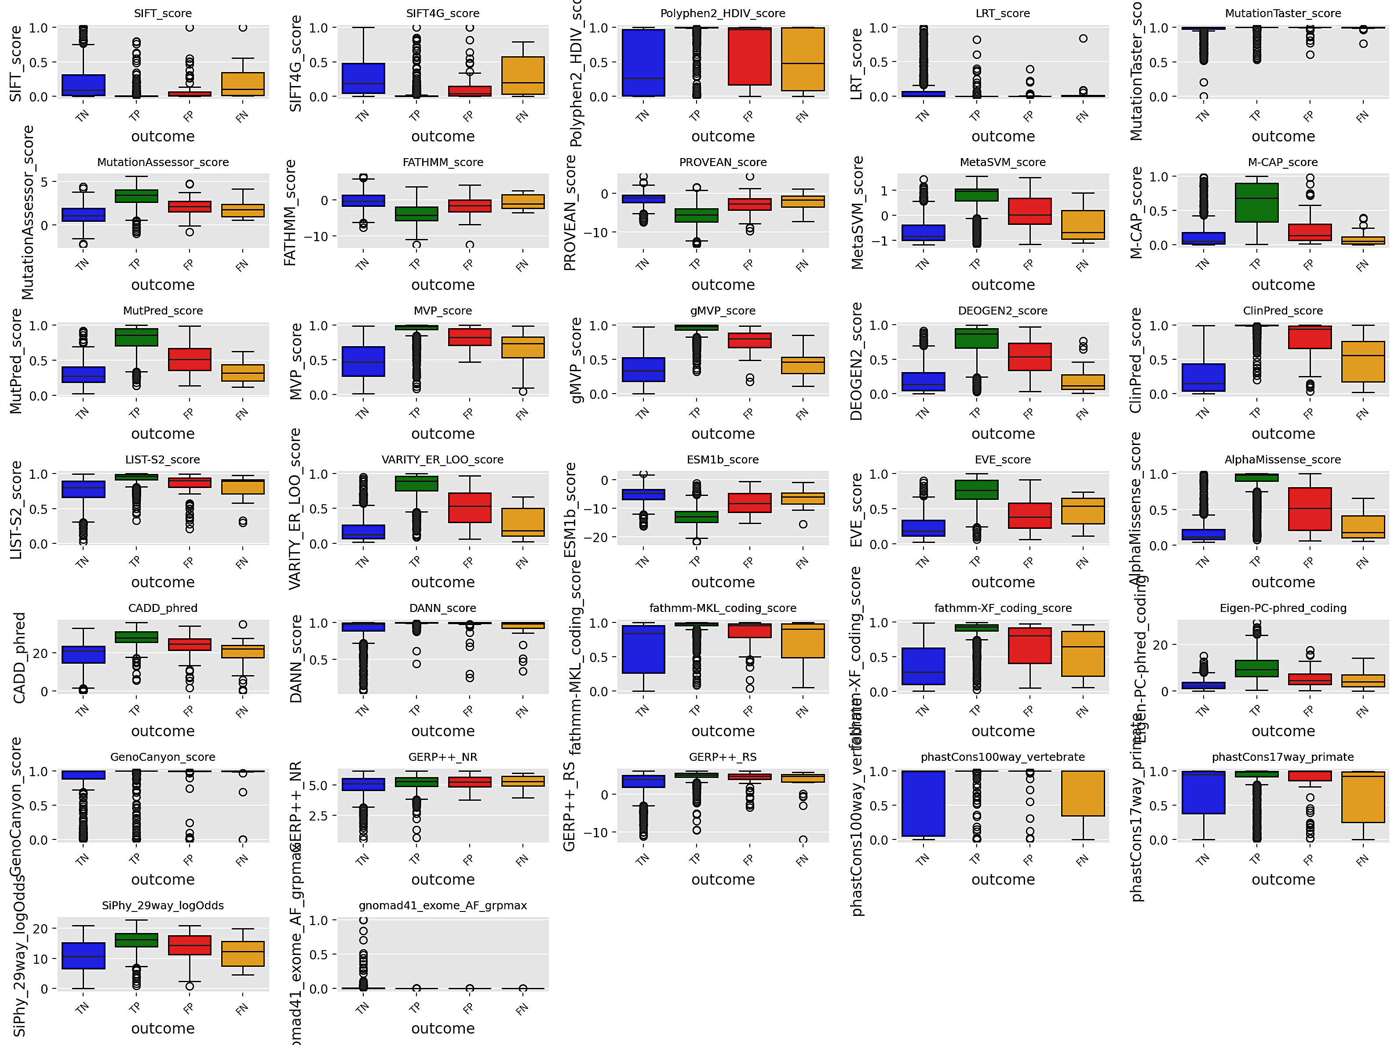

Figure S2: Distribution of each feature scores across outcome classes. TN: blue, TP: green, FP: red, FN: brown

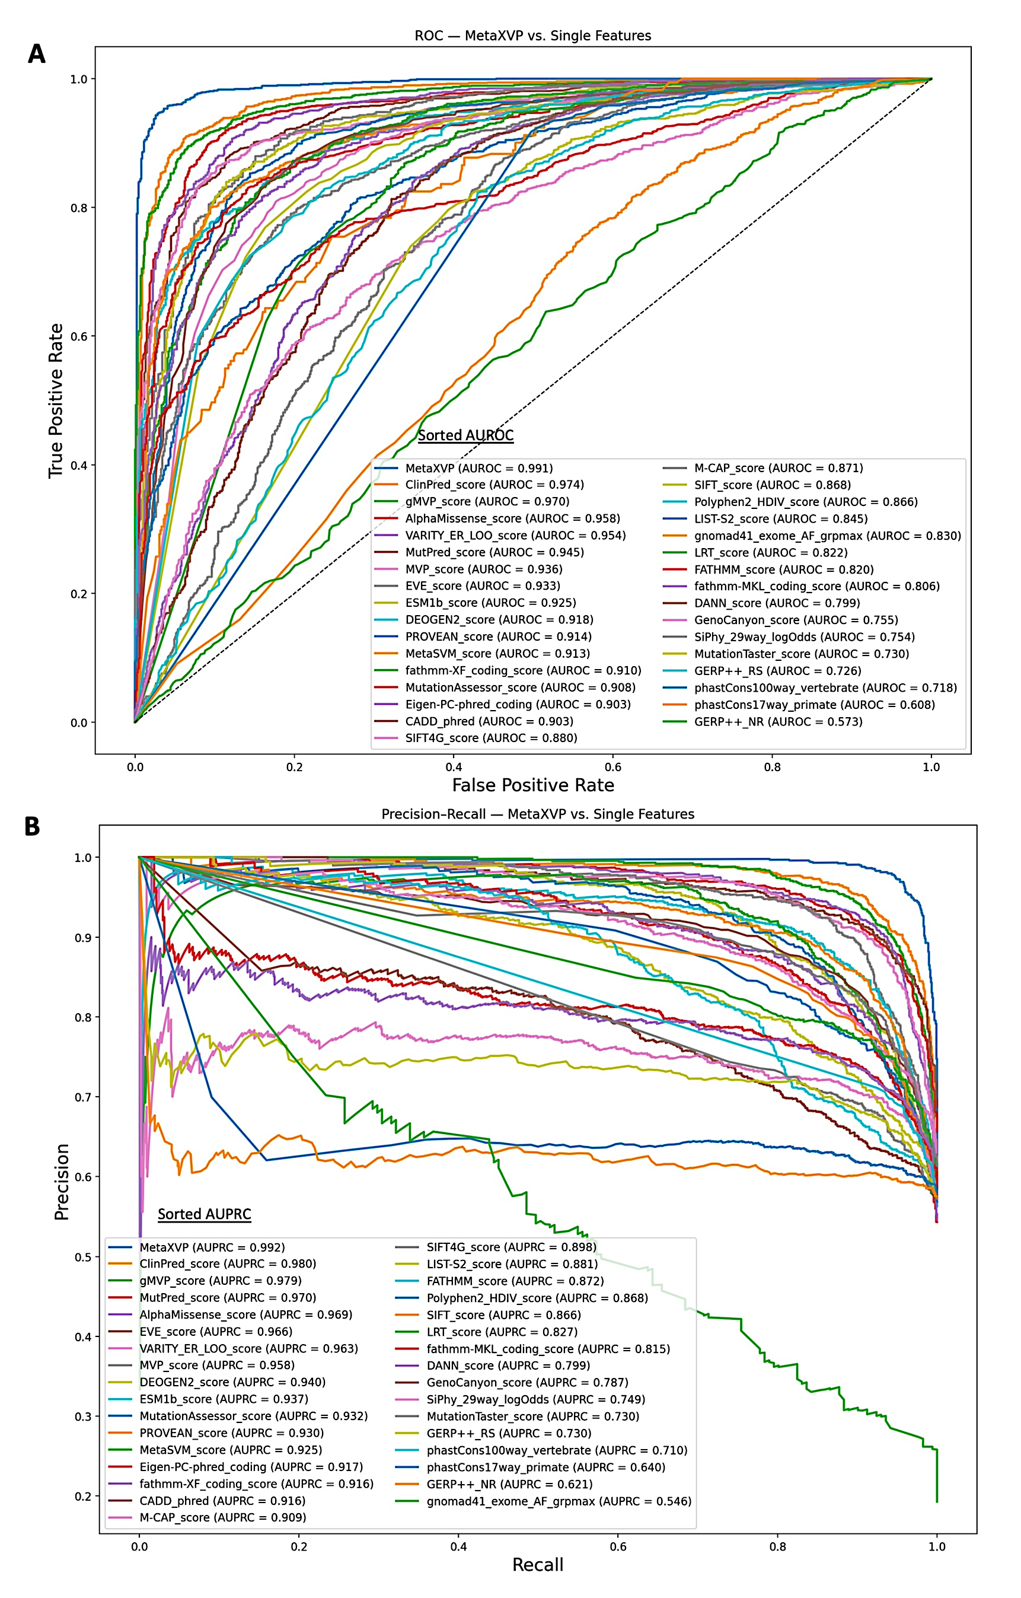

Fig S3: Comparison of MetaXVP with individual features on test set 1, Pathogenic vs. Benign. A: ROC curves with AUROC values, B: Precision–Recall curves with AUPRC values. In both panels, predictors are listed in the legend in descending order of performance.
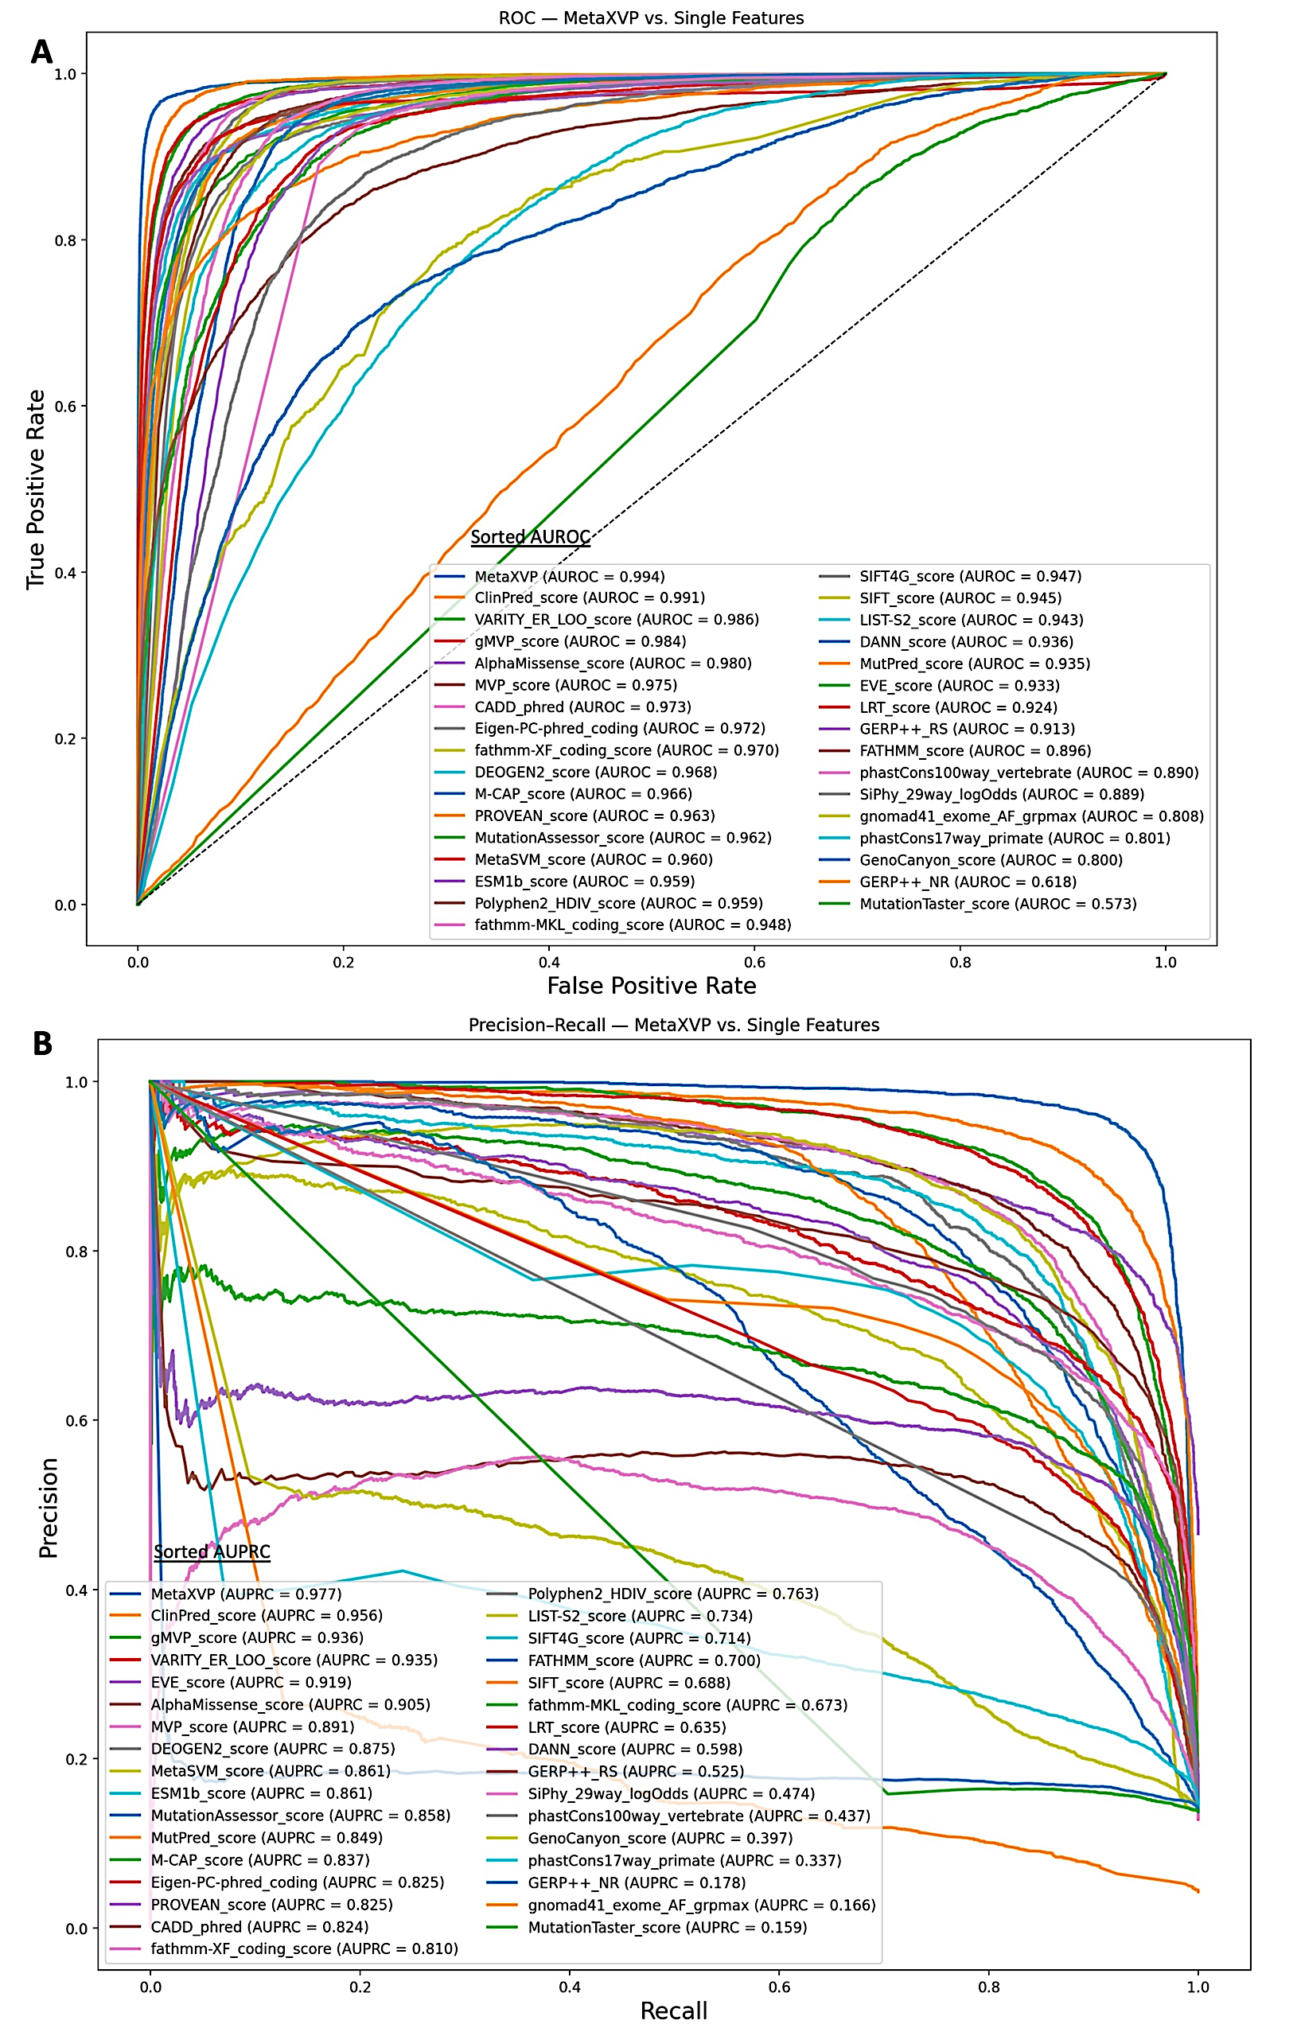

Figure S4: Comparison of MetaXVP with individual features on test set 2, Likely Pathogenic vs. Likely Benign. A: ROC curves with AUROC values, B: Precision–Recall curves with AUPRC values. In both panels, predictors are listed in the legend in descending order of performance.
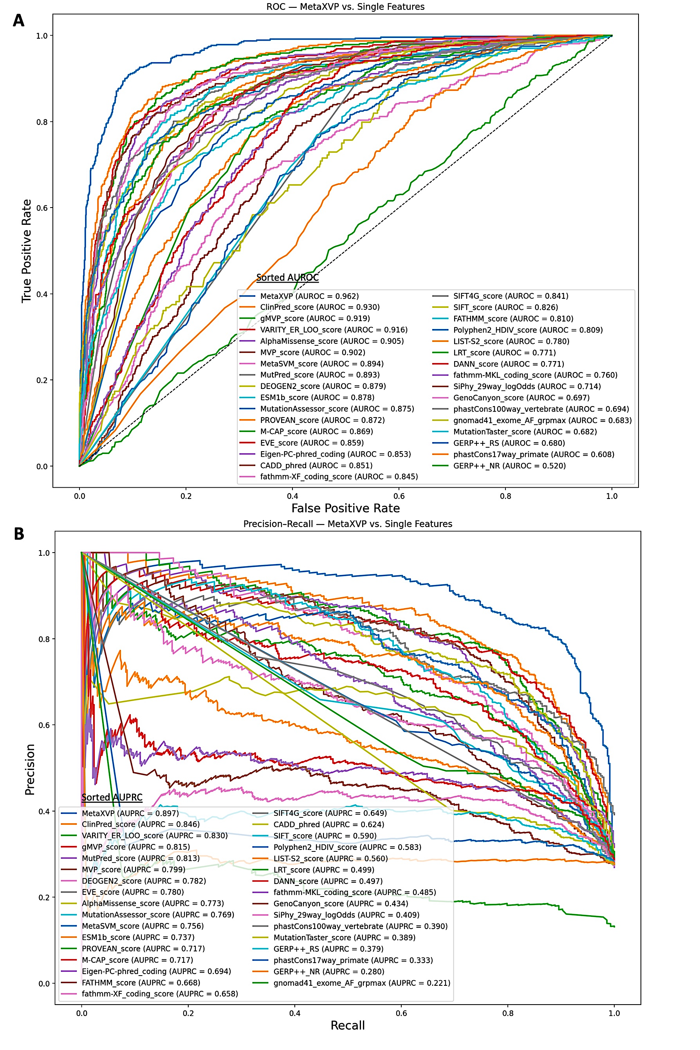

Figure S5: Comparison of MetaXVP with individual features on test set 4, VUS relabeled to Likely Pathogenic and Likely Benign. A: ROC curves with AUROC values, B: Precision–Recall curves with AUPRC values. In both panels, predictors are listed in the legend in descending order of performance.
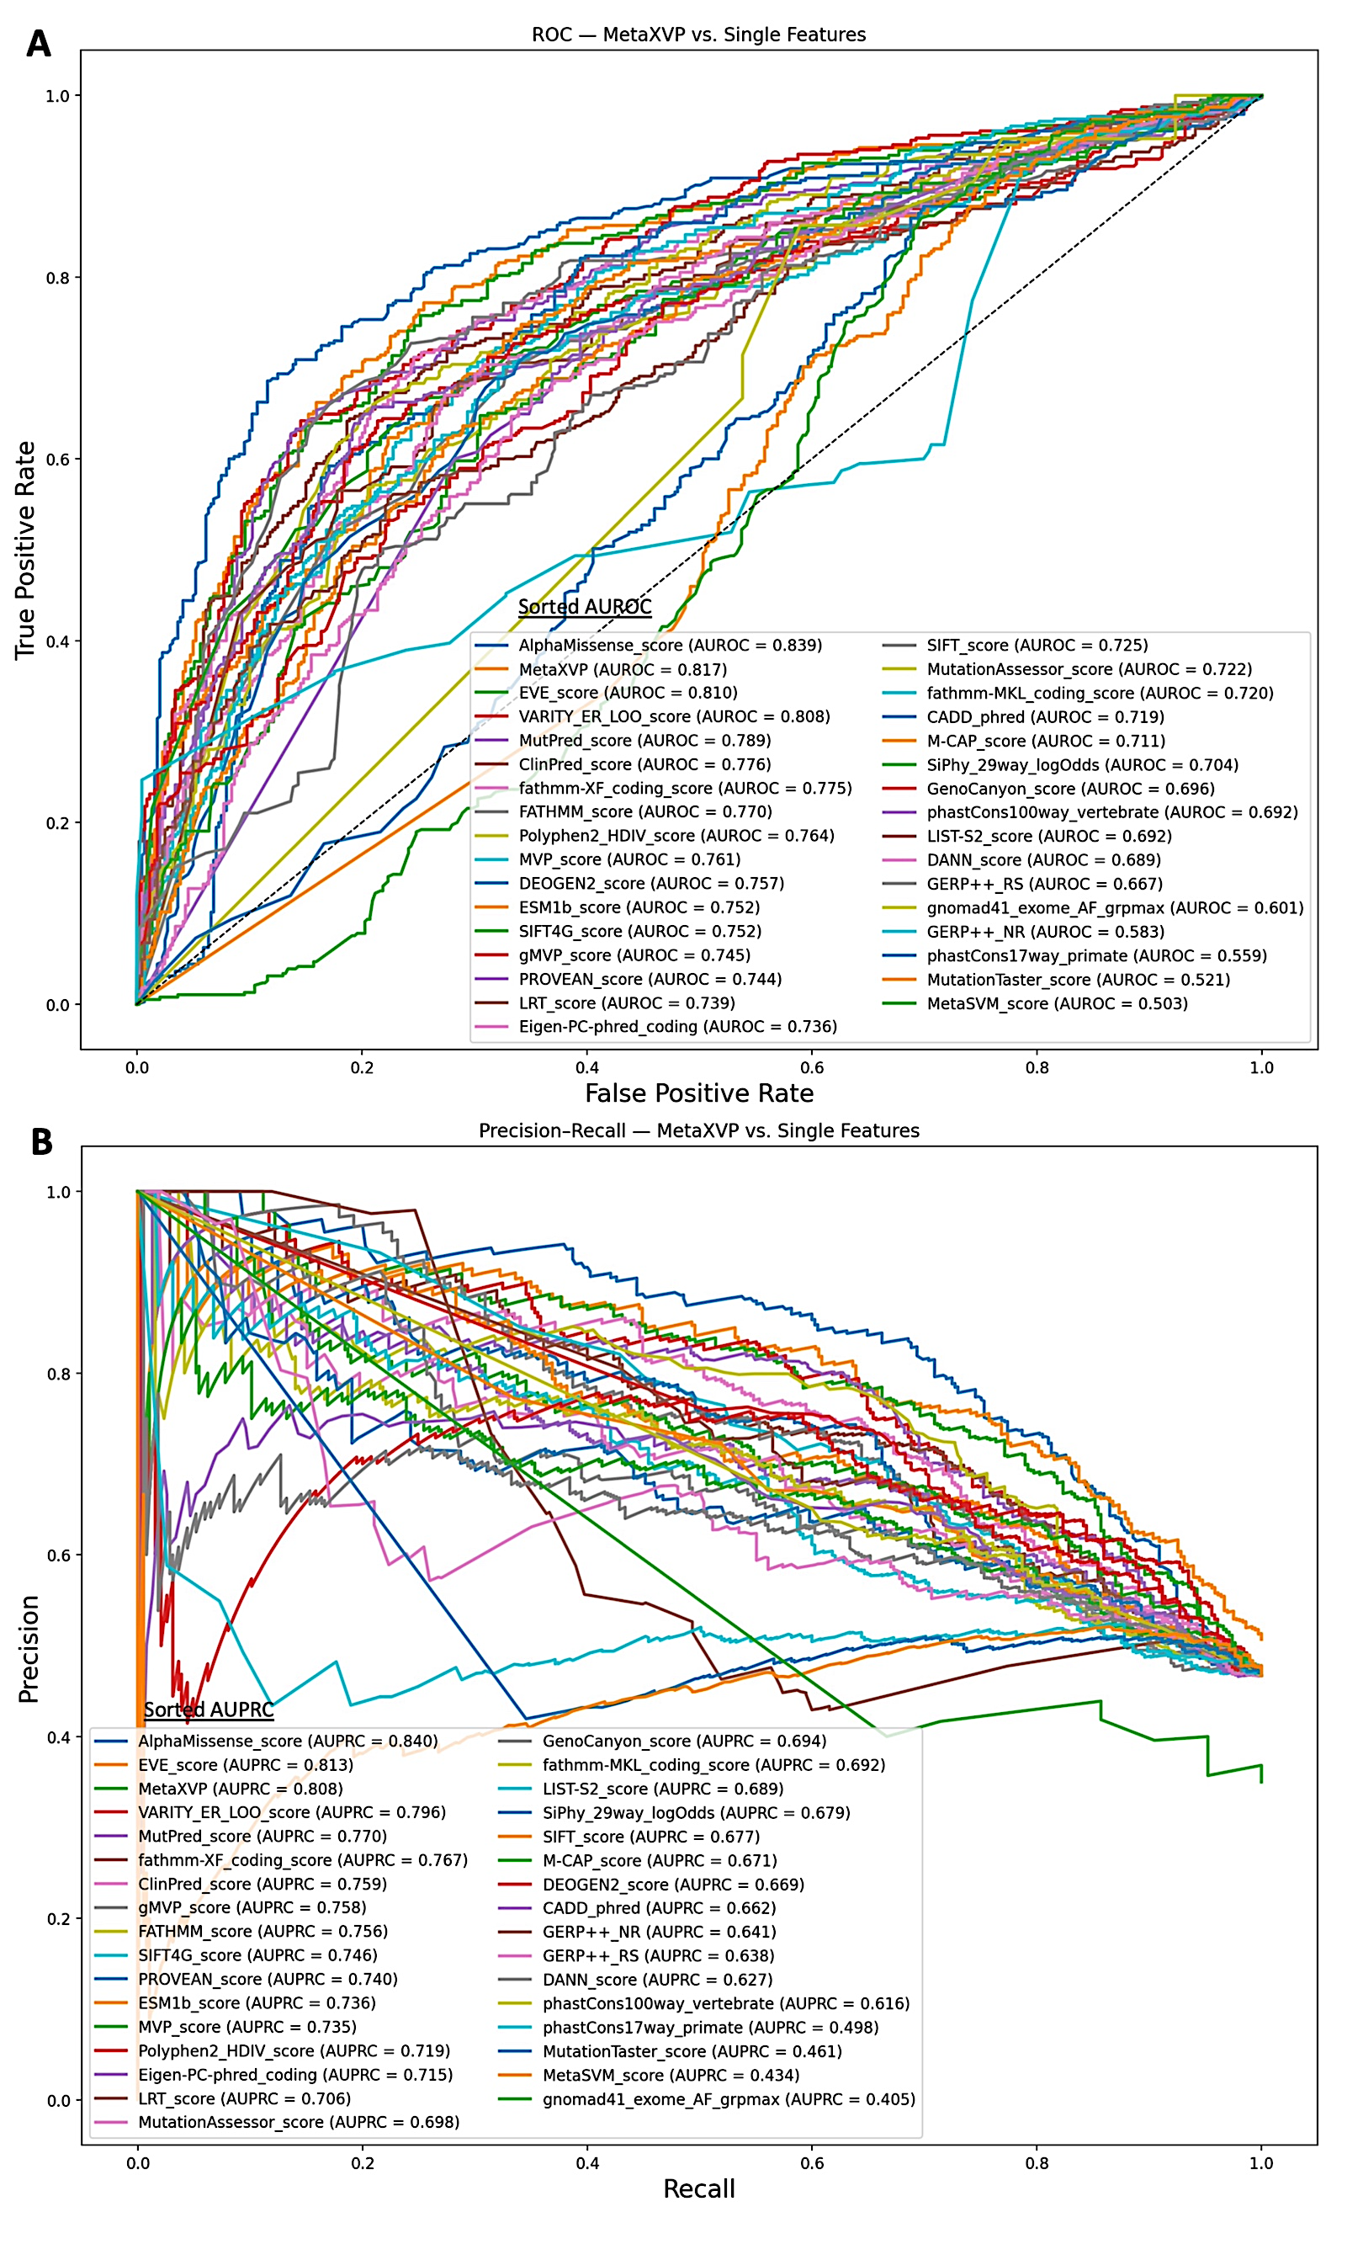

Figure S6: Comparison of MetaXVP with individual features on test set 5, TP53. A: ROC curves with AUROC values, B: Precision–Recall curves with AUPRC values. In both panels, predictors are listed in the legend in descending order of performance.

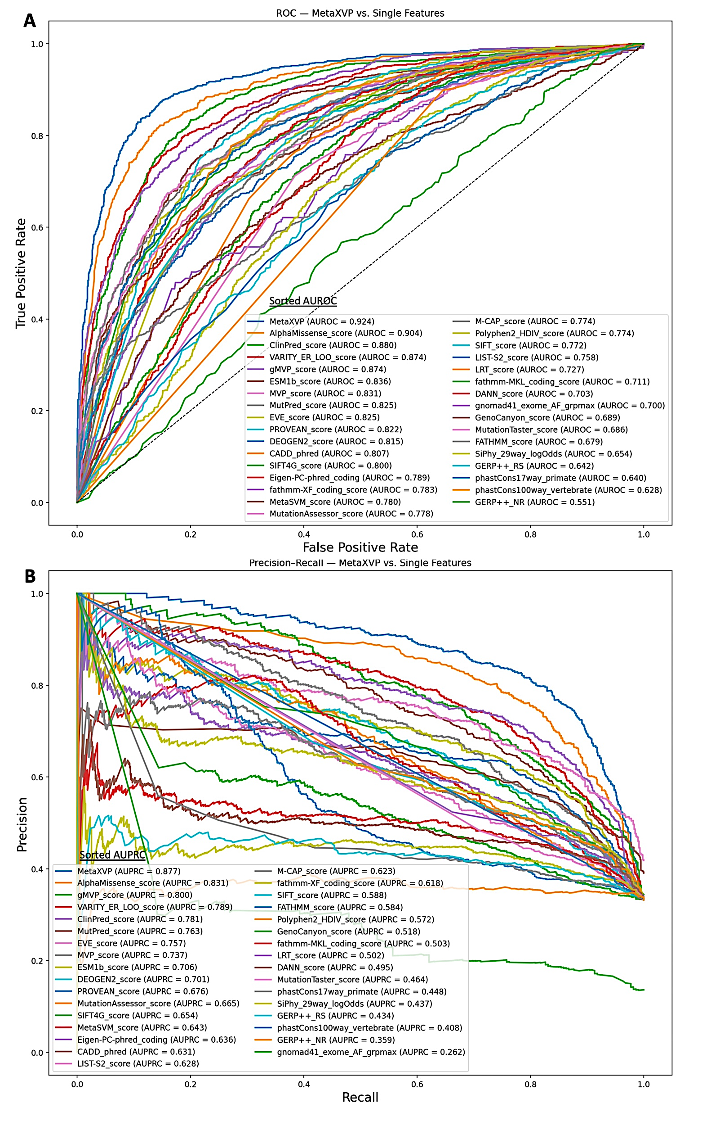

Figure S7: Comparison of MetaXVP with individual features on test set 6, cancer dataset. A: ROC curves with AUROC values, B: Precision–Recall curves with AUPRC values. In both panels, predictors are listed in the legend in descending order of performance.
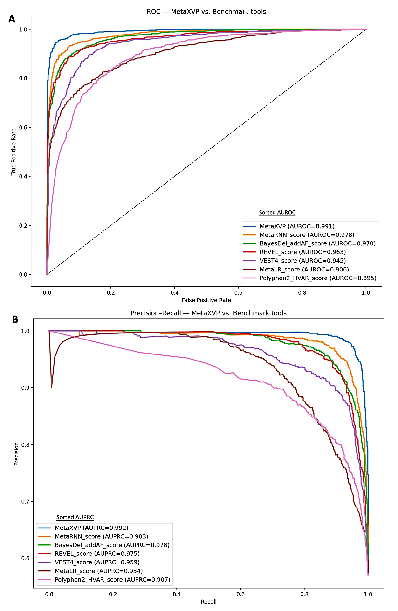

Figure S8: Comparison of MetaXVP with benchmark tools on test set 1, Pathogenic vs. Benign. A: ROC curves with AUROC values, B: Precision–Recall curves with AUPRC values. In both panels, tools are listed in the legend in descending order of performance.
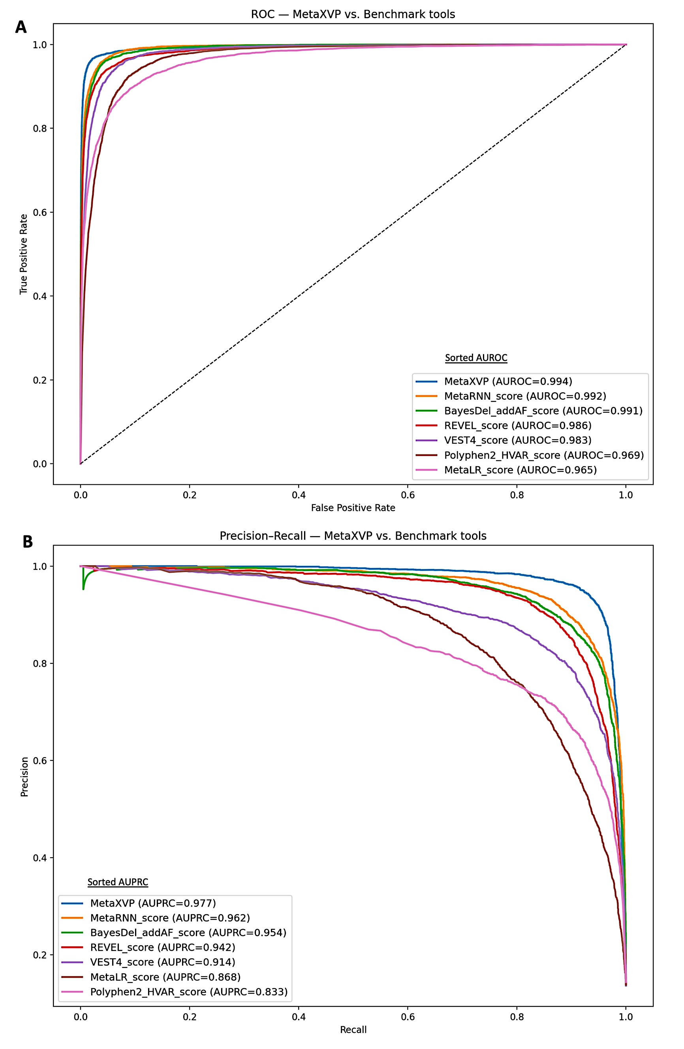

Figure S9: Comparison of MetaXVP with benchmark tools on test set 2, Likely Pathogenic vs. Likely Benign. A: ROC curves with AUROC values, B: Precision–Recall curves with AUPRC values. In both panels, tools are listed in the legend in descending order of performance.

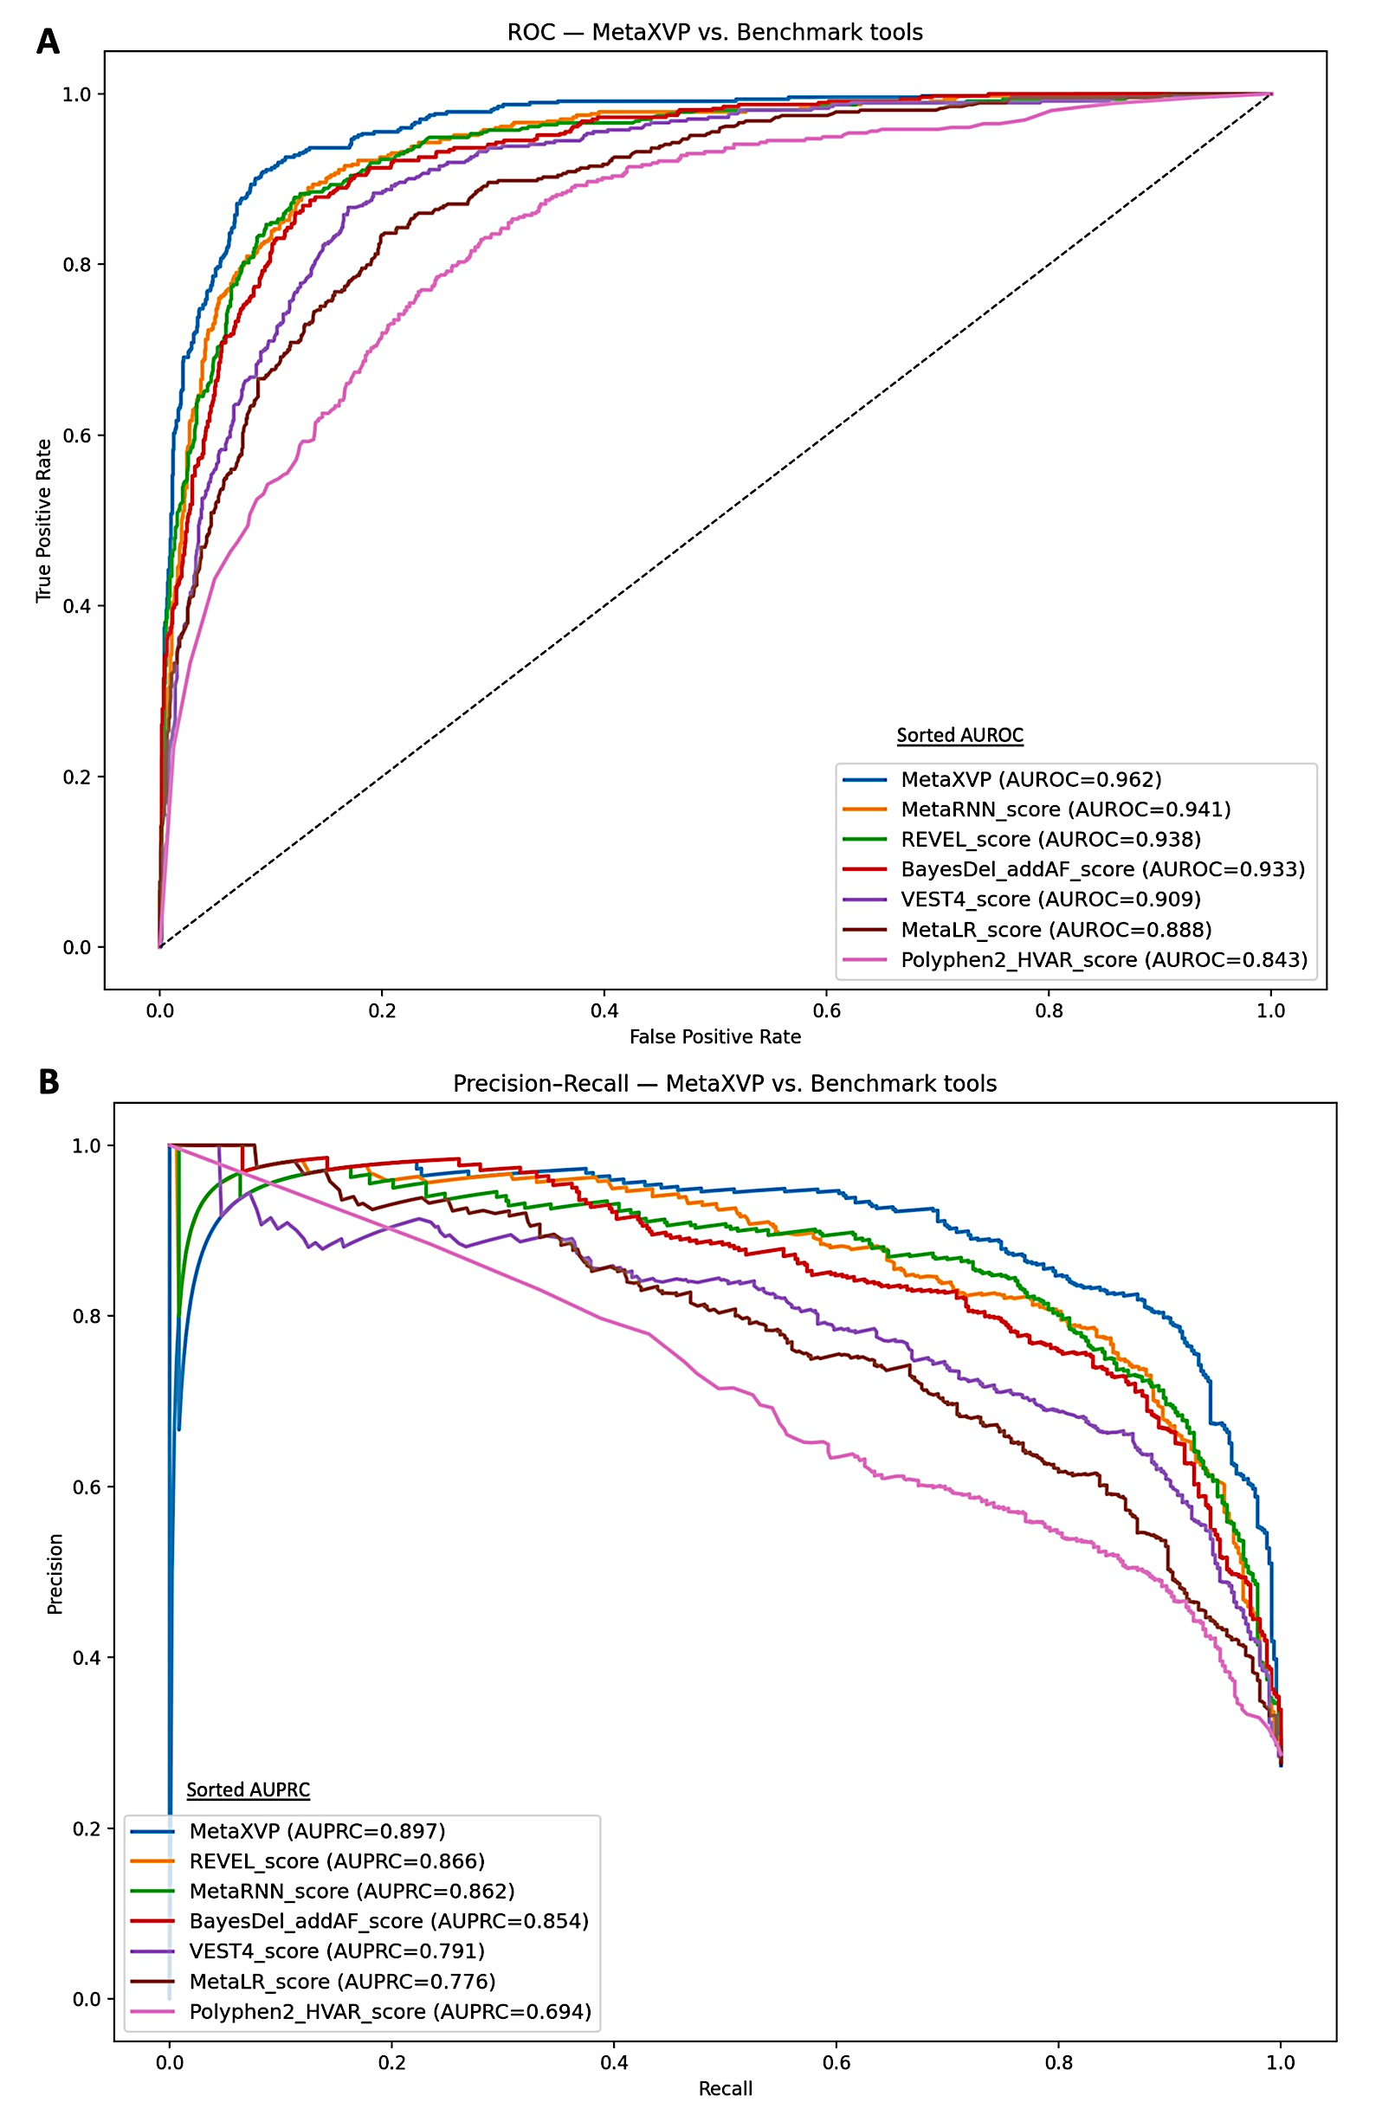
Figure S10: Comparison of MetaXVP with benchmark tools on test set 4, VUS relabeled to Likely Pathogenic and Likely Benign. A: ROC curves with AUROC values, B: Precision–Recall curves with AUPRC values. In both panels, tools are listed in the legend in descending order of performance.

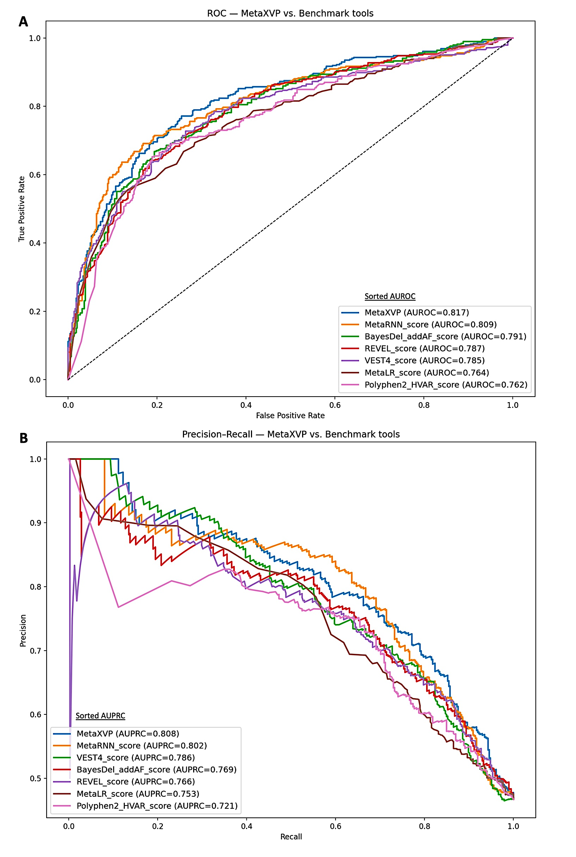

Figure S11: Comparison of MetaXVP with benchmark tools on test set 5, TP53. A: ROC curves with AUROC values, B: Precision–Recall curves with AUPRC values. In both panels, tools are listed in the legend in descending order of performance.

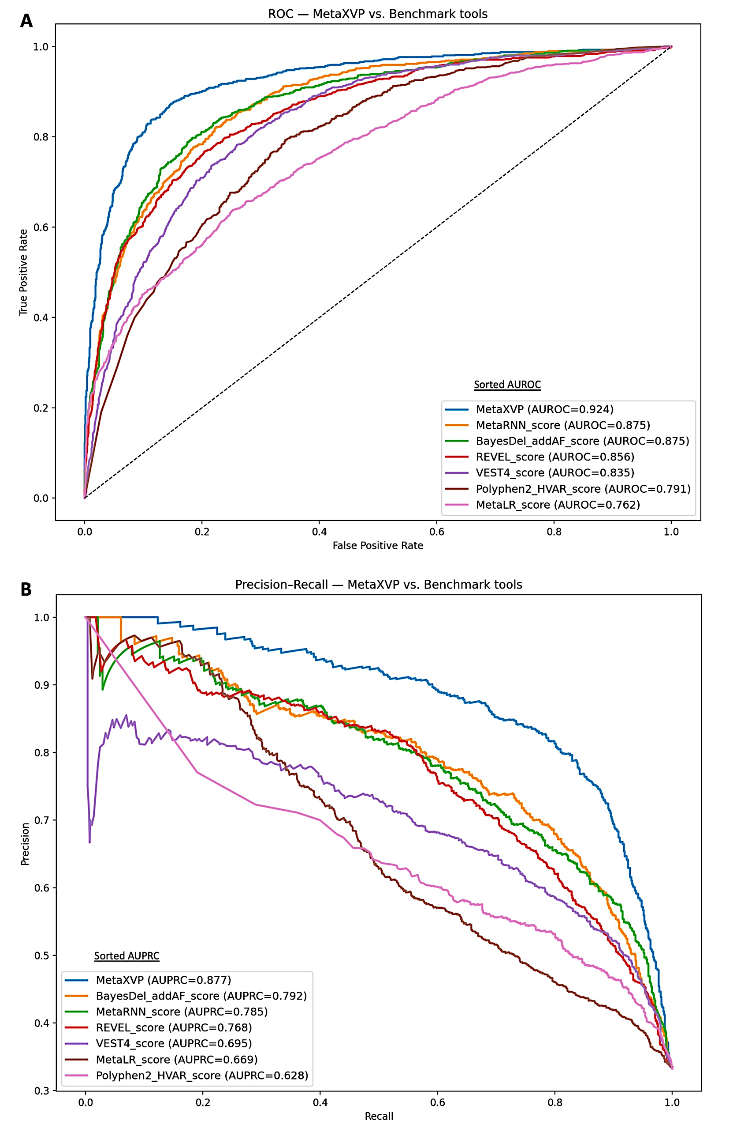

Figure S12: Comparison of MetaXVP with benchmark tools on test set 6, cancer dataset. A: ROC curves with AUROC values, B: Precision–Recall curves with AUPRC values. In both panels, tools are listed in the legend in descending order of performance.

