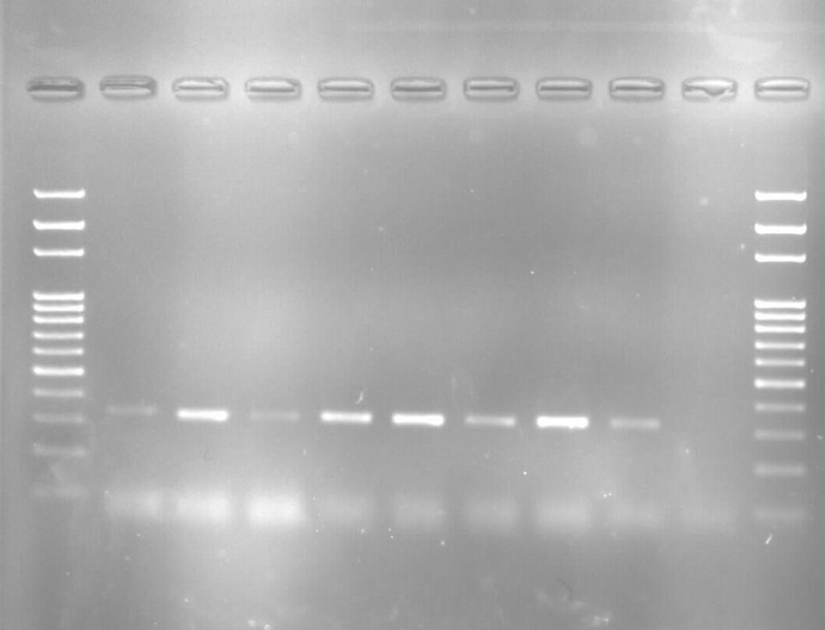

Figure 1: Agarose gel electrophoresis showing detection of human blood meals in Anopheles mosquitoes using host-specific PCR. first lane: 100bp DNA ladder, Lane 2-8 An. gambiae (M form) positive for human blood meal with the presence of 334bp band, Lane 9: Positive control and last lane: Negative control.

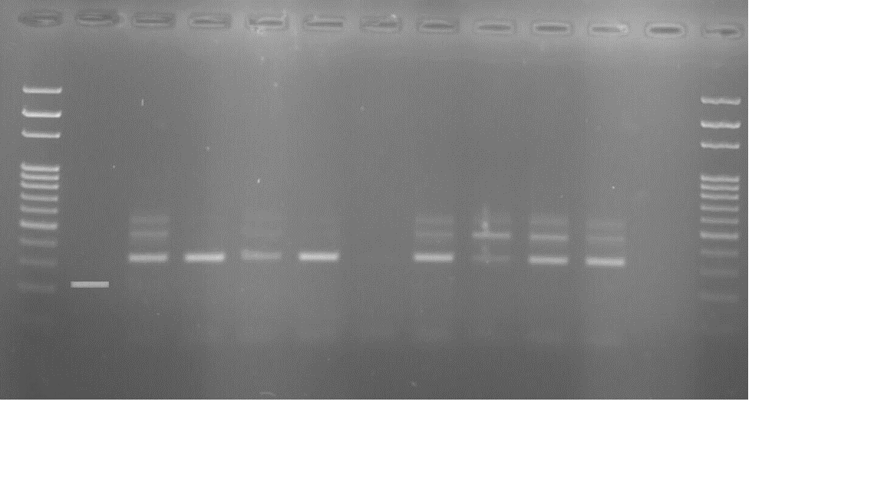

Figure 2: Agarose gel electrophoresis showing species identification of Anopheles gambiae s.s and Anopheles colluzzi using species-specific PCR.
First Lane (100Bp): DNA ladder; Lane 2 (222Bp): Anopheles gambiae s.s; Lane 3,4,5,6,8, 9 and 10 (333Bp): Anopheles colluzzi; Lane 11: Positive control and 12: Negative control.

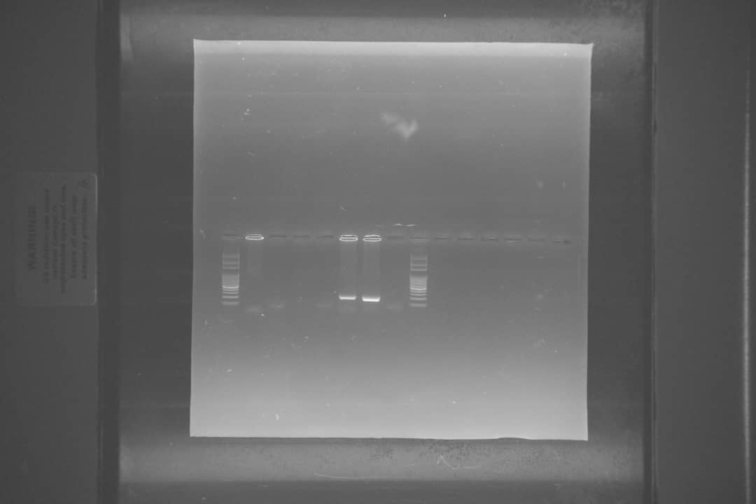

Figure 3: Agarose gel electrophoresis showing PCR amplification of Plasmodium falciparum. First Lane: DNA ladder (100bp); Lane 2-5: Anopheles colluzzi negative for Plasmodium falciparum; Lane 6: Anopheles colluzzi positive for Plasmodium falciparum with presence of specific 205bp band, Lane 7: Positive control and Lane 8: Negative control.

