Appendix A

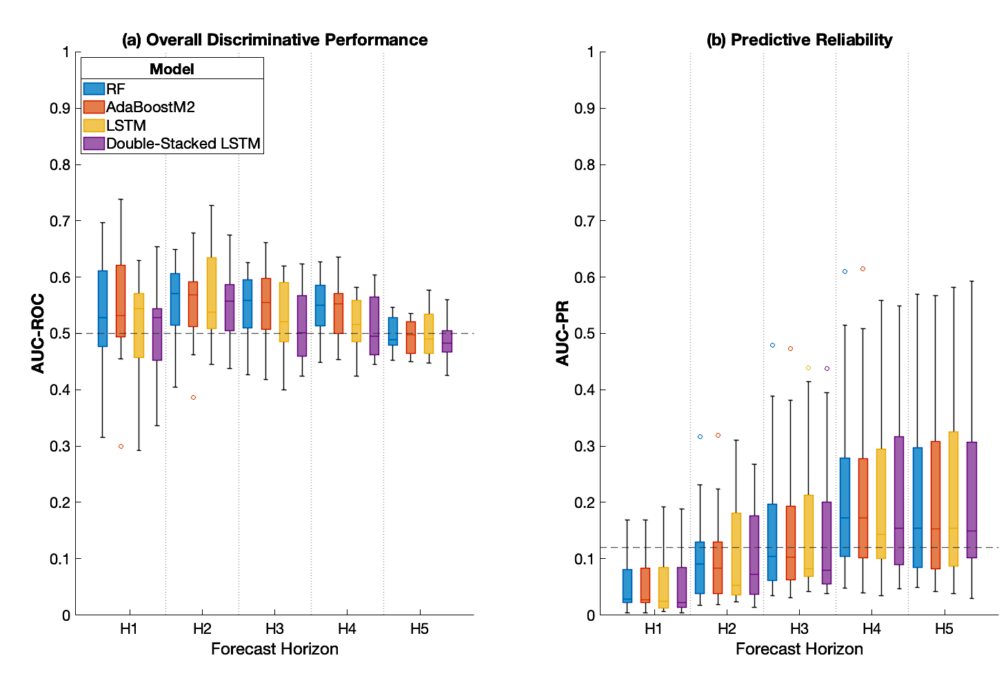

Figure A1. Forecasting performance by model and horizon for the 'Motion' feature set. Distributions of (a) AUC-ROC and (b) AUC-PR scores from Leave-One-Subject-Out (LOSO) cross-validation. The dashed lines represent the chance level for each metric. Dashed horizontal lines represent the chance level for each panel: 0.5 for AUC-ROC (a) and 0.12 for AUC-PR (b).

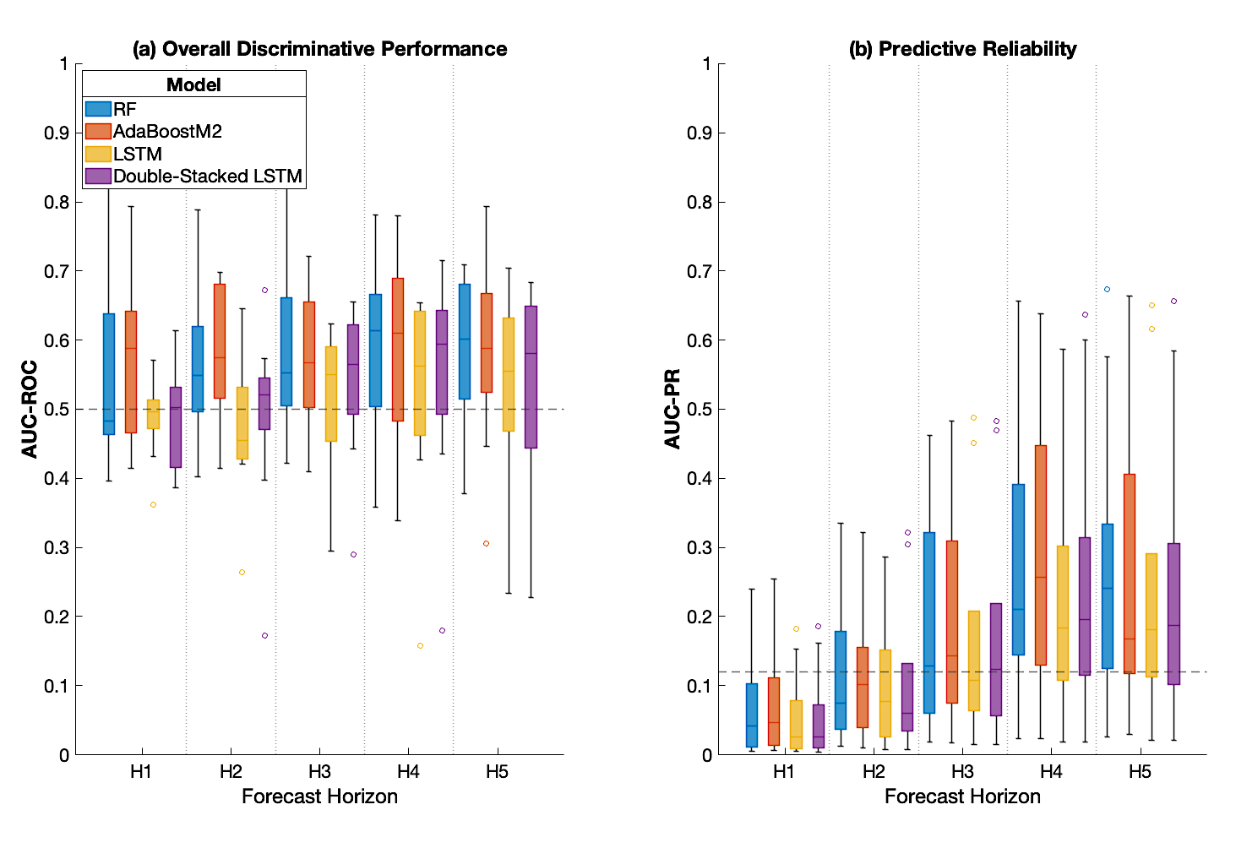

Figure A2. Forecasting performance by model and horizon for the 'Physiological' feature set. Distributions of (a) AUC-ROC and (b) AUC-PR scores from LOSO cross-validation. The dashed lines represent the chance level for each metric.

Appendix B

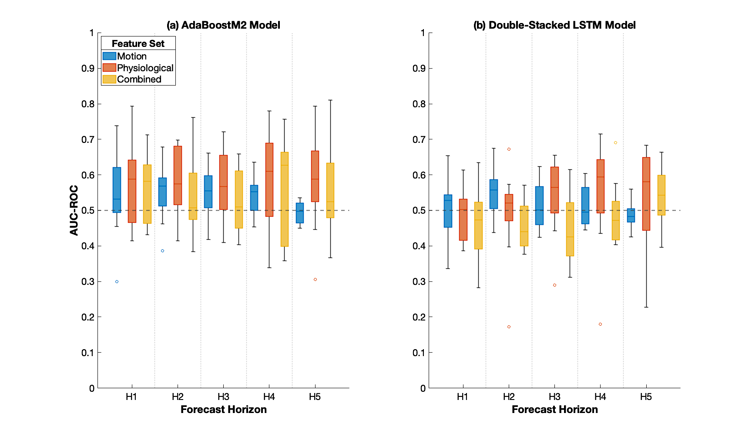

Figure B1. AUC-ROC performance by feature set for (a) the Adaboost.M2 model and (b) the Double-Stacked Long Short-Term Memory (LSTM) model. Distributions of scores are shown across the five forecast horizons. The dashed line indicates the 0.5 chance level.

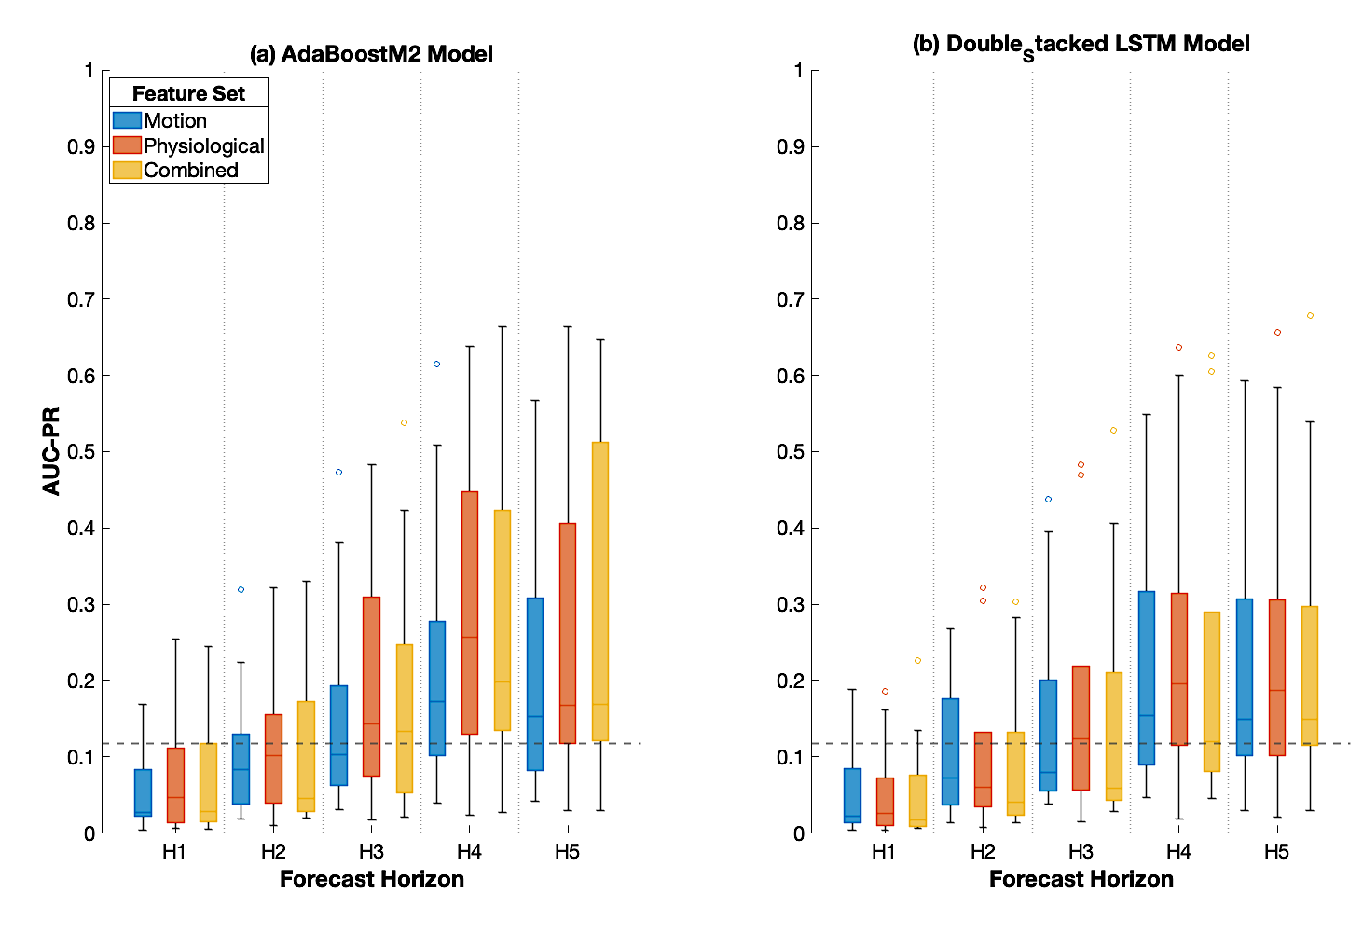

Figure B2. AUC-PR performance by feature set for (a) the Adaboost.M2 model and (b) the Double-Stacked LSTM model. Distributions of scores are shown across the five forecast horizons. The dashed line indicates the 0.5 chance level
Appendix C

Table C1. Subject-level performance gain (AUC-PR) attributable to physiological features at the longest forecast horizon (H5). Gain values represent the difference in AUC-PR between the 'Combined' and 'Motion-Only' feature sets. Positive values (i.e., inclusion of physiological data improves predictive performance) are highlighted in blue.

 |  | P01 | P02 | P03 | P04 | P06 | P07 | P09 | P10 | P11
RF | Motion | 0.0626 | 0.0487 | 0.114 | 0.520 | 0.569 | 0.163 | 0.154 | 0.222 | 0.0921
RF | Combined | 0.0503 | 0.0292 | 0.132 | 0.632 | 0.661 | 0.194 | 0.184 | 0.174 | 0.475
RF | Gain | -0.0122 | -0.0195 | 0.0184 | 0.112 | 0.0922 | 0.031 | 0.0303 | -0.0484 | 0.382
Adaboost.M2 | Motion | 0.0608 | 0.0419 | 0.115 | 0.532 | 0.567 | 0.157 | 0.152 | 0.233 | 0.0892
Adaboost.M2 | Combined | 0.0572 | 0.0572 | 0.142 | 0.612 | 0.647 | 0.238 | 0.146 | 0.169 | 0.479
Adaboost.M2 | Gain | -0.00356 | -0.00356 | 0.0272 | 0.080 | 0.0797 | 0.0813 | -0.00683 | -0.0643 | 0.390
LSTM | Motion | 0.0649 | 0.0649 | 0.124 | 0.516 | 0.582 | 0.155 | 0.213 | 0.262 | 0.0937
LSTM | Combined | 0.0772 | 0.0772 | 0.176 | 0.599 | 0.649 | 0.113 | 0.152 | 0.210 | 0.137
LSTM | Gain | 0.0123 | 0.0123 | 0.0516 | 0.0825 | 0.0675 | -0.0414 | -0.0607 | -0.0517 | 0.0434
Double-Stacked LSTM | Motion | 0.0555 | 0.0555 | 0.137 | 0.512 | 0.593 | 0.149 | 0.204 | 0.238 | 0.116
Double-Stacked LSTM | Combined | 0.0694 | 0.0694 | 0.199 | 0.540 | 0.678 | 0.130 | 0.149 | 0.216 | 0.139
Double-Stacked LSTM | Gain | 0.0139 | 0.0139 | 0.0626 | 0.0278 | 0.0852 | -0.0188 | -0.0547 | -0.0214 | 0.0231

Table C2. Descriptive statistics and paired t-test results comparing 'Motion-Only' vs. 'Combined' feature sets across all models and forecast horizons. AUC-PR performance is reported as mean (SD). Statistical significance (p<0.05) is highlighted in bold.

Model | Horizon | Motion | Combined | Gait | t-Stat (p value)
RF | H1 | 0.0559 (0.0608) | 0.0790 (0.0231) | 0.0231 | 1.422 (0.0964)
RF | H2 | 0.107 (0.102) | 0.113 (0.102) | 0.00592 | 0.401 (0.349)
RF | H3 | 0.163 (0.159) | 0.181 (0.185) | 0.0182 | 0.866 (0.206)
RF | H4 | 0.226 (0.198) | 0.280 (0.228) | 0.0539 | 2.154 (0.0317)
RF | H5 | 0.216 (0.194) | 0.281(0.243) | 0.0651 | 1.508 (0.0850)
Adaboost.M2 | H1 | 0.0564 (0.0613) | 0.0702 (0.0812) | 0.0139 | 1.028 (0.167)
Adaboost.M2 | H2 | 0.105 (0.102) | 0.109 (0.113) | 0.00446 | 0.2748 (0.395)
Adaboost.M2 | H3 | 0.161 (0.156) | 0.180 (0.181) | 0.0187 | 0.803 (0.223)
Adaboost.M2 | H4 | 0.224 (0.199) | 0.279 (0.237) | 0.0551 | 2.111 (0.0339)
Adaboost.M2 | H5 | 0.216 (0.197) | 0.280 (0.237) | 0.0635 | 1.439 (0.0941)
LSTM | H1 | 0.0560 (0.0679) | 0.0525 (0.0697) | -0.00356 | -1.180 (0.864)
LSTM | H2 | 0.112 (0.105) | 0.0998 (0.127) | -0.01229 | -0.868 (0.795)
LSTM | H3 | 0.164 (0.153) | 0.158 (0.186) | 0.00601 | -0.455 (0.669)
LSTM | H4 | 0.220 (0.198) | 0.221 (0.221) | 0.00109 | 0.0731 (0.472)
LSTM | H5 | 0.228 (0.196) | 0.238 (0.226) | 0.0103 | 0.573 (0.291)
Double-Stacked LSTM | H1 | 0.0564 (0.0679) | 0.0550 (0.0762) | -0.00146 | -0.269 (0.602)
Double-Stacked LSTM | H2 | 0.107 (0.0957) | 0.0934 (0.115) | -0.0133 | -0.957 (0.817)
Double-Stacked LSTM | H3 | 0.153 (0.153) | 0.151 (0.185) | -0.00228 | 0.127 (0.549)
Double-Stacked LSTM | H4 | 0.224 (0.189) | 0.222 (0.229) | -0.00246 | -0.108 (0.542)
Double-Stacked LSTM | H5 | 0.226 (0.197) | 0.239 (0.0131) | 0.0131 | 0.908 (0.195)

Appendix D

Table D1. Aggregated confusion matrix from the RF model by forecast horizon. Note that each matrix shows the total classification counts (True/False Positives and Negatives) for a given forecast horizon, summed across all nine participant test folds from LOSO cross-validation.
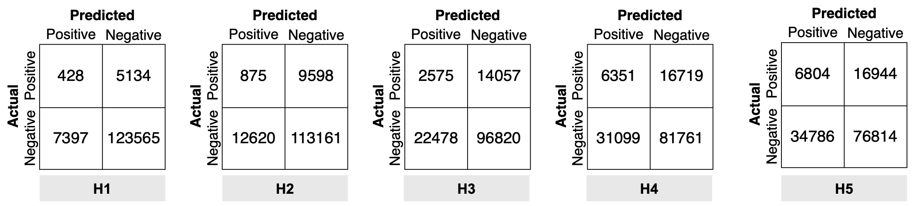

Table D2. Aggregated confusion matrix from the Adaboost.M2 model by forecast horizon.
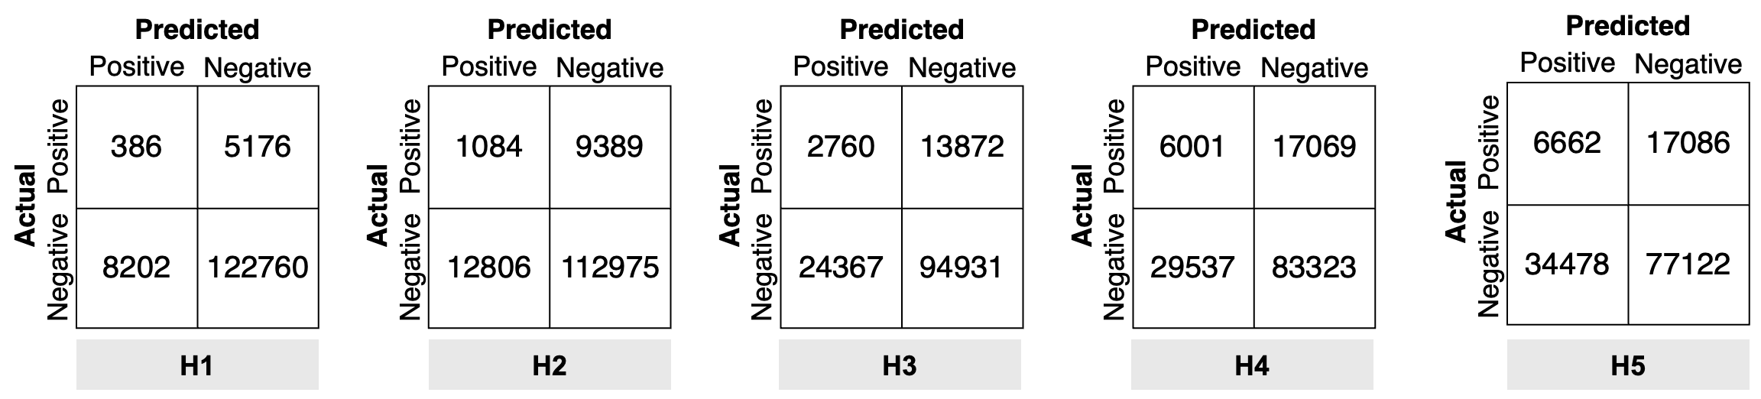

Table D3. Aggregated confusion matrix from the Long Short-Term Memory (LSTM) model by forecast horizon.
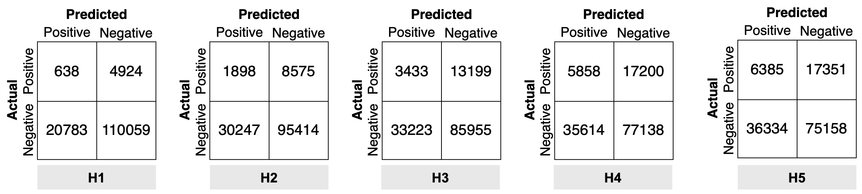

Table D4. Aggregated confusion matrix from the Double-Stacked LSTM model by forecast horizon.
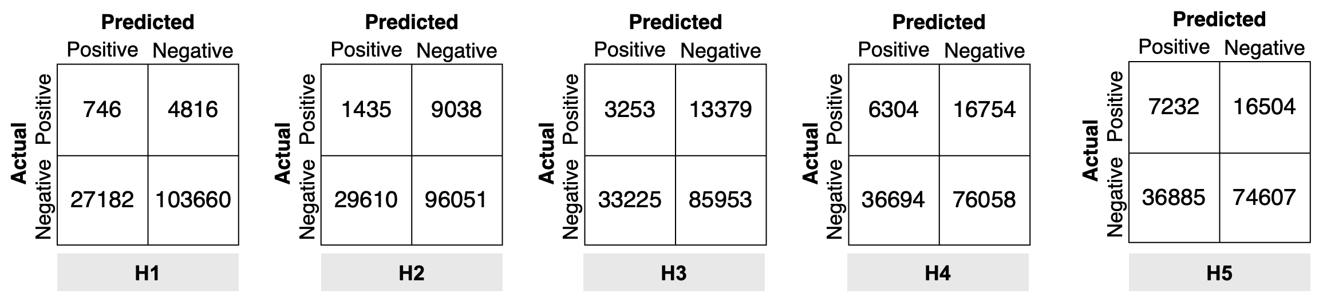

Appendix E

Table E1. Summary (mean [SD]) of secondary performance metrics for the RF model for each experimental condition using LOSO cross-validation. All metrics range from 0 to 1 (higher is better), except for the Matthews Correlation Coefficient (MCC), which ranges from -1 to 1 (0 = chance).

Horizon | Feature Set | Accuracy | Precision | Recall | Specificity | F1_Score | MCC
H1 | Motion | 0.902 (0.069) | 0.042 (0.043) | 0.070 (0.085) | 0.952 (0.038) | 0.033 (0.025) | 0.002 (0.029)
H2 | Motion | 0.818 (0.090) | 0.097 (0.074) | 0.135 (0.112) | 0.904 (0.054) | 0.073 (0.036) | 0.015 (0.048)
H3 | Motion | 0.736 (0.130) | 0.162 (0.163) | 0.188 (0.123) | 0.854 (0.070) | 0.118 (0.041) | 0.019 (0.052)
H4 | Motion | 0.649 (0.142) | 0.218 (0.180) | 0.270 (0.133) | 0.781 (0.089) | 0.176 (0.058) | 0.025 (0.057)
H5 | Motion | 0.602 (0.133) | 0.203 (0.184) | 0.266 (0.151) | 0.731 (0.127) | 0.163 (0.079) | -0.010 (0.032)
H1 | Physiological | 0.891 (0.091) | 0.059 (0.094) | 0.089 (0.121) | 0.935 (0.077) | 0.059 (0.076) | 0.028 (0.054)
H2 | Physiological | 0.818 (0.125) | 0.133 (0.129) | 0.117 (0.098) | 0.899 (0.104) | 0.079 (0.067) | 0.021(0.062)
H3 | Physiological | 0.680 (0.150) | 0.266 (0.310) | 0.268 (0.167) | 0.788 (0.159) | 0.152 (0.107) | 0.056 (0.121)
H4 | Physiological | 0.616 (0.170) | 0.278 (0.237) | 0.398 (0.261) | 0.712 (0.192) | 0.246 (0.121) | 0.095 (0.149)
H5 | Physiological | 0.605 (0.176) | 0.266 (0.240) | 0.390 (0.255) | 0.691 (0.206) | 0.241 (0.118) | 0.068 (0.127)
H1 | Combined | 0.907 (0.071) | 0.095 (0.184) | 0.064 (0.073) | 0.957 (0.054) | 0.047 (0.058) | 0.040 (0.068)
H2 | Combined | 0.841 (0.125) | 0.090 (0.097) | 0.074 (0.094) | 0.931 (0.094) | 0.044 (0.039) | 0.002 (0.068)
H3 | Combined | 0.737 (0.148) | 0.193 (0.205) | 0.161 (0.097) | 0.862 (0.120) | 0.110 (0.058) | 0.026 (0.080)
H4 | Combined | 0.643 (0.170) | 0.270 (0.253) | 0.306 (0.257) | 0.772 (0.176) | 0.191 (0.106) | 0.067 (0.136)
H5 | Combined | 0.635 (0.198) | 0.253 (0.264) | 0.304 (0.296) | 0.754 (0.217) | 0.193 (0.132) | 0.046 (0.155)

Table E2. Summary (mean [SD]) of secondary performance metrics for the Adaboost.M2 model for each experimental condition using LOSO cross-validation.

Horizon | Feature Set | Accuracy | Precision | Recall | Specificity | F1_Score | MCC
H1 | Motion | 0.897 (0.069) | 0.036 (0.037) | 0.074 (0.097) | 0.946 (0.045) | 0.030 (0.026) | -0.002 (0.029)
H2 | Motion | 0.821 (0.091) | 0.099 (0.085) | 0.125 (0.098) | 0.908 (0.052) | 0.072 (0.043) | 0.014 (0.049)
H3 | Motion | 0.726 (0.125) | 0.149 (0.146) | 0.193 (0.141) | 0.845 (0.069) | 0.110 (0.047) | 0.010 (0.064)
H4 | Motion | 0.646 (0.139) | 0.215 (0.179) | 0.270 (0.138) | 0.776 (0.086) | 0.175 (0.061) | 0.022 (0.059)
H5 | Motion | 0.594 (0.133) | 0.203 (0.185) | 0.271 (0.155) | 0.722 (0.135) | 0.163 (0.084) | -0.011 (0.034)
H1 | Physiological | 0.872 (0.098) | 0.082 (0.105) | 0.117 (0.094) | 0.916 (0.083) | 0.067 (0.056) | 0.027 (0.066)
H2 | Physiological | 0.792 (0.144) | 0.142 (0.115) | 0.192 (0.132) | 0.860 (0.122) | 0.120 (0.065) | 0.042 (0.061)
H3 | Physiological | 0.662 (0.205) | 0.205 (0.199) | 0.301 (0.295) | 0.763 (0.234) | 0.149 (0.091) | 0.054 (0.113)
H4 | Physiological | 0.634 (0.199) | 0.280 (0.235) | 0.354 (0.270) | 0.740 (0.216) | 0.234 (0.121) | 0.086 (0.158)
H5 | Physiological | 0.618 (0.157) | 0.277 (0.235) | 0.393 (0.202) | 0.705 (0.168) | 0.259 (0.137) | 0.084 (0.151)
H1 | Combined | 0.910 (0.076) | 0.075 (0.128) | 0.044 (0.063) | 0.960 (0.048) | 0.035 (0.043) | 0.010 (0.046)
H2 | Combined | 0.853 (0.112) | 0.059 (0.087) | 0.037 (0.055) | 0.945 (0.060) | 0.035 (0.057) | -0.016 (0.058)
H3 | Combined | 0.723 (0.151) | 0.176 (0.207) | 0.157 (0.142) | 0.850 (0.140) | 0.095 (0.064) | 0.011 (0.062)
H4 | Combined | 0.654 (0.180) | 0.294 (0.283) | 0.277 (0.235) | 0.786 (0.182) | 0.192 (0.102) | 0.070 (0.145)
H5 | Combined | 0.627 (0.176) | 0.245 (0.244) | 0.313 (0.238) | 0.746 (0.171) | 0.197 (0.110) | 0.042 (0.144)

Table E3. Summary (mean [SD]) of secondary performance metrics for the LSTM model from for each experimental condition using LOSO cross-validation.

Horizon | Feature Set | Accuracy | Precision | Recall | Specificity | F1_Score | MCC
H1 | Motion | 0.733 (0.142) | 0.055 (0.070) | 0.234 (0.118) | 0.768 (0.154) | 0.065 (0.062) | 0.002 (0.042)
H2 | Motion | 0.636 (0.084) | 0.100 (0.096) | 0.409 (0.230) | 0.686 (0.112) | 0.118 (0.064) | 0.027 (0.057)
H3 | Motion | 0.611 (0.084) | 0.161 (0.162) | 0.358 (0.151) | 0.687 (0.100) | 0.162 (0.093) | 0.020 (0.062)
H4 | Motion | 0.572 (0.088) | 0.216 (0.198) | 0.371 (0.118) | 0.668 (0.092) | 0.203 (0.082) | 0.020 (0.055)
H5 | Motion | 0.556 (0.131) | 0.216 (0.197) | 0.352 (0.162) | 0.658 (0.154) | 0.194 (0.084) | 0.004 (0.036)
H1 | Physiological | 0.798 (0.085) | 0.036 (0.041) | 0.128 (0.146) | 0.843 (0.111) | 0.030 (0.030) | -0.014 (0.019)
H2 | Physiological | 0.694 (0.140) | 0.075 (0.077) | 0.235 (0.253) | 0.765 (0.182) | 0.066 (0.055) | -0.005 (0.059)
H3 | Physiological | 0.643 (0.137) | 0.157 (0.179) | 0.249 (0.205) | 0.746 (0.172) | 0.116 (0.085) | 0.002 (0.063)
H4 | Physiological | 0.561 (0.136) | 0.232 (0.220) | 0.346 (0.272) | 0.675 (0.199) | 0.179 (0.089) | 0.029 (0.100)
H5 | Physiological | 0.606 (0.124) | 0.240 (0.245) | 0.284 (0.215) | 0.728 (0.142) | 0.185 (0.096) | 0.024 (0.102)
H1 | Combined | 0.872 (0.064) | 0.040 (0.063) | 0.047 (0.057) | 0.921 (0.058) | 0.025 (0.031) | -0.015 (0.031)
H2 | Combined | 0.800 (0.113) | 0.078 (0.115) | 0.085 (0.108) | 0.885 (0.103) | 0.041 (0.049) | -0.022 (0.032)
H3 | Combined | 0.707 (0.162) | 0.155 (0.205) | 0.151 (0.122) | 0.822 (0.154) | 0.096 (0.080) | -0.011 (0.047)
H4 | Combined | 0.664 (0.169) | 0.233 (0.229) | 0.182 (0.107) | 0.815 (0.130) | 0.144 (0.061) | 0.007 (0.085)
H5 | Combined | 0.631 (0.164) | 0.240 (0.246) | 0.275 (0.200) | 0.765 (0.173) | 0.168 (0.093) | 0.028 (0.073)

Table E4. Summary (mean [SD]) of secondary performance metrics for the Double-Stacked LSTM model for each experimental condition using LOSO cross-validation.

Horizon | Feature Set | Accuracy | Precision | Recall | Specificity | F1_Score | MCC
H1 | Motion | 0.706 (0.125) | 0.053 (0.070) | 0.232 (0.107) | 0.739 (0.140) | 0.066 (0.070) | -0.005 (0.035)
H2 | Motion | 0.655 (0.113) | 0.090 (0.086) | 0.330 (0.210) | 0.714 (0.136) | 0.100 (0.049) | 0.004 (0.043)
H3 | Motion | 0.611 (0.072) | 0.148 (0.160) | 0.320 (0.135) | 0.694 (0.088) | 0.140 (0.068) | -0.004 (0.044)
H4 | Motion | 0.560 (0.081) | 0.208 (0.195) | 0.364 (0.104) | 0.646 (0.086) | 0.200 (0.086) | 0.001 (0.049)
H5 | Motion | 0.574 (0.107) | 0.216 (0.189) | 0.342 (0.096) | 0.663 (0.095) | 0.209 (0.093) | 0.003 (0.050)
H1 | Physiological | 0.749 (0.142) | 0.065 (0.084) | 0.205 (0.191) | 0.789 (0.168) | 0.052 (0.035) | 0.005 (0.042)
H2 | Physiological | 0.731 (0.130) | 0.088 (0.119) | 0.128 (0.144) | 0.811 (0.158) | 0.053 (0.040) | -0.024 (0.038)
H3 | Physiological | 0.623 (0.126) | 0.164 (0.187) | 0.296 (0.228) | 0.720 (0.172) | 0.129 (0.078) | 0.016 (0.072)
H4 | Physiological | 0.571 (0.141) | 0.238 (0.235) | 0.339 (0.260) | 0.674 (0.193) | 0.193 (0.096) | 0.029 (0.106)
H5 | Physiological | 0.575 (0.130) | 0.232 (0.224) | 0.362 (0.252) | 0.670 (0.163) | 0.209 (0.116) | 0.031 (0.114)
H1 | Combined | 0.836 (0.107) | 0.024 (0.038) | 0.068 (0.108) | 0.885 (0.118) | 0.018 (0.026) | -0.027 (0.031)
H2 | Combined | 0.761 (0.170) | 0.058 (0.082) | 0.108 (0.165) | 0.844 (0.179) | 0.039 (0.042) | -0.037 (0.026)
H3 | Combined | 0.680 (0.149) | 0.134 (0.199) | 0.129 (0.121) | 0.792 (0.140) | 0.083 (0.078) | -0.049 (0.078)
H4 | Combined | 0.645 (0.165) | 0.238 (0.241) | 0.214 (0.126) | 0.788 (0.152) | 0.151 (0.060) | 0.011 (0.071)
H5 | Combined | 0.625 (0.175) | 0.232 (0.193) | 0.316 (0.224) | 0.747 (0.176) | 0.190 (0.082) | 0.038 (0.086)

Appendix F

Table F1. Summary of False Positive Rate (FPR) and Alert ratio across forecast horizons. FPR represents the percentage of non-SIB observation windows incorrectly flagged as pre-SIB, and the Alert Ratio indicates the number of false alarms generated for every single true positive prediction.

Model | Horizon | False Alarm Total | FPR (%) | Alert Ratio
RF | H1 | 2094 | 4.797 | 19.570
RF | H2 | 3182 | 7.589 | 18.940
RF | H3 | 6227 | 15.659 | 9.239
RF | H4 | 9783 | 26.005 | 4.846
RF | H5 | 10367 | 27.868 | 4.597
Adaboost.M2 | H1 | 1839 | 4.213 | 19.358
Adaboost.M2 | H2 | 2396 | 5.715 | 19.802
Adaboost.M2 | H3 | 6648 | 16.718 | 10.469
Adaboost.M2 | H4 | 9280 | 24.668 | 4.766
Adaboost.M2 | H5 | 9908 | 26.634 | 4.628
LSTM | H1 | 3511 | 8.050 | 43.888
LSTM | H2 | 4885 | 11.662 | 19.385
LSTM | H3 | 7675 | 19.320 | 9.522
LSTM | H4 | 7519 | 20.006 | 5.649
LSTM | H5 | 9563 | 25.732 | 4.989
Double-Stacked LSTM | H1 | 4927 | 11.297 | 68.431
Double-Stacked LSTM | H2 | 6567 | 15.678 | 25.854
Double-Stacked LSTM | H3 | 7866 | 19.801 | 10.895
Double-Stacked LSTM | H4 | 8536 | 22.712 | 5.768
Double-Stacked LSTM | H5 | 9267 | 24.935 | 4.423

