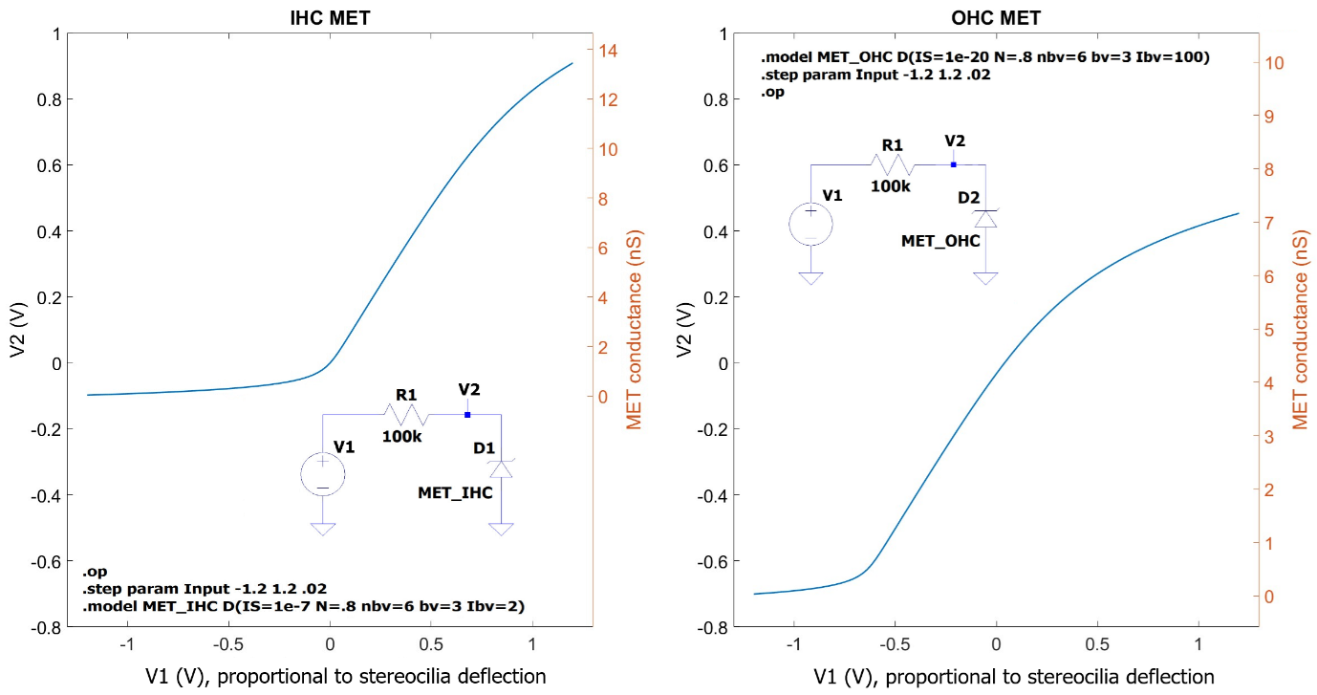
Fig. S1| Simulated MET transfer functions for the IHC and OHC. Insets in each panel show the testing circuit with the respective LTspice directives. Using equations (1.a) and (1.b), the voltage V2 (V_MET_IHC or V_MET_OHC in Fig. 3a) can be directly converted to MET conductance (right-hand-side scales). Voltage V1 represents and is proportional to the stereocilia deflection. The conversion between the two is undefined because the model does not quantify displacements.

